**Views:**

[**https://confluence.qualcomm.com/confluence/display/SCCM/ClearCase+View+Expiration+Management**](https://confluence.qualcomm.com/confluence/display/SCCM/ClearCase+View+Expiration+Management)

ct mkview -tag sunnyl_BetterSandbox-test_view -stream sunnyl_BetterSandbox-test@/vobs/Sandbox-PVOB  -stgloc cores_viewstg

P.S. according to your work project , may pick different "stgloc" , can find via command : ct lsstg

* **I do not see any files in ClearCase**

Cause

When I go into my view, I see no files in the directories where they are supposed to be.

Resolution

Seeing no files could be caused by a number of things.

**1.) Make sure you are in a view.**

To see which view you are in, use:

ct pwv

To go into a view, use either:

ct setview viewname

or

myview

or

ct startview AND cd /view/viewname/vobs/vobpath

If you do not even see your view as a subdirectory under /view, you need to run

cleartool startview

**2.) If you have a newly-created child stream, you may need to rebase it.**

If your parent stream had no recommended baselines, the child stream would have no baselines to pick up by default.

Ask the person in charge of your parent stream to recommend baselines for it, or rebase your stream manually to non-recommended baselines. This can be done in the GUI or via command line.

Command line:

Go into the view to your child stream and perform a rebase by explicitly naming the baselines:

**ct rebase -baseline baseline_name_1@/vobs/pvob_name baseline_name_2@/vobs/pvob_name ...**

For more information, see:

Starting a rebase to the recommended or non-recommended baselines

**3.) It's possible there is a system-wide problem and no VOBs are mounted to the UNIX system.**

To find out if VOBs are mounted, use:

ct lsvob

All mounted VOBs have asterisks (*).

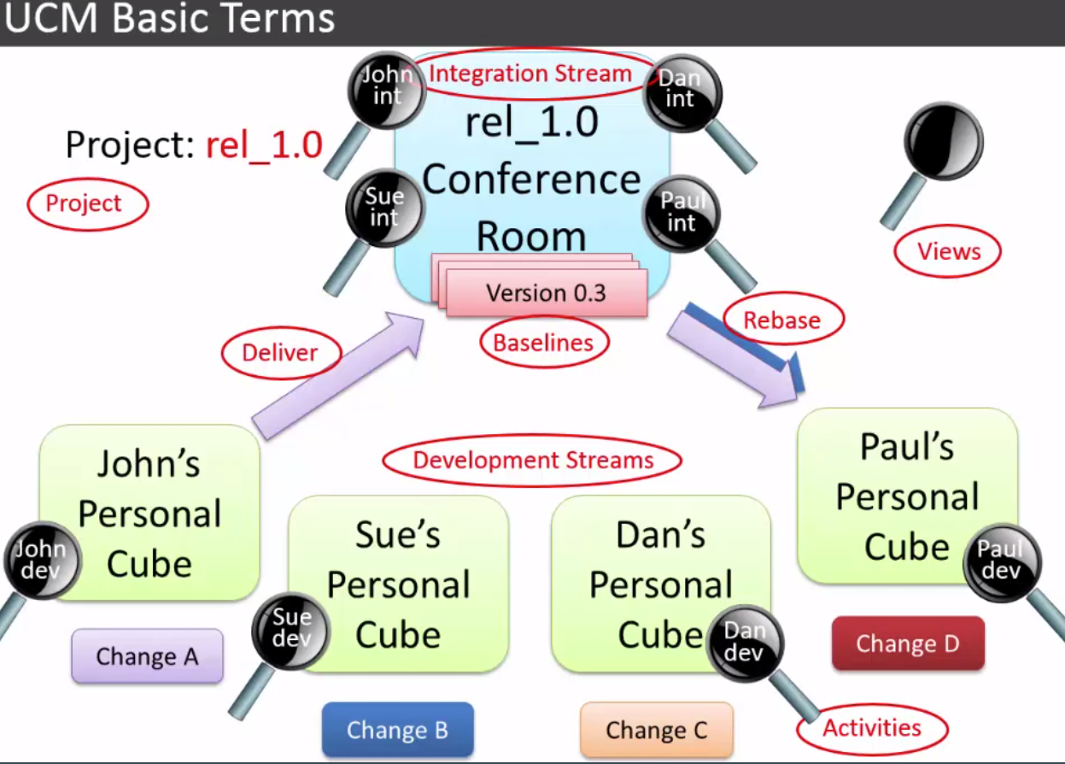

ct lsp -co

ct lsp -

ct pwv

ct setview viewname myview ct startview AND cd /view/viewname/vobs/vobpath

If you do not even see your view as a subdirectory under /view, you need to run

cleartool startview

ct setview viewname

ct lsview -l cview

sudo su user

id

ct rebase -sta

ct lstsream -anc

recommendedHistory

finducm

finducm -bl

ybls -sh -bl mybls -sh -bl

**Quick Guide: How to Join a ClearCase Project**

# Before you can join a project, you must have the proper UNIX groups for working in your project, and you must have followed the setup procedures for first time users in ClearCase and ClearQuest, including subscribing to ClearCase.

# First Time Users - San Diego / Non-BDC and Non-RTP

## New User Check List:

* Have you [requested the proper UNIX groups](https://projects.qualcomm.com/sites/qct-rational/TARDIS%20Frequently%20Asked%20Questions/What%20UNIX%20permissions%20do%20I%20need%20to%20get%20set%20up%20in%20ClearCase.aspx)from 8Help?
* Have you requested ClearQuest access from [scm.help](mailto:scm.help)?
* Have you talked to your team lead?
  + Do you know your project name and the PVOB for your project?
  + Will you use ClearCase, ClearQuest, or both?  (Most users of ClearCase will also use ClearQuest.)
* Do you know how to search the [Knowledge Base](https://projects.qualcomm.com/sites/qct-rational/Lists/QCTRational%20Knowledge%20Base/AllItems.aspx) and [get support](https://projects.qualcomm.com/sites/qct-rational/Pages/SupportPage.aspx)?
* Follow the steps below for setting up to use ClearQuest and ClearCase.

**clearjoinproj&**

1. On the next screen, name your **Development** [stream](https://projects.qualcomm.com/sites/qct-rational/Lists/Glossary/DispForm.aspx?ID=10)and choose your **Integration stream**.
   * Generally, you'll accept the default name for the development stream, but check with your team in case your team uses a different naming convention.
   * Usually, you will use the default Integration stream. If your team asks you to use a different Integration stream, click the elipsis button (…) next to the Integration stream name and browse to a different stream.
   * Click **Next**.

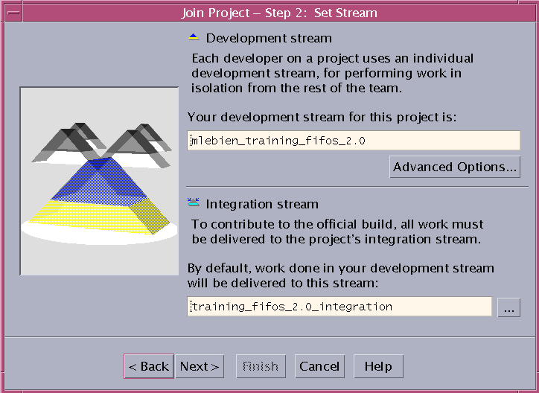

* + Select the storage location assigned to your team. (Click on it to select it)

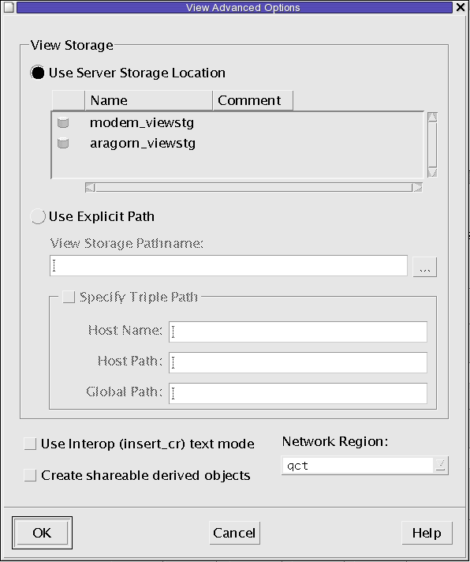

1. **If you are adding just a few files, you can use your development view. If you are importing several files and directories, you should use your integration view.**

**$ myview**(This command will show your views. **Select the number of a view you created when you joined the project**, e.g. “username_training_fifos_2.0”).

The ‘myview’ command allows the user to see their or someone else’s views and then select one of those views to be the current view.

If no param is passed, myview displays all views belonging to the current user.  If another user’s name is specified, then that user’s views are displayed.

Each view has a number preceding it, typing in one of those numbers will set the current view to the selected view.

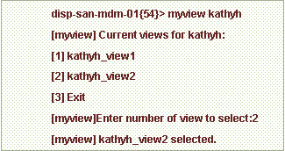

 Mkdir versus cleartool mkdir

# Submitted by Kevin Johnson

Please remember to use "cleartool mkdir" when you create a new directory. This creates a directory element under ClearCase control. The operating system command "mkdir" will work but it creates a view private directory not under ClearCase control. Only view private files and view private directories can be created under a view private directory.

Notice the "cleartool ls" command reports directory elements and view private directories differently:

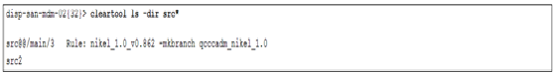  
  
The "src" directory is a directory element and versioning information is displayed.

The "src2" directory is a view private directory and no version information is shown.

Using "mkdir" instead of "cleartool mkdir" may cause problems for you later because if you create a directory structure of several directories and files then you cannot easily import these into ClearCase afterwards.

1. Change to the directory in the [VOB](http://projects/sites/qct-rational/Lists/Glossary/DispForm.aspx?ID=1) where you would like to add files. For example:

**$ cd /vobs/training/training-rpm/rpm/src**

1. To see the activities that are assigned to you, use **myact**.

**$ myact**

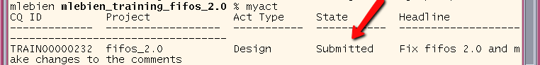

**Do NOT use any activity that starts with “deliver” or “rebase,”** as these are special activities created automatically by ClearCase and should not be used. If you use them, you will not be able to check in your imported files.

1. **Before you add the files into ClearCase**, make sure that all files have the permissions you wish them to have (e.g. Executable permissions for the group).

**$ ls -al**

**$ chmod <permissions> <filename.ext>**

**For example:**

**$ chmod g+x rpm.vhd**

1. Use cleartool mkelem to add each **file** into ClearCase. Please use the **-ci** option.

**$ ct mkelem -c "<Enter comments here>" -ci <filename.ext>**

**For example:**

**$ ct mkelem -c "Adding new files" -ci rpm.vhd**

You can also use cleartool mkelem to add a **subdirectory** into ClearCase (**but not the files it contains.** Skip to **step 13** to add entire directory trees into ClearCase). To add subdirectories, in addition to using the -ci option, use the -mkpath option.

**$ ct mkelem -c "<Enter comments here>" -ci -mkpath <directory_name>**

**For example:**

**$ ct mkelem -c "Adding new subdirectory" -ci -mkpath libs**

**$ ct ci .**

**(type a period and press enter to escape comment mode).**

The directory change is now checked in to your development stream. To see the new files listed in the group shared integration stream, you will need to [deliver](http://projects/sites/qct-rational/Lists/Glossary/DispForm.aspx?ID=18) your changes. Please see the [Quick Guide on delivering your changes](http://projects/sites/qct-rational/TARDISProjectDocumentLibrary/CC_Quick_Guide-How_to_Deliver_Changes.docx).

1. Use [clearfsimport](http://projects/sites/qct-rational/Lists/QCTRational%20Knowledge%20Base/DispForm.aspx?ID=82) to import several files and directories or an entire directory structure to ClearCase. NOTE: This command is for importing files from one location to another. Do NOT try to use it from a directory to itself. This will cause bad recursive things to happen. If your files already exist in the VOB directory as view private files, either add them one-by-one (as in step 8), or move them to your home directory and then import them.
2. To use clearfsimport to import files from one directory to another, first, run the command using the -preview option, which doesn't import the files but instead lets you check to make sure they will be imported to the proper place

**$ clearfsimport -nsetevent -recurse -comment "imported from myfiles" -follow -preview <path-to-import-from> <path-to-import-to>**

Note: The -nsetevent option will be needed for all non-administrators running clearfsimport.

-follow will follow symbolic links in the directories you are importing.  
-recurse will descend through subdirectories and import those as well as the current directory.

For more information about options available with clearfsimport, please type the following into a terminal window:

**$ cleartool man clearfsimport**

**For example (all on one line):**

**$ clearfsimport -nsetevent -recurse -comment "imported from /usr/local/kathyh/myfiles" -follow -preview /usr/local/kathyh/myfiles /vobs/training/training-rpm/rpm/src**

**$ clearfsimport -nsetevent -recurse -comment "imported from myfiles" -follow <path-to-import-from> <path-to-import-to>**

At the end of the command, consider redirecting the output and errors to a file, so you can review the file later for any errors. This is done differently depending on your UNIX shell. For example, in **csh**, at the end of the command, use

**>& logfile.txt**

**clearfsimport -nsetevent -recurse -comment "imported from /usr/local/kathyh/myfiles" -follow /usr/local/kathyh/myfiles /vobs/training/training-rpm/rpm/src >& logfile.txt**

**How to Deliver Changes to the Integration Stream**

Myview

1. Look for additional checkouts from your view to prepare for a delivery.

**$ ct lsco -cview -avobs**

**$ ct ci <filename.ext>**

1. Now make sure you have no view private files you forgot to add to source control.

**$ ct lsprivate -other**

1. Test your work and perform a [rebase](https://projects.qualcomm.com/sites/qct-rational/Lists/Glossary/DispForm.aspx?ID=11). It is best practice to rebase before you deliver.

**$ <Perform testing steps here. Fix things if tests do not pass.>**

**$ ct rebase -g**

. Then use *ct rebase -complete* to complete it.)

**$ <Perform testing steps again here. Fix things if tests do not pass.>**

**$ ct rebase -complete**

**$ ct deliver -g**

The **Deliver Preview** window will show. Ensure that your integration view is shown to the right of "Merge work to view." If not click Change… and select your integration view.

Click **OK.**

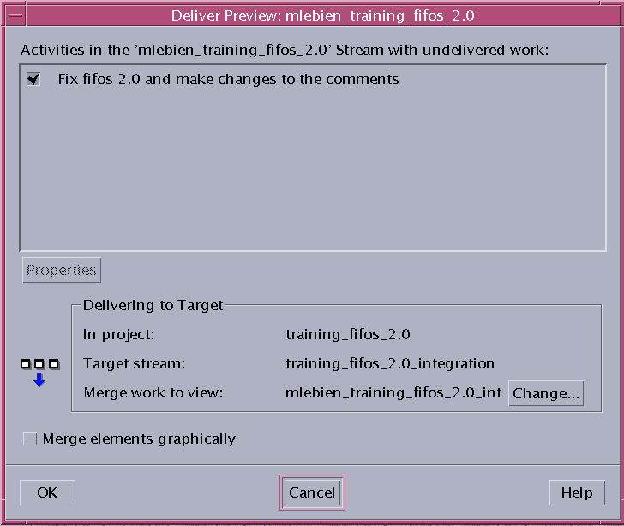

1. If a dialog appears saying, "The element below cannot be merged automatically," be sure to handle your merges, save your merges, and close the Diff Merge tool. See the [Quick Guide on merging](https://projects.qualcomm.com/sites/qct-rational/TARDISProjectDocumentLibrary/CC_Quick_Guide-How_to_Merge.docx) for more information.

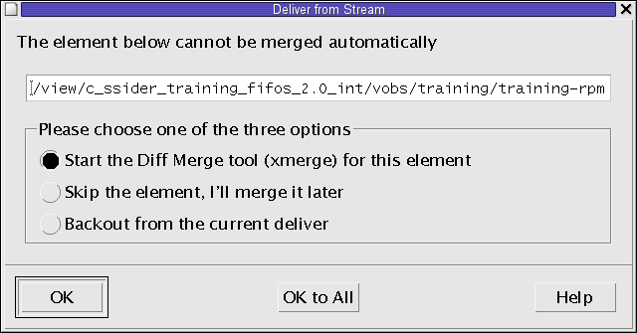

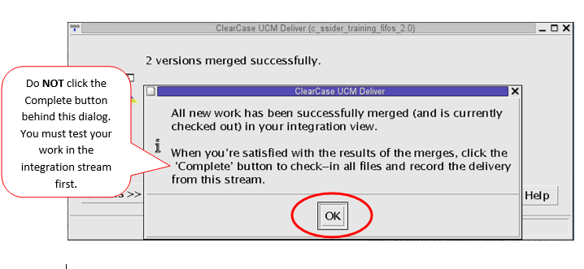

1. When a dialog appears telling you "All new work has been successfully merged," click **OK** and go back to your Unix terminal. **Do NOT click the Complete button in the GUI yet. You will test your work before completing your deliver.**
2. Open a new terminal window. In the new terminal window, set into your **integration view** to test your work there.

**$ myview**(This command will show your views. **Select the number of your integration view** selected in step 7 for "Merge work to view.")

1. Build and test your work in the **integration view**. This includes running make_modeltech and a sanity sim to ensure the changes did not break anything.

**$ <Perform testing steps here.>**

1. If the tests in step 11 do not pass, then try to determine the problem. After you determine the problem, cancel your delivery and fix the problem in your development view. Deliver again after fixing the problem.

To cancel your delivery, click **Close** and then **OK** in the GUI (shown below). Then go to the terminal window set to **your development view** and type **cleartool deliver -cancel (also shown below):**

**Quick Guide: How to Make a Baseline**

**Note: Baselines are generally made and recommended on integration streams, NOT on development streams.** To prevent confusion,avoid making baselines on a private development streams. Instead, deliver your work from your private development stream to your integration stream and make a baseline on the integration stream.

(Note: Most baselines are set on integration streams, not on development streams.)

1. The Baseline Type should be **Incremental**. The Project/Stream can be left as default. The view context should be your view to the stream in which you would like to make the baseline. The default is usually correct, but if it is not, click the ellipsis button (**…**) and select the correct view. 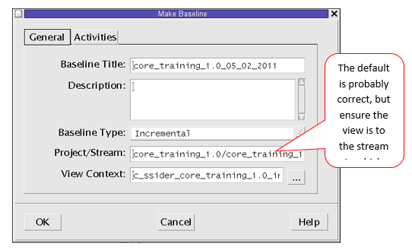 If you think there may be some work in the stream you don't want to include in the baseline, click the **Activities** tab (continue to the next step). If you are not sure, or if you want the baseline to include all work in the stream, just click **OK (skip to step 10)**.

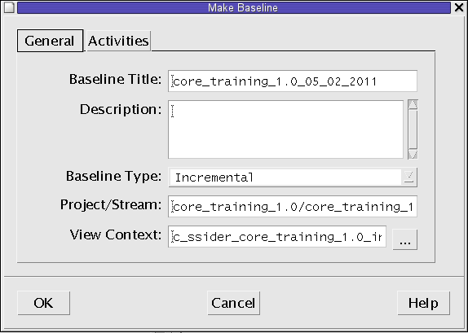

1. On the Activities tab, by default, all new activities since the last baseline will be included. Deselect any activities you do not want to include. Then click **OK**.

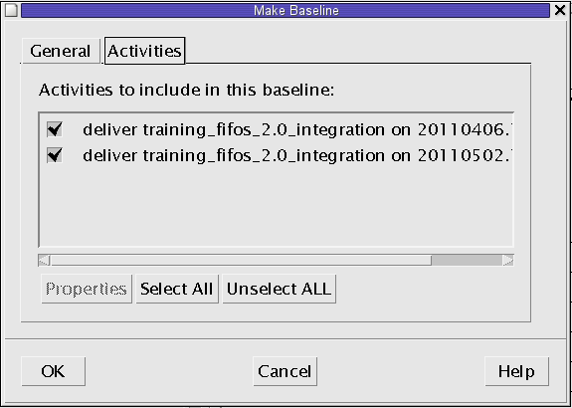

1. You may see the following dialog because deselecting an activity is subject to dependencies. This means the activity is necessary for including another activity in your list. To continue, you will have to add the indicated activity back to the list. Be sure the box next to "**Add all of these activities to the currently selected set**" is checked, and click **OK.** Otherwise, you will need to click **Cancel** and deselect additional activities. (Either way, you will go back to step 8.)

