**Terraform Assignments**

🡪Create a VPC with required document components using Terraform

Deploy an EC2 instance inside VPC

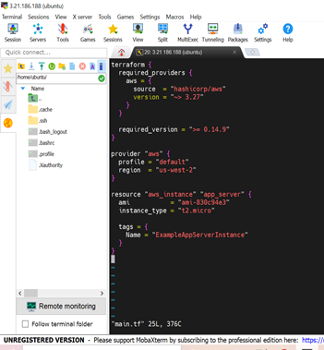

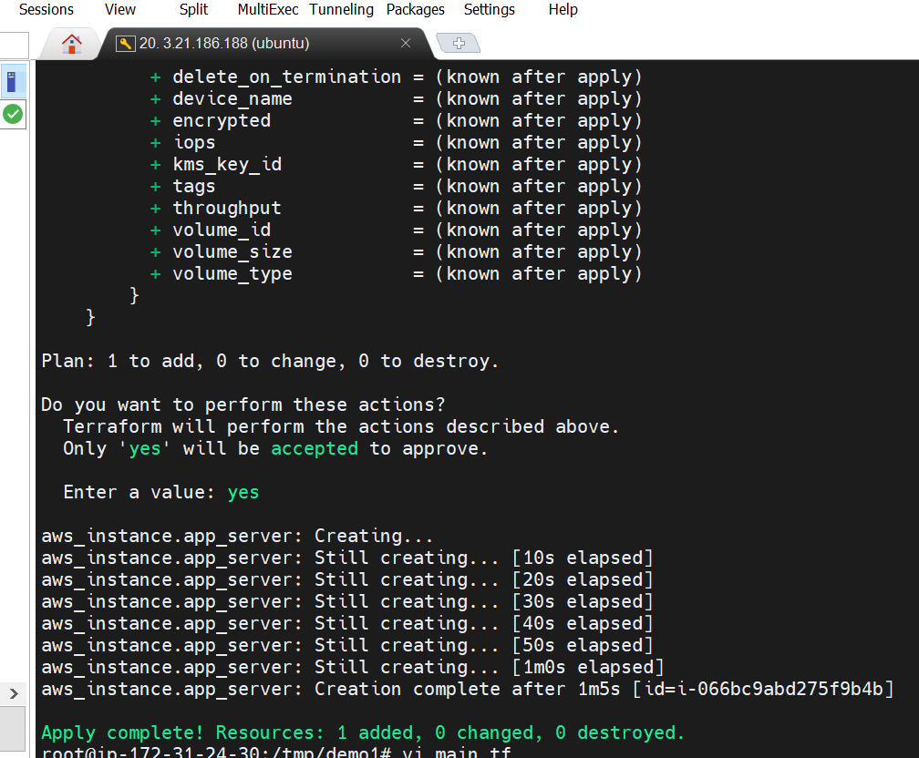

🡪Create a script to install apache2

Run the script on the newly created instance

Print the IP address

**Main.tf**

terraform {

required_providers {

aws = {

source = "hashicorp/aws"

version = "~> 3.0"

}

}

}

# Configure the AWS Provider

provider "aws" {

region = var.region

shared_credentials_file = "var.creds_path.var.creds_file"

profile = "default"

}

# Create a VPC

resource "aws_vpc" "app_vpc" {

cidr_block = var.vpc_cidr

tags = {

Name = "app-vpc"

}

}

resource "aws_internet_gateway" "igw" {

vpc_id = aws_vpc.app_vpc.id

tags = {

Name = "vpc_igw"

}

}

resource "aws_subnet" "public_subnet" {

vpc_id = aws_vpc.app_vpc.id

cidr_block = var.public_subnet_cidr

map_public_ip_on_launch = true

availability_zone = "us-west-2a"

tags = {

Name = "public-subnet"

}

}

resource "aws_route_table" "public_rt" {

vpc_id = aws_vpc.app_vpc.id

route {

cidr_block = "0.0.0.0/0"

gateway_id = aws_internet_gateway.igw.id

}

tags = {

Name = "public_rt"

}

}

resource "aws_route_table_association" "public_rt_asso" {

subnet_id = aws_subnet.public_subnet.id

route_table_id = aws_route_table.public_rt.id

}

resource "aws_instance" "web" {

ami = "ami-005e54dee72cc1d00"

instance_type = var.instance_type

key_name = var.instance_key

subnet_id = aws_subnet.public_subnet.id

security_groups = [aws_security_group.sg.id]

user_data = <<-EOF

#!/bin/bash

echo "*** Installing apache2"

sudo apt update -y

sudo apt install apache2 -y

echo "*** Completed Installing apache2"

EOF

tags = {

Name = "web_instance"

}

volume_tags = {

Name = "web_instance"

}

}

