**GIT**

Git is a DevOps tool used for source code management. It is a free and open-source version control system used to handle small to very large projects efficiently. Git is used to tracking changes in the source code, enabling multiple developers to work together on non-linear development

**GIT Strategy**

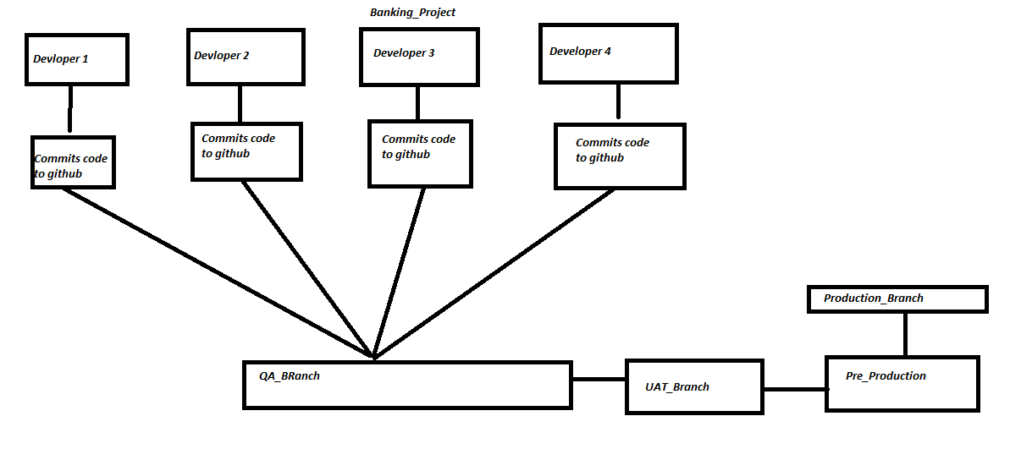

**Install GIT**

To install git in RHEL/Centos run the below command

sudo yum install git -y

Check GIT version

git - -version

**Create a git repository locally**

First create a directory for git & switch to that directory mkdir git_practice && cd git_practice

Create a local repository git init .

Now check local repository files including hidden ls -a

After executing ls -a, there you can see newly created .git directory

**Steps to commit a file**

Go to git_practice directory & create a file touch f1

Check status of git git status

Add that file to git git add f1

Commit the file with commit message git commit -m <”commit message”> <”file name”>

(git commit -m “This is my first commit” f1)

Check file commit details git log

Now commit the second file “f2” > Follow the same process above.

Execute git log to check number of commits

|  |  |  |  |
| --- | --- | --- | --- |
|  |  |  |  |
|  | | |

How many repositories in Git hub

1. Local 2. Central

How many repositories in Git

Local 2. Central 3.Remote

Create an account in [github.com](http://github.com/) & create a repository

By default there’s a main branch & there’s no master branch in central repository

Add repository

git remote add origin <repository url>

Check git branch

git branch

Push files to git repo

git push -u origin master

(it will ask for username and password - don’t give password, provide token)

**GIT BRANCHES**

Check git branch

git branch

Create a new branch

git branch <branch name>

Switch to new branch

git checkout <branch name>

Add files to new branch and commit those files

git add <file name> && git commit -m <”commit message”> <file name>

Push branch to GIT central repository

git push -u origin master <branch name>

Shortcut method for creating a branch and switching to that branch

git checkout -b <branch name>

Change branch name

git branch -m <old branch name> <new branch name>

Clone a branch

git clone -b <branch name> <repo url>

Delete a branch

git branch -D <branch name>