devopsca1

Q1.

The Linear Sequential or Classic Life Cycle is also called

1. Waterfall Model
2. Incremental Model
3. Spiral model
4. Prototyping Model

Answer: a

Q2.

The waterfall model of the software process considers each process activity as a _______ phase

1. separate
2. discrete
3. Both a and b options
4. None of the above

Answer: c

Q3.

What would be the current working directory at the end of the following command sequence?

$ pwd

/home/user1/proj

$ cd src

$ cd generic

$ cd .

$ pwd

a) /home/user1/proj  
b) /home/user1/proj/src  
c) /home/user1  
d) /home/user1/proj/src/generic

Answer: d

Q4.

What is the output of the following code:

os=Unix

echo 1.$os 2."$os" 3.'$os' 4.$os

a) 1.Unix 2.Unix 3.Unix 4.Unix  
b) 1.Unix 2.Unix 3.$os 4.Unix  
c) 1.Unix 2.Unix 3.Unix 4.$os  
d) 1.Unix 2.$os 3.$os 4.$os

ANS: B

Q5.

What is the output of the following program?

x = 3; y = 5; z = 10;

if [( $x -eq 3 ) -a ( $y -eq 5 -o $z -eq 10 )]

then

echo $x

else

echo $y

fi

a) 1  
b) 3  
c) 5  
d) Error

Answer: b

Q6.

What is the output of the following program?

File abc.txt has content “ devops test”

program

if [ -s abc.txt]

then

echo “ file empty”

else

echo “file is not empty”

fi

a) file empty

b) file is not empty

c) error

d) none of these

answer a

Q7

In waterfall model, output of one phase is input to next phase. True or false.  
  
a) True  
b) False

Answer: a

Q8

Selection of particular life cycle model is based on,  
  
a) Requirements  
b) Technical knowledge of development team  
c) Project types and associated risks  
d) All of the above

Ans: d

Q9

Regression testing is a major part of which of the life cycle?  
  
a) Waterfall model  
b) V model  
c) Iterative model  
d) All of the above

Ans: c

Q10

In a college,students are asked to develop a software. Which model would be preferable?  
  
a) Waterfall model  
b) Spiral model  
c) Agile model  
d) Code and fix model

Ans: d

Q11.

What is full form of SDLC?  
  
a) System Design Life cycle  
b) Software Design Life Cycle  
c) System Development Life Cycle  
d) Software Development Life Cycle

Ans: d

Q12.

In which step of SDLC project termination could be done?

a) Design Phase

b) System Maintenance Phase

c) Feasibility Study Phase

d) Coding Phase

Ans: c

Q13.

Which one of the is not a stage of SDLC?

a) System Analysis

b) Problem Identification

c) System Design

d) Feasibility Study

Ans: b

Q14.

Which command is used to display the operating system name  
a) os  
b) unix  
c) kernel  
d) uname

Ans: d

Q15

Which command creates an empty file if file does not exist?  
a) cat  
b) touch  
c) ed  
d) read

Ans: b

Q16

pwd command displays  
a) user password  
b) password file content  
c) present working directory  
d) none of the mentioned

Ans: c

Q17

Build & Fix Model is suitable for programming exercises of ___________ LOC (Line of Code).  
a) 100-200  
b) 200-400  
c) 400-1000  
d) above 1000

Ans: a

Q18

RAD stands for  
a) Relative Application Development  
b) Rapid Application Development  
c) Rapid Application Document  
d) None of the mentioned

Ans: b

Q19

What is the major advantage of using Incremental Model?  
a) Customer can respond to each increment  
b) Easier to test and debug  
c) It is used when there is a need to get a product to the market early  
d) Easier to test and debug & It is used when there is a need to get a product to the market early

Ans: d

Q20

What is the output of following flowchart?

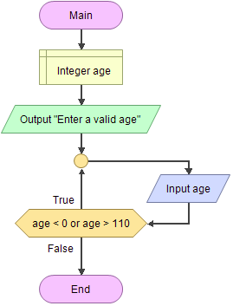

1. Will loop while the 'age' variable is less than 0 or greater than 110
2. Will loop while age is less than 110
3. Will loop while age is between 0 and 110
4. None of the above

Ans: a

Q21

The rules of writing 'if-then-else', 'case-switch', 'while-until' and 'for' control flow statements are called _____ .

1. Comments
2. Functions
3. Line length and wrapping
4. Control Structure

Ans: d

Q22

Which Software-end factors affecting maintenance Cost?

a) Structure of Software Program

b) Programming Language

c) Dependence on external environment

d) All mentioned above

Ans: d

Q23

The detailed study of existing system is referred to as

a) System planning

b) System analysis

c) Feasibility study

d) Design DFD

Ans: b

Q24

Who writes the Software Requirement Specification Document (SRS)?

a) System Developer

b) System Tester

c) System Analyst

d) None of these

Ans: c

Q25

What command is used to remove files?

a) dm

b) rm

c) delete

d) erase

Ans: b

Q26

How can you come out of the loop in this program?

#!/bin/bash

read x

while [ $x != "hello" ]

do

echo "Try to come out of the loop"

read x

done

echo "Welcome"

exit 0

a) by entering “hello”  
b) by entering anything except “hello”  
c) it is not possible  
d) none of the mentioned

Ans: a

Q27

After running this program, if you enter 1000, then what will be the output of the program?

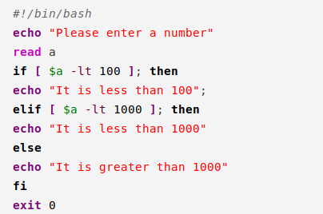

a) It is greater than 1000  
b) It is less then 1000  
c) It is equal to 1000  
d) None of then mentioned

Ans: a

Q28

Which principle is correct regarding lean model?

1. Amplify learning
2. Empower the team
3. Build integrity
4. All of these

Ans: d

Q29

Requirement to develop software is:

1. Model business
2. Analyse
3. Design
4. All of these

Ans: d

Q30

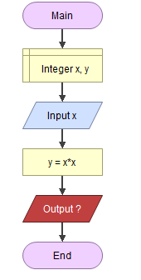

In above flowchart if value of x is 16 then output is ______

a) 256

b) 234

c) 343

d) None of these

Ans: a