22222222222222222222222222222

Jenkins

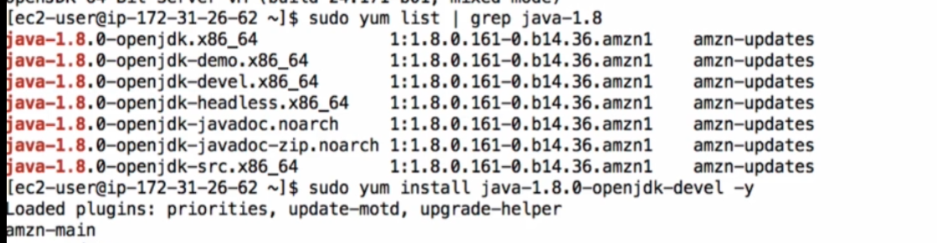Have compiler+run time

java -version --->1.7

sudo update-alternatives –config java (make java-1.8 as default)

*1.) 1.7 2.) 1.8 2

java -version --->1.8

66666666666

job--->freestayle

git-javahometech/my-app

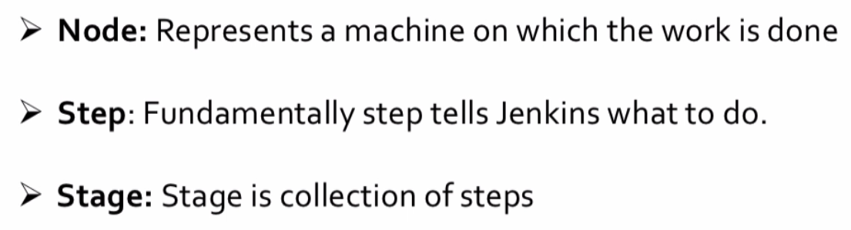

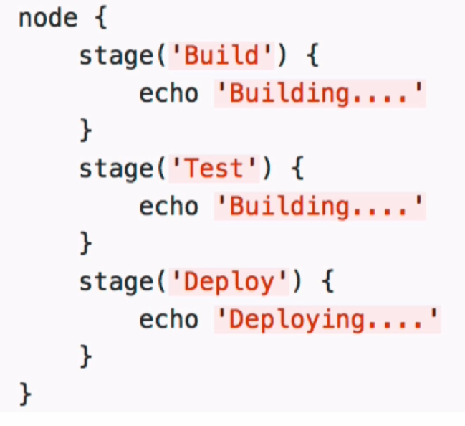

NTERPOLATION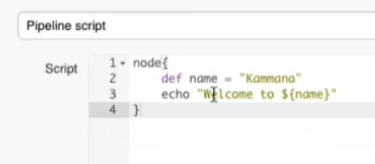S IN JENKINSFILE, IT MUST BE APPENDED BY DOUBLE QUOTES

|  |  |  |  |
| --- | --- | --- | --- |
| node{ |  |  |  |
|  |  |  | stage('SCM Checkout'){ |
|  |  |  | git 'https://github.com/javahometech/my-app' |
|  |  |  | } |
|  |  |  | stage('Compile-Package’){ |
|  |  |  | sh 'mvn package' |
|  |  |  | } |
|  |  |  |  |
|  |  |  | } |

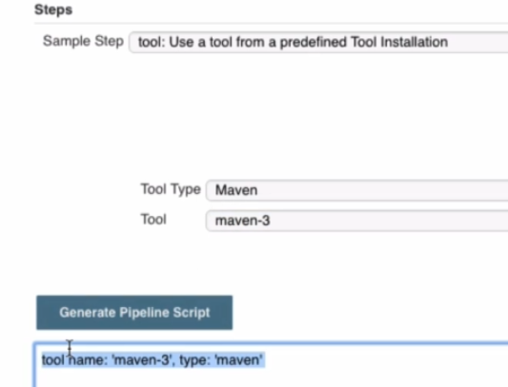

<https://github.com/javahometech/my-app/commit/6d65705b85e56eb9c3e3c770154ee1f0b8e04f8c#diff-e6ffa5dc854b843b3ee3c3c28f8eae2f436c2df2b1ca299cca1fa5982e390cf8>

|  |  |  |  |
| --- | --- | --- | --- |
| git 'https://github.com/javahometech/my-app' |  |  |  |
|  | } |  | } |
|  | stage('Compile-Package'){ |  | stage('Compile-Package'){ |
|  | sh 'mvn package' |  | // Get maven home path |
|  |  |  | def mvnHome = tool name: 'maven-3', type: 'maven' |
|  |  |  | sh "${mvnHome}/bin/mvn package" |
|  | } |  | } |
|  |  |  |  |
|  | } |  | } |

11) 11111111111111111111111111111111

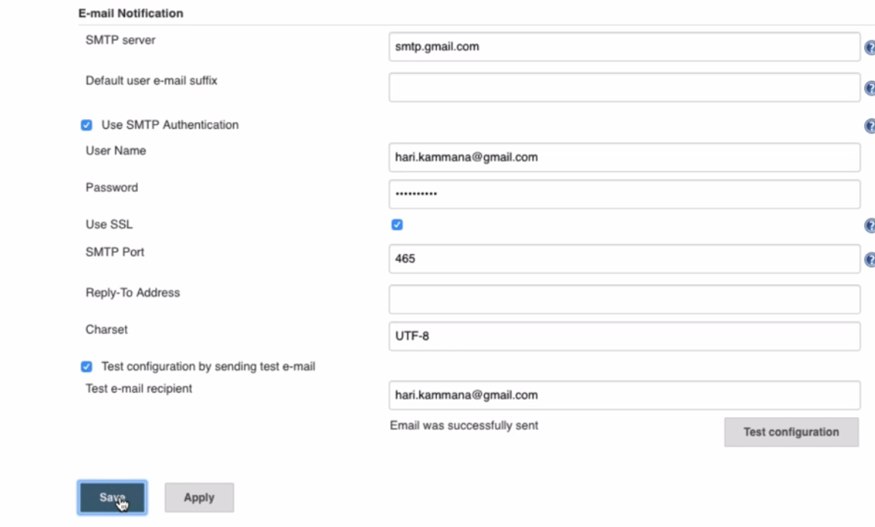

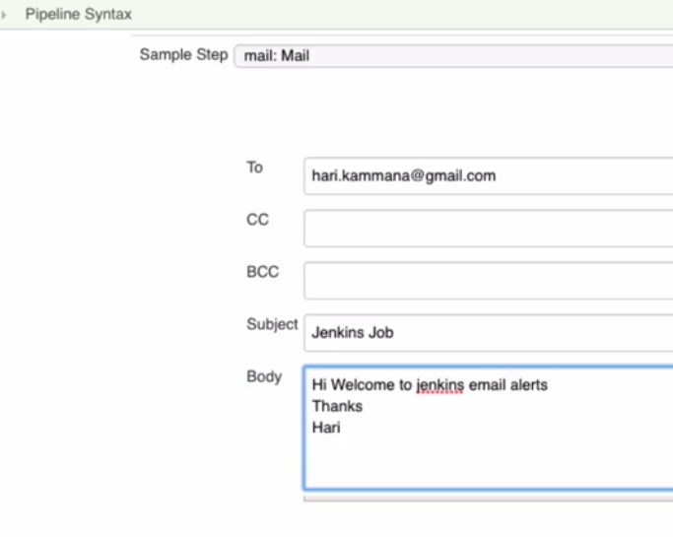

D

def mvnHome = tool name: 'maven-3', type: 'maven'

sh "${mvnHome}/bin/mvn package" sh "${mvnHome}/bin/mvn package"

} }

stage('Email Notification'){

mail bcc: '', body: '''Hi Welcome to jenkins email alerts

Thanks

Hari''', cc: '', from: '', replyTo: '', subject: 'Jenkins Job', to: 'hari.kammana@gmail.com'

}

} }

12 2222222222222222222222222222222222

SLACK NOTIFICATIONS

Plugin: slack notification

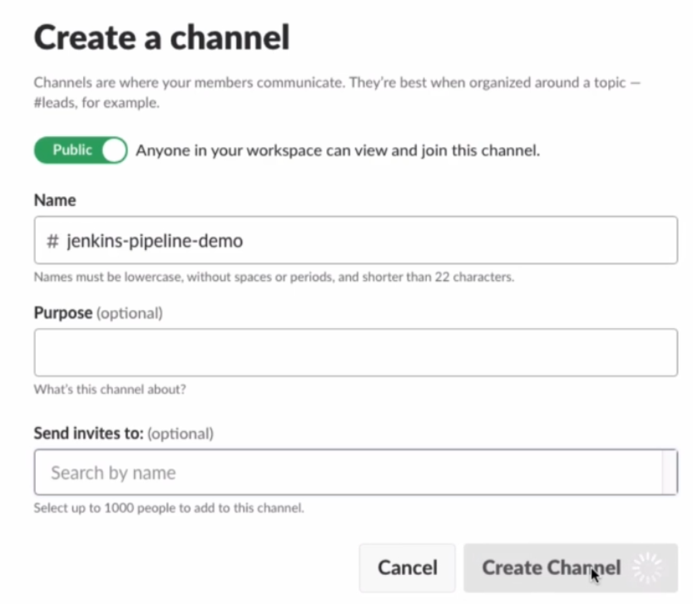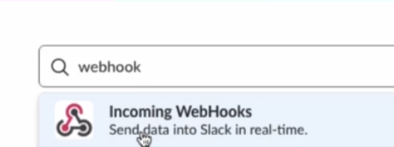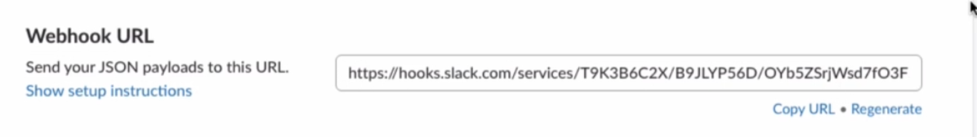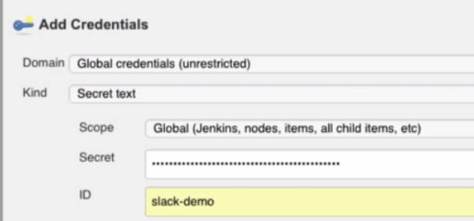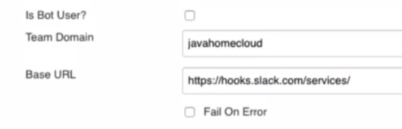

<https://github.com/javahometech/my-app/blob/d691f99573e91dedeb5bd8c28ac052b7e5a09f42/Jenkinsfile>

1743110-13 - Parametrizing Jenkins Jobs - DevOps with Jenkins Pipeline, Ansible, Kubernetes _ Docker

New-🡪pipeline-🡪]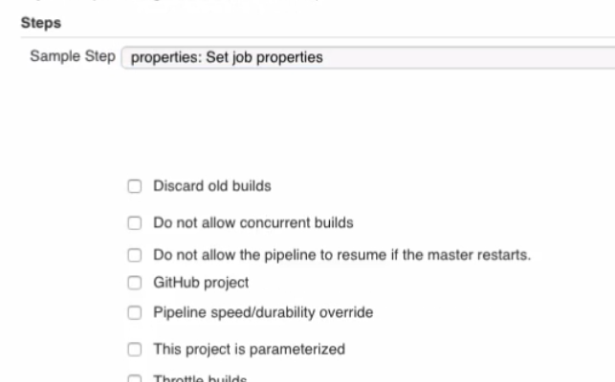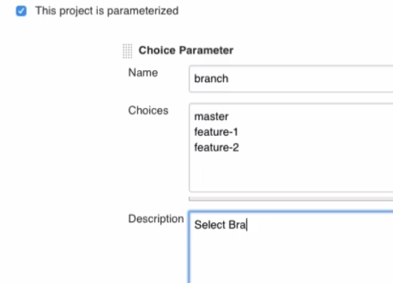

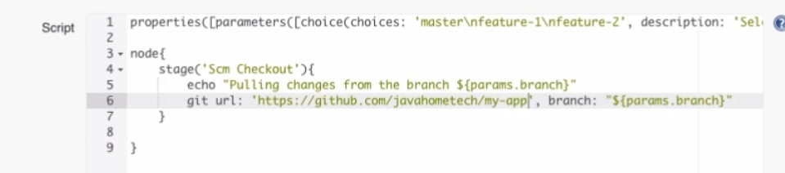

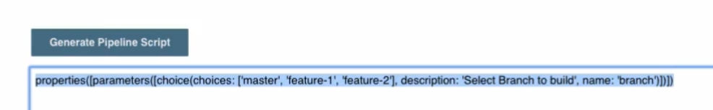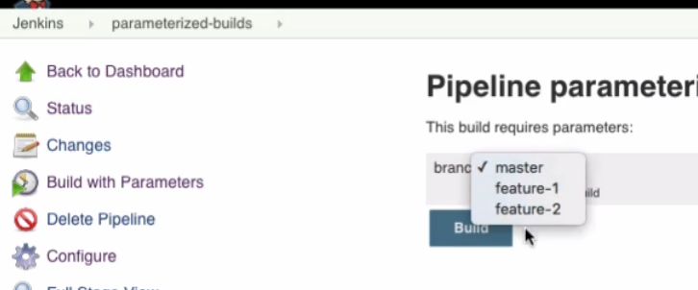

15,16 SonarQube:

Plugin: sonarqube scanner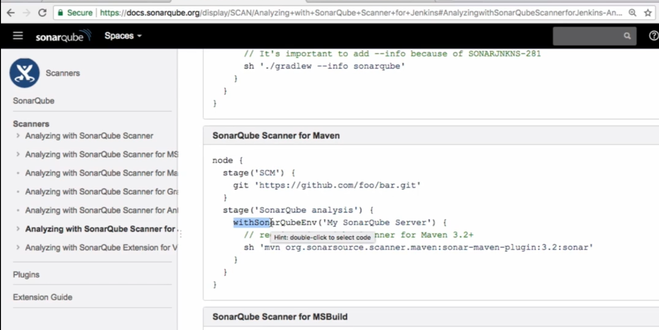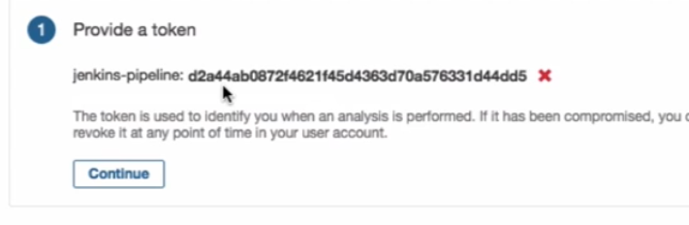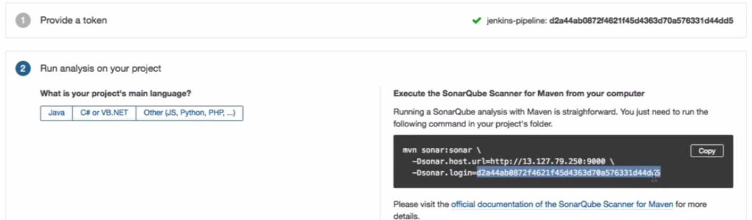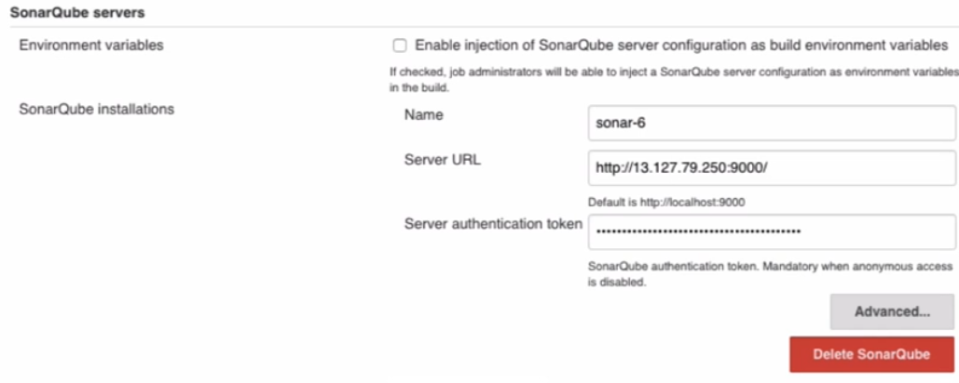https://github.com/javahometech/my-app/blob/c4c18b92c8dc55b14d42f9f3b262b1ad0cc6176a/Jenkinsfile

<https://github.com/javahometech/my-app/blob/master/sonarqube-analysis>

17 777777777777777777777

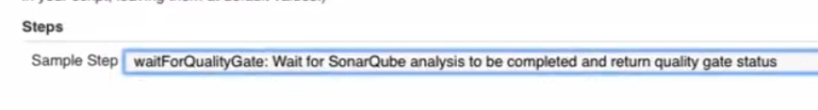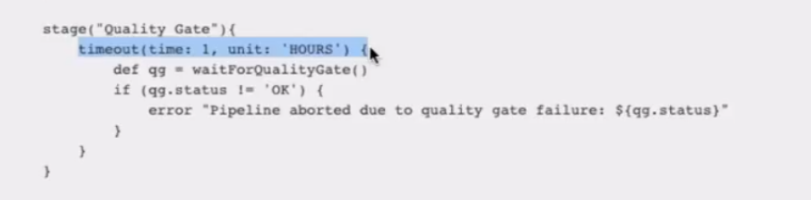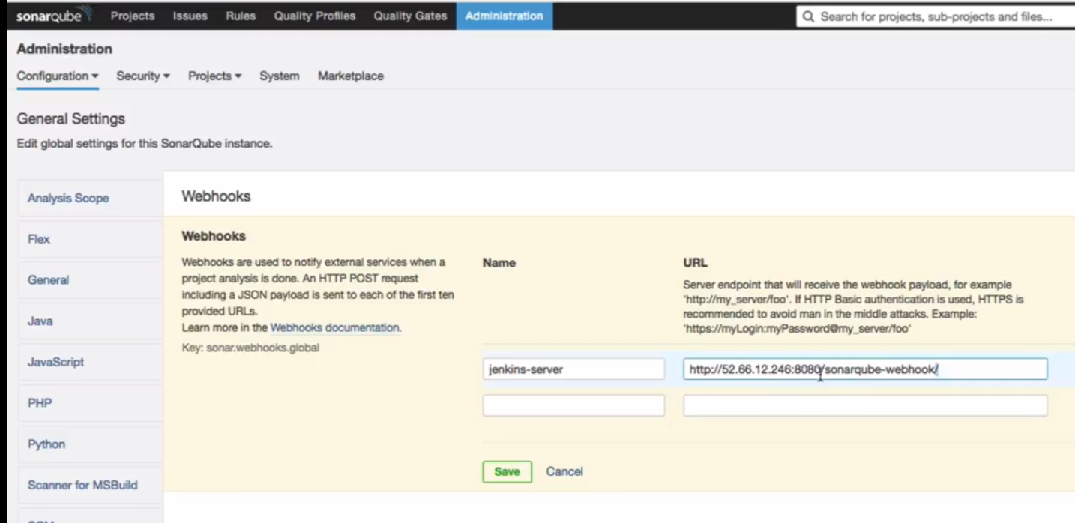https://github.com/javahometech/my-app/blob/master/sonar-status-check

1999999999

1743110-19 - Deploy War File to Tomcat Using - Jenkins Pipeline - DevOps with Jenkins Pipeline, Ansible, Kubernetes _ Docker

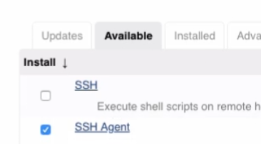

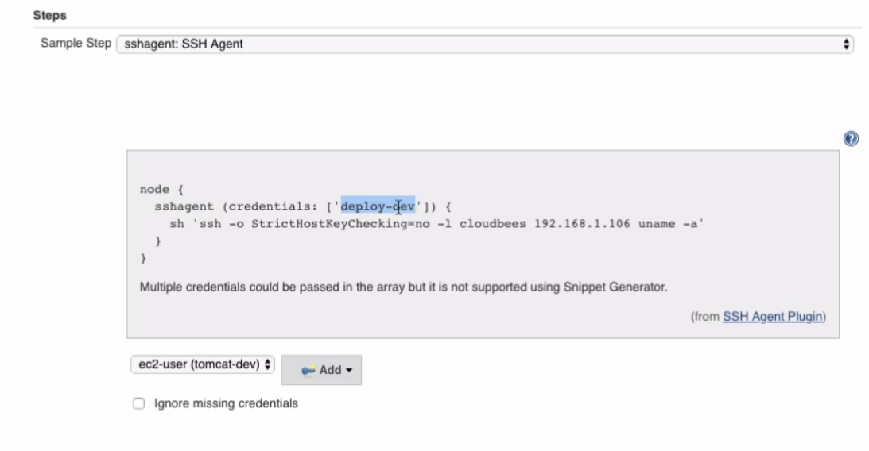

<https://github.com/javahometech/my-app/blob/master/deploy-to-tomcat>

<https://github.com/javahometech/my-app/blob/master/deploy-war-to-tomcat>

1743110-20 - Introduction to Declarative Pipelines - DevOps with Jenkins Pipeline, Ansible, Kubernetes _ Docker

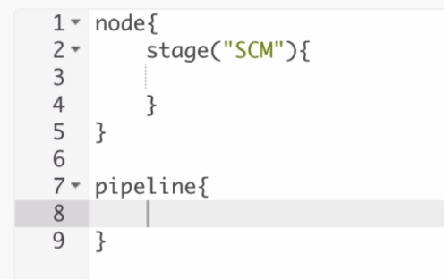

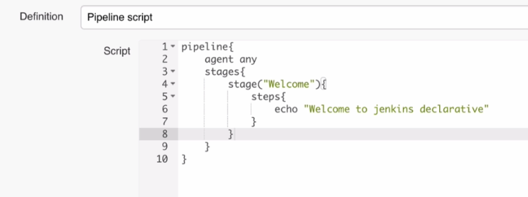

1743110-21 - Git Checkout 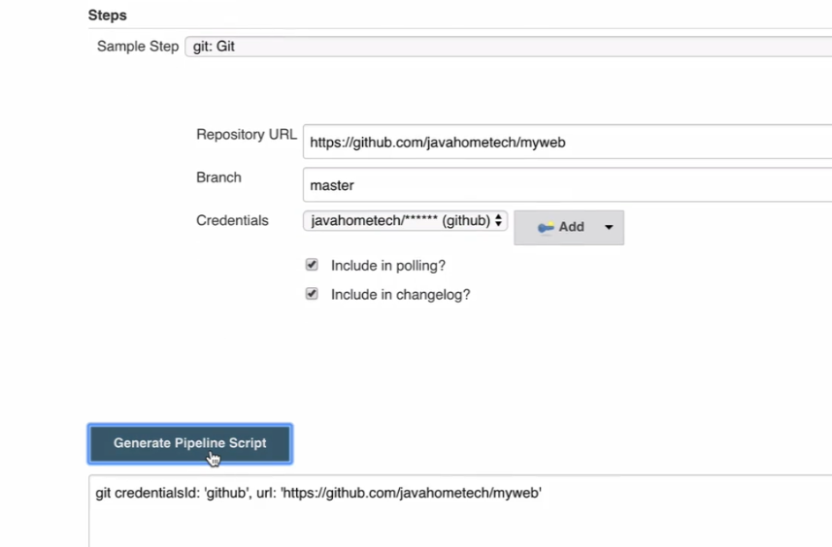

222--- Maven build

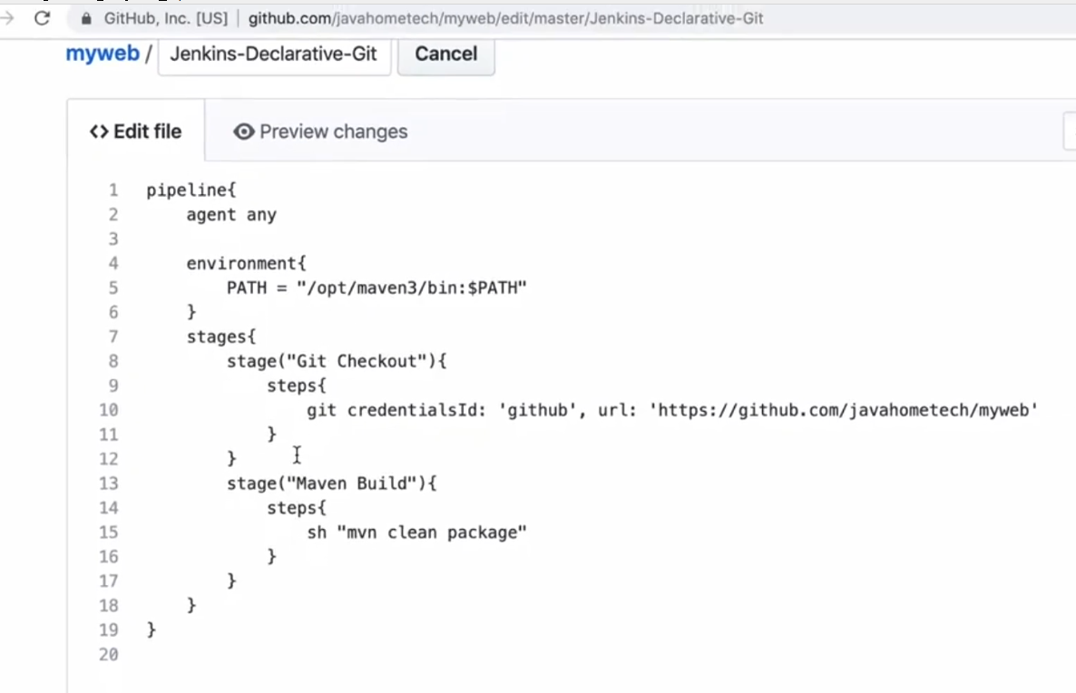

23: Deploy To tomcat

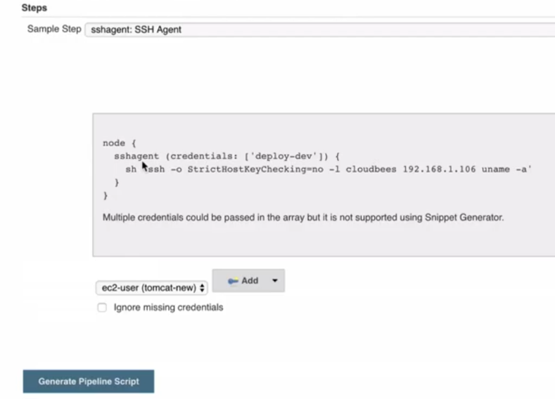 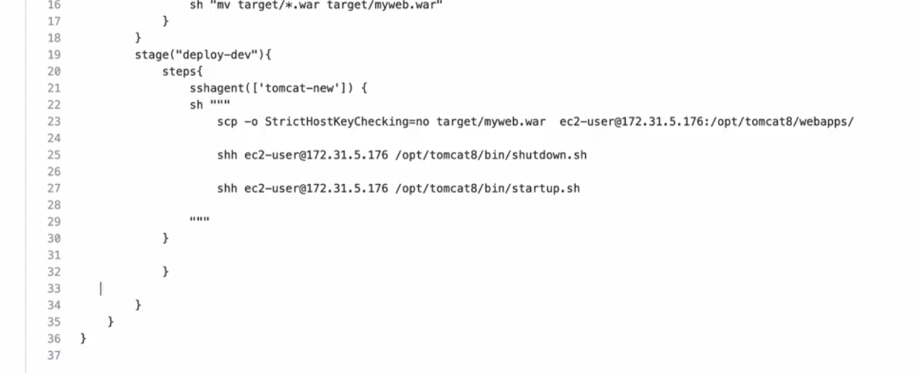 **24 - Display custom build names using Declarative Pipelines -** 