Date: 18/03/2026
Ref. No: DR-TEST-001

Dashen Bank
Addis Ababa, Ethiopia

Test Letter Generation
Dear Sir / Madam,
This is a test letter to verify the new letterhead template.
The letter should show the company logo and stamp from Response.docx.
Thank you for your time and consideration.

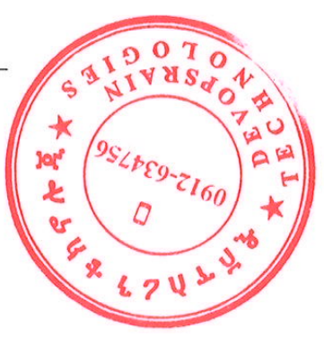 | Best Regards,

Authorised Signatures:
Project Manager (PM) | Finance Manager (FM) | Managing Director (MD)
_________________________ | _________________________ | _________________________
Signed: Test User  18 Mar 2026 10:00 | Not yet signed | Not yet signed

CC: Finance Manager

