**INSTALLATION**

* Linux : you can check and install (git) in your server the command is: yum install Git.
* Windows: <http://www.git-scm.com>.
* If already installed git checked it ->git –version.

**WORKING**

1.Firstly you can make an account in <https://github.com> [username -> devopsreema password -> reemapal99@]

2.create a folder devops name and then server name folder in vagrant script file .

3.then open folder C:\Users\reema pal\Desktop\devops classes\server4 and delete this content then write cmd command and open the terminal.

4.type the command **: vagrant up->**It is time to boot your first Vagrant environment. Run the following from your terminal.

5.then ssh login through putty write ip address of vagrant script and server name. open and then login as vagrant and type password vagrant

6.create a directory git name the command is -mkdir github.

7.create a two or more files in github directory the command is : touch file 1 file2

8.create a new local repository the command is : git init

9.check the status of git List the files you've changed and those you still need to add or commit: the command is : git status

10.start tracking new/edited filename.

|  |  |
| --- | --- |
| Add one or more files to staging (index)area: | git add <filename>  git add * |

11.Edit your file index.html and then check git status. The command is: vi index.html.

12.Commit changes to head (but not yet to the remote repository).the command is : git commit -m "Commit message".-m is a message

13.Commit any files you've added with git add, and also commit any files you've changed since then: git commit -a.

14.Lists all the files that have to be committed. the command is : git show filename.

**Connect to a remote repository**

1.If you haven't connected your local repository to a remote server, add the server to be able to push to it:

The command is: git remote add origin (url / https://github.com/devopsreema/pal.git).

2.Push operation copies changes from a local repository instance to a remote one. the command is : git push origin master.

Or

Pull operation copies the changes from a remote repository instance to a local one.the command is :git pull origin master

3.then your file get the github.com.

**Create a working copy of a local repository:**

The command is: git clone /path/to/repository

The command is: git pull [Repository Link]

This command fetches and merges changes on the remote server to your working directory.

**EXTRA COMMAND REMEMBER**

Configure git ->Configure the author name and email address to be used with your commits.the command is.

git config --global user.name "Sam Smith"

git config --global user.email [sam@example.com](mailto:sam@example.com)

git remote -v :-List all currently configured remote repositories.

git branch:- List all the branches in your repo, and also tell you what branch you're currently in.

git diff :- Preview changes, before merging.

git log :- display all commit.

git log –oneline **:-** View Just One Line Per Commit.

git config -l:-check your information.

git add -A :- Add all new and changed files to the staging area.

git branch [branch name] :-This command creates a new branch.

git checkout [branch name]:- This command is used to switch from one branch to another.

git merge [branch name] :-This command merges the specified branch’s history into the current branch.

git ignore :- create a .gitignore  file,

**Diagram of GIT**:

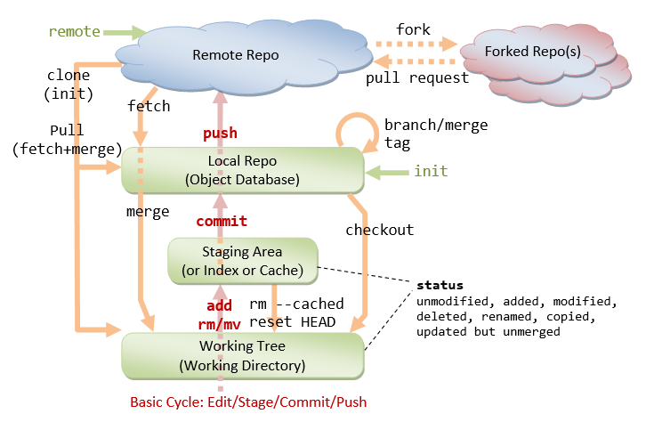

**QUESTIONS AND ANSWER:**

**1) What is GIT?**

Ans. GIT is a distributed version control system and source code management (SCM) system with an emphasis to handle small and large projects with speed and efficiency.

**2)What is a repository in GIT?**

Ans. A repository contains a directory named (.git), where git keeps all of its metadata for the repository. The content of the (.git) directory are private to git.

**3)What is the difference between Git and GitHub?**

Ans.Git is a distributed version control tool that developers install on local machines and use to track commit histories, merge files and share code with fellow developers. In comparison, GitHub is a cloud-based source code repository built around the Git tool. Along with providing a central location from which Git users can push and pull code, GitHub also adds a variety of services and features that are not native to Git, such as forking, user management, online editing and branch protection.

Git is maintained by The Linux Foundation, while GitHub was acquired by Microsoft.

**4)What is "version control"?**

**Ans.**Version control is a system that records changes to a file or set of files over time so that you can recall specific versions later.

There are two vcs.

### 1.

### 

2.

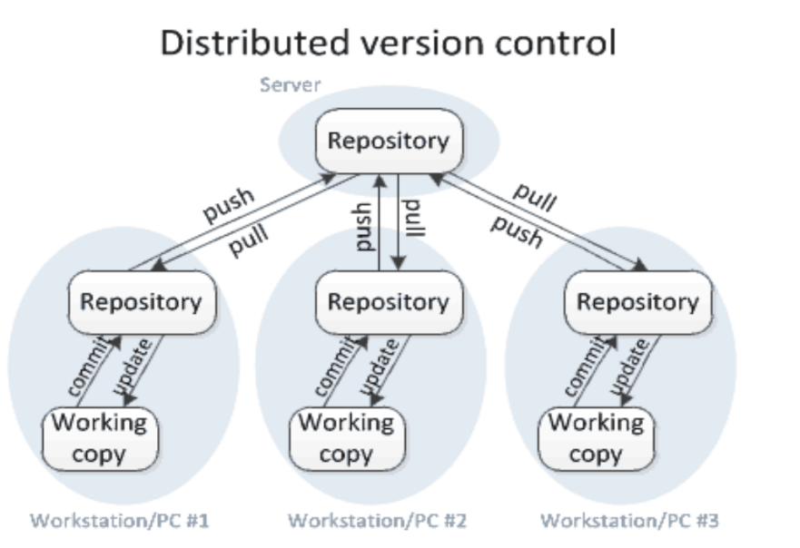

**5.the three states of git.**

Ans.Commited (stored in local database) ● Modified (file changed but not commited to database) ● Staged (modified file is marked to go into the next commit snapshot).

**6.what is a gitignore?**

**Ans. .gitignore** tells git which files (or patterns) it should ignore. It's usually used to avoid committing transient files from your working directory that aren't useful to other collaborators, such as compilation products, temporary files IDEs create, etc.

**7.ssh through login**

**Ans.1.**firstly key generate the command is:ssh-keygen

2.then cat /root/.ssh/id_rsa.pub. and copy the key.

3 .Go to setting -> and then click ssh and gpg key -> and then add new ssh key into the github account by pasting the key .