<https://wiki.jenkins-ci.org/display/JENKINS/Use+Jenkins> is a good page to get general instructions.

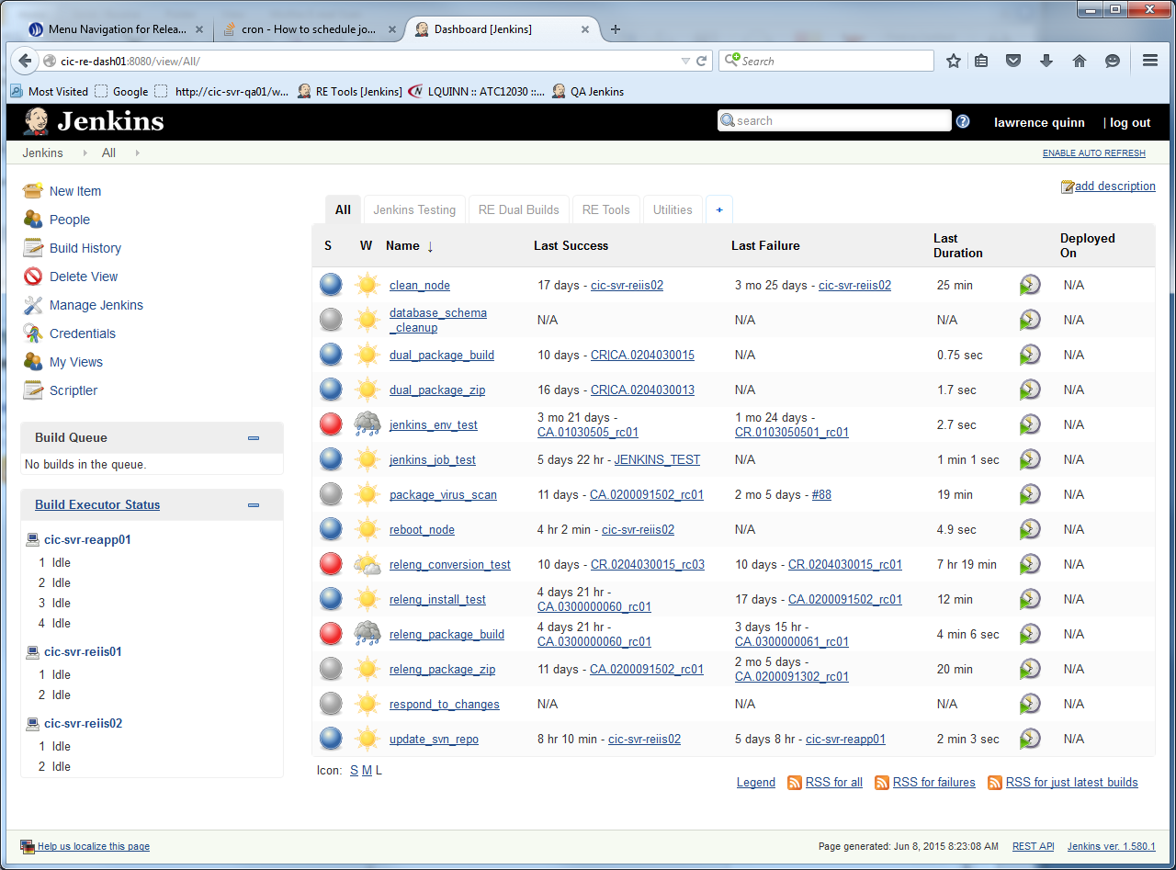

To create a job in Jenkins

Navigate to the item "New Item" at the top left hand pane to open this page:

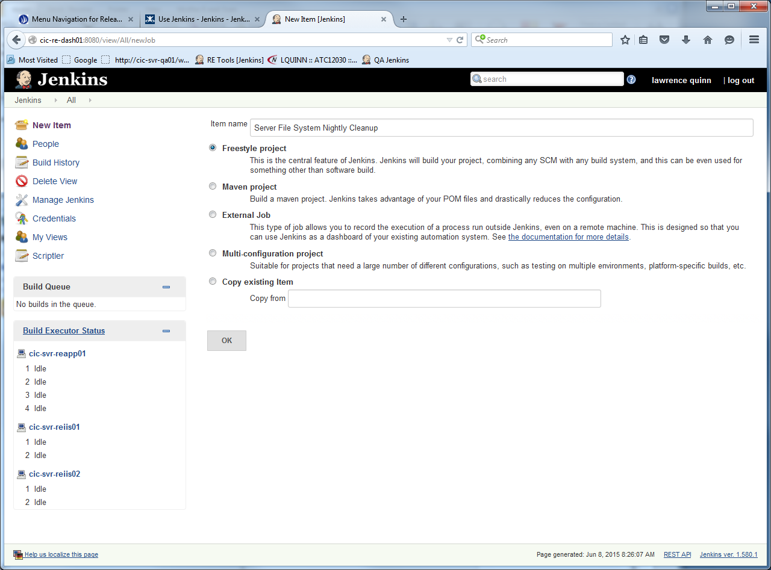

Select "Freestyle project", and give it a name that describes the job adequately. In this case I have named it "Server File System Nightly Cleanup"

Then click OK

This will open up the configuration window for this job:

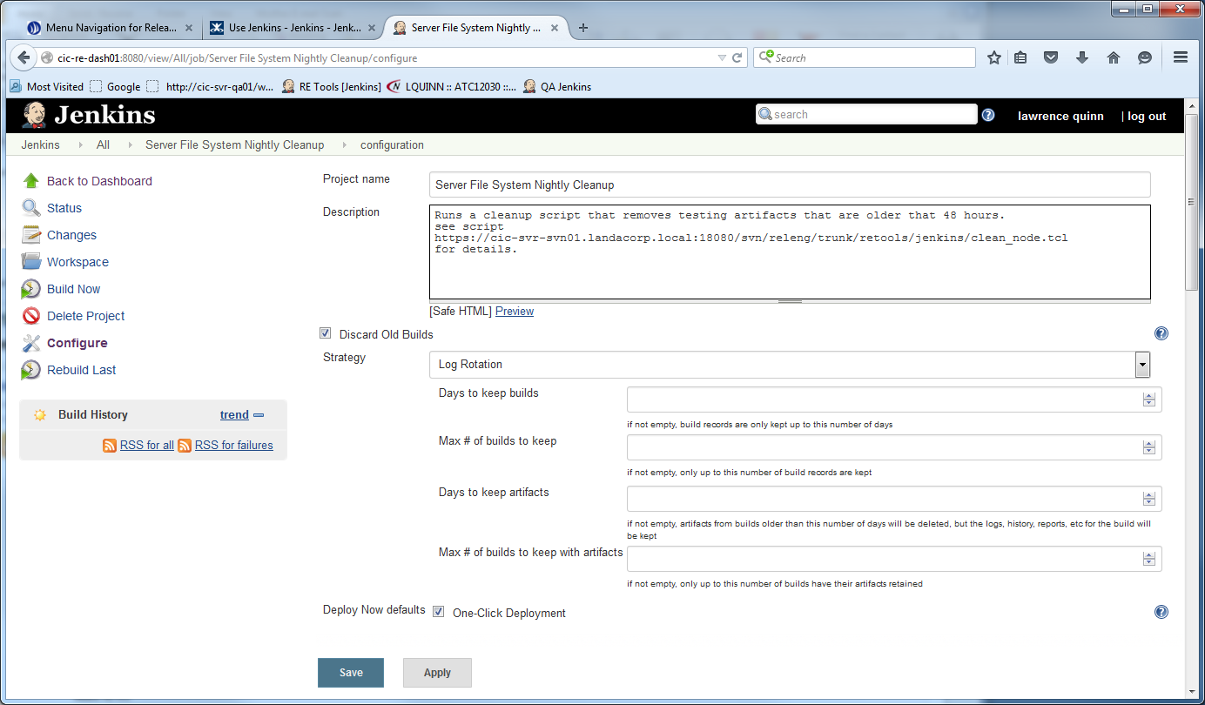

Add a useful description. I add the svn location of the script being called so that it can be easily found without searching around.

Note also that for this job, I don't really care about "Old Builds" so I checked "Discard Old Builds." If the job starts failing, we may want to change that to get a better look at the history.

We also checked the box to allow one-click deployment in case we want to run the job manually.

I may not be following best practices, but I think we should have one job per node - note that the node is on a particular server. In this case the default and the possible should be the same. We don't need a job for the master.

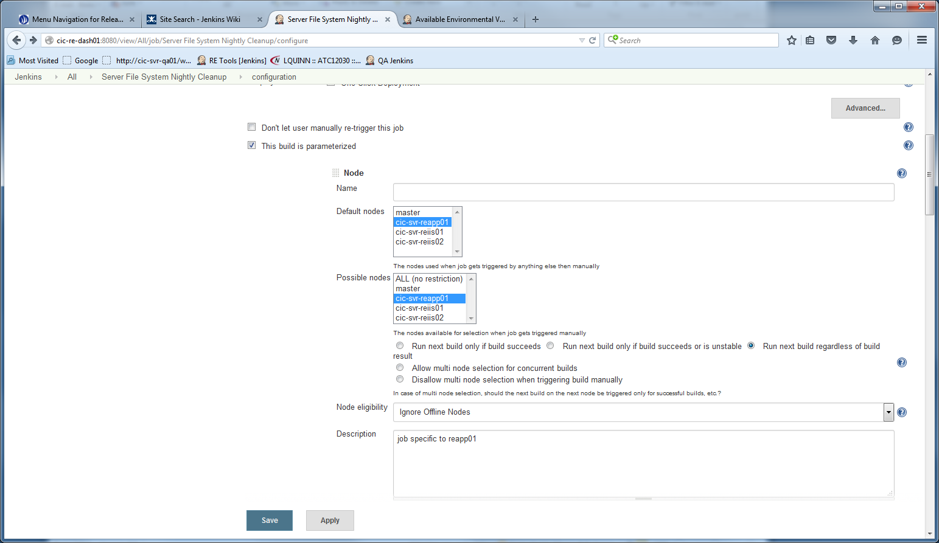

Most of the rest are defaults, until you get to "Build Triggers" here we want to select "Build periodically" Here I have set it to run at a hashed time between midnight and 7 am

Note that there is help available for most topics, in this case the format for cron

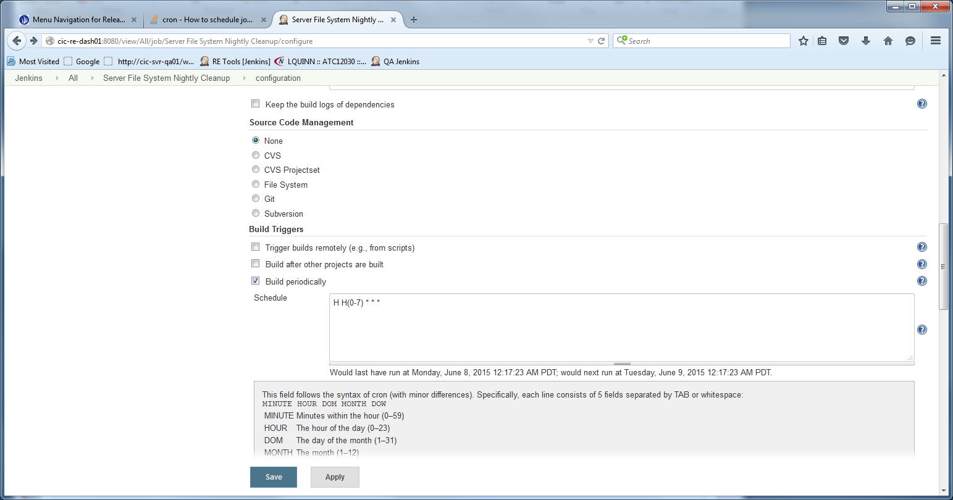

Next is the build steps we want to perform:

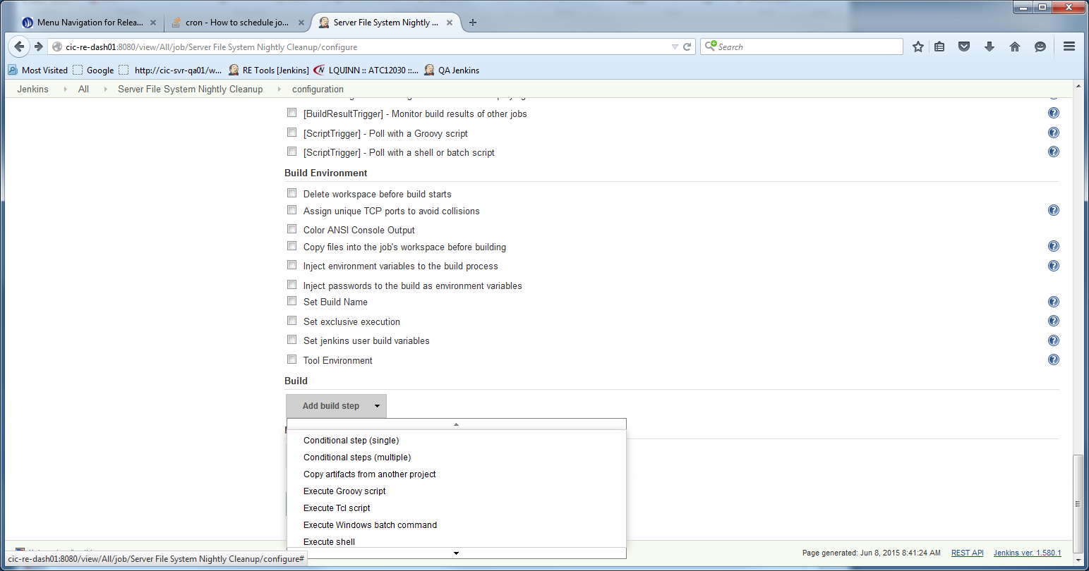

We typically run a batch or cron job, and utilize that to

1. set the environment
2. update files from svn (in this case the clean_node file)
3. call the script itself.

Note that there is help on this, by clicking the question mark, and below where it says "see the list of available environment variables"

You will write the actual batch script code into the box. But I recommend you try the batch script locally to ensure it is doing the job before inserting it into the Jenkins job.

When you click "save" (which returns you to) or "apply" (which leaves you on this page) the job will be ready to run next time for which it is set.