

Release Engineering: Schema Certification

Drafted by: Anna Devore

Approved by: __________________________
Jay Dunlap

Table of Contents

Overview 3
Figure 1, the Landacorp Database Schema Certification Process 3
Landacorp Schema Object Naming Conventions. 4
Table/Column Names: 4
Index Names: 4
Constraint Names: 4
Sequence Names: 4
Model Schema Description 4
User_Tables 4
User_Tab_Columns 4
User_Indexes 5
User_Ind_Columns 5
User_Constraints 5
User_Cons_Columns 5
User_Sequences 5
Tor_Table_Order 5
Model_Version 5
Dropped_Tables 5
dbCompare Logic 6
Preliminary Processing 6
Table/Column/Constraint Comparisons 6
Index Comparisons 7
Command File Construction 7
Sequence Comparisons 8
Disabled Constraints: 9
Figure 2 Sample Certification Report/Command File 10
DDLGen Logic 11
Preliminary Processing 11
Command File Processing 11
Figure 3 Sample SQL DDL Script 13

Overview

The Landacorp database upgrade process includes a schema certification before and after processing the upgrade scripts. This certification helps insure that the scripts will run without interruption/errors and that the upgraded database is complete and correct. Schema certification consists of comparing schema objects (tables, indices, constraints, sequences) on the ‘Target’ database, that is the database that is being upgraded, with a Schema Model for the purported Target version. The Schema Model may be a separate database, but more often is a directory containing a set data files that, for the most part, mirror Oracle's schema views. A TCL tool, dbCompare.tcl performs this comparison. dbCompare.tcl generates a Certification Report/Command file. When no differences are reported, the Target database is certified at the specified version. When schema differences are reported, The Certification Report, used as a Command File, is input, along with the Schema Model, to another TCL tool, DDLgen.tcl. DDLgen.tcl generates a SQL Script that is to be applied, using SQLPLUS, to the Target Database after which dbCompare.tcl is rerun to insure and document database certification. Figure 1 outlines the certification process.

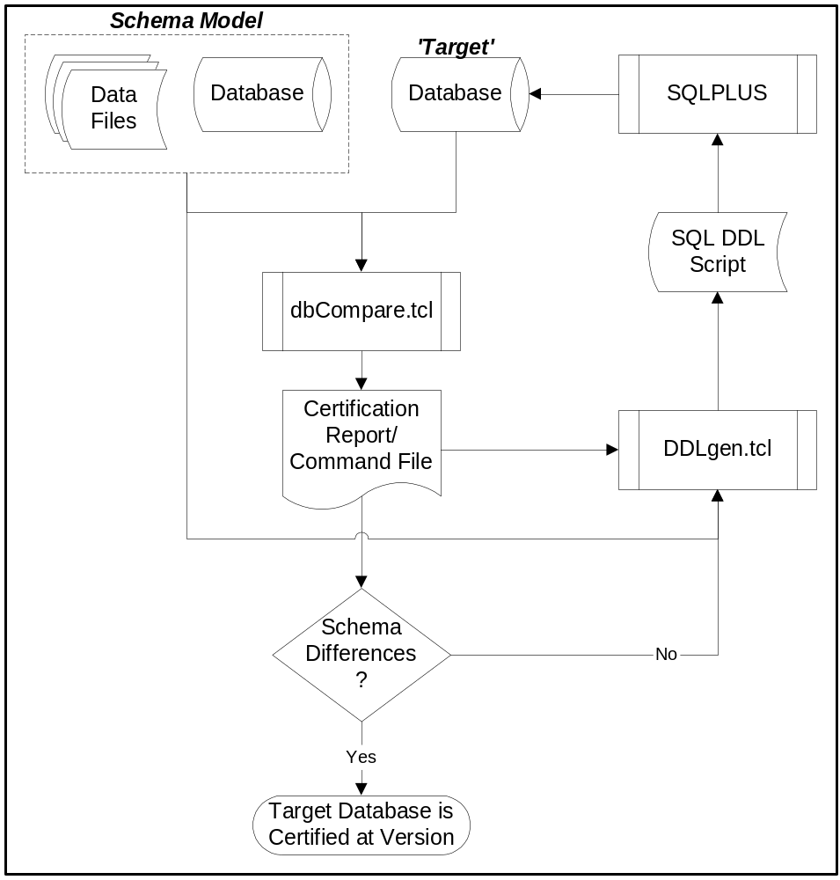

Figure 1, the Landacorp Database Schema Certification Process

Landacorp Schema Object Naming Conventions.

The schema certification process relies heavily on the Landacorp schema object naming conventions. For this reason, it is strongly recommended that a different naming convention be used when creating objects in the same database.

Table/Column Names:

All table names begin with a three character alpha-numeric prefix followed by an underscore. Table names are descriptive as to their use to the degree possible. Examples: ALG_ALLERGY, PEP_PATIENT_EPISODE, RIN_RISK_INCIDENT, STF_STAFF, TAU_TREATMENT_AUTHORIZATION. All column names within a table use the same prefix as the table_name. Examples: PEP_ID, STF_UID, ALG_CODE.

Index Names:

All index names use the same prefix as the table name whose columns are being indexed followed by ‘INDEX’, ‘UNIQUE’, or ‘PRIMARY_KEY’ as appropriate, and a two-digit suffix when not a primary key. Examples: RIN_UNIQUE_01, STF_PRIMARY_KEY, PEP_INDEX_16.

Constraint Names:

All constraint names use the same prefix as the table whose data is being constrained, followed by ‘PRIMARY_KEY’, ‘NOT_NULL’, ‘UNIQUE’ or the foreign key prefix and ‘FOREIGN_KEY’ plus a two digit suffix. Example: PEP_STF_FOREIGN_KEY_05, STF_PRIMARY_KEY, RIN_UNIQUE_01, RIN_NOT_NULL_04.

Sequence Names:

All sequence names use the same prefix as the table whose columns are being sequenced and end with the word SEQUENCEdata is being constrained, followed by ‘PRIMARY_KEY’, ‘NOT_NULL’, ‘UNIQUE’ or the foreign key prefix and ‘FOREIGN_KEY’ plus a two digit suffix. Examples: RIN_SEQUENCE, STF_SEQUENCE, CAU_AUTHORIZATION_SEQUENCE, RIN_ID_SEQUENCE, STF_NUR_ID_SEQUENCE.

Model Schema Description

The model schema for a Landacorp product version is derived from the Oracle schema definition views, supplemented by a couple of additional ‘lists’:

User_Tables
.
When the Model Schema is a directory, the file contains two records the first of which is a list of tables, the second of which is a list of the corresponding tablespaces. When the Model Schema is a database, these lists are obtained from a SQL query of the Oracle USER_TABLES view.

User_Tab_Columns
.
When the Model Schema is a directory, the file contains three records per table. The first contains the table name. The second is a list of columns for the table. The third is a list of corresponding formats (type, length, precision, scale delimited by !). When the Model Schema is a database, these lists are obtained from a SQL query of the Oracle USER_TAB_COLUMNS view.

User_Indexes
.
When the Model Schema is a directory, the file contains two records the first of which is a list of indexes, the second of which is a list of the corresponding tablespaces. When the Model Schema is a database, these lists are obtained from a SQL query of the Oracle USER_INDEXES view.

User_Ind_Columns
.
When the Model Schema is a directory, the file contains two records the first of which is a list of indexes, the name being repeated for multi-part indices, the second of which is a list of the corresponding columns. When the Model Schema is a database, these lists are obtained from a SQL query of the Oracle USER_IND_COLUMNS view.

User_Constraints
.
When the Model Schema is a directory, the file contains one records per table consisting of the table name, a list of constraints, and a list of corresponding constraint types, these three items being delimited by a pound sign (#). When the Model Schema is a database, these lists are obtained from a SQL query of the Oracle USER_CONSTRAINTS view.

User_Cons_Columns
.
When the Model Schema is a directory, the file one record per constraint consisting of the constraint name and list of the associated columns, the name and list being delimited by a pound sign (#). When the Model Schema is a database, these lists are obtained from a SQL query of the Oracle USER_CONS_COLUMNS view.

User_Sequences
.
When the Model Schema is a directory, the file contains three records the first of which is a list of sequences, the second of which is a list of the corresponding starting values, the third of which is a list of columns being sequenced.. When the Model Schema is a database, these lists are obtained from a SQL query of the SEQ_SEQUENCES table.

Tor_Table_Order
.
When the Model Schema is a directory, the file contains a single record listing the tables in order of dependency, tables with no foreign keys being listed first—tables with foreign keys always occurring later in the list than the tables they are dependent upon. When the Model Schema is a database, these lists are obtained from a SQL query of the TOR_TABLE_ORDER table.

Model_Version
.
When the Model Schema is a directory, the file contains a single record with the formatted version number. When the Model Schema is a database, these lists are obtained from a SQL query of SHS_SCHEMA_HISTORY table.

Dropped_Tables
.
When the Model Schema is a directory, the file contains a single record containing a list of tables that have been dropped from previous versions of the product. This information is not available when the Model Schema is a database in which case the determination as to whether a table should be dropped from a target database will be less precise.

dbCompare Logic

In general, dbCompare.tcl compares schema information between the model schema and the target database schema. When differences are detected, they are considered ‘actions’ that must be performed in order to bring the target database into compliance. These ‘actions’ are recorded on the command file as functions that will be processed by DDLgen.tcl. Each function will translate the ‘action’ statement into the SQL command necessary to correct the particular deviation. Examples of ‘actions’ generated by dbCompare: add_column PEP_NEW_INFORMATION, add_table NTB_NEW_TABLE, drop_constraint PEP_MNU_FOREIGN_KEY_05. The manner in which DDLgen.tcl processes these ‘actions’ is described in more detail in the DDLgen Logic portion of this document.

Preliminary Processing

dbCompare.tcl may be invoked in three ways:
- From a command prompt. This is determined by the lack of either an AutoStat.txt or a dbc00.bat file. The following positional parameters are required:
  - Model Schema – Either a directory containing the required files, or a database logon.
  - Target database logon.
  - Path/name of Certification Report/Command File.
- From compareDB.tcl, the TK gui front end. This is determined by detecting dbc00.bat. The same three positional parameters are required, the only difference being that a s_info file will be generated to provide status to compareDB.tcl.
- From AutoScript.tcl. This is determined by detecting AutoStat.txt. AutoStat.txt will contain an unformatted target version. The three required parameters are defined as follows:
  - A Model Directory name is created by using the prefix ‘MOD’ and a ‘collapsed’ target version. Example: 060001 would generate a directory name of Mod601. AutoScript.tcl does not allow for a Model Database.
  - Autoscript.tcl has logged onto the Target Database prior to invoking dbCompare.tcl.
  - A Certification Report/Command File name is created by using the ‘collapsed’ target version, prefixed by ‘cert’ with a .txt extent. Example: 060002 would generate a name of cert602.txt.

After validating/generating the required parameters which would include logging onto the target database, if required, dbCompare.tcl will open the Certification Report/Command File and output generic information including the line: !!! NOT REVIEWED !!! to be removed by the user and, if detected by DDLgen.tcl will terminate it’s processing. A sample Certification Report/Command File is shown in Figure 2.

Table/Column/Constraint Comparisons

Internal lists of the schema definition for tables and constraints for both model and target are then input.

Processing of Model Schema Table information proceeds as follows:
- Obtain Column Information. When the model is a directory, the next USER_TAB_COLUMNS entries must be in the same order as the USER_TABLES entries. If this is not the case, an error message is displayed and processing is terminated.
- When Table is in Target Schema:
  - Obtain Column Information from Target Database for Table.
  - Process each Column in Model Schema for Table:
    - Add to ‘add column’ internal list when not on Target Schema for Table
    - Add to ‘mod column’ internal list when format information differs.
  - Process each Column in Target Schema for Table:
    - Add to ‘drop column’ internal list when not on Model Schema list for Table.
- Add to ‘add table’ internal list. when Table is not in Target Schema
- Obtain Constraint Information. When model is a directory, the next USER_CONSTRAINTS entries must be in the same order as USER_TALBES entries. If this is not the case, an error message is displayed and processing is terminated.
- Obtain Target Database Constraint information for Table.
- Process each Constraint in Model Schema for Table:
  - Obtain Constraint Columns.
  - When Table is in Target Schema:
    - Obtain Model Constraint Column Information, (must be in sync as above, if directory).
    - When Constraint is in Target Schema.
      - Obtain Target Constraint Column Information
      - Compare with Model Constraint Column Information
      - When Target Constraint Column Information differs from Model Constraint Column Information, Add Model Constraint Column Information to one of the following lists, dependent on Constraint Type:
        - mod primary constraint List
        - mod unique constraint List
        - mod constraint List
    - When Constraint is not in Target Schema, add to ‘add constraint’ list.

When a Constraint from the Target Schema list is not on the Model Schema List,

When a Table from the Target Schema list is not on the Model Schema List, add to the ‘drop table’ list and add all associated constraints to the Drop Constraint List under the following conditions.
- DROPPED_TABLES information is available in the Model Schema directory.and it contains the Target Table.
- DROPPED_TABLES information is not available and the table uses the Landacorp convention of a three character prefix and the table was not created via the product application (and therefore does not have a non-null entry of SYT_USER_TABLE_ID in the SYT_SYSTEM_TABLE table with SYT_CODE as the Target Table name).

Index Comparisons

Internal lists of the schema definition for indices for both model and target are then input.

Processing of Model Schema Index information proceeds as follows:
- Add any index name from the schema that is not on the target database to the ‘add target’ index list. This is to separate them from indices that will be dropped and then added because a modification is required.
- Build column lists from both the model schema and target database list of index columns for each model schema index.
- Compare the two lists of columns for a model schema index.
  - Concatenate the two lists and add to the ‘mod index’ list when the target index column list is not null.
  - Add to the ‘add index’ list when the target index column is null.
- For Each entry in the Target Index List that is not on the Model Schema Index List:
  - Add to the ‘drop index’ list when table being indexed is on the Model Schema Table AND
    - is on the DROPPED_TABLES list OR
    - There is no DROPPED_TABLES list.

Command File Construction

Lists that have been generated by Table/Constraint and Index comparisons are used in constructing the command file. During this process, when it is determined that the target database schema should be modified in order to bring the database into compliance for version, commands (actual DDLgen.tcl procedure names and the arguments for the procedure) are output to the Command file. Each time a command is output the total count of changes is incremented. A descriptive heading precedes each section of the Command File. Headings are suppressed if no schema-corrective actions are required. Sections are processed in the following order:
- Each entry in the ‘add column’ list generates the following command:
  - add_column table_name column_name type(length);
  - Example: add_column PEP_PATIENT_EPISODE PEP_RETURN_YN VARCHAR2(1);
- Each entry in the ‘mod column’ list generates the following command:
  - modify_column table_name column_name new_type(new_length);
  - Example: modify_column MEM_MEMBER MEM_ADDRESS (30);
- Each Entry in the ‘mod primary constraint’ list generates the following two command:
  - drop_constraint table_name, constraint_name;
  - Example: drop_constraint CUS_CUSTOMER_INFORMATION CUS_PRIMARY_KEY;
  - add_constraint P table_name constraint_name (column(s));
  - Example: add_constraint P CUS_CUSTOMER_INFORMATION CUS_PRIMARY_KEY (CUS_CODE, CUS_SEQUENCE);
- Each Entry in the ‘mod unique constraint’ list generates the following two commands:
  - drop_constraint table_name, constraint_name;
  - add_constraint C table_name constraint_name (column(s));
- Each Entry in the ‘add table’ list generates the following command:
  - add_table table_name;
  - Example: add_table NTB_NEW_TABLE:
- Each Entry in the ‘drop (other) constraint’ list generates the following command:
  - drop_constraint table_name, constraint_name;
- Each Entry in the ‘drop index’ or ‘mod index’ list generates the following command:
  - drop_index table_name, index_name;
- Each Entry in the ‘mod (other) constraint’ list generates the following two commands:
  - drop_constraint table_name, constraint_name;
  - add_constraint C (not null) table_name constraint_name (column(s));
  - or add_constraing R (foreign key) table_name constraint_name (column(s)) references table_name (column(s));
  - Example: add_constraint R PEP_PATIENT_EPISODE PEP_CUS_FOREIGN_KEY_01 (PEP_CUS_CODE, PEP_CUS_SEQUENCE) references (CUS_CODE, CUS_SEQUENCE);
- Each Entry in the ‘add index’ or ‘mod index’ list generates the following command:
  - add_index table_name, index_name (column_name) tablespace tablespace_name;
  - Example : add_index PCT_PMI_PATIENT_CONTACT PCT_INDEX_01 (PCT_PEP_ID) tablespace MAX2_INDEX_E_TS ;
- Each Entry in the ‘drop column’ list generates the following command:
  - drop_column table_name, column_name;
  - Example: drop_column CCG_CLAIM_CATEGORY CCG_SEQUENCE
- Each Entry in the ‘drop table’ list generates the following command:
  - drop_table table_name;
  - Example: drop_table TCO_TRAINING_COURSE;

Sequence Comparisons

Internal lists of the schema definition of sequences for both model and target are then input. When the schema model is a directory, lists of minimum values and associated columns are input.

For every sequence on the Model Schema sequence list that is not on the target sequence list, the following logic is used:

- Obtain the three-character prefix from the sequence name.
- Find the table (if one exists) on the target database with the same three-character prefix.
- Determine the associated column either from:
  - The internal list
  - The primary key of the table with a matching prefix, if there is one.
- Determine the current sequence value from:
  - The maximum value plus 1 of the associated column, if one has been determined
  - A count plus 1 of the rows on the table with a matching prefix, if there is one.
  - Default of 1.
- Determine the minimum value.
  - The internal list
  - Default of 1.
- The beginning sequence value will be the maximum of the minimum value and the current sequence.

When sequences that are on the target database but not on the model schema and have a name formatted like ‘XXX_~SEQUENCE, advise is given that the sequences should be dropped or renamed in order to keep subsequent comparisons ‘clean’. These excess sequences are not, however, added to the list of differences, and their appearance on the report will not keep a target database from being considered as certified.

Disabled Constraints:

Finally, a list is made of disabled constraints, if any. For each disabled constraint, the following entry is made on the command file.

- enable_constraint table_name constraint name;
- Example: enable_constraint MNU_MENU_LIBRARY MNU_MNU_FOREIGN_KEY_01;

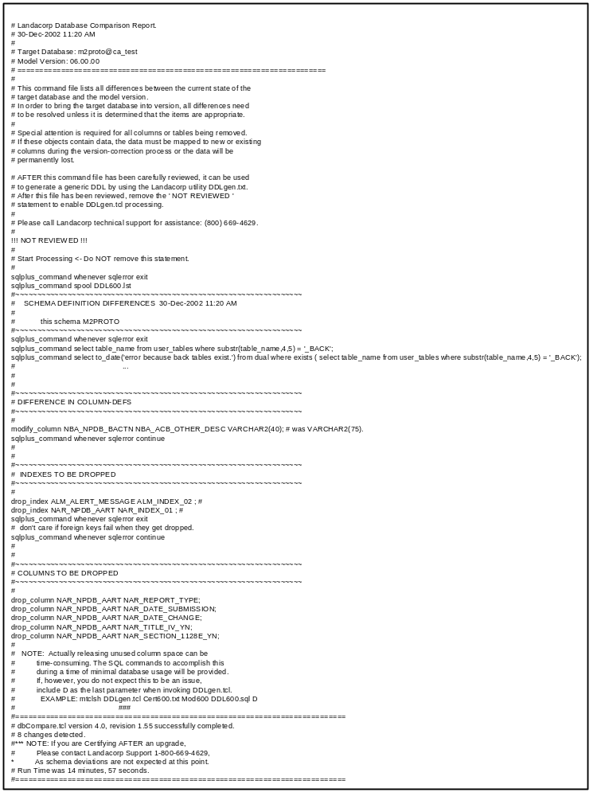Figure 2 Sample Certification Report/Command File

DDLGen Logic

DDLgen.tcl uses the command file generated by dbCompare.tcl (see Figure 2) and the model schema for the target version of the target database to generate a SQL DDL (see Figure 3) that will bring the database into compliance for the version. The model schema must be the same one that was used by dbCompare.tcl to generate the command file.

Preliminary Processing

DDLGen.tcl may be invoked in two ways:
- From a command prompt. This is determined by the lack of a dlg00.bat file. The following positional parameters are required:
  - Path/name of Certification Report/Command File.generated by dbCompare.tcl.
  - Model Schema – Either a directory containing the required files, or a database logon.
  - Path/name of SQL DDL.
  - (optional) a flag (D) if the release of space from tables with dropped columns is not to be deferred.
- From GenDDL.tcl, the TK gui front end. This is determined by detecting dlg00.bat. The same three positional parameters are required, the only difference being that a s_info file will be generated to provide status to GenDDL.tcl.

DDLGen.tcl first validates input parameters:
- If model schema is a database, logon
- Open the Certification Report
- Insure that the Certification Report has been reviewed
- Insure that the specified model schema is the same as the one used to create the Certification Report.

DDLGen.tcl then opens the DDL and outputs some boiler-plate guidance including an EXIT statement which must be removed prior to running the script against the database.

Command File Processing

The commands that DDLGen.tcl encounteres while reading through the command file are treated in two manners.
- Commands that can be processed in any order are immediately translated into SQL DDL Statements and output to the DDL Script. These include:
  - add_column
  - drop_table
  - add_table
  - add_sequence
- All other commanded are added to lists as they are encountered. When the command file end of file is reached, all lists are sorted and added to the DDL Script in the following order:
  - Drop Foreign key constraints
  - Drop constraints with SYS prefix.
  - Drop Primary key constraints
  - Drop all other constraints
  - Drop non-unique indices (all others dropped with constraints)
  - Modify Columns
  - Drop Columns (Actually just set as unused)
  - Add non-unique indices (all others added with constraints)
  - Add Primary Key constraints
  - Add all other constraints
  - Enable constraints

The optional flag is tested. If not there, the ALTER TABLE … DROP UNUSED COLUMNS statements for dropped columns will be surrounded by comments advising the user to run the statements at a time when database usage is low. Otherwise the statements will be output without comment. Finally, Statements to insert a documenting SHS_SCHEMA_HISTORY table entry and output to the DDL Script.

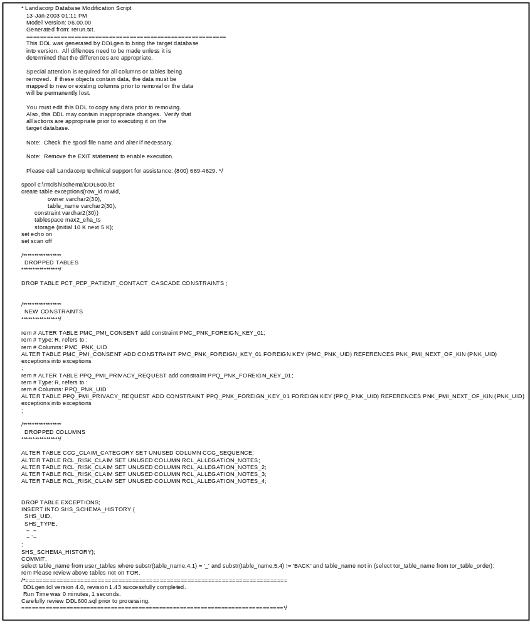Figure 3 Sample SQL DDL Script

