

Release Engineering: System Data Certification

Drafted by: Anna Devore

Approved by: __________________________
Jay Dunlap

Table of Contents

Overview 3
Figure 1, the Landacorp Database System Data Certification Process 3
Landacorp System Data Object Naming Conventions. 4
Table/Column Names: 4
Index Names: 4
Constraint Names: 4
Sequence Names: 4
Model System Data Description 4
User_Tables 4
User_Tab_Columns 4
User_Indexes 5
User_Ind_Columns 5
User_Constraints 5
User_Cons_Columns 5
User_Sequences 5
Tor_Table_Order 5
Model_Version 5
Dropped_Tables 5
dbCompare Logic 6
Preliminary Processing 6
Table/Column/Constraint Comparisons 6
Index Comparisons 7
Command File Construction 7
Sequence Comparisons 8
Figure 2 Sample Certification Report/Command File 10
DDLGen Logic 11
Preliminary Processing 11
Figure 3 Sample SQL DDL Script 13

Overview

The Landacorp database upgrade process includes system data certification after processing the upgrade scripts, and, depending on the complexity of the upgrade, prior to running certain scripts. This certification helps insure that scripts will run without interruption/errors and that the upgraded database is complete and correct. System Data certification consists of comparing the data in Landacorp System Tables on the ‘Target’ database, that is the database that is being upgraded, with the System Data Model. The System Data Model is a directory containing a set of data files that define system data. There is an option to generate the System Data Model from a source database in which case a directory ofA TCL tool, SysDataGen.tcl performs this comparison.

SysDataGen.tcl generates a Difference Report and two SQL DML scripts:
- nonSysRows_timestamp.sql to delete data that fits system data definition, but is not valid
- sysDataUpdate_timestamp.sql to insert and/or update system records.
The time stamp is of the format MMDDHHMM. For example a time stamp of 04151624 would be April 15 at 4:24 p.m. When neither of these scripts contain system data changes, the Target database is data-certified at the specified version. When System Data differences are included in either of these scripts, the scripts must be run against the Target database using SQLPLUS.

nonSysRows_timestamp.sql must be run first. NonSysRows_timestamp.sql generates a spool file, mod_version_id_Deletes_datastamp.lst (example, M2060002_Deletes_04151624.lst). If any errors are reported on mod_version_id_Deletes_datastamp.lst, an analysis/repair tool, SysDeleteEval.tcl must be run. SysDeleteEval.tcl creates new records with non-system keys and maps dependent data, then deletes the previous key, if required. A report is generated containing mapping information and/or guidance for managing non-system keys. Figure 1 outlines the system-data certification process.

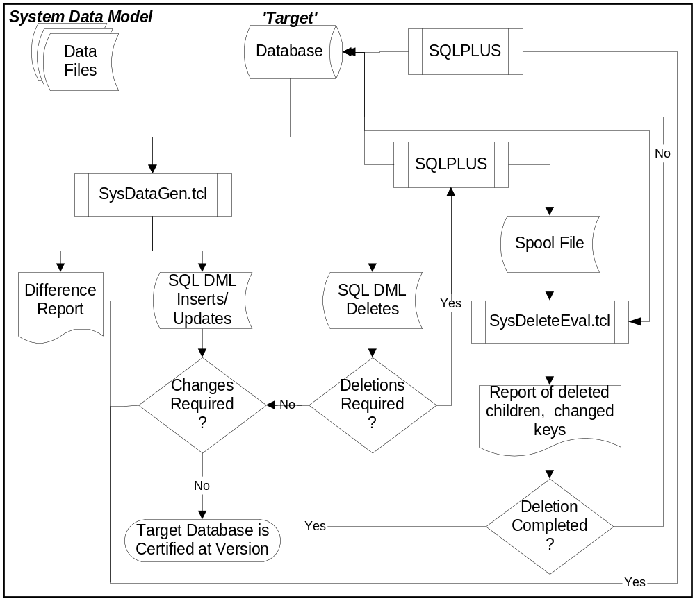

Figure 1, the Landacorp Database System Data Certification Process

Model System Data Description

The model System Data for a Landacorp product version consists of the following.

Model_Version
.
When the Model System Data is a directory, the file contains a single record with the formatted version number. When the Model System Data is a database, these lists are obtained from a SQL query of SHS_SYSTEM DATA_HISTORY table.

XXX_NAMES_xxx.txt
.
Each record in this file consists of:
- The System Table Name.
- Key Column name(s). Columns are delimited by a bang (!).
- System Data Column names. Columns are delimited by a bang (!).
Example:
TTP_TTY_PARAMETER TTP_TTY_CODE!TTP_SEQUENCE TTP_TPV_NAME!TTP_REQUIRED_YN!TTP_WFD_UID!TTP_TPV_COLUMN_NAME
The System Table TTP_TTY_PARAMETER has a key consisting of TTP_TTY_CODE and TTP_SEQUENCE. The columns TTP_TPV_NAME, TTP_REQUIRED_YN, TTP WFD_UID and TTP_TPV_COLUMN_NAME contain System Data.

XXX_VALUES_xxx.txt
.
System Data Values are defined by groups of records. The first record in a group specifies the System Table and is identified by the preceding characters ‘->’. Example: ->TTP_TTY_PARAMETER.
All subsequent records contain the Key Values and System Data Values delimited by ‘###’.
Columns are delimited by ‘!!!’.
Example:
DENIAL!!!1###Episode Number!!!Y!!!194
Specifies that for the keys:
- TTP_TTY_CODE = ‘DENIAL’
- TTP_SEQUENCE = 1
The System Data is:
- TTP_TPV_COLUMN_NAME = ‘Episode Number’
- TTP_REQUIRED_YN = ‘Y’
- TTP_WFD_UID = 194
- TTP_TPV_COLUMN_NAME = null (no entry after last ‘!!!’.)

XXX_WHERE_xxx.txt (optional)
.
Not all entries in every system table are considered to be system data. The range or specified list of keys can be defined by where clauses as defined in the WHERE file. There will be two records in the where file for each clause, the first containing the System Table Name, the second the actual clause.
Example:
TTP_TTY_PARAMETER
TTP_TTY_CODE in (SELECT TTY_CODE FROM TTY_TASK_TYPE WHERE TTY_SYSTEM_YN = 'Y')

SysDataGen.tcl Logic

In general, SysDataGen.tcl compares System Data information between the model System Data and the target database System Data. When differences are detected, the nature of the difference determines whether they can be resolved by INSERTing, UPDATEing or DELETEing a record, and SQL statements are generated accordingly. INSERTs and UPDATEs are output to sysDataUpdate_timestamp.sql. DELETEs are output to nonSysRows_timestamp.sql. SELECT statements capturing the data to be deleted are output to nonSysRows_timestamp.sql prior to the DELETE statements. A formatted report of the changes to be made, not including DELETEs is generated - sysDataDiff_timestamp.sql.

Preliminary Processing

SysDataGen.tcl may be invoked in two ways:
- From a command prompt. This is determined by the lack of either an AutoStat.txt or a dbc00.bat file. The following positional parameters are required:
  - Model System Data – A directory containing the required files.
  - Target database logon.
  - An optional directory where the SQL scripts and report are to be placed. Defaults to the current directory.
- From AutoScript.tcl. This is determined by detecting AutoStat.txt. AutoStat.txt will contain an unformatted target version. The parameters are defined as follows:
  - A Model Directory name is created by using the prefix ‘Mod’ and a ‘collapsed’ target version. Example: 060001 would generate a directory name of Mod601
  - Autoscript.tcl has logged onto the Target Database prior to invoking SysDataGen.tcl.

After validating/generating the required parameters and logging onto the target database, if required, SysDataGen.tcl will open the three files and output generic. Samples of sysDataUpdate_timestamp.sql, nonSysRows_timestamp.sql and sysDataDiff_timestamp.sql are shown in Figure 2, Figure 3 and Figure 4 respectively.

October 07, 2003

Database: m2devel60/m2devel60@ca_test
Generated from: M20600_NAMES.txt, M20600_VALUES.txt, and M20600_WHERE.txt
==========================================================
This DML was generated by SysDataGen.tcl version 5.0, revision 1.68
to update system data.

Contact the Landacorp Support Department for assistance
at (800) 669-4629 or HELP@landacorp.com.
*/

spool M2060003_Updates_10071022.lst
whenever sqlerror exit
set scan off
set echo on
alter session set nls_date_format = 'DD-MON-YYYY';
/* Landacorp System Data Modification Script

/*=====================================
Processing Table CCG_CLAIM_CATEGORY
=====================================*/

update CCG_CLAIM_CATEGORY set
CCG_DESC =
'Automobile',
CCG_usr_uid_updated_by = -1,
CCG_last_update_date = sysdate
where CCG_CODE = 'AUTO';

/*=====================================
Processing Table ILT_ILLNESS_TYPE
=====================================*/

insert into ILT_ILLNESS_TYPE
(ILT_CODE,ILT_DESC,ILT_DATE_BEGIN,ILT_DATE_END,ILT_usr_uid_created_by,ILT_create_date) values
('SKN02','Skin disorder','01-JAN-2002','31-DEC-2099',-1,sysdate);
insert into ILT_ILLNESS_TYPE
(ILT_CODE,ILT_DESC,ILT_DATE_BEGIN,ILT_DATE_END,ILT_usr_uid_created_by,ILT_create_date) values
('EAR02','Hearing loss','01-JAN-2002','31-DEC-2099',-1,sysdate);

INSERT INTO SHS_SCHEMA_HISTORY ( standard insert/update)

commit;

/* Table Inserts Updates
CCG_CLAIM_CATEGORY 0 1
ILT_ILLNESS_TYPE 2 0

No Changes in the following tables:
ACB_ACTION_CODE_BASIS
|
|
TLE_TTY_LABEL_ELEMENT
TTP_TTY_PARAMETER
*/

/*============================================================================
SysDataGen.tcl version 5.0, revision 1.68 built this script.
Run Time was 3 minutes, 12 seconds.
============================================================================*/
spool off
exit

Figure 2, Sample sysDataUpdate_timestamp.sql SQL Script
/* Landacorp System Data Delete Script
October 07, 2003

Database: m2devel60/m2devel60@ca_test
Generated from: M20600_NAMES.txt, M20600_VALUES.txt, and M20600_WHERE.txt.
==========================================================
This DML was generated by SysDataGen.tcl version 5.0, revision 1.68.

The data identified in the SQL SELECT statements
will be deleted as it is not valid system data.
Contact the Landacorp Support Department for assistance
at (800) 669-4629 or HELP@landacorp.com.
*/
spool M2060003_Deletes_10071022.lst
set scan off
set echo on

Select LTY_CODE,LTY_DESC,LTY_SYSTEM_MEANING
from LTY_LETTER_TYPE where LTY_CODE in (
'MASH');
DELETE
from LTY_LETTER_TYPE where LTY_CODE in (
'MASH');

commit;

INSERT INTO SHS_SCHEMA_HISTORY (standard insert/update)

COMMIT;
spool off
exit

Figure 3, Sample nonSysRows_timestamp.sql SQL Script

Landacorp System Data Difference Report October 07, 2003
Page 1
The differences in this report were created by comparing:
M20600_NAMES.txt, M20600_VALUES.txt, and M20600_WHERE.txt
with m2devel60/m2devel60@ca_test.
Generated using SysDataGen.tcl version 5.0, revision 1.68

- SYSTEM DATA CHANGES FOR CCG_CLAIM_CATEGORY. Key(s) are CCG_CODE.

Key: AUTO Column: CCG_DESC
IS -> Car
S/B -> Automobile

- SYSTEM DATA CHANGES FOR ILT_ILLNESS_TYPE. Key(s) are ILT_CODE.

Keys for records to be added:

SKN02 EAR02

Tables Inserts Updates
CCG_CLAIM_CATEGORY 0 1
ILT_ILLNESS_TYPE 2 0

No Changes in the following tables:
----------------------------------
ACB_ACTION_CODE_
|
|
TTP_TTY_PARAMETER

* * * End of Data Comparison Report * * *

Figure 4, Sample sysDataDiff_timestamp.txt Report

System Data Table Comparisons

Processing of Model System Data Table information is driven by the column information in the NAMES file as follows:
- The Table Name is extracted
- Counts of Updates and Inserts are initialized.
- A temporary working file is created.
- Unique constrains and foreign key constraints to the same table are disabled.
- Column names are extracted and primary key columns identified
- Process entries for the table from the VALUES file as follows:
  - Concatenate key values
  - Concatenate non-key column names
  - Special processing for ORG/SBC tables. For the ORG table, ORG_ID is used as a ‘key’ and ORG_UID is used as data. When matching ORG_IDs are found, if the ORG_UIDS are not the same, they are not changed on the target database, but a cross reference is built between what system data specifies and what is on the target database. The ORG table is processed prior to the SBC table because of TOR order. As SBC system data is processed, if the SBC_ORG_UID is on the system ORG_UID table, the cross reference ORG_UID will be used as system/comparison data as SBC_ORG_UID instead of the one for the System Data File.
  - Determine if Menu definition records (MNU, MSL) are part of contracted module. If not, set flag not to insert.
  - If Data is not there, perform insert logic (unless not part of contracted module)
    - Add the key to the new key list.
    - Output beginning of INSERT statement to temporary file.
    - Start building the rest of the statement with the list of columns
    - Parse out VALUES entry and append the rest of the statement
    - Special processing for ORG cannot use and existing UID. If the Specified System Data UID exists, locate a different UID and cross-reference the Specified System Data UID to the new, as yet unused one.
    - When the remainder of the INSERT statement is complete, chop into sections of less than 100 bytes and output to the temporary file.
  - If the Data is there, perform update logic.
    - Special processing was required for Oracle 7 if the result of the select to test for the existence of data returned too large a string. In this case, the system columns are retrieved separately and concatenated within tcl, rather than as part of the Oracle statement.
    - If the string of data from the target database does not match the string of data from the system files, the two strings are parsed and each column is tested. A ‘difference_found’ flag is initialized to trigger the output to the temporary file of the UPDATE clause. When a difference is found.
      - The previous difference for the row (if there is one), is output to the temporary file. The logic loop processes changes delayed by one in order to suppress the last comma.
      - Break up value in segments of 80 characters.
      - Add the information to the change value list.
    - Output the last clause and the last update information to the temporary file.
- Use the new key list and change value list to report required changes to the target database in order to bring system data into compliance.
- Use the list of system data keys for the table and the list of keys identified as system data by the WHERE clause on the target database to identify delete candidates. Add SELECT statements to the DML that will delete rows, so a record of deleted data is available.
- Copy contents of temporary file onto DML script, inserting the constraint disables and enables before and after.
- Format and add DELETE statements to the delete DML script.
- Insert closing SHS statements to both DML scripts.
- Output summary information to reports, DMLs, screen.

