

Release Engineering: Compacting a Site Database

Drafted by: Anna Devore

Approved by: __________________________
Jay Dunlap

Table of Contents

Requirement 3
Overview 3
Figure 1, Shrinking to a new database. 4
ShrinkDB.tcl 5

Requirement

Both the developers and interface specialists would find it of value to use a ‘compressed’ version of a ‘real’ database, i.e. a database imported from site. This would facilitate interface development and testing as well as testing new features in a more robust environment.

Previous attempts to achieve this have compressed the individual tables, but not released the tablespace.
A completely different strategy has been used as described in this document.
Although extremely time-consuming (over 10 hours) the result is a consistent, compressed database that takes no more physical storage than the standard databases on CA.

If this approach is found to be satisfactory, automation, leveraging off AutoScript can be developed to streamline the process.

Overview

Where as the previous approach started with a fully populated database and removed data, ShrinkDB.tcl assumes an empty database, with the exception of the TOR table, and copies a subset of data from a full copy of a site database. The empty, target database may be created using dbMaint.tcl or by running DROP_TAB.sql.

TblspAnalysis.tcl should be run on the site database prior to running ShrinkDB.tcl. Any tablespaces not currently on the target database must be added.

After populating the tables, schema (dbCompare.tcl, DDLgen.tcl, SQLPLUS with resultant script) certification is required to add indices, constraints and sequences; Sequence adjustment (seqfix.txl) and data certification (SysDataGen.tcl, SQLPLUS with resultant scripts)) are recommended.

Figure 1 illustrates the recommended steps to ‘shrink’ a site database into an empty target database.

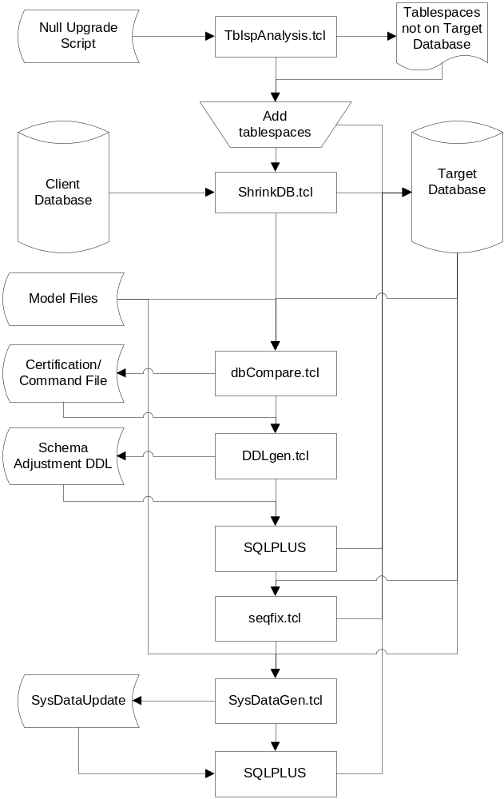

Figure 1, Shrinking to a new database.

ShrinkDB.tcl

Evaluates tables in TOR table order. If the table prefix is on ignore_lst, no data will be copied. If the table is on the except_lst, all possible data will be copied. Otherwise, the following strategy is used to copy approximately n rows where n can be determined by the user and defaults to 1500:
- A database link is established to the site database. TNS names in the $ORACLE_HOME/network/admin folder on the Landacorp database server must include the database logon string. Currently only Queenstest at NYH_test is included on CA.
- Row_cnt is obtained from the site database.
- If Row_cnt greater than n, date_diff, the difference between the maximum create_date and the minimum create_date is then obtained from the site. Days, the proportion of days is determined using the proportion of n to Row_cnt. The maximum create_date less Days is the criteria used to filter data from the source table. This technique yields an imprecise number of rows copied, but will definitely shrink the source database.
- In either case, parent keys may not be available in which case fewer rows are copied.

