

UNIVERSITY OF SALFORD
Student Information System

Accman - Banner Interface – CR1521
Functional Requirements Specification

Author: Mike Meaney - SIS Business Analyst
Version: 1.4
Date: 8 June 2005

Document Control

Project Name: | FastTrack Registration – Automatic Network Account Allocation
Document Title & Location: | Accman Banner Interface  Functional Requirements  /tmp/lo/0000.doc
Issued by: | Mike Meaney – SIS Business Analyst

Version | Reason for Change | Author | Date
0.1 | Initial Draft Issue | MSM | 29 April 2005
1.1 | Initial release for Approval | MSM | 13 May 2005
1.4 | Final changes to Accman & SIS status options | MSM | 8 June 2004

Distribution for Approval
Title | Signature | Date
Paul Waters
Distribution for Review
Title | Signature | Date
Colin Walton
Alan Goodkin
Andrew White
Akram Ulhaq
Tom Gordon
Distribution for Information Only
Title
Jim Heaton | Paul Earl
John Ryan | Mike James
Mike Taylor | Peter Stacey
John Green | Paul Buckley

Related Documents
Title | Author
Communications Strategy | Clare Hallows/Paul Buckley
RPRPT Business Objectives, Scope and Standards V1.2 | Nigel Cradock
SIS Student Lifecycle.doc | Mike Meaney
Banner-Accman.doc | Mike Meaney
Change Request 1565 –  Automation of Accman Account Email Collection.doc | Mike Meaney
ISD Computer Network Account Pre ex CW vn 1.doc | Colin Walton
Outline AccMan - Banner Interface - AccMan.doc | Alan Goodkin
Process Flow.doc | Alan Goodkin
Transfer of Email Addresses.doc | Akram Ulhaq
Allocation of Usernames and Passwords.doc | Andrew White
transfer_macro.rtf | Akram Ulhaq
transfer_SQL.rtf | Akram Ulhaq
transfer_tables.rtf | Akram Ulhaq
Table of contents
1 Introduction 5
1.1 Overview 5
1.2 Accman-Banner Interface 5
2 Functional Requirements 6
2.1 Generate school & level specific unallocated Netware accounts. 6
(a) Automatically Create Netware account for specific school & level 6
(b) Manually Create Netware account for specific school & level 6
2.2 CR1626 - Populate Banner with these unallocated accounts 7
(a) Get ACCMAN & SYRACCS in step 7
(b) Keep ACCMAN & Banner in step 7
2.3 CR1625 - Match UFAA applicant & allocate an appropriate account 8
(a) Re-activate old accounts 8
(b) Match a student to an appropriate account 8
(c) Manage condition where no accounts are available 8
(d) Run the allocation process for Applicants reaching UFAA 8
(e) Run the process for all Registered students 8
(f) Have the ability to manually start the process 9
2.4 CR1624 - Activation of the account via Accman 10
(a) Activate accounts within 30 minutes 10
(b) Identify matched SYRACCS accounts & activate the account in Netware via ACCMAN 10
(c) Deactivate ‘No Shows’ 10
(d) Check re-order levels and request additional accounts where appropriate. 10
2.5 CR1565 -Identification of the personalised email address in Banner 11
(a) All synchronisation is required to be run each night. 11
(b) Populate Banner with all the Accman Salford email accounts 11
(c) Deactivate any account type 1 emails that are not in Accman 11
(d) Set the Preferred indicator if not already set 11
3 Business Issues 12
3.1 Associate Membership 12
3.2 Students belonging to other universities 12
3.3 Distance Learners 12
3.4 Returning to study 12
3.5 Transferring students 12
3.6 Post Graduate Researchers 13
3.7 Support Tools 13
4 Policy Details 14
4.1 Writing Up 14
4.2 Email accounts 14
4.3 Pre-Registered Students 14
4.4 Placement Students 14
5 Data Flow Diagrams 15
5.1 Account Creation Allocation & Activation 15
5.2 Email Synchronisation 16

Introduction

Overview
This sub-project forms part of the FastTrack project that in turn is made up of five distinct work streams. These are:-
- FastTrack - The Web interface that enables a student to confirm the details we hold on them are correct.
- Accman-Banner Interface - The creation & allocation of security details such as the network id and password at the point an applicant’ status reaches UFAA.
- Automatic Letter Distribution - The method of informing the student of their security details
- Registration Screens - The Quickflow screens used during the central registration process.
- Registration Forms - The extract of student details in order to generate registration forms.
This document will consider the items contained in the second work stream that is deemed to be a long term development, i.e. it will used as part of the full blown web registration project.

Accman-Banner Interface
As an applicant reaches the UFAA status the university will regard him/her as a pre-registered student. At this point we will issue them with their personalised network account and password that gives them access to their email via the web.
This email account will then be used to deliver other information to the student, this information will include the student ID and pin so that they will be able to use the self service software on the Web, Blackboard and receive general information from course tutors and the school’s details on induction.
The process itself is made up of five functions, these are:-
- Generation of unallocated/available Netware accounts that are school & level specific.
- The population of Banner with these unallocated and available accounts
- The matching of a UFAA student with an appropriate account.
- Allocation & Activation of email and Netware accounts via Accman
- Identification of the personalised email address allocated to the student in Banner.

Functional Requirements

Generate school & level specific unallocated Netware accounts.
(CW) We will require new Netware accounts for new students. Currently these are pre-created and are level & school specific.
- Automatically Create Netware account for specific school & level
1 - Only recognised school specific accounts to be set up. We need the ability to check the school is in the list of schools in Banner
2 - There needs to be a maximum number of accounts that can be created at any one time. The maximum total accounts available for any school/level combination is 999.
3 - Where some schools have more than 999 students at the same level (e.g. Nursing) then more than one letter codes is used, i.e. NUA & NZA. This process would need to be managed and automated.
If we had term independent network ids then we could simply roll to the next available letter.
4 - Generate the accounts and identify them so that the information can be ported to Banner.
Requests for new accounts mean that the lower limit of available accounts has been reached and so a new batch needs creating immediately.
The reorder level and the amount to create each time are figures held on the Accman database against of school & level combinations.
- Manually Create Netware account for specific school & level
1 - This should be the same process as above but have the ability to be run by an individual. This would be run in the event of a failure in the automation process.
Info
The process is required to run continuously from the first day which means that it will span numerous terms and years. Where year specific accounts are required then this has to be accommodated.
BANNER ID – The Banner ID identifies the student throughout their studying period. The student may already be aware of this from the application stage. When the user ID is set up it follows the following configuration - SSYNNN Where SS represents the school - Y represents the year for U/G or the letter ‘P’ for P/G

CR1626 - Populate Banner with these unallocated accounts
Within Banner there is a table called SYRACCS. This contains a list of all the NetWare accounts both allocated and unallocated. For every active account in Accman there will be an equivalent record in the SYRACCS table.
- Get ACCMAN & SYRACCS in step
1 - Initially there will be a necessary to bring the SYRACCS table into sync with the account details held in Accman. This is probably a one off exercise.
- Keep ACCMAN & Banner in step
1 - Where an ACCMAN account is deleted, the same record needs to be removed from Banner.
2 - Where new ACCMAN accounts are added then this same information is ported to Banner.
3 - Keeping the SYRACCS table updated with newly generated Accman accounts needs to be done immediately as these accounts would have been created due to the lower limit of available accounts for a specific school/level combination being reached.
Info
A pre-requisite to the process being fully implemented is that all students currently without a username & password will need one allocating.

CR1625 - Match UFAA applicant & allocate an appropriate account
By using the level of the student and the school that the program belongs to, allocate the student to the next appropriate free account.
- Re-activate old accounts
1 - Where a student has an old account in the same school and at the same level then it can be reused. Mark the account to be reactivated by putting an ‘R’ in the Accman status field.
- Match a student to an appropriate account
1 - Using the level and school match the student with the next available account. Set the flag in SYRACCS to indicate the account has been matched and allocated to a student. Change the Banner status from ‘N’ not allocated to ‘A’ allocated.
- Manage condition where no accounts are available
1 - There is a possibility that the allocation of the account to a student outstrips the creation of new available accounts. This needs to be handled by use of an automated exception report so that manual intervention can rectify the problem.
A support procedure needs putting into place whereby this condition is acknowledged and rectified.
- Run the allocation process for Applicants reaching UFAA
1 - As an applicant reaches UFAA status we will regard them as a pre-registered student and hence allow them access to the network and associated facilities.
- Run the process for all Registered students
1 - Due to the fact that some students do not go through an application stage, hence UFAA, we also need to activate the same process at the time they register. Normally this would identify the fact that they have registered on the program they applied for but where it is different and the school or level is different then they will be issued with a new network account. This will handle students who transfer programs but do not re-apply.
Most of the time the process, run at registration, would simply find the record in SYRACCS that was set at the UFAA stage so the flag would simply set the Accman status to ‘R’ to reactivate the account. As it will already be active then no changes to the account will be made and the status would be reset to ‘A’
This matching processed needs to be triggered when either the applicant reaches UFAA or the student registers (‘RE’, ‘RS’ or ‘RP’ where the ‘RP’ option will pick up any student repeating or returning from an interruption in study and ‘RS’ is a re-instated student)
- Have the ability to manually start the process
1 - There may be occasions whereby the trigger fails to run for UFAA applicants so we need to be able to manually run the process for students who have reached this status but have not yet been allocated an account.

CR1624 - Activation of the account via Accman
When an account has been allocated to a student it will need to be activated.
- Activate accounts within 30 minutes
1 - This will become time critical only on a day where the student is registering, they will probably need to use their email account – hence Self Service – within 30 minutes from the point the account has been allocated.
- Identify matched SYRACCS accounts & activate the account in Netware via ACCMAN
1 - Each request for activation will have the SIS status as ‘A’ Allocated and the Accman status set to ‘N’ for not yet activated or ‘R’ for reactivation. Once the account is active then both flags will be set to ‘A’ to represent Allocated Active accounts.
- Deactivate ‘No Shows’
1 - We have to be able to deactivate accounts that are no longer used, these will include the new UFAA no shows and current students who withdraw or interrupt. These are identified by the ‘student status’ being set to one of the following regardless of the registration status (STVSTST):-
IS – IG – DE – WD – RR – WN – IN – SU
Outside the scope of this project will bet he need to be able to set all the ‚no shows’ to ‚IS’. This manually activated process would find all the ’pre-registered’ students who have failed to register at the required time.
- Check re-order levels and request additional accounts where appropriate.
1 - For each school and level we will need appropriate re-order levels so that when a set was running low a request would automatically be generated to create the additional accounts required and post them to the SYRACCS table.
These levels would need to be parameterised but would initially be based on previous year’s levels. For each school/level combination you would have a level which would trigger a reorder and then the value of that reorder – i.e. For School XX the reorder level may be 20 and if reached then 50 new records could be created. This means the available accounts will fluxuate between 20 and 70.
Info
TALIS – The bar code is then identified but not activated in TALIS. This would eventually allow the use of the library functions but only once they have registered.
BLACKBOARD – The account is set up but not fully activated until the user is registered although they will have partial access.

CR1565 -Identification of the personalised email address in Banner
Banner needs to reflect the email accounts held in Accman.
- All synchronisation is required to be run each night.
1 - The process for synchronising the accounts, which itself is build up from items ‘b’ to ‘d’ needs to run each evening. This means that any erroneous changes made at the Banner end are corrected each evening.
- Populate Banner with all the Accman Salford email accounts
1 - Some students may have more than one Salford account, both need to co-exist if both are active in Accman.
All Salford email accounts are stored in Banner as type 1 accounts.
- Deactivate any account type 1 emails that are not in Accman
1 - This will include any Salford accounts removed or deactivated in Accman and any additional type one accounts created by a different process.
Possible solution: deactivate all type 1 accounts and then reactive all matches and add in any new ones. This will leave old Banner records still deactivated
- Set the Preferred indicator if not already set
1 - On adding a Salford email account, if the preferred indicator has not already been set against another email account then set the Salford account as the preferred option.
Info
Potentially we may have timing issues if we do a full load each evening, this will have to be investigated as part of the design.

Business Issues
There are a number of issues that have yet to be resolved. Each affects the student status and what access they require to the network.

Associate Membership
Each school would need to set up a new programme in order to register the ‘Associate Membership’ on. These have been previously referred to as ‘Grey Membership’ students. These include programmes such as the English Language gateway course. These all need to stay outside HESA. Solution is to set up 14 GREY COURSES – 1 per school
We currently accept a number of ‘Associate’ membership students which means they currently do not register but do use the facilities. As they won’t currently go through an Application, hence UFAA, they will not automatically be allocated a network id.

Students belonging to other universities
We run courses whereby the student will do 2 years at one institution and then 2 with us. We will treat them in the same way as a new student on a 2 year course is as far as we will expect an application to be completed and for the student to register.

Distance Learners
Distance learning students may be registered at MMU – gain access to Blackboard but they are not our registered students so we will need a process to identify the accounts and activate them when appropriate.

Returning to study
We will have students returning from an interruption in study in order to continue studying. These will include SU & IN student, for these students the accounts will have been deactivated and would need reactivation upon registration.
A student that has been out on placement will continue to use his/her existing account as that would have remained active.

Transferring students
Some students will move to a different program in a different school and hence require an account appropriate to the new program. It is likely the old degree record will be closed off as being transferred away from. ‘TR’. (STVDEGS)
This code is found in SHRDGMR_DEGS_CODE for the student.
As these students would not necessarily go through an application stage then the automated processes would miss them out. We need a process that double checks that a student has an account when they register.

Post Graduate Researchers
All Post Graduate Researchers will be required to register

Support Tools
We will need to provide the support desks with the appropriate systems so that they can firstly identify a student when he/she requests help.

Policy Details

Writing Up
For a Post Graduate writing up their status will be AS/WU where AS is their student status and WU their registration status and they will retain their network access.
All writing up students will have to register each year in order to continue their network access.

Email accounts
A student can have more than one active account and may have more than one Salford issued account. Any personalised data that is covered by the Data Protection Act will only be sent to Salford accounts.

Pre-Registered Students
Prior to an Applicant reaching a UFAA status the will be regarded as an applicant and as such will not be allowed to register.
Once the student reaches UFAA they will be regarded as a pre-registered student and have limited access to various elements of the network.
Once a pre-registered students completes their registration, i.e. being set to ‘RE’ as their registration status, they are then regarded as a student.

Placement Students
All placement students will register (or be registered on their behalf) for each term code they are a student.

Data Flow Diagrams

Account Creation Allocation & Activation
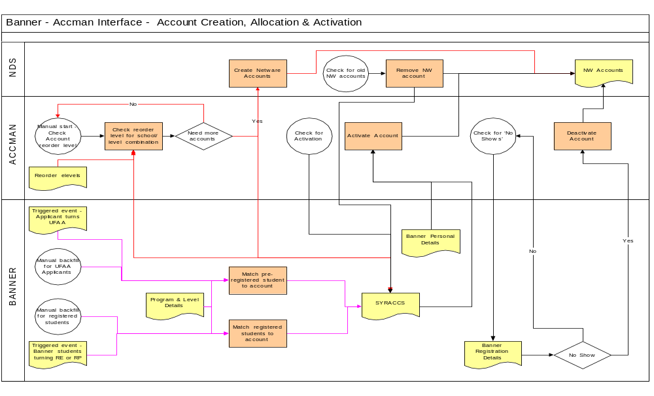

Email Synchronisation
Error! Not a valid link.

