Creating NIC Bonding:
- Add a new NIC if it does not exist
- Install bonding driver = modprobe bonding
- To list the bonding module info = modinfo bonding
You will see the driver version as seen below if the driver is installed and loaded

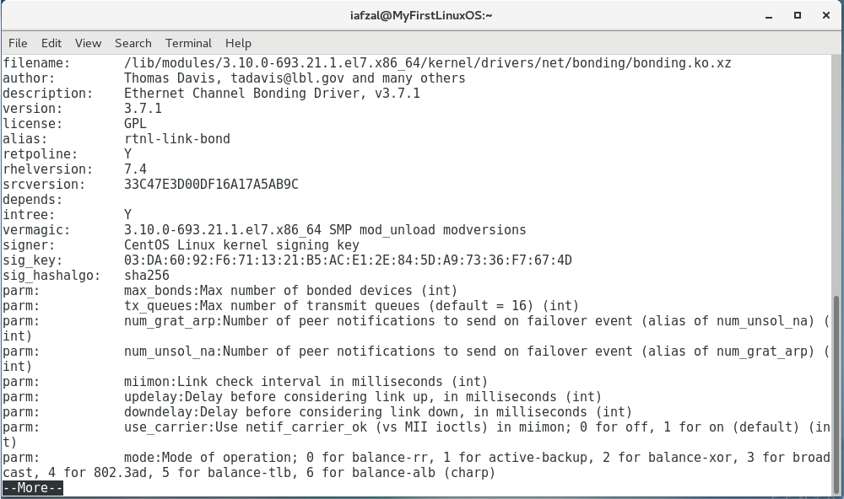

Create Bond Interface File
- vi /etc/sysconfig/network-scripts/ifcfg-bond0
- Add the following parameters
DEVICE=bond0
TYPE=Bond
NAME=bond0
BONDING_MASTER=yes
BOOTPROTO=none
ONBOOT=yes
IPADDR=192.168.1.80
NETMASK=255.255.255.0
GATEWAY=192.168.1.1
BONDING_OPTS=”mode=5 miimon=100”

- Save and exit the file
- The bonding options details are can be found on the following table
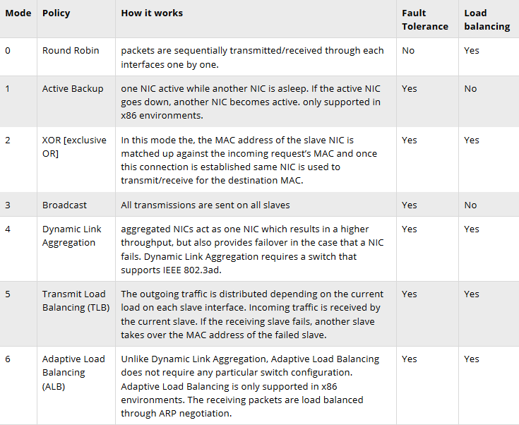

miimon
Specifies the MII link monitoring frequency in milliseconds. This determines how often the link state of each slave is inspected for link failures

Edit the First NIC File (enp0s3)
- vi /etc/sysconfig/network-scripts/ifcfg-enp0s3
- Delete the entire content
- Add the following parameters
TYPE=Ethernet
BOOTPROTO=none
DEVICE=enp0s3
ONBOOT=yes
HWADDR=”MAC from the ifconfig command”
MASTER=bond0
SLAVE=yes
- Save and exit the file

Create the Second NIC File (enp0s8) or Copy enp0s3
- vi /etc/sysconfig/network-scripts/ifcfg-enp0s8
- Add the following parameters
TYPE=Ethernet
BOOTPROTO=none
DEVICE=enp0s8
ONBOOT=yes
HWADDR=”MAC from the ifconfig command”
MASTER=bond0
SLAVE=yes
- Save and exit the file

Restart the Network Service
- systemctl restart network

Test and verify the configuration
- ifconfig or ifconfig | more

Use following command to view bond interface settings like bonding mode & slave interface
- cat /proc/net/bonding/bond0

