STUDENT-TEACHER UI
Maglalagay din daw ng E-BOOK dito para isang pindot na lang labas lahat ng ebook list..then yong RECOMENDATION pwedi nya ma reserved online
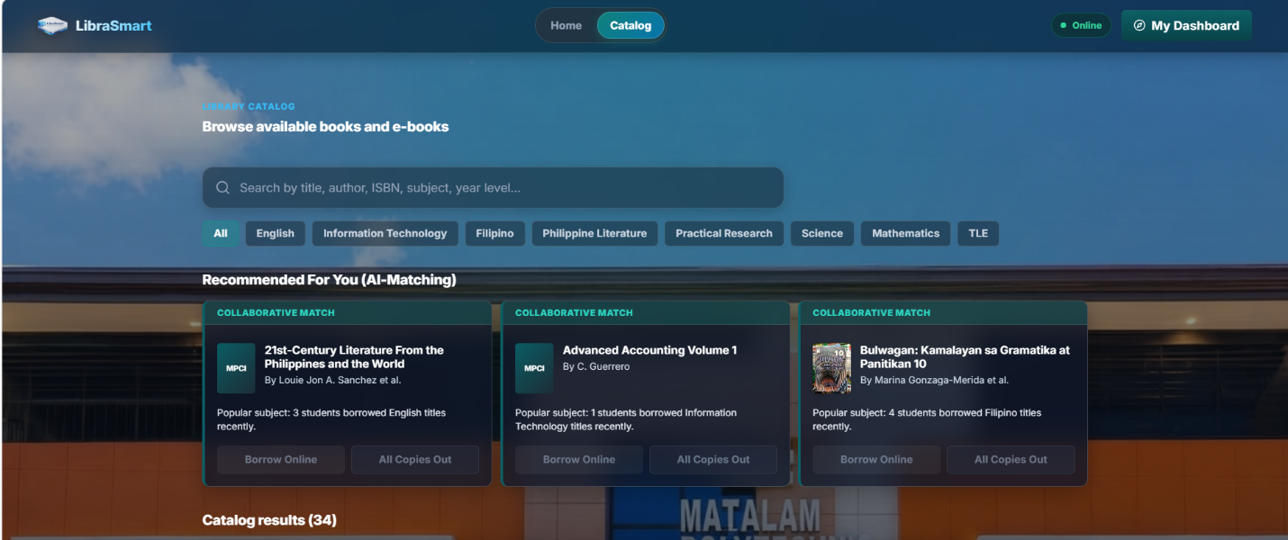
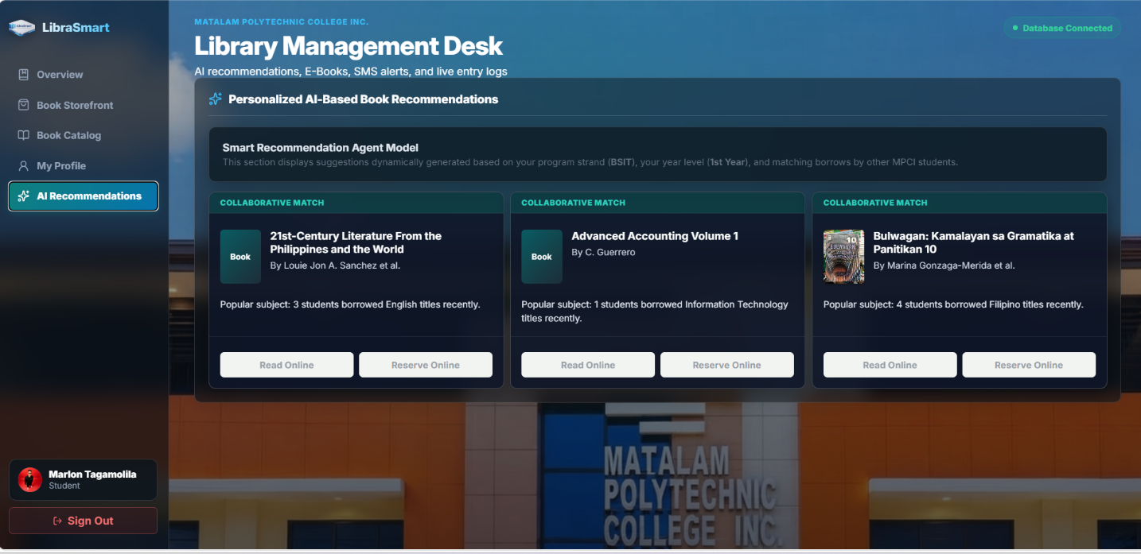

ADMIN UI
Sa STUDENT RECORD pa delete si prof. john smith tapos si Ms. Jane kasi si Principal Administrator lang naman yong librarian tapos pwedi pati number ma change ni LIBRARIAN sa account nya ..
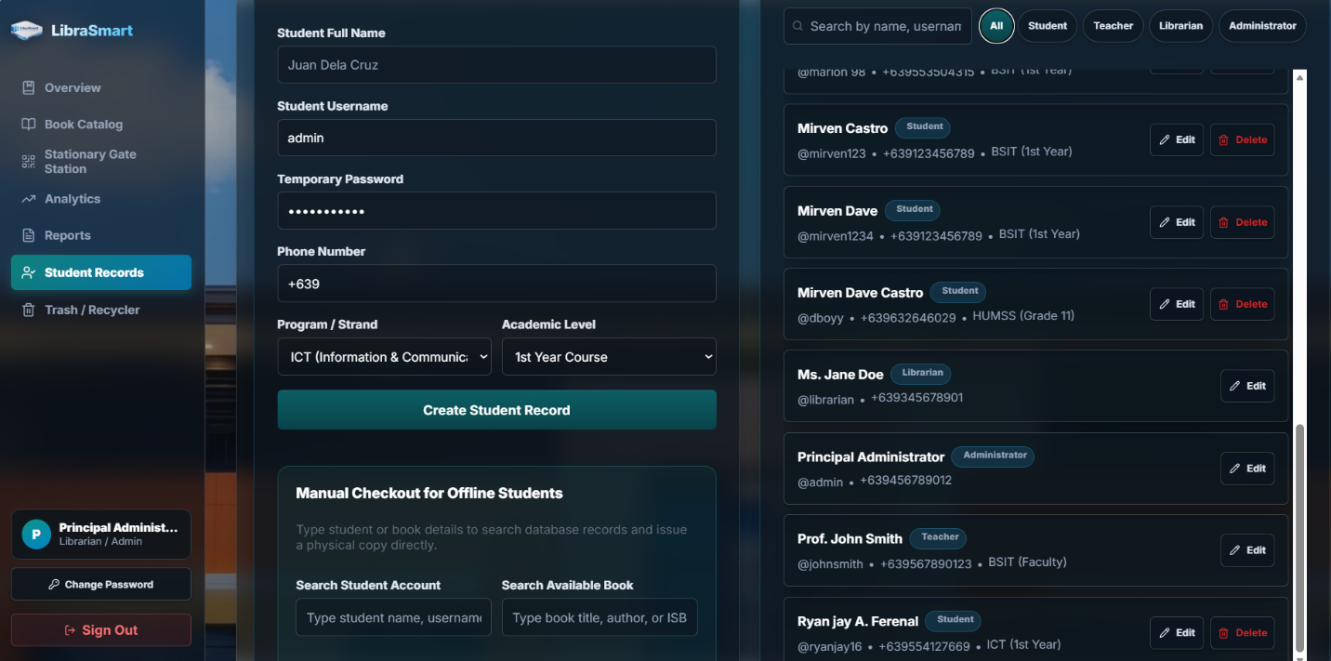

Tapos dapat log in , log out dapat to hindi Sign in , Sign out
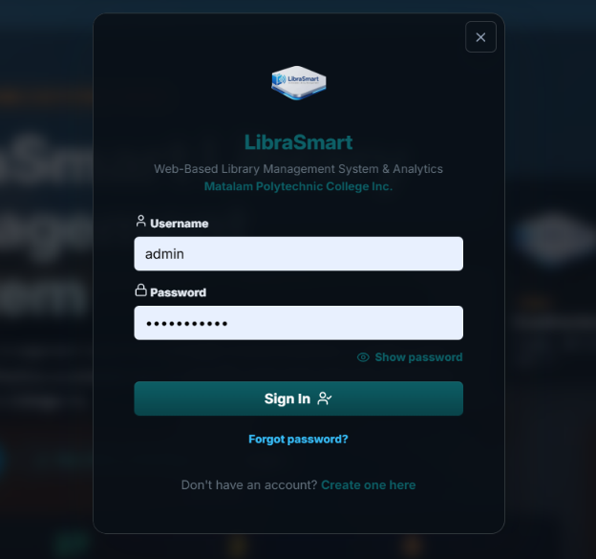

Tapos in general dapat yong color palet is mag match dito


Then mag lagay ng school logo..pa enhance na lng kasi medyo blurd


