Student
1. PERFORMACE
Sa performance history prelim and midterm pa rin naka display e may grades na sa final.. for example pag PRELIM , prelim grade lng muna naka lagay jan.. then pag MIDTERM ..ilalagay yong PRELIM GRADES then MIDTERM RAW GRADES ( prelim-40% + midterm-60% = (current) midterm final grades).. same sa PREFINAL , ilalagay MIDTERM grades then PREFINAL RAW GRADES , sa CURRENT ( midterm- 40% + prefinal- 60% = current PRIFINAL GRADES…same process sa final
Then COURSE-BY-COURSE TRAJECTORY kung anung subject na naka enrolled kay student yan yong naka display jan
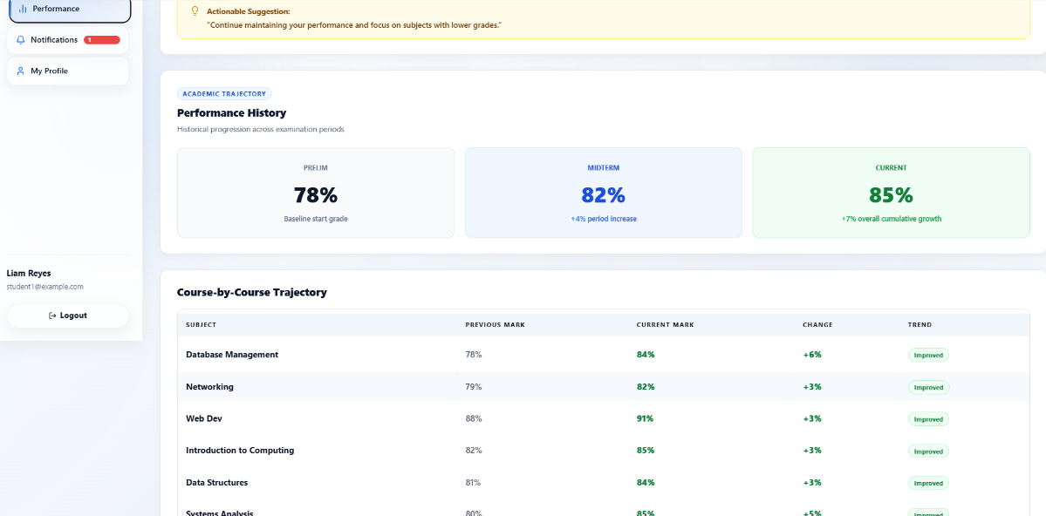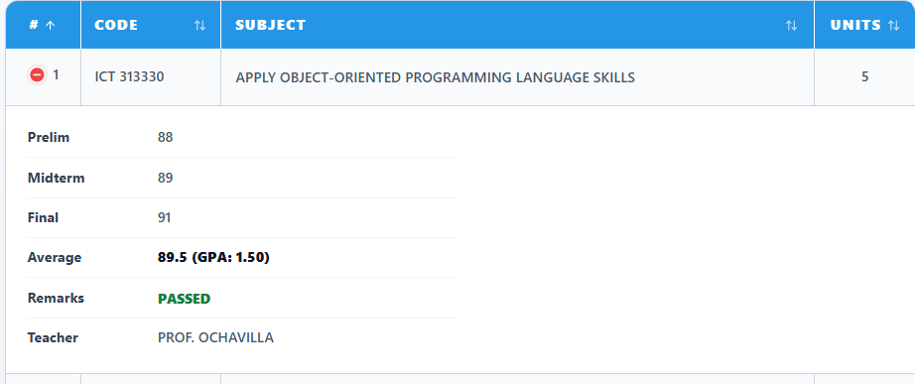
My GRADES
Dapat yong grades is naka round off na
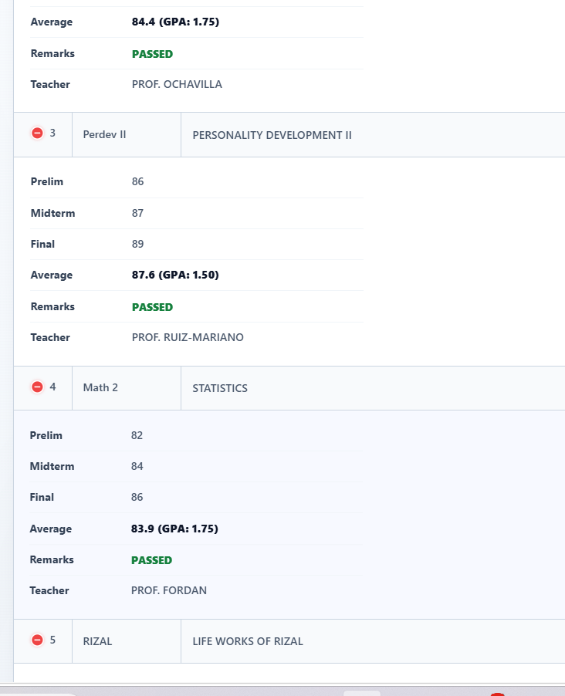

ADMIN
Mag lagay tayo GRADES kung saan pag open makikita ni admin yong subject per yer per section then kung sino instructor pero ang laman mga grades ng mga student (prelim to final) pero dapat di ma edit ni admin yong grades
STUDENT
Sa ADD NEW STUDENT sa course and section ..si instructor lang mag input then dapat searchable din..mag lagay din tayo ng DROP OUT para kung sakali may mag DROP OUT
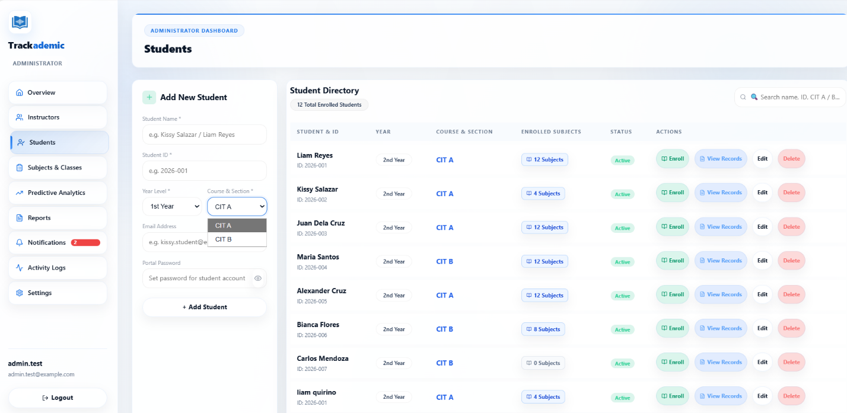
NOTIFICATION (ADMIN)
Ma notify si admin kung naka pag input na sya ng grades yan lang ata fuctions nya or yan lang muna
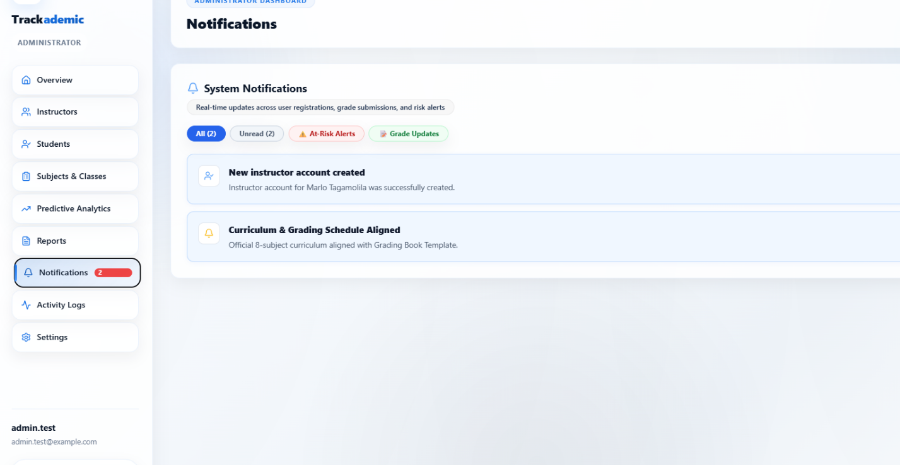
1. SUBJECT AND CLASSES
Paayos lang ako boss di kasi makita
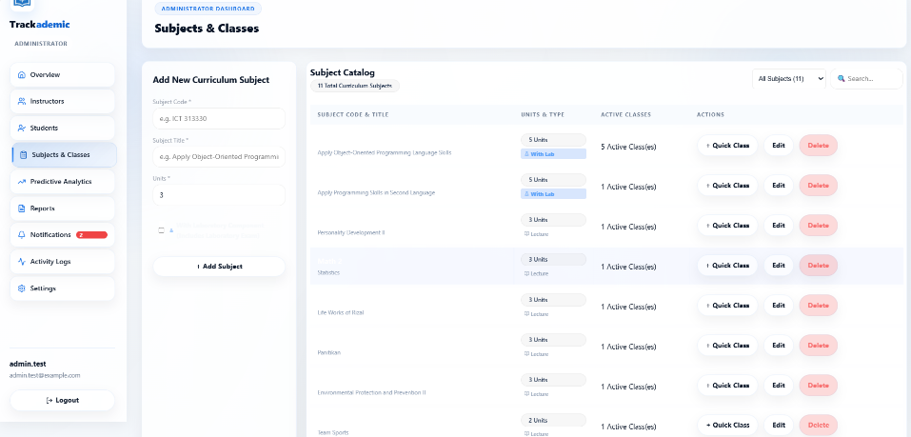

Class Creation & Instructor Assignment
Dito boss sa course and section pwede e input lng nila yong course and section as well as parang searchable siya
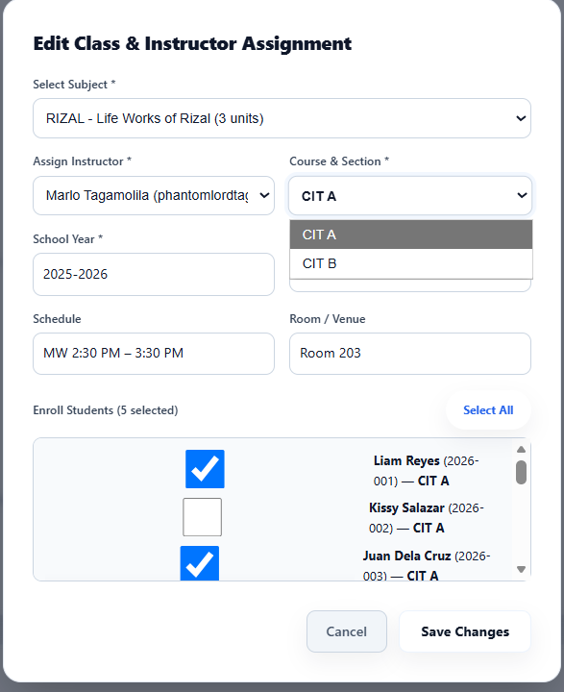

SETTING
Sa grading setting formula..
PRELIM
Attendance- 10% | Quizzes- 20% | Activity- 20% | Participation-10% | Exam-40% | = PRELIM GRADE

MIDTERM
Attendance- 10% | Quizzes- 20% | Activity- 20% | Participation-10% | Exam-40% | Midterm Raw GRADE | Prelim garde (40%) + midterm raw grades (60%) = MIDTERM GRADES

Same process sa pre final to final
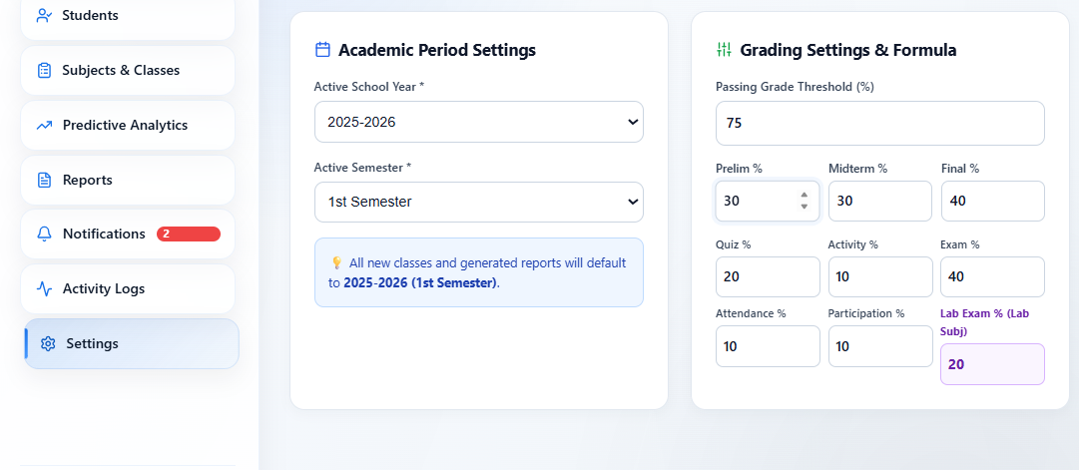
INSTRUCTOR
Dito sa classes boss if anong subject lang yong binigay or na add ng admin yong lang yong ma display at makita nya
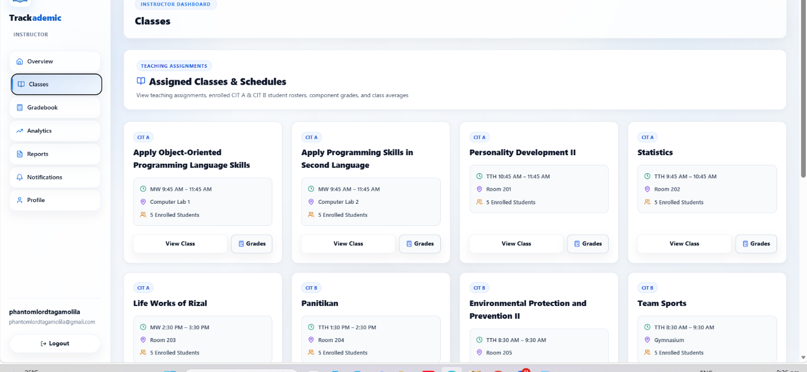
GRADEBOOK
Pa sunod lng ako don sa binigay kung grading sytem …pero goods na yan yong format..then parang naka auto fill yong mga data kasi nag add ako ng bagong subjects automatic may grades na agad pati si student..then dba kompleto na ang grades parang e uupload niya or send nya kay admin yong grades
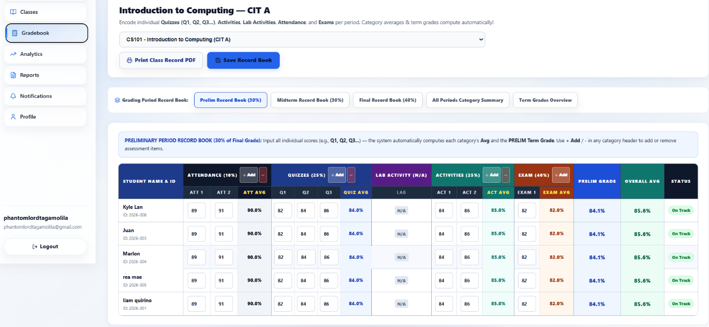
NOTIFICATION(INSTRUCTOR)
Ma notify si instructor if may na add na subjects/classes sa kanya , may na enrolled na student sa subject niya at kung may nag drop out sa klase niya
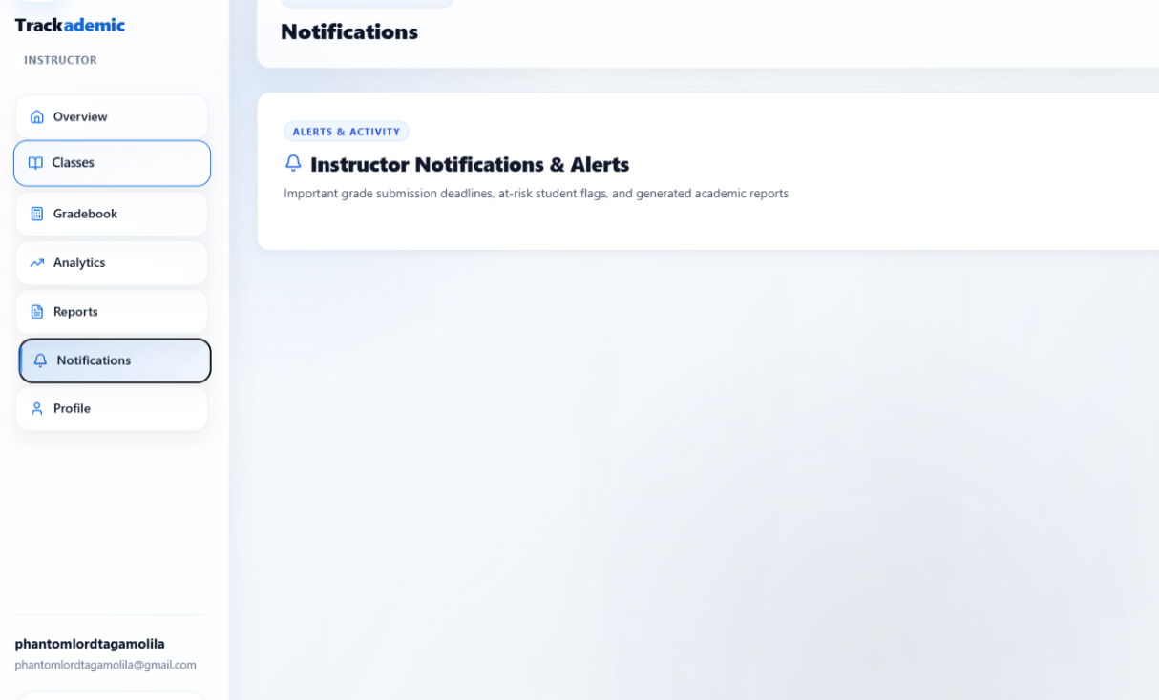
PROFILE
Sa assigned classes isa pa lang yong na add ko pero tatlo na naka lagay
