SYSTEM
- Contract agreement – on the catalogue for the available cubes, ma view ni renter yung contract before reserving para alam nya first yung agreement.
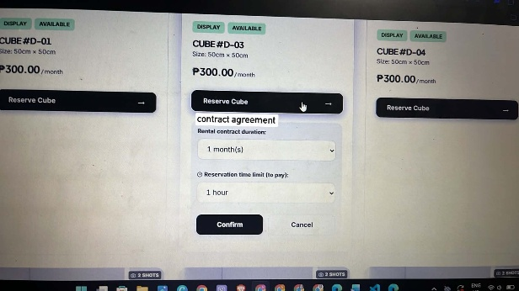

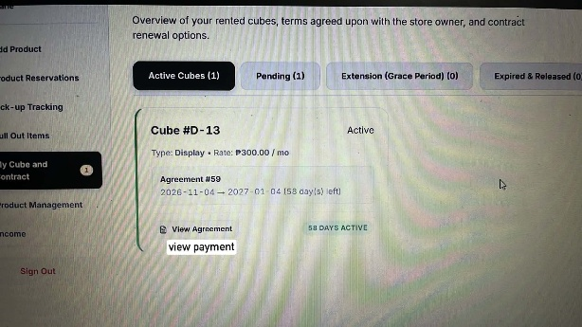
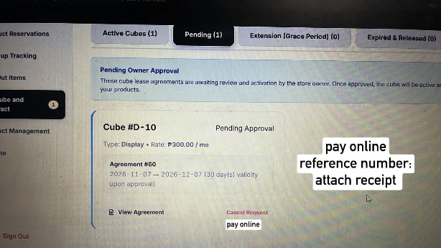
- Renter can upload a receipt and put reference number when paying the cube online then owner and staff will confirm it and before marking the cube payment as paid.

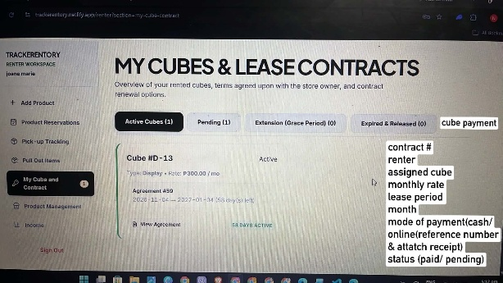
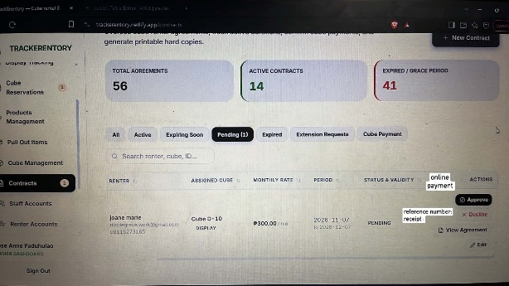

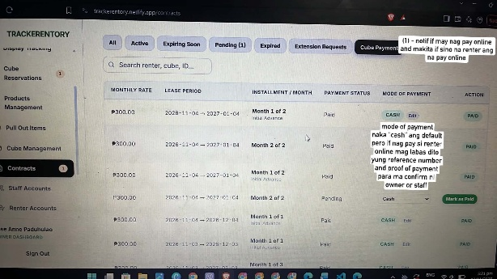

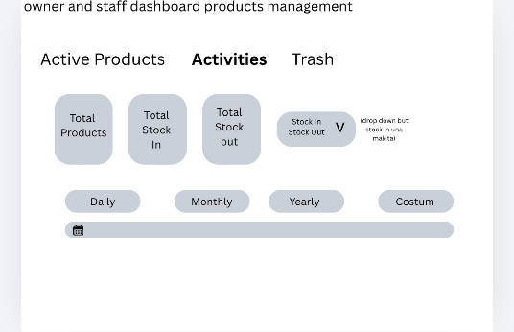
- Inventory – stock in and stock out
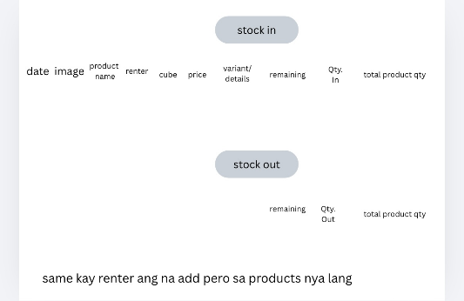

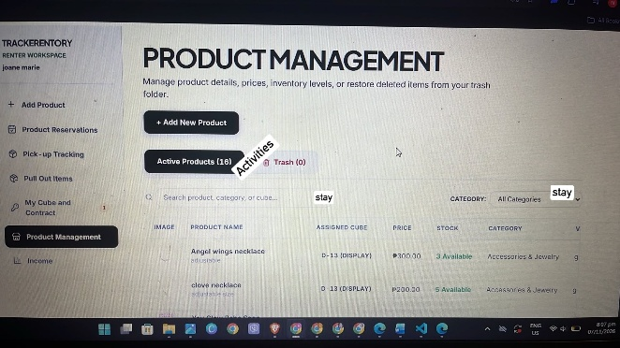
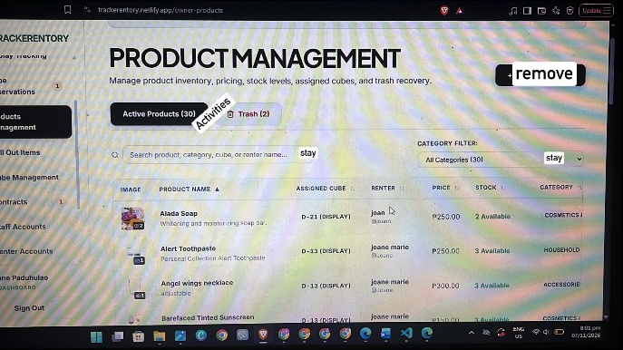

CHAPTER 3
- IPO – add receipt or payment features
- Data dictionary – put description on each table (di nag match yung table sa erd and data dictionary. Erd has 10 tables tapos 7 lang nasa data dictionary)
- Change the context diagram also mention the uploading of receipt
- System flowchart – follow the correct format, dapat daw per user, and also add the uploading of receipt

