Before testing create database and set the your db password

Step 1. Create database ‘Emp_db’ using the following script

CREATE DATABASE Emp_db;

Step 2. DB access userid/password configured as below

userid : root

Password : root

TESTING

|  |  |
| --- | --- |
| Test No.1 | Run the program |
|  | Expected Result: Code should run successfully and creates an ‘Employees’ table in Emp_db database |

Result :

Code execution:

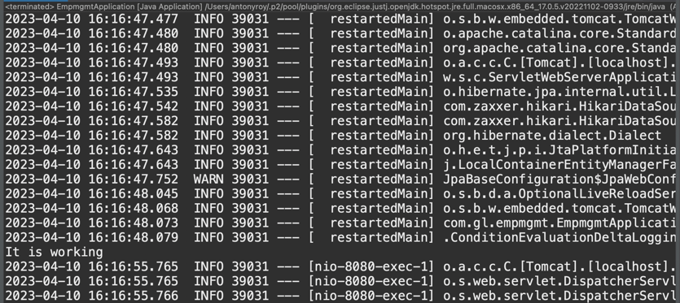

Db

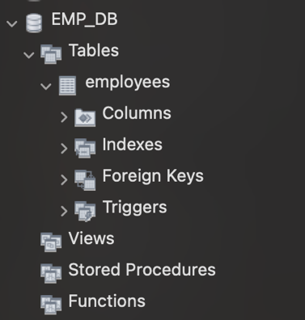

|  |  |
| --- | --- |
| Test No.2 | After running the code go to the browser and type in Localhost:8080/employees |
|  | Expected Result: The employee Management home page should open |

Result:

Localhost:8080/employees

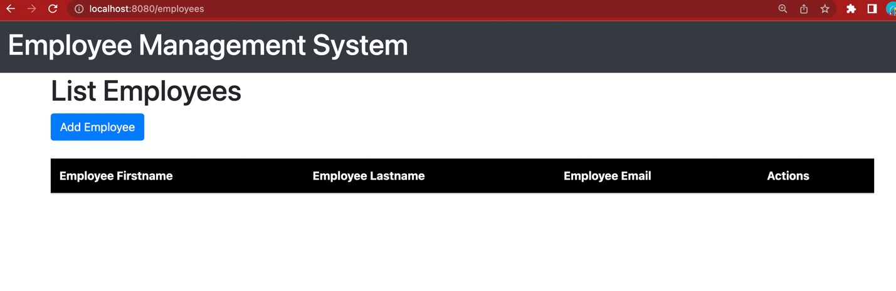

|  |  |
| --- | --- |
| Test No. 2 | On the Employee Management System home page, click on the ‘Add Employee’ button to add an employee |

Result :

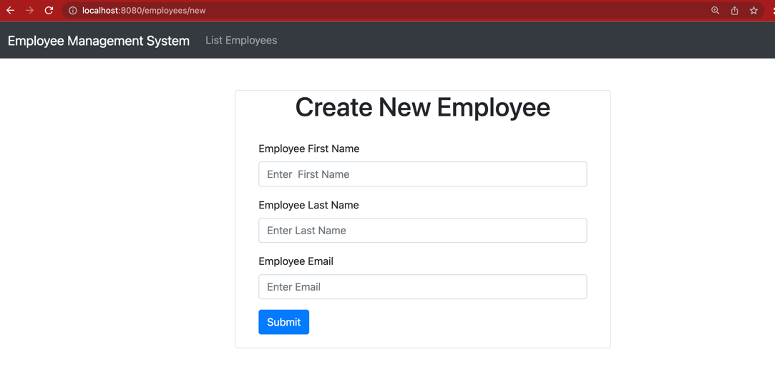

|  |  |
| --- | --- |
| Test No. 3 | In ‘Create Employee’ Screen Add the following data  First Name : Vinesh  Last Name : Kumar  Email : [vk@gmail.com](mailto:vk@gmail.com)  Expected Result : After adding it successfully it will List all the users |

Adding

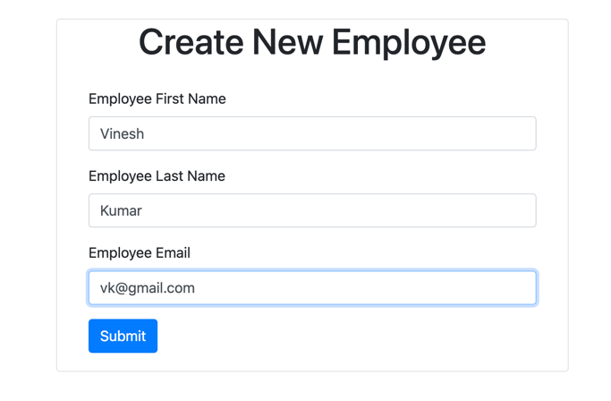

Listing :

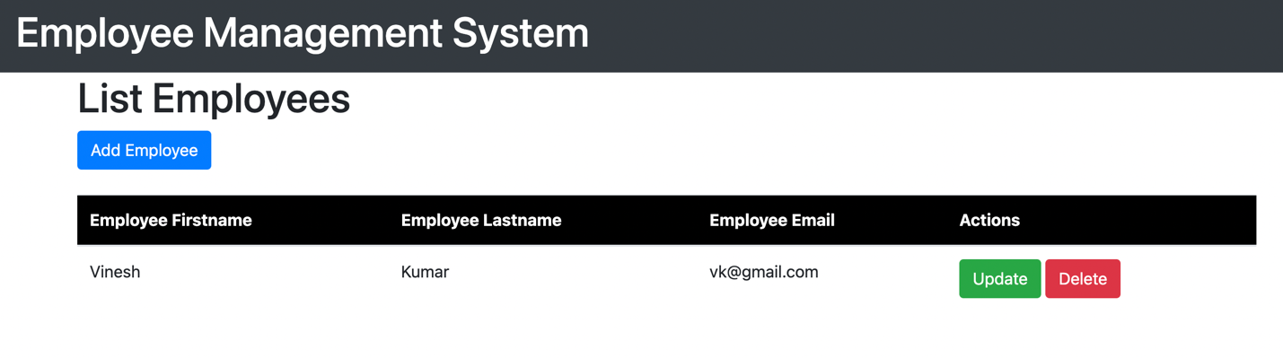

Checking the Emp_db

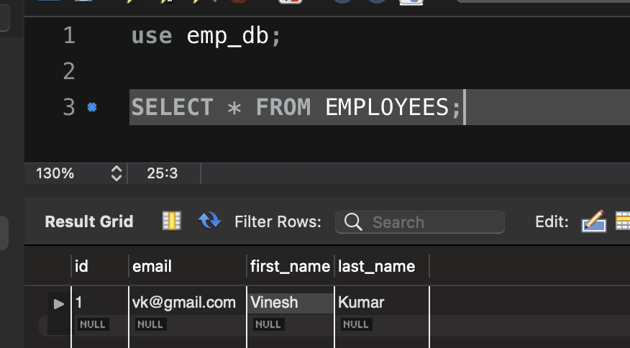

|  |  |
| --- | --- |
| Test No. 5 | In the listing screen click on the update to make changes to the name and the email  First Name : Ramesh  Last Name : Kumar  Email : [rameshkumar@gmail.com](mailto:rameshkumar@gmail.com)  Expected Result : After update it successfully it will show the latest update |

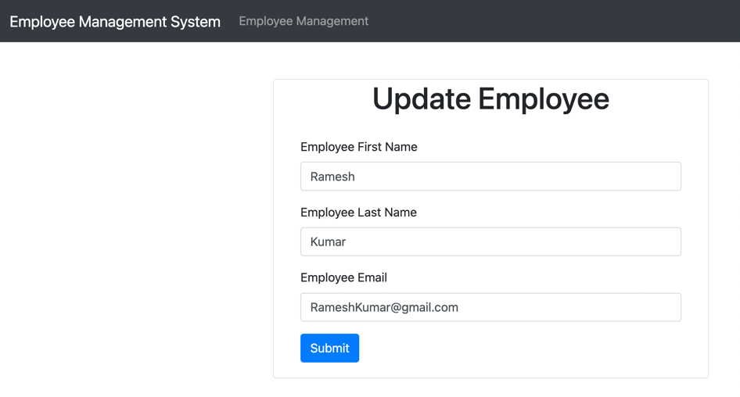

Result:

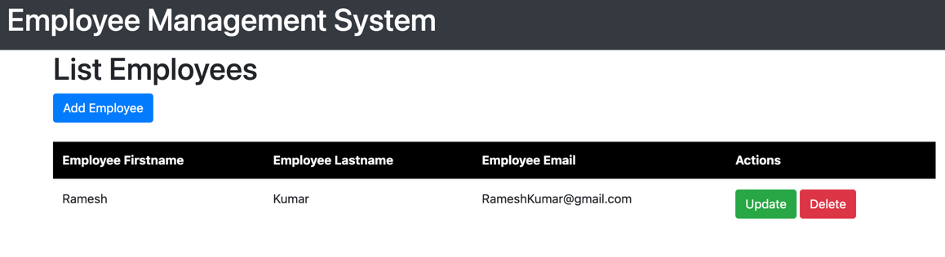

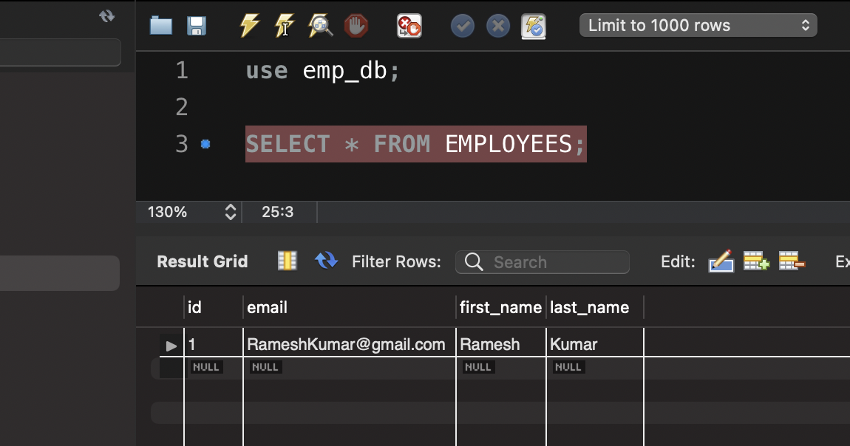

|  |  |
| --- | --- |
| Test No. 6 | In the listing screen, click on the delete button to delete employee record  After deletion it removes from the database and refreshes the list |

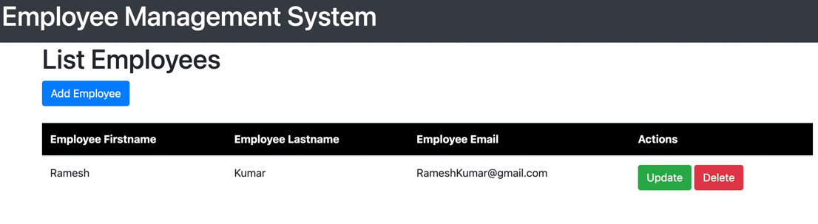

After clicking on the delete.

No records shown on the webpage

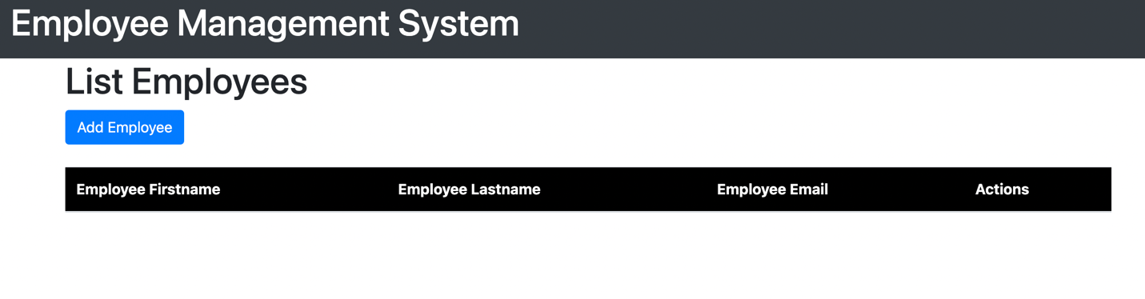

Database Result: No records in db

