**Testing**

**Question1-query.sql**

**Question2-query.sql**

**Question3-query.sql**

**-- 3) Display the total number of customers based on gender who have placed orders of worth at least Rs.3000.**

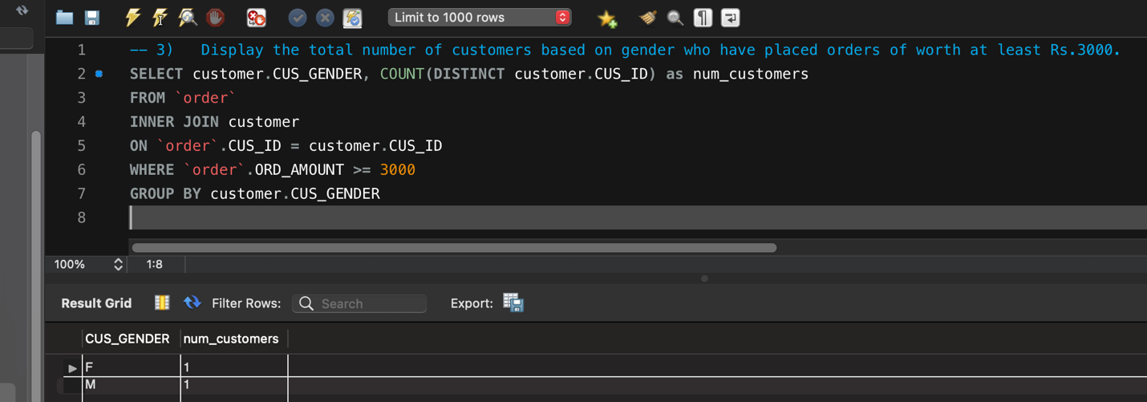

**Question4-query.sql**

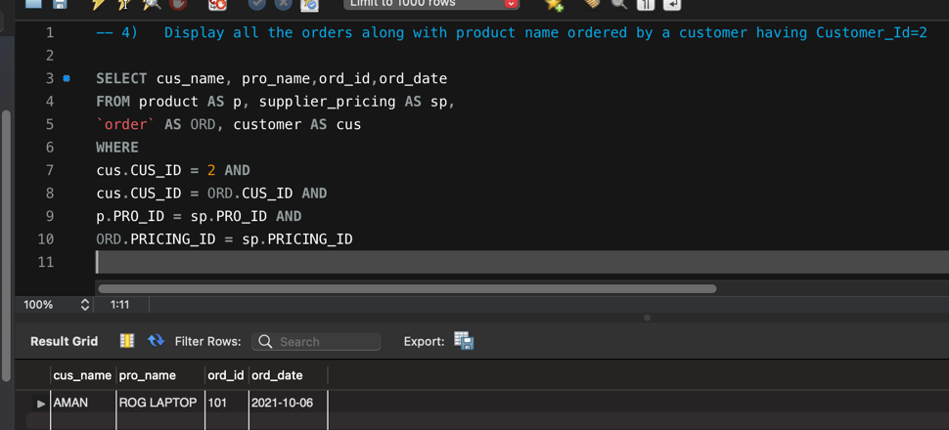

**Question5-query.sql**

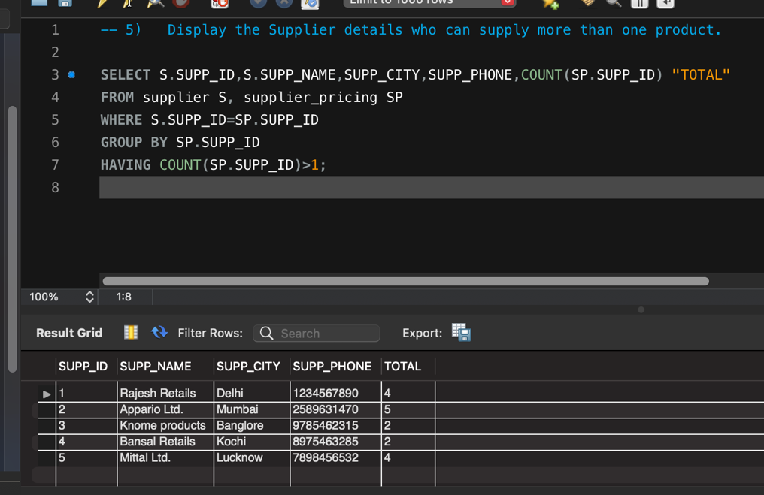

**Question6-query.sql**

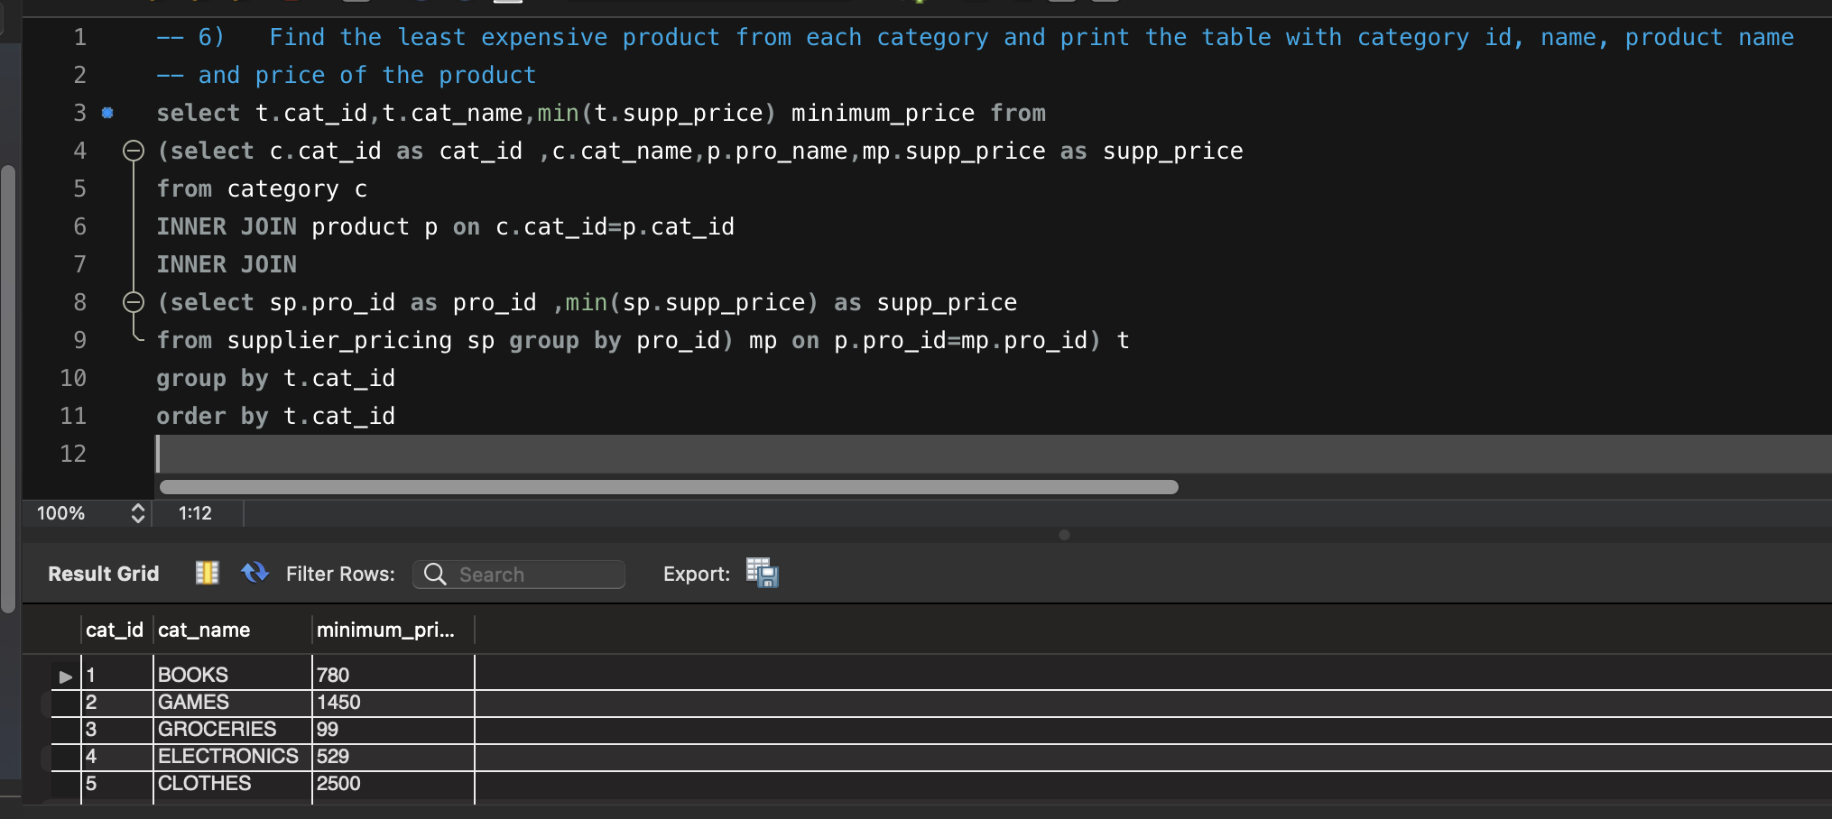

**Question7-query.sql**

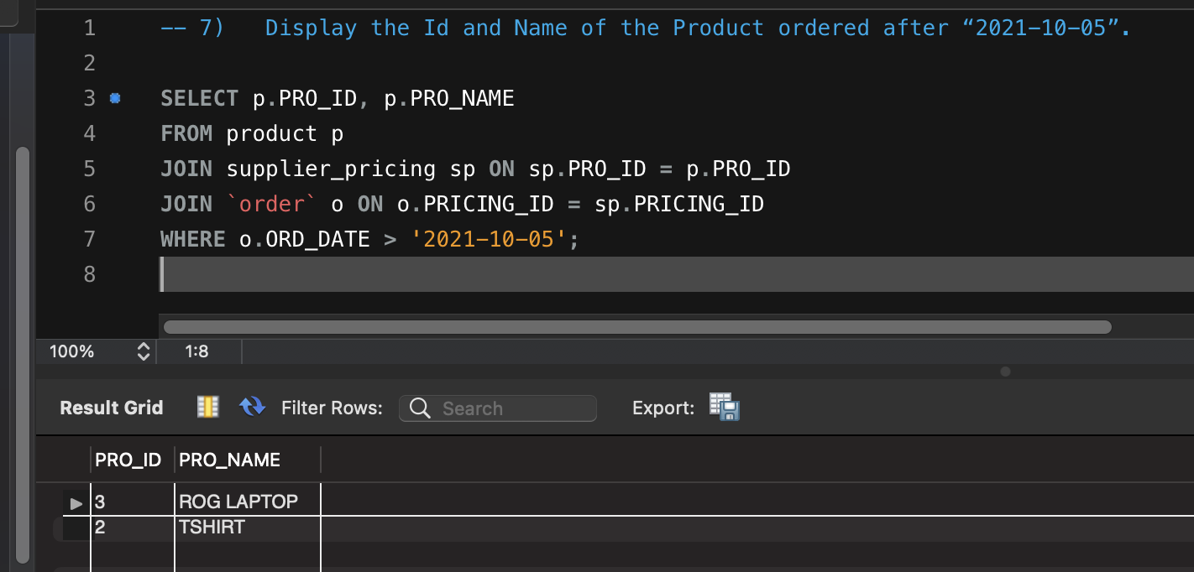

**Question8-query.sql**

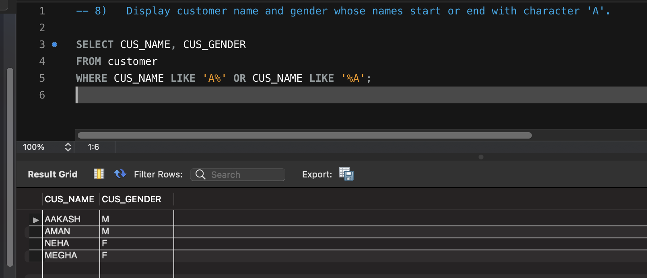

**Question9-query.sql**

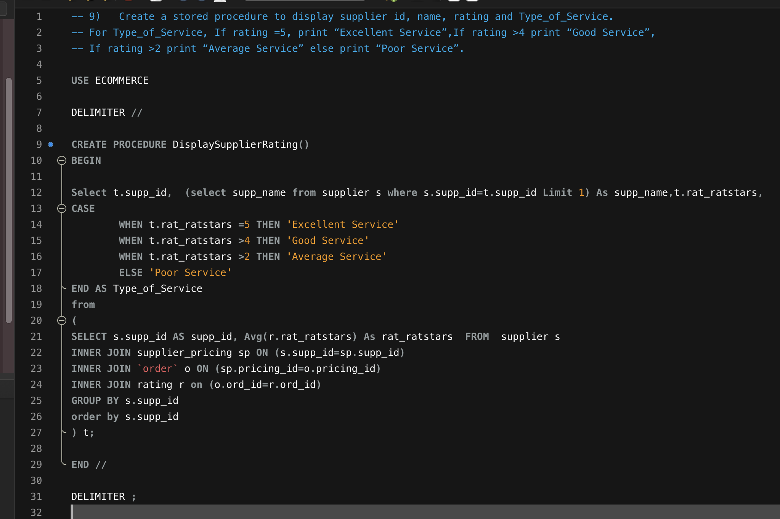

**Execution of Stored procedure DisplaySupplierRating()**

