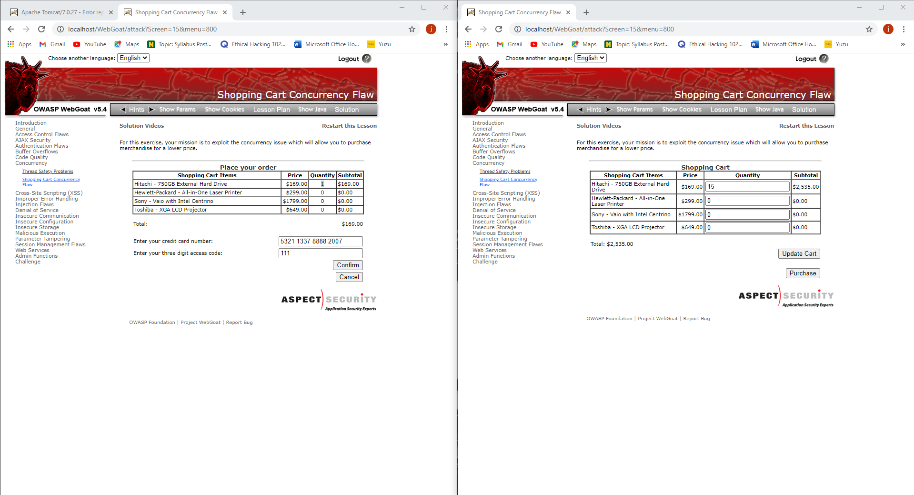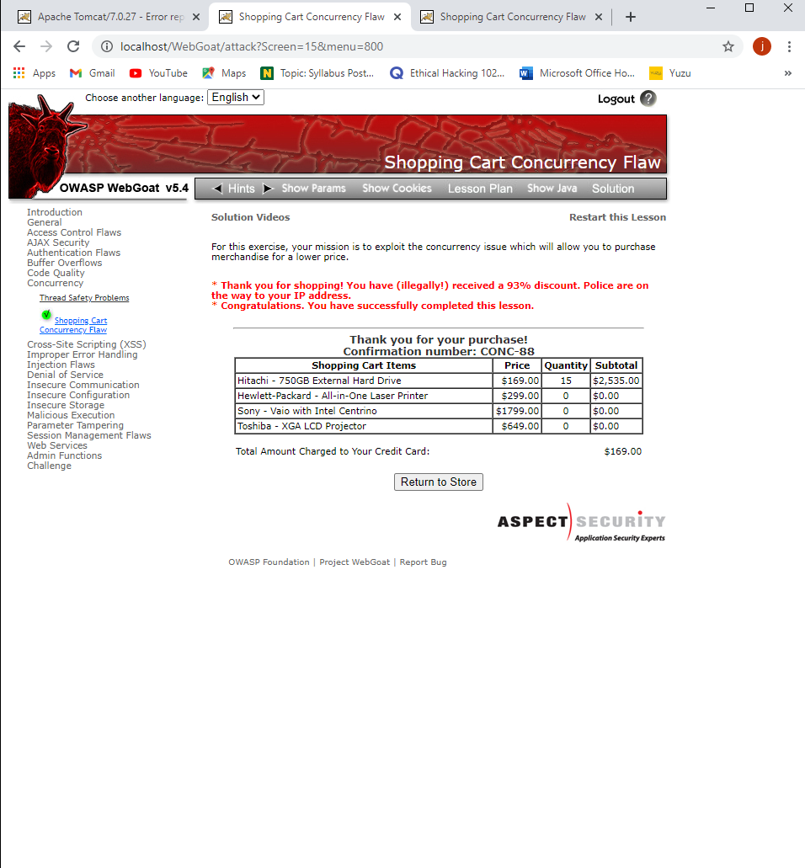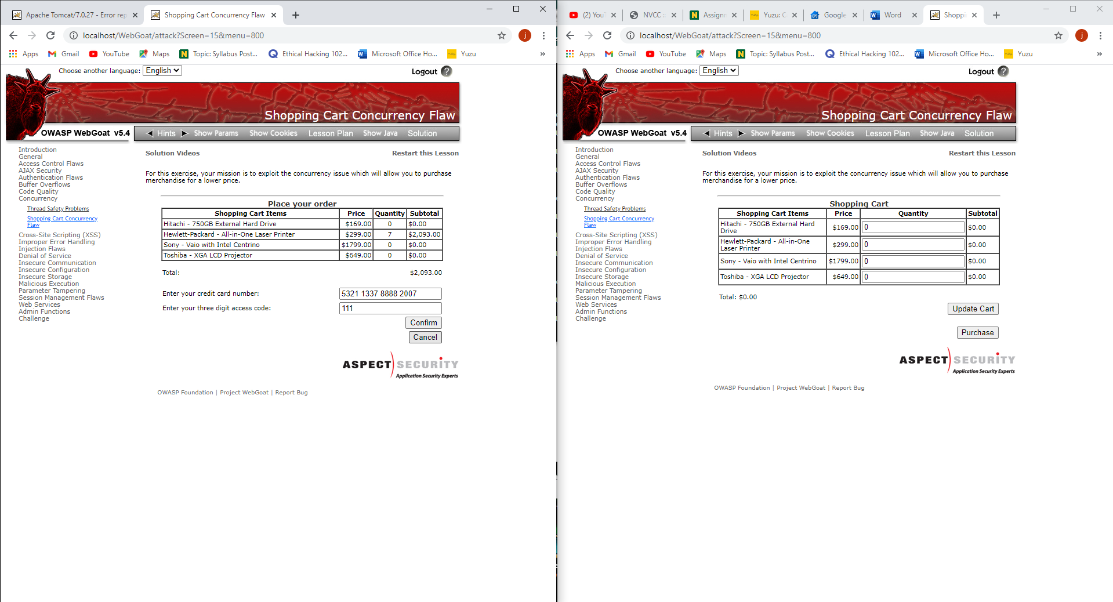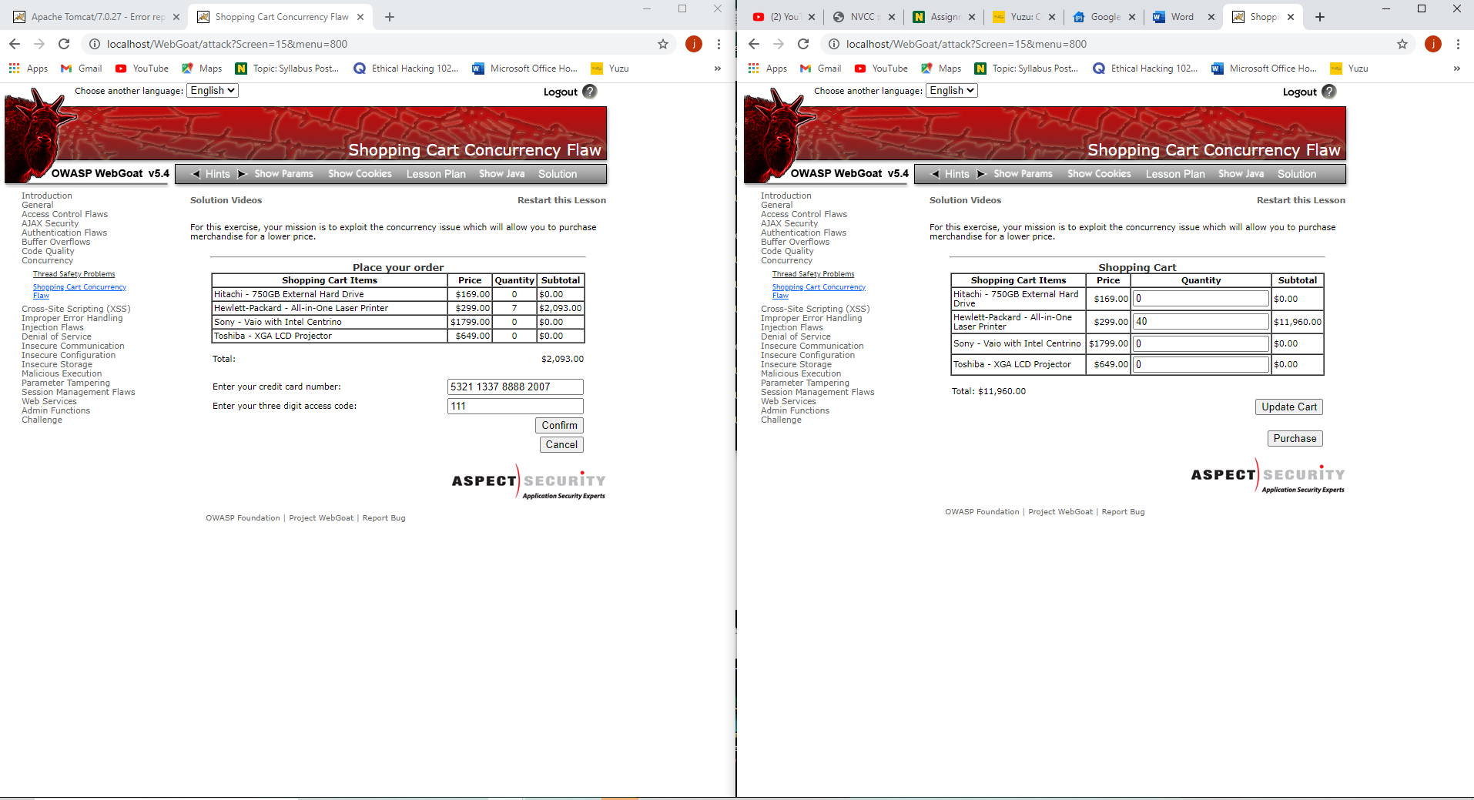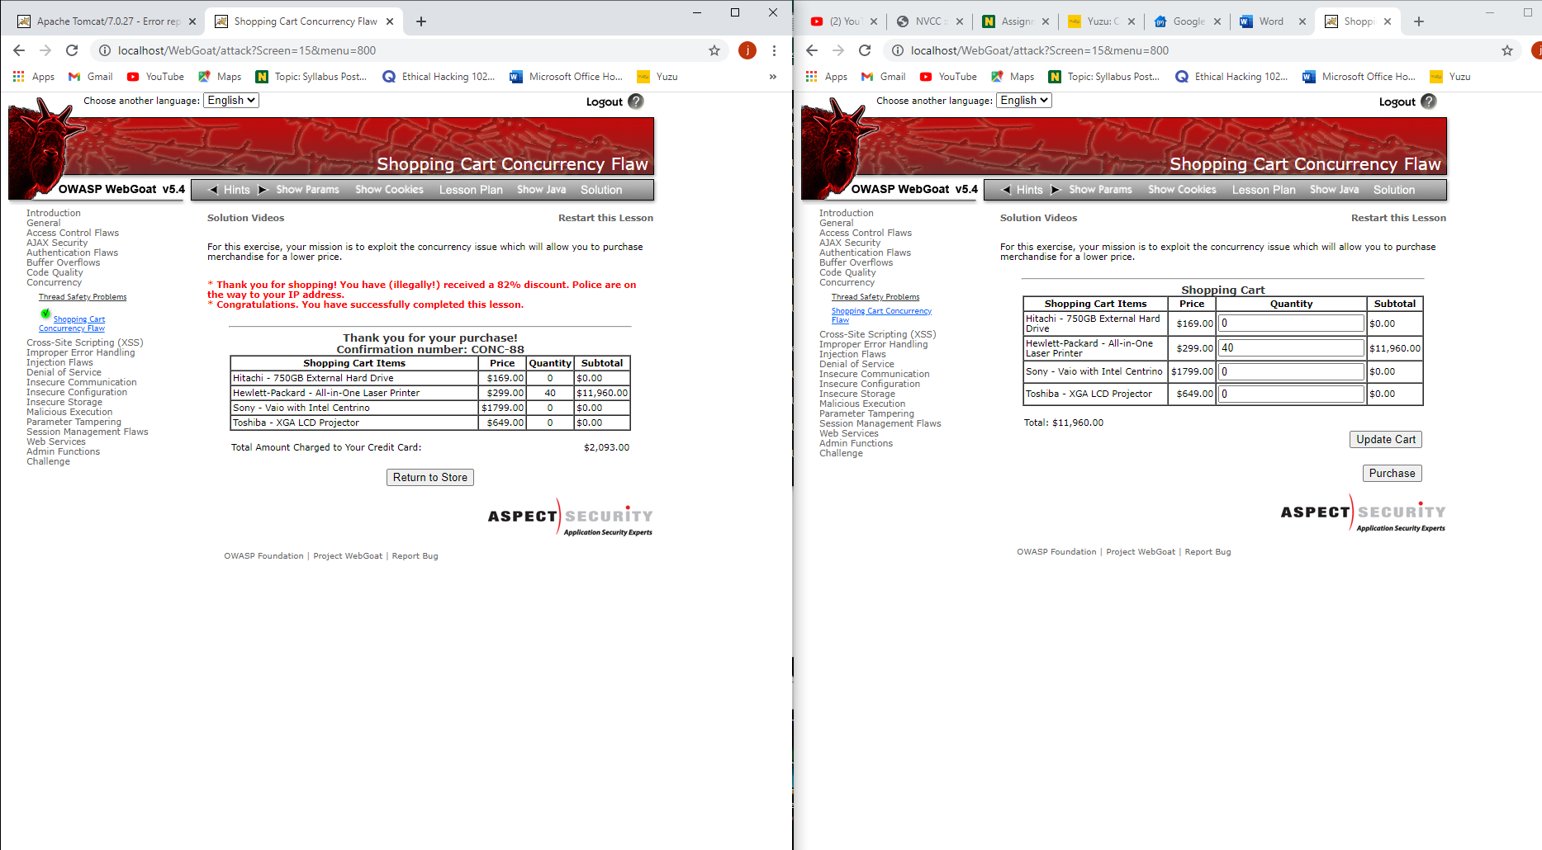

Question 5: Concurrency is decomposability property of a program, algorithm or problem into order independent or partially ordered parts. If concurrent units of program, algorithm or problem are executed out of order or partial order, the outcome remains same.

Question 6: Some websites are still vulnerable to concurrency flaws and they will need to change however most large websites will have written secure code to prevent concurrency flaw from happening.

Question 7: cross-site scripting attacks include when an attacker stores malicious script in the data sent from a website's search or contact form. A typical example of reflected cross-site scripting is a search form, where visitors sends their search query to the server, and only they see the result.

Question 8: They don’t have to worry about bringing down a real website or losing real data. Also people can use this on their own computer for training.