"Global Energy Consumption Patterns: Challenges in the Fossil Fuel Transition"

Problem Statement: "The Energy-Economy-Environment Nexus"
- Global energy consumption continues to rise in correlation with economic growth across all major economies
- Fossil fuel dependency remains high (consistently above 70%) despite increased climate awareness and policy efforts
- Significant disparities exist between industrial and household energy consumption patterns across nations
- Economic development stage strongly influences energy intensity and efficiency, with varying GDP per unit energy ratios
- Environmental indicators like CO₂ emissions and sea level measurements show concerning trends linked to energy choices
- Population fluctuations and GDP growth create varying pressures on energy systems in different regions
- Renewable energy adoption shows major regional disparities, with most countries still heavily fossil-fuel dependent
- Cyclical environmental stress indicators point to mounting climate pressures directly related to energy consumption
- Energy efficiency improvements are not keeping pace with economic expansion in many major economies
- The transition away from fossil fuels is progressing too slowly to meet climate targets despite technological advances

OR
The data reveals a persistent global challenge where economic growth continues to be tightly coupled with fossil fuel consumption despite decades of climate awareness. Despite GDP growth across major economies from 1998-2025, fossil fuel dependency percentages have remained stubbornly stable, showing minimal reduction even in technologically advanced nations.
- Economic-Environmental Disconnect: Countries show significant GDP growth without proportional decreases in fossil fuel dependency, creating a dangerous gap between economic prosperity and environmental sustainability. This is particularly evident in the GDP vs. Fossil Fuel chart where the lines do not show the expected divergence over time.
- Regional Energy Inequality: Major disparities exist in energy composition and efficiency across nations, with countries like Germany achieving higher renewable percentages while India and China maintain heavy fossil fuel dependency. The energy composition chart highlights these stark differences, with some nations achieving over 20% renewable share while others remain below 10%.
- Industrial-Household Imbalance: The data shows industrial energy consumption dramatically outpacing household use in developing economies like China and India, driving higher overall fossil fuel dependency. This imbalanced growth pattern creates unique transition challenges that require targeted interventions.

Objectives
- Identify key factors driving persistent fossil fuel dependency across different economic development stages
- Analyze the relationship between population, GDP, and energy consumption patterns
- Evaluate regional disparities in energy efficiency and renewable adoption rates
- Assess environmental impact indicators related to current energy consumption models
- Develop targeted interventions based on country-specific energy consumption profiles

Recommendations
- Tailored Transition Pathways: Develop country-specific energy transition roadmaps based on industrial/household consumption balance (addressing China's industrial dominance vs. balanced approaches in Germany)
- Efficiency-First Policies: Prioritize energy efficiency improvements in low-performing countries (Japan, Germany, India) to maximize economic output per energy unit
- Strategic Renewable Deployment: Accelerate renewable adoption in high-dependency nations by replicating successful models from Germany and Brazil
- Demand Management Programs: Implement household energy conservation initiatives to address the stable household consumption patterns shown across most countries
- Environmental Response Systems: Establish early warning systems and adaptation strategies for countries with high environmental stress indices like Australia
- Economic Alignment Mechanisms: Create fiscal policies that align economic growth incentives with fossil fuel reduction targets to address the persistent GDP-fossil fuel correlation

GDP vs Fossil Fuel Use Over Time

Description:
- This graph shows the relationship between GDP (in USD) and fossil fuel dependency percentage over time (1998-2025) for multiple countries.
- Bar charts represent GDP (left axis) while the line chart represents fossil fuel dependency percentage (right axis).
- It covers 10 countries together, filtered by "Country Name" on the right, aggregating the total GDP and fossil fuel percentage yearly.

Key Points:
- GDP steadily rises over the years, with a dip around 2010.
- Fossil fuel dependency percentage stays fairly stable with minor fluctuations.
- No drastic inverse relationship is visible — GDP grows without a significant drop in fossil fuel use percentage.

Key Insights (What this means):
- Economic growth hasn’t been accompanied by a significant reduction in fossil fuel dependency.
- Despite global efforts for sustainability, fossil fuel reliance remains strong even as economies expand.
- The dip around 2010 could hint at a global economic event or crisis impacting both GDP and energy patterns.

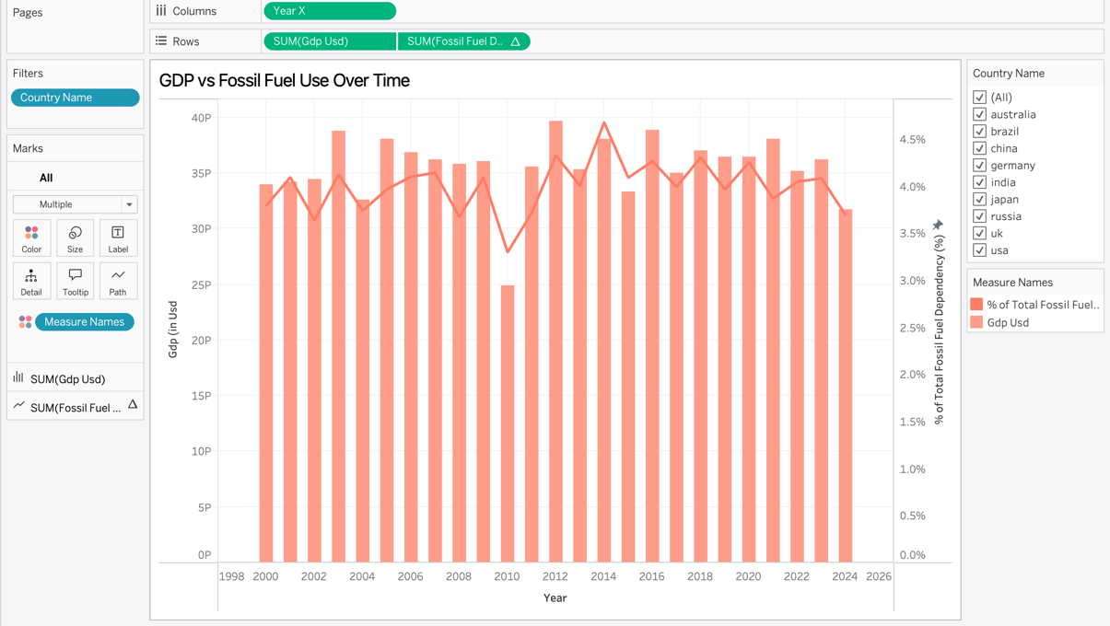

Energy Composition Across Countries (2018)

Description:
- This graph compares the percentage share of renewable energy and fossil fuel dependency across different countries in 2018.
- Top chart (in red) represents renewable energy share, and bottom chart (in orange) shows fossil fuel dependency.
- Each country’s energy mix is visualized to highlight their energy source balance.

Key Points:
- Germany leads in renewable energy share, followed by Brazil.
- India shows the highest fossil fuel dependency.
- Most countries show a higher fossil fuel percentage than renewables — except some notable exceptions like Germany.

Key Insights (What this means):
- Countries like Germany and Brazil have made stronger shifts toward renewable energy, indicating policy or resource advantages.
- India’s heavy fossil fuel reliance highlights developmental and infrastructural dependency on traditional energy sources.
- The global energy landscape is still predominantly fossil-fuel driven, though renewable adoption varies by region.
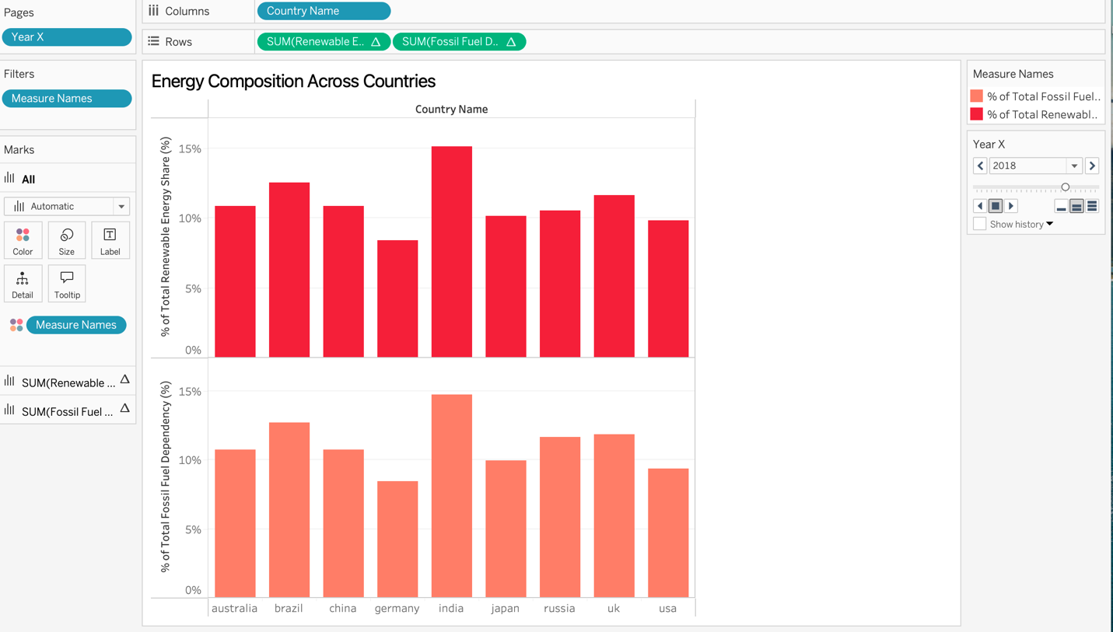

Industrial vs Household Energy Use Across Countries (2016)

Description:
- This graph compares industrial energy use (bars) and household energy use (line) as a percentage of total energy consumption across countries for 2016.
- Bar height represents industrial usage, while the line indicates household energy use.
- Displays how different sectors consume energy differently across various nations.

Key Points:
- China has the highest industrial energy use, followed by India and Japan.
- Household energy use is relatively balanced across countries, with China leading slightly.
- Countries like Germany and USA have a more balanced industrial and household energy split.

Key Insights (What this means):
- Industrial growth in countries like China and India demands more energy, driving their higher industrial consumption.
- The relatively even household usage implies a similar baseline lifestyle energy need across nations.
- Countries with lower industrial use may either be more service-based economies or have implemented energy-efficient practices.
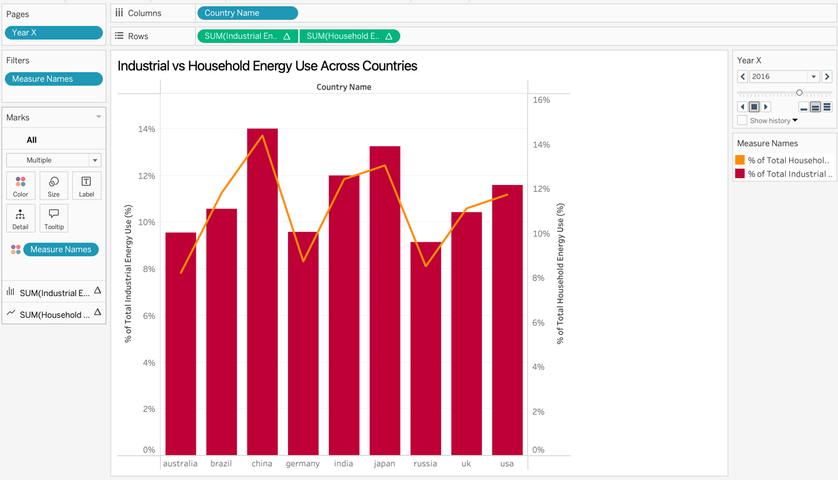

Population v/s Total Energy Use (USA)

Description:
- The graph tracks USA's population (green bars) and total energy consumption (red line) from 1998 to 2026.
- Population is measured in absolute numbers on the right axis while energy consumption is measured in TWh on the left axis.
- The time series shows significant fluctuations in both metrics with no consistent correlation pattern.

Key Points:
- Energy consumption peaked dramatically around 2011 at approximately 1600B TWh, with another major spike around 2016.
- Population shows major fluctuations rather than steady growth, with notable peaks around 2003, 2006, and 2020.
- There are periods (like 2010-2012) where energy consumption increased while population decreased, suggesting changes in per capita consumption.

Key Insights:
- The lack of consistent correlation between population and energy use suggests other factors (economic activity, energy efficiency, climate) strongly influence energy consumption.
- The sharp drops in energy consumption (like after 2011) likely represent economic downturns or significant policy/technological changes affecting energy intensity.
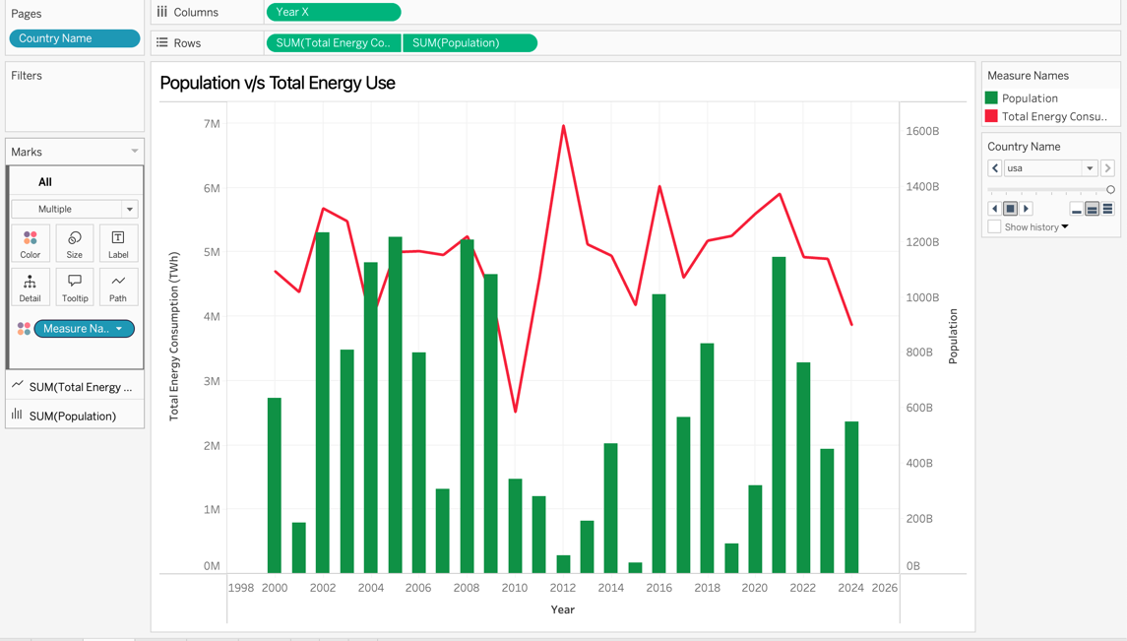
- Recent trends (post-2020) show stabilizing energy consumption despite population changes, possibly indicating improved efficiency or structural economic shifts.

CO₂ Emissions & Sea Level with Rainfall

Description:
- The graph displays three environmental metrics for Japan from 2000 to 2024: carbon emissions (top red line), sea level rise (middle blue line), and rainfall (bottom orange line).
- Each metric has its own scale, with carbon emissions measured in million tons, sea level in millimeters, and rainfall in millimeters.
- All three metrics show cyclical patterns with multiple peaks and valleys throughout the period.

Key Points:
- Carbon emissions fluctuate between approximately 1.5-3 million tons, showing several dramatic shifts but no clear long-term reduction trend.
- Sea level measurements oscillate between 0.5K-4.5K mm with notable peaks around 2004, 2014, and 2018.
- Rainfall shows extreme variability with major spikes around 2013 (reaching ~3M mm) and several smaller peaks throughout the period.

Key Insights:
- The absence of a declining trend in carbon emissions suggests Japan's climate mitigation efforts have not yet led to sustained emissions reductions during this period.
- The lack of clear correlation between emissions and sea level/rainfall indicates these environmental measures are influenced by multiple factors beyond local emissions.
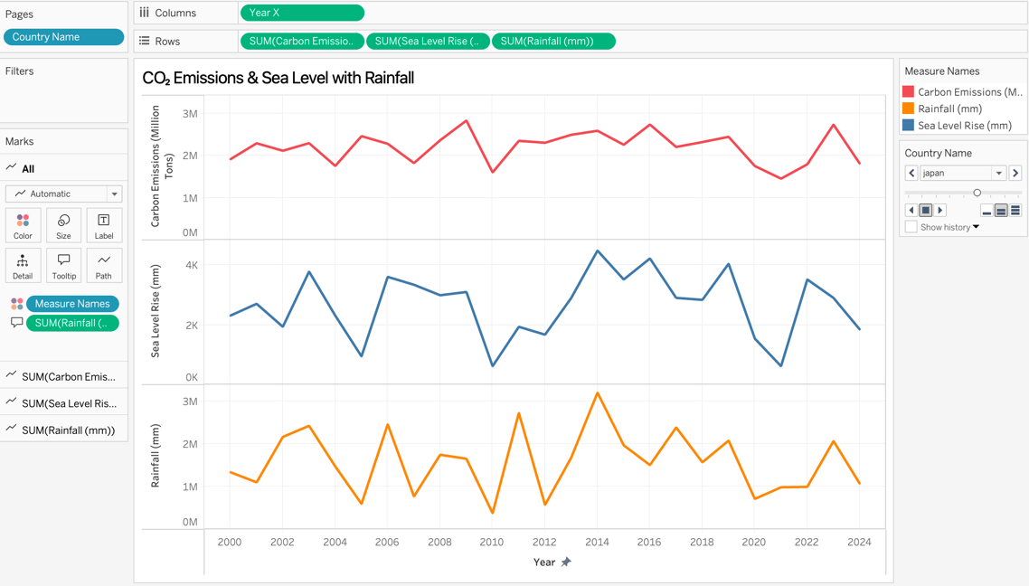
- The cyclical nature of all three metrics highlights the challenge of identifying clear climate trends amid natural variability.

GDP per Unit Energy (2024)

Description:
- This bar chart compares energy efficiency across nine countries for 2024, showing percentage of GDP per unit energy.
- Countries are arranged along the x-axis with their efficiency percentages displayed on the y-axis.
- The color intensity of the bars corresponds to the efficiency level, with darker red indicating higher efficiency.

Key Points:
- The UK leads with the highest efficiency at 14.072%, followed by Australia (13.174%) and Russia (11.976%).
- The USA and China show moderate efficiency at 11.078% and 11.377% respectively.
- Japan, Germany, and India demonstrate the lowest efficiency ratios at 8.383%, 8.683%, and 9.581% respectively.

Key Insights:
- Developed economies show significant differences in energy efficiency, suggesting varying approaches to energy use and economic structure rather than a simple development correlation.
- Russia's high ranking is notable given its resource-heavy economy, potentially indicating progress in specific industrial sectors or methodological particularities in the measurement.
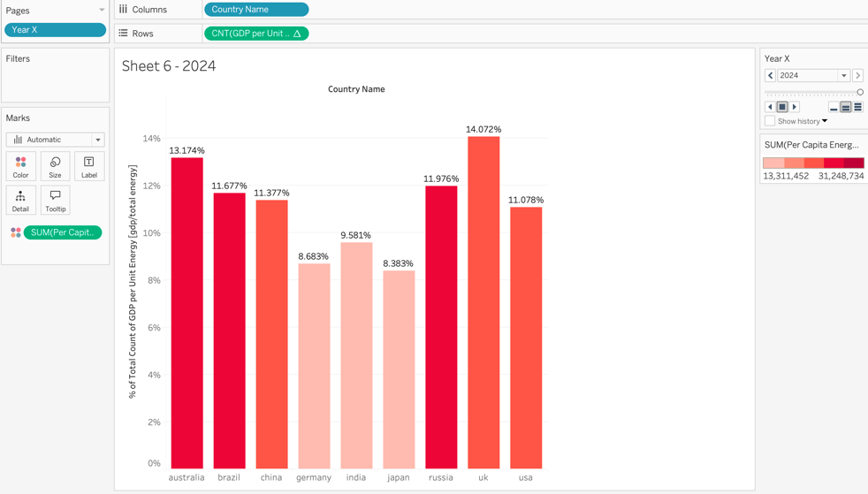
- Japan's surprisingly low efficiency despite technological advancement may reflect its energy security challenges and reliance on imported fuels following the Fukushima disaster.

Household/Industrial Energy Use and Population/GDP

Description:
- This multi-metric chart shows household energy use (orange bars), industrial energy use (red line), GDP (blue line), and population percentage (green bars) for the USA from 1998 to 2026.
- The chart uses four different scales to track percentage measurements of these metrics over time.
- The data is organized with household/industrial energy at the top and GDP/population at the bottom panels.

Key Points:
- Household energy consumption remains relatively stable between 3-5% with a significant dip around 2011.
- Industrial energy use (red line) closely follows household patterns but shows more volatility, particularly during economic transitions.
- GDP percentages show substantial fluctuation with a major spike around 2012, while population percentages display dramatic variability throughout the period.

Key Insights:
- The parallel trends between household and industrial energy use suggest common drivers (like energy prices or economic conditions) affect both sectors similarly.
- The 2011 dip across multiple metrics likely corresponds to economic recovery challenges following the 2008 financial crisis.
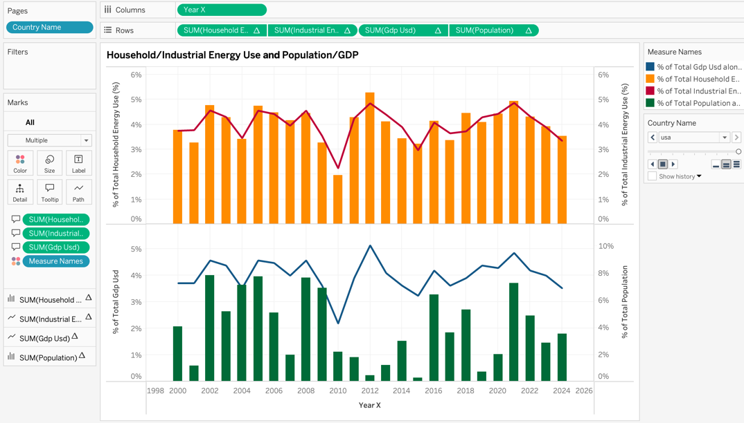
- Recent stabilization in household and industrial energy percentages despite GDP growth may indicate improving energy efficiency in the American economy.

Environmental Stress Index vs Year

Description:
- This line chart tracks Australia's environmental stress index from 2000 to 2024.
- The y-axis shows the stress index value (0-180) while the x-axis displays the year.
- The visualization uses a single blue line to show the fluctuating stress levels over the 24-year period.

Key Points:
- The environmental stress index follows a cyclical pattern with major peaks occurring approximately every 4-5 years.
- The highest stress level occurred around 2014, reaching approximately 175 on the index.
- Other significant peaks occurred in 2006, 2010, 2018, and 2022, each reaching above 90 on the index.

Key Insights:
- The cyclical nature of environmental stress suggests influence from recurring climate patterns like El Niño/La Niña cycles that particularly affect Australia.
- The extraordinary 2014 peak likely corresponds to severe drought conditions and record-breaking temperatures experienced in Australia during that period.
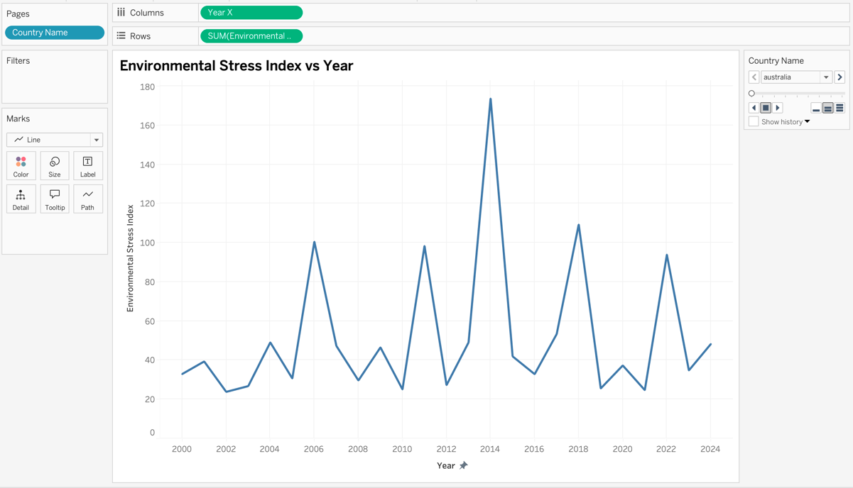
- The consistent pattern of peaks indicates Australia faces regular environmental challenges requiring cyclical adaptation rather than steady, incremental pressures.

Sea Level Rise vs Fossil Fuel Use

Description:
- This dual-axis chart compares sea level rise (yellow bars, measured in mm) with fossil fuel dependency percentage (green line) from 1998 to 2026.
- Sea level measurements use the left axis (0-25K mm) while fossil fuel dependency uses the right axis (0-4.5%).
- Both metrics are tracked annually, allowing for comparison of trends over the approximately 25-year period.

Key Points:
- Sea level measurements consistently range between 15,000-25,000mm with several peak periods around 2002, 2014, and 2016.
- Fossil fuel dependency fluctuates between approximately 3.5-4.5% over the entire period.
- Despite climate change concerns, there's no clear downward trend in fossil fuel dependency over the 25-year timespan.

Key Insights:
- The persistent high levels of fossil fuel dependency despite growing climate awareness suggest structural challenges in transitioning energy systems.
- The lack of clear correlation between annual fossil fuel usage and sea level measurements reflects the complex, cumulative nature of climate impacts.
- Sea level rise appears to follow independent cycles rather than directly tracking fossil fuel use, highlighting the influence of natural variability and delayed climate response.

