
MBA AF 632 – Asset Management Practicum
DuPoint Analysis
Tax Burden | 96.67
Interest Burden | 97.28
Operating Margin | 31.13
Asset Turnover | 0.41
Leverage Ratio | 1.45
Adjusted ROE | 18.23

Dev Amit Pandya
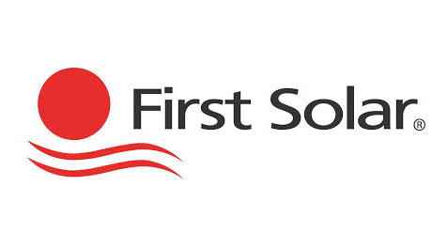
SELL SIDE EQUITY REPORT
First Solar Inc.
(NYSE: FSLR)
)
Price: 198.815
Rating: Buy
Target price: 250
Earnings Call
Company Overview

Most recent earnings call: February/24/2026
First Solar, Inc. is an American solar energy corporation that sets up, develops, and assembles thin-film photovoltaic (CdTe) solar panels and offers utility-scale solar project solutions. The company provides end-to-end solutions such as project development, engineering services, procurement, construction (EPC) and operations and maintenance services to utilities and independent power producers as well as commercial clients. First Solar is the company that specializes in the large-scale technologies that provide high-performance energy with a low cost, and it is environmentally friendly. Its combined strategy and own technology leave the company in a position to exploit the need of clean and sustainable energy in the world.

Next earnings call: April/29/2026
Valuation Metrics
Sector Technology

Industry Semiconductors
Market cap. $21.3667 B

52-week range 285.99 to 116 ROIC 14.65%
P/E Ratio (TTM) 13.39
Industry Overview
Beta 0.982
Price/Book 2.23
The solar energy sector is among the rapidly developing branches of renewable energy because of the decreased price of panels, government subsidies, and the worldwide tendency to decrease carbon emissions. Large-scale solar facilities are driving the industry forward and innovations such as high- efficiency and thin-film panels are increasing the energy production and affordability. The competition in market is high, and business enterprises differentiate themselves based on technology, size and integrated project development. Increasing world energy demand and sustainability measures place companies such as First Solar at the center of a world to increase its presence and realize long term growth prospects.
Price/Sales 4.09
Dividend yield N/A Projected upside 25.7%
1-Year Return 56%
3-Year Return -0.4%

Price Movement
Financial Metrics
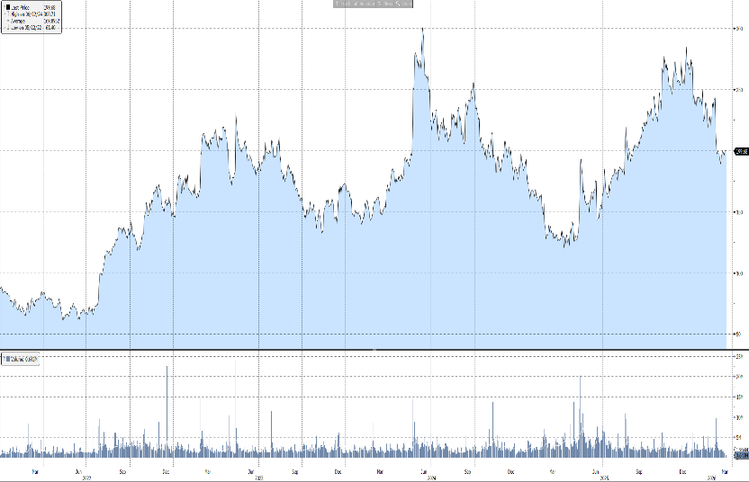
Net Revenue | $5369.5 B (Est.2026)
Gross Profit | $2538.4 B (Est.2026)
Net Income | $ 1981.6 B (Est.2026)
Interest Coverage | 48.64
LT Debt/Capital | 4.,13
LT Debt/Assets | 3.16
ROA | 12.01
ROE | 17.45

Sales (in USD billions)
Diluted EPS
Year | Q1 | Q2 | Q3 | Q4 | FY
2023 | 0.548 | 0.811 | 0.801 | 1.158 | 3.318
y-o-y | 49.3% | 30.6% | 27.3% | 15.5% | 26.7%
2024 | 0.794 | 1.015 | 0.888 | 1.514 | 4.206
y-o-y | 44.95% | 25.1% | 10.9% | 30.7% | 26.8%
2025 | 0.845 | 1.097 | 1.5941 | 1.683 | 5.219
y-o-y | 6.4% | 8.1% | 79.5% | 11.2% | 24.1%
2026E | 1.060 | 1.220 | -- | -- | --
y-o-y | 25.4% | 24.1% | -- | -- | --

Year | Q1 | Q2 | Q3 | Q4 FY
2023 | 0.4 | 1.59 | 2.5 | 3.25 7.74
y-o-y | -197.6% | 205.8% | -644% | -4743% -1988%
2024 | 2.2 | 3.25 | 2.91 | 3.65 12.02
y-o-y | 450% | 104.4% | 16.4% | 12.3% 55.3%
2025 | 1.95 | 3.18 | 4.24 | 4.84 14.21
y-o-y | -11.4% | -2.2% | 45.7% | 32.6% 18.2%
2026E | 3.36 | 4.42 | -- | -- --
y-o-y | 72.3% | 39% | -- | -- --

- Advanced Solar Manufacturing Platform: First Solar is a major U.S. based photovoltaic thin-film modules manufacturer, with cadmium telluride (CdTe) technology that is economical in terms of cost and suitable in high-temperature conditions. The business earned high revenues (range of $5+ billion in recent years) based on rising demand of solar power in the world and large-scale utility applications.
- Strong Backlog & Policy Tailwinds: The firm boasts a large backlog of contracts that are already contracted at about 16+ billion up to 2030, which will guarantee it a great deal of revenue. Favorable U.S. policies are also encouraging growth including the Inflation Reduction Act which provides strong incentives to domestic Solar manufacturing and enhances the competitiveness of First Solar.
- Robust Growth & Profitability Outlook: First Solar has shown good growth of its earnings, where the EPS has increased with high growth rate of about 40%+ compounded growth rate in the last years and the margins of the company are high (~27%+ net margin). Analysts believe further expansion will be based on evolving into higher levels of renewable energy sources, escalating electricity usage, and broadening of manufacturing capacities.
- Domestic Supply Chain Advantage & Energy Security Positioning: First Solar has a robust domestic manufacturing presence in the U.S., which will lower the risks of geopolitical factors and import tariffs on its export transactions to foreign suppliers of solar equipment. With the trend of deglobalization, energy security has become a strategic factor and therefore, when utilities and governments need modules, they are more inclined to utilize modules that are domestic in nature.

Investment Thesis
Risk Analysis
First Solar’s performance could get affected by the following factors:
- The reliance on government policies and incentives (e.g. tax credits and tariffs) that in case of reduced or altered may hurt demand and profitability.
- Risks of supply chain disruption, raw material shortages, and production slowdown and delay that has the potential to impact production capability and delivery schedules.
- Fluctuation in the prices of solar modules because of competition globally and the low-cost international producers.
- High capital expenditure cost of increasing manufacturing facilities, which could strain on short term cash flows.
- Execution risk associated with high project backlog in performing the contracts and cancellation or delaying risks.
- Innovation in alternative energy sources that can make the company less competitive in case of the lag.
Porter’s 5 Forces

Threat of New Entrants
Low. Capital is required in the manufacture of solar in large quantities, high technological expertise and production in large quantities. There is also the barrier posed by powerful government regulations, and the necessity of the already established supply chains. The entry is also made difficult by First Solar proprietary CdTe technology and its manufacturing base in the United States.

Bargaining Power of Suppliers
Low to Medium. First Solar has also minimized the supplier power by vertical integration and its exclusive thin-film technology that minimizes reliance on traditional suppliers of silicon. Nevertheless, the dependence on certain materials, such as glass and cadmium and a small concentration of local suppliers may present a little supply-side risk.

Bargaining Power of Buyers
High. Large energy developers and utilities, for example, buy in bulk and have significant bargaining power. Because there are more solar panel manufacturers in the world, buyers have more options and can demand better contract terms and lower prices. However, this power is somewhat diminished by long-term contracts and policy-driven demand (IRA incentives).

Threat of Substitutes
High. Alternative solar technologies, especially crystalline silicon panels, which frequently offer higher efficiency, pose a serious threat to First Solar. Furthermore, alternative renewable energy sources like wind and energy storage devices may serve as replacements, restricting the expansion of pricing power and market share.

Rivalry Between Existing Competitors
High. Global firms like JinkoSolar, Canadian Solar, and SunPower compete fiercely in the solar market. Margin pressure is brought on by fierce price competition, particularly from low-cost Asian manufacturers. First Solar sets itself apart with technology and U.S. policy advantages, but price wars and industry overcapacity continue to fuel fierce competition.

