EQUITY RESEARCH | INTERACTIVE ENTERTAINMENT
Take-Two Interactive Software, Inc.
NASDAQ: TTWO Sector: Communication Services / Interactive Media
Report date: July 4, 2026 Prices as of the July 3, 2026 close
Rating (illustrative) | 12-mo. Target | Recent Price | Implied Return | Market Cap
OVERWEIGHT (long-term) | $281 | ~$250 | +12% | ~$47B
Rating reflects the consensus set-up; see Valuation and Scenario Analysis. Near-term stance is more cautious given launch-timing and "sell-the-news" risk.

Executive Summary
Take-Two is a top-tier global video-game publisher entering the most consequential release cycle in its history. The investment case turns almost entirely on one asset: Grand Theft Auto VI (GTA VI), confirmed for November 19, 2026. Management guides fiscal 2027 net bookings to $8.0-$8.2 billion, roughly 20% growth over FY26's record $6.72 billion, with the increment driven overwhelmingly by the launch.
The company is emerging from a multi-year investment trough - trailing earnings are still negative - into what should be a sharp free-cash-flow inflection. The supporting portfolio (NBA 2K, Zynga mobile, a deep back catalog) is genuinely strong and increasingly recurring-revenue driven, which de-risks the between-release years.
Our concerns are threefold: the stock trades near 52-week highs on a premium forward multiple; management's FY27 net-bookings guide of $8.0-$8.2B came in below the ~$9.1B the Street had penciled in; and - critically - GTA VI ships single-player-only, with GTA Online not launching alongside it. The durable, high-margin online annuity that underpins the most bullish targets is therefore deferred to an unspecified later date. Add the perennial Rockstar delay risk, and the near-term set-up is more balanced than the headline hype suggests.
We view TTWO as a high-conviction long-term holding but a poor candidate for an all-at-once, "get in before it pops" entry.

Investment Thesis

Bull case
- Generational catalyst. GTA V has sold 200M+ lifetime units; GTA VI is positioned to be one of the largest entertainment launches ever, with day-one estimates around 25M units - more than double GTA V's record.
- Recurring-revenue engine. Recurrent consumer spending was 78% of FY26 bookings and grew 17%. The GTA Online successor is a future - not day-one - catalyst, but it is the durable, high-margin annuity that underpins the highest Street targets once it arrives.
- Diversified hit portfolio. NBA 2K grew 30%+ in FY26; Zynga posted its best bookings since the 2022 acquisition. This is not a single-title company.
- Cash-flow inflection. The heavy GTA VI development spend is largely behind the company; FY27 should mark a step-change in operating cash flow and margins.
- Unpriced optionality. A later GTA VI PC release is not in any published analyst model as of mid-2026 - a clean source of upside if/when it lands.

Bear case
- Delay risk. GTA VI has already slipped once (from a prior 2026 window to November 19). Rockstar has a long history of moving dates; any further slip breaks the FY27 guide.
- Online deferred. GTA VI launches single-player-only with no online mode and no announced timeline for one. FY27 revenue leans on one-off unit sales rather than the recurring online spend the bull case is built on.
- Guidance below the Street. FY27 net-bookings guidance of $8.0-$8.2B undershot the ~$9.1B consensus, and FY27 is still expected to post a GAAP net loss. Management calls it conservative; skeptics call it a reality check.
- Valuation & "sell-the-news." At ~37x forward earnings and near 52-week highs, much of the good news is priced. The stock has dipped on positive pre-order data, a classic anticipation-unwind pattern.
- Pricing & leverage. The $79.99 base price is ~10% under the $90-$100 some analysts had modeled; net debt makes the balance sheet a risk multiplier if the launch disappoints.
- Insider selling. Notable executive share sales around recent highs have tempered some analysts' conviction - common near peaks, but a sentiment negative.

Company Overview
Founded in 1993 and headquartered in New York, Take-Two develops and publishes interactive entertainment across three principal labels:
- Rockstar Games - the crown jewel: Grand Theft Auto, Red Dead Redemption, Max Payne, Midnight Club. Management now pegs GTA at under 15% of net bookings (down from roughly a third of sales historically) as mobile and NBA 2K have scaled - though GTA VI will re-concentrate the mix in FY27.
- 2K - NBA 2K (the dominant basketball sim), WWE 2K, PGA TOUR 2K, plus Borderlands, BioShock, Mafia, Civilization and XCOM.
- Zynga - acquired in 2022; free-to-play mobile including Toon Blast, Match Factory!, Empires & Puzzles, Words With Friends and Zynga Poker. Mobile is now roughly half of total sales.
The model is increasingly one of recurring, in-game spending rather than one-time unit sales: more than three-quarters of bookings now come from recurrent consumer spending (RCS), which smooths the historically lumpy release cycle.

Recent Financial Performance (FY2026)
Take-Two closed fiscal 2026 (ended March 31, 2026) with record results that beat guidance across the board.
Metric | FY2026 Actual | Commentary
Net bookings (FY) | $6.72B | ~$750M above initial guide; +19% YoY
Q4 net bookings | $1.58B | Above the high end of guidance
GAAP net revenue (FY) | $6.65B | +18% YoY
GAAP net loss (FY) | -$298.2M | Narrowed sharply from prior-year impairment losses
Recurrent spending | 78% of bookings | +17% YoY; RCS was 82% of Q4
Operating cash flow | $624.3M | vs. ~$450M forecast
Free cash flow (FY) | $434.1M | Already positive - inflection is about scale, not sign

Segment strength was broad: NBA 2K grew more than 30%, mobile rose 13%, and GTA Online grew 6% - all ahead of the company's initial May guidance. On mobile specifically, Toon Blast rose ~25% and Color Block Jam became the highest-grossing title in Rollic's history.
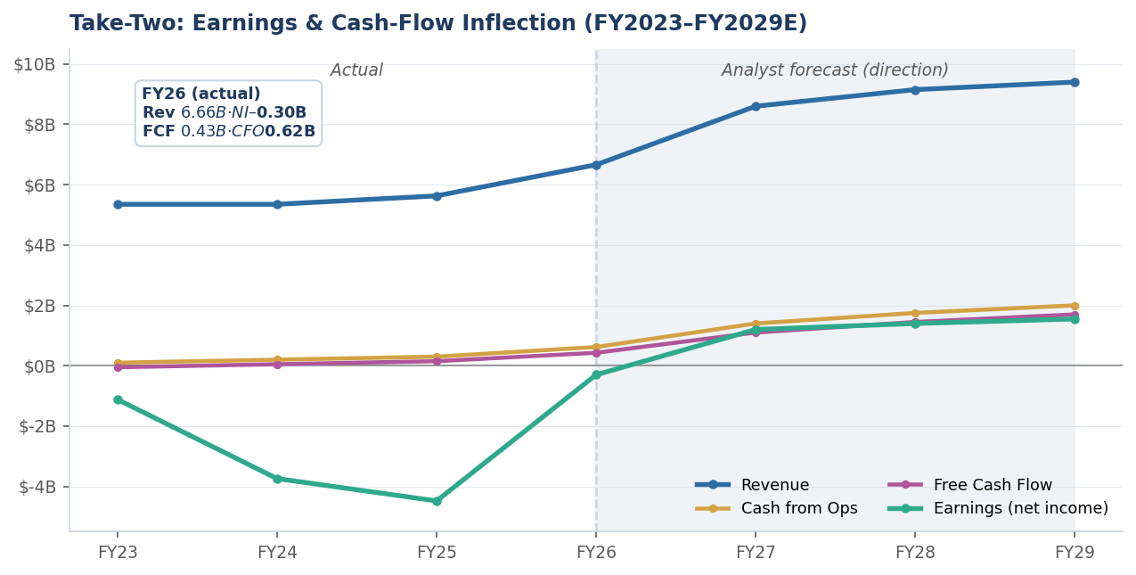
Exhibit: Earnings deeply negative through the FY24-FY25 development/impairment trough, then a sharp recovery; revenue, operating cash flow and free cash flow all inflecting up. Actuals through FY2026; FY27-FY29 show analyst-forecast direction, not point estimates.

FY2027 Guidance & the GTA VI Catalyst
Management frames fiscal 2027 as a breakout year. The FY27 guide of $8.0-$8.2B net bookings implies ~20% growth, and the arithmetic is instructive: the ~$1.3-$1.5B of incremental bookings essentially must come from GTA VI, since base-business growth is already embedded.
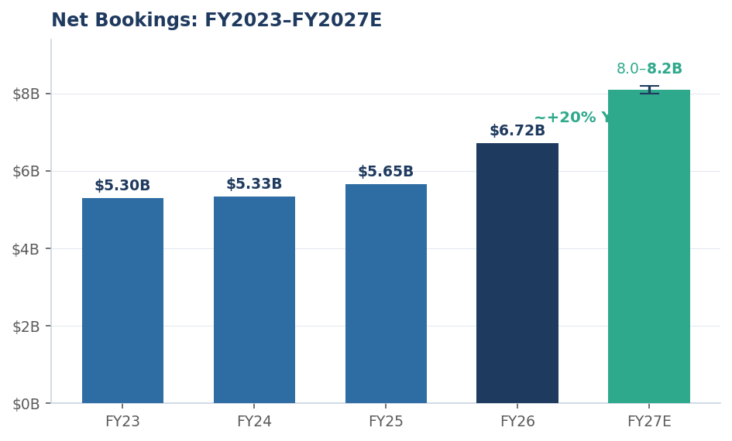
Exhibit: Years of a roughly flat ~$5.3-$5.7B base, then the FY26 record and the guided ~20% FY27 step-up. FY27E shows the $8.0-$8.2B guidance range; base years are actuals.
The launch quarter (December 2026, fiscal Q3) is where the story concentrates. Consensus points to roughly $3.28B of revenue in that quarter - an ~86% YoY jump - with EBITDA margins expanding toward the high-20s from ~19% a year earlier, and adjusted EPS stepping to roughly $3.84 in the launch quarter alone.
One important caveat: the $8.0-$8.2B guide landed below the Street's ~$9.1B expectation, and the stock fell on the print despite a quarterly beat. CEO Strauss Zelnick pushed back - noting this was the first guidance given to the Street and that the company habitually exceeds its own numbers - and Morgan Stanley (Overweight, $280) echoed Take-Two's long record of conservative forecasting. The guide implies roughly 31-40 million GTA VI units in FY27. Read charitably it is a sandbag; read skeptically it reflects that the online annuity is not yet contributing. FY27 is still expected to post a GAAP net loss.

GTA VI: A Staggered Catalyst Timeline
A recent structural disclosure reshapes how to model GTA VI. Rockstar has confirmed the game ships as a single-player-only experience on November 19, 2026, with no GTA Online mode at launch and no announced timeline for one. Distribution is digital-first - even the "physical" edition is a download code in a box, not a disc. This follows Rockstar's own precedent (GTA Online arrived two weeks after GTA V; Red Dead Online came later still), but the separation is now explicit.
The practical consequence: GTA VI is not one event but a sequence of distinct, differently-priced catalysts spread over multiple years. FY27 captures only the first of them.
Catalyst (in sequence) | Detail | Timing
1. Single-player launch | Std. $79.99 / Ultimate $99.99; ~31-40M units implied by guidance | Nov 19, 2026 (FY27)
2. Physical / continued sales | Download-code boxes; long-tail unit sales | FY27-FY28
3. GTA Online successor | Recurring monetization; BofA bull case assumes Fortnite-level spend | Unannounced - likely FY28+
4. PC version | Not modeled in any published target as of mid-2026 | Later (unpriced)

This staggering is a double-edged sword. On one hand it lets Take-Two "double-dip," spreading major revenue beats across years and sustaining engagement - and it de-risks the launch from the server-collapse chaos that marred GTA Online's 2013 debut. On the other, it pushes the highest-value driver - the recurring online economy - out of FY27 entirely, which is precisely why near-term revenue leans on one-off unit sales and why the FY27 guide looks conservative.
Early demand for the single-player release has still been extraordinary: one French retailer reported roughly six times more pre-orders in the first 24 hours than a typical Call of Duty or EA Sports FC window, with some batches selling out within an hour. Yet the stock dipped on that news - consistent with the view that launch-week unit enthusiasm is already priced, and the marginal buyer is underwriting later catalysts, not November.

Product Pipeline (FY27-FY29)
GTA VI headlines a genuinely deep multi-year slate. Management outlined 29 titles across FY27-FY29, of which seven land in FY27 alongside GTA VI, and 22 fill FY28-FY29 (including six remakes/remasters). This is described as the most robust pipeline in the company's history.
Window | Selected titles | Note
Already shipped | Mafia: The Old Country (Aug '25), Borderlands 4 (Sep '25) | Strong critical reception
FY27 | GTA VI, NBA 2K27, WWE 2K27, PGA TOUR 2K27, CSR 3, Judas, Project ETHOS | 7 titles + GTA VI
FY28-FY29 | 22 titles incl. 6 remakes/remasters; Max Payne 1+2 remake (Remedy) | Potential GTA VI PC extension

The remake/remaster layer (Max Payne via original developer Remedy; likely Mafia and legacy Rockstar catalog work) is a lower-risk, higher-margin complement that helps fill the post-GTA-VI years - addressing the classic "what comes after the big release?" concern.

Balance Sheet & Financial Health
Item | Approx. latest | Comment
Cash & equivalents | ~$2.16B | Ample near-term liquidity
Total debt | ~$3.51B | Long-term debt ~$2.49B
Net debt | ~$1.35B | Manageable pre-launch
Debt / equity | ~84-88% | Rose from ~0% over 5 yrs
Debt repaid in FY26 | $1.15B | Deleveraging underway

Management has named debt repayment the top capital-allocation priority after launch. Leverage is the single biggest amplifier of downside if GTA VI disappoints, but the cash position and the FY26 repayment pace suggest the balance sheet is defensible into the launch. There is no dividend; capital returns are not part of the thesis.

Valuation & Analyst Consensus
Sell-side sentiment is nearly unanimous - itself a mild contrarian caution. Across ~29 covering analysts, the split is roughly 25 Buy / 3 Outperform / 1 Hold / 1 Underperform.
Firm / measure | Target | Stance
Street mean | $281 | ~+12% vs. recent price
Bank of America (Street high) | $368 | Fortnite-level GTA Online monetization
BTIG | $290-$293 | Buy (initiation)
BMO Capital | $285 | Raised
Piper Sandler | $280 | Overweight (initiation)
Independent DCF (Simply Wall St) | ~$278 | ~14.8% rev. CAGR assumed
Street low | ~$170 | Delay / execution-miss scenario
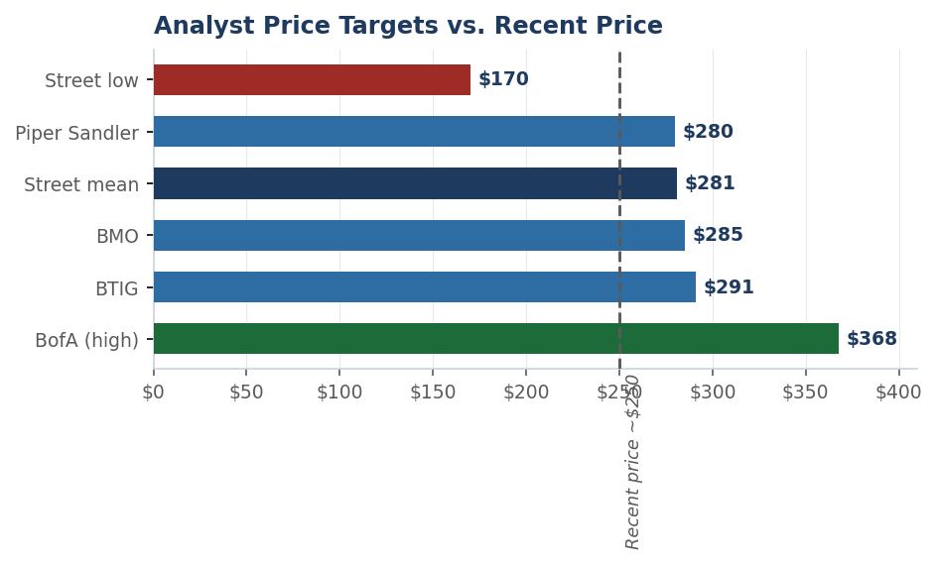
Exhibit: Published targets cluster in the high-$270s to high-$280s just above the recent price, with BofA a clear high-side outlier and the Street low reflecting a delay/miss scenario. Illustrative selection, not exhaustive.

Note: JPMorgan is not currently a data point - the firm suspended coverage of TTWO and removed it from its Equity Analyst Focus List due to an internet-group policy matter, so it carries no live rating or target at this time.
At ~37x forward EPS the stock is not cheap on near-term numbers; the bull case rests on GTA Online monetization exceeding a Fortnite-comparable baseline. That is plausible - GTA's pay-to-progress model can generate higher per-player spend than pure-cosmetic models - but it is an assumption, not a fact.

Scenario Analysis
Scenario | Key assumptions | Illustrative range
Bull | On-time launch; strong units; online successor arrives sooner and monetizes at/above Fortnite; PC optionality surfaces | $330-$370+
Base | On-time launch; ~31-40M units in FY27 (per guidance); online follows in FY28 and ramps solidly | $280-$300
Bear | Delay/slip; long gap to online; weaker spend; multiple compresses on leverage | $170-$200

The distribution is asymmetric around two variables: the launch date and the (unannounced) timing of the online successor. Upside is larger in magnitude than downside, but the downside is triggered by a single, historically-recurring risk - a Rockstar delay - and the biggest value driver now sits beyond FY27. That shape argues for building a position over time rather than concentrating it ahead of the November date.

Key Risks
- Release timing. Any slip past November 19 pushes bookings into FY28 and breaks the FY27 guide.
- Online-mode timing. With no GTA Online at launch and no announced date, the recurring-revenue catalyst is unquantified; a long gap delays the highest-value earnings stream.
- Execution / reception. A launch-week technical or quality stumble would dent sentiment and the eventual online ramp.
- Monetization shortfall. If the eventual GTA Online under-monetizes vs. the Fortnite comparison, the highest targets deflate.
- Valuation / positioning. Crowded, consensus-long name near highs; guidance already trailed the Street; vulnerable to a post-launch unwind.
- Insider selling. Executive share sales near recent highs have been flagged as a sentiment negative.
- Macro & consumer. Discretionary spending, FX, and platform-fee dynamics affect both units and RCS.
- Index/technical. Recent removal from the Russell 1000 Value benchmark can create mechanical flow pressure.

Bottom Line
Take-Two pairs a rare, potentially generational catalyst with a strong supporting portfolio and a credible cash-flow inflection. We are constructive on the multi-year story and assign an illustrative long-term Overweight. But the near-term reward is asymmetric against the calendar: you would be buying near highs, guidance already trailed the Street, and the durable online payoff is deferred well beyond the November single-player launch - while the dominant risk remains a single delay that has precedent. For an investor drawn to the story, phasing capital in over time - rather than committing everything ahead of one launch date - is the more defensible way to express the view.

Important disclosures
This is an independent equity research note prepared for educational purposes as a personal analytical project. The rating and price target are illustrative analytical judgments, not official recommendations, and I am not a licensed financial professional. It is not investment advice and does not consider your circumstances. Figures are approximate, drawn from public sources as of early July 2026, and may be stale. Investing risks loss of principal; consult a licensed financial professional before making any decision.

