Value VS Growth Stock Analysis Using Bloomberg Terminal

MBA AF 632
Dev Amit Pandya
Stock Selected: Apple Inc. (AAPL)
Date: 02/21/2026
COMPANY OVERVIEW (DES FUNCTION):
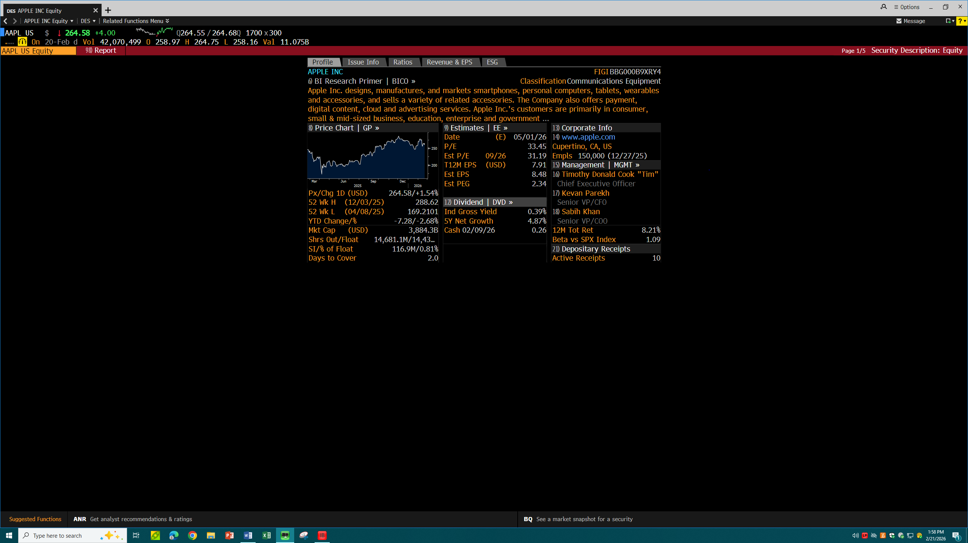

REASON FOR SELECTING THE STOCK (NI FUNCTION):
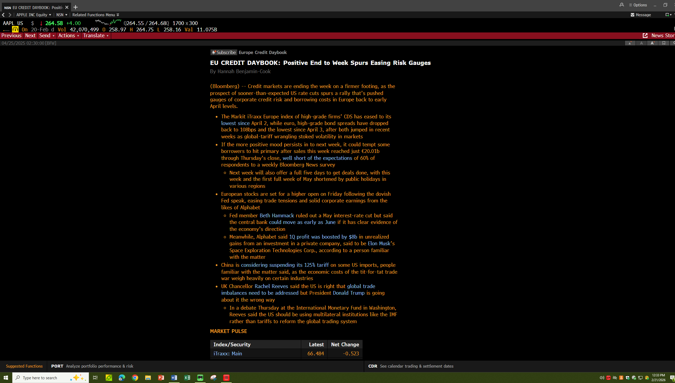
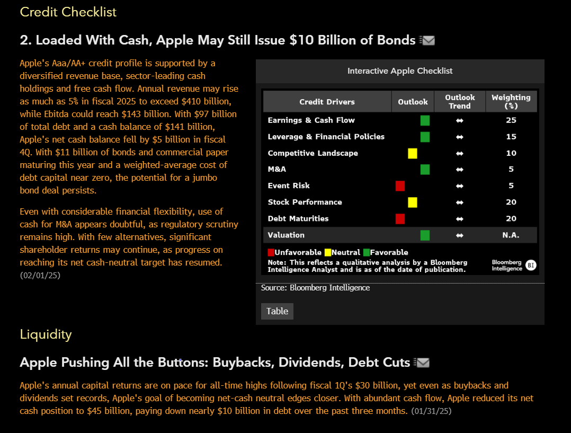
According to the Bloomberg Intelligence report, there is an improvement in the financial conditions as credit markets stabilize, and borrowing costs drop, as well as decreasing credit risk. This is a very good environment especially to technology firms which are financially sound such as Apple Inc. so that they can continue to grow and invest. Also, the reduction of market risk and high expectations of corporate earnings show that investors are optimistic about the major companies in the technological niche. It is this enabling credit and market conditions that further support the future of Apple and makes it worthy as a growth stock.

FINANCIAL ANALYSIS (FA FUNCTION):
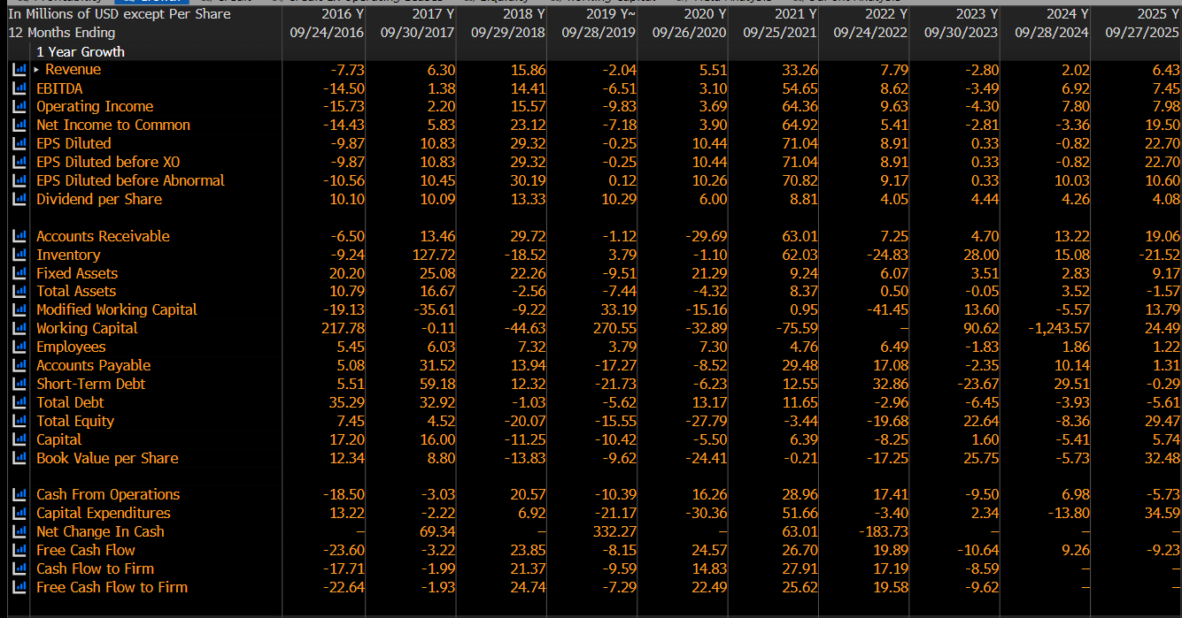
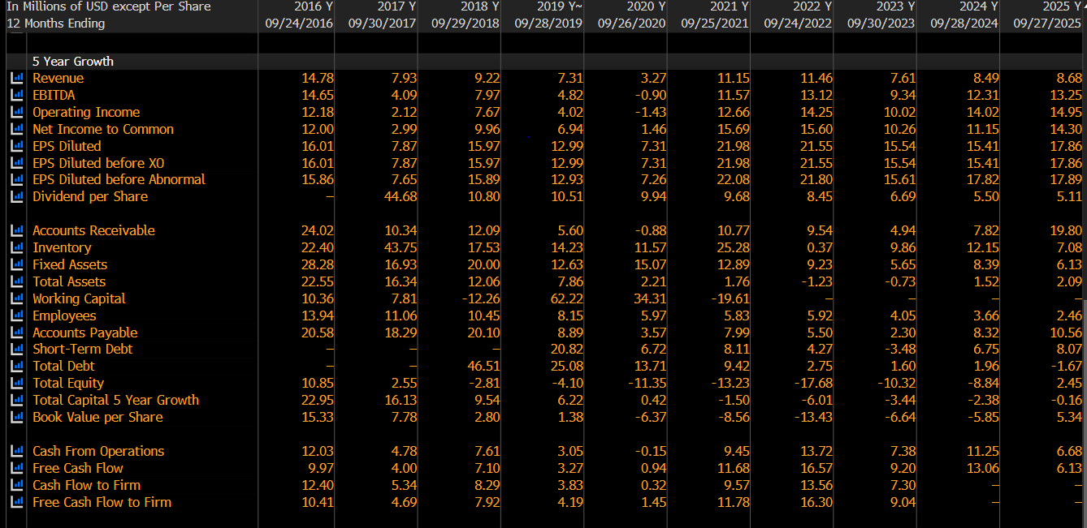
Apple Inc. displays good financial results since the company is characterized by a steady rise in revenue, increasing profits, and the high cash flow. The firm has shown the expansion of its revenues by 33.26 percent in 2021 and the firm is expected to experience further expansion of around 6.43 percent in 2025, which indicates the sustained demand of its products and services. The earnings performance is also good and the EPS growth was 71.04 in 2021 and is projected to increase to 22.70 in 2025 which reflects good profitability in the future.
Moreover, the operating income of Apple is estimated to increase by 7.98 percent in 2025, which is a factor that indicates that the company has been improving operational efficiency and profitability. The company has also experienced good shareholder returns, which is assisted by the increase in dividends in the year 2025 by about 4.08%. Moreover, Apple has a high liquidity level and financial flexibility as its growth in free cash flow is 19.58% in 2022.
In general, financial strength is demonstrated by the steady increase in the revenues of Apple, the notable growth in earnings, growth in operating income, and high level of the free cash flow generation that prove the company as a growth stock with significant prospects in the future.

VALUATION ANALYSIS (RV FUNCTION):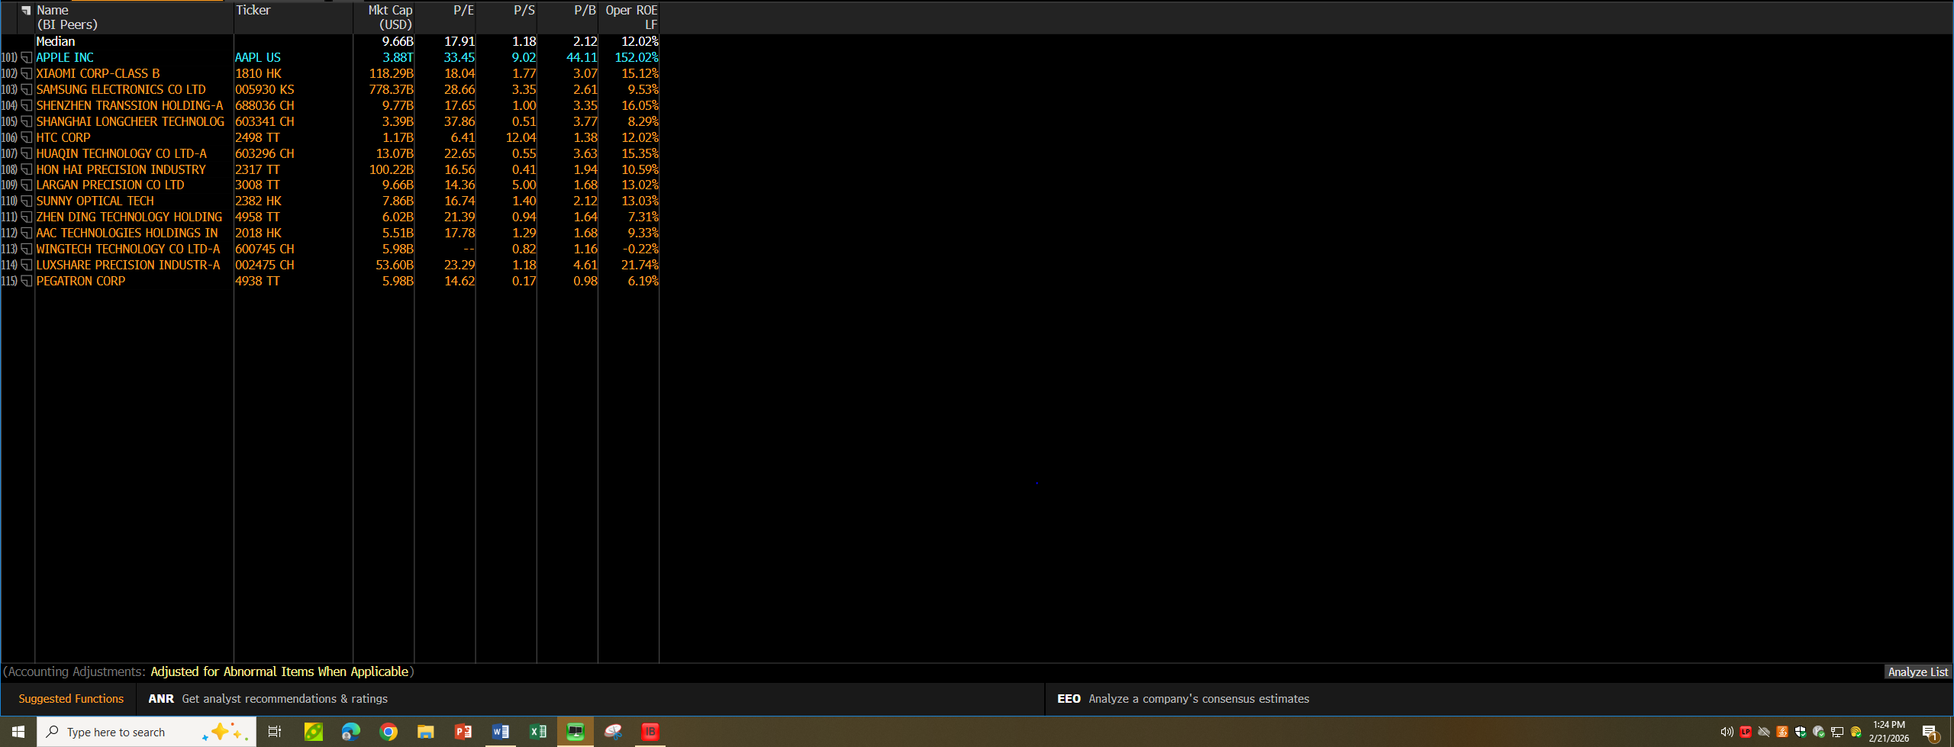
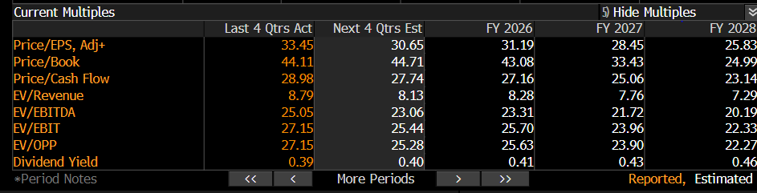
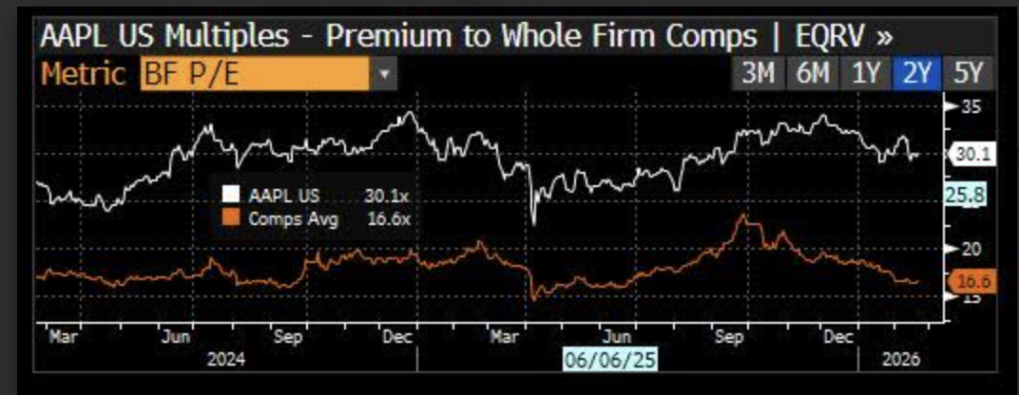
It indicates that Apple has a higher P/E ratio of 33.45 than the median of the peers of between 17.91, which means that the company is highly priced compared to its counterparts.
Also, the forward P/E of Apple is projected to be good at 31.19 whereas the company has a Price-to-Book ratio of 44.11 and EV/EBITDA multiple of 25.05 which are high valuation ratios. The increased valuation multiples are indicative of the high confidence of the investors in the future earnings the Apple is capable of achieving, its dominance in the market, and its further growth.
The trend of the premium valuation shows that Apple has been trading higher in comparison to its peer group, which depicted a positive market sentiment and good growth prospects. This type of long-term high-valuation and high confidence among investors are some of the most prominent attributes of growth stocks.

ANALYSTS EXPECTATIONS (EE FUNCTION): 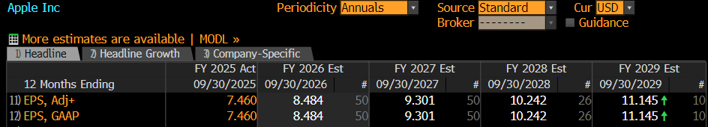
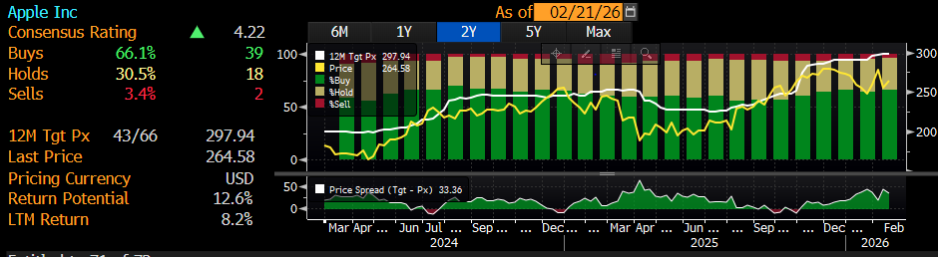
The estimated EPS of Apple is expected to grow by 7.460 in FY2025 through FY2029 by 8.484, 10.242 and 11.145 respectively.
This consistent growth in earnings per share indicates high forecasts on profit growth in the future and growth in profits over time.
Besides, the analysts sentiment towards Apple is extremely positive as there is 66.1% Buy rating, 30.5% Hold rating and 3.4% Sell rating which have given the company a good consensus rating of 4.22 out of 5. Besides this, the target price of Apple is 297.94 versus the present price of 264.58, which shows that the potential of the returns is 12.6.
The persistent growth in the EPS projections, high buy recommendations, and high potential returns suggest that analysts have a lot of confidence in the future performance of Apple Company. These high growth earnings expectations and positive analyst coverage are some of the significant attributes of growth stocks.

MARKET SENTIMENT:
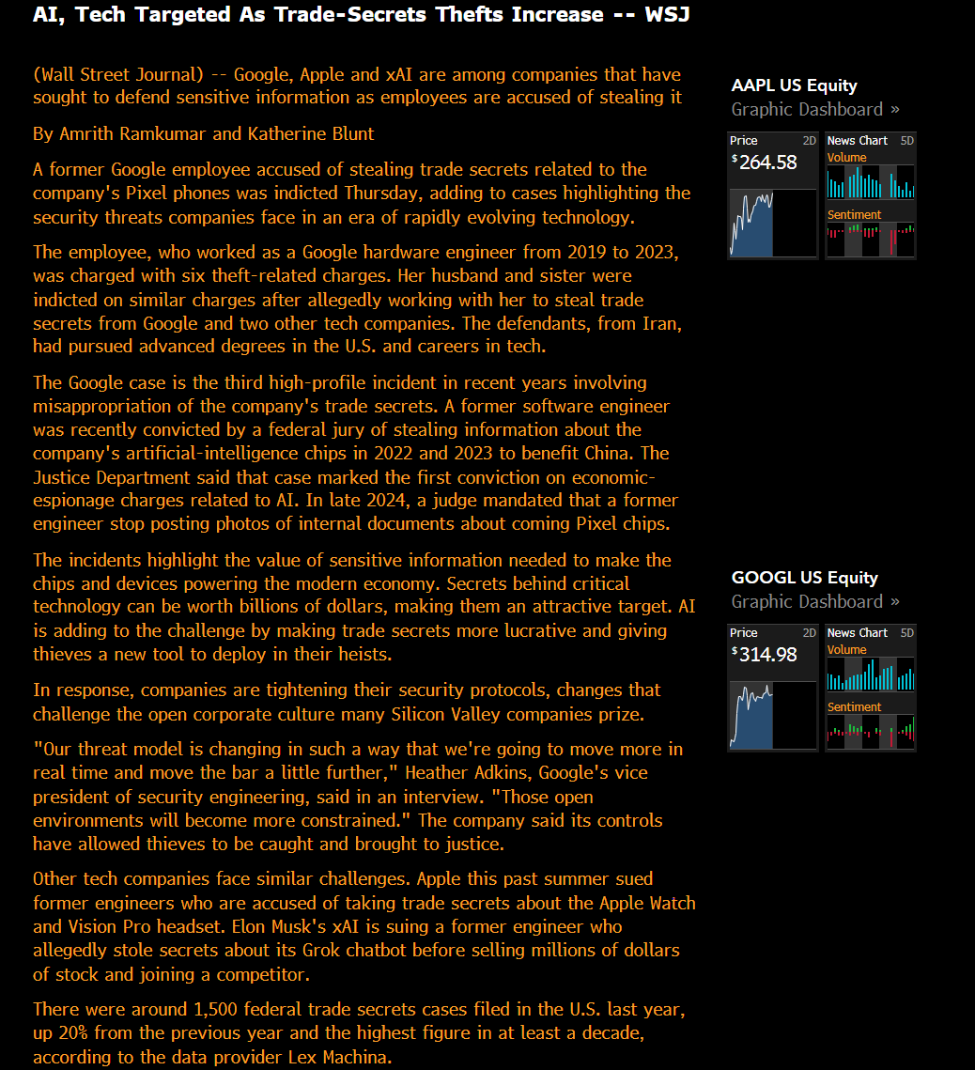
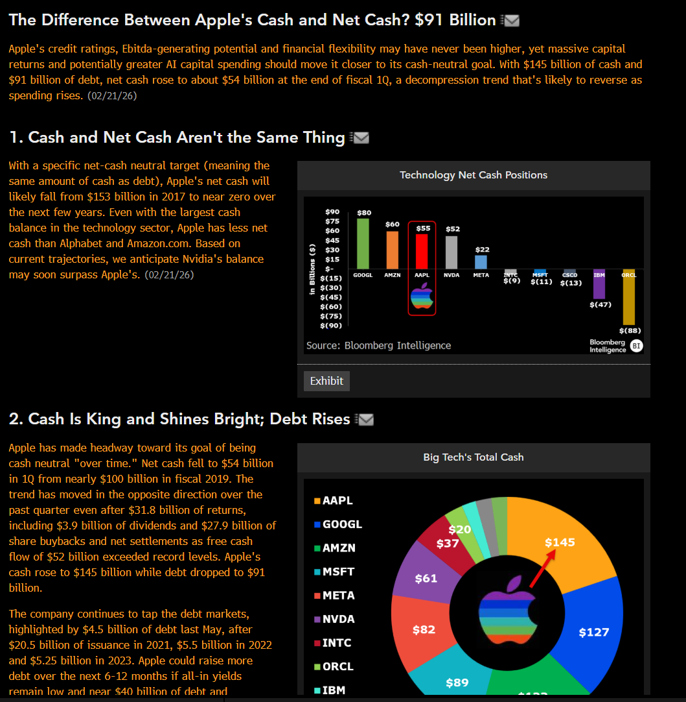
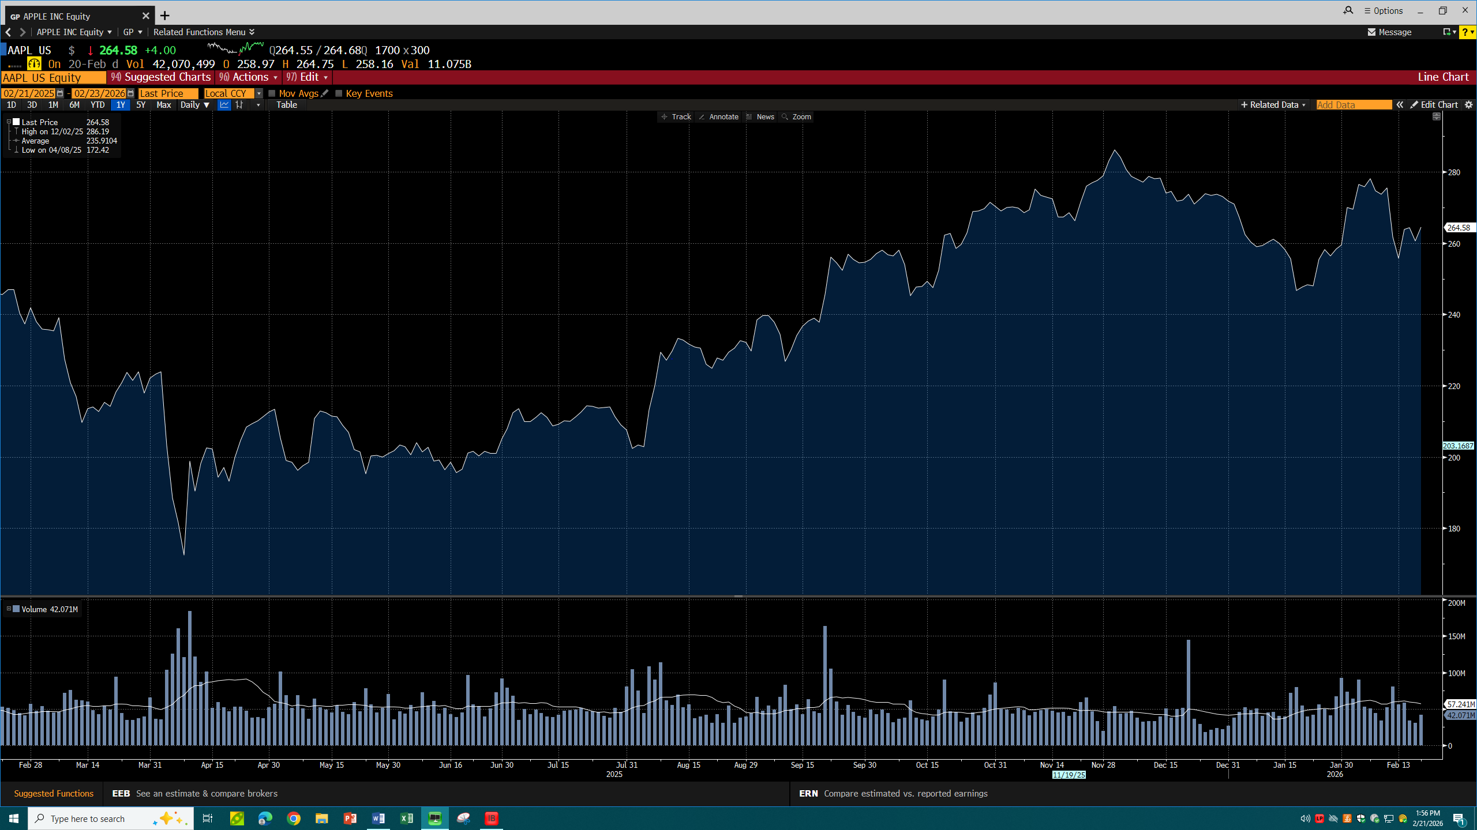
Based on the above-presented information, we conclude that the market attitude toward Apple Inc. is quite positive and is backed by the fact that it has a solid financial background and retains the confidence of its investors, as well as that its stock performance has not significantly declined.
According to Bloomberg Intelligence, Apple has been financially sound and has a cash amount of about 145 billion and a net cash amount of about 91 billion which shows that it is liquid and flexible. The firm still has a high free cash flow and gives back to shareholders by way of buybacks and dividends, which further solidifies the investor confidence on the long-term growth prospects of the firm.
Moreover, the stock price analysis indicates that the stock has an overall upward trend in the last one year, and the stock of the company is currently at a price of about 264.58 which is a positive indication of the market perception, as well as the long-term investor interest in the company. This positive change in prices shows the investors anticipate the earnings to grow and the future value to be created.
Moreover, the positive investor sentiment is reinforced by the strong position of Apple in the market, financial stability, and further innovation despite increasing competition and risks related to the technologies in the industry. The fact that the company has had high cash reserves and good performance in operations further enhances the trustworthiness of investors.
In sum, the financial stability, positive stock price movement, and investor trust of Apple suggests that the markets have a positive impression of the firm, which is expected of growth stock companies.

