J.D.B v. North Carolina: Miranda Rights and Teens
This activity is based on the Supreme Court decision in J.D.B. v. North Carolina. In this case, the Supreme Court was asked to decide if the age of a juvenile being questioned by police should be taken into consideration when deciding if he or she is in police custody and, therefore, entitled to a Miranda warning. Participants analyze the Supreme Court case and apply it to a fictional scenario involving a high school student and shoplifting.

How to Use These Resources
These resources can be adapted for use in courtrooms, classrooms, and independent study.
In Advance -- 30-Minute Preparation with No Additional Reading or Research
Preparation for Volunteer Attorneys
- Preparation starts with downloading the activity package.
- The ready-to-go resources can be reviewed in 30 minutes.
Preparation for Teachers and Students
- No preparation is needed for courtroom programs.
- Everything is provided in the courtroom, including time for volunteer attorneys to prepare participants.

Activity Duration
One, 50-minute class period or a 60-to-90-minute courtroom program. Timing depends on the length of discussion segments. Each program component can be adjusted to fit the time allotted

Student Take Away
Miranda rights come into play when someone is in police custody. But do they apply to people under 18? Students analyze the fictional scenario and discuss the questions to come to an understanding of their rights when they find themselves in the custody of law enforcement.

In the Courtroom or the Classroom

1. Use or modify the agenda.

2. Analyze the facts and case summary.

3. Apply the Supreme Court’s decision to the fictional teen scenario.

4. Use critical thinking skills and share reflections using the discussion questions.

5. Learn about related Circuit Court cases, and compare them using the worksheet and answer key.

J.D.B. v. North Carolina
In a Courtroom or a Classroom
FLEXIBLE AGENDA
60-90 minutes in a Courtroom – 50-minutes in a Classroom

Part I Activity: Overview/Review of Miranda (15 minutes)
Volunteer attorneys present the Miranda v. Arizona facts and case summary.
- The attorneys take apart the phrases in the Miranda warning and involve participants in a discussion of each element.

Key Question
Are juveniles – like adults – entitled to be advised of their Miranda rights when they are in police custody? If so, at what point during a police interaction should juveniles receive a Miranda warning?

J.D.B. v. North Carolina
Volunteer attorneys present J.D.B. v. North Carolina facts and case summary.

Fictional Scenario
Two participants read aloud the fictional scenario. One student reads the first three paragraphs. Another student reads the last four paragraphs.

Part II Activity: Factors Considered in Establishing Police Custody
(35 minutes in a classroom or 90 minutes in a courtroom)
Small Groups Identify Factors
Participants form five small groups.
- Someone in each group volunteers to take notes and be the spokesperson who will report the small group’s findings to the large group.
- Each group is assigned a factor that courts take into consideration to determine if someone is in police custody: 1) Language Used to Summon the Individual; 2) Confrontation with Evidence of Guilt; 3) Physical Surroundings/Location; 4) Duration of Time; 5) Degree of Pressure Applied – Physical or Otherwise.
- Within each small group, members take turns reading the paragraphs in the fictional scenario. As they go through the reading, they underline and discuss information that might constitute the factor they are assigned to find.
.

Spokespersons Report Out to the Large Group
When the small groups come back together, each group spokesperson reports on the group’s findings.

Attorneys Use the Worksheet to Summarize Key Points
To clarify the factors and the key points to take away from the activity, the volunteer attorneys go through the worksheet with the large group and summarize the factors that courts considered when determining if someone is in police custody in each case.

Option: Discussion Questions
Attorneys lead the students in a wrap-up exercise with the discussion questions.

If the Program is in a Courtroom
- A Judge enters and conducts a Q/A session and discussion with the participants.
- If there is time, the participants socialize in the well with the Judge and the attorneys.
- A group photo is taken.
- The program is adjourned.

Facts and Case Summary - J.D.B. v. North Carolina

Background
In 1966, in the landmark case Miranda v. Arizona, the Supreme Court held that a person questioned by law enforcement officers after being "taken into custody or otherwise deprived of his freedom of action in any significant way" must first "be warned that he has a right to remain silent, that any statement he does make may be used as evidence against him, and that he has a right to the presence of any attorney, either retained or appointed." Statements made by a defendant when law enforcement has not complied with this rule may not be admitted as evidence of guilt in a criminal trial.
An officer's obligation to administer Miranda warnings attaches only where there has been such a restriction on a person's freedom as to render him "in custody." In determining whether an individual was in custody, a court must examine all the circumstances surrounding the interrogation in determining whether there was a "formal arrest or restraint of freedom of movement of the degree associated with a formal arrest."
Many Circuit Courts of Appeals have laid out a number of nonexclusive factors to consider in determining whether a defendant is in custody, such as (1) the language or tone used when initially confronting or later questioning the suspect; (2) the physical surroundings or location of the questioning; (3) the duration of the interview; (4) the extent to which the defendant is confronted with evidence of guilt; and (5) the degree of pressure applied to detain the individual, including whether the officers brandished weapons or touched the suspect.
In J.D.B. v. North Carolina, the Supreme Court was asked to decide whether the age of a child subjected to police questioning is also relevant to this custody determination.

Facts
J.D.B. was a 13 year-old student in the seventh grade when a uniformed police officer on detail at the school escorted him from his social studies classroom to a conference room where two school administrators and another police officer were waiting. In the closed-door room, Police Investigator Joseph DiCostanzo questioned J.D.B. for 30 to 45 minutes about some recent neighborhood break-ins. Among the items reported stolen was a digital camera that had been found at the school and seen in J.D.B.'s possession.
J.D.B. first denied his involvement. However, after the investigator pressed him for additional details about his presence in the neighborhood after one of the break-ins and confronted him with the stolen camera, and after the assistant principal urged him to tell the truth, J.D.B. asked whether he would "still be in trouble" if he returned the "stuff."
Investigator DiCostanzo then warned J.D.B. that he may face juvenile detention. J.D.B. confessed. At that time, Investigator DiCostanzo told J.D.B. that he could refuse to answer questions and was free to leave. Asked whether he understood, J.D.B. nodded and provided further details, including the location of the stolen items. He also wrote a statement, at the investigator's request. When the school day ended, J.D.B. was permitted to leave.

Procedural History
The state of North Carolina charged J.D.B. with breaking and entering and larceny. The public defender who represented J.D.B. moved to suppress his statements and any evidence gathered as a result of those statements. The public defender argued on behalf of J.D.B. that J.D.B. was in custody at the time he was interrogated and that the police had failed to give him a Miranda warning. The state trial court ruled that J.D.B. was not in police custody and denied the motion to suppress the statements and evidence. The court adjudicated him delinquent, finding that J.D.B had violated criminal laws.
J.D.B.'s public defender disagreed and appealed first to the North Carolina Court of Appeals and then to the North Carolina Supreme Court. Both appellate courts agreed with the trial court. The North Carolina Supreme Court held that the test for custody did not include consideration of the age of an individual subjected to questioning by police.

Issue
"[W]hether the Miranda custody analysis includes consideration of a juvenile suspect's age." More specifically, whether "a child's age 'would have affected how a reasonable person' in the suspect's position 'would perceive his or her freedom to leave.'"

Supreme Court Holding
Yes. "So long as the child's age was known to the officer at the time of police questioning, or would have been objectively apparent to any reasonable officer, its inclusion in the custody analysis is consistent with the objective nature of the test. . . . Just as police officers are competent to account for other objective circumstances that are a matter of degree such as the length of questioning or the number of officers present, so too are they competent to evaluate the effect of relative age."
The Supreme Court reversed the judgment of the North Carolina Supreme Court and remanded the case to the lower court to determine whether, taking his age into consideration, J.D.B. was in custody when he was interrogated.

Dissent
Four Justices dissented, noting that the Miranda rule "places a high value on clarity and certainty." The dissent states that the majority's holding "shifts the Miranda custody determination from a one-size-fits-all reasonable-person test into an inquiry that must account for at least on individualized characteristic–age–that is thought to correlate with susceptibility to coercive pressures." The dissent asserts that "[t]he Court's decision greatly diminishes the clarity and administrability that have long been recognized as 'principal advantages' of Miranda's prophylactic requirements."

Argued: March 23, 2011
Decided: June 16, 2011
Vote: 5-4
Majority opinion written by Justice Sotomayor and joined by Justices Kennedy, Ginsburg, Breyer, and Kagan.
Dissenting opinion written by Justice Alito and joined by Chief Justice Roberts and Justices Scalia and Thomas.

Fictional Scenario – J.D.B. v. North Carolina
Applying J.D.B. v. North Carolina to a teen shoplifting scenario.
Brandon Salinger was a 15-year-old high school sophomore and his school's 6'2" wrestling champion, weighing in at 220 pounds when he won the regional championship last year. He was mistaken for the team's assistant coach at several tournaments because of his physical appearance and mature demeanor.
During his social studies class period one Wednesday afternoon, Brandon was at the mall with his 18-year-old sister Katie, who was helping him shop for a tie to wear to the homecoming dance. When Brandon refused to touch a hot pink paisley tie that Katie handed to him, she stuffed it in the back pocket of his pants. Finding nothing they liked in the men's formal wear department, they left the store and continued through the mall.
Sam Sanchez was an on-duty security guard employed by MallSecure. When he noticed Brandon walk by with a pink paisley tie and price tag hanging out of his back pocket, he asked to see the receipt for the tie. When Brandon could not produce the receipt, the security guard escorted Brandon and Katie away from the public area and into the mall's security office suite.
Anita Colton, a city police officer who worked part-time as a security guard for MallSecure, was in the security office at the end of her shift when Mr.Sanchez brought in Brandon and Katie. Officer Colton was on her way to the police station and had changed into her police officer's uniform, which included a badge and a handgun.
Security Guard Sanchez put Brandon in an empty office and took Katie to another room to question her. Officer Colton entered the room where Brandon was seated and closed the door. When she asked Brandon to produce his driver's license, Brandon said he did not have one yet. He gave the officer his school ID, which did not indicate his age or year in school. Brandon then told Officer Colton that he was 15 years old, and she responded by raising her eyebrows and asking him to recite his exact birth date.
Based on his stature and mature appearance, Officer Colton suspected that Brandon was misrepresenting his age – a common tactic used by shoplifters who hope to be sent home with just a warning. Brandon refused to give Officer Colton further information without knowing where his sister was. Officer Colton told Brandon that – even though she was a police officer -- he was not required to speak to her or to offer any information.
However, she added that it was likely that both Brandon and his sister would spend the night in jail if he did not tell the whole story and resolve the situation before she had to report to the police station in a few minutes. The officer also warned that punishment for Katie would likely be much worse because she is considered an adult at 18. Brandon did not want to risk his sister going to jail, so he answered the officer's questions over the next 15 minutes.

Discussion Questions – J.D.B. v. North Carolina
Use these questions to jumpstart a discussion about juveniles and the Fifth Amendment.
Review Miranda v. Arizona
1. How does J.D.B. v. North Carolina relate to Miranda v. Arizona?
2. In what circumstances does the Miranda decision apply?
3. What does the Miranda decision require law enforcement officers to do in those circumstances?

Apply J.D.B. v. North Carolina to the scenario in People v. Brandon Salinger.
1. What impact does the Supreme Court’s decision in J.D.B. v. North Carolina have on juveniles like Brandon – and you?
2. What factors should be considered in determining whether a juvenile is in custody and is entitled to a Miranda warning?
3. Among the factors considered in determining whether a juvenile is in custody, should age be one of the factors?
4. Does it matter if J.D.B. and Brandon were in custody at the time they were questioned? Why or why not?
5. If J.D.B. and Brandon had been given a Miranda warning, what would the police have said to them?

J.D.B v. North Carolina: Worksheet

Note to Teachers: Use this worksheet as a discussion guide to apply J.D.B. v. North Carolina to the fictional shoplifting scenario of People v. Brandon Salinger

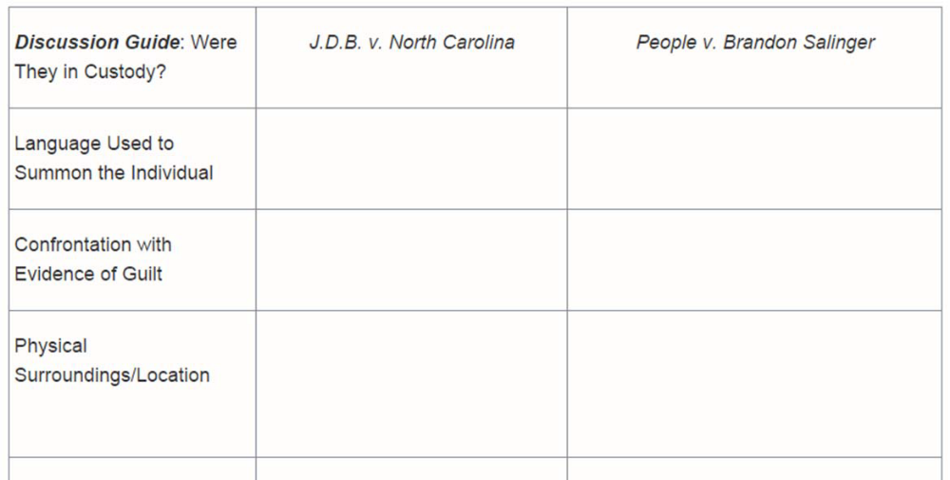
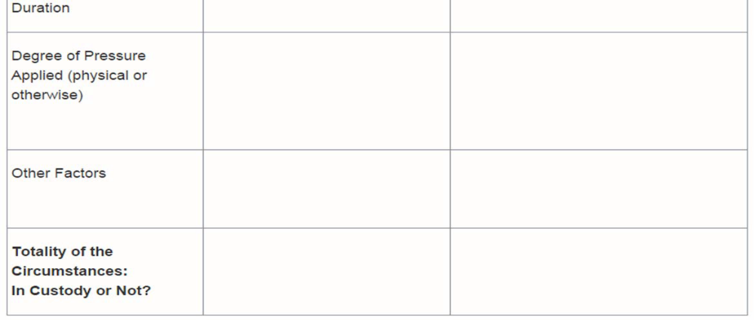

J.D.B. v. North Carolina: WORKSHEET ANSWER KEY
When is a Juvenile in Custody and Entitled to a Miranda Warning?

Answer Key for applying the decision in J.D.B. v. North Carolina to a scenario in which teens are questioned by police.
Note to Teachers: Use this answer key to help students identify the factors that came into play in J.D.B. v. North Carolina. Apply those factors to decide if Brandon in the fictional scenario is in custody and, therefore, should receive a Miranda warning.
