Name- Aman Jain

USN- 1BM18IS146

1. Write an application to calculate the bill of a cellular service customer depending upon on his/her usage. The following calculates ‘Bill’ as per ‘Usage’ with the following rules applicable. If ‘Bill’ is more than $100, 10% discount is given. Perform data flow testing for all variables. Determine the output using test suite for variables.

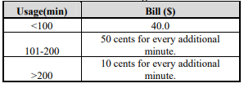

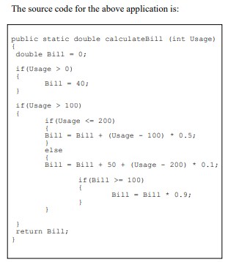

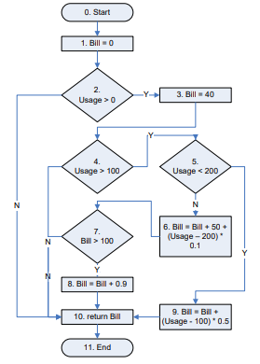

CODE:

import java.util.*;  
import java.io.*;  
  
class billing   
{  
public static double calculateBill (int Usage)  
{  
 double Bill = 0;  
 if(Usage > 0)  
 {  
 Bill = 40;  
 }  
 if(Usage > 100)  
 {  
 if(Usage <= 200)  
 {  
 Bill = Bill + (Usage - 100) * 0.5;  
 }  
 else  
 {  
 Bill = Bill + 50 + (Usage - 200) * 0.1;  
 if(Bill >= 100)  
 {  
 Bill = Bill * 0.9;  
 }  
 }  
 }  
 return Bill;  
}   
// main function   
 public static void main(String[] args)   
 {   
 Scanner in = new Scanner(System.in);  
 int x;  
 x = in.nextInt();  
 double op = calculateBill(x);  
 System.out.println("Bill = "+ op);  
 }   
}

Output:

Enter Usage:

350  
Bill = 94.5

Enter Usage:

220  
Bill = 92.0

**Data-flow testing paths for each variable**

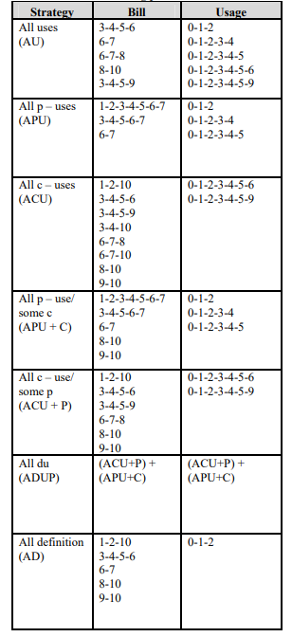

**Test Suite for variable ‘Bill’**

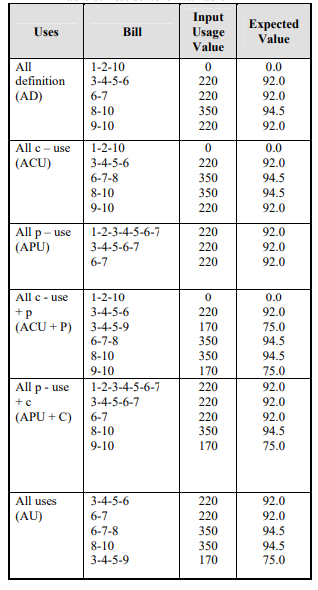

**Test Suite for variable ‘Usage’**

