**1.** Check the current working directory command, then get a list of all files & folders including hidden file as well as file-size of each file and folder.

1. 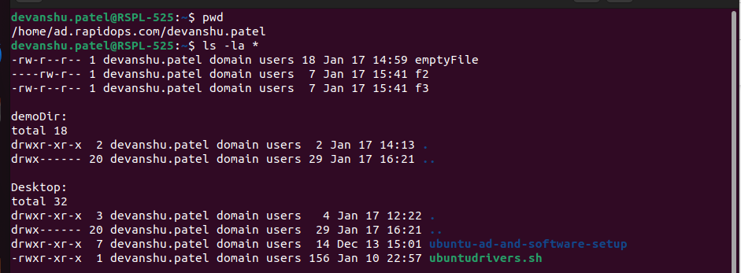

**2.** Then create two folders named as **'intern-2021'** & **'rapidops-2021'**,

2. 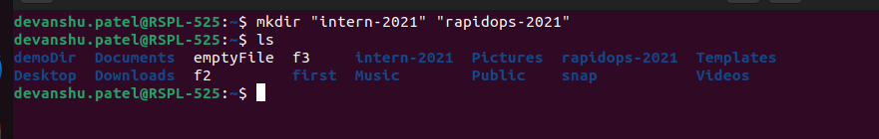

**3.** Then create two files within **'intern-2021'** folder, names are **'dev.txt'** & **'helloworld.txt'**

**3.** 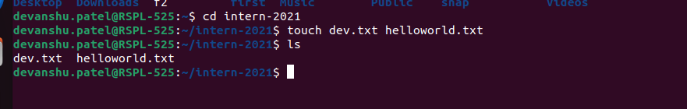

**4.** Then open the **'dev.txt**' file and write something in it, and in **'helloworld.txt'** file write **'helloworld'** using echo command

4. 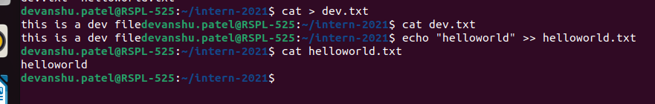

**5.** Now copy 'dev.txt' and 'helloworld.txt' into **rapidops-2021** folder,

5. 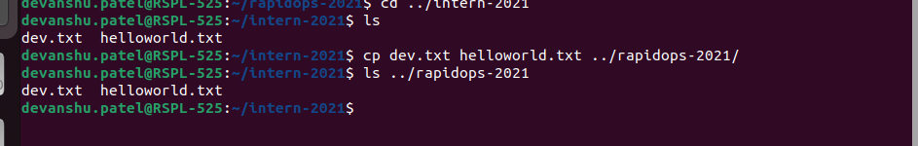

**6.** Now go to the **rapidops-2021** folder and rename those two (dev.txt, helloworld.txt) files.

6. 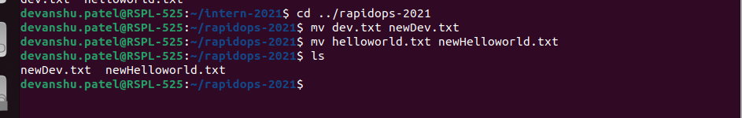

**7.** In the same directory path, give 'read only' permission to **dev.txt** for file’s owner, and for **helloworld.txt** give 'read-write-execute' permission to it's owner & 'read-write' permission to it's group.

7. 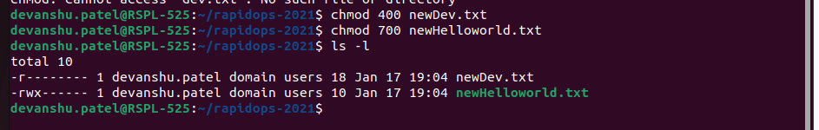

**8.** Now create archive file within same directory and shift into **intern-2021** directory.

8. 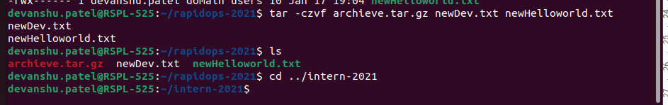

**9.** Now copy that archive file in this directory location and remove that older archive file.

9. 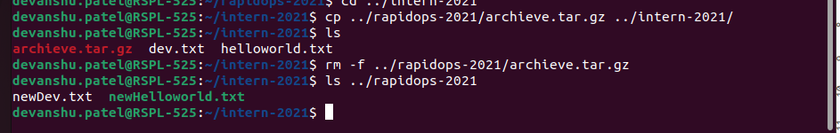

**10.** Using the command find out the **dev.txt** file.

10. 

**11.** Check the CPU, memory usage using CLI.

11. 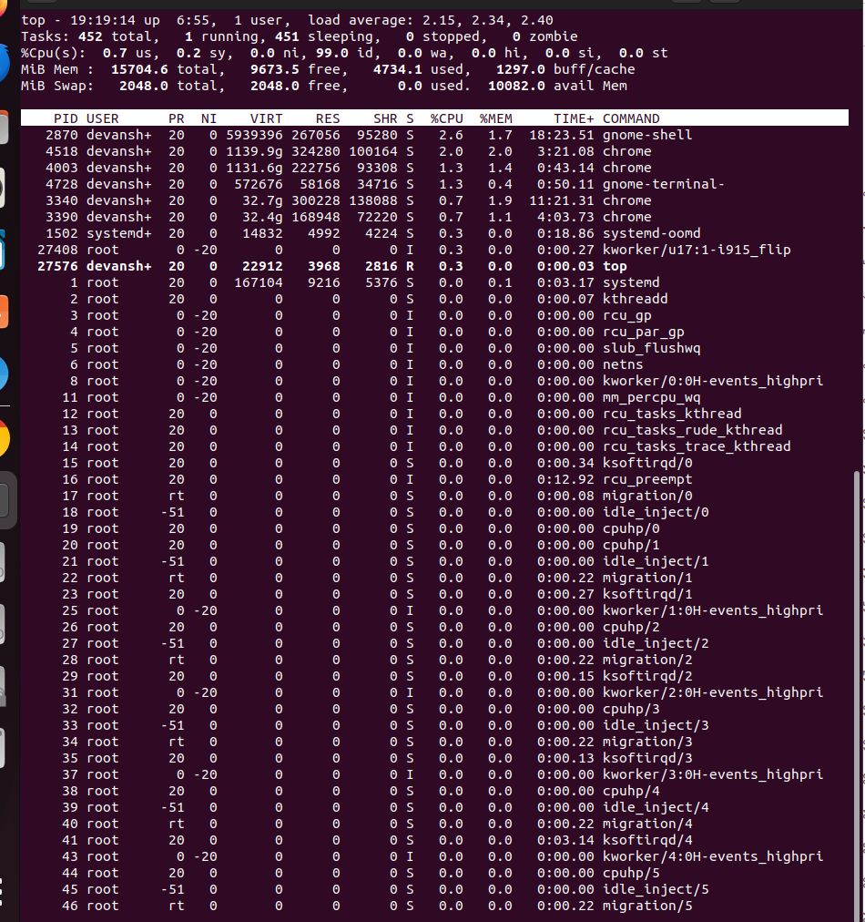

**12.** Check the disk usage and free disk space using CLI.

12. 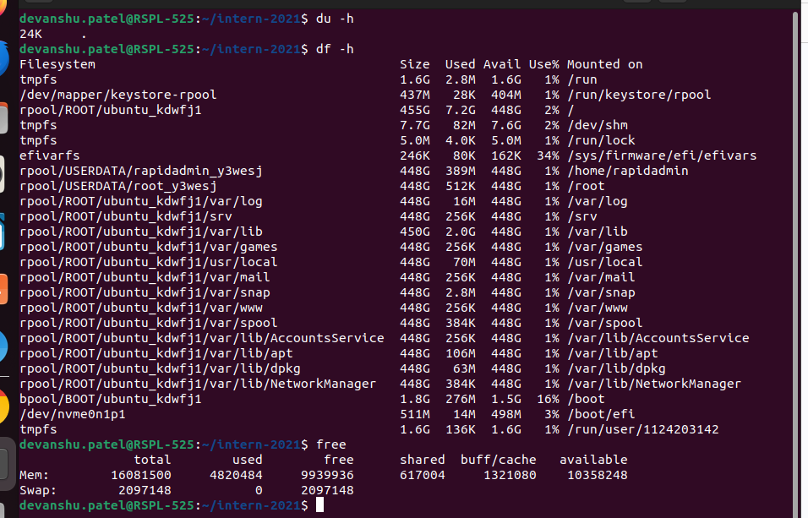

**13.** Check the all system process and filter out any of one process service using CLI.

13. 

**14.** Retrieve the content from web server using CLI.

14. 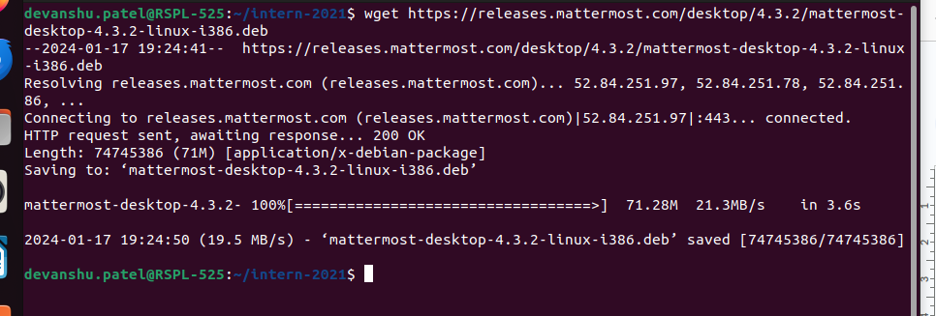

**15.** Check your network interface information using CLI.

15. 