Gary,

First of all, I found some issues on the Home page that needs correcting.

1. Remove “Agent” in the Call Agent phone number section at the top of the Home page.
2. Remove “Home Study Courses” in the navigation bar at the top of the Home page.
3. Remove all “READ MORE” buttons.

The pages to be titled and linked from the navigation bar:

Live Online Courses https://www.smithseminars.com/liveonlinecourses

Online Courses https://www.smithseminars.com/onlinecourses

FAQ https://www.smithseminars.com/faqs

Contact https://www.smithseminars.com/contact

Terms and Privacy Policy https://www.smithseminars.com/termsprivacy

HOME PAGE LINKS:

READ MORE button removed

Under Live Online Courses “VIEW THE COURSES” will link to https://www.smithseminars.com/liveonlinecourses

Under Online Courses “VIEW THE COURSES” will link to https://www.smithseminars.com/onlinecourses

READ MORE button removed

**History of Smith Seminars**

Smith Seminars was started in September 2003, by Debra Smith, RRT. She worked full-time at the hospital and started running the company on her days off. She had a passion for digging into the books and journals at the Medical Library while in college for a course named “Seminars.”

At first, traveling all over the United States presenting seminars was fun, but when the website was started, the traveling slowed down.

Today, Debra Smith-Harr, BSRC, RRT runs the company from home. She no longer works in a facility after working in Respiratory Care since 1987. She claims she is “Retired on Active Duty.”

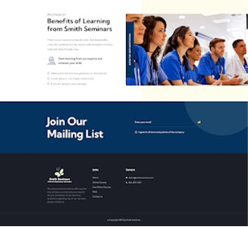

**Add “Terms and Privacy”**

**History of Smith Seminars**

Smith Seminars was started in September 2003, by Debra Smith, RRT. She worked full-time at the hospital and started running the company on her days off. She had a passion for digging into the books and journals at the Medical Library while in college for a course named “Seminars.”

At first, traveling all over the United States presenting seminars was fun, but when the website was started, the traveling slowed down.

Today, Debra Smith-Harr, BSRC, RRT runs the company from home. She no longer works in a facility after working in Respiratory Care since 1987. She claims she is “Retired on Active Duty.”

***END OF HOME PAGE***

**__________________________________________________________________________________**

***BEGINNING OF NEXT PAGE***

https://www.smithseminars.com/liveonlinecourses

**Live Online Courses**

**Each Presentation Completed is**

**One (1) AARC-Approved Traditional Live CEU/CRCE**

1) **Purchase the Presentations you want to Complete**

2) **Watch the Presentation (Anytime 8 a.m.—11 p.m. Central Time Zone)**

3) **Follow the Prompt to enter your email address and name during the course to show you are still watching**

4) **Complete the Evaluation at the end of the Presentation. (Do not skip forward during the Presentation because there is an audit process)**

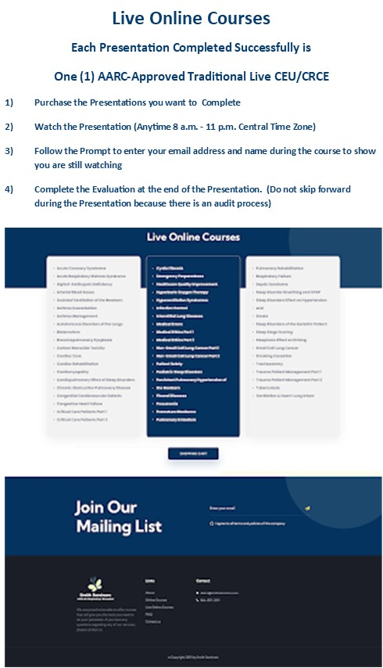

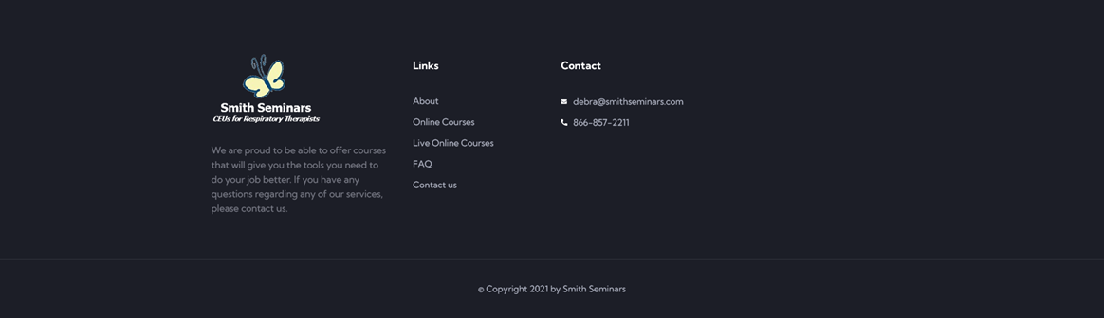

**Add “Terms and Privacy”**

**SHOPPING CART Button will direct the students to shopping cart link for the Live Online Courses**

***END OF LIVE ONLINE COURSES PAGE***

***__________________________________________________________________________________***

***BEGINNING OF NEXT PAGE – ONLINE COURSES***

***https://www.smithseminars.com/onlinecourses***

**Online Courses**

**Each Course Completed is One (1) or Two (2) Non-Traditional Live CEU/CRCE**

1. **Purchase the Courses you want to Complete**
2. **Go to your Email and click on the Course you want to Complete**
3. **Click on Course Material to Open the Document**
4. **Complete the Test and Evaluation**
5. **The Test is Automatically Graded**
6. **The Certificate of Completion is instantly available for download and a copy will be sent to your email**

**ON THIS PAGE EACH COURSE WILL BE ENTERED BY ME WITH THE LINKS TO THE SHOPPING CART**

**ONCE THE STUDENT PURCHASES THE COURSE, THE SHOPPING CART WILL SEND AN EMAIL WITH THE**

**LINK TO THE FLEXIQUIZ COURSES. I DO NOT WANT PICTURES ON EACH ONLINE COURSE LINK.**

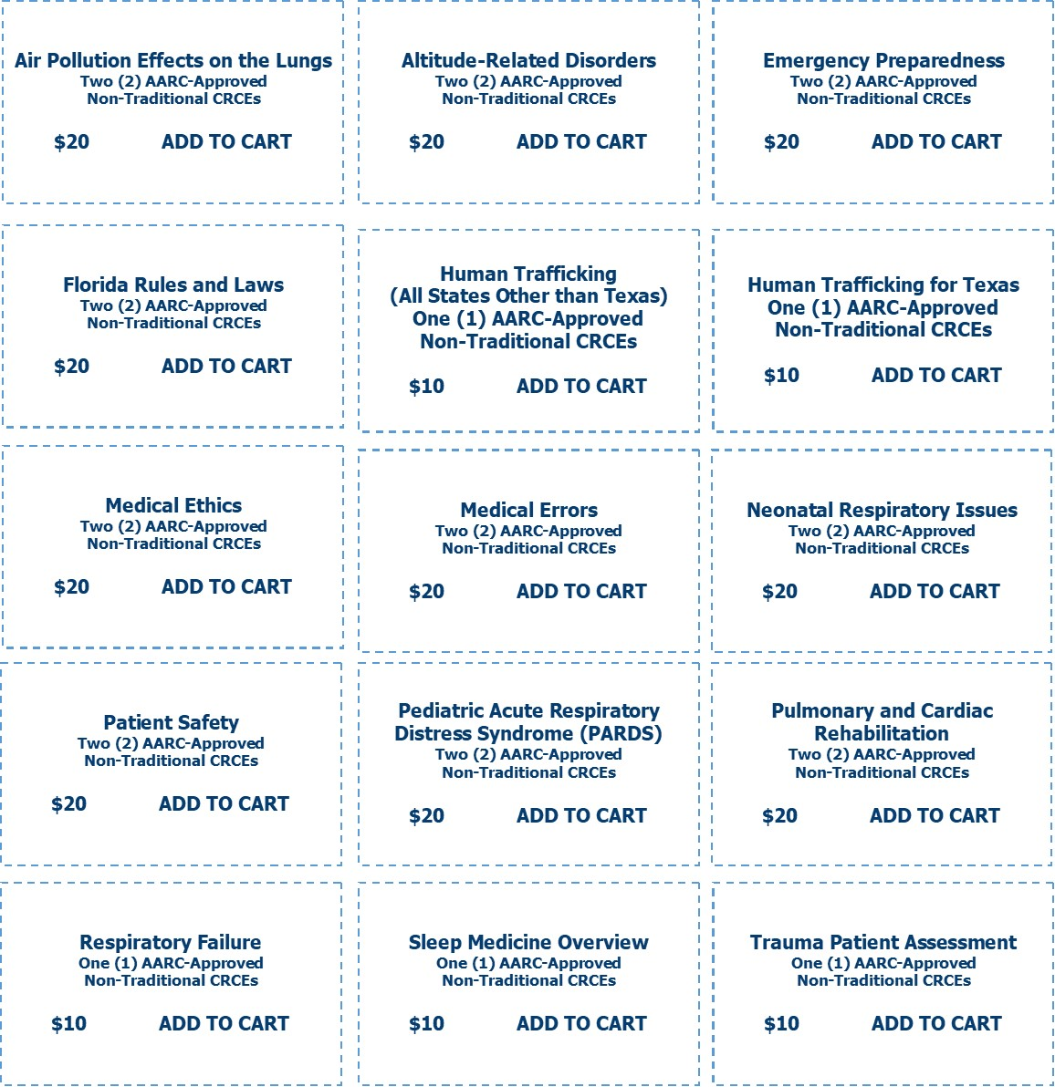

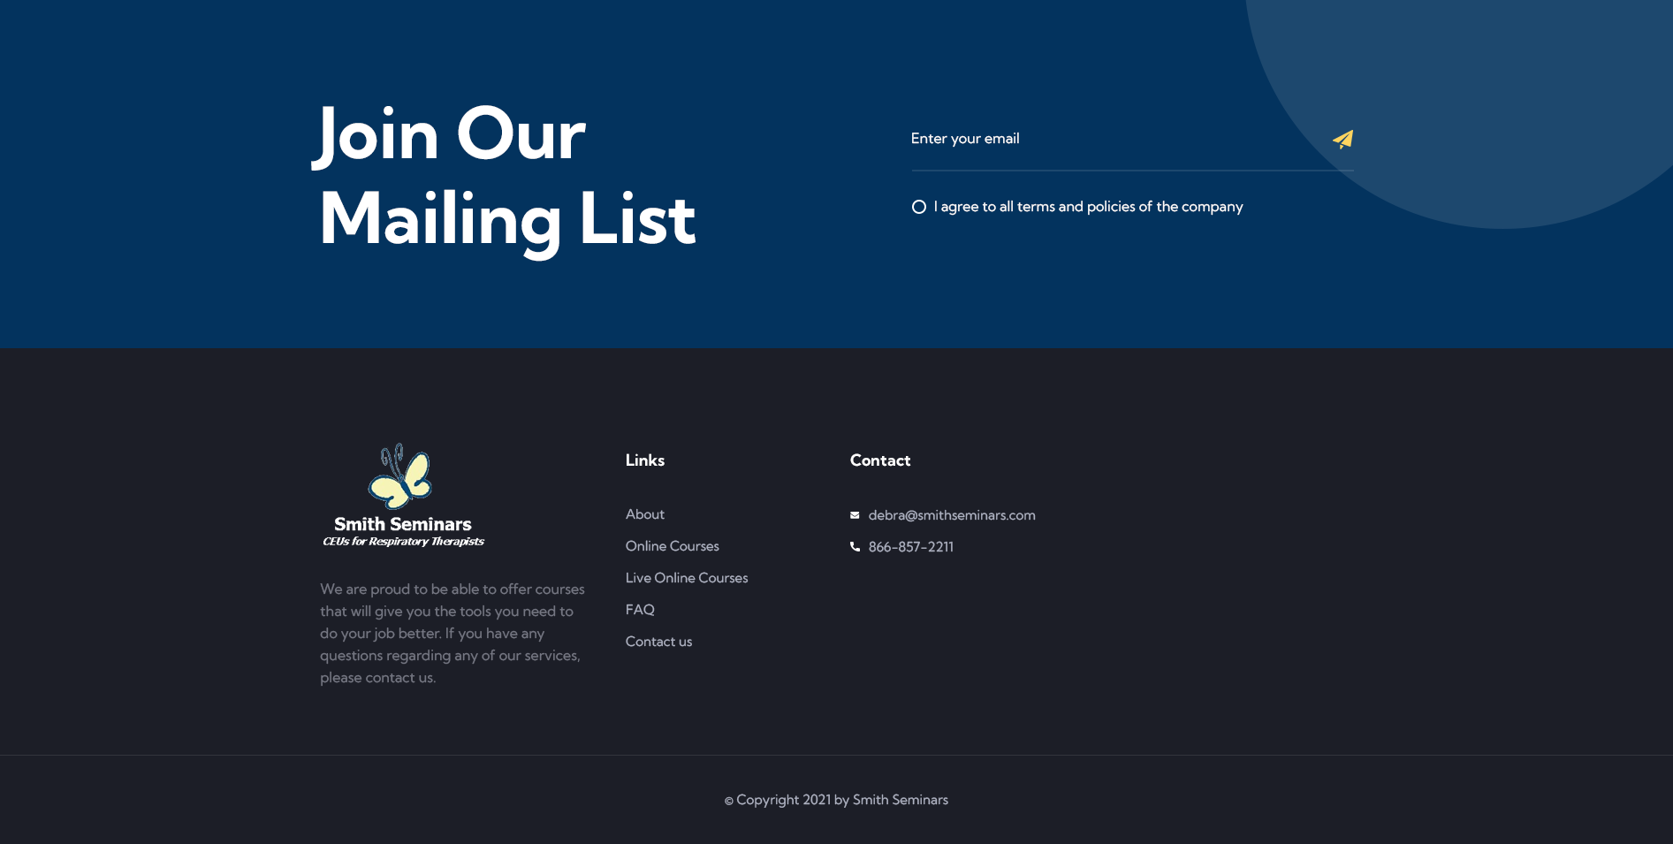

**Add “Terms and Privacy”**

***END OF ONLINE COURSES PAGE***

***__________________________________________________________________________________***

***BEGINNING OF NEXT PAGE - FAQS***

***https://www.smithseminars.com/faqs***

**FAQS**

*If I run out of time and fail to complete the CEUs before my state license renewal, can you backdate my certificate?*

NO! Absolutely not! The date on your certificate will be the date you successfully completed the course.

*If I do not need the CEUs I purchased, can I get a refund?*

No, but you will have access to them when you need them with the next renewal period. Just make sure that you are aware of how many hours you need before placing the order. The Online Courses need to be completed by December 31th of the year of purchase because the test and course material might be updated for the new year.

*Do I have to be a member of AARC (American Association for Respiratory Care)?*

No, you do not have to be a member of AARC to complete continuing education with Smith Seminars. If you would like to become a member or find out about membership, [click here](http://www.aarc.org/) (http://www.aarc.org/). One AARC CRCE (Continuing Respiratory Care Education) is worth one CEU or continuing education unit.

*Does my state accept Smith Seminars continuing education?*

All the courses are AARC-approved and every state accepts AARC continuing education. If you have any questions about your state license requirements, please contact your state board. I am not a representative of your state board. I cannot speak for them on the matter of what will or will not be accepted by them.

*Does my state accept Smith Seminars Live Online as a live course?*

AARC approves courses as "Traditional" (Lectures and Live Online) or "Non-traditional" (Self-taught internet, Online or Home Study). Because the Live Online is a "Traditional" course, it is approved as live continuing education hours just like you receive setting in a classroom.

To make sure you are attending the Live Online Course, you may be required to enter your email address during the presentation to prove that you are watching the presentation. You can interact with the instructor by calling 866-857-2211 or email [debra@smithseminars.com](mailto:debra@smithseminars.com). Please contact your state board for confirmation of acceptance of AARC-approved Live Online CEUs.

*What if I lose my certificate, can I get another copy?*

Yes, there will be a copy in your personal password protected vault. You can also contact Smith Seminars and another copy will be provided for you at no cost. It is always best to keep your certificates in a safe place. It is your career that is affected if you are not able to produce the certificates in an audit by your state.

*Do I have to watch all the Live Online presentations without stopping?*

If you have several presentations to watch, you can spread it out for several days or weeks. You must keep within the time limitations, 8 a.m. - 11 p.m. or call for permission to have an extension of time if needed. The presentation can be paused while watching if needed.

*Can I let someone else use my link to watch a Live Online Presentation?*

No, because of the increasing risk of theft, it is not allowed for another person to use your link.

*Can I use another person's credit card to purchase CEUs?*

Yes, as long as you have permission to use their card. You must place YOUR NAME on the order. You must use the card holders address because the system has an address verification that must be passed.

*Will I get my certificate as soon as I submit a test or complete a Live Online presentation?*

When you complete an Online Test, you will get your certificate instantly if you pass the test.

The Live Online course certificate will be produced as soon as all the presentations and evaluations for the entire month have been completed. You will receive one certificate with the number of hours and a list of presentations completed.

*Does Smith Seminars submit the certificates to the state licensure?*

Smith Seminars will submit to CEBroker if your Florida state license number has been provided. All other state license holders are required to submit all continuing education to their state agency. Smith Seminars will send the information to AARC.

***END OF FAQS PAGE***

***__________________________________________________________________________________***

**BEGINNING OF NEXT PAGE - CONTACT**

https://www.smithseminars.com/contact

**CONTACT**

**Debra Smith-Harr, BSRC, RRT**

**Email: debra@smithseminars.com**

**Phone: 866-857-2211 or 940-600-4700**

**Hours of Service 8 a.m. to 11 p.m. – 365 days per year**

***END OF CONTACT PAGE***

__________________________________________________________________________________

***BEGINNING OF NEXT PAGE – TERMS AND PRIVACY POLICY***

***https://www.smithseminars.com/termsprivacy***

**TERMS OF SERVICE**

**Refund Policy**

No refunds will be given. Please make sure you are purchasing what you need. You will have access to the courses you have purchased to use in the future.

**Check Policy**

No checks are accepted by mail.

**Forms of Payment Accepted**

MasterCard, Visa, Discover, and American Express.

**PRIVACY POLICY**

Your right to privacy is very important to us. We recognize that providing us with personal information is an act of trust. Our Privacy Policy has been developed to protect your personal information and make your experience using our service safe and satisfying.

**Use of Information**

Primarily the information we collect is to provide and improve our service. We will not provide any of your personal information to other organizations or third parties unless required to do so by law. We do not sell our clients' personal information to anyone.

**Transmission, Storage, and Access**

When you transmit your information via our shopping cart we use industry-standard Secure Socket Layers to insure digital encryption so your information cannot be seen by others. Credit card information we collect for payment is not stored on our servers. It is passed through Secure Socket Layers to our provider (Stripe.com) for authorization and storage. Credit card information is stored at our provider, and is protected by their secure infrastructure.