KATSINA STATE INSTITUTE OF TECHNOLOGY
AND MANAGEMENT
SCHOOL OF TECHNOLOGY
DEPARTMENT OF ARTIFICIAL INTELLIGENCE
AIT 312: PYTHON FOR ARTIFICIAL INTELLIGENCE
GROUP ASSIGNMENT
PREDICTING THE OUTCOME OF INTERNATIONAL FOOTBALL MATCHES USING PYTHON, PANDAS AND AN ARTIFICIAL NEURAL NETWORK
A complete data-driven prediction system: from raw data to neural-network forecasts
GROUP | SPORT
SUBMITTED BY | Hussaina Akilu
REGISTRATION NUMBER | HND/AIT/25/0057
PROGRAMME | Higher National Diploma (HND), Artificial Intelligence
COURSE | AIT 312 – Python for Artificial Intelligence
DATE OF SUBMISSION | September, 2026

ABSTRACT
This report presents the design, implementation and evaluation of a complete data-driven system for predicting the outcome of international (national-team) football matches. The problem was selected from the Sports domain, which was assigned to Group SPORT. A real, publicly available dataset of 49,547 international matches played between 1872 and 2026 was read, inspected, cleaned and transformed using Python and the Pandas library. Because the raw data records only final scores, meaningful predictors were engineered from match history, most importantly a World-Football-style Elo rating for every national team and each team’s recent form over its previous five matches, computed strictly from matches played before each fixture to prevent information leakage.
Exploratory analysis confirmed a strong home advantage (home sides win 50.74% of matches at their own venue against 44.16% for the first-listed team at neutral venues) and a strong relationship between rating difference and outcome (correlation of 0.514 with the result). A multilayer perceptron (MLP) neural network was then trained on 20,778 matches from 2000–2021 and tested on 4,707 unseen matches from 2022–2026, a chronological split that mirrors genuine forecasting. The network achieved a test accuracy of 60.31% and a log-loss of 0.8732, compared with 47.69% accuracy for always predicting a home win and a log-loss of 1.0986 for uninformed guessing. Its probability estimates were well calibrated, and when the model was at least 80% confident it was correct in 85.90% of matches. On the 2026 FIFA World Cup it predicted 66.35% of the 104 matches correctly. The main limitation observed is that draws are rarely predicted. Possible applications and improvements are discussed.
Keywords: football match prediction, neural network, multilayer perceptron, Pandas, Elo rating, feature engineering, sports analytics

TABLE OF CONTENTS
CHAPTER ONE: INTRODUCTION 1
1.1 Background of the Study 1
1.2 Selected Domain and Problem Statement (Task 1) 1
1.3 Aim and Objectives 1
1.4 Tools and Environment 1
1.5 Mapping of Assignment Tasks to this Report 2
CHAPTER TWO: DATA ACQUISITION, INSPECTION AND CLEANING 3
2.1 Source of the Dataset (Task 2) 3
2.2 Reading the Dataset with Pandas 3
2.3 Inspection and Description of the Dataset (Task 3) 3
2.4 Identification and Handling of Data-Quality Problems (Task 4) 4
CHAPTER THREE: DATA TRANSFORMATION, ANALYSIS AND VISUALISATION 6
3.1 Data Transformation and Feature Creation (Task 5) 6
3.2 Analysis of the Dataset (Task 6) 7
3.3 Data Visualisation (Task 7) 8
CHAPTER FOUR: NEURAL NETWORK MODELLING 13
4.1 Input Features and Prediction Target (Task 8) 13
4.2 Training and Testing Sets (Task 9) 13
4.3 Development of the Neural Network (Task 10) 14
4.4 Training the Network and Generating Predictions (Task 11) 15
CHAPTER FIVE: RESULTS AND EVALUATION 16
5.1 Performance Evaluation (Task 12) 16
5.2 Actual versus Predicted Results (Task 13) 17
CHAPTER SIX: DISCUSSION, APPLICATION AND FUTURE WORK 19
6.1 Discussion of Performance, Strengths and Limitations (Task 14) 19
6.2 Application of the System to the Real-World Problem (Task 15) 20
6.3 Possible Improvements for Future Work (Task 16) 20
CHAPTER SEVEN: CONCLUSION AND SUBMISSION 21
7.1 Conclusion 21
7.2 Submitted Materials (Task 17) 21
REFERENCES 22
APPENDIX A: COMPLETE PYTHON SOURCE CODE 23

CHAPTER ONE: INTRODUCTION

1.1 Background of the Study
Football is the most widely followed sport in the world, and international matches between national teams attract enormous public, commercial and media interest. Coaches, football federations, broadcasters, journalists and sports-analytics companies all benefit from reliable estimates of how likely a match is to end in a home win, a draw or an away win. Traditionally such judgements are made informally, using reputation and intuition. Data science offers a more objective approach: by learning from thousands of past matches, a model can estimate outcome probabilities consistently and transparently.

1.2 Selected Domain and Problem Statement (Task 1)
Domain: Sports (Group SPORT).
Problem: Given two national teams that are about to play, together with information about the venue and the type of competition, predict whether the match will end in a Home Win, a Draw or an Away Win, and estimate the probability of each outcome.
The problem is well suited to a data-driven solution for three reasons. First, more than a century of results is publicly available, providing enough examples for a neural network to learn from. Second, the outcome depends on measurable factors, such as the relative strength of the two teams, their recent form and whether the match is played at home, which can be derived from historical data. Third, the outcome is genuinely uncertain, so a probabilistic prediction is more useful than a simple rule. The problem is framed as a three-class supervised classification task.

1.3 Aim and Objectives
The aim of this work is to develop a complete Python-based system that predicts international football match outcomes. The specific objectives are to:
- obtain a real international football results dataset and load it with Pandas;
- inspect, clean and transform the data into a form suitable for machine learning;
- engineer informative predictive features (team strength ratings and recent form) from match history;
- analyse and visualise patterns such as home advantage and scoring trends;
- design, train and evaluate a neural-network classifier on a realistic chronological train/test split; and
- interpret the results, discuss strengths and limitations, and propose applications and improvements.

1.4 Tools and Environment
The system was implemented in Python 3.12 using Pandas (data handling and analysis), NumPy (numerical computation), Matplotlib and Seaborn (visualisation), and scikit-learn (neural network, scaling and evaluation metrics). All steps are contained in a single, fully commented script, football_prediction.py, reproduced in Appendix A.

1.5 Mapping of Assignment Tasks to this Report
Table 1 shows where each of the seventeen assignment tasks is addressed.
Table 1: Mapping of assignment tasks to report sections
Task | Requirement | Section
1 | Select domain and explain the problem | 1.2
2 | Obtain dataset and read it with Python/Pandas | 2.1 – 2.2
3 | Inspect and describe the dataset | 2.3
4 | Identify and handle data-quality problems | 2.4
5 | Transform and prepare the data | 3.1
6 | Analyse the data with Pandas and statistics | 3.2
7 | Visualise the data and explain each visual | 3.3
8 | Identify input features and target | 4.1
9 | Divide data into training and testing sets | 4.2
10 | Develop a neural network model | 4.3
11 | Train the network and generate predictions | 4.4
12 | Evaluate the network | 5.1
13 | Present actual versus predicted results | 5.2
14 | Discuss performance, strengths and limitations | 6.1
15 | Explain real-world application | 6.2
16 | Propose at least two improvements | 6.3
17 | Submit code, dataset, results and report | 7.2 and Appendix A

CHAPTER TWO: DATA ACQUISITION, INSPECTION AND CLEANING

2.1 Source of the Dataset (Task 2)
The dataset used is the International Football Results from 1872 to 2026 dataset compiled by Mart Jürisoo and published openly on GitHub and Kaggle. It records every men’s full international match for which a result is known, from the first-ever international (Scotland vs England, 30 November 1872) to August 2026, including friendlies, qualifiers and major tournaments such as the FIFA World Cup and the Africa Cup of Nations. The file used is results.csv, downloaded from:
https://github.com/martj42/international_results
This dataset was chosen because it is real, large, regularly maintained, free to use, and directly relevant to the problem: every record is one match with a known final outcome, which provides the labelled examples a supervised neural network requires.

2.2 Reading the Dataset with Pandas
The CSV file was read into a Pandas DataFrame with a single function call:
import pandas as pd

df = pd.read_csv("results.csv")
print("Loaded:", df.shape) # -> Loaded: (49547, 9)
print(df.head())

2.3 Inspection and Description of the Dataset (Task 3)
Inspection with df.shape, df.dtypes, df.head() and df.describe() showed that the dataset contains 49,547 records (matches) and 9 attributes. It covers 337 distinct national teams, 202 distinct competition names and matches hosted in 269 countries, spanning 1872-11-30 to 2026-08-26. Table 2 describes each attribute.
Table 2: Attributes of the raw dataset
Attribute | Pandas type | Description
date | str (text) | Date the match was played
home_team | str | Name of the home (or first-listed) team
away_team | str | Name of the away (or second-listed) team
home_score | int64 | Goals scored by the home team (incl. extra time, excl. penalty shoot-outs)
away_score | int64 | Goals scored by the away team
tournament | str | Name of the competition, e.g. Friendly, FIFA World Cup
city | str | City where the match was played
country | str | Country where the match was played
neutral | bool | TRUE if played at a neutral venue

The basic statistical characteristics of the two numeric attributes are shown in Table 3.
Table 3: Descriptive statistics of goals scored (df.describe())
Statistic | home_score | away_score
Count | 49547.000 | 49547.000
Mean | 1.757 | 1.183
Standard deviation | 1.774 | 1.402
Minimum | 0.000 | 0.000
25th percentile | 1.000 | 0.000
Median | 1.000 | 1.000
75th percentile | 2.000 | 2.000
Maximum | 31.000 | 21.000

Home teams score on average 1.76 goals against 1.18 for away teams, an early indication of home advantage. Both distributions are strongly right-skewed: the median is only one goal, yet the maxima are 31 and 21 goals, showing that a small number of very one-sided matches exist. Of all matches, 13,158 (26.6%) were played at neutral venues.

2.4 Identification and Handling of Data-Quality Problems (Task 4)
Every column was systematically checked for missing values, duplicates, incorrect data types, inconsistent categories, impossible values and outliers. Table 4 summarises what was found and the action taken for each problem.
Table 4: Data-quality problems found and how they were handled
Check | Finding | Action taken
Missing values | 0 missing values in all 9 raw columns | Verified with df.isna().sum(); rows without a score would be dropped (0 found)
Exact duplicate records | 0 exact duplicates | df.drop_duplicates() applied as a safeguard
Same fixture on same day | 2 rows: Tahiti vs New Caledonia, 17 Feb 1974, with different scores (2–1 and 1–2) | Not true duplicates (different results); retained as two genuine matches
Incorrect data type | date stored as text (str), not as a date | Converted with pd.to_datetime(); 0 unparseable dates
Inconsistent text values | Possible leading/trailing spaces in names | All text columns stripped with .str.strip()
High-cardinality / inconsistent categories | 202 different tournament names, many very rare | Grouped into 6 consistent categories (Friendly, Qualifier, World Cup, Continental Final, Nations League, Other)
Impossible values | 0 negative scores; 0 teams playing themselves | None found; no action required
Outliers | 268 matches with a margin of 10+ goals (maximum 31–0) | Verified as genuine results between very unequal teams; kept, and their influence limited through scaling and Elo goal-margin damping
Missing values created during feature engineering | 303 matches involving a team’s first-ever international have no previous form | Imputed with neutral values (1 goal for, 1 against, 1 point per game)

The key cleaning code is shown below:
# (a) strip whitespace from text columns
for col in ["home_team", "away_team", "tournament", "city", "country"]:
df[col] = df[col].astype(str).str.strip()

# (b) fix incorrect data type: text -> datetime
df["date"] = pd.to_datetime(df["date"], errors="coerce")
df = df.dropna(subset=["date"])

# (c) remove exact duplicates, (d) drop matches without a score
df = df.drop_duplicates()
df = df.dropna(subset=["home_score", "away_score"])

# (e) group 202 tournament names into 6 consistent categories
df["tournament_cat"] = df["tournament"].apply(tournament_category)

After cleaning, 49,547 valid records remained. The dataset turned out to be of good quality overall; the most important problems were the incorrect date type and the very large number of inconsistent tournament labels, both of which would have prevented correct analysis and modelling had they not been handled.

CHAPTER THREE: DATA TRANSFORMATION, ANALYSIS AND VISUALISATION

3.1 Data Transformation and Feature Creation (Task 5)
The raw dataset records only who played and the final score. A neural network cannot predict a future match from the final score of that same match, so the data had to be transformed into pre-match information. The following transformations were carried out.

3.1.1 Target creation
A new categorical column, result, was created from the goal difference: Home Win if home_score > away_score, Draw if equal, and Away Win otherwise. For modelling it was label-encoded as 0 = Away Win, 1 = Draw and 2 = Home Win.

3.1.2 Elo team-strength ratings
The single most important feature is a measure of each team’s strength before the match. An Elo rating system, adapted from the World Football Elo Ratings method, was implemented. Every team starts at 1,500 points. After each match the ratings are updated as follows:
New rating = Old rating + K × G × (W − We)
- W is the actual result (1 for a win, 0.5 for a draw, 0 for a loss);
- We is the expected result, We = 1 / (1 + 10^(−dr/400)), where dr is the rating difference plus 100 points for the home side at a non-neutral venue;
- K reflects match importance (60 World Cup, 50 continental finals, 40 qualifiers and Nations League, 30 other tournaments, 20 friendlies);
- G increases the change for wider winning margins (1 for a one-goal margin, 1.5 for two goals, (11 + N)/8 for N ≥ 3), which also damps the effect of extreme outliers.
Ratings were computed chronologically over all 49,547 matches since 1872, and each match was given the ratings of both teams as they stood before kick-off. From these, home_elo, away_elo and elo_diff (home minus away, including the home-advantage bonus) were created.

3.1.3 Recent form and experience
For each team, a rolling window of its previous five matches was maintained to create average goals scored (gf5), average goals conceded (ga5) and average points per game (pts5, with 3 for a win and 1 for a draw). The difference in form (form_diff) and the difference in international experience (exp_diff, the log of the number of previous matches) were also created.

3.1.4 Venue, encoding and scaling
A binary feature home_in_own_country flags genuine home matches. The neutral flag was converted from Boolean to 0/1. The six tournament categories were one-hot encoded with pd.get_dummies(). Finally, all continuous features were standardised (zero mean, unit variance) using StandardScaler, fitted on the training data only and then applied to the test data. Scaling is essential for neural networks, whose gradient-based training is sensitive to features measured on very different scales (Elo ratings are in the thousands, whereas form values are below three).
Preventing data leakage
All engineered features for a match are computed only from matches played before it; ratings and form are updated only after the features for the current match have been recorded. Similarly, the scaler is fitted on the training set only. This guarantees that the model never sees information it would not have had before the match, making the evaluation honest.

3.2 Analysis of the Dataset (Task 6)
Pandas operations such as value_counts(), groupby(), crosstab(), cut() and corr() were used to uncover patterns in the cleaned data.

3.2.1 Outcome distribution
Across all matches, home teams won 49.00%, away teams won 28.28% and 22.73% ended in a draw. The classes are therefore imbalanced: home wins are more than twice as common as draws.

3.2.2 Home advantage
A cross-tabulation of result against venue type (Table 5) shows a clear home advantage. At genuine home venues the home side wins 50.74% of matches, but at neutral venues the first-listed team wins only 44.16%, while the away/second team’s win rate rises from 26.41% to 33.42%. The draw rate is almost unchanged.
Table 5: Outcome percentages by venue type (pd.crosstab)
Venue | Home Win | Draw | Away Win
Home venue | 50.74% | 22.84% | 26.41%
Neutral venue | 44.16% | 22.41% | 33.42%

3.2.3 Competition type
Grouping by the cleaned tournament category (Table 6) shows that friendlies and qualifiers make up most of the data, and that ‘other’ regional tournaments have the highest scoring rate, reflecting more mismatched opponents.
Table 6: Summary statistics by competition type (df.groupby)
Competition type | Matches | Avg. goals / match | Home win %
Friendly | 18,385 | 2.87 | 47.32%
Qualifier | 15,928 | 2.87 | 51.47%
Other Tournament | 10,003 | 3.27 | 49.43%
Continental Final | 3,083 | 2.73 | 47.32%
Nations League | 1,080 | 2.78 | 45.09%
World Cup | 1,068 | 2.84 | 45.69%

3.2.4 Relationship between features and outcome
To measure relationships, the result was coded numerically (−1 = away win, 0 = draw, 1 = home win) and Pearson correlations were computed for matches since 2000 (Table 7). The Elo difference has by far the strongest relationship with the outcome (r = 0.514), followed by the experience difference and the form difference. Goals conceded by the home team in recent matches is negatively related to a home win, as expected.
Table 7: Correlation of engineered features with the match result (2000–2026)
Feature | Correlation (r) | Strength
Elo difference | 0.514 | Strong
Experience difference | 0.319 | Moderate
Form difference (points) | 0.290 | Moderate
Home goals conceded (last 5) | -0.202 | Weak
Away goals conceded (last 5) | 0.178 | Weak
Away goals scored (last 5) | -0.160 | Weak
Home goals scored (last 5) | 0.139 | Weak
Neutral venue | -0.095 | Very weak
Home team in own country | 0.093 | Very weak

3.2.5 Trends over time
Grouping by decade shows that average goals per match fell from 5.58 in the 1880s to around 2.72 in the 2020s, with most of the decline happening between the 1950s and 1980s as tactics became more defensive and competitive. Because the game has changed so much, the neural network was trained on modern matches only (from 2000), although Elo ratings were built from the full history so that every team has a well-established rating.

3.3 Data Visualisation (Task 7)
The following visualisations were produced with Matplotlib and Seaborn. Each is followed by an explanation of what it reveals about the problem.
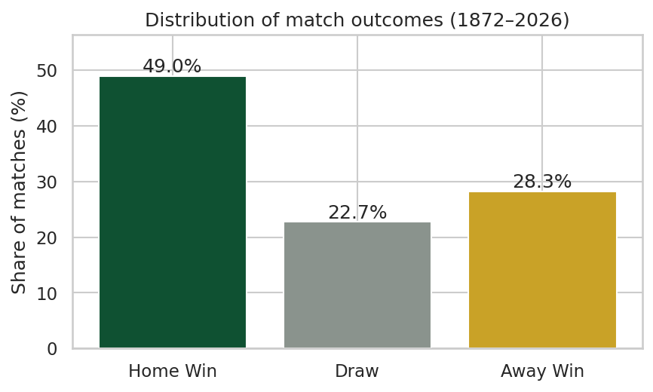
Figure 1: Distribution of match outcomes, 1872–2026
What it reveals: Home wins dominate, while draws are the least common outcome. This class imbalance means a model can reach almost 50% accuracy by always predicting a home win, so any useful model must do clearly better than that. It also warns that draws will be the hardest class to predict.
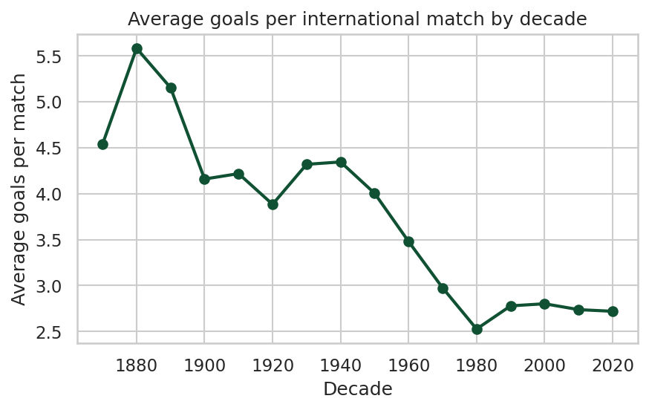
Figure 2: Average goals per international match by decade
What it reveals: Scoring has fallen sharply over time and has been stable at about 2.7–2.8 goals per match since the 1980s. This justifies restricting the modelling window to recent decades, where the patterns are consistent with the matches we want to predict.
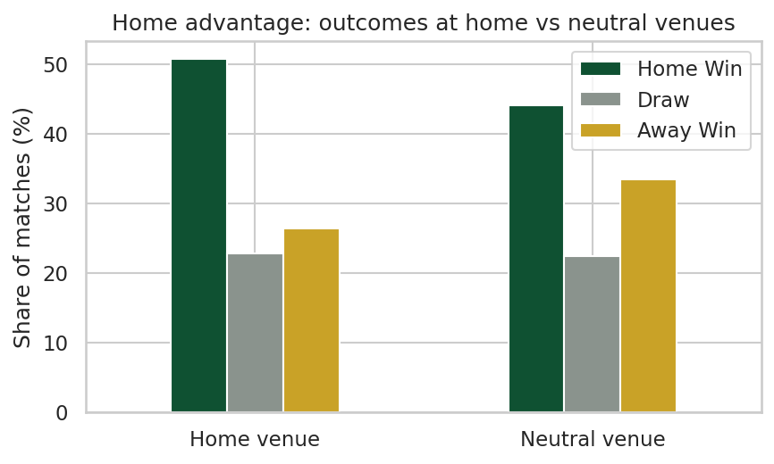
Figure 3: Match outcomes at home venues versus neutral venues
What it reveals: Playing at home clearly increases the probability of winning. The venue must therefore be included as an input feature, and the Elo model must add a home-advantage bonus.
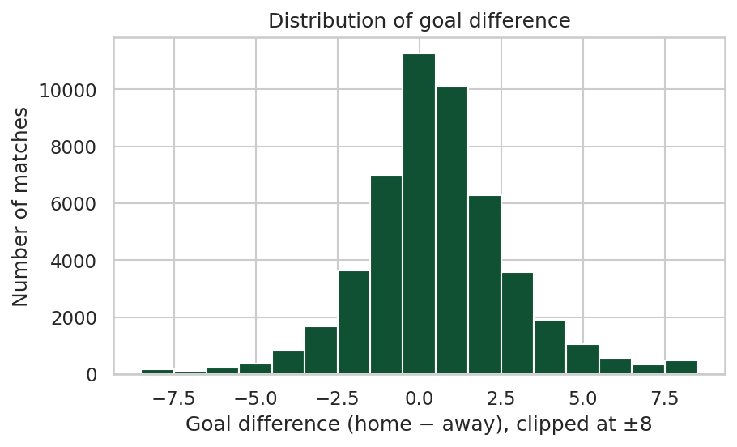
Figure 4: Distribution of goal difference (home minus away)
What it reveals: Most matches are decided by one or two goals, and the distribution is shifted to the positive (home) side. The long tails confirm the presence of rare but genuine lopsided results, which is why the Elo update damps large margins rather than rewarding them linearly.
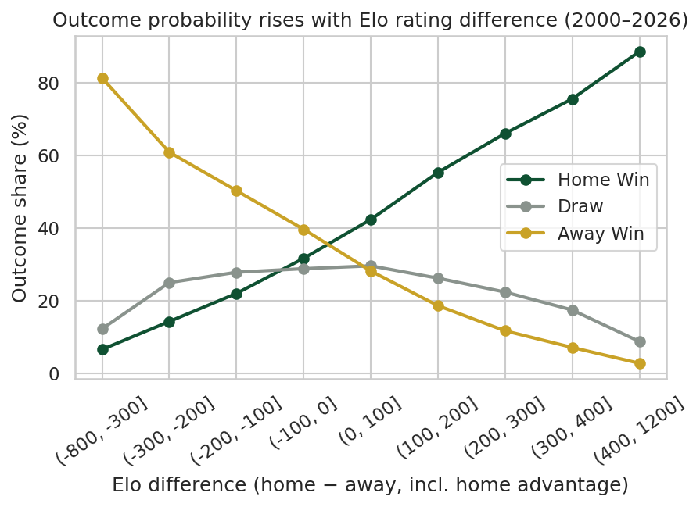
Figure 5: Outcome shares by Elo rating difference (2000–2026)
What it reveals: This is the most important analytical chart. As the Elo difference increases, the home-win share rises steadily from under 7% to almost 89%, while the away-win share falls. Draws peak when teams are evenly matched (around 29–30%). This confirms that the engineered Elo feature captures team strength extremely well and is the key predictor for the neural network.
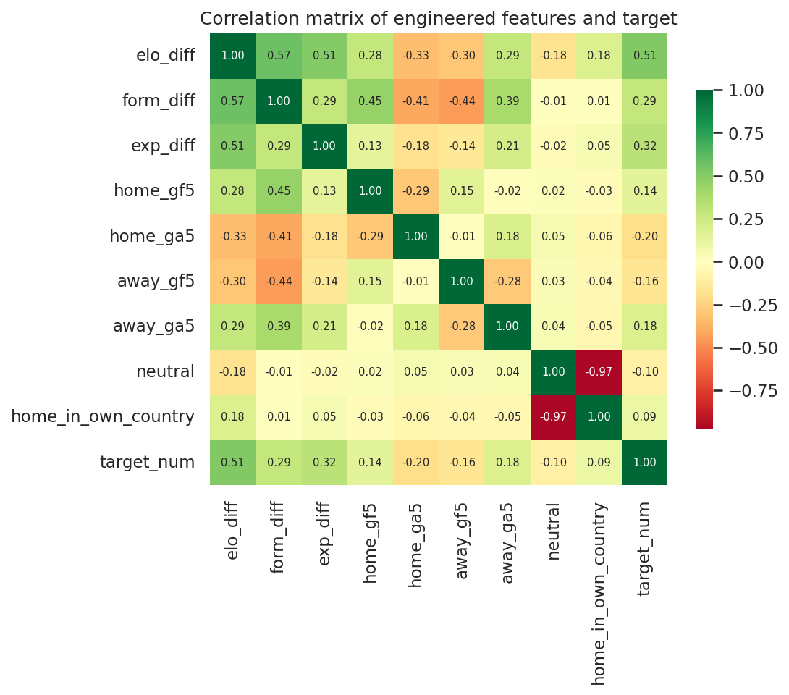
Figure 6: Correlation matrix of engineered features and the target
What it reveals: The Elo difference correlates most strongly with the target. Some features are correlated with each other (for example neutral and home_in_own_country, r ≈ −0.97; elo_diff and form_diff, r ≈ 0.57), which indicates overlapping information. Neural networks handle correlated inputs reasonably well, but this suggests that a smaller feature set could perform almost as well.
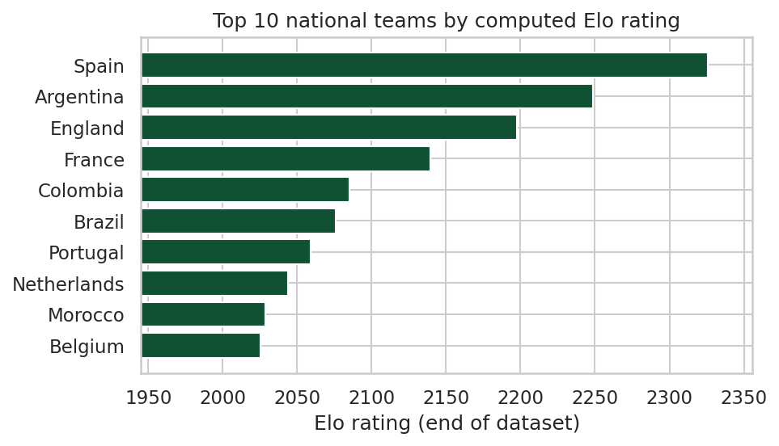
Figure 7: Top 10 national teams by computed Elo rating (end of dataset)
What it reveals: The ratings produced by the system rank Spain, Argentina, England and France as the strongest teams, which agrees with their real-world results at the 2026 World Cup and is a useful sanity check that the Elo implementation is working correctly. Morocco’s presence also reflects the recent rise of African football.

CHAPTER FOUR: NEURAL NETWORK MODELLING

4.1 Input Features and Prediction Target (Task 8)
Target (output): result, a three-class label (Away Win, Draw, Home Win).
Input features: 19 inputs, listed in Table 8.
Table 8: Input features used by the neural network
Group | Features | Why it is appropriate
Team strength | elo_diff, home_elo, away_elo | Summarises each team’s entire history of results, adjusted for opponent quality and match importance; strongest predictor (r = 0.51)
Recent form | home_gf5, home_ga5, home_pts5, away_gf5, away_ga5, away_pts5, form_diff | Captures short-term momentum, injuries or changes in squad quality not yet reflected in long-term ratings
Experience | exp_diff | Established football nations differ systematically from newer or smaller members
Venue | neutral, home_in_own_country | Home advantage is clearly visible in the data (Figure 3)
Competition | 6 one-hot tour_* columns | Match importance changes motivation and team selection (e.g. friendlies vs World Cup)

These features are appropriate because they are all available before the match, they are grounded in football knowledge, and the analysis in Chapter Three showed that each has a measurable relationship with the outcome. Raw team names were deliberately not used as inputs: with 337 teams, one-hot encoding names would create hundreds of sparse columns and encourage memorisation, whereas the Elo rating expresses the same information as a single, meaningful number.

4.2 Training and Testing Sets (Task 9)
The 25,485 matches played from 2000 onwards were used for modelling. Instead of a random split, a chronological split was used, because in real use the model will always predict future matches from past ones. A random split would allow the model to train on matches that happened after some test matches, giving an unrealistically optimistic result.
Table 9: Chronological division of the modelling data
Set | Period | Matches | Share
Training set | 2000 – 2021 | 20,778 | 81.53%
of which, internal validation (for model selection) | 2018 – 2021 | — | —
Test set (unseen) | 2022 – Aug 2026 | 4,707 | 18.47%
Total | 2000 – 2026 | 25,485 | 100.00%

This gives an approximate 81/19 split. In addition, within the training set, 10% of the data was held out automatically by the network’s early-stopping mechanism to decide when to stop training.

4.3 Development of the Neural Network (Task 10)
A multilayer perceptron (MLP), the classic feed-forward artificial neural network, was implemented with scikit-learn’s MLPClassifier. An MLP consists of an input layer, one or more hidden layers of neurons that apply a weighted sum followed by a non-linear activation function, and an output layer that produces one probability per class using the softmax function.

4.3.1 Architecture selection
Three architectures of increasing depth were trained on 2000–2017 data and compared on the 2018–2021 validation period (Table 10). Log-loss, which rewards accurate probabilities, was used as the selection criterion.
Table 10: Comparison of candidate network architectures on the validation period
Architecture (hidden layers) | Validation accuracy | Validation log-loss | Epochs
MLP (32) ✓ selected | 60.14% | 0.8640 | 21
MLP (64, 32) | 60.00% | 0.8675 | 32
MLP (128, 64, 32) | 60.20% | 0.8648 | 24

All three networks performed almost identically, which shows that the problem does not require a deep network: the important non-linear relationships (Figure 5) are simple enough for one hidden layer to learn. Following the principle of choosing the simplest adequate model, which also reduces the risk of overfitting, the MLP (32) network with the lowest validation log-loss was selected.

4.3.2 Final model configuration
Table 11: Configuration of the final neural network
Setting | Value | Purpose
Input layer | 19 neurons | One per input feature
Hidden layer | 32 neurons, ReLU activation | Learns non-linear combinations of the inputs
Output layer | 3 neurons, softmax | Probability of Away Win, Draw and Home Win
Trainable parameters | 739 | Weights and biases
Loss function | Categorical cross-entropy (log-loss) | Penalises confident wrong predictions
Optimiser | Adam, learning rate 0.001 | Adaptive gradient-based weight updates
Batch size | 128 | Mini-batch gradient descent
Regularisation | L2 penalty (alpha = 0.001) | Reduces overfitting
Early stopping | 10% validation, patience 15 epochs | Stops training when validation performance stops improving
Random seed | 42 | Makes results reproducible

from sklearn.neural_network import MLPClassifier

model = MLPClassifier(hidden_layer_sizes=(32,), activation="relu",
solver="adam", alpha=1e-3, learning_rate_init=1e-3,
batch_size=128, max_iter=300, early_stopping=True,
validation_fraction=0.1, n_iter_no_change=15,
random_state=42)

4.4 Training the Network and Generating Predictions (Task 11)
The network was trained on the 20,778 standardised training examples. Early stopping ended training after 41 epochs. The trained model was then used to generate class predictions (model.predict) and outcome probabilities (model.predict_proba) for all 4,707 test matches.
model.fit(X_train_s, y_train)
y_pred = model.predict(X_test_s) # predicted class for each match
y_prob = model.predict_proba(X_test_s) # probabilities: Away, Draw, Home

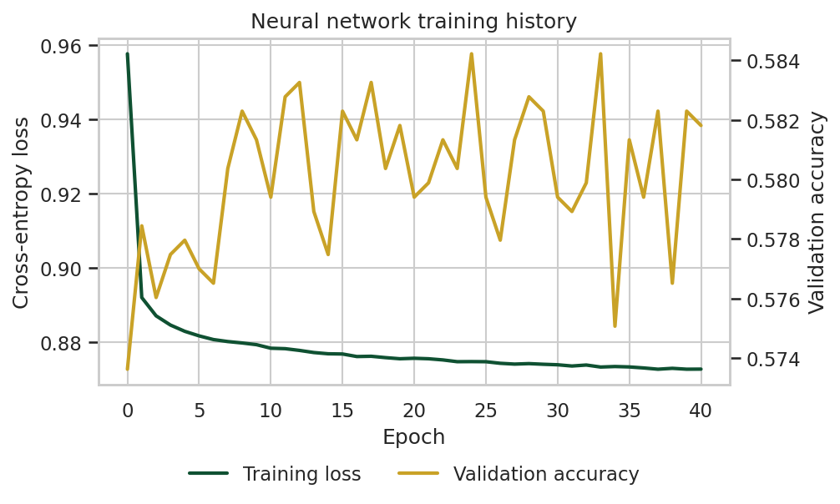
Figure 8: Training history of the neural network
Interpretation: The training loss drops rapidly in the first few epochs and then flattens, showing that the network converged quickly. The validation accuracy fluctuates within a narrow band of about one percentage point without trending downwards, which indicates that the model is not overfitting; early stopping halted training once no further improvement was observed.

CHAPTER FIVE: RESULTS AND EVALUATION

5.1 Performance Evaluation (Task 12)
Because this is a multi-class classification problem with imbalanced classes and a probabilistic output, several complementary measures were used: accuracy (share of correct predictions), precision, recall and F1-score per class, macro F1 (which treats the three classes equally), the confusion matrix, and log-loss (which measures the quality of the predicted probabilities; lower is better). Results were also compared with simple baseline methods, since a model is only useful if it beats them.
Table 12: Overall performance on the unseen test set (2022–2026)
Model | Accuracy | Log-loss | Macro F1
Baseline 1: always predict Home Win | 47.69% | — | —
Baseline 2: uniform guessing (1/3 each) | 33.33% | 1.0986 | —
Baseline 3: simple Elo rule (higher rated wins) | 60.21% | — | —
Neural network (MLP, 32 hidden neurons) | 60.31% | 0.8732 | 0.4564

Per-class results are shown in Table 13.
Table 13: Classification report of the neural network on the test set
Class | Precision | Recall | F1-score | Support
Home Win | 0.632 | 0.849 | 0.724 | 2,245
Draw | 0.354 | 0.021 | 0.040 | 1,075
Away Win | 0.560 | 0.657 | 0.604 | 1,387
Weighted average | 0.547 | 0.603 | 0.533 | 4,707

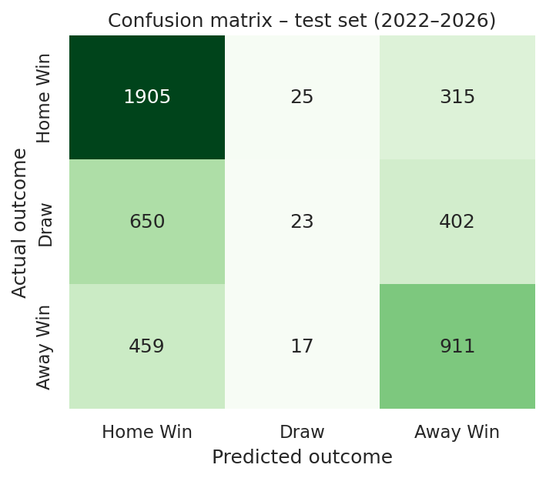
Figure 9: Confusion matrix of the neural network on the test set
Interpretation: The network correctly identified 1,905 of the 2,245 home wins (recall 84.9%) and 911 of the 1,387 away wins (recall 65.7%). It very rarely predicted a draw: only 23 of 1,075 draws were identified. Actual draws were instead predicted as home wins (650) or away wins (402). Importantly, clear reversals are uncommon: the model confuses neighbouring outcomes (win vs draw) much more often than it predicts a win for the wrong team.
Overall, the network improves accuracy by 12.6 percentage points over the majority baseline and reduces log-loss by 20.5% compared with uninformed guessing. Its accuracy is essentially equal to the simple Elo rule (60.21%); this is an honest and important finding, discussed further in Section 6.1. The network’s added value lies in providing calibrated probabilities for all three outcomes rather than a single hard choice.

5.2 Actual versus Predicted Results (Task 13)
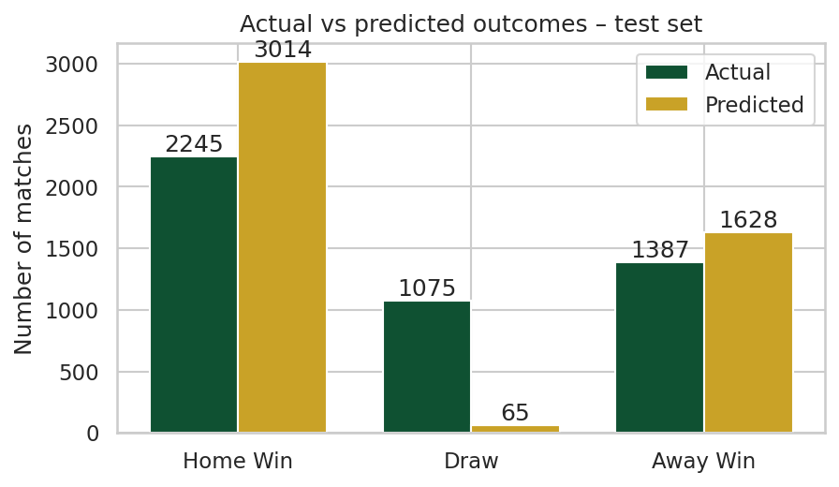
Figure 10: Number of actual versus predicted outcomes in the test set
Interpretation: The network predicted 3,014 home wins against 2,245 actual ones and 1,628 away wins against 1,387, but only 65 draws against 1,075 actual draws. Because a draw is rarely the single most likely outcome of any individual match (its probability seldom exceeds 30%, Figure 5), choosing the most probable class almost never selects ‘Draw’, even though about one match in four ends level.

5.2.1 Case study: the 2026 FIFA World Cup
The test period includes the 104 matches of the 2026 FIFA World Cup. The network predicted 66.35% of them correctly, higher than its overall test accuracy, because tournament matches between well-rated teams have highly informative Elo ratings. Table 14 compares actual and predicted results for the final eight matches of the tournament (probabilities are given as Home / Draw / Away).
Table 14: Actual versus predicted results: 2026 FIFA World Cup, final stages
Date | Match | Score | Actual | Predicted | P(H / D / A)
09 Jul 2026 | France vs Morocco | 2–0 | Home Win | Home Win ✓ | 0.57 / 0.23 / 0.19
10 Jul 2026 | Spain vs Belgium | 2–1 | Home Win | Home Win ✓ | 0.48 / 0.27 / 0.25
11 Jul 2026 | Norway vs England | 1–2 | Away Win | Away Win ✓ | 0.26 / 0.25 / 0.49
11 Jul 2026 | Argentina vs Switzerland | 3–1 | Home Win | Home Win ✓ | 0.64 / 0.22 / 0.15
14 Jul 2026 | France vs Spain | 0–2 | Away Win | Away Win ✓ | 0.32 / 0.30 / 0.39
15 Jul 2026 | England vs Argentina | 1–2 | Away Win | Away Win ✓ | 0.23 / 0.25 / 0.52
18 Jul 2026 | France vs England | 4–6 | Away Win | Home Win ✗ | 0.39 / 0.26 / 0.35
19 Jul 2026 | Spain vs Argentina | 1–0 | Home Win | Away Win ✗ | 0.32 / 0.26 / 0.42

Six of the eight matches were predicted correctly. In the two misses, the model’s probabilities were close (for example 0.32 vs 0.42 in the final), correctly signalling that these were near-even contests. Note that in knockout ties decided on penalties the dataset records a draw, since shoot-out goals are not counted in the score.

5.2.2 Reliability of predicted probabilities
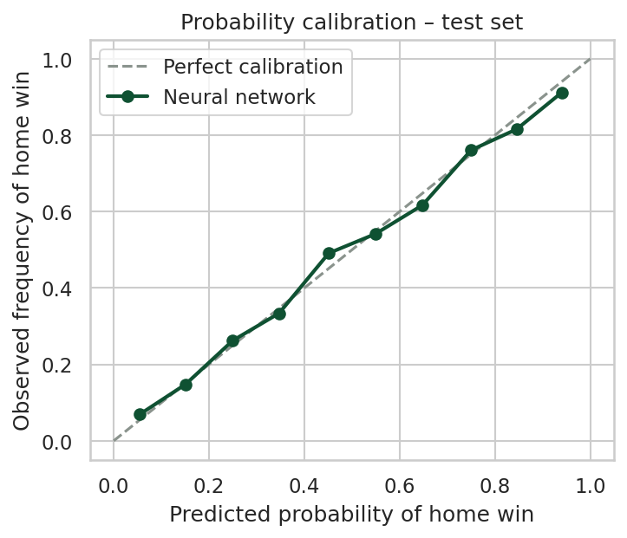
Figure 11: Calibration of predicted home-win probabilities
Interpretation: The points lie very close to the diagonal line of perfect calibration. For example, among matches where the network gave the home side about a 75% chance, the home side actually won 76% of the time. This means the probabilities can be trusted at face value, which is essential for practical use.
Table 15 shows that accuracy increases steadily with the model’s confidence, another sign that the network knows when it is likely to be right.
Table 15: Test accuracy grouped by the model’s confidence
Highest predicted probability | Matches | Accuracy
Up to 50% | 1,575 | 42.92%
50% – 60% | 816 | 53.92%
60% – 70% | 767 | 60.63%
70% – 80% | 648 | 74.69%
Above 80% | 901 | 85.90%

CHAPTER SIX: DISCUSSION, APPLICATION AND FUTURE WORK

6.1 Discussion of Performance, Strengths and Limitations (Task 14)
The neural network achieved 60.31% accuracy on more than four years of unseen matches. This should be judged against the nature of the problem: football is a low-scoring, high-variance sport in which a single goal often decides the result, so perfect prediction is impossible. Published studies and professional bookmakers typically reach roughly 50–55% accuracy on club football, where teams are more evenly matched; international football is somewhat more predictable because of wide differences in team quality.
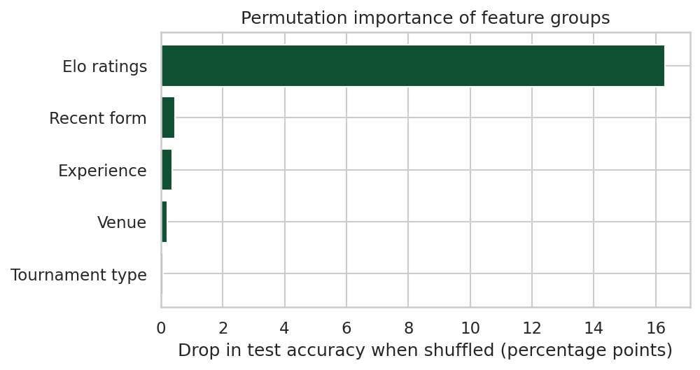
Figure 12: Permutation importance of feature groups on the test set
Permutation importance (Figure 12) measures how much accuracy drops when a feature group is randomly shuffled. Shuffling the Elo ratings reduces accuracy by 16.3 percentage points, whereas each other group contributes less than half a point. The network therefore relies overwhelmingly on team strength, which explains why its accuracy is close to the simple Elo rule.

Strengths observed
- Genuine predictive power: the model beats the majority baseline by 12.6 points and uninformed guessing by a wide margin in log-loss.
- Well-calibrated probabilities: predicted probabilities closely match observed frequencies (Figure 11), making them directly usable for decision-making.
- Knows when it is confident: accuracy exceeds 85% when the model is more than 80% confident (Table 15).
- Realistic evaluation: the chronological split and leakage-free feature engineering mean the reported performance reflects real forecasting ability.
- Stable and efficient: a small network of only 739 parameters trains in seconds, did not overfit, and gave consistent accuracy in every test year (57%–63%).

Limitations observed
- Draws are almost never predicted (recall 2.1%), because a draw is rarely the single most likely outcome. This lowers the macro F1-score to 0.456.
- Little gain over the Elo rule in accuracy: the network’s advantage is mainly in probability estimation rather than in the number of correct picks, showing that most of the useful information is already captured by the engineered Elo feature.
- Limited information: the dataset contains no player-level data (injuries, suspensions, squad selection), tactics, weather or betting-market information, all of which influence results.
- Neutral-venue labelling: at neutral venues ‘home’ simply means the first-listed team, which adds some noise to the venue features.
- Penalty shoot-outs: knockout matches decided on penalties are recorded as draws, which does not always reflect how the tie was decided.

6.2 Application of the System to the Real-World Problem (Task 15)
The developed system can be used in several practical ways:
- National football federations and coaches (for example the Nigeria Football Federation) can estimate the difficulty of upcoming qualifiers and friendlies, plan squad rotation, and choose friendly opponents that give useful preparation.
- Media and broadcasters can publish data-driven previews showing each team’s win, draw and loss probabilities before a match, adding objective analysis to coverage.
- Tournament simulation: by running the model on every fixture of a competition thousands of times (Monte-Carlo simulation), the probability of each team qualifying or winning a tournament can be estimated.
- Fantasy football and fan-engagement apps can use the probabilities to power prediction games, and the calibrated probabilities help users understand uncertainty.
- Sports-analytics education and research: the pipeline demonstrates a reusable end-to-end workflow that can be extended to club football, women’s football or other team sports.
In operation, the system would be updated after every international match: the new result is appended to the dataset, Elo ratings and form are recalculated, and predictions are generated for the next fixtures by supplying the two teams, the venue and the competition.

6.3 Possible Improvements for Future Work (Task 16)
- Better handling of draws: apply class weighting or a probability-threshold rule (for example, predict a draw when the two win probabilities are close and the draw probability exceeds a set value), or train an ordinal model that respects the natural order Away Win < Draw < Home Win.
- Richer input data: add player-level information (squad market value, injuries, key absences), FIFA ranking points, travel distance, rest days between matches and betting-market odds.
- Predict scores rather than outcomes: train a network (or Poisson-based model such as Dixon–Coles) to predict the number of goals for each team, from which win/draw/loss probabilities, and exact-score probabilities, can be derived.
- Model comparison and ensembling: compare the MLP with gradient-boosted trees and logistic regression, and combine their probabilities; tune hyperparameters with time-series cross-validation.
- Deployment: package the model as a simple web or mobile application that automatically downloads new results and publishes predictions for upcoming fixtures.

CHAPTER SEVEN: CONCLUSION AND SUBMISSION

7.1 Conclusion
This project demonstrated the complete data-science process on a real-world sports problem: raw data → data cleaning → data transformation → data analysis → visualisation → neural-network prediction → evaluation → interpretation. A dataset of 49,547 international football matches was cleaned and transformed with Pandas; informative, leakage-free features were engineered, most notably Elo ratings; and a multilayer perceptron neural network was trained and tested on a realistic chronological split.
The network predicted 60.31% of unseen matches correctly and 66.35% of the 2026 World Cup, clearly outperforming naive baselines and producing well-calibrated probabilities. The work also showed that careful feature engineering matters at least as much as the neural network itself: once team strength was captured by the Elo rating, even a small network was sufficient. The main remaining challenge is the prediction of draws, which future work can address through the improvements proposed in Section 6.3.

7.2 Submitted Materials (Task 17)
The following materials make up the complete submission:
Table 16: Contents of the submission
File / folder | Description
football_prediction.py | Complete, commented Python source code for the whole pipeline (also in Appendix A)
results.csv | Original raw dataset (49,547 international matches, 1872–2026)
outputs/cleaned_featured_dataset.csv | Cleaned dataset with all engineered features
outputs/test_predictions.csv | Actual and predicted result with probabilities for every test match
outputs/results_summary.json | All numerical results reported in this document
figures/ (12 PNG files) | All visualisations shown in this report
This report (.docx) | Written documentation of the work

To reproduce all results, place results.csv in the same folder as the script, install the required libraries (pip install pandas numpy matplotlib seaborn scikit-learn) and run python football_prediction.py.

REFERENCES
Dixon, M. J., & Coles, S. G. (1997). Modelling association football scores and inefficiencies in the football betting market. Journal of the Royal Statistical Society: Series C (Applied Statistics), 46(2), 265–280.
Elo, A. E. (1978). The Rating of Chessplayers, Past and Present. New York: Arco Publishing.
Goodfellow, I., Bengio, Y., & Courville, A. (2016). Deep Learning. Cambridge, MA: MIT Press.
Hunter, J. D. (2007). Matplotlib: A 2D graphics environment. Computing in Science & Engineering, 9(3), 90–95.
Hvattum, L. M., & Arntzen, H. (2010). Using ELO ratings for match result prediction in association football. International Journal of Forecasting, 26(3), 460–470.
Jürisoo, M. (2026). International football results from 1872 to 2026 [Data set]. GitHub. https://github.com/martj42/international_results
McKinney, W. (2010). Data structures for statistical computing in Python. Proceedings of the 9th Python in Science Conference, 56–61.
Pedregosa, F., Varoquaux, G., Gramfort, A., et al. (2011). Scikit-learn: Machine learning in Python. Journal of Machine Learning Research, 12, 2825–2830.
Waskom, M. L. (2021). seaborn: Statistical data visualization. Journal of Open Source Software, 6(60), 3021.
World Football Elo Ratings. (n.d.). About the ratings. Retrieved from https://www.eloratings.net/about

APPENDIX A: COMPLETE PYTHON SOURCE CODE
The full source code of football_prediction.py is reproduced below.
"""
AIT 312 - Python for Artificial Intelligence | Group Assignment (Group: SPORT)
Katsina State Institute of Technology and Management
School of Technology, Department of Artificial Intelligence

Project : Predicting the Outcome of International Football Matches
(Home Win / Draw / Away Win) using Pandas and a Neural Network
Author : Hussaina Akilu (HND/AIT/25/0057)

Pipeline: raw data -> inspection -> cleaning -> transformation/feature
engineering -> analysis -> visualisation -> neural-network
prediction -> evaluation -> interpretation

Dataset : International football results, 1872-2026 (Mart Jurisoo),
https://github.com/martj42/international_results (results.csv)

Run : python football_prediction.py
Requires: pandas, numpy, matplotlib, seaborn, scikit-learn
"""

import json
import os
from collections import defaultdict, deque

import matplotlib
matplotlib.use("Agg")
import matplotlib.pyplot as plt
import numpy as np
import pandas as pd
import seaborn as sns
from sklearn.metrics import (accuracy_score, classification_report,
confusion_matrix, f1_score, log_loss)
from sklearn.neural_network import MLPClassifier
from sklearn.preprocessing import StandardScaler

# ---------------------------------------------------------------------------
# 0. Configuration
# ---------------------------------------------------------------------------
DATA_FILE = "results.csv"
FIG_DIR = "figures"
OUT_DIR = "outputs"
MODEL_START = "2000-01-01" # modelling window starts here
TEST_START = "2022-01-01" # chronological hold-out test set
RANDOM_STATE = 42
os.makedirs(FIG_DIR, exist_ok=True)
os.makedirs(OUT_DIR, exist_ok=True)

GREEN, GOLD, GREY, RED = "#0F5132", "#C9A227", "#8A938D", "#B23A48"
sns.set_theme(style="whitegrid", font_scale=1.0)
plt.rcParams.update({"figure.dpi": 150, "savefig.bbox": "tight"})
LABELS = ["Away Win", "Draw", "Home Win"]
report = {} # collects numbers used in the written report

def save(fig, name):
fig.savefig(os.path.join(FIG_DIR, name))
plt.close(fig)

# ---------------------------------------------------------------------------
# 1-2. Read the dataset
# ---------------------------------------------------------------------------
df = pd.read_csv(DATA_FILE)
print("Loaded:", df.shape)

# ---------------------------------------------------------------------------
# 3. Inspect and describe
# ---------------------------------------------------------------------------
print(df.head())
print(df.dtypes)
print(df.describe())
report["raw_records"] = int(df.shape[0])
report["raw_attributes"] = int(df.shape[1])
report["raw_dtypes"] = {c: str(t) for c, t in df.dtypes.items()}
report["describe"] = df[["home_score", "away_score"]].describe().round(3).to_dict()
report["n_teams"] = int(pd.concat([df.home_team, df.away_team]).nunique())
report["n_tournaments"] = int(df.tournament.nunique())
report["n_countries"] = int(df.country.nunique())
report["date_range"] = [df.date.min(), df.date.max()]
report["neutral_counts"] = df.neutral.value_counts().to_dict()

# ---------------------------------------------------------------------------
# 4. Data-quality checks and cleaning
# ---------------------------------------------------------------------------
quality = {}
quality["missing_per_column"] = df.isna().sum().to_dict()
quality["exact_duplicates"] = int(df.duplicated().sum())
key_dups = df[df.duplicated(["date", "home_team", "away_team"], keep=False)]
quality["same_fixture_same_day"] = int(len(key_dups))
quality["same_fixture_rows"] = key_dups.to_dict("records")
quality["date_dtype_before"] = str(df["date"].dtype)
quality["self_matches"] = int((df.home_team == df.away_team).sum())
quality["negative_scores"] = int(((df.home_score < 0) | (df.away_score < 0)).sum())

# (a) text cleaning: strip whitespace in categorical columns
for col in ["home_team", "away_team", "tournament", "city", "country"]:
df[col] = df[col].astype(str).str.strip()

# (b) incorrect data type: date is stored as text -> convert to datetime
df["date"] = pd.to_datetime(df["date"], errors="coerce")
quality["unparseable_dates"] = int(df["date"].isna().sum())
df = df.dropna(subset=["date"])

# (c) remove exact duplicate rows (none expected, but enforced)
df = df.drop_duplicates()

# (d) matches without a recorded score (future fixtures) cannot be labelled
before = len(df)
df = df.dropna(subset=["home_score", "away_score"])
quality["rows_without_score_removed"] = int(before - len(df))
df[["home_score", "away_score"]] = df[["home_score", "away_score"]].astype(int)

# (e) inconsistent / high-cardinality categorical values:
# 202 tournament names are grouped into 6 consistent categories
def tournament_category(name):
n = name.lower()
if n == "friendly":
return "Friendly"
if n == "fifa world cup":
return "World Cup"
if "qualification" in n:
return "Qualifier"
if "nations league" in n:
return "Nations League"
continental = ["uefa euro", "copa américa", "african cup of nations",
"afc asian cup", "gold cup", "ofc nations cup",
"confederations cup"]
if any(n.startswith(c) for c in continental):
return "Continental Final"
return "Other Tournament"

df["tournament_cat"] = df["tournament"].apply(tournament_category)

# (f) extreme scores (e.g. 31-0) are genuine results between very unequal
# teams, so they are kept; they are flagged for the analysis.
df["goal_diff"] = df.home_score - df.away_score
quality["extreme_margin_matches_(>=10)"] = int((df.goal_diff.abs() >= 10).sum())
df = df.sort_values("date").reset_index(drop=True)
quality["records_after_cleaning"] = int(len(df))
report["quality"] = quality
print("Data quality:", {k: v for k, v in quality.items() if k != "same_fixture_rows"})

# ---------------------------------------------------------------------------
# 5. Transformation and feature creation
# Features are computed strictly from matches played BEFORE each game,
# so no information from the match itself leaks into its prediction.
# ---------------------------------------------------------------------------
df["result"] = np.select([df.goal_diff > 0, df.goal_diff == 0], ["Home Win", "Draw"],
default="Away Win")
df["total_goals"] = df.home_score + df.away_score
df["year"] = df.date.dt.year
df["decade"] = (df.year // 10) * 10
df["neutral"] = df["neutral"].astype(int)
df["home_in_own_country"] = (df.home_team == df.country).astype(int)

K_BY_CAT = {"World Cup": 60, "Continental Final": 50, "Qualifier": 40,
"Nations League": 40, "Other Tournament": 30, "Friendly": 20}
HOME_ADV = 100
elo = defaultdict(lambda: 1500.0)
history = defaultdict(lambda: deque(maxlen=5)) # (goals_for, goals_against, points)
played = defaultdict(int)

rows = []
for r in df.itertuples(index=False):
h, a = r.home_team, r.away_team
eh, ea = elo[h], elo[a]

def form(team):
hist = history[team]
if not hist:
return np.nan, np.nan, np.nan
g = np.array(hist)
return g[:, 0].mean(), g[:, 1].mean(), g[:, 2].mean()

hgf, hga, hpts = form(h)
agf, aga, apts = form(a)
rows.append((eh, ea, hgf, hga, hpts, agf, aga, apts, played[h], played[a]))

# --- update Elo (World Football Elo style) -----------------------------
adv = 0 if r.neutral else HOME_ADV
exp_h = 1 / (1 + 10 ** ((ea - (eh + adv)) / 400))
s_h = 1.0 if r.goal_diff > 0 else 0.5 if r.goal_diff == 0 else 0.0
gd = abs(r.goal_diff)
mult = 1 if gd <= 1 else 1.5 if gd == 2 else (11 + gd) / 8
change = K_BY_CAT[r.tournament_cat] * mult * (s_h - exp_h)
elo[h] += change
elo[a] -= change

# --- update recent form and experience ---------------------------------
pts_h = 3 if s_h == 1 else 1 if s_h == 0.5 else 0
pts_a = 3 if s_h == 0 else 1 if s_h == 0.5 else 0
history[h].append((r.home_score, r.away_score, pts_h))
history[a].append((r.away_score, r.home_score, pts_a))
played[h] += 1
played[a] += 1

feat_cols = ["home_elo", "away_elo", "home_gf5", "home_ga5", "home_pts5",
"away_gf5", "away_ga5", "away_pts5", "home_played", "away_played"]
df[feat_cols] = pd.DataFrame(rows, index=df.index, columns=feat_cols)
df["elo_diff"] = df.home_elo - df.away_elo + np.where(df.neutral == 1, 0, HOME_ADV)
df["form_diff"] = df.home_pts5 - df.away_pts5
df["exp_diff"] = np.log1p(df.home_played) - np.log1p(df.away_played)

# Missing values created by feature engineering (a team's first match has
# no previous form). Handled by imputing the neutral value for a new team.
missing_form = int(df[["home_gf5", "away_gf5"]].isna().any(axis=1).sum())
report["quality"]["missing_form_values_imputed"] = missing_form
impute = {"home_gf5": 1.0, "home_ga5": 1.0, "home_pts5": 1.0,
"away_gf5": 1.0, "away_ga5": 1.0, "away_pts5": 1.0}
df = df.fillna(impute)
df["form_diff"] = df.home_pts5 - df.away_pts5

df.to_csv(os.path.join(OUT_DIR, "cleaned_featured_dataset.csv"), index=False)

# ---------------------------------------------------------------------------
# 6. Analysis with Pandas and statistics
# ---------------------------------------------------------------------------
res_share = (df.result.value_counts(normalize=True) * 100).round(2)
report["result_share_all"] = res_share.to_dict()

decade_goals = df.groupby("decade")["total_goals"].mean().round(3)
report["goals_by_decade"] = decade_goals.to_dict()

home_adv = (pd.crosstab(df.neutral.map({0: "Home venue", 1: "Neutral venue"}),
df.result, normalize="index") * 100).round(2)
report["home_advantage"] = home_adv.to_dict("index")

tour = (df.groupby("tournament_cat")
.agg(matches=("result", "size"), avg_goals=("total_goals", "mean"),
home_win_pct=("result", lambda s: (s == "Home Win").mean() * 100))
.round(2).sort_values("matches", ascending=False))
report["tournament_summary"] = tour.to_dict("index")

modern = df[df.date >= MODEL_START].copy()
modern["elo_bin"] = pd.cut(modern.elo_diff, bins=[-800, -300, -200, -100, 0, 100,
200, 300, 400, 1200])
elo_bins = (pd.crosstab(modern.elo_bin, modern.result, normalize="index") * 100).round(2)
report["elo_bins"] = {str(k): v for k, v in elo_bins.to_dict("index").items()}

corr_cols = ["elo_diff", "form_diff", "exp_diff", "home_gf5", "home_ga5",
"away_gf5", "away_ga5", "neutral", "home_in_own_country"]
modern["target_num"] = modern.result.map({"Away Win": -1, "Draw": 0, "Home Win": 1})
corr = modern[corr_cols + ["target_num"]].corr().round(3)
report["corr_with_target"] = corr["target_num"].drop("target_num").to_dict()

top_teams = (pd.Series(elo).sort_values(ascending=False).head(10).round(1))
report["top_elo_teams"] = top_teams.to_dict()

# ---------------------------------------------------------------------------
# 7. Visualisation
# ---------------------------------------------------------------------------
fig, ax = plt.subplots(figsize=(6.5, 3.6))
order = ["Home Win", "Draw", "Away Win"]
vals = [res_share[o] for o in order]
bars = ax.bar(order, vals, color=[GREEN, GREY, GOLD])
ax.bar_label(bars, fmt="%.1f%%")
ax.set_ylim(0, max(vals) * 1.15)
ax.set_ylabel("Share of matches (%)")
ax.set_title("Distribution of match outcomes (1872–2026)")
save(fig, "fig01_outcome_distribution.png")

fig, ax = plt.subplots(figsize=(6.5, 3.6))
ax.plot(decade_goals.index, decade_goals.values, marker="o", color=GREEN, lw=2)
ax.set_xlabel("Decade"); ax.set_ylabel("Average goals per match")
ax.set_title("Average goals per international match by decade")
save(fig, "fig02_goals_by_decade.png")

fig, ax = plt.subplots(figsize=(6.5, 3.6))
home_adv[order].plot(kind="bar", ax=ax, color=[GREEN, GREY, GOLD], rot=0)
ax.set_ylabel("Share of matches (%)"); ax.set_xlabel("")
ax.set_title("Home advantage: outcomes at home vs neutral venues")
ax.legend(title="")
save(fig, "fig03_home_advantage.png")

fig, ax = plt.subplots(figsize=(6.5, 3.6))
clipped = df.goal_diff.clip(-8, 8)
ax.hist(clipped, bins=np.arange(-8.5, 9.5, 1), color=GREEN, edgecolor="white")
ax.set_xlabel("Goal difference (home − away), clipped at ±8")
ax.set_ylabel("Number of matches")
ax.set_title("Distribution of goal difference")
save(fig, "fig04_goal_difference.png")

fig, ax = plt.subplots(figsize=(6.5, 3.8))
x = [str(i) for i in elo_bins.index]
for lab, col in zip(order, [GREEN, GREY, GOLD]):
ax.plot(x, elo_bins[lab], marker="o", label=lab, color=col, lw=2)
ax.set_xlabel("Elo difference (home − away, incl. home advantage)")
ax.set_ylabel("Outcome share (%)")
ax.set_title("Outcome probability rises with Elo rating difference (2000–2026)")
ax.tick_params(axis="x", rotation=35)
ax.legend()
save(fig, "fig05_elo_vs_outcome.png")

fig, ax = plt.subplots(figsize=(6.8, 5.4))
sns.heatmap(corr, annot=True, fmt=".2f", cmap="RdYlGn", center=0, ax=ax,
cbar_kws={"shrink": .75}, annot_kws={"size": 7})
ax.set_title("Correlation matrix of engineered features and target")
save(fig, "fig06_correlation_heatmap.png")

fig, ax = plt.subplots(figsize=(6.5, 3.6))
ax.barh(top_teams.index[::-1], top_teams.values[::-1], color=GREEN)
ax.set_xlim(top_teams.min() - 80, top_teams.max() + 30)
ax.set_xlabel("Elo rating (end of dataset)")
ax.set_title("Top 10 national teams by computed Elo rating")
save(fig, "fig07_top_elo_teams.png")

# ---------------------------------------------------------------------------
# 8. Input features and target
# ---------------------------------------------------------------------------
num_features = ["elo_diff", "home_elo", "away_elo", "form_diff",
"home_gf5", "home_ga5", "home_pts5",
"away_gf5", "away_ga5", "away_pts5",
"exp_diff", "neutral", "home_in_own_country"]
data = df[df.date >= MODEL_START].copy()
X = pd.get_dummies(data[num_features + ["tournament_cat"]],
columns=["tournament_cat"], prefix="tour", dtype=int)
# label encoding of the target: 0 = Away Win, 1 = Draw, 2 = Home Win
LABEL_TO_ID = {lab: i for i, lab in enumerate(LABELS)}
y = data["result"].map(LABEL_TO_ID)
feature_names = list(X.columns)
report["features"] = feature_names
report["model_records"] = int(len(data))

# ---------------------------------------------------------------------------
# 9. Train / test split (chronological, to mimic real forecasting)
# ---------------------------------------------------------------------------
train_mask = data.date < TEST_START
X_train, X_test = X[train_mask], X[~train_mask]
y_train, y_test = y[train_mask], y[~train_mask]
report["split"] = {"train": int(len(X_train)), "test": int(len(X_test)),
"train_period": f"{MODEL_START[:4]}–2021",
"test_period": f"2022–{data.date.max():%Y}"}

scaler = StandardScaler()
scale_cols = [c for c in feature_names if not c.startswith("tour_")
and c not in ("neutral", "home_in_own_country")]
X_train_s, X_test_s = X_train.copy().astype(float), X_test.copy().astype(float)
X_train_s[scale_cols] = scaler.fit_transform(X_train[scale_cols])
X_test_s[scale_cols] = scaler.transform(X_test[scale_cols])

# ---------------------------------------------------------------------------
# 10. Neural network: architecture selection on a time-based validation set
# ---------------------------------------------------------------------------
val_mask = data.loc[train_mask, "date"] >= "2018-01-01"
Xtr_in, Xval = X_train_s[~val_mask.values], X_train_s[val_mask.values]
ytr_in, yval = y_train[~val_mask.values], y_train[val_mask.values]
candidates = {"MLP (32)": (32,), "MLP (64, 32)": (64, 32), "MLP (128, 64, 32)": (128, 64, 32)}
cand_scores = {}
for name, layers in candidates.items():
m = MLPClassifier(hidden_layer_sizes=layers, activation="relu", solver="adam",
alpha=1e-3, learning_rate_init=1e-3, batch_size=128,
max_iter=300, early_stopping=True, validation_fraction=0.1,
n_iter_no_change=15, random_state=RANDOM_STATE)
m.fit(Xtr_in, ytr_in)
p = m.predict_proba(Xval)
cand_scores[name] = {"val_accuracy": round(accuracy_score(yval, m.predict(Xval)) * 100, 2),
"val_log_loss": round(log_loss(yval, p, labels=m.classes_), 4),
"epochs": int(m.n_iter_)}
report["architecture_search"] = cand_scores
best_name = min(cand_scores, key=lambda k: cand_scores[k]["val_log_loss"])
report["best_architecture"] = best_name
print("Architecture search:", cand_scores, "-> best:", best_name)

# ---------------------------------------------------------------------------
# 11. Train final network and predict the test set
# ---------------------------------------------------------------------------
model = MLPClassifier(hidden_layer_sizes=candidates[best_name], activation="relu",
solver="adam", alpha=1e-3, learning_rate_init=1e-3,
batch_size=128, max_iter=300, early_stopping=True,
validation_fraction=0.1, n_iter_no_change=15,
random_state=RANDOM_STATE)
model.fit(X_train_s, y_train)
y_pred = np.array(LABELS)[model.predict(X_test_s)]
y_prob = model.predict_proba(X_test_s) # columns: Away, Draw, Home
y_test = y_test.map(dict(enumerate(LABELS)))
report["epochs_trained"] = int(model.n_iter_)
report["n_parameters"] = int(sum(w.size for w in model.coefs_) +
sum(b.size for b in model.intercepts_))

fig, ax1 = plt.subplots(figsize=(6.5, 3.6))
ax1.plot(model.loss_curve_, color=GREEN, lw=2, label="Training loss")
ax1.set_xlabel("Epoch"); ax1.set_ylabel("Cross-entropy loss")
ax2 = ax1.twinx()
ax2.plot(model.validation_scores_, color=GOLD, lw=2, label="Validation accuracy")
ax2.set_ylabel("Validation accuracy"); ax2.grid(False)
h1, l1 = ax1.get_legend_handles_labels(); h2, l2 = ax2.get_legend_handles_labels()
ax1.legend(h1 + h2, l1 + l2, loc="upper center", bbox_to_anchor=(0.5, -0.18), ncol=2, frameon=False)
ax1.set_title("Neural network training history")
save(fig, "fig08_training_curve.png")

# ---------------------------------------------------------------------------
# 12. Evaluation
# ---------------------------------------------------------------------------
acc = accuracy_score(y_test, y_pred)
report["test_accuracy"] = round(acc * 100, 2)
report["test_macro_f1"] = round(f1_score(y_test, y_pred, average="macro"), 4)
report["test_weighted_f1"] = round(f1_score(y_test, y_pred, average="weighted"), 4)
report["test_log_loss"] = round(log_loss(y_test, y_prob, labels=LABELS), 4)
report["classification_report"] = classification_report(y_test, y_pred, output_dict=True)

# baselines for context
majority = LABELS[y_train.value_counts().idxmax()]
report["baseline_majority_acc"] = round((y_test == majority).mean() * 100, 2)
elo_rule = np.where(data.loc[~train_mask, "elo_diff"] > 0, "Home Win", "Away Win")
report["baseline_elo_rule_acc"] = round((y_test.values == elo_rule).mean() * 100, 2)
report["baseline_uniform_log_loss"] = round(np.log(3), 4)

cm = confusion_matrix(y_test, y_pred, labels=order)
report["confusion_matrix"] = cm.tolist()
fig, ax = plt.subplots(figsize=(5.2, 4.2))
sns.heatmap(cm, annot=True, fmt="d", cmap="Greens", xticklabels=order,
yticklabels=order, ax=ax, cbar=False)
ax.set_xlabel("Predicted outcome"); ax.set_ylabel("Actual outcome")
ax.set_title("Confusion matrix – test set (2022–2026)")
save(fig, "fig09_confusion_matrix.png")

# ---------------------------------------------------------------------------
# 13. Actual vs predicted
# ---------------------------------------------------------------------------
test = data.loc[~train_mask, ["date", "home_team", "away_team", "home_score",
"away_score", "tournament", "result"]].copy()
test["predicted"] = y_pred
cls = LABELS
for lab in order:
test[f"p_{lab}"] = y_prob[:, cls.index(lab)]
test["correct"] = test.result == test.predicted
test.to_csv(os.path.join(OUT_DIR, "test_predictions.csv"), index=False)

act = y_test.value_counts().reindex(order)
pred = pd.Series(y_pred).value_counts().reindex(order).fillna(0)
report["actual_vs_pred_counts"] = {"actual": act.to_dict(), "predicted": pred.astype(int).to_dict()}
fig, ax = plt.subplots(figsize=(6.5, 3.6))
w = 0.38; xi = np.arange(3)
b1 = ax.bar(xi - w / 2, act.values, w, color=GREEN, label="Actual")
b2 = ax.bar(xi + w / 2, pred.values, w, color=GOLD, label="Predicted")
ax.bar_label(b1); ax.bar_label(b2)
ax.set_xticks(xi, order); ax.set_ylabel("Number of matches")
ax.set_title("Actual vs predicted outcomes – test set"); ax.legend()
save(fig, "fig10_actual_vs_predicted.png")

# calibration: predicted home-win probability vs observed home-win frequency
test["p_bin"] = pd.cut(test["p_Home Win"], bins=np.linspace(0, 1, 11))
calib = test.groupby("p_bin", observed=True).agg(
mean_pred=("p_Home Win", "mean"),
observed=("result", lambda s: (s == "Home Win").mean()),
n=("result", "size"))
calib = calib[calib.n >= 20]
fig, ax = plt.subplots(figsize=(5.2, 4.2))
ax.plot([0, 1], [0, 1], ls="--", color=GREY, label="Perfect calibration")
ax.plot(calib.mean_pred, calib.observed, marker="o", color=GREEN, lw=2, label="Neural network")
ax.set_xlabel("Predicted probability of home win")
ax.set_ylabel("Observed frequency of home win")
ax.set_title("Probability calibration – test set"); ax.legend()
save(fig, "fig11_calibration.png")
report["calibration"] = calib.round(3).reset_index(drop=True).to_dict("records")

# accuracy by confidence
test["confidence"] = y_prob.max(axis=1)
conf = test.groupby(pd.cut(test.confidence, [0, .5, .6, .7, .8, 1.0]), observed=True).agg(
matches=("correct", "size"), accuracy=("correct", "mean"))
conf["accuracy"] = (conf.accuracy * 100).round(2)
report["accuracy_by_confidence"] = {str(k): v for k, v in conf.to_dict("index").items()}

# showcase: FIFA World Cup 2026
wc = test[(test.tournament == "FIFA World Cup") & (test.date.dt.year == 2026)]
report["wc2026"] = {"matches": int(len(wc)),
"accuracy": round(wc.correct.mean() * 100, 2) if len(wc) else None}
sample = wc.tail(8) if len(wc) else test.tail(8)
report["sample_predictions"] = [
{"date": f"{r.date:%d %b %Y}", "match": f"{r.home_team} vs {r.away_team}",
"score": f"{r.home_score}–{r.away_score}", "actual": r.result,
"predicted": r.predicted,
"probs": f"{r['p_Home Win']:.2f} / {r['p_Draw']:.2f} / {r['p_Away Win']:.2f}"}
for _, r in sample.iterrows()]

# permutation importance (drop in accuracy when each feature group is shuffled)
rng = np.random.default_rng(RANDOM_STATE)
groups = {"Elo ratings": ["elo_diff", "home_elo", "away_elo"],
"Recent form": ["form_diff", "home_gf5", "home_ga5", "home_pts5",
"away_gf5", "away_ga5", "away_pts5"],
"Experience": ["exp_diff"],
"Venue": ["neutral", "home_in_own_country"],
"Tournament type": [c for c in feature_names if c.startswith("tour_")]}
imp = {}
for g, cols in groups.items():
drops = []
for _ in range(5):
Xp = X_test_s.copy()
idx = rng.permutation(len(Xp))
Xp[cols] = Xp[cols].values[idx]
drops.append(acc - accuracy_score(y_test, np.array(LABELS)[model.predict(Xp)]))
imp[g] = round(float(np.mean(drops)) * 100, 2)
imp = dict(sorted(imp.items(), key=lambda kv: kv[1], reverse=True))
report["feature_group_importance"] = imp
fig, ax = plt.subplots(figsize=(6.5, 3.4))
ax.barh(list(imp)[::-1], list(imp.values())[::-1], color=GREEN)
ax.set_xlabel("Drop in test accuracy when shuffled (percentage points)")
ax.set_title("Permutation importance of feature groups")
save(fig, "fig12_feature_importance.png")

with open(os.path.join(OUT_DIR, "results_summary.json"), "w") as f:
json.dump(report, f, indent=2, default=str)
print(f"Test accuracy: {report['test_accuracy']}% | macro-F1: {report['test_macro_f1']}"
f" | log-loss: {report['test_log_loss']}")
print("Done. Figures saved in", FIG_DIR, "and outputs in", OUT_DIR)

