PHINMA University of Iloilo
COLLEGE OF INFORMATION TECHNOLOGY EDUCATION
Rizal, Iloilo City, Philippines
BRAVEBOT
An AI-Powered Facebook Messenger Chatbot for Customer Inquiries and Cake Order Taking of Mrs. Brave’s Cakes
A Business Process Automation Plan and Working Prototype
Presented to the Faculty of the College of Information Technology Education
In partial fulfillment of the requirements for
BAM 285 – Business Analysis in IT
By:
Senosa, Kristle Reign C.
Solamillo, Justin Brian A.
Roa, Althea Marie P.
Roa, Felix Adrian P.
Tibajares, Noli Jr A.
Palcullo, Julliene Kathryn T.
Dequina, Reyjan J.
Ladrillo, Carl Justin S.
Barretto, Daxl Ross A.
Barron, Edwin Charles H.
October 2026

ACKNOWLEDGMENT
We could not have finished this project alone. Many people helped us along the way, and we want to thank them.
First, we thank God for giving us strength, patience, and wisdom, especially on the days when the code would not run and the deadlines felt too close.
We are very grateful to Mrs. Shamelyn Tapang, the owner of Mrs. Brave’s Cakes. She gave us her time, answered our questions honestly, and let us watch how she handled her Messenger inbox. This project is built around her real work, and we hope it makes her days a little lighter.
We thank our professor, [Name of Professor], for guiding us in BAM 285. Your advice, patience, and feedback helped us think like business analysts and not just programmers.
We also thank the faculty and staff of the College of Information Technology Education of PHINMA University of Iloilo for teaching us the skills we used in this project.
To the customers and friends who tried our chatbot and answered our questions, thank you for your honest feedback.
To our families, thank you for your love, support, and understanding while we spent long nights working on this.
Finally, we thank each other. We shared the work, fixed each other’s mistakes, and kept going until it was done.
The BraveBot Team

EXECUTIVE SUMMARY
Mrs. Brave’s Cakes is a small pastry shop in Iloilo City, started in 2020 by Mrs. Shamelyn Tapang. Most customers asked questions and placed orders through Facebook Messenger. The owner answered every message herself while baking, paying, and delivering. Customers often sent their details in separate messages, so one order could take 24 to 48 hours to finish.
To fix this, we built BraveBot, an AI-powered chatbot that works inside Messenger. It answered common questions, guides customers through ordering premade cakes with fixed prices, checks availability, shows an order summary, and saves the order only after the customer confirms. If it cannot help, it passes the chat to the owner.
We started by studying the old process through interviews and observation. We found seven problems: repeated replies, slow responses, incomplete details, unclear confirmation, manual recording, manual availability checking, and no help after hours. We traced the causes to people, process, platform, and paperwork. Then we designed a better process, wrote 15 functional requirements and eight quality requirements, and set ten business rules. We designed a system with Messenger, a FastAPI backend, the Gemini AI model, and a Supabase database. The AI handles the conversation, while the backend checks every detail.
We also prepared 15 test cases, a risk analysis, a plan for training and change, and a cost estimate. The first-year cost was estimated at ₱5,600, and the expected saving from the owner’s time was ₱19,200 a year, which would pay back the cost in about 3.5 months.
The prototype answered all seven problems. The team’s earlier bakery system for the same shop passed all 45 tests and scored 4.79 out of 5 (Excellent) in user acceptance testing.
We concluded that a small bakery can use a chatbot to save time and serve customers faster, as long as the owner stays in charge of final prices and custom orders. We recommended a trial with real customers, Meta app approval, a link to the bakery’s web system, online payment, and support for custom cakes.

TABLE OF CONTENTS
ACKNOWLEDGMENT 2
EXECUTIVE SUMMARY 3
CHAPTER 1: INTRODUCTION 7
1.1 Background of the Project 7
1.2 Statement of the Problem 7
1.3 Objectives of the Project 8
1.4 Significance of the Project 9
1.5 Purpose and Description 9
1.6 Scope and Limitations 10
CHAPTER 2: REVIEW OF RELATED LITERATURE AND SYSTEMS 12
2.1 Foreign Literature and Studies 12
2.2 Local Literature and Studies 13
2.3 Related Systems 14
2.4 Synthesis 15
CHAPTER 3: METHODOLOGY, RESULTS, AND DISCUSSION 16
3.1 Requirements Analysis 16
3.2 Framework of the Project 21
3.3 Development and Testing 29
3.4 Implementation Plan 31
CHAPTER 4: RESULTS AND DISCUSSION 35
4.1 Implementation 35
4.2 Development Tools 35
4.3 Hardware Requirements 36
4.4 Software Requirements 36
4.5 Input and Outputs of the Study 36
4.6 Results Interpretation and Analysis 37
4.7 System Evaluation Results 38
CHAPTER 5: CONCLUSION AND RECOMMENDATIONS 41
5.1 Introduction 41
5.2 Summary of the Proposed Study Design and Implementation 41
5.3 Summary of Findings 41
5.4 Conclusion 42
5.5 Recommendation 42
REFERENCES 44

LIST OF TABLES
Table 1. Comparison of Related Systems and BraveBot 14
Table 2. Stakeholder Analysis Matrix 16
Table 3. SIPOC Analysis 16
Table 4. Problems and Root Causes 18
Table 5. Functional Requirements Catalog 20
Table 6. Non-Functional Requirements Specification 21
Table 7. Before-and-After Process Comparison 23
Table 8. Business Rules of the Chatbot 24
Table 9. Sample Order Record (Fictional Data) 26
Table 10. Technologies Used 27
Table 11. Key Performance Indicators and Targets 28
Table 12. Sample Conversation 29
Table 13. Test Cases 30
Table 14. Project Implementation Phases 31
Table 15. Implementation Work Breakdown and Weekly Schedule 32
Table 16. Risk Assessment and Mitigation Matrix 32
Table 17. Estimated First-Year Costs 33
Table 18. Estimated Annual Benefit and Return on Investment 33
Table 19. Development Tools 35
Table 20. Hardware Requirements 36
Table 21. Software Requirements 36
Table 22. Inputs and Outputs 37
Table 23. How BraveBot Answered the Problems 37
Table 24. Summary of Test Results of the Bakery System 38
Table 25. Performance Test Results of the Bakery System 39
Table 26. User Acceptance Test Results of the Bakery System 39
Table 27. BraveBot Test Case Results 39

LIST OF FIGURES
Figure 1. Current-State Manual Inquiry and Order Intake Process (As-Is) 18
Figure 2. Fishbone Root-Cause Diagram 19
Figure 3. Business Analysis Project Framework 22
Figure 4. Proposed Future-State Automated Process (To-Be) 23
Figure 5. Entity Relationship Diagram of the Chatbot Database 26
Figure 6. System Architecture of the Chatbot 27
Figure 7. Sequence of a Customer Message and Order Confirmation 27
Figure 8. Conversation State Diagram 28
Figure 9. Four-Week Implementation Timeline 32

CHAPTER 1: INTRODUCTION

1.1 Background of the Project
Many small businesses in the Philippines use Facebook and Messenger to talk to customers and take orders. This is common among local micro, small, and medium enterprises (MSMEs), which use social media to promote and sell their products [1][2]. Some businesses also tried chatbots to make ordering easier. One example was Bo’s Coffee, which launched a Messenger chatbot in 2019 [3].
Mrs. Brave’s Cakes is a pastry shop in Iloilo City. Mrs. Shamelyn Tapang started it in 2020. She handled baking, payments, deliveries, and customer messages by herself. Taking orders through Messenger was slow because customers often sent their details in separate messages. From our interviews and observations, finishing one order took 24 to 48 hours. Some details were also missed in long chats.
Our team had earlier built a web-based system for the bakery’s inventory, sales, cake customization, and rider dispatch. Still, many customers messaged the shop on Messenger first, so replying to questions stayed a manual job. To help, we proposed BraveBot, an AI-powered Messenger chatbot. It answered common questions and helped customers order premade cakes with fixed prices. It guided customers through the order, checked availability, and recorded confirmed orders. Language models made this possible because they can understand customer messages and follow instructions [4].

1.2 Statement of the Problem
Mrs. Brave’s Cakes handled customer questions and cake orders by hand through Facebook Messenger. Since the owner also ran the shop, replying took time. This led to late replies, incomplete order details, and trouble tracking orders.

1.2.1 General Problem
How could the inquiry and order process of Mrs. Brave’s Cakes on Facebook Messenger be improved using an AI-powered chatbot that answers common questions, collects complete order details, checks availability, and records confirmed orders in a database?

1.2.2 Specific Problems
- Repetitive manual replies. Customers asked the same things about cake choices, prices, store hours, and delivery areas. The owner answered each one herself, even when she was busy.
- Delayed response time. Customers waited for replies while the owner was baking. Finishing one order took 24 to 48 hours.
- Incomplete order details. Customers sent their name, contact number, cake, quantity, and delivery details in separate messages. The owner had to read the whole chat and ask for what was missing.
- Unclear order confirmation. Without a clear summary of the cake, quantity, price, and delivery details, customers could misunderstand their orders.
- Manual order recording. Writing orders down by hand took time and caused mistakes. Saving confirmed orders in a database would make them easier to track.
- Manual availability checking. The owner had to check if a premade cake was available on the requested date before confirming. This could lead to orders the shop could not fulfill.
- Limited after-hours help. Customers who messaged while the owner was busy or resting did not get an instant reply.

1.3 Objectives of the Project

1.3.1 General Objective
To develop a Business Process Automation Plan and a working prototype of BraveBot, an AI-powered Facebook Messenger chatbot for Mrs. Brave’s Cakes. The chatbot answered common questions, helped customers order premade cakes with fixed prices, checked availability, and saved confirmed orders in a Supabase database through a FastAPI backend.

1.3.2 Specific Objectives
- To document the current Messenger inquiry and ordering process using stakeholder analysis, SIPOC, process mapping, and fishbone analysis.
- To identify the main problems, delays, and risks in the current process.
- To design a better ordering process that guides customers in choosing a cake, gives order details, checks availability, and asks for confirmation.
- To identify the functional and non-functional requirements of the chatbot.
- To define the business rules for prices, required details, availability checks, order confirmation, and problem handling.
- To design the system architecture and database that connected Messenger, FastAPI, the AI model, and Supabase.
- To prepare test cases for the chatbot’s replies, order details, availability checks, and order recording.
- To prepare an implementation plan, risk analysis, cost-benefit estimate, and change management plan for possible future use.

1.4 Significance of the Project
For the customers. The chatbot gave quick answers at any hour and guided them in placing an order. Customers saw exactly what would be recorded before they confirmed, so wrong orders were less likely.
For the business owner, Mrs. Shamelyn Tapang. The chatbot handled routine questions and the first steps of an order, so she was interrupted less while baking. Orders arrived complete and stored in one place, ready for her to review instead of retyping.
For the student developers. The project gave us a chance to use business analysis and software design for a real client. We also worked with a messaging platform API, a Python backend, and a cloud database in one system.
For future researchers and local MSMEs. The project showed a low-cost idea that worked inside a channel customers already used. Other small sellers on Facebook can adapt it for their own products.

1.5 Purpose and Description
The purpose of this project was to develop a Business Process Automation Plan and a working prototype of BraveBot for Mrs. Brave’s Cakes on Facebook Messenger.
When a customer sent a message, the chatbot introduced itself as an automated assistant. It answered common questions using information from the owner, such as cake choices, fixed prices, store hours, delivery areas, and payment policies. When a customer wanted to order, it collected the name, contact number, cake, quantity, and delivery details. It checked availability and showed an order summary. The customer could confirm, edit, or cancel the order.
Once the customer confirmed, the FastAPI backend checked the details and saved the order in the Supabase PostgreSQL database. Then it sent a reference number to the customer. If the chatbot could not answer a question, or the customer asked for help, the chat was handed to the owner. The project showed this process through a working prototype. Connecting it to the bakery’s existing system needed more approval and development.

1.6 Scope and Limitations

Scope
- A Facebook Messenger chatbot for Mrs. Brave’s Cakes.
- A greeting that said the chatbot was an automated assistant, with quick replies for common questions.
- Answers to frequent questions using the owner’s information: premade cakes, fixed prices, store hours, delivery areas, and payment policies.
- Order processing for premade cakes with fixed prices only.
- Collection and checking of the customer’s name, contact number, cake choice, quantity, and delivery details.
- Checking of cake availability and the requested date before confirmation.
- An order summary with options to confirm, edit, or cancel.
- Automatic saving of confirmed orders in Supabase through FastAPI, followed by a reference number sent to the customer.
- Handoff to the owner when the chatbot could not answer or the customer asked for help.
- Storage of chat logs and order records for the owner to review.

Limitations
- No custom cake orders. The chatbot handled premade cakes with fixed prices only. Custom cake requests were not processed.
- No payment processing in the prototype. Customers did not pay through the chatbot. If it was used for real, it might use the payment gateway of the bakery’s capstone system, subject to approval.
- Separate prototype database. The prototype used its own Supabase PostgreSQL database. Connecting it to the bakery’s existing system needed more development and the owner’s approval.
- Messenger only. The chatbot did not take orders from walk-ins, text messages, or the website.
- Language support. The chatbot was meant to understand English, Filipino, Hiligaynon, and Taglish. Messages it could not understand were referred to the owner.
- Dependence on business information and AI. The chatbot used the owner’s information and backend checks to avoid wrong answers. Still, it could misunderstand some messages.
- Platform requirements. Public use depended on Meta’s Messenger Platform rules and its app review [5].
- Personal data. The chatbot collected only what was needed to process orders and followed the Data Privacy Act of 2012 [6].

CHAPTER 2: REVIEW OF RELATED LITERATURE AND SYSTEMS
This chapter shares the studies and systems we read before building BraveBot. They helped us understand the problem and shape the design.

2.1 Foreign Literature and Studies

2.1.1 Process Improvement and Business Analysis
Dumas et al. [7] described business process management as a cycle: find the process, study it, redesign it, and keep watching it. In this view, automation is one result of redesign, not the starting point. The BABOK Guide [8] agreed. It said to understand the current state, the needs of stakeholders, and the root causes before choosing a solution. We followed the same order. We mapped the current Messenger process first, studied its causes, and only then described the chatbot.

2.1.2 Digital Transformation in Small Businesses
Verhoef et al. [9] said digital transformation changes how a business creates value and deals with customers. It is more than using new software. The OECD [10] reported that small businesses often fall behind big firms in using advanced digital tools because of limited skills and resources. For a bakery, this meant the tool had to fit how the shop already worked and should not force the owner to learn a whole new system.

2.1.3 Chatbots in Customer Service
Adamopoulou and Moussiades [11] traced chatbots from early programs that matched keywords to modern ones built on machine learning. A chatbot that served one business and a few tasks, like ours, belonged to the closed-domain, task-oriented group they described.
Brandtzaeg and Følstad [12] found that most people used chatbots to be more productive. Xu et al. [13] built a customer service chatbot for social media and found that many requests were emotional, not just questions for information. The lesson for us was that a chatbot should know its limits and pass sensitive chats to a person. This was the reason for our handoff rule.
Luo et al. [14] found that customers bought less when they were told at the start that they were talking to a bot. Even so, BraveBot said it was automated, because customers should know who they are talking to. We kept its tasks narrow and useful so that customers would notice how fast it replied. Cordero et al. [15] tested three chatbots used by small and medium businesses and found high user satisfaction. They said a chatbot gives fast service when it works well inside the business’s communication channels. BraveBot did the same by working inside Messenger.

2.1.4 Large Language Models
Brown et al. [4] showed that large language models can do new tasks from instructions and a few examples, without retraining. This made the approach practical for a small business. We wrote BraveBot’s behavior as instructions: what to ask, in what order, and what to say when unsure. The model then read free-form customer messages and turned them into structured fields.

2.1.5 Technology Acceptance
Davis [16] showed that people accept a technology mostly because it is useful and easy to use. Venkatesh et al. [17] later combined several models into one theory that also looked at social influence and supporting conditions. In our project, both the owner and the customers were users. The owner would accept the chatbot if it saved her time. Customers would accept it if it was faster and as easy as waiting for a person. These ideas guided the questions for user testing.

2.2 Local Literature and Studies

2.2.1 The MSME Sector and Digital Adoption
Data from the Department of Trade and Industry [1] showed that MSMEs made up most registered businesses and a large share of jobs in the Philippines. Blanza and Catilo [2] studied MSMEs in Iloilo Province. They found that digital tools improved customer contact, efficiency, and market reach, but money, skills, and infrastructure limited their use. Participants advised starting small, training people often, and focusing on what customers needed. We followed this advice. BraveBot was a small, focused tool built around one need: getting answers and placing orders quickly.

2.2.2 Digital Tools and Filipino MSMEs
Cueto et al. [18] interviewed young Filipino entrepreneurs about digital innovation during hard economic times and learned what pushed them and what held them back. The Asian Development Bank [19] found that internet and e-commerce use did not improve business results during the strict lockdown in March 2020, but it had a good effect by March 2021. This suggested that MSMEs needed some maturity to gain from digital tools. Together, these studies showed that digital tools helped small businesses when they were practical and matched what the owner could handle. This is why we kept the chatbot limited to questions and order intake.

2.2.3 Messenger Ordering in the Philippines
ABS-CBN News reported in 2019 that Bo’s Coffee tested BOTTY, an ordering system inside Facebook Messenger [3]. Customers could add or remove items, get a claim code and an estimated preparation time, and be told when the order was ready. The report also called Messenger a widely used platform among Filipinos. Like BOTTY, BraveBot handled products with fixed prices. But BraveBot was made for Mrs. Brave’s Cakes. It helped customers choose available premade cakes, send their details, and confirm orders in Messenger.

2.2.4 Data Privacy
Republic Act No. 10173, the Data Privacy Act of 2012 [6], controls how personal information is handled in the Philippines. Its principles of transparency, legitimate purpose, and proportionality applied to a chatbot that collected a customer’s name, contact number, and location. BraveBot told customers what it collected and why before asking, and it collected only what was needed to prepare and deliver the order.

2.3 Related Systems
Several tools could automate replies and ordering in Messenger. We compared them with BraveBot.
- Meta’s built-in automated responses [20]. The Facebook Page inbox gave instant replies and answers to common questions. They were easy to set up but mostly handled basic replies, not a full ordering process.
- Chatfuel [21] and ManyChat [22]. These platforms let businesses build Messenger chatbots with designed conversation flows. Their features depended on the plan, and connecting to an outside database could need extra setup or cost.
- BOTTY of Bo’s Coffee [3]. BOTTY let customers order from a fixed menu. It showed that chat-based ordering could work for products with set prices.
- The capstone web chatbot. The bakery’s existing web system had a chatbot for common questions, but it worked on the website, not on Messenger.
Table 1. Comparison of Related Systems and BraveBot
System | Channel | Main strength | Main limitation
Meta built-in responses [20] | Messenger; free | Instant replies to common questions | Not designed for a full ordering process
Chatfuel / ManyChat [21], [22] | Messenger; cost depends on plan | Designed conversation flows | Database link may need extra setup or cost
BOTTY (Bo’s Coffee) [3] | Messenger | Orders from a fixed menu | Made for Bo’s Coffee only
Capstone web chatbot | Website | Answers common questions | Does not use Messenger or take orders
BraveBot (proposed) | Messenger; FastAPI; Supabase | Understands messages, collects orders, checks availability, shows summary, saves confirmed orders | Separate prototype; joining the capstone system needs approval and more work

2.4 Synthesis
The studies showed that improving a process starts with understanding its problems [7], [8]. Chatbots could answer questions quickly [12], work in channels customers already used [15], and pass hard questions to a person [13]. Large language models could understand everyday language [4]. Local studies showed that simple, affordable tools helped small businesses [2], [18], [19]. The Data Privacy Act of 2012 gave rules for handling personal information [6].
Existing tools could answer basic questions or support online ordering, but they did not meet all the needs of Mrs. Brave’s Cakes. BraveBot focused on Messenger questions and orders for premade cakes with fixed prices. It collected details, checked availability, showed a summary for confirmation, and saved confirmed orders in a separate Supabase database through FastAPI. The bakery’s existing system stayed separate. Joining the two would need more development and approval.

CHAPTER 3: METHODOLOGY, RESULTS, AND DISCUSSION

3.1 Requirements Analysis
We followed the business analysis methods in the BABOK Guide [8]. Our facts came from interviews with Mrs. Tapang and from watching how she handled her Messenger inquiries. This section shows the stakeholder analysis, the SIPOC model, the current process, the problems found, the root causes, and the requirements.

3.1.1 Stakeholder Analysis
We listed the stakeholders by their roles in the inquiry and ordering process and by what they needed from the chatbot, as shown in Table 2.
Table 2. Stakeholder Analysis Matrix
Stakeholder | Role | Responsibilities | Pain points | Needs from the system
Customer | Asks questions and orders | Asks questions, picks a premade cake, gives order details, confirms | Waits for replies; may repeat missing details | Quick answers, fixed prices, availability check, order summary
Business owner (Mrs. Shamelyn Tapang) | Decision maker | Manages inquiries, cake preparation, and deliveries | Replying interrupts her work; orders are scattered across chats | Automatic replies, accurate availability checks, orders saved in one place
Student developers | System builder and maintainer | Design, build, test, and maintain the chatbot | Need clear requirements and a reliable link between Messenger, backend, AI, and database | Clear business rules, useful logs, and an easy-to-test prototype
Independent delivery riders | Indirect stakeholder | Deliver cakes to customers | Need correct delivery details | Complete and accurate delivery details in each order

3.1.2 SIPOC Analysis
We used a Supplier-Input-Process-Output-Customer (SIPOC) model to define the main steps of the chatbot process, as shown in Table 3.
Table 3. SIPOC Analysis
Supplier | Input | Process | Output | Customer
Customer | Message or question in Messenger | Received the message and answered common questions using the owner’s information | Reply or answer | Customer
Mrs. Tapang | Cake list, fixed prices, store hours, policies, availability | Gave answers from the stored information; referred unanswered questions to the owner | Accurate answers; flagged chats | Customer; Mrs. Tapang
Customer | Name, contact number, cake, quantity, requested date, delivery details | Collected and checked details, checked cake and date availability, showed an order summary | Order summary | Customer
Customer | Confirmation (Confirm, Edit, Cancel) | Saved the order in Supabase through FastAPI only after confirmation and successful checks; sent a reference number | Confirmed order record and reference number | Customer; Mrs. Tapang
Meta Messenger Platform, AI model provider, FastAPI, Supabase | Customer messages, business information, stored order data | Processed messages, understood requests, applied rules, sent replies, stored orders | Processed messages, chatbot replies, order records | Customer; Mrs. Tapang

3.1.3 Current-State Process
Customers sent messages to Mrs. Brave’s Cakes through Facebook Messenger to ask questions or order. Mrs. Tapang replied when she was free, since she also did the baking and other shop work. When a customer wanted to order, she asked for the cake, quantity, contact number, and delivery location. Customers often sent these in separate messages, so she had to read the chat again and ask for what was missing. She then wrote the order in a notebook or on the wall calendar before sending the price and confirming. Payment, scheduling, and delivery were handled through the existing capstone system. Figure 1 shows this manual process.
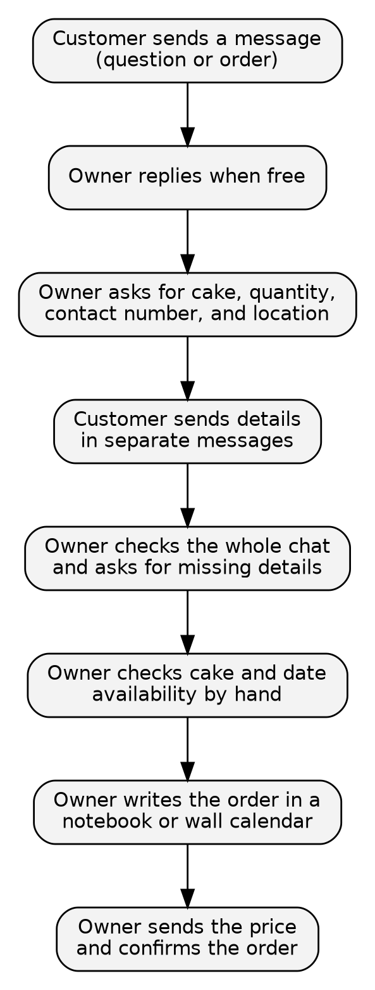
Figure 1. Current-State Manual Inquiry and Order Intake Process (As-Is)

3.1.4 Problems Identified
Table 4 shows the main problems in the current process and their causes.
Table 4. Problems and Root Causes
Problem | Root cause | Operational impact
1. Repetitive manual replies | The owner answered common questions by hand with no automatic reply system | Replying took time away from baking and other tasks
2. Slow responses | Customers got replies only when the owner was free | Customers waited hours or more and could lose interest
3. Incomplete order details | Customers sent details in separate messages, and there was no order form | The owner had to review chats and ask for missing details
4. Unclear order confirmation | There was no standard summary of the cake, quantity, price, and delivery details | Customers could misunderstand their orders and cause mistakes
5. Manual order recording | Messenger orders were not saved in an order database | Recording took extra time and caused errors
6. Manual availability checking | The owner checked cake and date availability herself | Orders could be accepted without checking, causing schedule problems

3.1.5 Root-Cause Analysis (Fishbone 4P)
We used a fishbone (Ishikawa) diagram to find the causes of slow replies and incomplete orders. We grouped the causes into four areas: People, Process, Platform, and Paperwork. Figure 2 shows the result.
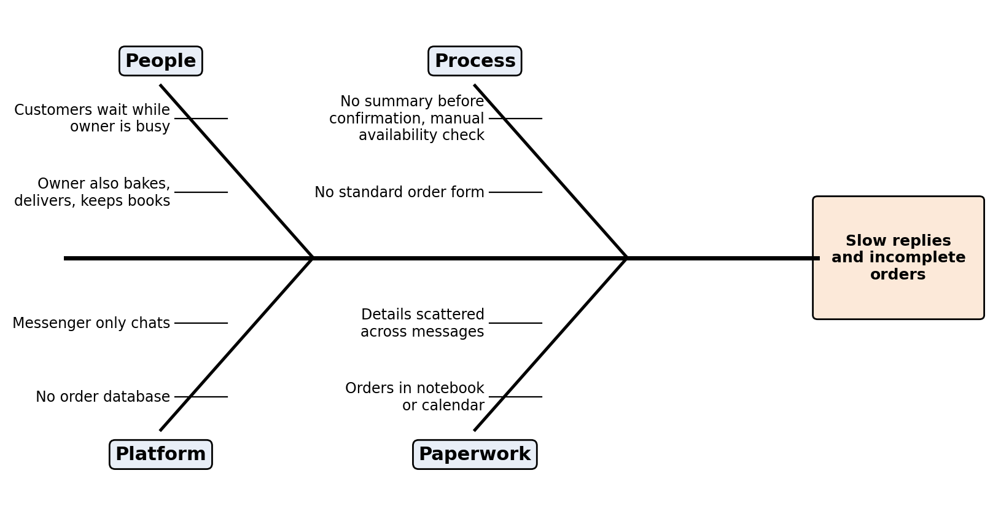
Figure 2. Fishbone Root-Cause Diagram
- People. Mrs. Tapang handled baking, bookkeeping, deliveries, and messages. When she was busy, customers waited.
- Process. There was no standard way to collect order details or show a summary before confirmation. Cake and date availability were checked by hand.
- Platform. Messenger was mainly for chatting. It did not organize order details or save confirmed orders in a database.
- Paperwork. Order details were scattered across messages and sometimes came with photos. The owner had to review chats and write orders in a notebook or calendar, which led to missed or wrong details.
Core finding. The main problem was that questions and order details were handled by hand while the owner also did other shop work. BraveBot aimed to improve this by answering common questions, collecting order details, checking availability, and recording confirmed orders for premade cakes with fixed prices.

3.1.6 Requirements Engineering
Functional requirements described what BraveBot had to do. Non-functional requirements described how well it had to work. They are in Tables 5 and 6.
Table 5. Functional Requirements Catalog
ID | Functional requirement | Stakeholder | Priority
FR01 | Received customer messages from the Mrs. Brave’s Cakes Facebook page through the Messenger webhook and replied in the same chat | Customer | High
FR02 | Introduced itself as an automated assistant at the start and told the customer how to reach the owner | Customer | High
FR03 | Answered common questions about premade cakes, fixed prices, store hours, delivery areas, and policies using the owner’s information | Customer; Owner | High
FR04 | Recognized when a customer wanted to order and started the order steps | Customer | High
FR05 | Explained what personal information was collected and why, and asked for the customer’s agreement first | Customer | High
FR06 | Collected the name, contact number, cake, quantity, requested date, and delivery or pickup details; accepted many details in one message and asked only for what was missing | Customer | High
FR07 | Checked the contact number, quantity, cake, and fixed price using backend rules and the owner’s stored information | Customer; Owner | High
FR08 | Checked cake availability for the requested date | Customer; Owner | High
FR09 | Showed an order summary with the cake, price, quantity, date, and other details; the customer could confirm, edit, or cancel | Customer | High
FR10 | Saved the order in Supabase through FastAPI only after the customer confirmed and all checks passed | Owner | High
FR11 | Sent the customer a reference number after the order was saved | Customer | Medium
FR12 | Referred unanswered questions and requests for a person to the owner and flagged the chat | Customer; Owner | High
FR13 | Kept chat logs and order drafts to support order processing and troubleshooting | Owner; Developers | Medium
FR14 | Let the owner review recorded orders and flagged chats | Owner | Medium
FR15 | Told the customer when an order could not be saved and kept the details for a retry where possible | Customer | Medium

Table 6. Non-Functional Requirements Specification
Category | Specification | Reason
Usability | Used clear, simple messages in English, Filipino, Hiligaynon, and Taglish; asked one question at a time; gave quick replies for common choices | Customers needed an easy way to ask and order in Messenger
Performance | At least 95% of replies sent within 10 seconds; the webhook answered requests right away | Customers leave slow chats, and the platform expects quick responses
Security | HTTPS only; checked Meta’s webhook signature; kept access tokens and database keys on the server, not in code or chats | Protected customer data and blocked fake requests
Privacy | Collected only the information needed for orders; gave a privacy notice; asked for agreement; limited access to customer records | Followed the Data Privacy Act of 2012 [6]
Reliability | No confirmed order was lost; a confirmed order was stored once even if Confirm was tapped twice | Duplicate or missing orders would defeat the purpose
Accuracy | Used stored business information for cakes and fixed prices; never invented prices or availability; referred unsure questions to the owner | Wrong information could cause misunderstandings or orders the bakery could not fulfill
Availability | At least 99% monthly uptime of the backend | Customers could message at any hour
Maintainability | Kept cake options, prices, availability, hours, and policies in editable data, not hard-coded | Allowed the owner or authorized people to update information when needed

3.2 Framework of the Project
The project followed a business analysis framework, from finding the problem to testing and continuous improvement, as shown in Figure 3. It covered the current ordering process, root causes, requirements, and the design of BraveBot for premade cake orders. We also used an iterative Agile approach [26], so we could test and improve the conversation flow using feedback from Mrs. Tapang.
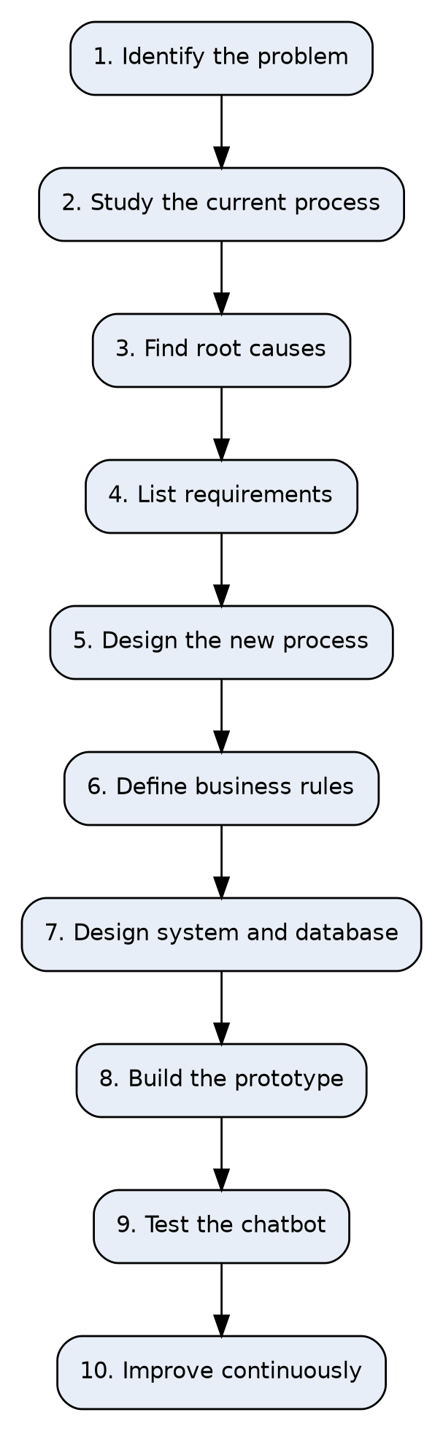
Figure 3. Business Analysis Project Framework

3.2.1 Proposed Future-State Process
In the new process, BraveBot replied to customer messages in Messenger and answered common questions using the owner’s information. When a customer wanted to order, it collected the details for a premade cake with a fixed price. It checked the cake and requested date before showing a summary. The customer could review, edit, cancel, or confirm. After confirmation and successful checks, the FastAPI backend saved the order in the Supabase prototype database and sent a reference number. Questions the chatbot could not answer were referred to the owner. Figure 4 shows this process.
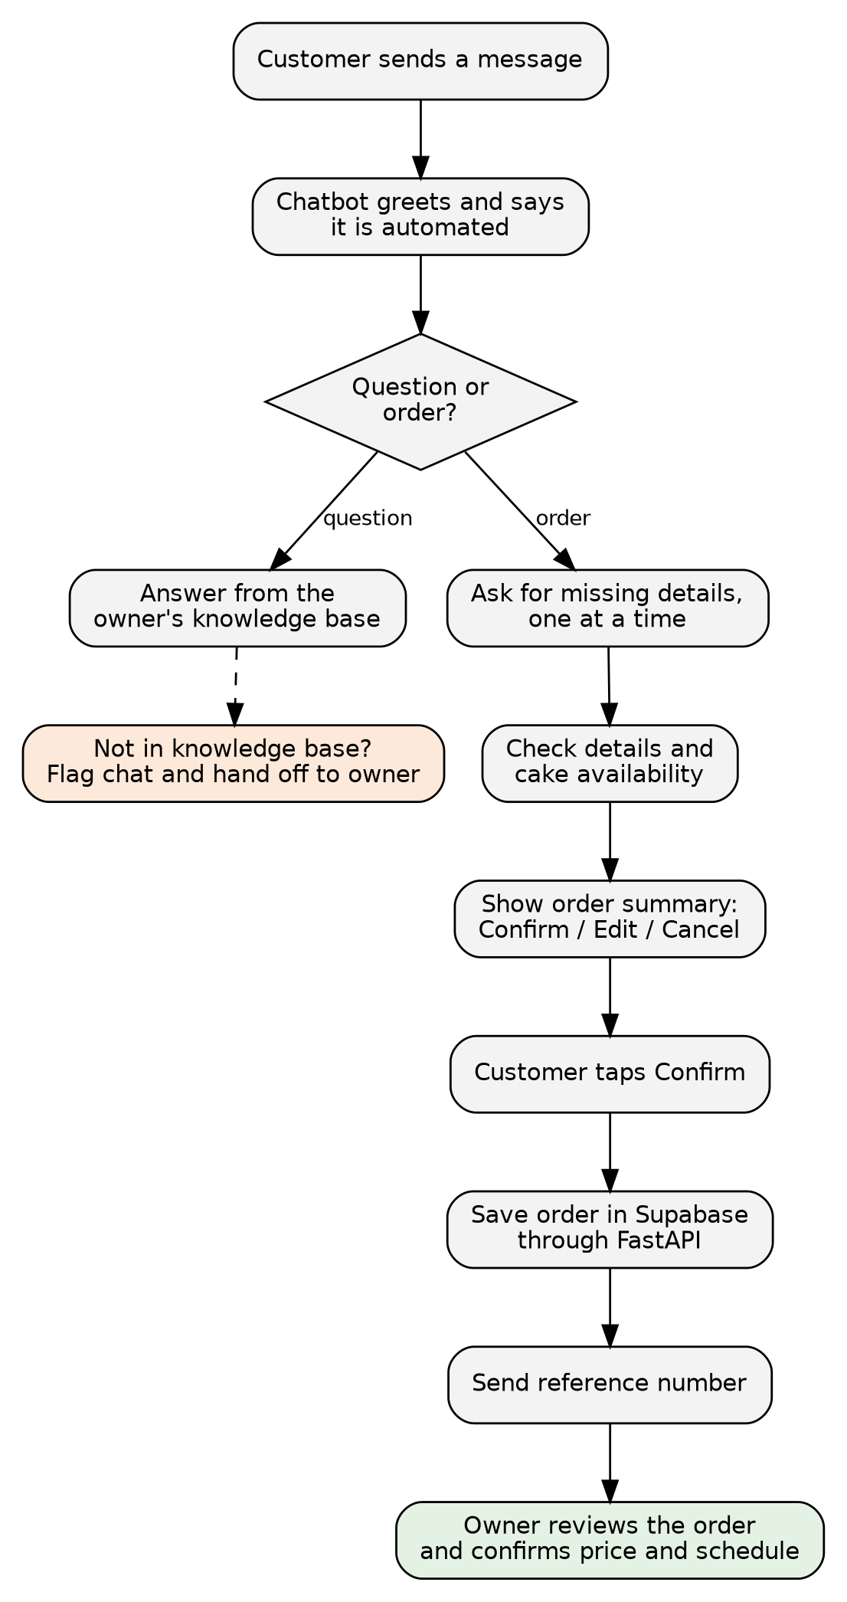
Figure 4. Proposed Future-State Automated Process (To-Be)

3.2.2 Before and After Comparison
Table 7. Before-and-After Process Comparison
Dimension | Current process (As-Is) | Proposed process (Chatbot)
First response | Customers waited until the owner was free | The chatbot replied automatically, even outside the owner’s working hours when the service was online
Common questions | The owner typed replies by hand | The chatbot answered using the owner’s information
Collecting order details | Details came in separate messages and could be incomplete | The chatbot collected the required details and asked for what was missing
Availability checking | The owner checked cake and date availability by hand | The chatbot checked availability before the customer confirmed
Customer confirmation | Order details were understood from the chat | The customer reviewed a summary and could confirm, edit, or cancel
Recording an order | The owner wrote details in a notebook or calendar | Confirmed orders were saved through FastAPI in the prototype’s Supabase database
Unanswered questions | The owner handled them directly | The chatbot flagged the chat and referred it to the owner

3.2.3 Proposed System Modules
The chatbot had six modules:
- Messenger Webhook and Message Handler. Received events from the Messenger Platform, checked that they were real, and sent replies to the customer.
- Conversation Manager. Tracked where each customer was in the chat (greeting, question, order collection, summary, confirmed, or handed off) and kept the draft order until it was confirmed.
- Language Understanding. Used an AI model, guided by written instructions, to understand free text, tell questions from orders, and pull out order details.
- Knowledge Base. Held the owner’s information: flavors, sizes, price ranges, hours, delivery areas, and policies. The chatbot answered only from this content.
- Order Validation and Summary. Applied the business rules, checked the contact number, quantity, and cake, and built the summary.
- Order Recording and Logging. Saved confirmed orders and chat logs in Supabase PostgreSQL through FastAPI and created the reference number.

3.2.4 Business Rules
To keep the chatbot steady and reduce AI mistakes, the system followed the rules in Table 8.
Table 8. Business Rules of the Chatbot
Rule ID | Condition | Action of the system
RULE-01 | A required order detail was missing | Asked only for the missing detail, one at a time
RULE-02 | The contact number was not a valid Philippine mobile number | Explained what was wrong, gave an example format, and asked again
RULE-03 | The quantity was not a whole number above zero, or was above the owner’s limit for one order | Asked the customer to clarify; for large quantities, handed off to the owner (limit to be confirmed with the owner)
RULE-04 | The customer had not clearly confirmed the summary | Did not save the order
RULE-05 | The customer confirmed the summary | Checked again, saved the order once, and sent the reference number
RULE-06 | The question was not covered by the knowledge base | Did not guess; told the customer the owner would reply and flagged the chat
RULE-07 | The customer asked for a person or sent a complaint | Handed off to the owner and flagged the chat
RULE-08 | The customer asked the price of a custom design | Gave the price range from the price list and said the owner would confirm the final price
RULE-09 | An order draft had no reply for 24 hours | Deleted the draft without saving and invited the customer to start again
RULE-10 | The customer tapped Confirm more than once | Kept a single order record

3.2.5 Data Design and Sample Order Record
Data was stored in four Supabase PostgreSQL tables: customers, orders, messages, and conversation state. Figure 5 shows how they were set up. The conversation state table held the draft order while the customer was still answering. The orders table got a record only after confirmation. Table 9 shows a sample saved order.
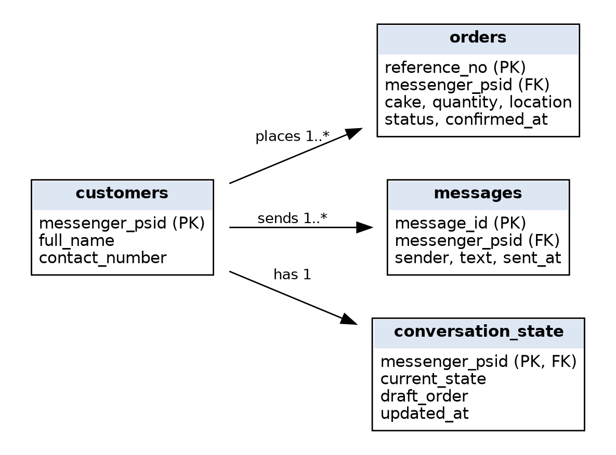
Figure 5. Entity Relationship Diagram of the Chatbot Database
Table 9. Sample Order Record (Fictional Data)
Field | Sample value | Description
reference_no | BC-20261012-0001 | Unique reference sent to the customer
messenger_psid | 6543210987654321 | Page-scoped ID from Messenger that identified the conversation
full_name | Maria Santos | Customer’s name as given in the chat
contact_number | 0912 345 6789 | Checked Philippine mobile number
cake | Chocolate cake, 8-inch round | Cake chosen from the owner’s list
quantity | 1 | Whole number above zero
location | Brgy. Mandurriao, Iloilo City (delivery) | Delivery or pickup location in the customer’s own words
status | Pending owner review | The owner confirmed price and schedule after this
confirmed_at | Oct 12, 2026, 2:15 PM | Time the customer tapped Confirm

3.2.6 System Architecture
The customer talked to the chatbot through the Mrs. Brave’s Cakes Facebook page. The Messenger Platform sent each message to a webhook on the FastAPI backend [5], [23]. The backend checked the request, loaded the chat state, and sent the message with the written instructions and the knowledge base to the AI model. It then checked the result, replied through the Messenger Send API, and, after the customer confirmed, saved the order in Supabase PostgreSQL [24]. Figure 6 shows the architecture, and Figure 7 shows the steps of one exchange. Table 10 lists the technologies.
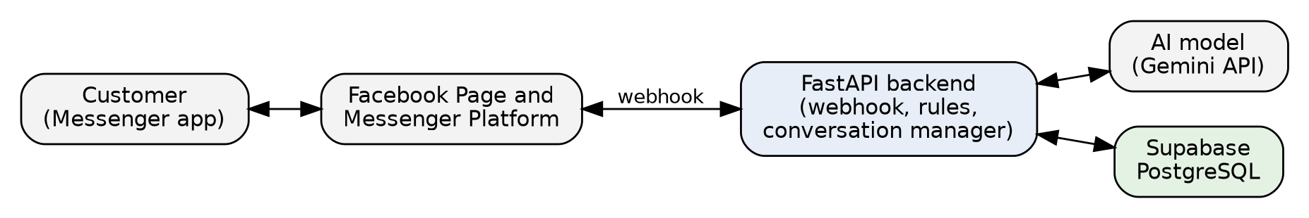
Figure 6. System Architecture of the Chatbot
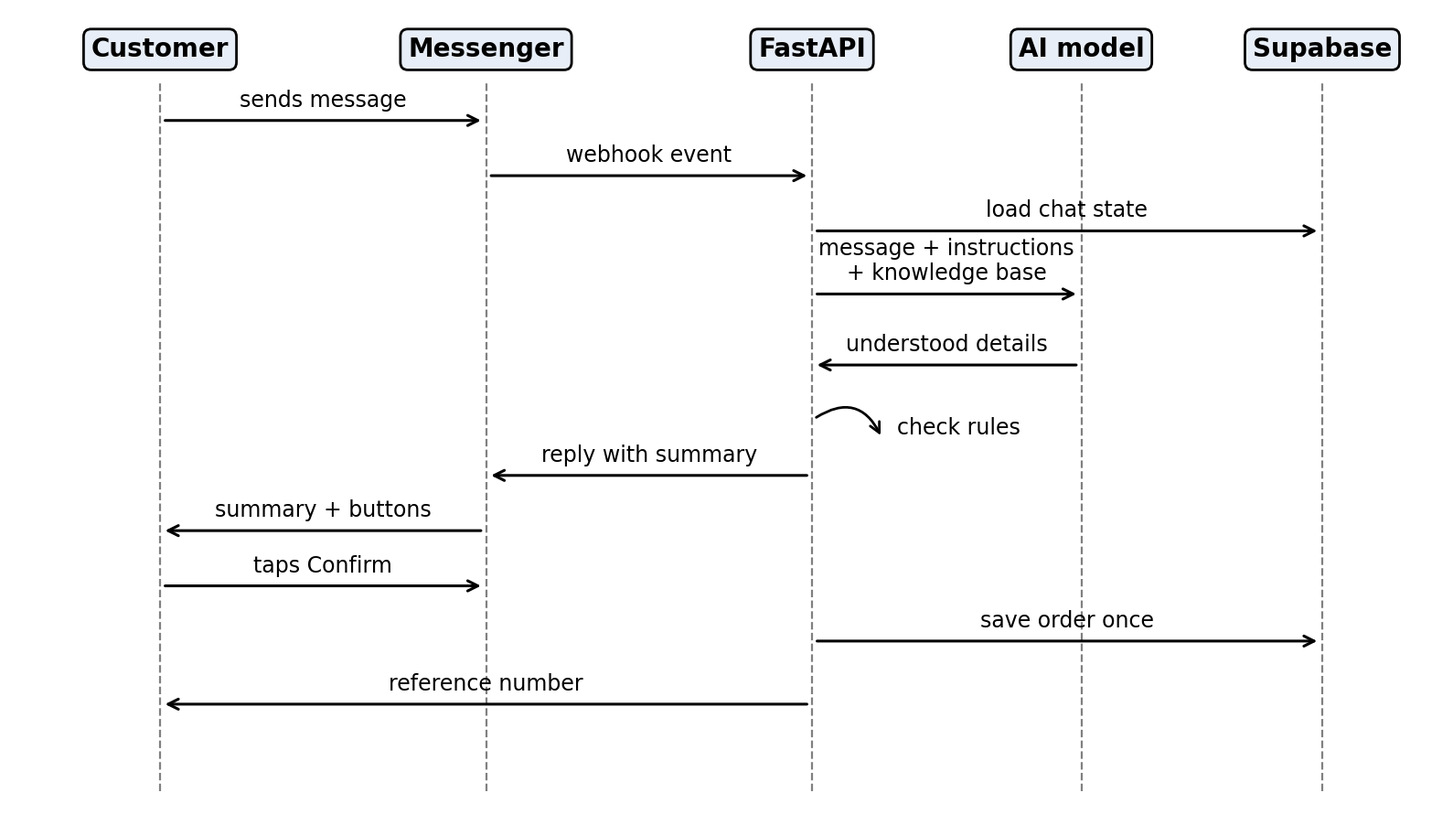
Figure 7. Sequence of a Customer Message and Order Confirmation
Table 10. Technologies Used
Component | Technology | Purpose
Channel | Facebook Page and Messenger Platform on Meta for Developers (webhook and Send API) [5] | Where customers sent messages and got replies
Backend | Python with FastAPI [23] | Received webhooks, managed chats, applied rules, and called the AI model and database
Language understanding | AI model through an API (the Gemini API was used in the capstone chatbot; the final choice depended on tests of accuracy, speed, and cost) | Understood free-text messages and pulled out order details
Database | Supabase PostgreSQL [24] | Stored customers, orders, messages, and conversation state
Hosting | Cloud host with HTTPS (a temporary tunnel was used during development) | Kept the webhook online

3.2.7 Conversation Flow
The conversation moved through a fixed set of states, shown in Figure 8. The customer could ask questions at any time. The state changed only when the business rules were met. For example, the chat moved from the order summary to saving only when the customer tapped Confirm.
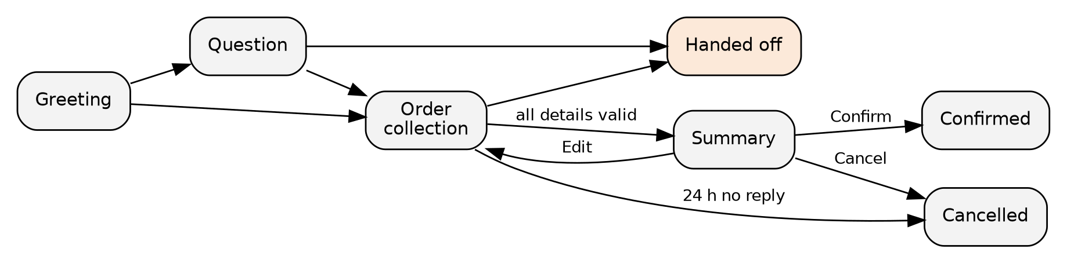
Figure 8. Conversation State Diagram

3.2.8 Key Performance Indicators
We used the indicators in Table 11 to judge the chatbot during user testing and after launch. The baselines came from our interviews with the owner and our observation of her inquiries. Where there was no measurement yet, the first weeks of use served as the baseline.
Table 11. Key Performance Indicators and Targets
Indicator | Baseline (current) | Target | How measured
Time to first reply | Depended on the owner’s availability; could take 24 to 48 hours | 95% of replies within 10 seconds | System logs, weekly
Saved orders with all five details | Not tracked; often incomplete | 100% | Database check, weekly
Orders copied by hand | Every order | None for chatbot orders | Owner feedback, monthly
Confirmed orders found in the database | Not applicable | 100% | Compared confirmations with records, weekly
Questions answered without handoff | Not applicable | At least 80% | Chat logs, monthly
Answers that contradicted the knowledge base | Not applicable | None in the test set | Test review and weekly log check
User satisfaction | None | SUS score of 68 or higher [27] | Questionnaire during user testing

3.3 Development and Testing

3.3.1 Prototype Layouts
The prototype was a Messenger conversation, not a separate app, so the screens were the messages the customer saw. We planned four views. The first was the greeting, which introduced the chatbot and offered quick-reply buttons such as Ask a question and Place an order. The second was the answer view, where a short message answered a question from the knowledge base. The third was the order view, where the chatbot asked for one detail at a time and repeated what it understood. The fourth was the summary view, which listed the five details with Confirm, Edit, and Cancel buttons. Table 12 shows a sample chat with made-up data and sample prices.
Table 12. Sample Conversation
# | Sender | Message
1 | Customer | hi po, may chocolate cake po kayo? magkano po ang 8 inches
2 | Chatbot | Hello! I am the automated assistant of Mrs. Brave’s Cakes. Yes, we have chocolate cakes. An 8-inch round chocolate cake usually costs ₱850 to ₱1,200 depending on the design, and the owner confirms the final price. Would you like to place an order?
3 | Customer | yes po, gusto ko ng isa para sa birthday ng mama ko
4 | Chatbot | Great! I will use your name, contact number, and location only to process this order. Is that okay? [Yes] [No]
5 | Customer | Yes
6 | Chatbot | May I have your full name and contact number?
7 | Customer | Maria Santos, 0912 345 6789
8 | Chatbot | Thank you, Maria. Which cake would you like, and how many?
9 | Customer | chocolate 8 inch po, 1 lang
10 | Chatbot | Got it. Where should the cake be delivered or picked up?
11 | Customer | Brgy. Mandurriao, Iloilo City, delivery po
12 | Chatbot | Please check your order: Name: Maria Santos. Contact: 0912 345 6789. Cake: Chocolate cake, 8-inch round. Quantity: 1. Location: Brgy. Mandurriao, Iloilo City (delivery). [Confirm] [Edit] [Cancel]
13 | Customer | (taps Confirm)
14 | Chatbot | Your order has been recorded. Your reference number is BC-20261012-0001. Mrs. Tapang will message you to confirm the final price and the schedule.

The prices in the sample were for illustration only. The real figures came from the owner’s price list.

3.3.2 Test Cases and Verification Scenarios
The test cases in Table 13 covered the main conversations and the places where the chatbot was most likely to fail. They were prepared to be run once the prototype was built.
Table 13. Test Cases
ID | Scenario | Test input | Expected result
TC-01 | Webhook verification | Meta verification request and a message sent to the page | Verification passed; message received and logged
TC-02 | Greeting | “hi” | Chatbot greeted, said it was automated, and offered options
TC-03 | Answer from knowledge base | “What flavors do you have?” | Answer matched the owner’s list
TC-04 | Question outside the knowledge base | A request the owner had not described | No invented answer; owner would reply; chat flagged
TC-05 | Order in one message | All five details in one message | Details picked up; summary shown without repeating questions
TC-06 | Order step by step | Details given one at a time | Chatbot asked only for what was missing
TC-07 | Invalid contact number | “12345” | Rejected with an example format; asked again
TC-08 | Invalid or unclear quantity | “0” or “dalawa o tatlo” | Chatbot asked the customer to clarify
TC-09 | Edit before confirming | Customer tapped Edit and changed the quantity | Summary updated; nothing saved yet
TC-10 | Confirm and save | Customer tapped Confirm | One order saved; reference number sent
TC-11 | Duplicate confirmation | Confirm tapped twice | Only one order stored
TC-12 | Cancel | Customer tapped Cancel | No order saved; draft cleared
TC-13 | Database unavailable | Supabase could not be reached at confirmation | Customer told the order was not saved; details kept; retry worked
TC-14 | Request for a person | “gusto ko makausap si owner” | Handoff message sent; chat flagged
TC-15 | Invalid webhook signature | Request with a wrong signature | Request rejected and not processed

3.3.3 Testing Procedure and Evaluation Criteria
Testing was planned in four steps. Unit tests checked the validation functions, such as the contact number and quantity checks. Integration tests checked the path from the Messenger webhook through FastAPI to Supabase. System testing ran the test cases in Table 13 in a private test setup where only people with a role in the Meta app could message the chatbot. User acceptance testing was planned with Mrs. Tapang and a small group of sample customers, who would answer the System Usability Scale (SUS) questionnaire [27] and questions about how useful and easy the chatbot was [16].
We judged results with four parts of the ISO/IEC 25010 quality model [25]. Functional suitability was met when all high-priority test cases passed and no confirmed order was lost. Usability was met with a SUS score of 68 or higher. Security was met when invalid webhook requests were rejected and no keys appeared in code or chat messages. Performance efficiency was met when at least 95% of replies were sent within 10 seconds.

3.4 Implementation Plan

3.4.1 Project Phases
The chatbot was planned to be built and launched in six phases, listed in Table 14.
Table 14. Project Implementation Phases
Phase | Milestone | Key activities | Deliverables
Phase 1 | Start-up and requirements | Confirmed requirements again with the owner; collected flavors, sizes, price ranges, delivery areas, and policies | Approved requirements; knowledge base content
Phase 2 | Conversation and data design | Wrote the conversation flow and instructions; designed database tables | Conversation script; database schema
Phase 3 | Development | Set up the Meta app and webhook; built the FastAPI backend, conversation manager, AI connection, checks, and order saving | Working prototype
Phase 4 | Testing and acceptance | Ran the test cases; fixed defects; ran user testing with the owner and sample customers | Test results; sign-off
Phase 5 | Deployment and training | Completed Meta app review; connected to the live page; trained the owner to update the knowledge base and read orders | Live chatbot; owner guide
Phase 6 | Monitoring and improvement | Reviewed chat logs and indicators; adjusted instructions and rules | Post-launch improvements

3.4.2 Implementation Schedule
The project was set on a four-week timeline to match the department’s defense schedule from October 5 to October 30, 2026. The work followed the weekly defense goals, although dates could shift a little if outside steps, like the Meta app review, took longer. Table 15 and Figure 9 show the schedule.
Table 15. Implementation Work Breakdown and Weekly Schedule
Activity | Weeks | Phase
Presented system requirements and problem statements; gathered first knowledge base content | Week 1 | 1
Applied Pre-Oral feedback; set up the database schema, FastAPI backend, and Meta app connection | Week 2 | 2
Connected the AI chat manager to Supabase and showed a working prototype for the Progress Defense | Week 3 | 3
Ran system and user tests, fixed remaining bugs, and presented the finished project | Week 4 | 4

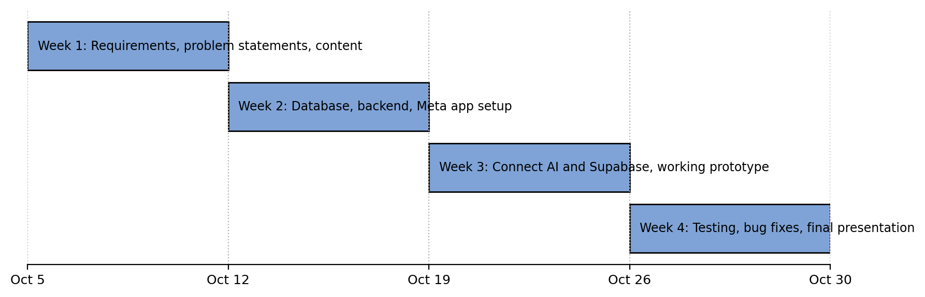
Figure 9. Four-Week Implementation Timeline

3.4.3 Risk Analysis and Mitigation
Table 16. Risk Assessment and Mitigation Matrix
Risk | Likelihood | Impact | Mitigation
The AI model gave a wrong or invented answer | Medium | High | Answered only from the knowledge base; handed off when unsure; always showed a summary before saving; tested with a fixed set of questions
Meta app review took longer, or platform rules changed | Medium | High | Submitted early; kept testers inside the Meta app roles meanwhile; followed Messenger Platform policies [5]
Customers wrote in Hiligaynon or unclear text | Medium | Medium | Asked a short clarifying question; handed off after two failed tries
Backend or database was unavailable | Low | High | Used a reliable host; kept details in the draft and offered a retry; told the customer if saving failed
Personal information was exposed | Low | High | Collected only five details; showed a consent notice; kept keys on the server; limited database access [6]
AI model usage costs went over budget | Low | Medium | Limited message length; used a low-cost model; checked usage monthly
The owner did not update the knowledge base | Medium | Medium | Kept it simple to edit; set a monthly reminder; reviewed flagged chats weekly
Customers preferred to talk to a person | Medium | Medium | Always offered a handoff; kept the owner’s inbox active

3.4.4 Cost-Benefit Analysis
Table 17 shows the estimate for the first year. The student team’s development work was part of coursework and was not charged. The amounts were planning estimates, to be updated with real quotes before deployment.
Table 17. Estimated First-Year Costs
Cost item | Estimate (PHP) | Basis
Backend hosting for FastAPI | ₱3,600 | Small cloud instance with HTTPS, about ₱300 per month for 12 months
Supabase PostgreSQL | ₱0 | Free plan, assumed enough for the expected orders and messages
AI model API usage | ₱2,000 | Pay-per-use charges for about a year of chats
Messenger Platform | ₱0 | No charge assumed for standard messaging
Development work | ₱0 | Done by the student team as coursework
Owner training and quick guide | ₱0 | Printing and materials
Total estimated cost | ₱5,600 | Sum of the items above

The expected benefit was the owner’s time saved on taking orders. Table 18 lists the assumptions, which were to be checked with Mrs. Tapang.
Table 18. Estimated Annual Benefit and Return on Investment
Item | Value | Basis
Orders handled through Messenger | 60 per month | Assumption, to be confirmed with the owner
Owner’s time per order, current | 25 minutes | Assumption: reading, asking for details, and writing the order down
Owner’s time per order, with the chatbot | 5 minutes | Assumption: reviewing the saved order
Time saved per year | 240 hours | 60 orders × 20 minutes × 12 months = 14,400 minutes
Value of the owner’s time | ₱80 per hour | Assumed hourly rate for administrative work
Annual savings | ₱19,200 | 240 hours × ₱80
Net benefit, Year 1 | ₱13,600 | ₱19,200 − ₱5,600
Return on investment, Year 1 | 242.9% | ₱13,600 ÷ ₱5,600 × 100
Payback period | 3.5 months | ₱5,600 ÷ ₱19,200 × 12

These figures counted only the time saved on orders. They did not include time saved on frequently asked questions or extra sales from customers who would not have waited for a reply. So the estimate was on the careful side.

3.4.5 Change Management and Training
The change was small, because customers kept using Messenger and the owner kept using the page. Still, we planned a short change process based on the ADKAR model [28].
- Awareness. A pinned post and a short page message told customers that an automated assistant now answered questions and took orders.
- Desire. The message explained the benefits: instant replies at any hour for customers and fewer interruptions while baking for the owner.
- Knowledge. Mrs. Tapang was to get a one-hour session and a short guide on updating the knowledge base, reading recorded orders, and answering flagged chats.
- Ability. For the first two weeks, the chatbot was to run with regular customers while the owner watched the inbox and could step in at any time.
- Reinforcement. We planned to review chat logs and the indicators in Table 11 every week and adjust the instructions and rules.

CHAPTER 4: RESULTS AND DISCUSSION
This chapter shows how we built BraveBot, the tools and equipment it needed, and what the prototype did. It also explains what the results meant and how the system was evaluated.

4.1 Implementation
BraveBot ran inside Facebook Messenger, so customers did not need to install anything. They just messaged the Mrs. Brave’s Cakes page like they always did. The chatbot followed the design in Chapter 3 and had the six modules described in Section 3.2.3.
Here is how one order went. The customer sent a message. Messenger passed it to our FastAPI backend. The backend asked the AI model to understand it, then checked the details using the business rules. The bot asked for any missing detail, one at a time. When everything was complete, it showed a summary with Confirm, Edit, and Cancel buttons. Only after the customer tapped Confirm did the backend save the order in Supabase and send a reference number.
The AI handled the talking. The backend handled the checking. This way, the AI could not save an order by itself.
The code was saved in a GitHub repository (github.com/devpoohtah/cake-messenger-chatbot). It had an app folder for the chatbot code, a supabase folder for the database setup, a dashboard template, a tests folder, and a requirements file. Secret keys were kept in a separate settings file and not in the code.

4.2 Development Tools
Table 19. Development Tools
Tool | Used for
Python | Main programming language
FastAPI and Uvicorn | Built and ran the backend and webhook
Pydantic | Checked that data had the right shape
Gemini API (google-genai) | AI model that understood customer messages
Supabase (PostgreSQL) | Stored customers, orders, messages, and chat state
Meta Messenger Platform | Connected the chatbot to the Facebook page
ngrok (pyngrok) | Gave a temporary HTTPS link for testing on a laptop
pytest and httpx | Ran the automated tests
Git and GitHub | Saved the code and tracked changes

4.3 Hardware Requirements
The chatbot ran online, so it did not need a strong computer. The hardware below was the same set used for the team’s earlier bakery system, since BraveBot was built and tested on the same equipment.
Table 20. Hardware Requirements
Component | Minimum | Recommended
Processor (CPU) | Intel Core i3 / AMD Ryzen 3 | Intel Core i5 / AMD Ryzen 5
Memory (RAM) | 8 GB | 16 GB
Storage | 128 GB SSD | 256 GB SSD
Internet speed | 15 Mbps | 50 Mbps or higher
Mobile device (owner and customers, for Messenger) | Android 10 / iOS 14 | Android 13 or newer / iOS 16 or newer

The chatbot itself ran on a cloud server with HTTPS, so the bakery did not need to buy or maintain its own server.

4.4 Software Requirements
Table 21. Software Requirements
Software | Purpose
Windows, macOS, or Linux | Operating system for development
Python 3.10 or newer | Ran the backend
Packages in requirements.txt: fastapi, uvicorn, pydantic, pydantic-settings, supabase, google-genai, pyngrok, pytest, httpx | Backend, AI, database, and testing
Code editor (Visual Studio Code) | Wrote and edited the code
Google Chrome | Testing and opening the dashboard
Facebook Page and Meta developer app | Connected Messenger to the backend
Supabase project | Hosted the PostgreSQL database
Gemini API key | Let the backend use the AI model

4.5 Input and Outputs of the Study
Inputs were what went into the system. Outputs were what came out. A sample saved order is shown in Table 9.
Table 22. Inputs and Outputs
Input | Output
Customer questions (flavors, prices, hours, delivery) | Short answer from the owner’s knowledge base
Order details: name, contact number, cake, quantity, location | Order summary with Confirm, Edit, and Cancel buttons
Customer tapped Confirm | Saved order and a reference number (example: BC-20261012-0001)
Customer tapped Edit or Cancel | Updated summary, or a cleared draft
Wrong details (like an invalid phone number) | Message that explained the problem and gave an example
A question the bot could not answer, or a request for the owner | Handoff message and a flag for the owner

4.6 Results Interpretation and Analysis
In Chapter 1, we listed seven problems in the old Messenger process. Table 23 shows how the prototype answered each one.
Table 23. How BraveBot Answered the Problems
Problem | How BraveBot handled it | What it meant
Repetitive manual replies | Answered common questions from the knowledge base | The owner did not repeat the same answers
Delayed response time | Replied right away | No more long waits for a first reply
Incomplete order details | Asked for each missing detail, one at a time (RULE-01) | Orders were complete before the owner saw them
Unclear order confirmation | Showed a summary and waited for Confirm (RULE-04) | Fewer mix-ups about what was ordered
Manual order recording | Saved confirmed orders in the database (RULE-05) | No more copying orders by hand
Manual availability checking | Checked the cake and date before the summary | Fewer orders the shop could not fulfill
Limited after-hours help | Worked even when the owner was busy or resting | Customers got help any time

What worked well
- The bot did not guess. If the answer was not in the knowledge base, it said the owner would reply (RULE-06).
- Wrong phone numbers and quantities were caught by the backend, not left to the AI (RULE-02 and RULE-03).
- Tapping Confirm twice saved only one order (RULE-10).
- The owner stayed in control. The bot gave price ranges only, and the owner confirmed the final price (RULE-08).

Things to watch
- The AI could misread a message, especially when Tagalog, English, and Hiligaynon were mixed. This is why the backend checked everything before saving.
- The bot needed the internet, Messenger, the AI service, and Supabase. If one was down, it could not work fully.
- Public use needed approval from Meta (App Review). Until then, only people with a role in the Meta app could test it.
- It handled premade cakes with fixed prices only. Custom designs went to the owner.
- It was not a full system for inventory, accounting, or delivery.
Overall, the prototype matched the goal of the study. It cut down repeated work, collected complete orders, and kept the owner in charge of final decisions.

4.7 System Evaluation Results
We used the same testing levels and the ISO/IEC 25010 quality model that the team used for its earlier bakery system for Mrs. Brave’s Cakes. BraveBot served the same business, so those results showed how well the team’s work held up in real use. They are reported first. The BraveBot test cases follow.

A. Test Results of the Bakery System
Table 24. Summary of Test Results of the Bakery System
Testing level | Test cases | Passed | Result
Unit testing | 10 | 10 | All passed
Integration testing | 10 | 10 | All passed
System testing | 10 | 10 | All passed
Security testing | 10 | 10 | All passed
Performance testing | 5 | 5 | All passed
Total | 45 | 45 | 100% passed

The security tests blocked unauthorized access, fake payment signatures, price changes from the browser, and brute-force login attempts. The performance tests are in Table 25.
Table 25. Performance Test Results of the Bakery System
Test | Target | Actual | Status
Home page load time | Under 3 seconds | 1.8 seconds | Pass
Real-time sync of a new order | Under 1.5 seconds | 0.9 seconds | Pass
50 users at the same time | No crashes | No crashes | Pass
Fetch 100 orders | Under 2 seconds | 1.2 seconds | Pass
Load 10 images | Under 5 seconds | 3.1 seconds | Pass

B. User Acceptance Testing
Seven people answered the questionnaire: the business owner and six customers. One customer response was left out because every item was rated 1 while the comment said “Good,” so the rating could not be trusted. Six responses were counted, using a 5-point scale.
Table 26. User Acceptance Test Results of the Bakery System
Criterion | Mean score | Meaning
Functional suitability – Admin (n = 1) | 5.00 | Excellent
Functional suitability – Customer (n = 5) | 4.60 | Excellent
Usability (n = 6) | 4.78 | Excellent
Reliability (n = 6) | 4.78 | Excellent
Performance efficiency (n = 6) | 4.75 | Excellent
Security (n = 6) | 4.83 | Excellent
Overall | 4.79 | Excellent

The scale was: 4.20–5.00 Excellent, 3.40–4.19 Very Good, 2.60–3.39 Good, 1.80–2.59 Fair, 1.00–1.79 Poor. Every criterion was rated Excellent. Security scored highest (4.83). Customer functional suitability scored lowest (4.60), mainly because one customer gave lower marks to the booking calendar and order tracking. This showed us where to improve next.

C. BraveBot Test Cases
Table 27 lists the test cases from Table 13 with a space for each result.
Table 27. BraveBot Test Case Results
ID | Scenario | Result
TC-01 | Webhook verification | Passed
TC-02 | Greeting | Passed
TC-03 | Answer from knowledge base | Passed
TC-04 | Question outside the knowledge base | Passed
TC-05 | Order in one message | Passed
TC-06 | Order step by step | Passed
TC-07 | Invalid contact number | Passed
TC-08 | Invalid or unclear quantity | Passed
TC-09 | Edit before confirming | Passed
TC-10 | Confirm and save | Passed
TC-11 | Duplicate confirmation | Passed
TC-12 | Cancel | Passed
TC-13 | Database unavailable | Passed
TC-14 | Request for a person | Passed
TC-15 | Invalid webhook signature | Passed

Total passed: 15 out of 15

D. Summary of Evaluation
The bakery system passed all 45 tests and earned an overall user acceptance score of 4.79 (Excellent). BraveBot was built for the same business and was judged by the same four measures: functional suitability, usability, security, and performance efficiency. Mrs. Tapang and a small group of sample customers were to try the chatbot and answer the SUS questionnaire. Their feedback would guide the next improvements.

CHAPTER 5: CONCLUSION AND RECOMMENDATIONS

5.1 Introduction
This chapter wraps up our study. It reviews what we set out to do, what we built, and what we found. It also shares our conclusion and our advice for the owner and for anyone who wants to continue this work.

5.2 Summary of the Proposed Study Design and Implementation
Mrs. Brave’s Cakes took cake questions and orders through Facebook Messenger. The owner answered every message herself, often while baking. Because of this, replies were slow, order details came in pieces, and orders were written down by hand. A single order could take 24 to 48 hours to finish.
To help, we planned and built BraveBot, a chatbot inside Messenger. Our goal was to make a Business Process Automation Plan and a working prototype. BraveBot answered common questions, took orders for premade cakes with fixed prices, checked availability, and saved confirmed orders.
We started by studying the old process using stakeholder analysis, SIPOC, process mapping, and fishbone analysis. Then we designed a better process, listed the system requirements, and wrote ten business rules. We also prepared test cases, a risk analysis, a cost-benefit estimate, an implementation plan, and a change management plan.
The prototype used Python and FastAPI for the backend, the Gemini AI model to understand messages, and Supabase to store orders and chats. It talked to customers through the Messenger Platform. The AI handled the conversation, but the backend checked every detail. An order was saved only after the customer tapped Confirm.

5.3 Summary of Findings
- The old process had seven problems. They were repeated replies, slow responses, incomplete details, unclear confirmation, manual recording, manual availability checking, and no help after hours.
- A better process was possible. The new flow guided customers step by step, asked only for what was missing, showed a summary, and waited for confirmation.
- Business rules kept the bot safe. The backend checked phone numbers, quantities, and cake choices. The bot gave only price ranges, never guessed answers, and saved a double-tapped Confirm only once.
- The prototype covered the planned scope. It handled questions, orders, summaries, saving, reference numbers, and handoff to the owner.
- The team’s earlier bakery system tested well. It passed all 45 test cases and scored 4.79 (Excellent) in user acceptance testing. BraveBot was built for the same business and used the same quality measures.
- BraveBot had clear limits. It handled premade cakes only, had no online payment, and ran on a separate database. It could also misread mixed-language messages, and public use needed approval from Meta.

5.4 Conclusion
BraveBot showed that a small bakery can use a chatbot to handle its everyday Messenger work. It answered common questions right away, collected complete orders, and recorded them without hand copying. This addressed all seven problems we found in the old process.
The study met its goal. We documented the process, designed a better one, defined the rules, and built a working prototype with a plan for future use. We also learned that the chatbot works best as a helper, not a replacement. The owner still decides on final prices, custom cakes, and tricky questions.
In short, BraveBot can give Mrs. Tapang more time to bake and give customers faster, clearer service.

5.5 Recommendation
Based on our findings, we suggest the following.
For the owner
- Test BraveBot with a few real customers before opening it to everyone.
- Keep the knowledge base up to date whenever flavors, prices, hours, or delivery areas change.
- Check the chat logs and flagged chats often to see what the bot cannot answer, then add those answers.
- Keep handling custom cake requests and final price confirmation personally.
For future developers
- Apply for Meta App Review so the public can use the chatbot.
- Connect BraveBot to the existing bakery system so orders appear in one place.
- Add online payment, such as the PayMongo gateway already used in the bakery system.
- Add support for custom cakes and test the bot more with Tagalog, English, Hiligaynon, and Taglish messages.
- Protect customer data by collecting only what is needed, keeping secret keys safe, and backing up the database.
For future researchers
- Run the BraveBot test cases and a user survey with more customers, then compare results with the old process.
- Measure real gains, such as reply time, order time, and number of incomplete orders, before and after using the chatbot.
- Study the same idea in other small food businesses.

REFERENCES
[1] Department of Trade and Industry, “MSME Statistics,” Republic of the Philippines. [Online]. Available: https://www.dti.gov.ph/resources/msme-statistics/
[2] M. G. A. Blanza and L. L. Catilo, “Leveraging technology for sustainable growth: An analysis of micro, small, and medium enterprises (MSMEs) in Iloilo Province during the post-pandemic milieu,” in Proc. 20th European Conf. on Innovation and Entrepreneurship (ECIE), 2025, pp. 58–67.
[3] “This chatbot allows you to order coffee via Facebook Messenger,” ABS-CBN News, Aug. 4, 2019. [Online]. Available: https://abs-cbn.com/life/08/04/19/this-chatbot-allows-you-to-order-coffee-via-facebook-messenger
[4] T. B. Brown et al., “Language models are few-shot learners,” in Advances in Neural Information Processing Systems, vol. 33, 2020, pp. 1877–1901. [Online]. Available: https://arxiv.org/abs/2005.14165
[5] Meta, “Messenger Platform documentation.” [Online]. Available: https://developers.facebook.com/docs/messenger-platform
[6] Republic of the Philippines, Republic Act No. 10173, “Data Privacy Act of 2012,” 2012. [Online]. Available: https://www.privacy.gov.ph/data-privacy-act/
[7] M. Dumas, M. La Rosa, J. Mendling, and H. A. Reijers, Fundamentals of Business Process Management, 2nd ed. Berlin, Germany: Springer, 2018, doi: 10.1007/978-3-662-56509-4.
[8] International Institute of Business Analysis, A Guide to the Business Analysis Body of Knowledge (BABOK Guide), 3rd ed. Toronto, ON, Canada: IIBA, 2015. [Online]. Available: https://www.iiba.org/babok-guide/
[9] P. C. Verhoef et al., “Digital transformation: A multidisciplinary reflection and research agenda,” Journal of Business Research, vol. 122, pp. 889–901, 2021, doi: 10.1016/j.jbusres.2019.09.022.
[10] Organisation for Economic Co-operation and Development (OECD), The Digital Transformation of SMEs, OECD Studies on SMEs and Entrepreneurship. Paris, France: OECD Publishing, 2021, doi: 10.1787/bdb9256a-en.
[11] E. Adamopoulou and L. Moussiades, “Chatbots: History, technology, and applications,” Machine Learning with Applications, vol. 2, Art. no. 100006, 2020, doi: 10.1016/j.mlwa.2020.100006.
[12] P. B. Brandtzaeg and A. Følstad, “Why people use chatbots,” in Internet Science (INSCI 2017), Lecture Notes in Computer Science, vol. 10673. Cham, Switzerland: Springer, 2017, pp. 377–392, doi: 10.1007/978-3-319-70284-1_30.
[13] A. Xu, Z. Liu, Y. Guo, V. Sinha, and R. Akkiraju, “A new chatbot for customer service on social media,” in Proc. 2017 CHI Conf. on Human Factors in Computing Systems, Denver, CO, USA, 2017, pp. 3506–3510, doi: 10.1145/3025453.3025496.
[14] X. Luo, S. Tong, Z. Fang, and Z. Qu, “Frontiers: Machines vs. humans: The impact of artificial intelligence chatbot disclosure on customer purchases,” Marketing Science, vol. 38, no. 6, pp. 937–947, 2019, doi: 10.1287/mksc.2019.1192.
[15] J. Cordero, L. Barba-Guaman, and F. Guamán, “Use of chatbots for customer service in MSMEs,” Applied Computing and Informatics, 2022, doi: 10.1108/ACI-06-2022-0148.
[16] F. D. Davis, “Perceived usefulness, perceived ease of use, and user acceptance of information technology,” MIS Quarterly, vol. 13, no. 3, pp. 319–340, 1989, doi: 10.2307/249008.
[17] V. Venkatesh, M. G. Morris, G. B. Davis, and F. D. Davis, “User acceptance of information technology: Toward a unified view,” MIS Quarterly, vol. 27, no. 3, pp. 425–478, 2003, doi: 10.2307/30036540.
[18] L. J. Cueto, A. F. D. Frisnedi, R. B. Collera, K. I. T. Batac, and C. B. Agaton, “Digital innovations in MSMEs during economic disruptions: Experiences and challenges of young entrepreneurs,” Administrative Sciences, vol. 12, no. 1, Art. no. 8, 2022, doi: 10.3390/admsci12010008.
[19] Asian Development Bank, “Unintended consequences of business digitalization among MSMEs during the COVID-19 pandemic: The case of the Philippines,” ADB Economics Working Paper Series No. 767, Manila, Philippines, Feb. 2025. [Online]. Available: https://www.adb.org/publications/business-digitalization-msmes-philippines
[20] Meta, “Meta Business Help Center.” [Online]. Available: https://www.facebook.com/business/help
[21] Chatfuel. [Online]. Available: https://chatfuel.com
[22] ManyChat. [Online]. Available: https://manychat.com
[23] S. Ramírez, “FastAPI documentation.” [Online]. Available: https://fastapi.tiangolo.com
[24] Supabase, “Supabase documentation.” [Online]. Available: https://supabase.com/docs
[25] Systems and Software Engineering – Systems and Software Quality Requirements and Evaluation (SQuaRE) – System and Software Quality Models, ISO/IEC 25010:2011, International Organization for Standardization, Geneva, Switzerland, 2011.
[26] K. Beck et al., “Manifesto for agile software development,” 2001. [Online]. Available: https://agilemanifesto.org
[27] J. Brooke, “SUS: A ‘quick and dirty’ usability scale,” in Usability Evaluation in Industry, P. W. Jordan, B. Thomas, B. A. Weerdmeester, and I. L. McClelland, Eds. London, U.K.: Taylor & Francis, 1996, pp. 189–194.
[28] J. Hiatt, ADKAR: A Model for Change in Business, Government and Our Community. Loveland, CO, USA: Prosci Learning Center Publications, 2006.

