Manufacturing Quality Prediction
  - Project Report
Poojan Chauhan
IBM SkillsBuild Data Analytics with AI Academic Internship
Conducted by BharatCares in association with AICTE
September 2026

Abstract
This project investigates whether anonymous semiconductor sensor readings can identify production records that fail quality testing. I use the public UCI SECOM dataset, compare three class weighted classifiers, and evaluate an inspection threshold selected without access to test labels. The deliverable combines an executed Python notebook with optional Streamlit application code.
Random Forest achieved a held out average precision of 0.2108 and detected 13 of 21 failed records at the selected threshold. It also flagged 62 passing records. The results show useful ranking information, but the low inspection precision and small failure sample limit practical conclusions. The model is an academic prototype, not a validated production quality system.

Problem and objectives
Failures are uncommon in the dataset, so a classifier can achieve high accuracy by predicting that every product passes. The objective is to expose this weakness, detect a meaningful share of failures and make the inspection trade off measurable.
- Analyze missing measurements, imbalance and relationships between sensors.
- Prevent data leakage by fitting preprocessing inside each cross validation fold.
- Compare Logistic Regression, Random Forest and Extra Trees using average precision.
- Provide reproducible evaluation, input validation and an interactive prediction interface.

Scope of this report
The following sections document the source data, experimental design, measured results, prediction workflow, execution instructions, verification and limitations. All reported model metrics come from the executed notebook supplied in the submission.

Dataset and exploratory analysis
SECOM was published by Michael McCann and Adrian Johnston in 2008 through the UCI Machine Learning Repository [1]. Each record describes one production entity, with sensor measurements and an associated pass or fail test outcome. The original measurements are used; no demonstration data is substituted.
Dataset property | Value
Production records | 1,567
Raw sensor columns | 590
Pass and failure records | 1,463 pass / 104 fail
Failure prevalence | 6.64%
Timestamp range | 19 July to 17 October 2008
Development and test sizes | 1,253 / 314
Failures in development and test | 83 / 21

UCI descriptive metadata lists 591 features, while the raw measurement matrix contains 590 sensor columns. Labels and timestamps are handled separately. Original labels -1 and 1 are mapped to pass 0 and failure 1. Sensor names are one based: sensor_001 corresponds to raw column zero. Engineering names and physical units are unavailable.
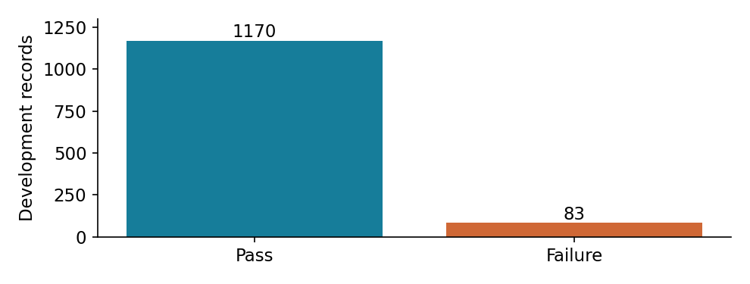
Figure 1 Class imbalance in the development partition
Development measurements contain 4.58% missing cells. Some sensors are entirely missing or constant. Exploration uses the development partition only; the test partition is reserved. Missing readings remain available for training fold imputation, and unusual numeric readings are not automatically discarded because they may indicate failures.

Methodology and implementation
The notebook reserves a stratified 20% test set with random seed 42 before detailed exploration. The remaining 80% is used for five fold stratified cross validation. The timestamp is excluded from predictors. This random split provides a benchmark, not a test of later factory operation.

Preprocessing within each training fold
- Remove sensors with more than 60% missing values or at most one observed unique value.
- Replace missing measurements with training fold medians.
- Select the 40 highest ANOVA F score sensors using training fold labels.
- Standardize selected features with training fold statistics, then fit the classifier.
The complete sequence is a scikit learn Pipeline [2]. Fitting it separately inside each fold prevents validation measurements from influencing imputation, feature selection or scaling. After final development fitting, 450 sensors remain eligible before the 40 feature selection step.
Model | Predeclared settings
Logistic Regression | C 0.1; balanced weights; liblinear solver
Random Forest | 200 trees; minimum leaf 3; balanced subsample weights
Extra Trees | 200 trees; minimum leaf 3; balanced weights

Model and threshold selection
The model with the highest mean cross validation average precision is selected. Average precision summarizes precision and recall across score thresholds; it is not accuracy or the trapezoidal area under a precision recall curve [3].
Out of fold scores from the selected model are used to maximize F2, which favors recall over precision. Ties prefer the higher threshold. This selection uses development data only. The frozen model is then fitted on all development rows and evaluated on the held out set. No test label influences model choice or the threshold.
Class weights address the rare failure class without generating synthetic samples. The model outputs an uncalibrated failure score. F2 is an academic objective; no factory cost function or probability calibration is estimated.

Model comparison and measured results
Candidate | Mean AP | AP standard deviation | Mean ROC AUC
Random Forest | 0.2142 | 0.0697 | 0.7115
Extra Trees | 0.2131 | 0.0973 | 0.7085
Logistic Regression | 0.1576 | 0.0341 | 0.6642

Random Forest narrowly leads the development comparison. The fold standard deviations show substantial variability and do not establish that it is reliably superior to Extra Trees. The locked threshold is 0.137692. Development selection scores are not independent final performance estimates.
Held out metric | Always pass | Selected threshold
Accuracy | 93.31% | 77.71%
Balanced accuracy | 50.00% | 70.37%
Failure precision | 0.00% | 17.33%
Failure recall | 0.00% | 61.90%
Failure F1 | 0.0000 | 0.2708
Failure F2 | 0.0000 | 0.4088
Average precision | 0.0669 | 0.2108
ROC AUC | 0.5000 | 0.7972

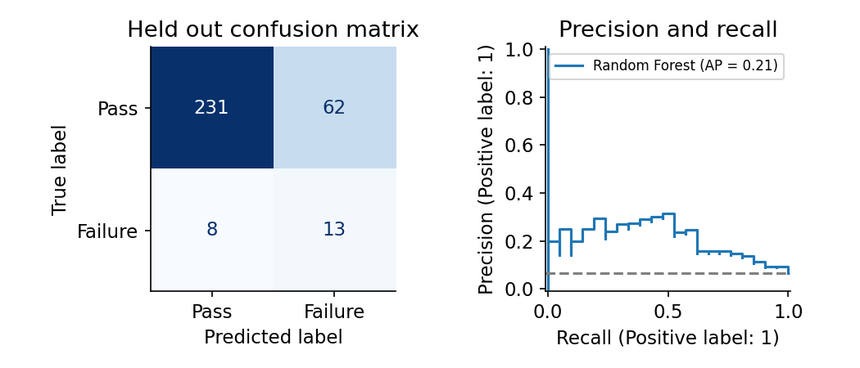
Figure 2 Final test confusion matrix and precision recall curve

Interpretation and prediction interface
At the selected threshold, 75 of 314 records require inspection, but only 13 of those flagged records are actual failures. Failure recall is 61.90%, while inspection precision is 17.33%. At the default threshold of 0.50, the model predicts every test record as pass. A useful threshold depends on the cost of missed failures relative to unnecessary inspections.
With only 21 failed test records, recall is uncertain. Its approximate 95% Wilson interval is 40.9% to 79.2%, under an independent binomial assumption. This interval does not account for model selection, temporal dependence or factory drift.
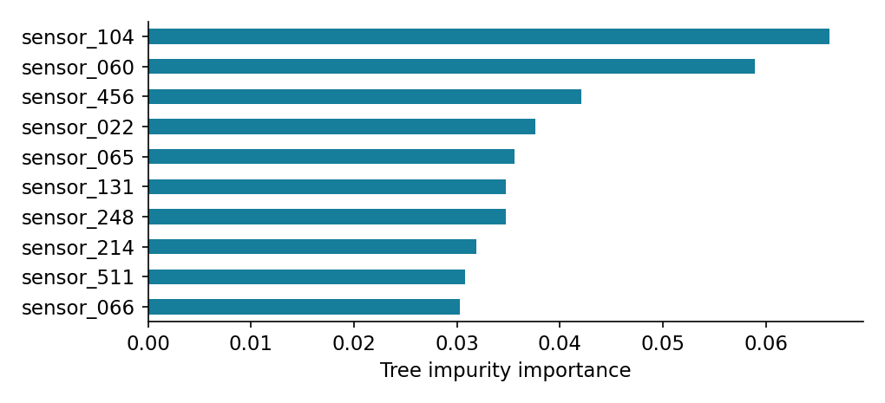
Figure 3 Leading training derived Random Forest sensor associations
Tree impurity importance indicates model association, not physical fault causation. Correlated sensors may share importance, and anonymous features cannot be translated into engineering recommendations without additional information.

Streamlit application
The notebook includes a standalone app exporter built from the same data loader, preprocessing and model selection functions. The four pages are Overview, Sensor analysis, Model evaluation and Predict quality. Streamlit caches the experiment after first startup; a process restart retrains it.
Prediction supports an editable held out sample and uploaded CSV batches. Inputs must contain exactly sensor_001 through sensor_590, using the original scales. Nonnumeric text, infinity, wrong schemas and excessively incomplete records are rejected. At least 295 total readings and half of the selected sensors must be observed. Blanks use training medians. The upload limit is 10 MB and 10,000 rows.

Reproducibility and verification

Submission structure
The ZIP contains the complete notebook PoojanChauhan_ManufacturingQualityPrediction.ipynb, requirements.txt, this report and README.md. The notebook includes saved output tables and charts. The dataset is downloaded from UCI on the first run and is not bundled in the four file package.

Local execution
Use Python 3.12. Create and activate a virtual environment, install requirements.txt, then open the notebook in JupyterLab. The README contains the complete Windows and macOS or Linux commands. Select the environment kernel and run all cells in order.
python -m pip install -r requirements.txt
python -m jupyter lab PoojanChauhan_ManufacturingQualityPrediction.ipynb
In Colab, upload the notebook and requirements file, install the listed packages, restart the session if package changes require it, and run all cells. Internet access is required for installation and the initial data download. Offline dataset fallback accepts the original secom.data and secom_labels.data files in a data folder.

Optional app execution and hosting
After the notebook runs, set EXPORT_STREAMLIT_APP to True in section 13 and rerun that cell. It writes streamlit_export/app.py. Existing files are protected unless OVERWRITE_APP is also enabled. Start the app from the submission directory with the command below.
python -m streamlit run streamlit_export/app.py
For Streamlit Community Cloud, place the generated app.py and requirements.txt in a GitHub repository, select app.py as the entry point, and choose Python 3.12 [4, 5]. The notebook is not itself a Streamlit entry point. No public app has been deployed as part of this submission.

Verification performed
All 20 notebook code cells completed without cell errors. The prediction checks confirm identical scores when sensor columns are reordered, scores within zero and one, and selection of exactly 40 sensors. Four invalid input examples are rejected: a missing column, nonnumeric text, infinity and an all missing record.
Streamlit AppTest checks passed for all four pages and navigation to batch upload mode. These checks validate application execution and key interactions; they do not constitute cloud deployment testing or browser layout inspection. Core package versions are pinned to the environment used for the recorded results.

Limitations conclusion and references

Limitations and future work
The dataset is small, historical and anonymous. Random splitting may yield optimistic estimates when manufacturing observations have temporal dependence. Future work should evaluate later records and independent production batches, monitor drift, and collect meaningful sensor descriptions.
The three model families use fixed settings and one feature selection method. Broader tuning should use nested cross validation or a fresh evaluation set. Repeated optimization against the existing test results would weaken their value. Calibration and missingness indicators are useful next experiments, but were not performed here.
The inspection threshold should eventually reflect real missed failure and inspection costs. The current model cannot certify product quality or establish causal process changes. Human quality control and independent validation remain necessary for any practical application.

Conclusion
The project demonstrates an end to end workflow for manufacturing failure analysis: source verification, exploratory analysis, leakage aware preprocessing, imbalanced classification, threshold selection, honest evaluation and interactive scoring. The selected Random Forest detects 13 of 21 test failures, with 62 false alarms. The main finding is that failure detection must be evaluated alongside inspection burden; a 93.31% always pass accuracy is not evidence of a useful quality classifier.

References
[1] McCann, M. and Johnston, A. (2008). SECOM [Dataset]. UCI Machine Learning Repository. DOI: https://doi.org/10.24432/C54305. Dataset page: https://archive.ics.uci.edu/dataset/179/secom. License: Creative Commons Attribution 4.0.
[2] scikit learn. Common pitfalls and recommended practices. https://scikit-learn.org/stable/common_pitfalls.html
[3] scikit learn. Average precision score. https://scikit-learn.org/stable/modules/generated/sklearn.metrics.average_precision_score.html
[4] Streamlit. Create an app. https://docs.streamlit.io/get-started/tutorials/create-an-app
[5] Streamlit. App dependencies for Community Cloud. https://docs.streamlit.io/deploy/streamlit-community-cloud/deploy-your-app/app-dependencies

