RAJASTHAN ROYALS · SupeRR SELECTOR SEASON 2
Identifying the Most Reliable Players Under Pressure
Round 1 — Methodology Report
A reproducible, delivery-level framework that measures how batters and bowlers perform in high-pressure situations relative to their own baseline, across IPL and T20I cricket (2022–2026). Every number in this report is traceable to the supplied data via the accompanying code (run_pipeline.py), an 11-test correctness suite, and an interactive dashboard.
Interactive Dashboard
A live, interactive version of this analysis (7 pages: overview, batter & bowler analytics, head-to-head pressure comparison, player explorer, final rankings, and model validation) accompanies this report. [ PASTE DEPLOYED DASHBOARD URL HERE — see DEPLOY.md ]
To deploy for free: push the project to GitHub and connect it to Streamlit Community Cloud (main file app.py); then paste the resulting https://…streamlit.app link above.
Eligible pool: 112 batters, 171 bowlers · 867 matches · 200,961 deliveries analysed · IPL + T20I combined, with format-adjusted baselines.

1 · Executive Summary
We define pressure as a continuous, per-delivery intensity (0–1) built from the match situation before each ball is bowled — innings phase, wickets already lost, balls remaining and, in run-chases, the required run rate and how alive the contest is. Crucially we build two separate, asymmetric models: a batting team is under pressure in hard chases and at the death, whereas a bowling team is under pressure when batters are set and scoring freely. Every player is judged against a context-matched baseline — their own non-pressure level in the same innings phases — and scored on an absolute-leaning blend: 50% absolute pressure performance, 30% uplift versus baseline, 20% match-to-match consistency, with empirical-Bayes shrinkage so small samples cannot spike. Rankings are stress-tested across nine model configurations; the reliability column is the share in which a player stays in the top 10. The lists below are the primary statistical result and apply no nationality filter; an optional IPL-availability view is given separately in §15.
Top 10 Batters Under Pressure
# | Batter | Score | Rel. | Pr. balls | Pr. mts | Pr. SR | Base SR | SR upl. | Pr. avg
1 | Matthew Wade | 88.6 | 67% | 229 | 19 | 162 | 110 | +52 | 53
2 | Naman Dhir | 87.2 | 89% | 267 | 25 | 193 | 152 | +41 | 32
3 | Babar Azam | 82.6 | 67% | 114 | 8 | 193 | 136 | +57 | 44
4 | Rohit Sharma | 82.5 | 33% | 82 | 5 | 194 | 142 | +52 | 80
5 | Rishabh Pant | 82.1 | 89% | 339 | 31 | 182 | 137 | +46 | 33
6 | Mohammad Rizwan | 82.1 | 44% | 117 | 9 | 174 | 126 | +47 | 41
7 | Shai Hope | 79.3 | 56% | 116 | 12 | 178 | 139 | +40 | 34
8 | Harry Tector | 79.2 | 56% | 182 | 16 | 162 | 114 | +48 | 30
9 | Fakhar Zaman | 78.8 | 67% | 129 | 12 | 171 | 124 | +48 | 32
10 | Shubman Gill | 78.8 | 33% | 202 | 17 | 193 | 155 | +38 | 39

Top 10 Bowlers Under Pressure
# | Bowler | Type | Score | Rel. | Pr. balls | Pr. mts | Pr. wkts | Pr. econ | Base econ | Wkts/ov
1 | Haris Rauf | Pace | 95.3 | 100% | 283 | 29 | 28 | 8.31 | 9.16 | 0.59
2 | Craig Young | Pace | 89.9 | 78% | 98 | 11 | 9 | 8.45 | 8.34 | 0.55
3 | Ravi Bishnoi | Spin | 88.6 | 78% | 223 | 28 | 18 | 9.09 | 8.86 | 0.48
4 | Wanindu Hasaranga | Spin | 88.3 | 78% | 432 | 37 | 33 | 7.79 | 7.96 | 0.46
5 | Mitchell Starc | Pace | 86.6 | 89% | 171 | 20 | 19 | 10.11 | 9.68 | 0.67
6 | Moeen Ali | Spin | 86.1 | 56% | 73 | 11 | 8 | 6.66 | 8.73 | 0.66
7 | Vaibhav Arora | Pace | 85.9 | 56% | 171 | 22 | 15 | 10.14 | 10.34 | 0.53
8 | Digvesh Rathi | Spin | 85.1 | 56% | 146 | 14 | 9 | 8.26 | 9.65 | 0.37
9 | Mukesh Choudhary | Pace | 84.5 | 67% | 97 | 13 | 7 | 9.40 | 10.94 | 0.43
10 | Nathan Ellis | Pace | 82.4 | 89% | 193 | 21 | 13 | 8.83 | 8.72 | 0.40

Rel. = reliability (of 9 configs). Pr. = pressure. SR upl. = pressure SR minus own baseline SR. Wickets credited to the bowler only (run-outs excluded).

2 · Problem Statement & Approach
Round 1 asks us to build a data-driven system that measures how batters and bowlers perform in high-pressure situations compared with their usual level, and to rank the players who deliver most consistently. The definition of pressure is left to us. Our guiding principles were:
- Reliability over reputation. Every pick is derived from the supplied ball-by-ball data; no player list is hard-coded.
- Self-referenced. A high pressure strike rate is only credited relative to that batter's own baseline — we reward players who maintain or raise their level when it matters.
- No future leakage. Pressure at a delivery uses only information available up to that ball; the match result is never used to label earlier deliveries.
- Honest about the data. Where a quantity (e.g. exact team totals) cannot be reconstructed reliably, we say so and avoid building on it.
- Robustness first. A single formula is not trusted; the answer must survive reasonable changes to thresholds, weights and the pressure definition itself.
3 · Dataset
Seven supplied files. The core is ball_by_ball.csv (200,961 main-innings deliveries after excluding 6 super-over innings), joined to match metadata (883 matches, 867 with ball data), competitions (141; 5 IPL seasons 2022–2026), teams, playing XIs and competition–team–player mappings. Coverage splits roughly evenly: ~397 T20 matches (371 IPL) and ~470 T20I. All joins are verified; the delivery key (match, innings, ball) is unique.
4 · Data Cleaning & the Extras Puzzle
The single most important data-quality finding: extras1_runs is not a number of runs — it is a category code, one-to-one with extras_type (6 = legal ball, 2 = wide, 3 = leg-bye, 4 = bye, 1 = no-ball, 5 = other, 7 = penalty). Summing it would be meaningless. We confirmed that runs is runs off the bat (every six has runs = 6, every four runs = 4, with zero contradictions). Therefore:
- Batting metrics are exact — strike rate, boundary %, dot %, dismissals all come from reliable fields.
- Bowler economy is reliable — byes and leg-byes are not charged to the bowler, so a bowler's runs = off-bat + wides + no-balls (+ recorded extra runs).
- Team totals / required run rate are approximate — bye/leg-bye magnitudes beyond 1 are not stored. Validated against 356 result margins: median error 0, 266 within ±3 runs; the large misses are all DLS rain games, which we exclude from chase logic.
- Bowler wickets exclude run-outs, retired-out and obstruction (609 of 10,881); 10,272 are credited. Legal balls exclude wides, no-balls and the re-bowled ‘other’ extra. All aggregation keys on player_id, since some names map to two IDs.
5 · Pressure Definition — the Factors We Chose
Pressure is a weighted blend of normalised signals, each in [0,1], combined differently for batting and bowling. The chart below shows the mean intensity by over: batting pressure climbs steadily and jumps at the death; bowling pressure is flatter but peaks when batters attack — exactly the asymmetry we want.
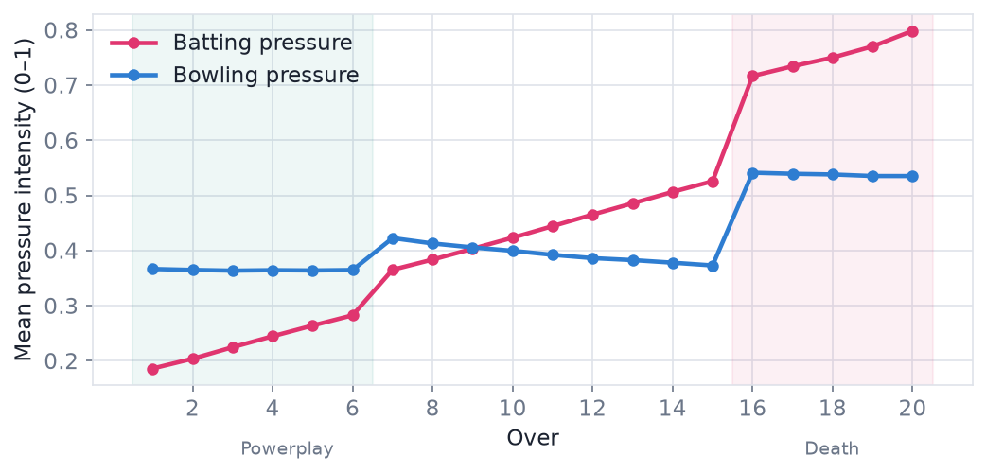
Batting-pressure factors
- Innings phase — death overs carry the highest stake, the powerplay the lowest.
- Wickets already lost — rebuilding after a collapse is higher pressure than batting with a full hand.
- Required run rate (chases) — a demanding chase is high pressure; but a hopeless chase (needing >3 runs/ball with few resources) is dampened, since garbage-time hitting is not a fair clutch test.
- Balls remaining — pressure concentrates as the innings runs out.
Bowling-pressure factors
- Death overs, where margins are smallest and every ball is decisive.
- Batting momentum — a high current run rate with wickets in hand means the bowler must stem the flow.
- Defending a gettable chase — when the batting side is cruising (low required rate), the bowler is under the most pressure to break through.
A delivery is classified ‘pressure’ when its intensity ≥ 0.55 (configurable; swept in §12). This yields 33% batting-pressure and 19% bowling-pressure deliveries.
6 · Match-State Reconstruction
For every delivery we reconstruct the state before the ball, chronologically: score so far, wickets fallen, wickets in hand, legal balls bowled and remaining, and — in the second innings — the target (first-innings total + 1), runs required, required run rate and current run rate. Balls remaining are clamped to ≥ 0; DLS matches are flagged and excluded from chase-based pressure. Correctness is covered by unit tests on hand-built innings (score, wickets, legal-ball counting, RRR, and a no-future-leakage invariant) — 11/11 pass.
7 · Batter Performance Metrics
On each delivery set (pressure and the player's own baseline) we compute: balls faced, runs, strike rate, average (runs per dismissal, counting only the batter's own dismissals), dot-ball %, boundary % and match counts. The headline comparison is pressure vs baseline strike rate and survival.
8 · Bowler Performance Metrics
Per delivery set: legal balls, runs conceded (bowler-charged), credited wickets, economy, strike rate, wicket rate per over, dot-ball % and boundary % conceded — each compared against the bowler's own baseline.
Context-matched baseline — controlling for innings-phase bias
A subtle but important issue: pressure deliveries are heavily concentrated at the death (≈59% of batting-pressure balls) whereas a player's pooled non-pressure baseline is dominated by the powerplay and middle overs (death is only ≈4% of it). Because strike rate and economy are naturally higher at the death, a raw pressure-minus-baseline uplift partly measures the phase, not a pressure response. We therefore compare each player to their own non-pressure level in the same phases, reweighted to the phase mix of their pressure balls. Since death-over non-pressure samples are thin, each per-phase baseline is shrunk toward the player's overall baseline, trading phase-bias for a controlled, honest estimate rather than noise.
9 · Player Rating — the Factors We Score
Score = 0.50 · Absolute + 0.30 · Uplift + 0.20 · Consistency (each component a 0–1 percentile within the eligible pool, ×100). Absolute carries the most weight so that a genuinely high-level pressure performance is rewarded on its own merit — a clutch knock is a clutch knock — while uplift and consistency keep the measure honest about who lifts when it matters:
- Absolute (50%) — performance under pressure, format-adjusted against the league's pressure par for the formats the player actually played (so IPL and T20I are compared fairly). Batters: pressure SR + survival; bowlers: economy-vs-par + wicket rate + dot %.
- Uplift (30%) — pressure minus the player's context-matched baseline (own non-pressure level in the same phases, shrunk toward their overall baseline), then empirical-Bayes shrunk toward zero by pressure sample size, so a player with 15 good balls cannot outrank one with 300.
- Consistency (20%) — the share of a player's pressure matches in which they delivered. Batters: strike rate within 10% of their (context-matched) baseline — a tolerance so high-baseline players are not punished for a strong-but-slightly-below-average innings. Bowlers: a graded blend of economy improvement (45%), wicket contribution (30%) and dot-ball rate (25%), replacing the old ‘economy ≤ baseline OR one wicket’ rule, which a single wicket could fully satisfy.
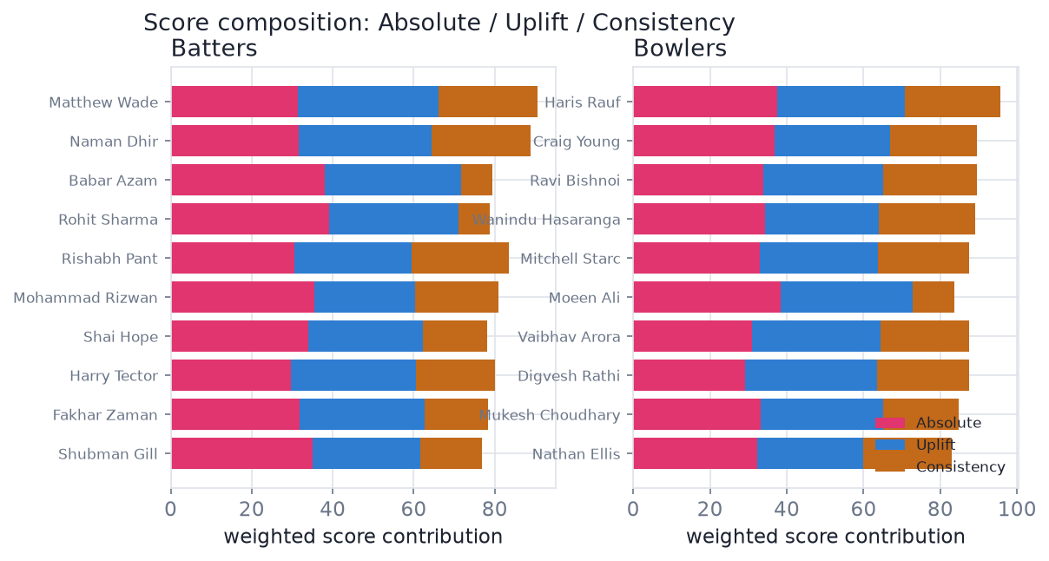
10 · Sample Size, Eligibility & Reliability
Eligibility (configurable): batters need ≥ 75 pressure balls, ≥ 5 pressure matches, ≥ 150 baseline balls; bowlers ≥ 60 pressure legal balls, ≥ 5 pressure matches, ≥ 120 baseline balls. Shrinkage priors (60 balls for batters, 48 for bowlers) pull small-sample uplifts toward zero. We never tune thresholds to force a particular player in.
11 · IPL and T20I Comparison
Both formats are combined, but baselines are computed per player (their own non-pressure balls in the formats they played) and the absolute component is adjusted against format-specific pressure par (IPL pressure SR ≈ 153 vs T20I ≈ 138; IPL pressure economy ≈ 10.6 vs T20I ≈ 10.0). Two sensitivity configs — IPL-weighting and a strict-sample cut — check that associate-nation inflation does not drive the picks.
12 · Sensitivity & Ranking Stability
We re-ran the entire rating under nine reasonable configurations: three pressure thresholds (0.50/0.55/0.60), two alternative batting definitions (chase-centric; death-and-collapse with no RRR) and two bowling definitions (death-heavy; defend-heavy), a strict-sample variant, and three weight mixes (uplift-, absolute- and consistency-heavy). The context-matched baseline and the balanced bowling consistency are applied inside every configuration, so reliability reflects the final model. The bars show how often each player stayed in the top 10.
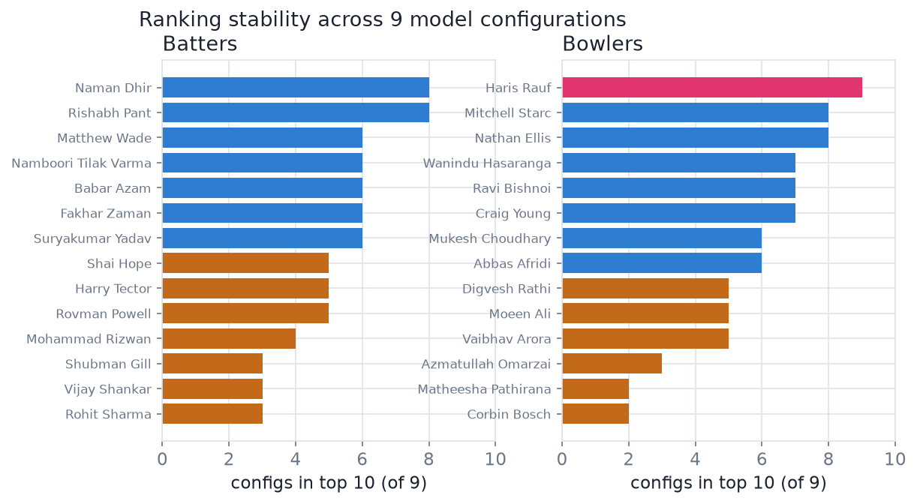

13 · Top 10 Batters — Evidence
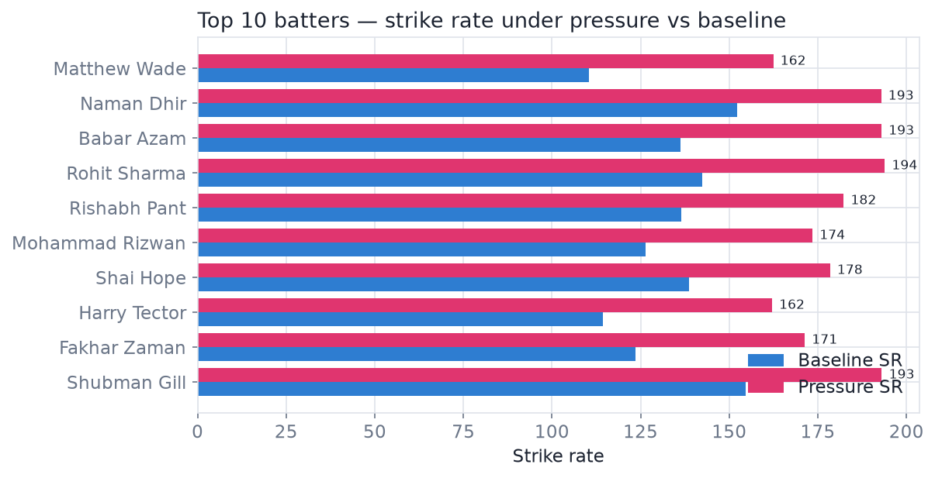
# | Batter | Score | Rel. | Pr. balls | Pr. mts | Pr. SR | Base SR | SR upl. | Pr. avg
1 | Matthew Wade | 88.6 | 67% | 229 | 19 | 162 | 110 | +52 | 53
2 | Naman Dhir | 87.2 | 89% | 267 | 25 | 193 | 152 | +41 | 32
3 | Babar Azam | 82.6 | 67% | 114 | 8 | 193 | 136 | +57 | 44
4 | Rohit Sharma | 82.5 | 33% | 82 | 5 | 194 | 142 | +52 | 80
5 | Rishabh Pant | 82.1 | 89% | 339 | 31 | 182 | 137 | +46 | 33
6 | Mohammad Rizwan | 82.1 | 44% | 117 | 9 | 174 | 126 | +47 | 41
7 | Shai Hope | 79.3 | 56% | 116 | 12 | 178 | 139 | +40 | 34
8 | Harry Tector | 79.2 | 56% | 182 | 16 | 162 | 114 | +48 | 30
9 | Fakhar Zaman | 78.8 | 67% | 129 | 12 | 171 | 124 | +48 | 32
10 | Shubman Gill | 78.8 | 33% | 202 | 17 | 193 | 155 | +38 | 39

Why each batter is here (all figures from the supplied data)
1. Matthew Wade — pressure strike rate 162 vs baseline 110 (+52), averaging 53 under pressure over 229 pressure balls in 19 matches; delivered in 94% of qualifying pressure matches; stays top-10 in 67% of configurations.
2. Naman Dhir — pressure strike rate 193 vs baseline 152 (+41), averaging 32 under pressure over 267 pressure balls in 25 matches; delivered in 90% of qualifying pressure matches; stays top-10 in 89% of configurations.
3. Babar Azam — pressure strike rate 193 vs baseline 136 (+57), averaging 44 under pressure over 114 pressure balls in 8 matches; delivered in 75% of qualifying pressure matches; stays top-10 in 67% of configurations.
4. Rohit Sharma — pressure strike rate 194 vs baseline 142 (+52), averaging 80 under pressure over 82 pressure balls in 5 matches; delivered in 100% of qualifying pressure matches; stays top-10 in 33% of configurations.
5. Rishabh Pant — pressure strike rate 182 vs baseline 137 (+46), averaging 33 under pressure over 339 pressure balls in 31 matches; delivered in 86% of qualifying pressure matches; stays top-10 in 89% of configurations.
6. Mohammad Rizwan — pressure strike rate 174 vs baseline 126 (+47), averaging 41 under pressure over 117 pressure balls in 9 matches; delivered in 100% of qualifying pressure matches; stays top-10 in 44% of configurations.
7. Shai Hope — pressure strike rate 178 vs baseline 139 (+40), averaging 34 under pressure over 116 pressure balls in 12 matches; delivered in 88% of qualifying pressure matches; stays top-10 in 56% of configurations.
8. Harry Tector — pressure strike rate 162 vs baseline 114 (+48), averaging 30 under pressure over 182 pressure balls in 16 matches; delivered in 83% of qualifying pressure matches; stays top-10 in 56% of configurations.
9. Fakhar Zaman — pressure strike rate 171 vs baseline 124 (+48), averaging 32 under pressure over 129 pressure balls in 12 matches; delivered in 88% of qualifying pressure matches; stays top-10 in 67% of configurations.
10. Shubman Gill — pressure strike rate 193 vs baseline 155 (+38), averaging 39 under pressure over 202 pressure balls in 17 matches; delivered in 73% of qualifying pressure matches; stays top-10 in 33% of configurations.

14 · Top 10 Bowlers — Evidence
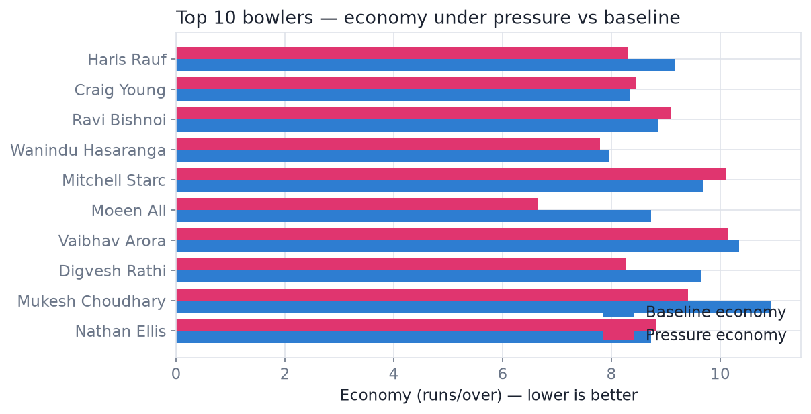
# | Bowler | Type | Score | Rel. | Pr. balls | Pr. mts | Pr. wkts | Pr. econ | Base econ | Wkts/ov
1 | Haris Rauf | Pace | 95.3 | 100% | 283 | 29 | 28 | 8.31 | 9.16 | 0.59
2 | Craig Young | Pace | 89.9 | 78% | 98 | 11 | 9 | 8.45 | 8.34 | 0.55
3 | Ravi Bishnoi | Spin | 88.6 | 78% | 223 | 28 | 18 | 9.09 | 8.86 | 0.48
4 | Wanindu Hasaranga | Spin | 88.3 | 78% | 432 | 37 | 33 | 7.79 | 7.96 | 0.46
5 | Mitchell Starc | Pace | 86.6 | 89% | 171 | 20 | 19 | 10.11 | 9.68 | 0.67
6 | Moeen Ali | Spin | 86.1 | 56% | 73 | 11 | 8 | 6.66 | 8.73 | 0.66
7 | Vaibhav Arora | Pace | 85.9 | 56% | 171 | 22 | 15 | 10.14 | 10.34 | 0.53
8 | Digvesh Rathi | Spin | 85.1 | 56% | 146 | 14 | 9 | 8.26 | 9.65 | 0.37
9 | Mukesh Choudhary | Pace | 84.5 | 67% | 97 | 13 | 7 | 9.40 | 10.94 | 0.43
10 | Nathan Ellis | Pace | 82.4 | 89% | 193 | 21 | 13 | 8.83 | 8.72 | 0.40

Why each bowler is here (all figures from the supplied data)
1. Haris Rauf (pace) — economy 8.31 vs baseline 9.16, 0.59 credited wickets/over and 42% dot balls under pressure, over 283 pressure legal balls in 29 matches; stays top-10 in 100% of configurations.
2. Craig Young (pace) — economy 8.45 (vs 8.34 baseline), 0.55 credited wickets/over and 41% dot balls under pressure, over 98 pressure legal balls in 11 matches; stays top-10 in 78% of configurations.
3. Ravi Bishnoi (spin) — economy 9.09 (vs 8.86 baseline), 0.48 credited wickets/over and 39% dot balls under pressure, over 223 pressure legal balls in 28 matches; stays top-10 in 78% of configurations.
4. Wanindu Hasaranga (spin) — economy 7.79 vs baseline 7.96, 0.46 credited wickets/over and 34% dot balls under pressure, over 432 pressure legal balls in 37 matches; stays top-10 in 78% of configurations.
5. Mitchell Starc (pace) — economy 10.11 (vs 9.68 baseline), 0.67 credited wickets/over and 40% dot balls under pressure, over 171 pressure legal balls in 20 matches; stays top-10 in 89% of configurations.
6. Moeen Ali (spin) — economy 6.66 vs baseline 8.73, 0.66 credited wickets/over and 37% dot balls under pressure, over 73 pressure legal balls in 11 matches; stays top-10 in 56% of configurations.
7. Vaibhav Arora (pace) — economy 10.14 vs baseline 10.34, 0.53 credited wickets/over and 36% dot balls under pressure, over 171 pressure legal balls in 22 matches; stays top-10 in 56% of configurations.
8. Digvesh Rathi (spin) — economy 8.26 vs baseline 9.65, 0.37 credited wickets/over and 32% dot balls under pressure, over 146 pressure legal balls in 14 matches; stays top-10 in 56% of configurations.
9. Mukesh Choudhary (pace) — economy 9.40 vs baseline 10.94, 0.43 credited wickets/over and 41% dot balls under pressure, over 97 pressure legal balls in 13 matches; stays top-10 in 67% of configurations.
10. Nathan Ellis (pace) — economy 8.83 (vs 8.72 baseline), 0.40 credited wickets/over and 40% dot balls under pressure, over 193 pressure legal balls in 21 matches; stays top-10 in 89% of configurations.

15 · IPL-Availability — an Optional, Secondary View
The problem statement does not ask for a nationality filter, so the primary rankings in this report apply none — they are the pure statistical result. Separately, because Rajasthan Royals is an IPL franchise, we provide an optional view that removes players an IPL side cannot sign. Nationality is inferred from the national team a player represents in T20Is — a data-only heuristic that is not independently verified (players with no T20I record cannot be classified), which is why it is presented only as a secondary lens, never as the headline answer. The scoring model is identical; this view simply drops the flagged players and re-ranks.
Removed from the IPL-availability view — batters: Babar Azam, Mohammad Rizwan, Fakhar Zaman, Usman Khan, Salman Agha, Iftikhar Ahmed, Hasan Nawaz, Mohammad Haris.
Removed from the IPL-availability view — bowlers: Haris Rauf, Abbas Afridi, Sufiyan Muqeem, Abrar Ahmed, Naseem Shah, Shadab Khan, Shaheen Afridi, Mohammad Nawaz, Mohammad Wasim.
Full IPL-available top-10s are in outputs/batter_rankings_ipl_available.csv and the dashboard.
16 · Model Validation
- Unit-tested cricket logic — hand-built innings verify score/wicket reconstruction, legal-ball counting, bowler wicket credit, required run rate, and a no-future-leakage invariant (11/11 pass).
- Innings totals cross-checked against 356 result margins (median error 0; 266 within ±3 runs; large misses are DLS games).
- Pressure definition is meaningful — mean intensity rises monotonically through the innings and differs by role, matching cricketing intuition.
- Small samples are shrunk, not rewarded — the sample-size-vs-score plots show no runaway effect from low-ball players.
- Rankings are stable — the strongest picks appear in the top 10 across nearly all nine configurations.
17 · Limitations
- Approximate targets — bye/leg-bye magnitudes are not stored, so required run rate is accurate to ±1–3 runs; DLS matches are excluded from chase logic. Coarse pressure bands make this immaterial to classification.
- Pressure is a modelling choice, not an official RR definition; we mitigate with nine configurations and per-player reliability.
- T20I strength varies by opponent; baselines are format-adjusted but some associate-nation inflation can remain — checked via IPL-weighted and strict-sample configs.
- No fitted win-probability model — contest closeness is proxied by required run rate, wickets and phase.
- Availability filter uses nationality inferred from T20I appearances; a handful of uncapped players have no T20I record and are treated as IPL-eligible.
18 · Conclusion
The framework turns the vague idea of ‘clutch’ into a reproducible, delivery-level measurement: a transparent pressure index, self-referenced performance, a balanced and shrinkage-protected rating, and a robustness check across nine model variants. The resulting top-10 batters and bowlers are not reputation picks — every name is backed by its own pressure-versus-baseline numbers and a reliability score, and every figure in this report is traceable to the supplied data via the accompanying code (run_pipeline.py) and the interactive dashboard.

