**Software Requirements Specification – Team Provers**

**Product - CRM**

# Introduction

## Purpose

This document provides an overview of a Customer Relationship Management (CRM) System from a functional perspective, highlights some technical considerations relating to the application, and also highlights some technical and organizational implementation issues.  
This is the requirement-gathering document needed to fully identify the functional features of the release version of CRM System. CRM is a standalone project and as such will not be associated with any other projects.

## Scope

The scope of this project is the creation of a CRM system. “Team Provers” will develop a CRM system that provides information for managing the business/sales process, monitor, analyze, integrated requests module, employee’s communication and improve all the related activities. The most advantageous feature is, all the activities and their respective summary reports are management informative for decision-making, paperless and with least effort. This new system will be a huge improvement over the outdated traditional CRM systems in use. Also to keep the info of the customer. It adds, deletes, and updates the records of the customers. It provides the promotional offer to the customer based on provided info. It also measures the customer care representative’s performance. In this manager can see customer care representative performance as a report. User can access it from the mobile if they have internet on the mobile device.

## Overview

The rest of this document contains the overall description of the Customer Relationship Management system (section 2), and the specific requirements for the system (section 3).

# Overall Description

This section provides a high level view of the product capabilities, interfaces to other applications and system configurations. This section usually consists of three subsections, as follows:

* Product perspective
* Product functions
* User characteristics
* Constraints
* Assumptions and dependencies
* Requirements subsets

## Product Perspective

CRM will be an off-the shelf software product. Customers will need to buy the product and customize it to reflect their organizations sales model before deploying it enterprise-wide. Once the system has the enterprise sales model it can become operational. End users only need any conventional web browser to use the system. The interface is intuitive and requires minimal training. The CRM Modules will run on an enterprise application server. The modules are J2EE compliant and can be plugged into any existing application server that the enterprise may have. In case the organization does not have an application server it can be deployed on a free open source Application server like Jboss. Thus additional investments for deployment are minimal.

## Product functions

### Enables effective contact management:

CRM PROVERS enables sales and marketing to customize, manage, and schedule sales generation activities such as cold-call, mail literature, follow-up, sales-call, etc. The effectiveness of CRM PROVERS contact management functionality comes from the fact that the underlying sales generation activities are 100% customizable. This feature allows organizations to define sales generation activities suitable to their own business environment.

### Offers a single, uniform view of customer information:

In an environment with multiple sales people, lack of centralized contact management system results in un-coordinated sales efforts. Everyone works on their own. Further, organizations don't have one single database of its sales generation activities. This prevents organizations from capitalizing on its historical sales generation data for generating new sales. With centralized management of information, CRM PROVERS offers a single and uniform view of customer information across multiple processes. In addition, a CRM PROVERBSuses database technology that supports automatic synchronization of portable (micro) databases with their server database. This enables sales people to work offline.

### Promotes effective client-communication:

CRM PROVERBS enable organizations to build communication frameworks consisting of e-mail and letter templates. The idea behind building such framework is to enable all of its sales people to offer a uniform and consistent service to its current as well as future customers. CRM PROVERBS also provide e-tools for sending automatic email messages, constructed dynamically from e-mail templates.

### Eliminates costly delays associated with manual coordination of sales and completion processes:

For an example, in a scenario where the co-ordination between sales and fulfilment processes is manual, often sales people do not know the right people in the engineering group to whom they should send/handover customer quotes for approval. This could lead to quotes getting ignored by the engineering department or even getting lost somewhere in the flow. Here two different groups of people - sales and engineering - are participating in one unified scenario – the quotation. Unifying and automating these different groups would eliminate above-mentioned delays resulting in better customer service.

### Establishes well-defined responsibilities:

In a scenario where responsibilities are not clearly defined, there is often confusion among the participants as to who is supposed to do what and when. This confusion translates into slower (or lack of) response to customer needs. By unifying processes and resources under one business model, CRM PROVERS enable organizations to clearly set rules and responsibilities in terms of who is to handle what kind of work and when. This results in improved productivity and better respond to customer requirements.

### Eliminates manual handling of documents:

Manual handling of documents often leads to documents reaching wrong destinations (or disappearing altogether somewhere in the flow). With CRM PROVERS, documents are stored in the central repository, and their URIs (Uniform Resource Identifiers) is automatically delivered to the correct destinations every time.

### Enables live tracking of customer requirements:

A significant part of satisfying customers is to know precisely at what stage their requirements are within the sales fulfilment cycle. CRM PROVERS have always provided "live" status (current activity type, who is assigned, when was the activity assigned, how long should it take, etc.) of customer requirements. This allows customer service people to instantaneously respond to customers' requests or forward their requests to the people that are currently working on their requirements.

### Provides necessary and sufficient information online:

Many times resources don't have enough information to perform tasks or it may be too cumbersome to find necessary information. CRM PROVERS allow users to access information right from their Web browsers. It also gives IT departments a complete control and flexibility over determining which information to make available to the users.

## Constraints

**The following are the constraints:**

* The project must be completed within the budget
* The project must be completed within a specified period of time.
* The system should be up 24/7.
* The system should enforce user authentication security and guarantee reliability.

## Assumptions and dependencies

Initially, companies already having significant sales operations and running enterprise software will be targeted. This would lead to the faster growth of sales of CRM, as deployment would be easiest in these organizations.

# Flow Chart

**Applications**

* **Market Place**
* **All Applications**

**Customer**

**Workgroups**

**Login**

# 

**Company**

* **Employees**
* **Company Drive**
* **Company Structure**
* **Absense Drive**
* **Administrative Workflows**

**Settings**

* **Intranet Settings**
* **Manage E-mail Accounts**
* **Subscription**

**Activity Stream**

**Tasks**

**Calendar**

**My Drive**

**Telephony**

* **Balance and Statistics**
* **Phone Numbers**
* **Telephony Users**
* **SIP Phones**
* **Other Settings**
* **Stream**
* **Activities**
* **Contacts**
* **Companies**
* **Deals**
* **Quotes**
* **Invoices**
* **Leads**
* **Reports**
* **Sales Funnel**
* **History**
* **Products**
* **Settings**
* **Message**
* **Task**
* **Meeting**
* **Email**

**My Photos**

**Conversion**s

**CRM**

**Webmail**

**Workflow**

**My Requests**

# Specific Requirements

## Product Functions

CRM Software should support the following use cases:

|  |  |  |  |
| --- | --- | --- | --- |
| CLASS OF USE CASES | № | USE CASES | DESCRIPTION OF USE CASES |
| Related to System Authentication | 1 | **Login** | *Login into the CRM system* |
| 2 | **Change Password** | *Changes the login password* |
| Related to Activity Stream | 3 | **Post Message** | *Posts a Message to the Activity Stream* |
| 4 | **Delete Message** | *Delete Message from Activity Stream* |
| 5 | **Processes** | *Requests an Approval from Manager* |
| Related to Tasks | 6 | **New Task** | *Creates a task for execution* |
| 7 | **Execute Task** | *Executes the task* |
| 8 | **Finish Task** | *Finishes the task* |
| 9 | **Delete Task** | *Deletes the task* |
| Related to Calendar | 10 | **New Event** | *Creates an event in the Calendar* |
| 11 | **Delete Event** | *Deletes the event from the Calendar* |
| Related to CRM | 12 | **Create Contact** | *Creates a Contact in the CRM* |
| 13 | **Delete Contact** | *Deletes the Contact from the CRM* |
| 14 | **Create Company** | *Creates a Company in the CRM* |
| 15 | **Delete Company** | *Delete the Company from CRM* |
| 16 | **Create Activity** | *Creates an Activity* |
| 17 | **Finish Activity** | *Finishes an Activity* |
| 18 | **Delete Activity** | *Deletes an Activity* |
| Related to Information Display | 19 | **Display Message** | *Display information about the message* |
| 20 | **Display Request** | *Display information about the request* |
| 21 | **Display Task** | *Display information about the task* |
| 22 | **Display Event** | *Display information about the event* |
| 23 | **Display Contact** | *Display information about the contact* |
| 24 | **Display Company** | *Display information about the company* |
| 25 | **Display Activity** | *Display information about the activity* |

## Functional Requirements

We describe the functional requirements by giving various use cases.

*Use cases related to System Authentication:*

*Use Case №1:* Login  
*Primary Actor*: User  
*Pre Condition*: Installed browser and active internet connection   
*Main scenario*:

1. User initiates browser
2. User specifies web address for accessing the CRM
3. User gives the login and password ( refer to next chapters section “User Screens” )
4. System does authentication
5. Activity Stream is displayed

*Alternate scenario:*  
 4.1 Authorization fails – wrong username/password  
 4.1.1 Prompt the user that he typed the username/password wrong  
 4.1.2 Allow him to re-enter the username/password  
 4.2 Authorization fails – forgotten username/password  
 4.2.1 Prompt the user to enter his registered email  
 4.2.2 User receives an email with instructions about his login credentials

*Use Case №2*: Change password  
*Primary Actor*: User  
*Pre Condition*: User logged in   
*Main scenario*:

1. User goes to Bitrix24.Network Page from the profile menu located at the top pane ( refer to next chapters section “User Screens” )
2. User goes to Edit Profile
3. User initiates “Change Password” functionality
4. User provides current password, new password and confirm new password
5. System displays message for successful change

*Alternate scenario:*  
 4.1 Authorization fails – wrong password  
 4.1.1 Prompt the user that he typed the password wrong  
 4.1.2 Allow him to re-enter the password  
 4.2 Authorization fails – new password and confirm new password do not match  
 4.2.1 Prompt the user that new password and confirm new password do not match  
 4.2.2 Allow him to re-enter the attributes.  
 4.3 Authorization fails – new password and confirm password are less than 6 chars  
 4.3.1 Prompt the user that password must be at least 6 characters  
 4.3.2 Allow him to re-enter new and confirm password

*Use cases related to Activity Stream:*

*Use Case №3:* Post Message   
*Primary Actor*: User  
*Pre Condition*: User logged in   
*Main scenario*:

1. User initiates “Post Message” functionality from Activity Stream ( refer to next chapters section “User Screens” )
2. User enters message text
3. User specifies attachments (if necessary)
4. User specifies recipients
5. User posts the message
6. Message is created
7. All recipients receive notification

*Alternate scenario:*  
 5.1 Post Message Cancellation  
 5.1.1. User cancels Post Message functionality  
 5.1.2. Post Message canceled

*Use Case №4:* Delete Message   
*Primary Actor*: User  
*Pre Condition*: User logged in   
*Main scenario*:

1. User initiates “Delete Message” functionality from selected message
2. System displays a confirmation message
3. System displays a successful deletion message
4. Message is deleted

*Use Case №5:* Processes   
*Primary Actor*: User  
*Secondary Actor*: User - Approver  
*Pre Condition*: Users logged in   
*Main scenario*:

1. User initiates “Processes” functionality from Activity Stream ( refer to next chapters section “User Screens” )
2. User selects type of needed approval
3. User specifies absence type
4. User specifies reasons
5. User sends the request approval
6. Request is created
7. Approver receives a notification about the request
8. User receives approvers decision

*Alternate scenario:*  
 5.1 Request Approval cancellation  
 5.1.1. User cancels Request Approval functionality  
 5.1.2. Request Approval canceled

*Use cases related to Tasks:*

*Use Case №6:* New Task  
*Primary Actor*: User  
*Pre Condition*: User logged in   
*Main scenario*:

1. User initiates the “New Task” functionality from Tasks ( left pane, refer to next chapters section “User Screens” )
2. User enters a name for the task
3. User specifies responsible person
4. User specifies deadline for completion
5. User enters the task description
6. Task is created
7. System creates and assigns the task to the responsible person
8. System sends notification to the responsible person

*Alternate scenario:*  
 6.1 New Task cancellation  
 6.1.1. User cancels New Task functionality  
 6.1.2. New Task canceled

*Use Case №7:* Execute Task  
*Primary Actor*: User  
*Pre Condition*: User logged in   
*Scenario*:

1. User selects task from Tasks ( left pane, refer to next chapters section “User Screens” )
2. User initiates the “Execute Task” functionality from the task itself
3. Task execution is started

*Use Case №8:* Finish Task  
*Primary Actor*: User  
*Pre Condition*: User logged in   
*Scenario*:

1. User selects task from Tasks ( left pane, refer to next chapters section “User Screens” )
2. User initiates the “Finish Task” functionality from the task itself
3. System marks the task as completed

*Use Case №9:* Delete Task  
*Primary Actor*: User  
*Pre Condition*: User logged in   
*Main scenario*:

1. User selects task from Tasks ( left pane, refer to next chapters section “User Screens” )
2. User initiates the “Delete Task” functionality from the task itself
3. System displays a confirmation message
4. Task is deleted

*Use cases related to Calendar:*

*Use Case №10:* New Event  
*Primary Actor*: User  
*Pre Condition*: User logged in   
*Main scenario*:

1. User initiates the “New Event” functionality from Calendar ( left pane, refer to next chapters section “User Screens” )
2. User enters start and end time and sets reminders
3. User specifies event name and location
4. User specifies event description
5. User adds participants (if needed)
6. User submits the event
7. Event is created
8. System sends notifications to the participants
9. System sends reminders

*Alternate scenario:*  
 6.1 New Event cancellation  
 6.1.1. User cancels New Event functionality  
 6.1.2. New Task canceled

*Use Case №11:* Delete Event  
*Primary Actor*: User  
*Pre Condition*: User logged in   
*Main scenario*:

1. User selects the event from Calendar ( left pane, refer to next chapters section “User Screens” )
2. User initiates the “Delete Event” functionality from the event itself
3. System displays a confirmation message
4. Event is deleted

*Use cases related to CRM:*

*Use Case №12:* Add Contact  
*Primary Actor*: User  
*Pre Condition*: User logged in   
*Main scenario*:

1. User initiates the “Add Contact” functionality from CRM/Contacts ( left pane, refer to next chapters section “User Screens” )
2. User specifies first and last names of the contact
3. User specifies email
4. User specifies phone
5. User specifies Company (if necessary)
6. User specifies contact type
7. User specifies responsible person
8. A contact is created

*Alternate scenario:*  
 8.1. Add Contact cancelation  
 8.1.1. “Add Contact” functionality is canceled  
 8.2. Contact with the same information exists  
 8.2.1. System asks the user for different information  
 8.2.1. Contact is created  
 8.2.2. System asks the user for merging with existing contact  
 8.2.1. Contact is merged  
 8.2.3. System cancels the “Add Contact” functionality

*Use Case №13:* Delete Contact  
*Primary Actor*: User  
*Pre Condition*: User logged in   
*Main scenario*:

1. User selects the contact from CRM/Contacts ( left pane, refer to next chapters section “User Screens” )
2. User initiates the “Delete Contact” functionality from the contact itself
3. System displays a confirmation message
4. Contact is deleted

*Use Case №14:* Add Company  
*Primary Actor*: User  
*Pre Condition*: User logged in   
*Main scenario*:

1. User initiates the “Add Company” functionality from CRM/Companies ( left pane, refer to next chapters section “User Screens” )
2. User specifies company name
3. User specifies responsible person
4. User specifies company information
5. User associates employees / contacts (if present)
6. User submits the company form

*Alternate scenario:*  
 6.1. Add Company cancelation  
 6.1.1. “Add Company” functionality is canceled  
 6.2. Company with the same information exists  
 6.2.1. System asks the user for different information  
 6.2.1. Company is created  
 6.2.2. System asks the user for merging with existing Company  
 6.2.1. Company is merged  
 6.2.3. System cancels the “Add Company” functionality

*Use Case №15:* Delete Company  
*Primary Actor*: User  
*Pre Condition*: User logged in   
*Main scenario*:

1. User selects the company from CRM/Companies ( left pane, refer to next chapters section “User Screens” )
2. User initiates the “Delete Company” functionality from the company itself
3. System displays a confirmation message
4. Company is deleted

*Use Case №16:* Create Activity  
*Primary Actor*: User  
*Pre Condition*: User logged in   
*Main scenario*:

1. User initiates the “Create Activity” functionality from CRM/Activities ( left pane, refer to next chapters section “User Screens” )
2. User selects the activity type (new call or new meeting)
3. User specifies date and reminder
4. User specifies where/with information
5. User specifies subject and information
6. User specifies responsible person
7. An activity is created
8. System sends notification and reminders

*Alternate scenario:*  
 7.1 Create Activity cancellation  
 7.1.1. User cancels Create Activity functionality  
 7.1.2. Create Activity canceled

*Use Case №17:* Finish Activity  
*Primary Actor*: User  
*Pre Condition*: User logged in   
*Scenario*:

1. User selects the activity from CRM/Activities ( left pane, refer to next chapters section “User Screens” )
2. User initiates the “Finish Activity” functionality from the activity itself
3. System marks the activity as finished

*Use Case №18:* Delete Activity  
*Primary Actor*: User  
*Pre Condition*: User logged in   
*Main scenario*:

1. User selects the activity from CRM/Activities ( left pane, refer to next chapters section “User Screens” )
2. User initiates the “Delete Activity” functionality from the activity itself
3. System displays a confirmation message
4. Activity is deleted

*Use cases related to Information Display:*

*Use Case №19:* Display Message  
*Primary Actor*: User  
*Pre Condition*: User logged in   
*Scenario*:

1. Message is displayed in Activity Stream ( refer to next chapters section “User Screens” )

*Use Case №20:* Display Request  
*Primary Actor*: User  
*Pre Condition*: User logged in   
*Scenario*:

1. Request is displayed in Activity Stream

*Use Case №21:* Display Task  
*Primary Actor*: User  
*Pre Condition*: User logged in   
*Scenario*:

1. User selects task from Tasks ( left pane, refer to next chapters section “User Screens” )
2. System displays the Task information

*Use Case №22:* Display Event  
*Primary Actor*: User  
*Pre Condition*: User logged in   
*Scenario*:

1. User selects an event from Calendar ( left pane, refer to next chapters section “User Screens” )
2. System displays the event information

*Use Case №23:* Display Contact  
*Primary Actor*: User  
*Pre Condition*: User logged in   
*Scenario*:

1. User selects a contact from CRM/Contacts ( left pane, refer to next chapters section “User Screens” )
2. System displays the contact information

*Use Case №24:* Display Company  
*Primary Actor*: User  
*Pre Condition*: User logged in   
*Scenario*:

1. User selects a company from CRM/Companies ( left pane, refer to next chapters section “User Screens” )
2. System displays the contact information

*Use Case №25:* Display Activity  
*Primary Actor*: User  
*Pre Condition*: User logged in   
*Scenario*:

1. User selects an activity from CRM/Activities ( left pane, refer to next chapters section “User Screens” )
2. System displays the activity information

## Visibility (User Screens)

1. Login

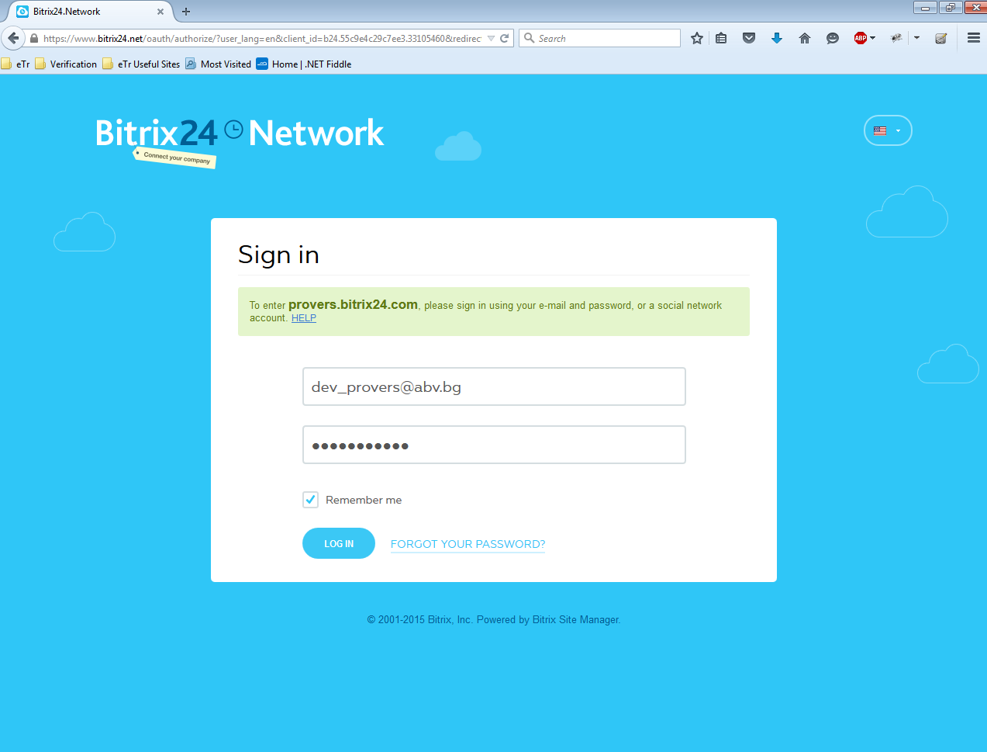

1. Bitrix Network

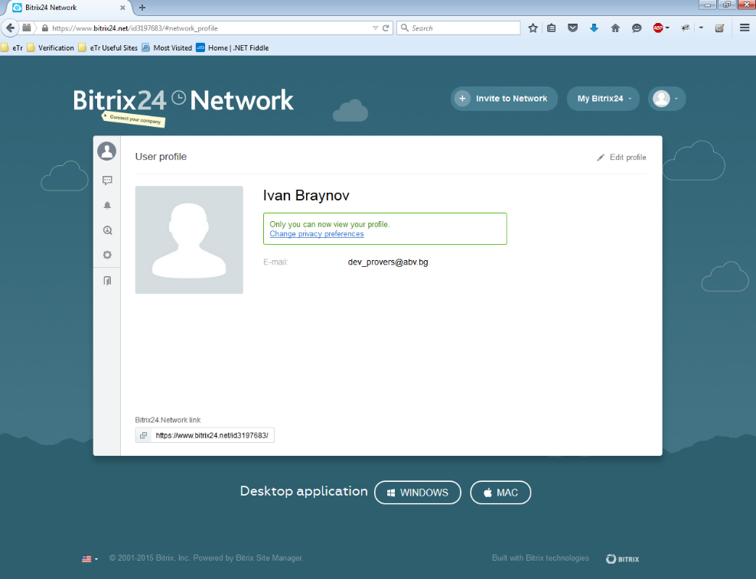

1. Activity Stream

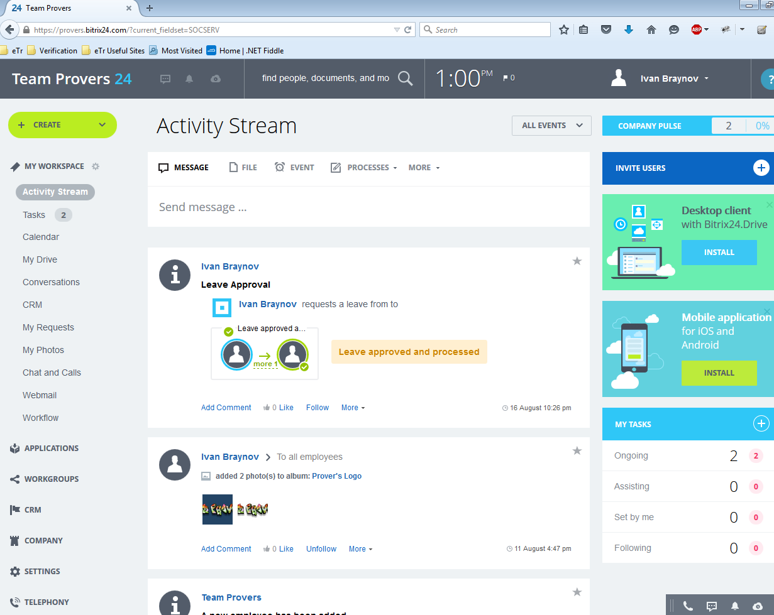

1. Tasks

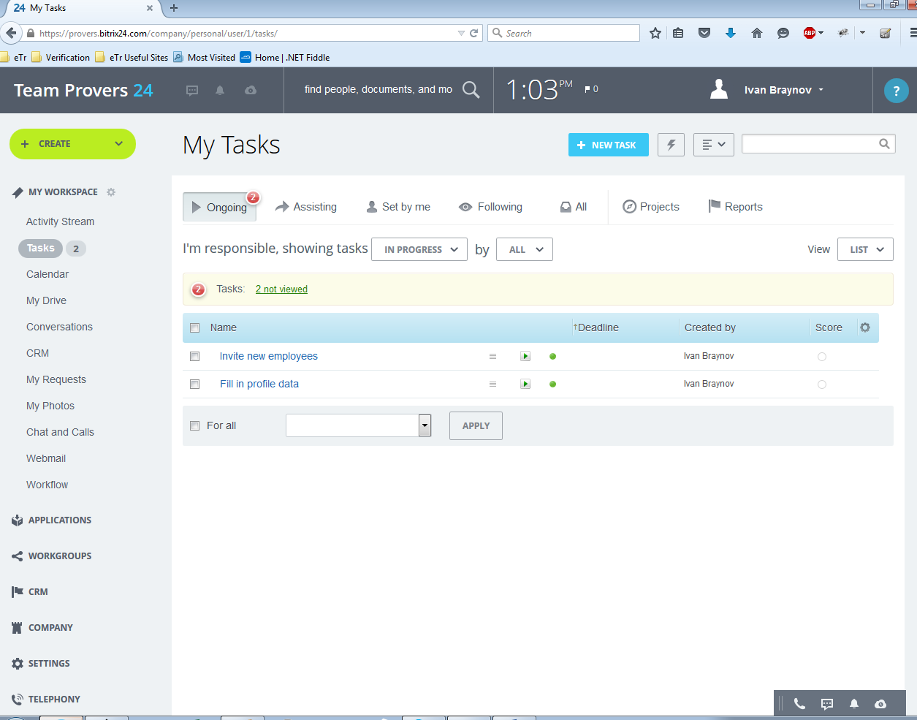

1. Calendar

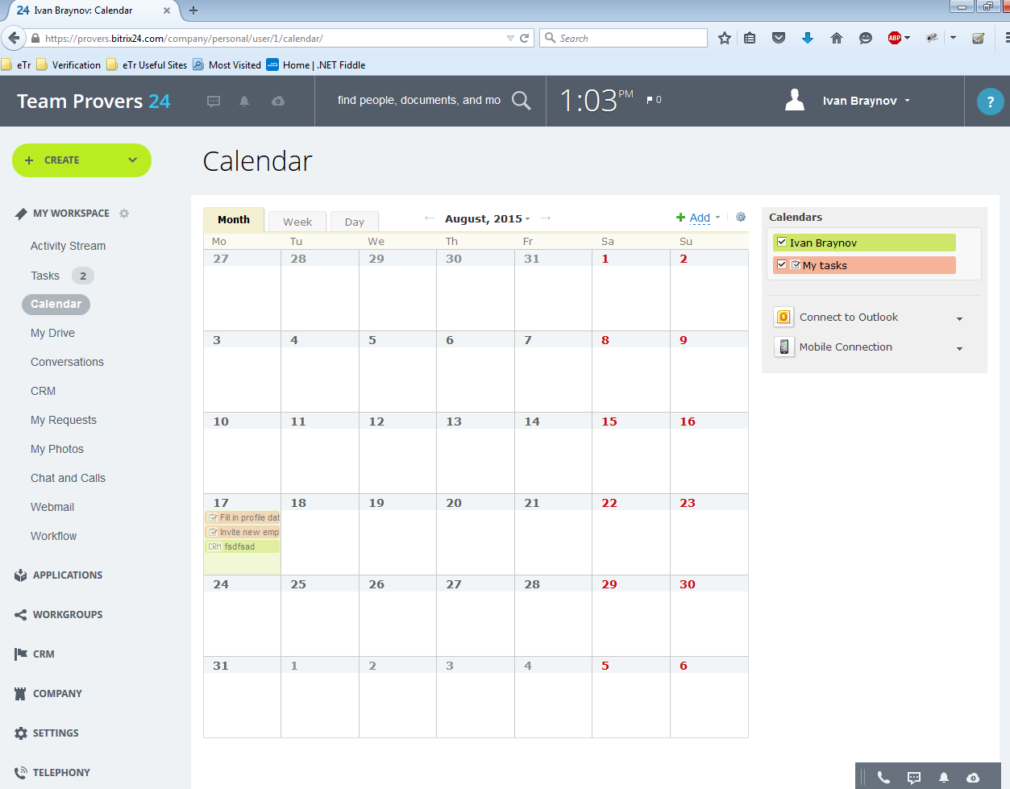

1. CRM

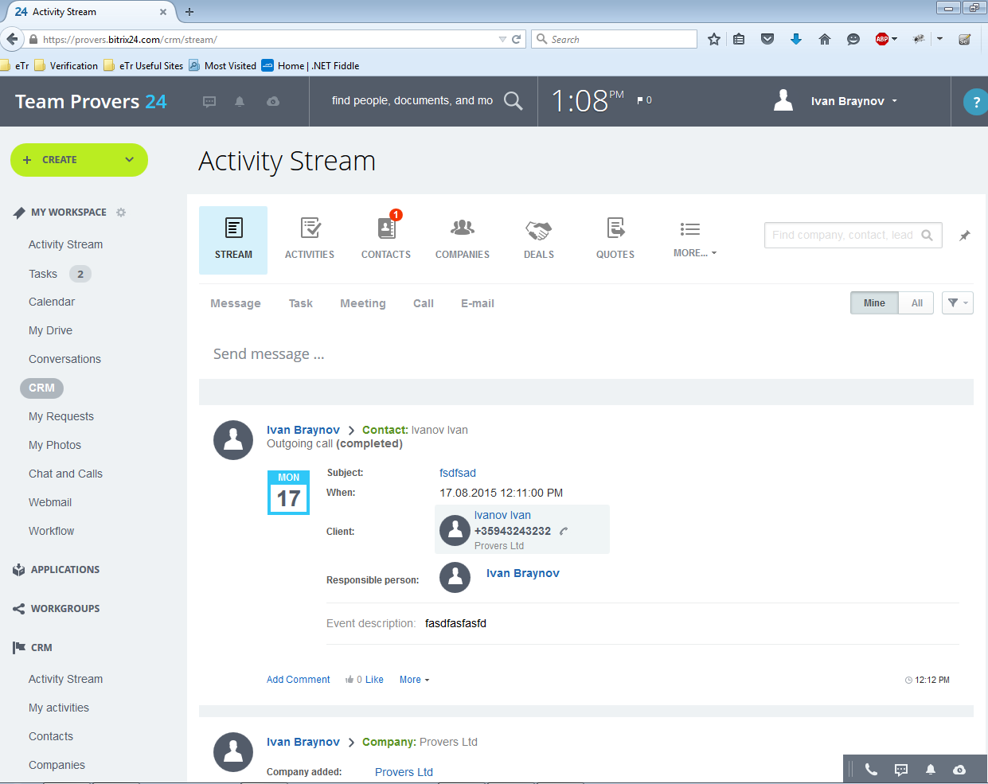

1. CRM/Contacts

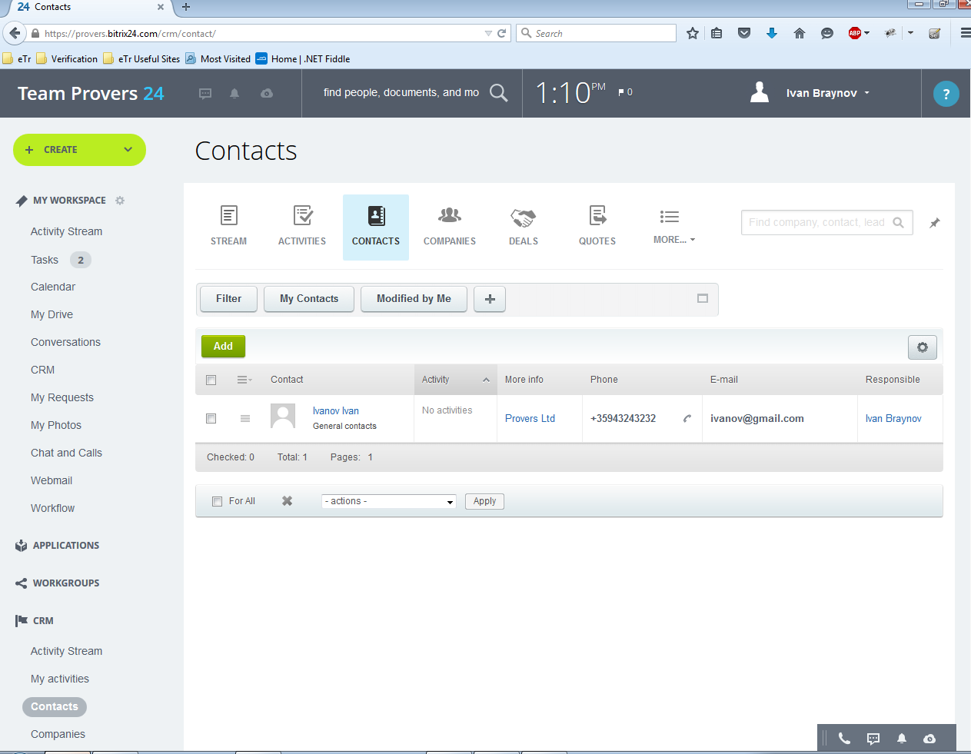

1. CRM/Companies

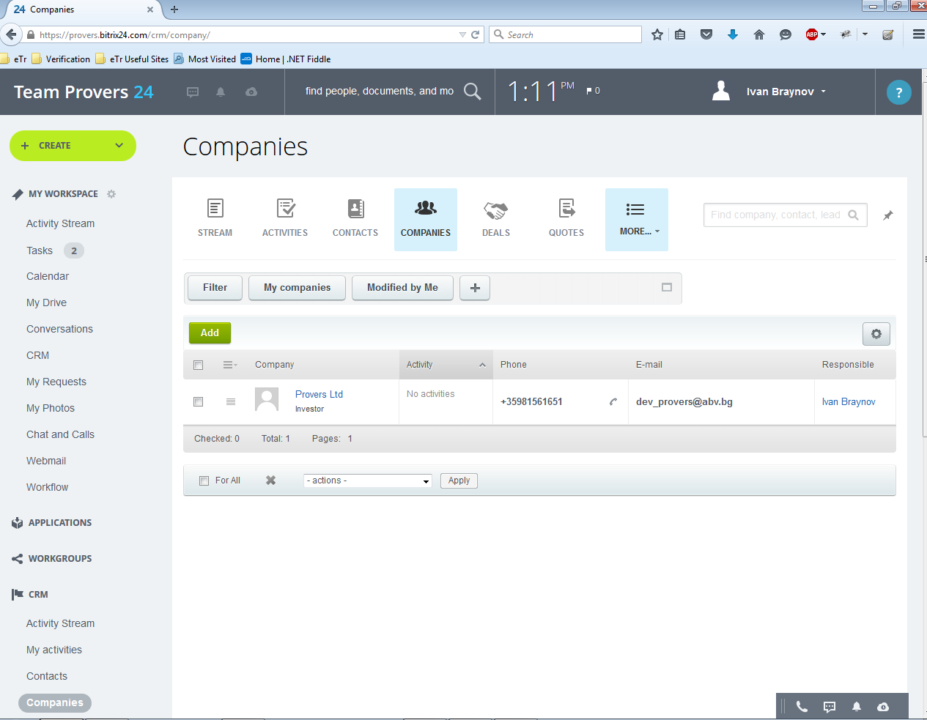

1. CRM/Activities  
   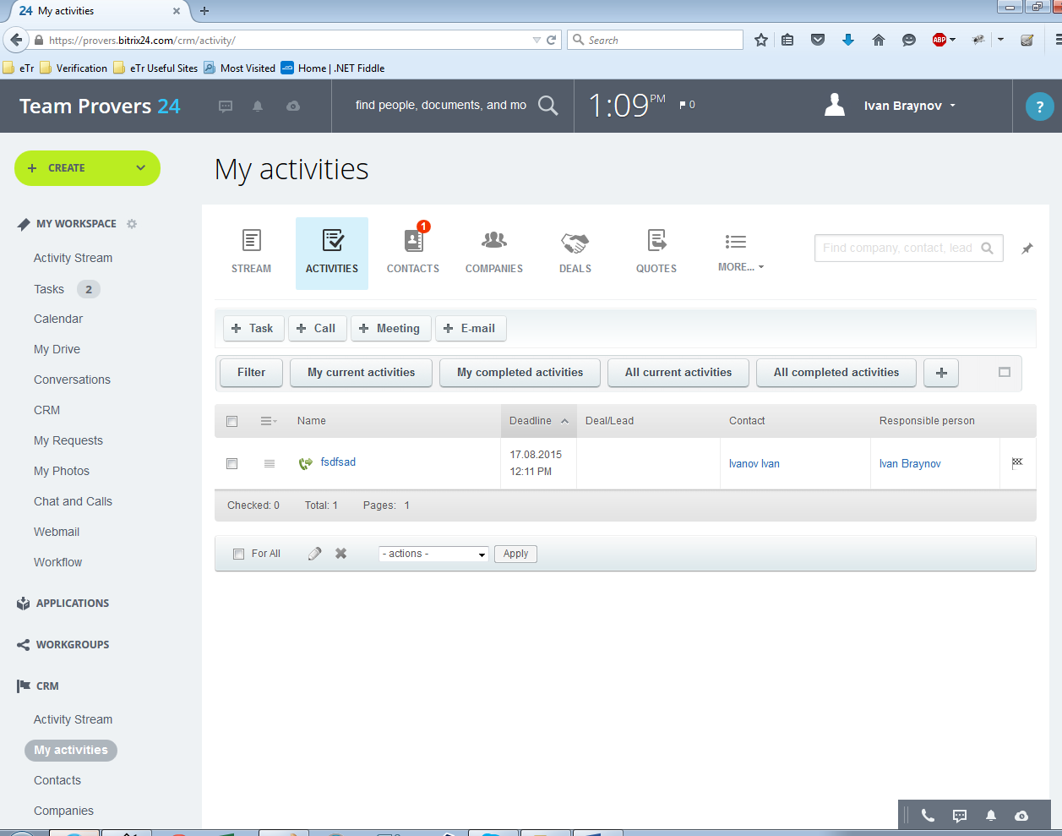

## Reliability

Reliability is an important factor to make CRM trustable. Some issues should be considered as following:

### Availability:

CRM should be available 24 hours per day, 7 days per week. Maintenance access period is a month. Database is backed up.

### Mean Time Between Failures (MTBF):

3 month.

### Mean Time To Repair (MTTR):

2 hours

### Maximum Bugs or Defect Rate:

Less than 1minor bug per 1000 lines of code.

### Bugs or Defect Rate:

No critical bug that causes data loss or system crash is allowed.

## Performance

### The information retrieval should be as fast as possible for customer satisfaction.

To ensure this, the consumer should be able to download a page in 5 seconds with a 33.6 Kbps modem. The form submission should not take a long time to be processed, especially in the CRM module case, in which form applications play a major role.

### The server should be able to serve 25 percent of registered customers

The server should be able to serve 25 percent of registered customers simultaneously, which may be about several thousands for a medium scaled electronic enterprise.

### Separation of connection handling and data processing

Separation of connection handling and data processing would definitely improve the overall system performance as well as cost incurred.

### Software runs on an online platform

Slow data retrieval because of poor programming must be absolutely discarded since the software runs on an online platform.

### Minimize the data transfer time

The size of data sent to the user can be limited to an upper bound, especially for the multimedia files, to minimize the data transfer time.

### Size of the secondary storage

The larger the primary memory, the faster the applications would run. Moreover the size of the secondary storage should be sufficient for data swapping, recovery and backup procedures.

## Supportability

### Compatible With Operating Systems

* Windows
* Linux
* Sun Solaris

### Compatible With J2EE Application Servers

* WebLogic
* WebSphere
* Oracle9i

### Compatible With Database

* Oracle8i on Solaris 2.7 and Windows NT 4.0 with Oracle JDBC driver
* Microsoft SQL Server 7.0 with JTurbo 2.0 JDBC driver

### Compatible With Java Virtual Machines

* Sun JDK 1.3.1 with Windows NT, Solaris, VA Linux, and Red Hat Linux

### Compatible With System Requirements

* 128 MB RAM or more 200 MHz processor or better
* 1 MB disk space for application .ear file
* JDK 1.3.1 or higher
* JDBC 2.0 –compliant
* SQL database

## Design Constraints

The underlying database structure is to be designed using relational design methodology. CRM PROVERS should runs on any JDBC 2.0 compliant database. CRM CONNECT application components are to be designed and developed using object oriented methodology. CRM CONNECT is to be 100% J2EE 1.2.1 compatible. The open architecture of CRM CONNECT safeguards organizations’ investment in the technology and establishes a robust and widely accepted application development and hosting platform essential for the successful implementation of web-enabled business applications.

## On-line User Documentation and Help System Requirements

### User Manual

User manuals: will be self-explanatory guide to installation and troubleshooting of CRM. It will allow users to install system using 3 major installation options, namely:

Minimal-Meeting the need of users with limited resources or resource constraint product installation requirements.

Typical: For standard installations

Custom: For expert installations

CD-ROM: Includes the CRM product setup files, with help files and configuration files and Read me.

### Online Help

Online help is available to all registered users. Internet downloadable, online instructions guide is available on web. Online guide also provide complete system description and technologies.

## Purchased Components

* Data Warehouse Build tools (e.g. Data Propagator, Prism, Extract) can be used to help Build & Maintain Marketing Data mart.
* OLAP tools such as Business Objects, of DSS-Agent will support multi-dimensional analyses, and Data Visualization tools such as Decision House will help to interpret the data as required in Strategic Analyses: Trend Analyses, Profitability, and Customer Potential
* Software Packages such as SAS, or SPSS, are a frequent starting point to implement Data Mining and can be enhanced by Neural Network products from companies such as HNC.
* Campaign Management Systems from companies such as AIMS-Software, Exchange Applications, Intrinsic, Oracle, Prime Response, and Recognition Systems provide the multi-channel, event-driven functionality to support the generation of Customer Communications and increasingly attempt to address the measurement of effectiveness.
* Point, Siebel, and other products increasingly support a variety of front-office contact with customers functionality and other systems support mailing and sales force functionality

## Interfaces

### User Interfaces

Since the customers are assumed to be in novice level of e-commerce experience in the worst case, the user interface will be designed to have a simple and easy to learn feature. In a similar extent, the internal interface should be kept as simple as possible for the employees but this is not mandatory. As an option, difficult features for this group can be eliminated by extra training activities.

In any case, since the customers will be asked to fill in some registration forms in order to use the company services like electronic shopping facilities, customer relations features and membership privileges, it is needed that the input information must be supervised to be absolutely correct. To achieve this control, the above-mentioned forms should pass through a detailed check for input errors. Although it is a tedious task to overcome, it is absolutely necessary for the database integrity and pattern consistency.

The system can be accessed with a simple personal computer having an Internet connection. Although the connection speed is not a primary concern for the program functionality, it would be preferred to have it faster for maximum customer satisfaction.

### Hardware Interfaces

There are two aspects for hardware configuration: clients and server.

#### Server

The server should be capable of handling connections simultaneously of all the internal employees and 25 percent of registered users. The server should run ISS on a Windows NT based operating system, so that ASP applications can be executed.

The server should have necessary disk storage for its related data. The size of primary and secondary storage should be proportional to the size of the company and the number of customers. An additional server may be preferred to keep the database separately, in case the number of connections per hour exceeds a threshold value. This separation would enhance the performance of the overall system by dedicating the Web Server to focus on connection handling and transferring the burden of excessive data processing to the Data Server.

#### The client

The client computers can be as simple as a personal computer with Microsoft Internet Explorer software installed. The only mandatory hardware requirement is an Internet connection with a reasonable speed via modem or LAN.

### Software Interfaces

The CRM module will basically be in contact with the CRM, Settings, Telephony and Applications modules. The CRM department will communicate with the customer using a carefully designed GUI.

The interfacing with the other modules of the CRM PROVERS will be done by provision of class methods operating on the module databases. The purchasing transactions of the customer will be supervised by the e-shop and recently issued product specifications will be controlled by the Production modules. That information will then be received by the CRM module in order to categorize the customers and to introduce new product campaigns to the market accordingly.

CRM and Applications modules will perform login operations for employees and customers, respectively. Since username and password information of customers is kept in the Customer Password table of CRM, there will bean interface between the CRM and e-shop modules for the provision of customer login operation.

## Licensing Requirements

CRM will be sold with fewer than two licenses policies. Evaluation Use License, which will give a fully functional trial copy for 30 days after which to use the product, it has to be upgraded to a Production Use License. Each copy sold is for installation with one application server. The number of users that can connect to CRM is unlimited. Purchase of an Annual Maintenance and Support contract after the first year of installation is needed to continue getting services such as

* Software upgrades and product enhancements upon their commercial release, and appropriate documentation, and
* Technical assistance with respect to the Software, including
  + Clarification of functions and features;
  + Clarification of documentation;
  + Technical support and guidance in the operation of the Software; and
  + Software error analysis and correction.

## Applicable Standards

CRM needs to conform to high software and security standards.

Communication Standards to be followed are TCP / IP.

Platform Compliance would be with that of Windows 98 or higher.

Quality Standards to act in accordance with that of ISO 9001 and ISO 9002 standards.

The system development process shall conform to the process and deliverables defined in Req-Stan-02

# Supporting Information

## Implementation Approach:

Most of the components of a CRM PROVERS are already available as relatively mature software products. In particular:

* Data Warehouse Build tools (e.g. Data Propagator, Prism, Extract) can be used to help Build & Maintain Marketing Data mart
* OLAP tools such as Business Objects, of DSS-Agent will support multi-dimensional analyses, and Data Visualization tools such as Decision House will help to interpret the data as required in Strategic Analyses: Trend Analyses, Profitability, and Customer Potential
* Software Packages such as SAS, or SPSS, are a frequent starting point to implement Data Mining and can be enhanced by Neural Network products from companies such as HNC.
* Campaign Management Systems from companies such as AIMS-Software, E-epiphany, Exchange Applications, Intrinsic, Oracle, Prime Response, and Recognition Systems provide the multi-channel, event-driven functionality to support the generation of Customer Communications and increasingly attempt to address the measurement of effectiveness.
* Point, Siebel, and other products increasingly support a variety of front-office contact with customers functionality and other systems support mailing and sales force functionality

The major elements of cost are usually the build of the data warehouse / data marts and the implementation in distributed channels (e.g. branch networks). This usually drives a phased implementation with both the data warehouse and channels being delivered in phases.

In particular, attention should be paid to the development of the required CRM PROVERS skills, and the business process re-engineering required. This is frequently best addressed by an incremental, iterative implementation approach where each implementation phase is defined to meet key business objectives.

## Data and Functional flexibility:

The CRM PROVERBS is used to compete in the marketplace and so must incorporate high levels of functional and data flexibility to meet Sales and Marketing's changing requirements driven by changes in the marketplace.

The tool-kit currently available to support CRM PROVERBS is likely to continue to develop. The tools available to support most functional areas are, at the time of writing, relatively early in the development cycle and one can expect to see significant functional improvement and the development of new approaches.

An approach of "ring-fencing" the implementation of any of these tools so that they can be replaced with limited effort in the future may well be appropriate.

## Parallel Processing:

In most CRM implementations there are three areas of substantial activity using a very large database and often involving complete database scans:

* Workflow
* Module Project Management
* Coordinate and Generate Customer Communications

Marketing activity is frequently constrained by the time taken to undertake these processes. Parallel processing can be highly advantageous in minimising elapsed times for these processes. The CRM CONNECT application itself does not need to implement parallel processing, provided that the underlying database engine does so.

The benefit of parallel processing increases significantly as the size of the database increases. Most RFS organizations with 6M+ customers will consider the appropriateness of parallel processing.

## Scalability:

For similar reasons a scaleable environment is also highly desirable so that, as Marketing activity on the CRM PROVERS increases, the implementation environment can be expanded incrementally at low cost and with minimum system changes so as to provide more CPU and disk storage capacity to support the additional workload.

## Quality Issues

Quality means the fitness for use. The most important dimension of quality that concerns this CRM module is reliability. The program should be kept online as long as possible, without any interruptions. Since the program will be accessible by customers living in different time zones around the world, there is no acceptable downtime period. The system should provide consistent data for every information retrieved.

It would be better to make the system modular, which enables quick and efficient upgrade. Moreover, this feature will make the system easier to maintain, more durable and eliminate major basic changes that forces the company to halt the whole system and creates hard-to-manage organizational issues.

Optimum resource usage would take the costs down, increasing the company benefits.

## System Modifications

The system may need an upgrade as the number of customer increases. A separate server for the data manipulation may be needed to compensate the increasing connection traffic. As new advances in technology occur, the server may be upgraded, especially in terms of the CPU and the primary memory. Also, the bandwidth of the connection can be increased in order to support more customers simultaneously.

## Physical Environment

Since the e-Enterprise exists only “virtually” there will be no need for huge locations to store the system. The main server can be located anywhere that provides normal room temperature and pressure.

## Security Issues

Security is a significant issue in the implementation of the CRM CONNECT. Since private information about customers is needed for the company, they should be protected from bad intentioned third parties. The implementation of the protection system will be done co-operatively with the other modules. This information will not be made public under any circumstances.

A light security system for the server would be sufficient for the protection of the physical system.

## Resource Issues

The system should provide backup and recovery options for emergency cases. The backup procedure should be run at such intervals that the performance of the overall system should not degrade. The system should be backed up without halting the system as much as possible, since any stoppage of the server would result in sale losses. Moreover, this procedure must be user transparent.

The recovery system should respond as quickly as possible in case of server failures. The information on the database should never be lost, damaged or be inconsistent under any conditions. These services may be provided by some hardware systems that support recovery such as RAID.

The system installation can be done by the developers and maintained by computer/software engineers or the system administrator who has sufficient knowledge about the underlying structure of the program.