Dokumentasi Pengerjaan Tugas

PEMROGRAMAN WEB

# 21-A2-MIbnuHasyimAsshidiqB

|  |  |
| --- | --- |
| NIM | 2113221099 |
| NAMA MAHASISWA | Muhammad Ibnu Hasyim Asshidiq Bachdar |
| FOTO |  |

# MINGGU 1 – PENGENALAN PHP

NAMA : Muhammad Ibnu Hasyim Asshidiq Bachdar

NPM : 2113221099

NO ABSEN : 21

KELAS : A2

Dokumentasikan source code program dan outputnya, sajikan dengan rapih.

## First.php

*Source code:*

|  |
| --- |
| <!DOCTYPE HTML> |
| <HTML> |
| <HEAD> |
| <TITLE>Contoh list dengan HTML </TITLE> |
| <HEAD> |
|  |
| <BODY> |
| <H2>Daftar Absensi Mahasiswa</H2> |
| <ol> |
| <li>Nama Mahasiswa ke-1</li> |
| <li>Nama Mahasiswa ke-2</li> |
| <li>Nama Mahasiswa ke-3</li> |
| <li>Nama Mahasiswa ke-4</li> |
| <li>Nama Mahasiswa ke-5</li> |
| <li>Nama Mahasiswa ke-6</li> |
| <li>Nama Mahasiswa ke-7</li> |
| <li>Nama Mahasiswa ke-8</li> |
| <li>Nama Mahasiswa ke-9</li> |
| <li>Nama Mahasiswa ke-10</li> |
| </ol> |
| </BODY> |
| </HTML> |

*Output:*

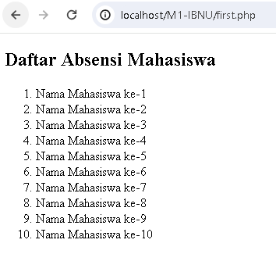

## 2. List.php

*Source code:*

|  |
| --- |
| <!DOCTYPE HTML> |
| <HTML> |
| <HEAD> |
| <TITLE> Contoh List dengan PHP </TITLE> |
| <HEAD> |
| <BODY> |
| <H2> Daftar Absensi Mahasiswa </H2> |
| <OL> |
| <?PHP |
| for ($i= 1; $i <= 1000; $i++) |
| { |
| echo "<li> Nama Mahasiswa ke-$i</li>"; |
| } |
| ?> |
| </OL> |
| </BODY> |
| </HTML> |

*Output:*

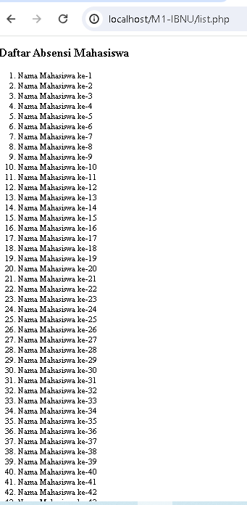

## 3. Hello World!

Source code:

|  |
| --- |
| <!DOCTYPE HTML> |
| <HTML> |
| <HEAD> |
| <TITLE>Hello world</TITLE> |
| </HEAD> |
| <BODY> |
| <?php |
| echo "Hello World...!!!"; |
| echo "<br/>"; |
| echo "WEb Programming with PHP"; |
| ?> |
| </BODY> |
| </HTML> |

Output:

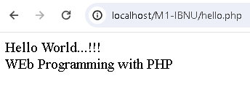

## 4. Variabel

Source code:

|  |
| --- |
| <!DOCTYPE HTML> |
| <HTML> |
| <HEAD> |
| <TITLE> </TITLE> |
| <HEAD> |
|  |
| <BODY> |
| <h2> VARIABEL PHP </h2> |
| <OL> |
| <?php |
| $nama="Naufal"; |
| echo $Nama; //Notice: Undefined variable: Nama |
| ?> |
| </OL> |
| </BODY> |
| </HTML> |

Output:

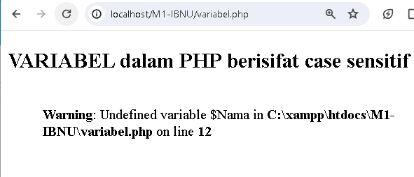

Source Code:

|  |
| --- |
| <!DOCTYPE HTML> |
| <HTML> |
| <HEAD> |
| <TITLE> </TITLE> |
| <HEAD> |
|  |
| <BODY> |
| <h2> Var deklarasi </h2> |
| <OL> |
| <?php |
| $nama = "Naufal "; |
| $umur = 19; |
| $pesan = " Saya sedang belajar PHP"; |
|  |
| echo $nama; |
| echo $umur; |
| echo $pesan; |
| ?> |
| </OL> |
| </BODY> |
| </HTML> |

Output:

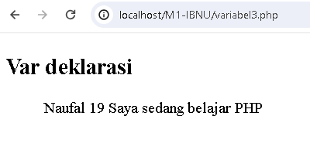

Source Code:

|  |
| --- |
| <!DOCTYPE HTML> |
| <HTML> |
| <HEAD> |
| <TITLE> </TITLE> |
| <HEAD> |
|  |
| <BODY> |
| <h2> Var deklarasi </h2> |
| <OL> |
| <?php |
| $a = 17; |
| $a = "aku"; |
| $a = 17.42; |
|  |
| echo $a; |
| echo $a; |
| echo $a; |
| ?> |
| </OL> |
| </BODY> |
| </HTML> |

Output:

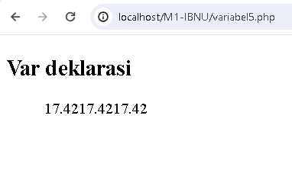

Source code:

|  |
| --- |
| <!DOCTYPE HTML> |
| <HTML> |
| <HEAD> |
| <TITLE> Contoh List dengan PHP </TITLE> |
| <HEAD> |
| <BODY> |
| <H2> Daftar Absensi Mahasiswa </H2> |
| <OL> |
| <?PHP |
| const situs = "https://igracias.telkomuniversity.ac.id/"; |
| echo situs; // https://igracias.telkomuniversity.ac.id/ |
| ?> |
| </OL> |
| </BODY> |
|  |
| </HTML> |

Output:

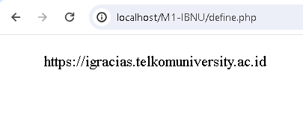

Source code:

<!DOCTYPE HTML>

<HTML>

<HEAD>

<TITLE> </TITLE>

<HEAD>

<BODY>

<H2> </H2>

<OL>

<?PHP

define("situs", "https://igracias.telkomuniversity.ac.id");

echo situs; //https://igracaias.tekomuniversity.ac.id

?>

</OL>

</BODY>

</HTML>

Output:



Source Code:

<!DOCTYPE HTML>

<HTML>

<HEAD>

<TITLE> </TITLE>

<HEAD>

<BODY>

<h2> </h2?

<ol>

<?php

$string1='Ini adalah string sederhanan';

</ol>

</BODY>

</HTML>

Output:

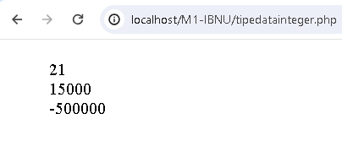

Source Code:

<!DOCTYPE HTML>

<HTML>

<HEAD>

<TITLE> </TITLE>

<HEAD>

<BODY>

<h2> </h2>

<ol>

<?php

$a=14;

$b=16;

$c= $a +$b;

echo $c; //30

$d = $a * $b;

echo $d; //224

?>

</ol>

</BODY>

Output:

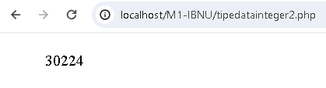

## 5. Tipe data float

Source code:

|  |
| --- |
| <!DOCTYPE HTML> |
| <HTML> |
| <HEAD> |
| <TITLE> tipe data float </TITLE> |
| <HEAD> |
| <BODY> |
| <H2> tipe data float </H2> |
|  |
| <?php |
| $angka_float1=0.78; |
| $angka_float2=14.99; |
| $angka_scientific1=0.314E1; |
| $angka_scientific2=0.3365E-3; |
|  |
| echo $angka_float1; // 0.78 |
| echo "<br />"; |
| echo $angka_float2; //14.99 |
| echo "<br />"; |
| echo $angka_scientific1; //3.14 |
| echo "<br />"; |
| echo $angka_scientific2; //0.0003365 |
| ?> |
| </BODY> |
|  |
| </HTML> |

Output:

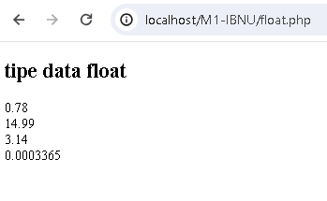

Source Code:

<!DOCTYPE HTML>

<HTML>

<HEAD>

<TITLE> </TITLE>

<HEAD>

<BODY>

<h2> </h2>

<ol>

<?php

$string1='Ini adalah string sederhana';

$string2='Ini adalah string yang bisa memiliki beberapa baris';

$string3='Dia berkata: "I\'ll be back"';

$string4='Anda telah berhasil menghapus C:\\xampp\\htdoc';

$string5='Kalimat ini tidak akan pindah ke: \n baris baru';

$string6='Varibel juga tidak otomatis ditampilkan $string1 dan $string3';

echo $string1; echo "<br>";

echo $string2; echo "<br>";

echo $string3; echo "<br>";

echo $string4; echo "<br>";

echo $string5; echo "<br>";

echo $string6;

?>

</ol>

</BODY>

</HTML>

Output:

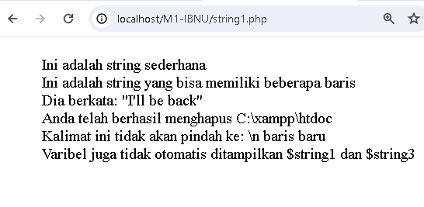

Source code:

<!DOCTYPE HTML>

<HTML>

<HEAD>

<TITLE> </TITLE>

<HEAD>

<BODY>

<h2> </h2>

<ol>

<?php

$benar = true;

$salah= false;

echo "benar = $benar, salah= $salah";

?>

</ol>

</BODY>

</HTML>

Output:

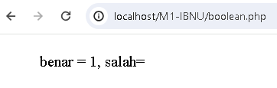

Source Code:

<!DOCTYPE HTML>

<HTML>

<HEAD>

<TITLE> </TITLE>

<HEAD>

<BODY>

<h2> </h2>

<ol>

<?php

$nama = array(

1=>"Andri",

2=>"Joko",

3=>"Sukma",

4=>"Rina",

5=>"Sari");

//cara akses array

echo $nama[1]; //Andri

echo "<br />";

echo $nama[2]; //Joko

echo "<br />";

echo $nama[3]; //Sukma

?>

</ol>

</BODY>

</HTML>

Output:

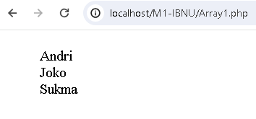

Source code:

<!DOCTYPE HTML>

<HTML>

<HEAD>

<TITLE> </TITLE>

<HEAD>

<BODY>

<h2> </h2>

<ol>

<?php

//pembuatan array

$nama = array("Andri","Joko","Sukma", "Rina", "Sari");

//cara akses array

echo $nama[1]; //Joko

echo "<br />";

echo $nama[2]; //Sukma

echo "<br />";

echo $nama[3]; //Rina

?>

</ol>

</BODY>

</HTML>

Output:

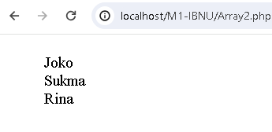

Source Code:

<!DOCTYPE HTML>

<HTML>

<HEAD>

<TITLE> </TITLE>

<HEAD>

<BODY>

<h2> </h2>

<ol>

<?php

//pembuatan array

$coba = array(

2=>"Andri",

"dua"=>"2",

'tiga'=>3,

true=>true,

9=>"sembilan",);

//cara akses array

echo $coba[2];

echo "<br />";

echo $coba["dua"];

echo "<br />";

echo $coba['tiga'];

echo "<br />";

echo $coba[true];

echo "<br />";

echo $coba[9];

?>

</ol>

</BODY>

</HTML>

Output:

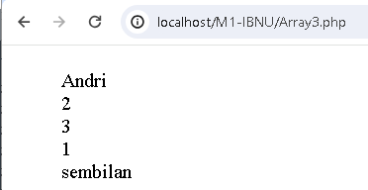

Source code:

<!DOCTYPE HTML>

<HTML>

<HEAD>

<TITLE> </TITLE>

<HEAD>

<BODY>

<h2> </h2>

<ol>

<?php

$hasil1= -3 ;

$hasil2= 3+5;

$hasil3= 8-4.5;

$hasil4= 2*5;

$hasil5= 3+8/5-3;

$hasil6= 10 % 4;

echo "\$hasil1:"; var_dump($hasil1);

echo "<br />";

echo "\$hasil2:"; var_dump($hasil2);

echo "<br />";

echo "\$hasil3:"; var_dump($hasil3);

echo "<br />";

echo "\$hasil4:"; var_dump($hasil4);

echo "<br />";

echo "\$hasil5:"; var_dump($hasil5);

echo "<br />";

echo "\$hasil6:"; var_dump($hasil6);

?>

</ol>

</BODY>

</HTML>

Output:

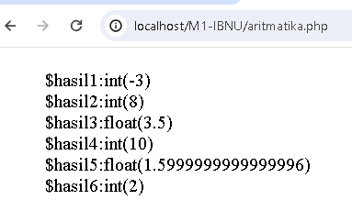

Source code:

<!DOCTYPE HTML>

<HTML>

<HEAD>

<TITLE> </TITLE>

<HEAD>

<BODY>

<h2> </h2>

<ol>

<?php

$hasil1= -3 ;

$hasil2= 3+5;

$hasil3= 8-4.5;

$hasil4= 2*5;

$hasil5= 3+8/5-3;

$hasil6= 10 % 4;

echo "\$hasil1:"; var_dump($hasil1);

echo "<br />";

echo "\$hasil2:"; var_dump($hasil2);

echo "<br />";

echo "\$hasil3:"; var_dump($hasil3);

echo "<br />";

echo "\$hasil4:"; var_dump($hasil4);

echo "<br />";

echo "\$hasil5:"; var_dump($hasil5);

echo "<br />";

echo "\$hasil6:"; var_dump($hasil6);

?>

</ol>

</BODY>

</HTML>

Output:

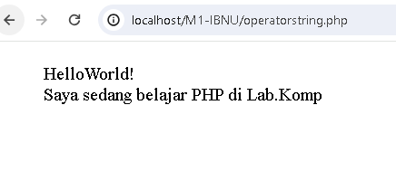

Source Code:

DOCTYPE HTML>

<HTML>

<HEAD>

<TITLE> </TITLE>

<HEAD>

<BODY>

<h2> </h2>

<ol>

<?php

$a = "Hello";

$hasil = "{$a} World!";

echo $hasil; // Hello world!

echo "<br />";

$a = "belajar";

$b = " PHP";

$c = " di Lab.Komp";

$hasil = "Saya sedang {$a} {$b} {$c}";

echo $hasil;

?>

</ol>

</BODY>

</HTML>

Output

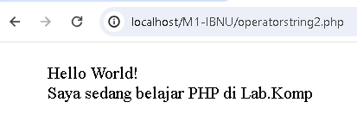

## 6. Operator Logika

Source code:

<!DOCTYPE HTML>

<HTML>

<HEAD>

<TITLE> </TITLE>

<HEAD>

<BODY>

<h2> </h2>

<ol>

<?php

$hasil1 = true and false;

echo '$hasil1= ';

echo var_dump($hasil1)."<br/>";

$hasil2 = (true and false);

echo '$hasil2= ';

echo var_dump($hasil2)."<br/>";

$hasil3 = (true xor false);

echo '$hasil3= ';

echo var_dump($hasil3)."<br/>";

$hasil4 = (false or true && false) ;

echo '$hasil4= ';

echo var_dump($hasil4)."<br/>";

$a=true;

$b=false;

$hasil5=($a and $b || $a or $b);

echo '$hasil5 =' ;

echo var_dump($hasil5);

?>

</ol>

</BODY>

</HTML>

Output:

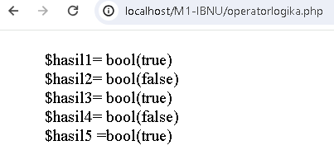

7. Operator perbandingan:

Source Code:

<!DOCTYPE HTML>

<HTML>

<HEAD>

<TITLE> </TITLE>

<HEAD>

<BODY>

<h2> </h2>

<ol>

<?php

echo "1.12 < 14 = "; var_dump (12<14);

echo "<br />";

echo "2. 14 < 14 = "; var_dump (14<14);

echo "<br />";

echo "3. 14 <= 14 = "; var_dump (14<=14);

echo "<br />";

echo "4. 10 <> '10'= "; var_dump (10<>'10');

echo "<br />";

echo "5. 10 < '10' = "; var_dump (10=='10');

echo "<br />";

echo "6. 10 < '10' = "; var_dump (10==='10');

echo "<br />";

echo "7. '150' === '10' = "; var_dump(10==='10');

echo "<br />";

echo "8. 'duniailkom' == 0 = "; var_dump('duniailkom'==0)

?>

</ol>

</BODY>

</HTML>

Output:

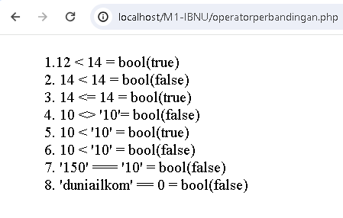

## 7. Operator Increment Decrement

Source Code:

<!DOCTYPE HTML>

<HTML>

<HEAD>

<TITLE> </TITLE>

<HEAD>

<BODY>

<h2> </h2>

<ol>

<?php

echo "<h3> Postincrement</h3>";

$a = 5;

echo "\$a=$a <br/>";

echo "\$a akan bernilai 5: " . $a++ . "(\$a++)<br />";

echo "\$a akan bernilai 6: " . $a . "<br />";

echo "<h3>Preincrement</h3>";

$a = 5;

echo "\$a=$a <br />";

echo "\$a akan bernilai 6: " . ++$a . " (++\$a) <br />";

echo "\$a akan bernilai 6: " . $a . "<br />";

echo "<h3>Postdecrement</h3>";

$a = 5;

echo "\$a=$a <br />";

echo "\$a akan bernilai 5: " . $a-- . " (\$a--) <br />";

echo "\$a akan bernilai 4: " . $a . "<br />";

echo "<h3>Predecrement</h3>";

$a = 5;

echo "\$a=$a <br />";

echo "\$a akan bernilai 4: " . --$a . " (--\$a) <br />";

echo "\$a akan bernilai 4: " . $a . "<br />";

?>

</ol>

</BODY>

</HTML>

Output:

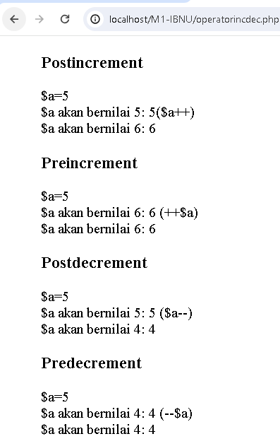

# MINGGU 2 – STRUKTUR KONTROL

NAMA : Muhammad Ibnu Hasyim Asshidiq Bachdar

NPM : 2113221099

NO ABSEN : 21

KELAS : A2

Dokumentasikan source code program dan outputnya, sajikan dengan rapih.

## a. Struktur logika switch

<?php

    $a=3;

    if ($a=="0"){

        echo "Angka Nol";

    }

    elseif($a=="1"){

        echo "Angka Satu";

    }

    elseif($a=="2"){

        echo "Angka Dua";

    }

    elseif($a=="3"){

        echo "Angka Tiga";

    }

    elseif($a=="4"){

        echo "Angka Empat";

    }

    elseif($a=="5"){

        echo "Angka Lima";

    }

    else{

        echo "Angka di luar jangkauan";

    }

?>

Output



## b. Struktur logika switch

<?php

    $a=3;

    switch ($a){

        case 0:

            echo "Angka Nol";

            break;

        case 1:

            echo "Angka Satu";

            break;

        case 2:

            echo "Angka Dua";

            break;

        case 3:

            echo "Angka Tiga";

            break;

        case 4:

            echo "Angka Empat";

            break;

        case 5:

            echo "Angka Lima";

            break;

        default:

            echo "Angka di luarjangkuan";

            break;

    }

?>

Output:



## c. Struktur logika switch

<?php

    $a=9;

    switch ($a){

        case 0:

            echo "Angka Nol";

            break;

        case 1:

            echo "Angka Satu";

            break;

        case 2:

            echo "Angka Dua";

            break;

        case 3:

            echo "Angka Tiga";

            break;

        default:

            echo "Angka di luar jangkuan";

            break;

    }

?>

Output:

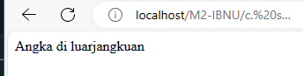

## d. struktur logika switch

<?php

    $a=3;

    switch ($a){

        case 0:

        case 1:

        case 2:

        case 3:

            echo "Angka berada di dalam range 0-3";

            break;

        case 4:

        case 5:

        case 6:

        case 7:

            echo "Angka berada di dalam rangke 4-7";

            break;

        default:

            echo "Angka di luar jangkauan";

            break;

    }

?>

Output:



## IF-else-elseif

1. <?php
2. $nilai = 83;
3. if ($nilai>70){
4. echo "Selamat Anda Lulus Ujian";
5. }
6. elseif($nilai==70){
7. echo "Anda harus ujian lagi";
8. }
9. else{
10. echo"Anda Tidak Lulus";
11. }
12. ?>

Output:

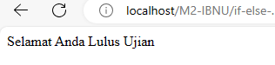

## Switch case

<?php

    $bilangan = "x";

    switch ($bilangan){

        case 28:

            echo "bilangan genap";

            break;

        case 3:

            echo "bilangan ganjil";

            break;

        default:

            echo "bukan bilangan";

            break;

    }

?>

Output:

`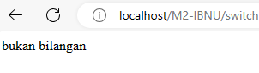

## Struktur Perulangan for

<?php

    for($i=1; $i<=15; $i++){

        echo $i;

        echo "<br />";

    }

?>

Output:

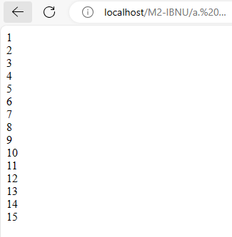

## b. Struktur Perulangan for

<?php

    for($i=0; $i<=100; $i=$i+5){

        echo $i;

        echo "<br />";

    }

?>

Output:

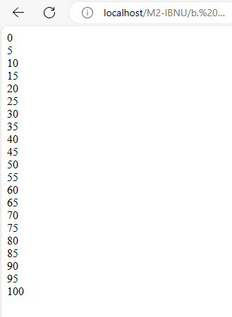

## Struktur perulangan for

<?php

    for($i=20; $i>=1; $i--){

        echo $i;

        echo "<br />";

    }

?>

Output:

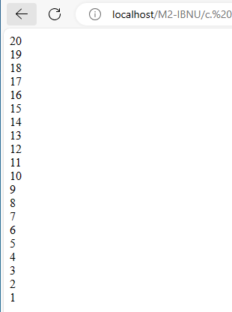

## d.Struktur perulangan for

<?php

    for($i=0; $i<10; $i++)

    {

        for($j=0; $j<10; $j++)

        {

            echo $i;

        }

        echo "<br />";

    }

?>

Output:

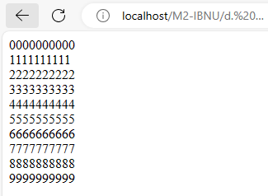

## Perulangan While

<?php

    $i=1;

    while ($i<=10){

        echo "$i";

        echo "<br />";

        $i=$i+1;

    }

?>

Output:

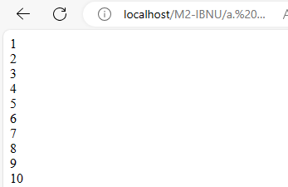

## b. Perulangan while

<?php

    $i=100;

    while ($i>=0){

        echo "$i";

        echo "<br />";

        $i-=8;

    }

?>

Output:

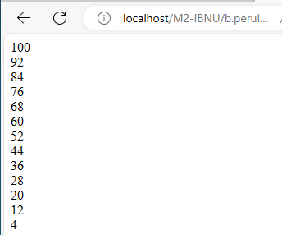

## c. Perulangan While

<?php

    $i=0;

    while($i<10){

        $j=0;

        while($j<10){

            echo $i;

            $j++;

        }

        echo "<br />";

        $i++;

    }

?>

Output:

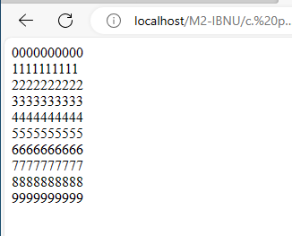

## d.Perulangan while

<?php

    for ($i=0; $i<100; $i++){

        if($i==13){

            break;

        }

        echo $i;

        echo "<br />";

    }

?>

Output:

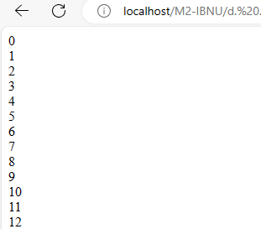

## Continue

<?php

    for ($i=0; $i<10; $i++){

        if($i==7){

            continue;

        }

        echo $i;

        echo "<br />";

    }

?>

Output:

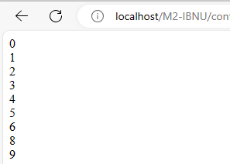

## Foreach

<?php

    $nama = array(

        1=>"Andri",

        6=>"Joko",

        12=>"Sukma",

        45=>"Rina",

        55=>"Sari");

    foreach($nama as $kunci => $isi){

        echo "Urutan ke-$kunci adalah $isi";

        echo "<br />";

    }

?>

Output:

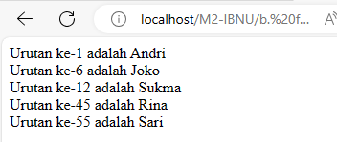

Simpan file dokumentasi dan program dengan nama file : WEB20232-M1-KELAS-NOABSEN-NAMA.RAR

Email ke : [gunawan@usbypkp.ac.id](mailto:gunawan@usbypkp.ac.id)

Subject : WEB20232-M1-KELAS-NOABSEN-NAMA

# MINGGU 3 – FUNGSI PADA PHP

NAMA : Muhammad Ibnu Hasyim Asshidiq Bachdar

NPM : 2113221099

NO ABSEN : 21

KELAS : A2

## Fungsi String

1. <?php
2. $str = "Everything i do, i do it for YOU";
3. echo "<b>String asli</b> : $str";
4. echo "<br><b>strtolower()</b> : $str";
5. echo "<br><b>strtoupper()</b> : $str";
6. echo "<br><b>ucfirst() :</b> ". ucfirst($str);
7. echo "<br><b>ucwords() :</b> ". ucwords($str);
8. echo "<br><b>strrev() :</b> ". strrev($str);
9. echo "<br><b>Jumlah karakter</b> : ". strlen($str);
10. ?>

**Output:**

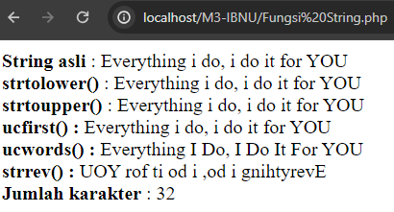

## 2. Fungsi addslashes & stripslashes

<?php

    $str = "Is your name O'reilly ?";

    $str2 = addslashes ($str);

    $str3 = stripslashes($str2);

    echo "<b>String asli</b> : $str";

    echo "<br><b>addslashes()</b> : $str2";

    echo "<br><b>stripslashes()</b> : $str3";

?>

**Output:**

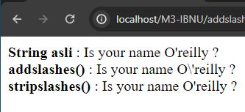

## 3. Fungsi chr() untuk menampilkan 256 karakter ASCII

<?php

    echo "Menampilkan bilangan ASCII";

    for ($i=1; $i<=256; $i++){

        echo "<br>$i.\t". chr($i);

    }

?>

**Output**

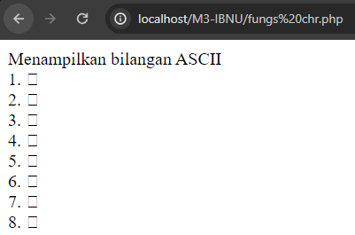

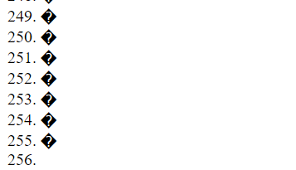

## 4. Fungsi strip_tags, htmlspecialchars, htmlentities

<?php

    $str = "<b><u>Everything I do, I do it for you</u></b>";

    echo $str."<br";

    //no tag html

    echo strip_tags ($str). "<br>";

    //allow tag <u>

    echo strip_tags ($str,"<u>")."<br>";

    //tampil apa adanya

    echo htmlspecialchars ($str)."<br>";

    //tampil apa adanya

    echo htmlentities ($str);

?>

**Output:**

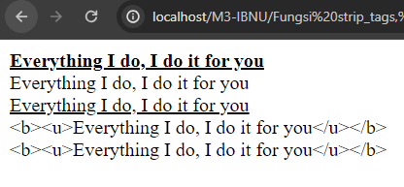

## 5. Fungsi memformat Angka

<?php

    $number = 1234.56;

    //english notation (default)

    $english_format_number = number_format($number);

    echo "<br>".$english_format_number; // 1,235

    //French notation

    $nombre_format_francais = number_format($number, 2, ',', ' ');

    echo "<br>".$nombre_format_francais; // 1 234,56

­    //indonesian notation

    $format_indonesia = number_format ($number, 2, ',', '.');

    echo "<br>".$format_indonesia; //1.234,56

    $number = 1234.5678;

    // english notation without thousands seperator

    $english_format_number = number_format($number, 2, '.', '');

    echo "<br>". $english_format_number; // 1234.57

?>

**Output:**

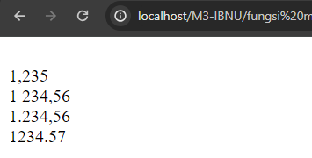

## 6. Fungsi memecah String menjadi Array

<?php

    // Contoh 1

    $buah = "mangga pisang rambutan apel jeruk kedondong";

    $buahan = explode(" ", $buah);

    echo $buahan[0]."<br>"; //mangga

    echo $buahan[3]."<br>";//apel

    // Contoh 2

    $data = "foo:*:1023:1000::/home/foo:/bin/sh";

    list($user, $pass, $uid, $gid, $gecos, $home, $shell) =

    explode(":", $data);

    echo $user."<br>"; //foo

    echo $pass; // *

?>

**Output:**

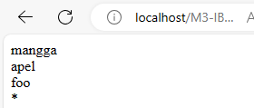

## 7. Fungsi menggabungkan Array menjad String

<?php

    $buahan = array('mangga','jeruk','rambutan','apel','nanas');

    $buah = implode(",",$buahan);

    echo "Saya suka buah ". $buah;

    // mangga,jeruk,rambutan,apel,nanas

?>

**Output:**

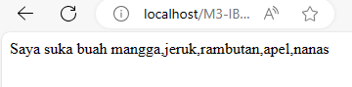

## 8.Fungsi Mengambil Sebagian String

<?php

    $file = "test.this.txt";

    $ext1= strstr($file,".");

    $ext2= strchr($file,".");

    $ext3 = strrchr($file,".");

    echo $ext1."<br>";

    echo $ext2."<br>";

    echo $ext3;

?>

**Output:**

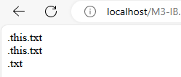

## 9. Fungsi wordwrap()

<?php

    $text = "The quick brown fox jumped over the lazy dog.";

    $newtext = wordwrap($text, 15, "<br>");

    echo $text."<br></br>";

    echo $newtext;

?>

**Output:**

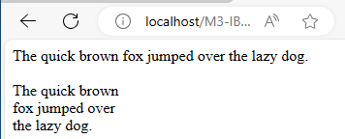

## 10. Fungsi nl2br dalam String

<form action="" method="post">

Input teks di sini:<br>

<textarea name="input" cols="40" rows="4"></textarea><br>

<input type="submit" name="Submit" value="Proses">

</form>

<?php

    if(isset($_POST['Submit'])){

        $txt =$POST['input'];

        echo "<u>Tana nl2br() :</u> <br>$txt<br><br>";

        echo "<u>Dengan nl2br :</u> <br>".nl2br($txt);

    }

?>

**Output:**

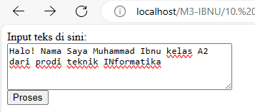

## 11. Fungsi substr()

<form action="" method="post">

    NIM anda:

    <input type="text" name="txtnim"><br>

    <input type="submit" name="Submit" value="Proses">

</form>

<?php

    if(isset($_POST['Submit'])){

        $nim = $_POST['txtnim'];

        $a = substr ($nim, 0, 2);

        switch($a){

            case '51': $jurusan = "Teknik Informatika";

            break;

            case '52': $jurusan = "Sistem Informasi";

            break;

            case '53': $jurusan = "Sistem Komputer";

            break;

            case '54': $jurusan = "Komputerisasi Akuntansi";

            break;

            default:$jurusan = "Salah Jurusan";

        }

        echo "Nim anda : $nim<br>";

        echo "Jurusan anda : $jurusan";

    }

?>

**Output:**

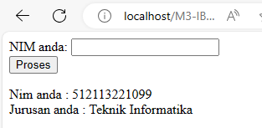

## Fungsi fungsi operasi tanggal

1. <?php
2. //Sekarang tanggal 13 April 2006 09:43:49
3. echo "<br>".date("d/m/Y h:i:s"); //
4. echo "<br>".date("F j, y, g:i a");
5. echo "<br>".date("d.m.y");
6. echo "<br>".date("Ymd");
7. //
8. echo "<br>".date('j-m-y, it is w day z ');
9. //
10. echo "<br>".date('\i\t \i\s \t\h\e jS \d\a\y.');
11. //
12. echo "<br>".date("D M j G:i:s T Y");
13. echo "<br>".date("H:i:s");
14. ?>

Output:

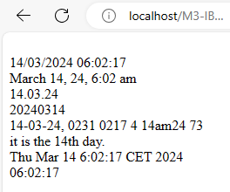

## 13. Fungsi Tanggal_2

<?php

    $arrDay = array("Minggu", "Senin", "Selasa", "Rabu", "Kamis", "Jum'at", "Sabtu");

    $day = date ("w"); //0-6 of day

    echo "Hari ini hari : <b>".$arrDay[$day]."</b>";

?>

Output:

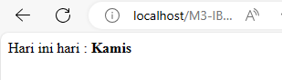

# MINGGU 4 – PHP pada MySQL

NAMA : Muhammad Ibnu Hasyim Asshidiq Bachdar

NPM : 2113221099

NO ABSEN : 21

KELAS : A2

Dokumentasi

## Buka xampp Control Panel, aktifkan Apache dan MySQL

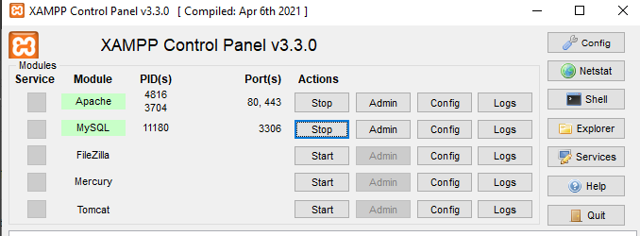

## Membuat Database dbBukuTamu, membuat table bukutamu

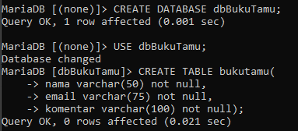

## Melihat struktur table bukutamu

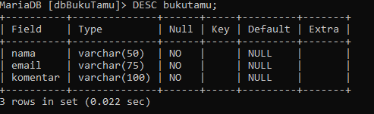

## Memasukan data ke bukutamu

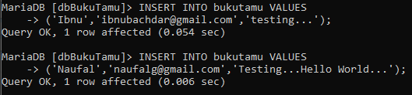

## Melihat semua isi di table bukutamu

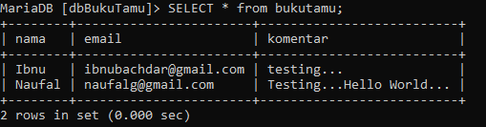

## Membuat file bukutamu.html

1. <!DOCTYPE HTML>
2. <HTML>
3. <HEAD>
4. <TITLE>Buku Tamu</TITLE>
5. </HEAD>
6. <BODY>
7. <h1>Buku Tamu untuk database MYSQL</h1>
8. <form action="prosesTambah.php" method="post">
9. Nama: <input type="text" name="name" size="35" maxlength="50"><br>
10. Email: <input type="text" name="email" size="35" maxlength="50"><br>
11. Komentar: <textarea name="komentar" rows="5" cols="30"></textarea><br>
12. <input type="submit" value="Simpan">
13. <input type="reset" values="Reset">
14. </form>
15. </BODY>
16. </HTML>

Output:

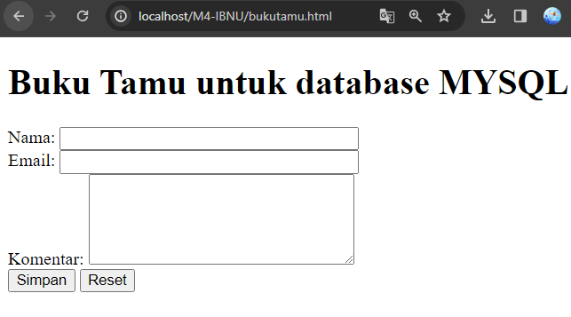

## 7. Membuat file prosesTambah.php

<HTML>

    <HEAD>

        <TITLE>Simpan Buku Tamu</TITLE>

    </HEAD>

    <BODY>

        <h1>Simpan Buku Tamu MYSQL</h1>

        <!-- PHP -->

        <?php

            $nama = $_POST["nama"];

            $email= $_POST["email"];

            $komentar= $_POST["komentar"];

            $link = mysqli_connect("localhost","root","","dbBukuTamu")

            or die

            ("koneksi gagal");

            echo "Nama : $nama <br>";

            echo "Email : $email <br>";

            echo "Komentar : $komentar <br>";

            $sqlstr="INSERT INTO bukutamu (nama,email,komentar)

            VALUES('$nama','$email','$komentar')";

            $hasil=mysqli_query($link,$sqlstr);

            echo "Simpan bukutamu berhasil dilakukan";

        ?>

    </BODY>

</HTML>

Output:

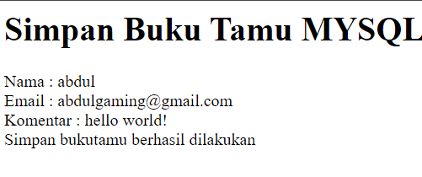

## 8. Membuat file view.php

<?php

    $link =mysqli_connect("localhost","root","","dbBukuTamu");

    $hasil = mysqli_query($link,"SELECT * FROM bukutamu");

    $jumlah = mysqli_num_rows($hasil);

    echo "<center>Daftar Pengunjung</center>";

    echo "Jumlah pengunjung : $jumlah";

    $a=1;

    while($baris =mysqli_fetch_array($hasil)){

        echo "<br>";

        echo $a;

        echo "<br>";

        echo "Nama : ";

        echo $baris[0];

        echo "<br>";

        echo "Email : ";

        echo $baris[1];

        echo "<br>";

        echo "Komentar : ";

        echo $baris[2];

        $a++;

    }

?>

Output:

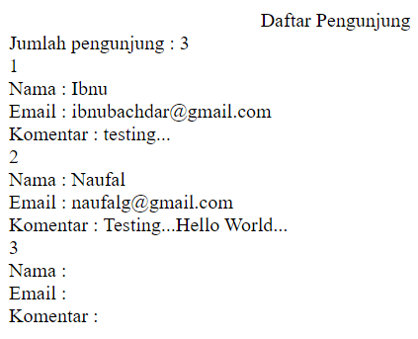

## 9. Membuat file search.html

<HTML>

<HEAD>

    <TITLE>Cari Database</TITLE>

</HEAD>

<BODY>

    <H1>Searching Buku Tamu untuk database MYSQL</H1>

    <FORM action="hasilsearch.php" method="post">

    <SELECT name="kolom">

        <OPTION value="nama">nama</OPTION>

        <OPTION values="value">email</OPTION>

    </SELECT>

    Masukkan kata yang anda Cari

    <INPUT type = "text" type = "text" name="cari">

    <INPUT type = "submit" value="cari">

    </FORM>

</BODY>

</HTML>

Output:

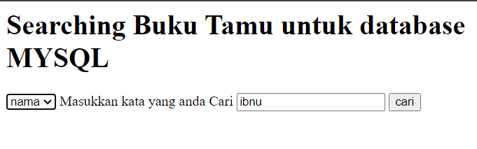

## 10. Membuat hasilsearch.php

<?php

    $kolom=$_POST['kolom'];

    $cari=$_POST['cari'];

    $link = mysqli_connect("localhost","root","","dbBukuTamu");

    $hasil = mysqli_query($link,"select * from bukutamu where $kolom like '%$cari%'");

    $jumlah = mysqli_num_rows($hasil);

    echo "<br>";

    echo "Ditemukan: $jumlah";

    echo "<br>";

    while($baris = mysqli_fetch_array($hasil)){

        echo "Nama : ";

        echo $baris[0];

        echo "<br>";

        echo "Email: ";

        echo $baris[1];

        echo "<br>";

        echo "Komentar :";

        echo $baris[2];

    }

?>

Output:

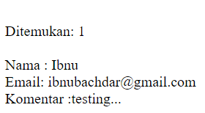

# MINGGU 5 – Pemrograman Web Modul Transaksi

NAMA : Muhammad Ibnu Hasyim Asshidiq Bachdar

NPM : 2113221099

NO ABSEN : 21

KELAS : A2

Dokumentasi sajikan dengan rapih!

## 1. Setelah menyalakan xampp, masuk ke mysql cmds

C:\xampp\mysql\bin\mysql.exe -u root

## 2 .Membuat database



## 3. Masuk ke database db_akademik_ibnu



## 4. Membuat table Mahasiswa

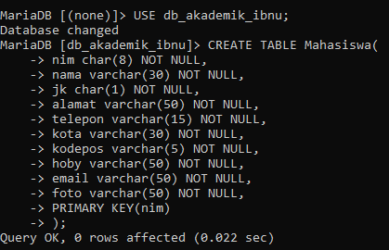

## 5.Menambahkan data pada table nim, dan nama saja





**6. Membuat tabel matakuliah**

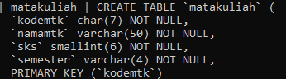

## 7. Membuat table nilai

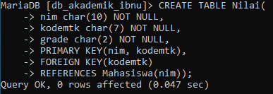

## 8. Membuat file koneksi.php

<?php

    define('DB_HOST', 'localhost');

    define('DB_USER', 'root');

    define('DB_PASS', '');

    define('DB_NAME', 'db_akademik_ibnu');

    $link = mysqli_connect(DB_HOST, DB_USER, DB_PASS, DB_NAME)

    or die ("Koneksi Gagal");

?>

## 9. Membuat file pilih_semester.php

<html>

<head><title>Pilih Semester</title></head>

<body>

Pilih Semester:<br>

<ol>

    <li><a href="kontrak.php?semester=I">Semester I</a></li>

    <li><a href="kontrak.php?semester=II">Semester II</a></li>

    <li><a href="kontrak.php?semester=III">Semester III</a></li>

    <li><a href="kontrak.php?semester=IV">Semester IV</a></li>

    <li><a href="kontrak.php?semester=V">Semester V</a></li>

    <li><a href="kontrak.php?semester=VI">Semester VI</a></li>

</ol>

</body>

</html>

Output:

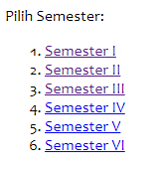

## 10. Membuat file kontrak.php

<html>

<head><title>Kontrak Matakuliah</title></head>

<body>

<form method = "post" action ="proses_kontrak.php">

    <table border=1>

        <tr>

            <td colspan='2'>Pilih Nama Mahasiswa :

            <select name="nim">

                <?php

                    include "koneksi.php";

                    $query = "SELECT * FROM Mahasiswa";

                    $hasil = mysqli_query($link,$query);

                    while($data = mysqli_fetch_array($hasil))

                    {

                        echo "<option value='".$data['nim']."'>"

                        .$data['nim']."&nbsp;|$nbsp;".$data['nama']."</option>";

                    }

                ?>

            </select>

                </td>

                    </tr>

                        <tr><th>KODE | NAMA MATA KULIAH</th><th>SKS</th></tr>

                <?php

                    $semester = isset($_GET['semester'])?$_GET['semester']:'';

                    $query = "SELECT * FROM matakuliah WHERE semester = '$semester'";

                    $hasil = mysqli_query($link,$query);

                    $no = 1;

                    while ($data = mysqli_fetch_array($hasil))

                    {

                        echo "<tr>

                                <td><input type='checkbox'

                                    value='$data[kodemtk]'name='mtk$no'>$data[kodemtk]-$data[namamtk]

                                </td>

                                <td align='center'>$data[sks]</td>

                              </tr>";

                              $no++;

                    }

                ?>

                <input type="hidden" name="jummk"

                value="<?php echo $no-1; ?>" />

                <tr>

                    <td align="center" colspan='2'>

                    <input type="submit" name="submit" value="Submit"/></td>

                </tr>

    </table>

            </form>

</body>

</html>

Output:

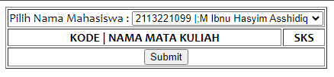

## 11. Membuat file proses_kontrak.php

<html>

<head><title>Proses Kontrak Matakuliah</title></head>

<body>

    <?php

        include "koneksi.php";

        $nim = $_POST['nim'];

        $jummk = $_POST['jummk'];

        for($i = 1; $i <= $jummk; $i++){

            $mtk=isset($_POST['mtk'.$i])?$_POST['mtk'.$i]:'';

            if(!empty($mtk)){

                $query = "INSERT INTO nilai VALUES('$nim','$mtk','-')";

                $update = mysqli_query($link,$query);

            }

        }

        if($update){

            echo "Kontrak Matakuliah Berhasil!";

        }

        else{

            echo "Kontrak Matakuliah Gagal!";

        }

    ?>

</body>

</html>

## 12. Membuat file pilih_input_nilai.php

<html>

<head><title>Pilih Matakuliah</title></head>

<body>

<form method="post" action="proses_input_nilai.php">

    <center>

        Pilih Matakuliah :

    <select name="kodemtk">

        <?php

            include "koneksi.php";

            $query = "select * from matakuliah order by semester";

            $hasil = mysqli_query($link,$query);

            while ($data = mysqli_fetch_array($hasil))

            {

                echo "<option value='".$data['kodemtk']."'>".$data['semester']." - ".$data['kodemtk']." - ".$data['namamtk']."</option>";

            }

        ?>

    </select>

    <input type = "submit" value="OK">

</form>

</body>

</html>

Output:



## 13. Membuat file proses_input_nilai.php

<html>

<head><title>Proses Input Nilai</title></head>

<body>

    <?php

        //koneksi ke mysql

        include "koneksi.php";

        //membaca kode matakuliah yang disubmit dari form

        $kodeMK= $_POST['kodemtk'];

        //menampilkan data nim dan nilai mahasiswa yg mengambil matkul berdsrkan kode MK

        $query1= "SELECT * FROM matakuliah WHERE kodemtk='$kodeMK'";

        $hasil1 = mysqli_query($link,$query1);

        $data1= mysqli_fetch_array($hasil1);

        echo "<center><h3>Semester/Kode Matakuliah/Nama Mata Kuliah : <br>".

        "</h3></center>";

    ?>

    <form method ="post" action="update_nilai.php">

        <table width = "80%" border = "1" align = "center">

            <tr>

                <th width = "5%">NO</th>

                <th width = "20%">NIM</th>

                <th width = "65%">NAMA MAHASISWA</th>

                <th width = "10%">NILAI</th>

            </tr>

        <?php

            $query="SELECT * FROM nilai INNER JOIN mahasiswa ON nilai.nim=mahasiswa.nim

            WHERE kodemtk='$kodeMK'";

            $hasil=mysqli_query($link,$query);

            $i = 1;

            while($data = mysqli_fetch_array($hasil)){

                echo"<tr>";

                echo"<td align='center'>".$i."</td><td align='center'>".$data['nim']."</td>";

                echo"<td>".$data['nama']."</td>";

                echo"<td><input type='hidden' name='nim".$i."' value='".$data['nim']."'/>

                <input type ='text' size='3'

                name ='grade".$i."' value='".$data['grade']."'/></td>";

                echo"</tr>";

                $i++;

            }

            $jumMhs = $i-1;

        ?>

            <input type="hidden" name="n" value="<?php echo $jumMhs ?>"/>

            <input type="hidden" name="kodemtk" value="<?php echo $kodeMK; ?>"/>

            <tr><td colspan='4' align='center'>

            <input type="submit" value="Update"/>

                </td>

                    </tr>

        </table>

    </form>

</body>

</html>

Output:

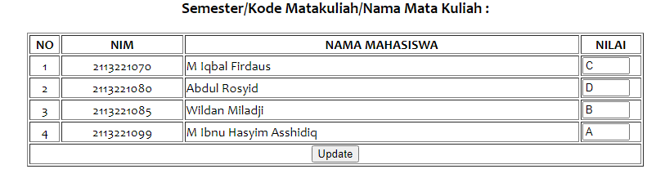

## 14. Membuat file update_nilai.php

<html>

<head><title>Proses Update Nilai</title></head>

<body>

<?php

    include "koneksi.php";

    //membaca jumlah mahasiswa (n) dari submit.php

    $jumMhs = $_POST['n'];

    //membaca kode MK yang akan diupdate

    $kodeMK = $_POST['kodemtk'];

    //proses looping untuk membaca nilai dan nim mhs dari form, serta menjalankan query

    for($i=1; $i<=$jumMhs; $i++){

        //membaca nim mhs ke-i, 1,2,3...,n

        $nimMhs= $_POST['nim'.$i];

        //membaca nilai mhs ke-1, i=1,2,3...,n

        $nilai = $_POST['grade'.$i];

        //update nilai mhs ke-i, i=1,2,3,...,n

        $query = "UPDATE nilai SET grade = '$nilai' WHERE nim = '$nimMhs' AND kodemtk = '$kodeMK'";

        mysqli_query($link,$query);

    }

    echo"<meta http-equiv='refresh' content='0; url=pilih_input_nilai.php'>";

?>

</body>

</html>

Output:

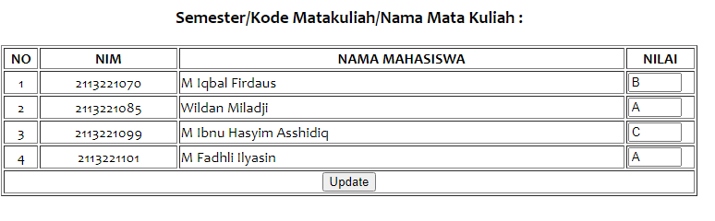

Simpan file dokumentasi dan program dengan nama file : WEB20232-M1-KELAS-NOABSEN-NAMA.RAR

Email ke : [gunawan@usbypkp.ac.id](mailto:gunawan@usbypkp.ac.id)

Subject : WEB20232-M1-KELAS-NOABSEN-NAMA

# MINGGU 6 – HTML form

NAMA : Muhammad Ibnu Hasyim Asshidiq Bachdar

NPM : 2113221099

NO ABSEN : 21

KELAS : A2

Dokumentasi sajikan dengan rapih!

## HTML (Hyper Text Markup Language)

### 1. Membuat form dengan placeholder

Source Code

<!DOCTYPE html>

<html>

<head>

    <title>

        latihan1

    </title>

</head>

<body>

    <h1>Memberikan Keterangan pada Input-an</h1>

    <!-- Membuat FORM -->

<form>

    <table>

        <tr>

            <td>Nama Lengkap:</td>

            <td><input type="text" name="nama" placeholder="Masukan Nama Lengkap Anda"></td>

        </tr>

        <tr>

            <td>Username:</td>

            <td><input type="text" name="username" placeholder="Masukan Username Anda"></td>

        </tr>

        <tr>

            <td>Password:</td>

            <td><input type="text" name="password" placeholder="Masukan Password Anda"></td>

        </tr>

        <tr>

            <td>Email:</td>

            <td><input type="text" name="email" placeholder="Masukan Email Anda"></td>

        </tr>

        <tr>

            <td>Telepon:</td>

            <td><input type="text" name="telepon" placeholder="Masukan Telepon Anda"></td>

        </tr>

    </table>

</form>

</body>

</html>

Output:

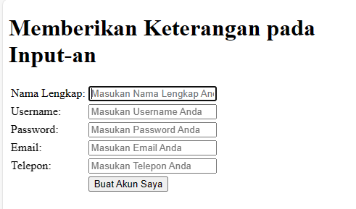

### 2. Membuat form dengan validasi date

<!DOCTYPE html>

<html>

<head>

    <title>

        latihan1

    </title>

</head>

<body>

    <h1>Memberikan Keterangan pada Input-an</h1>

    <!-- Membuat FORM -->

<form>

    <table>

        <tr>

            <td>Nama Lengkap:</td>

            <td><input type="text" name="nama" placeholder="Masukan Nama Lengkap Anda"></td>

        </tr>

        <tr>

            <td>Username:</td>

            <td><input type="text" name="username" placeholder="Masukan Username Anda"></td>

        </tr>

        <tr>

            <td>Password:</td>

            <td><input type="text" name="password" placeholder="Masukan Password Anda"></td>

        </tr>

        <tr>

            <td>Tanggal Lahir:</td>

            <td><input type="date" name="birth" required></td>

        </tr>

        <tr>

            <td>Email:</td>

            <td><input type="text" name="email" placeholder="Masukan Email Anda"></td>

        </tr>

        <tr>

            <td>Telepon:</td>

            <td><input type="text" name="telepon" placeholder="Masukan Telepon Anda"></td>

        </tr>

        <tr>

            <td></td>

            <td><button type="submit" value="submit">Buat Akun Saya</button></td>

        </tr>

    </table>

</form>

</body>

</html>

Output:

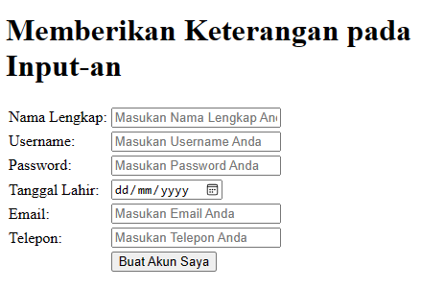

### 3. Membuat validasi Email

<td>Email:</td>

            <td><input type="email" name="email" placeholder="Masukan Email Anda" size="30" required></td>

Output:

### 4.Membuat warn pada saat data NULL

**(Sertakan required di dalam input)**

<td>Username:</td>

            <td><input required type="text" name="username" placeholder="Masukan

Username Anda"></td>

Output:

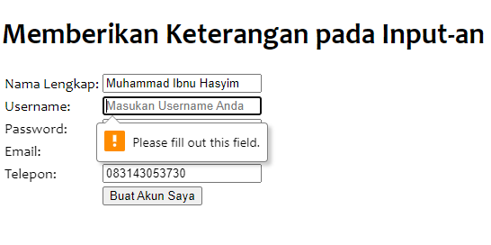

### 5. Membuat maksimal karakter

<td>Telepon:</td>

            <td><input type="text" name="telepon" maxlength="12" required></td>

Output:

Maximal character pada variable telepon yaitu 12

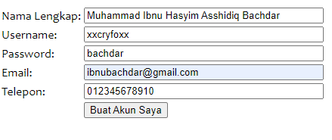

## CSS (Cascading Style Sheet)

### External Style Sheet

Ex1.css

body{

    background-color: yellow;

}

h1{

    font-size:36pt;

}

h2{

    color:blue;

}

p{

    margin-left:50px;

}

External.html

<html>

<head>

    <link rel="stylesheet" type="text/css" href="ex1.css">

</head>

<body>

    <h1>This header is 36pt</h1>

    <h2>This header is blue</h2>

    <p>This paragraph has left margin of 50 pixels</p>

</body>

</html>

**Output**



### Internal Style Sheet

1. **Internal.html**

<html>

    <head>

    <style type = "text/css">

        h1{

            text-decoration:overline;

            text-align: center;

            color:red;

        }

        h2{

            text-decoration: line-through;

            text-align: left;

            color:green;

        }

        h3{

            text-decoration: underline;

            text-align: right;

        }

        hr{

            color:pink;

        }

    </style>

    </head>

    <body>

        <h1>This is header 1</h1>

        <hr>

        <h2>This is header 2</h2>

        <hr>

        <h3>This is header 3</h3>

        <hr>

    </body>

</html>

**Output:**

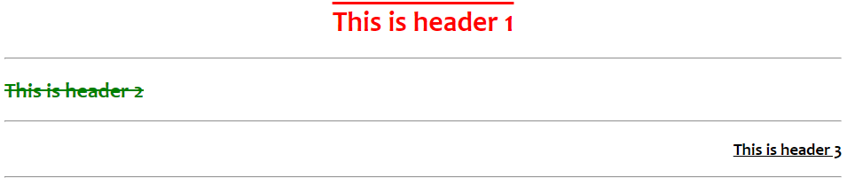

### InternalB.html

<html>

    <head>

    <title>Belajar CSS</title>

    <style type = "text/css">

        p{

            color:red;

        }

        em{

            color:green;

        }

        b{

            color:blue;

        }

    </style>

    </head>

    <body>

        <p>

            ini adalah paragraf pertama. <em>Ini adalah teks dicetak miring dan hijau.</em>

            Ini adalah paragraf pertama. Ini adalah paragraf pertama. Ini adalah paragraf pertama.

            Ini adalah paragraf pertama. Ini adalah paragraf pertama. <b>Ini adalah teks dicetal tebal dan biru.</b>

            Ini adalah paragraf pertama.

        </p>

    </body>

</html>

Output:



### Inline style sheet

Inline.html

<html>

    <head>

        <title>Belajar CSS</title>

    </head>

    <body>

        <h1 style="color:red; text-align:center">Paragraf Pertama</h1>

        <p style="color:white; background:red; font-family:arial;">

            Ini adalah paragraf pertama. Ini adalah paragraf pertama. Ini adalah Paragraf pertama.

            Ini adalah paragraf pertama. Ini adalah paragraf pertama. Ini adalah Paragraf pertama.

            Ini adalah paragraf pertama. Ini adalah paragraf pertama. Ini adalah Paragraf pertama.

        </p>

        <h1 style="color: orange; text-align:right">Paragraf Kedua</h1>

        <p style="color:yellow; background: orange; font-family:verdana;">

            Ini adalah paragraf Kedua. Ini adalah paragraf Kedua. Ini adalah Paragraf Kedua.

            Ini adalah paragraf Kedua. Ini adalah paragraf Kedua. Ini adalah Paragraf Kedua.

            Ini adalah paragraf Kedua. Ini adalah paragraf Kedua. Ini adalah Paragraf Kedua.

        </p>

    </body>

</html>

Output:

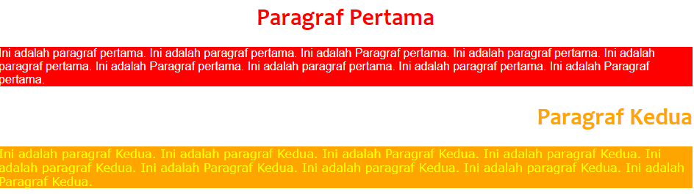

## TUGAS

1. Buat tampilan halaman web brkt ini dngn menggunakan CSS, dalam format:

### Inline Style Sheet (di tag HR)

### Internal Style Sheet ( tag H1)

### External Style Sheet ( tag P)

<html>

    <head>

        <title>Tugas CSS</title>

        <link rel="stylesheet" href="ex2.css">

        <style type="text/css">

            h1{

                text-align: right;

                color:red;

                background-color: yellow;

            }

        </style>

    </head>

    <body>

        <h1>Pengenalan Cascading Style Sheets</h1>

        <hr width="100%" size="3" color="blue">

        <p>Style Sheets merupakan feature yang sangat penting dalam membuat Dynamic HTML. Meskipun bukan merupakan keharusan dalam membuat web, akan tetapi penggunaan style sheets merupakan kelebihan tersendiri.

        </p>

        <hr width="100%" size="3" color="blue">

        <p>Suatu style sheet merupakan tempat dimana Anda mengontrol dan memanage style-style yang ada. Style sheet mendeskripsikan bagaimana tampilan document HTML di layar. Anda juga bisa menyebutnya sebagai template dari documents HTML yang menggunakannya.

        </p>

        <hr width="100%" size="3" color="blue">

        <p>Anda Juga bisa membuat efek-efek spesial di web Anda dengan menggunakan style sheet. sebagai

            contoh Anda bisa membuat style sheet yang mendefinisikan style untuk tag H1 dengan style bold

            dan italic dan berwarna biru. Atau pada tag P yang akan di tamplkan dengan warna kuning dan menggunakan font Verdana

            dan masih banyak lagi yang bisa Anda lakukan dengan style sheet. Secara teoritis Anda bisa

            menggunakan style sheet technology dengan HTML. Akan tetapi pada prakteknya hanya Cascading Style Sheet (CSS)

            technology yang support pada hampir semua web Browser. Karena CSS telah di standarkan oleh World Wide Web Consortium (W3C)

            untuk digunakan di web browser.

        </p>

    </body>

</html>

Output:

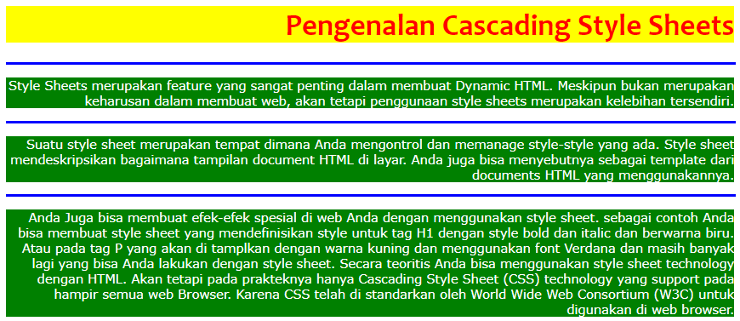

# MINGGU 7 – CRUD

NAMA : Muhammad Ibnu Hasyim Asshidiq Bachdar

NPM : 2113221099

NO ABSEN : 21

KELAS : A2

Dokumentasi sajikan dengan rapih!

## 1. Index.php

Membuat tampilan awal

<!DOCTYPE html>

<html lang="en">

<head>

    <meta charset="UTF-8">

    <meta name="viewport" content="width=device-width, initial-scale=1.0">

    <title>CRUD</title>

    <link rel="stylesheet" href="style.css">

    <link rel="preconnect" href="https://fonts.googleapis.com">

    <link rel="preconnect" href="https://fonts.gstatic.com" crossorigin>

    <link href="https://fonts.googleapis.com/css2?family=Poppins:ital,wght@0,100;0,200;0,300;0,400;0,500;0,600;0,700;0,800;0,900;1,100;1,200;1,300;1,400;1,500;1,600;1,700;1,800;1,900&display=swap" rel="stylesheet">

</head>

<body>

    <div class="container">

        <h2>Data Mahasiswa</h2>

        <a class="buat-akun" href="create.php">Create</a>

        <br/>

        <!-- HEAD START -->

        <table border="1" >

            <tr>

                <th>Id</th>

                <th>Nama Lengkap</th>

                <th>Username</th>

                <th>Password</th>

                <th>Tanggal Lahir</th>

                <th>Email</th>

                <th>Telepon</th>

                <th>Foto</th>

                <th>Opsi</th>

            </tr>

        <!-- HEAD END -->

        <!-- BODY START -->

        <?php

            include "koneksi.php";

            //READ semua baris di database tabel

            $sqlstr2 =  "SELECT * FROM mahasiswa ";

            $hasil2 = mysqli_query($link,$sqlstr2);

            if($hasil2){

            // $hasil -> fetch_assoc())

            while($row = mysqli_fetch_assoc($hasil2)){

                $id = $row['id'];

                $nama_lengkap = $row['nama_lengkap'];

                $username = $row['username'];

                $password = $row['password'];

                $tgl_lhr = $row['tgl_lhr'];

                $email = $row['email'];

                $telepon = $row['telepon'];

                $foto = $row['foto'];

                echo "<tr>

                            <th>$id</th>

                            <td>$nama_lengkap</td>

                            <td>$username</td>

                            <td>$password</td>

                            <td>$tgl_lhr</td>

                            <td>$email</td>

                            <td>$telepon</td>

                            <td><img width='100%' src='/assets'>$foto</td>

                            <td>

                                <a class='update' href='update.php?updateid=$id'>Update</a>

                                <a class='delete' href='delete.php?deleteid=$id'>Delete</a>

                            </td>

                    </tr>";

            }

            }

        ?>

        <!-- BODY END -->

        </table>

    </div>

</body>

</html>

## 2. koneksi.php

Menyambungkan ke database

<?php

    define("DB_HOST","localhost");

    define("DB_USER","root");

    define("DB_PASS","");

    define("DB_NAME","db_akademik_ibnu");

    $link = mysqli_connect(DB_HOST, DB_USER, DB_PASS, DB_NAME);

    if($link -> error){

        echo"Koneksi gagal!";

    }

?>

## 3. Create.php

<!DOCTYPE html>

    <html lang="en">

    <head>

        <meta charset="UTF-8">

        <meta name="viewport" content="width=device-width, initial-scale=1.0">

        <title>CRUD</title>

        <link rel="stylesheet" href="stylecreate.css">

        <!-- Google Fonts -->

        <link rel="preconnect" href="https://fonts.googleapis.com">

    <link rel="preconnect" href="https://fonts.gstatic.com" crossorigin>

    <link href="https://fonts.googleapis.com/css2?family=Poppins:ital,wght@0,100;0,200;0,300;0,400;0,500;0,600;0,700;0,800;0,900;1,100;1,200;1,300;1,400;1,500;1,600;1,700;1,800;1,900&display=swap" rel="stylesheet">

    </head>

    <body>

            <h2>Selamat Datang di menu CREATE</h2>

    <form action="proses_create.php" method="post">

      <table>

        <tr>

          <th >NIM : </th>

          <td><input  type="text" size="35" name="nim" placeholder="Masukan NIM" required /></td>

        </tr>

        <tr>

          <th class="nama">Nama Lengkap : </th>

          <td><input  type="text" size="35" name="nama" placeholder="Masukan Nama Lengkap" required /></td>

        </tr>

        <tr>

          <th>Jenis Kelamin : </th>

          <td><input type="radio" name="jk" value="L" required />Laki-laki</td>

        </tr>

          <tr>

            <td></td>

          <td><input type="radio" name="jk" value="P" required />Perempuan</td>

        </tr>

        <tr>

          <th>Alamat : </th>

          <td><input type="text" size="35" name="alamat" placeholder="Masukan Alamat" required /></td>

        </tr>

        <tr>

          <th>Telepon :</th>

          <td><input type="tel" size="35" name="telepon" maxlength="12"  pattern="[0-9]{4}[0-9]{4}[0-9]{4}" placeholder="Masukan No Telepon" required /></td>

        </tr>

        <tr>

          <th>Kota : </th>

          <td><input type="text" size="35"name="kota" placeholder="Masukan Nama Kota" required /></td>

        </tr>

        <tr>

          <th>Kode Pos :  </th>

          <td><input type="text" size="35" maxlength="5" name="kodepos" placeholder="Masukan Kode Pos" required /></td>

        </tr>

        <tr>

          <th>Hoby </th>

          <td><input type="text" size="35"  name="hoby" placeholder="Masukan Hoby" required /></td>

        </tr>

        <tr>

          <th>Email </th>

          <td><input type="email" size='35' name="email" placeholder="Masukan email" required/></td>

        </tr>

        <tr>

        <tr>

          <th>Foto </th>

          <td><input type="file" name="foto" required/></td>

        </tr>

        <tr>

            <td></td>

          <td><button type="submit" name="submit" >Submit </button></td>

        </tr>

      </table>

      <hr/>

      <i>copyright @ibnubachdar</i>

    </form>

  </body>

</html>

## 4. Read.php

<!DOCTYPE html>

<html lang="en">

<head>

    <meta charset="UTF-8">

    <meta name="viewport" content="width=device-width, initial-scale=1.0">

    <title>update</title>

</head>

<body>

    <h1>Data Mahasiswa</h1>

    <form  action='proses_search.php' method='post'>

    <input type = 'text' name='keyword' autocomplete="off">

    <input type = 'submit' name='submit' >

    <link rel="stylesheet" href="style.css" />

    <link href="https://fonts.googleapis.com/css2?family=Poppins:ital,wght@0,100;0,200;0,300;0,400;0,500;0,600;0,700;0,800;0,900;1,100;1,200;1,300;1,400;1,500;1,600;1,700;1,800;1,900&display=swap" rel="stylesheet">

    </form>

    <form>

    <table border='1'>

    <?php

        include "koneksi.php";

        // READ

        $sqlstr = "SELECT * FROM mahasiswa";

        $hasil = mysqli_query($link, $sqlstr);

        // READ

        if($hasil){

            echo"<thead>

            <th>nim</th>

            <th>nama</th>

            <th>jenis kelamin</th>

            <th>alamat</th>

            <th>telepon</th>

            <th>kota</th>

            <th>kodepos</th>

            <th>hoby</th>

            <th>email</th>

            <th>foto</th>

            <th>Opsi</th>

        </thead>";

        }

        while($data = mysqli_fetch_assoc($hasil)){

            $nim= $data ['nim'];

            $nama= $data['nama'];

            $jk=$data['jk'];

            $alamat=$data['alamat'];

            $telepon =  $data['telepon'];

            $kota =  $data['kota'];

            $kodepos=$data['kodepos'];

            $hoby  = $data['hoby'];

            $email=  $data['email'];

            $foto =$data['foto'];

            if($hasil){

                echo "<tbody>

                <tr>

                        <td>$nim</td>

                        <td>$nama</td>

                        <td>$jk</td>

                        <td>$alamat</td>

                        <td>$telepon</td>

                        <td>$kota</td>

                        <td>$kodepos</td>

                        <td>$hoby</td>

                        <td>$email</td>

                        <td><img class='fotoimg' src='assets/$foto'></td>

                        <td>

                        <a class='update' href='proses_update.php?updatenim=$nim'> Update </a>

                        <a class='delete' href='proses_delete.php?deletenim=$nim'> Delete </a>

                        </td>

                </tr>

                </tbody>";

            }

        }

    ?>

    </table>

    </form>

</body>

</html>

## 5. proses update.php

<!DOCTYPE html>

<html lang="en">

<head>

    <meta charset="UTF-8">

    <meta name="viewport" content="width=device-width, initial-scale=1.0">

    <title>Update</title>

    <link href="https://fonts.googleapis.com/css2?family=Poppins:ital,wght@0,100;0,200;0,300;0,400;0,500;0,600;0,700;0,800;0,900;1,100;1,200;1,300;1,400;1,500;1,600;1,700;1,800;1,900&display=swap" rel="stylesheet">

    <link rel="stylesheet" href="stylecreate.css" />

  </head>

<body>

<?php

    include "koneksi.php";

    $nim = $_GET['updatenim'];

    $sqlstr= "SELECT * FROM mahasiswa WHERE nim= $nim";

    $hasil = mysqli_query($link,$sqlstr);

    $row = mysqli_fetch_assoc($hasil);

    $nama = $row['nama'];

    $jk = $row['jk'];

    $alamat = $row['alamat'];

    $telepon = $row['telepon'];

    $kota =$row['kota'];

    $kodepos =$row['kodepos'];

    $hoby =$row['hoby'];

    $email = $row['email'];

    $foto =$row["foto"];

    if(isset($_POST['submit'])){

        $nim = $_POST['nim'];

        $nama =  $_POST['nama'];

        $jk = $_POST['jk'];

        $alamat =$_POST['alamat'];

        $telepon = $_POST['telepon'];

        $kota =$_POST['kota'];

        $kodepos =$_POST['kodepos'];

        $hoby =$_POST['hoby'];

        $email = $_POST['email'];

        $foto =$_POST["foto"].$_FILES["foto"];

        $sqlstr = "UPDATE mahasiswa SET nim = '$nim'

        , nama = '$nama'

        , jk = '$jk'

        , alamat = '$alamat'

        , telepon = '$telepon'

        , kota = '$kota'

        , kodepos = '$kodepos'

        , hoby = '$hoby'

        , email = '$email'

        , foto = '$foto' WHERE nim='$nim'";

        $hasil = mysqli_query($link, $sqlstr);

        if($hasil){

            header("Location: read.php");

        }

    }

?>

<h2>Selamat Datang di menu UPDATE</h2>

    <form method="post">

      <table>

        <tr>

          <th >NIM : </th>

          <td><input  type="text" size="35" name="nim" placeholder="Masukan NIM" required value=<?php echo $nim ?> /></td>

        </tr>

        <tr>

          <th class="nama">Nama Lengkap : </th>

          <td><input  type="text" size="35" name="nama" placeholder="Masukan Nama Lengkap" required value=<?php echo $nama ?> /></td>

        </tr>

        <tr>

          <th>Jenis Kelamin : </th>

          <td><input type="radio" name="jk" value="L" required value=<?php echo $jk ?> />Laki-laki</td>

        </tr>

          <tr>

            <td></td>

          <td><input type="radio" name="jk" value="P" required value=<?php echo $jk ?> />Perempuan</td>

        </tr>

        <tr>

          <th>Alamat : </th>

          <td><input type="text" size="35" name="alamat" placeholder="Masukan Alamat" required  value=<?php echo $alamat ?> /></td>

        </tr>

        <tr>

          <th>Telepon :</th>

          <td><input type="tel" size="35" name="telepon" maxlength="12"  pattern="[0-9]{4}[0-9]{4}[0-9]{4}" placeholder="Masukan No Telepon" required value=<?php echo $telepon ?> /></td>

        </tr>

        <tr>

          <th>Kota : </th>

          <td><input type="text" size="35"name="kota" placeholder="Masukan Nama Kota" required value=<?php echo $kota ?> /></td>

        </tr>

        <tr>

          <th>Kode Pos :  </th>

          <td><input type="text" size="35" maxlength="5" name="kodepos" placeholder="Masukan Kode Pos" required value=<?php echo $kodepos ?> /></td>

        </tr>

        <tr>

          <th>Hoby </th>

          <td><input type="text" size="35"  name="hoby" placeholder="Masukan Hoby" required value=<?php echo $hoby ?> /></td>

        </tr>

        <tr>

          <th>Email </th>

          <td><input type="email" size='35' name="email" placeholder="Masukan email" required value=<?php echo $email ?> /></td>

        </tr>

        <tr>

        <tr>

          <th>Foto </th>

          <td><input type="file" name="foto" required value=<?php echo $foto ?> /></td>

        </tr>

        <tr>

            <td></td>

          <td><button type="submit" name="submit" >Submit </button></td>

        </tr>

      </table>

      <hr/>

      <i>copyright @ibnubachdar</i>

    </form>

</body>

</html>

## 6. proses delete.php

<?php

    include "koneksi.php";

    $nim = $_GET['deletenim'];

    if(isset($_GET['deletenim'])){

        $sqlstr = "DELETE FROM mahasiswa WHERE nim = '$nim'";

        $hasil = mysqli_query($link, $sqlstr);

        if($hasil){

            header("Location: index.php");

        }else{

            echo "gagal menghapus";

        }

    }

?>

## 7. proses search.php

<!DOCTYPE html>

<html lang="en">

<head>

    <meta charset="UTF-8">

    <meta name="viewport" content="width=device-width, initial-scale=1.0">

    <title>Search</title>

    <link href="https://fonts.googleapis.com/css2?family=Poppins:ital,wght@0,100;0,200;0,300;0,400;0,500;0,600;0,700;0,800;0,900;1,100;1,200;1,300;1,400;1,500;1,600;1,700;1,800;1,900&display=swap" rel="stylesheet">

    <link rel="stylesheet" href="style.css" />

</head>

<body>

<h1>Hasil Pencarian: </h1>

<table border='1'>

<?php

    include "koneksi.php";

    if(isset($_POST['submit'])){

        $keyword = $_POST['keyword'];

        $sqlstr ="SELECT * FROM mahasiswa WHERE nim LIKE '%$keyword%'

        OR nama LIKE '%$keyword%'

        OR jk LIKE '%$keyword%'

        OR alamat LIKE '%$keyword%'

        OR telepon LIKE '%$keyword%'

        OR kota LIKE '%$keyword%'

        OR kodepos LIKE '%$keyword%'

        OR hoby LIKE '%$keyword%'

        OR email LIKE '%$keyword%'

        OR foto LIKE '%$keyword%'";

        $sqlstr2 = "SELECT * FROM mahasiswa";

        $hasil = mysqli_query($link,$sqlstr);

        if($hasil){

            if(mysqli_num_rows($hasil)>0){

                echo "

                        <thead>

                        <tr>

                        <th>nim</th>

                        <th>nama</th>

                        <th>jenis kelamin</th>

                        <th>alamat</th>

                        <th>telepon</th>

                        <th>kota</th>

                        <th>kodepos</th>

                        <th>hoby</th>

                        <th>email</th>

                        <th>foto</th>

                        <th>Opsi</th>

                    </tr>

                    </thead>

                    ";

            while($data = mysqli_fetch_assoc($hasil)){

                echo "<tr>

                        <td>$data[nim]</td>

                        <td>$data[nama]</td>

                        <td>$data[jk]</td>

                        <td>$data[alamat]</td>

                        <td>$data[telepon]</td>

                        <td>$data[kota]</td>

                        <td>$data[kodepos]</td>

                        <td>$data[hoby]</td>

                        <td>$data[email]</td>

                        <td><img class='fotoimg' src='assets/$data[foto]'></td>

                        <td>

                        <a class='update' href='proses_update.php?updatenim=$data[nim]'> Update </a>

                        <a class='delete' href='proses_delete.php?deletenim=$data[nim]'> Delete </a>

                        </td>

                    </tr>

                    ";

            }

        }

        }else{

            echo "DATA NOT FOUND!";

        }

    }

?>

</table>

</body>

</html>

## 8. Style.css

body {

  font-family: "Poppins", sans-serif;

  margin-left: 30px;

}

table {

  margin-right: auto;

  border-collapse: collapse;

  border: 2px solid black;

  width: 96%;

  margin-top: 40px;

}

th {

  background-color: aquamarine;

}

td {

  text-align: center;

}

img {

  width: 100px;

  height: 90px;

}

.buat-akun {

  padding: 5px;

  text-decoration: none;

  border-radius: 5%;

  background-color: green;

  color: #fff;

  padding: 5px 50px 5px 50px;

  font-weight: 700;

  font-size: 25px;

}

.update {

  display: flex;

  justify-content: center;

  background-color: DodgerBlue;

  color: #fff;

  margin: 2px;

  padding: 2px;

  text-decoration: none;

  border-radius: 5%;

}

.update:hover {

  background-color: #00bfff;

}

.delete {

  display: flex;

  justify-content: center;

  background-color: #dc143c;

  color: #fff;

  margin: 5px;

  padding: 5px;

  text-decoration: none;

  border-radius: 5%;

}

.delete:hover {

  background-color: rgb(255, 20, 75);

}