**“IOT BASED VOICE CONTROLLED CAR ROBOT”**

**A Major Project**

**submitted in the partial fulfillment for the award of the degree of**

**Bachelor of Technology**

**In**

**Computer Science & Engineering**

**Submitted to**



**RAJIV GANDHI PROUDYOGIKI VISHWAVIDYALAYA,**

**(State Technological University of M.P.)**

**Submitted By:**

**Abhishek Kumar - 0133CS181006**

**Anuj Kumar Sah - 0133CS181028**

**Deepak Kumar - 0133CS181046**

**Dev Purohit - 0133CS181050**

**Gaurav Dubey - 0133CS181060**

**Under the Guidance of**

**Prof. Monika Kerajani (Faculty, SIRT)**



**SAGAR INSTITUTE OF RESEARCH & TECHNOLOGY, BHOPAL (M.P.)**

**Department Of Computer Science and Engineering**

**MAY-2022**

# 

## DECLARATION

I hereby declare that the work, which is being presented in the major project, entitled

"**IOT BASED VOICE CONTROLLED CAR ROBOT**" Submitted in the **Department of Computer Science & Engineering**, **Sagar Institute of Research & Technology, Bhopal** is an authentic record of my own work carried out during the period from January 2022 - May 2022, under the guidance of **“Prof. Monika Kherajani**”,**Department of Computer Science & Engineering, Sagar Institute of Research & Technology, Bhopal.**

Date: **Abhishek Kumar [0133CS181006]**

**Anuj Kumar Sah [0133CS181028],**

**Deepak Kumar [0133CS181046],**

Place: Bhopal **Dev Purohit [0133CS181050],**

**Gaurav Dubey [0133CS181060]**

**CERTIFICATE**

This is to certify that the Major Project “**IOT BASED VOICE CONTROLLED CAR ROBOT**” being Submitted by **Abhishek Kumar[0133CS181006], Anuj Kumar Sah [0133CS181028], Deepak Kumar[0133CS181046], Dev Purohit[0133CS181050], Gaurav Dubey[0133CS181060]** in partial fulfillment of the requirement for the award of the degree of **Bachelor of Technology** in **Computer Science and Engineering** to **RAJIV GANDHI PROUDYOGIKI VISHWAVIDYALAYA, BHOPAL (M.P.)** during the academic year **2021-22** is a record of bona fide piece of work, carried out by her under my supervision and guidance in the **Department of Computer Science and Engineering, Sagar Institute of Research Technology, Bhopal.**

##### 

Dr. Monika Kherajani Dr.Ritu Shrivastava

**CSE Dept. HOD CSE SIRT,Bhopal SIRT,Bhopal**

**Supervisor**

**APPROVAL CERTIFICATE**

The major project entitled “**IOT BASED VOICE CONTROLLED CAR ROBOT**” being submitted by “**Abhishek Kumar [0133CS181006], Anuj Kumar Sah [0133CS181028], Deepak Kumar [0133CS181046], Dev Purohit [0133CS181050],Gaurav Dubey [0133CS181060] ”** to **RAJIV GANDHI PROUDYOGIKI VISHWAVIDYALAYA, BHOPAL (M.P.)** has been examined by us and is hereby approved for the award of degree **“Bachelor of Technology in Computer Science and Engineering”** in the academic year **2021-22**

**(InternalExaminer) (ExternalExaminer)**

Date: Date:

**ACKNOWLEDGEMENT**

This is one of the best moments of my B.Tech. program to publicly acknowledgment those who have contributed in many different ways to make my success a part of their own. The completion of the Major Project depends upon the co-operation, coordination and combined effects of several resources of knowledge energy.

I heartily thanks to Prof. **Monika Kherajani**, Prof. **Amit Shrivastava** who have supported in Major project, faculties of Department of Computer Science & Engineering, for accepting me to work under their Valuable Guidance, Closely Supervised this work over the past few months and offering many innovative ideas and helpful suggestions, which led to the successful completion of this dissertation work.

I am especially thankful Dr. Rajiv Srivastava, Director (SIRT, Bhopal) for his kind co- operation and rendering me all possible facilities.

I express my thanks to Dr. Ritu ShrivastavaHOD Computer Science & Engineering dept. **SIRT** Bhopal for kind support.

I am thankful to all staff members of the CSE department and my friends for their timely help co-operation and suggestion during my project work. Lastly but not the least, i must express thanks to my family, without their moral support it was impossible for me to complete this minor project work.

Abhishek Kumar,

Anuj Kumar sah,

Deepak Kumar,

DevPurohit,

Gaurav Dubey

........................

|  |  |
| --- | --- |
| **Table of Contents** | **Page No** |
| Title Page | i |
| Declaration Of Student | ii |
| Certificate | iii |
| Approval Certificate | iv |
| Acknowledgement | v |
| List Of Figures | vii |
| List Of Tables | viii |
| Abstract | ix |
| Chapter 1 **Introduction** | 2 |
| 1.1 Objective | 4 |
| 1.2 Scope | 5 |
| 1.3 Purpose | 6 |
| 1.4 Problem Statement | 7 |
| 1.5 Literature Survey | 8 |
|  |  |
| Chapter 2 **Design** | 10 |
| 2.1 Software Engineering Model Used | 10 |
| 2.2 Use Case Diagram | 15 |
| 2.3 Flow Chart Diagram | 16 |
| 2.4 Block Diagram | 17 |
| 2.5 Circuit Diagram | 18 |
| 2.6 System Flow | 19 |
| 2.7 Deployment Diagram | 20 |
| Chapter 3 **Implementation Requirements** | 21 |
| 3.1 Hardware Requirements | 21 |
| 3.2 Software Requirements | 34 |
|  |  |
| Chapter 4 **Lay-out** | 36 |
| 4.1 Coding | 36 |
| 4.2 Snapshot | 44 |
|  |  |
| Chapter 5 **Testing** | 47 |
| 5.1 Test Cases | 47 |
|  |  |
| Chapter 6 **Application** | 48 |
| 6.1 Advantage(s) | 48 |
| 6.2 Disadvantage(s) | 48 |
|  |  |
| Chapter 7 **Conclusion and Future Work** | 49 |
| 7.1 Conclusion | 49 |
| 7.2 Future Work | 50 |
| Chapter 8 **References** | **51** |

**List of Figures**

|  |  |  |
| --- | --- | --- |
| **Fig. No** | **Figure Name** | **Page no.** |
| Fig 1 | Iterative Waterfall Model | 10 |
| Fig 2 | Use Case Diagram | 15 |
| Fig 3 | Flow Chart | 16 |
| Fig 4 | Block Diagram | 17 |
| Fig 5 | Circuit diagram | 18 |
| Fig 6 | System Flow | 19 |
| Fig 7 | Deployment Diagram | 20 |
| Fig 8 | Arduino UNO | 21 |
| Fig 9 | Bluetooth Module | 22 |
| Fig 10 | Motor Driver | 24 |
| Fig 11 | Jumper Wires | 26 |
| Fig 12 | Wheels | 27 |
| Fig 13 | Power Supply | 28 |
| Fig 14 | AMR Voice App | 34 |
| Fig 15 | Snapshot 1 | 44 |
| Fig 16 | Snapshot 2 | 45 |
| Fig 17 | Snapshot 3 | 46 |
|  |  |  |

**ABSTRACT**

IOT based voice Controlled car is a mobile robot whose motions can be controlled by the user from remote place by giving specific predefined speech instruction through the mobile devices.

Methodology used to processes the instruction is received by the mobile devices which is enabled with Bluetooth technology and speech can be processed by the speech recognition module of AMR.

When an instruction for the car is identified, then voice module sends a command message to the Arduino, it will analyze the message and takes beneficial actions.

When instructions are given on the bluetooth, the bluetooth module will take the voice commands and the voice commands into digital signals

The aim is to develop a moving car which is controlled by human speech and applied to the automation domain such as robotics, defence and virtual reality.

**1. INTRODUCTION**

Nowadays smart things are very useful for communication, similar to in the world of automobile we need to implement something new which can be increase the smartness of the automobile. It will be very useful for the driving the automobile. Research project will be useful for the automobile to increase the smartness such that drivers can use their potential in a good manner.

Speech recognition car will be very useful for the new era. Speech recognition control car means it will be work according to human voice command. Voice module will be identify the human voice then according to the voice command robot will be react , so it is very useful for the parking. Usually park the car in the parking area and there is no space for opening the gate, at that time we can use our idea which is voice recognition system. With the help of automatic start feature we'll start our car after starting the car give the command according to our need (Left , Right , Forward , Back , stop).

After giving the voice command the car will be come out from the congested are then we can easily open the car door. The command will be given into the mobile app which is AMR voice after giving the command Bluetooth will receive the voice command and after receiving the voice command it will go to the Arduino UNO. According to the instruction motor driver will be

rotate the wheel. If command will be left then for few second the left wheel will be stop and right wheel will be rotate. And for turn right for few second both right wheel will be stop and left wheel will be rotate. For forward all

wheels will be rotate in forward direction and for back all the wheel will be

rotate in the backward direction .Even the robot model of the IoT driven car can be used for various purposes. We can use it as a land drone by attaching a camera to it.

This could help in solving various security problems, as it can reach places where humans find difficult to reach but human voice reaches. E.g- in a small pipeline, in a fire situation, in highly toxic area.

We’ve seen a lot about self-driven cars. Google tried it out, Tesla tested it, and even Uber came up with a version of self-driven cars that it later shelved. Since it’s human lives on the roads that we’re dealing with, we need to ensure the technology has all that it takes to ensure better safety for the passenger and those on the roads.

The cars use several sensors and embedded systems connected to the Cloud and the internet to keep generating data and sending them to the Cloud for informed decision-making through Machine Learning.

Though it will take a few more years for the technology to evolve completely and for countries to amend laws and policies, what we’re witnessing right now is one of the best applications of IoT.

Our design serves as a solution to demonstrate how the control of the DC geared motors in coordination of the signals obtained from Bluetooth module in conjunction of Arduino is used to achieve high degree of precise path control from the user side to achieve standard operations like moving at a particular target location, collecting data and avoiding any obstacle to prevent collision.

**1.1 OBJECTIVE**

This project builds a voice controlled car that can be controlled by voice commands and can conveniently react to the corresponding environment.

The project is basically a voice controlled car robot which moves and changes its direction according to the voice commands given to it.

The voice command can be given by using a simple android device. In the android device of the user , we just have to install a very light weight application which enables the Bluetooth connectivity with the robot, the robot contains a HC-05 bluetooth module for connectivity.

The app is called “AMR Voice”, it simply does text-to-speech operation and the communicate with he robot.

After the connectivity user can use some pre- defined commands like “move forward”, “turn left”, “turn right”, “stop”, “explore”, “dance”.

The device helps to understand the concepts of IoT with an ease, the Arduino UNO micro controller controls all the other components of the robot.

The device can be used for multiple purposes including –

**Security**- The robot can be used to monitor a certain institution or university by adding a camera module.

**Surveillance**- The robot can report a intrusion or misconduct in certain institution or examination centers, hence reducing the human effort.

**Assist** - Some modifications and updates of this robot can be used for human being who are specially abled to assist them.

**1.2 SCOPE**

As the scope for Automation is increasing, many industries and organizations are looking over a better option that can be only IoT. Scope Robot can listen and recognize human voicecontrol remotely by a smartphone.

It Provides an vehicle automation tool that is practical, reliable and helps in eliminating the complexity of already complex automation system.

In this paper an efficient control system of a robotic car is incorporate with IoT. The cloud service can help the system to reduce memory load.

Stored messages can automatically removed after a certain amount of time.

The performance results prove that if the incorporation is efficient.

The wireless range is too small. It can be efficient if GPRS, Zigbee module is used for wireless medium.

Including object detection method is one of the main future works that needs to be implemented.

**1.3 PURPOSE**

The purpose of this paper is to provide powerful computational android platforms with simpler robots hardware architecture. This paper describes how to control a robot using mobile through Bluetooth communication, some features about Bluetooth technology, components of the mobile and robot. It present a review of robots controlled by mobile phone via moving the robot upward, backward, left and right side by the android application such as Arduino, Bluetooth.

The device helps to understand the concepts of IoT with an ease, the Arduino UNO micro controller controls all the other components of the robot.

**1.4 PROBLEM STATEMENT**

In the present day Industrial robotization is getting the chance to be particularly essential with the true objective of advancing our life condition. Settlement and straight forwardness of using Industrial machines is the thing that Industrial computerization is publicizing.

Industrial automation offers a present day way of life in which an individual gets the chance to control his entire industry using a robot to locking/opening doors; it too offers again full use of imperativeness.

The objective of the project is to allows users to control the Robotic Vehicle remotely by Voice Commands.

Keeping in view, the current autonomous car seems very limited as they too have many drawbacks.

The imperative issues faced in extant system is namely sensing technology intervention, accident liability authority, less security, Wireless range is too small,

No video surveillance system.

It doesn’t work safely in some weather condition and crowd navigation.

Taking few of these flaws into consideration, here a system is designed to endure these flaws. This system detects obstacles and stops abruptly as it detects an obstacle.

The provision of video streaming, alert message will also be present in the designed system.

**1.5 LITERATURE SURVEY**

M Saravanan, B Selvababu, Anandhu Jayan, Angith Anand, and Aswin Raj, “Arduino Based Voice Controlled Robot Vehicle” , The project was developed in such a way that the robot would be controlled by voice commands. The Android application with microcontroller is used for essential functions. The connection between the Android app and the vehicle is facilitated with Bluetooth technology. The robot is controlled by a button on the application or by the user's spoken command. The movement of the robot is facilitated by two DC servo motors connected by a microcontroller to the side of the receiver. The command in the application is converted into a digital signal for the right range (about 100 meters) in a robot via a Bluetooth RF transmitter. At the end of the receiver the data is decoded by the receiver and delivered to the microcontroller which drives the DC motors for the required work. The purpose of a voice controlled robotic vehicle is to perform the required functions by listening to the user's commands. A pre-preparation session is required for easy operation of the robot by the user. The same code is used to notify the controller.

Subankar Roy, Tashi Rapden Wangchuk, Rajesh Bhatt, "Arduino Based Bluetooth Controlled Robot", A robot is usually an electro-mechanical machine guided by a computer and electronic programming. Many robots are manufactured for manufacturing purposes and are found in factories around the world. The design of the latest inverted ROBOT that can be controlled using the APP for Android mobile. And in which we use Bluetooth communication for Arduino UNO and Android interfaces. Arduino can be interfaced on a Bluetooth module despite the UROT protocol. The robot motion can be controlled according to the command received from Android. The consistent output of a robotic system does no

match with quality and repetition. These robots can be recyclable and can be interchanged to provide multiple applications.

Parth Verma, did a research with the title “The Google Autonomous car”. The Google autonomous automotive was fictional by Sebastian Thrum UN agency was the coinventor of the road read mapping service.

The advantage of this analysis was that it decreases human error whereas driving and end in reduced risk of accident occurring. The constraints of this analysis square measure once the automotive is traveling at high speed that over 100mph.

Michal Ruziicka and Peter Masek, did a research with the title “Real Time Visual Maker Detector and huntsman supported pc Vision for Semi-autonomous Convoy Purpose”. This analysis relies on dominant the semiautonomous convoy by coming up with vision methodology. The benefits of this analysis are low power consumption and economical product value. The constraints of this analysis at victimization 320x240 low resolution of captured frames which can cause the result inaccurate. Higher resolution cannot be used because of low value power device that doesn’t act in real time process thanks to low frame. However this downside is solved by Open CV improvement.

M. Naveen Kumar did a research on “OpenCV for Computer Vision Applications”. The purpose of picture getting ready is to help the PC with understanding the substance of an image. Open-CV contains different apparatuses to take care of PC vision issues. It contains low level picture preparing capacities and elevated level calculations for tracking location, highlight coordinating and following. Open-CV is a library of programming capacities with regards to the most part used for picture planning. It gives DE-fact standard API to PC vision applications. We can deal with various continuous issues using picture getting ready applications.

**2. DESIGN**

## 2.1 Software Engineering Model Used



The methodology used to implement this system follows a Iterative waterfall model for software processes. The Iterative waterfall model is a sequential (iterative) design process, used in software development processes, in which progress is seen as flowing steadily downwards (like a waterfall) through the phases of conception, initiation, analysis, design, construction, testing, production and maintenance.

In Iterative waterfall model, the feedback paths are provided from every phase to its preceding phase.

The feedback paths allow for correction of the errors committed during a phase, as and when these are detected in a later phase.

For example, if during a testing a design error is identified, then the feedback path allows the design to be reworked and the changes to be reflected in the design documents. However, observe that there is no feedback path to the feasibility stage. This means that the feasibility study errors cannot be corrected.

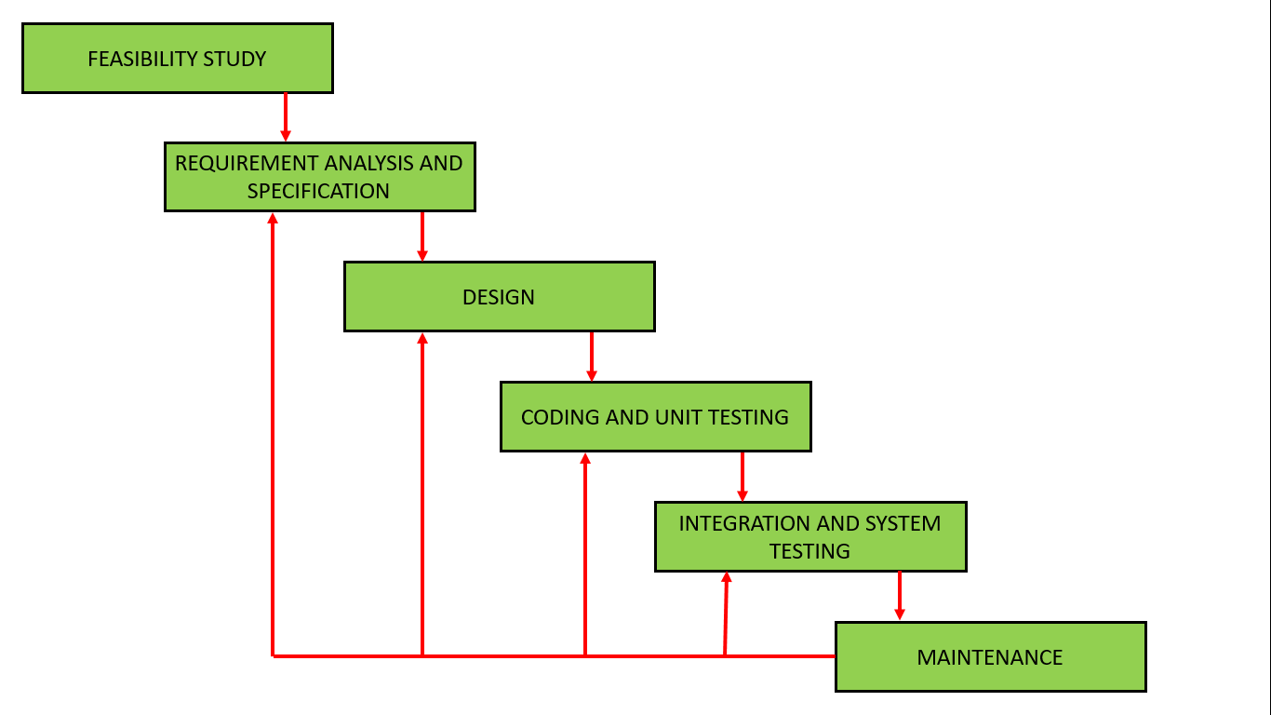

The iterative waterfall model is the most widely used software development model evolved so far.

### **The various phases of Iterative model are as follows:**

**1. Requirement gathering & analysis:** In this phase, requirements are gathered from customers and check by an analyst whether requirements will fulfil or not. Analyst checks that need will achieve within budget or not. After all of this, the software team skips to the next phase.

**2. Design:** In the design phase, team design the software by the different diagrams like Data Flow diagram, activity diagram, class diagram, state transition diagram, etc.

**3. Implementation:** In the implementation, requirements are written in the coding language and transformed into computer programmes which are called Software.

**4. Testing:** After completing the coding phase, software testing starts using different test methods. There are many test methods, but the most common are white box, black box, and grey box test methods.

**5. Deployment:** After completing all the phases, software is deployed to its work environment.

**6. Review:** In this phase, after the product deployment, review phase is performed to check the behaviour and validity of the developed product. And if there are any error found then the process starts again from the requirement gathering.

**7. Maintenance:** In the maintenance phase, after deployment of the software in the working environment there may be some bugs, some errors or new updates are required. Maintenance involves debugging and new addition options.

**When to use Iterative Waterfall Model**

* The requirement of the defined and clearly understood.
* New technology is being learned by the development team.
* There are some high risk features and goals which

might in the future.

**Application of Iterative Waterfall Model**

* Major requirements are defined but the minor details might involve when time goes.
* New technologies are being used and there is a

learning curve for the programmers to learn.

* Resource are limited to do a huge project as if a small project automates are in contact rather than permanent.
* Very high risk as a goal of the project might change from time to time .

**Advantages of Iterative Waterfall Model**

It is notably compulsory to recognize the Iterative model’s benefits before executing it in the SDLC (Software Development Life Cycle). This model’s significant benefit is that it is executed while the preceding phases of the software development process permit developers and testers to determine design or functionalities defects as quick as plausible, which permits them to get restorative actions in the insufficient budget. Other advantages or improvements to these models are:

* Few employable capabilities can be created in the software development life cycle in advance.
* It is efficiently versatile to the forever changeable requirements of the project as well as the customer.
* It is the finest [suitable for agile companies](https://www.educba.com/what-is-agile/).
* It is further efficiently priced to alter the range of specifications in the Iterative model.
* Aligned development can be organized.
* Examining and troubleshoot while the fewer iteration is simple.
* Hazards are recognized and fixed through iteration, and every iteration can be simply handled.
* In the iteration model, concise time is consumed on record, and extended time is provided for outlining.
* **Feedback Path**: iterative waterfall allows the mechanism of error connection because there is a feedback path from one phase to its preceding phase which it lacks in the Waterfall Model.
* **Simple**: iterative waterfall model is simple to understand and use. It is the most widely used software development model evolved so far.

Everyone obtains trustworthy consumer evaluation when displaying designs and outlines of the product to consumers for feedback.

**Disadvantage of Iterative Waterfall Model**

Although the iterative model is remarkably advantageous, there are some shortcomings and drawbacks connected to it, so every stage of iteration is rigid with no overlays. Furthermore, system structure or outline concerns might come up because not every requisite is collected at the inception of the complete life cycle. Additional drawbacks of the iterative model are mentioned below:

* Enhanced resources might be needed.
* Even though the price of alteration is lower, it does not always fit for alteration specifications.
* Additional administration recognition is needed.
* It does not fit for shorter projects.
* Extremely proficient resources are needed for abilities examination.
* Project advancement is greatly reliant on the risk assessment stages.
* Determining gradually increase might the interpretation of the entire system.
* **More resource**: may be required to implement the iterative waterfall model.

#### Difficult to include change requests: In the

iterative waterfall model, all the requirements must be clearly defined before starting of the development phase but sometimes customer requirement changes which is difficult to incorporate change requests that are made after development phase starts.

* **Risk handling**: Project is prone to many types of risk but there is no risk handling mechanism.

### **Examples of Iterative Model Design**

#### 1. User Interfaces

A requirement of a film company needs a custom system for equipment tracking, costumes, and props. The business section included is unusual for rendering specifications for technology-based projects. To evade the usual circumstances where developers continuously work for a month and build something that customers will decline, an iterative outline strategy is utilized.

#### 2. Graphic Design

The advertising agency’s creative department has 2 weeks to produce an ad print for a customer. They have a proposition to present to their clients days within. With the time the deadline encompassing, they would have previously gone over recurring series of customers’ responses and are convinced that it will perform and would be affirmed by the customer.

#### 3. Architecture

A firm of architecture promptly produces models and architecture animation to place in the presence of the customer. This holds the customer involved and delivers it more possible for the firm will be selected for a specific project.

#### 4. Marketing

An e-commerce fashion website nevermore begins designed again to displace an old website. Alternatively, the UI (user interface) is steadily contentious, altered and perfected. Track the metrics and correlate with alterations. The development by firms are expert established on practices that are incomparable to its industry.

#### 5. Urban Design

A town assists communities in building ten-year programs that serve as policies and tactics. Meanwhile, it proceeds to execution; city designers attempt something at a smaller scale and collection feedback before advancing in everything the manner with the program. For instance, a specific design of the living street pattern may be attempted in a place for a year before enhancing its further utilization.

# WhatsApp Image 2021-11-29 at 8.03.45 PM 2.2 USE CASE DIAGRAM

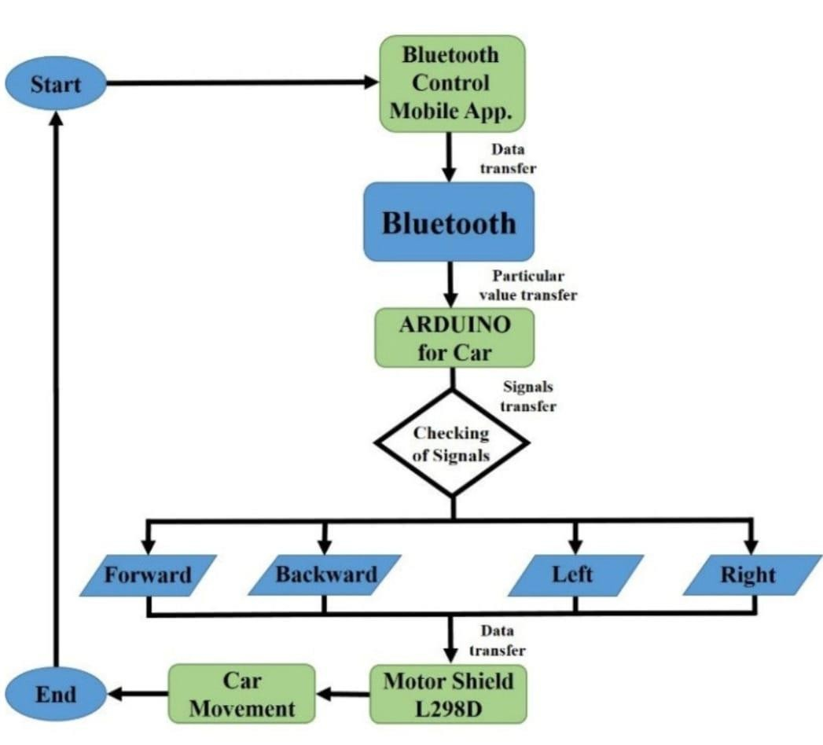**2.3 FLOW CHART**

**2.4 BLOCK DIAGRAM**

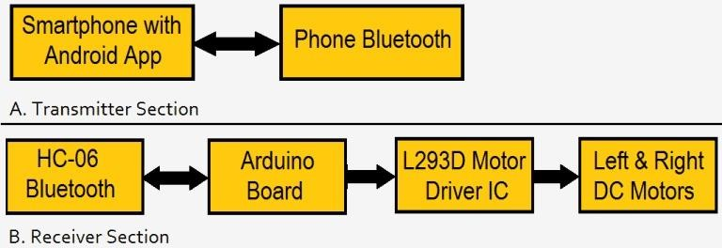

**2.5 CIRCUIT DIAGRAM**

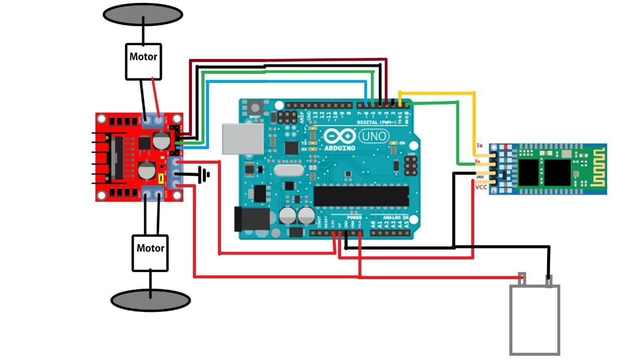

#### 2.6 SYSTEM FLOW

#### 

#### 2.7 DEPLOYMENT DIAGRAM

#### 

#### 3 IMPLEMENTATION REQUIREMENTS

#### 3.1 Hardware Requirements

#### 1) Arduino UNO

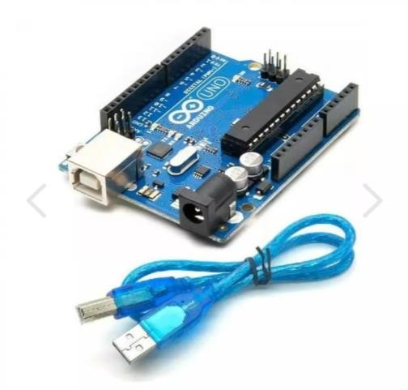

Arduino/Genuino Uno is a microcontroller board based on the ATmega328P ([datasheet](http://www.atmel.com/Images/doc8161.pdf)). It has 14 digital input/output pins (of which 6 can be used as PWM outputs), 6 analog inputs, a 16 MHz quartz crystal, a USB connection, a power jack, an ICSP header and a reset button.

It contains everything needed to support the microcontroller; simply connect it to a computer with a USB cable or power it with a AC-to-DC adapter or battery to get started.

You can tinker with your UNO without worring too much about doing something wrong, worst case scenario you can replace the chip for a few dollars and start over again.

"Uno" means one in Italian and was chosen to mark the release of Arduino Software (IDE) 1.0. The Uno board and version 1.0 of Arduino Software (IDE) were the reference versions of Arduino, now evolved to newer releases. The Uno board is the first in a series of USB Arduino boards, and the reference model for the Arduino platform; for an extensive list of current, past or outdated boards see the Arduino index of boards.

**2) Bluetooth HC-05**

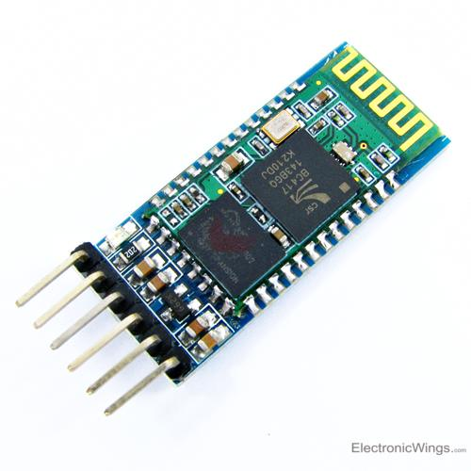

HC-05 is a Bluetooth module which is designed for wireless comunication. This module can be used in a master or slave configuration.

Bluetooth serial modules allow all serial enabled devices to communicate with each other using Bluetooth.

It has 6 pins,

1.  **Key/EN:** It is used to bring Bluetooth module in AT commands mode. If Key/EN pin is set to high, then this module will work in command mode. Otherwise by default it is in data mode. The default baud rate of HC-05 in command mode is 38400bps and 9600 in data mode.

HC-05 module has two modes,

          1.  **Data mode:**Exchange of data between devices.

          2.  **Command mode:**It uses AT commands which are used to change setting of HC-05. To send these commands to module serial (USART) port is used.

2.  **VCC:**Connect 5 V or 3.3 V to this Pin.

3.  **GND:**Ground Pin of module.

4.  **TXD:**Transmit Serial data (wirelessly received data by Bluetooth module transmitted out serially on TXD pin)

5.  **RXD:** Receive data serially (received data will be transmitted wirelessly by Bluetooth module).

6.  **State:**It tells whether module is connected or not.

**HC-05 module Information**

* HC-05 has red LED which indicates connection status, whether the Bluetooth is connected or not. Before connecting to HC-05 module this red LED blinks continuously in a periodic manner. When it gets connected to any other Bluetooth device, its blinking slows down to two seconds.
* This module works on 3.3 V. We can connect 5V supply voltage as well since the module has on board 5 to 3.3 V regulator.
* As HC-05 Bluetooth module has 3.3 V level for RX/TX and microcontroller can detect 3.3 V level, so, no need to shift transmit level of HC-05 module. But we need to shift the transmit voltage level from microcontroller to RX of HC-05 module.

To communicate smartphone with HC-05 Bluetooth module, smartphone requires Bluetooth terminal application for transmitting and receiving data. You can find Bluetooth terminal applications for android and windows in respective app. store.

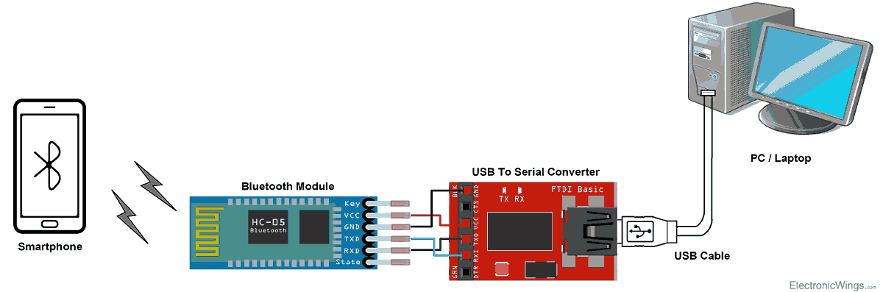

**Bluetooth Module Serial Interface**

So, when we want to communicate through smartphone with HC-05 Bluetooth module, connect this HC-05 module to the PC via serial to USB converter.

Before establishing communication between two Bluetooth devices, 1st we need to pair HC-05 module to smartphone for communication.

**3) Motor driver**

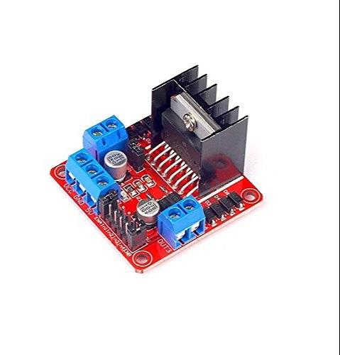

Motor drives are circuits used to run a motor. In other words, they are commonly used for motor interfacing. These drive circuits can be easily interfaced with the motor and their selection depends upon the type of motor being used and their ratings (current, voltage).

## ****Major components in Motor Drives****

* For [**DC Motors**](https://www.mepits.com/tutorial/204/Electrical/DC-Motor).

The major motor drive components for DC motors are: a controller, a motor driver IC or a motor driver circuit, the desired DC motor being used, power supply unit and the necessary connections to the motor.

1. Controller: The controller can be a [**microprocessor**](https://www.mepits.com/tutorial/79/Microprocessor/Microprocessor) or a microcontroller.
2. Motor Driver IC or Motor Driver Circuits: They are basically current [**amplifiers**](https://www.mepits.com/tutorial/92/Electronic-Circuits/Amplifiers)which accept the low current signal from the controller and convert it into a high current signal which helps to drive the motor.
3. Motor: Motor is defined as an electric or mechanic device that can create a motion. While interfacing with the [**controller**](https://www.mepits.com/tutorial/78/Microcontroller/Microcontroller); some of the motors like DC motor, [**stepper motor**](https://www.mepits.com/product/216/Stepper-Motor/12V-Stepper-Motor-4-Wire-1KG) and brushless dc motor may require a driver IC or driver circuit. DC motor is a type of motor that can convert DC into a mechanical power. In a brushless DC motor, it consists of a DC power source, an inverter producing an AC signal to drive the motor. While stepper motor is a brushless DC electric motor that converts electrical pulses into discrete mechanical motions.
4. Power Supply Unit: Provides the required power to the motor drive.

* For servo motor

Servo motor is a type of actuator device that consists of a motor and a sensor to control velocity, acceleration etc. The major motor drive components for a [**servo motor**](https://www.mepits.com/index.php/site/product/cat/270) are a controller, power supply unit, servo motor and the necessary connections with the motor.

### **DC Motor Driver Circuits**

Motor Driver circuits are current amplifiers. They act as a bridge between the controller and the motor in a motor drive. Motor drivers are made from discrete components which are integrated inside an IC. The input to the motor driver IC or motor driver circuit is a low current signal. The function of the circuit is to convert the low current signal to a high current signal. This high current signal is then given to the motor. The motor can be a brushless DC motor, brushed DC motor, stepper motor, other DC motors etc.

## ****Features****

* High level functionality.
* Better performance.
* Provides high voltage.
* Provides high current drive.
* Includes protection schemes to prevent the failure of motors due to any faults.

## ****Need for Motor Driver Circuits/ICs****

In motor interfacing with controllers, primary requirement for the operation of the controller is low voltage and small amount of current. But the motors require a high voltage and current for its operation. In other words we can say the output of the controller or processor is not enough to drive a motor. In such a case direct interfacing of controllers to the motor is not possible. So we use a Motor Driver Circuit or Motor Driver IC.

Not only in the case of controllers, while connecting motors with 555 timer ICs or 74 series ICs; they also cannot provide the large current required by the motor. If direct connection is given, there might be a chance of damage to the IC.

**4) Jumper wire**

A jump wire (also known as jumper, jumper wire, DuPont wire) is an [electrical wire](https://en.wikipedia.org/wiki/Electrical_wire), or group of them in a cable, with a connector or pin at each end (or sometimes without them – simply "tinned"), which is normally used to interconnect the components of a [breadboard](https://en.wikipedia.org/wiki/Breadboard) or other prototype or test circuit, internally or with other equipment or components, without soldering.[[1]](https://en.wikipedia.org/wiki/Jump_wire#cite_note-1)

Individual jump wires are fitted by inserting their "end connectors" into the slots provided in a breadboard, the [header connector](https://en.wikipedia.org/wiki/Pin_header#Header_connector) of a circuit board, or a piece of test equipment.

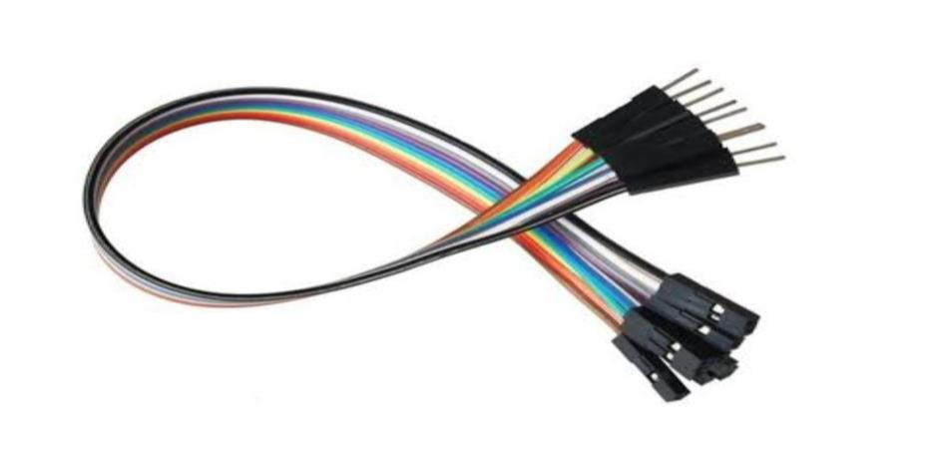

There are different types of jumper wires. Some have the same type of [electrical connector](https://en.wikipedia.org/wiki/Electrical_connector) at both ends, while others have different connectors. Some common connectors are:

* Solid tips – are used to connect on/with a breadboard or female header connector. The arrangement of the elements and ease of insertion on a breadboard allows increasing the mounting density of both components and jump wires without fear of short-circuits. The jump wires vary in size and colour to distinguish the different working signals.
* [Crocodile clips](https://en.wikipedia.org/wiki/Crocodile_clip) – are used, among other applications, to temporarily bridge sensors, buttons and other elements of prototypes with components or equipment that have arbitrary connectors, wires, [screw terminals](https://en.wikipedia.org/wiki/Screw_terminal), etc.
* [Banana connectors](https://en.wikipedia.org/wiki/Banana_connector) – are commonly used on test equipment for DC and low-frequency AC signals.
* [Registered jack](https://en.wikipedia.org/wiki/Registered_jack) (RJnn) – are commonly used in telephone (RJ11) and computer networking (RJ45).
* [RCA connectors](https://en.wikipedia.org/wiki/RCA_connector) – are often used for audio, low-resolution composite video signals, or other low-frequency applications requiring a [shielded cable](https://en.wikipedia.org/wiki/Shielded_cable).
* [RF connectors](https://en.wikipedia.org/wiki/RF_connector) – are used to carry [radio frequency](https://en.wikipedia.org/wiki/Radio_frequency) signals between circuits, test equipment, and antennas.
* RF jumper cables - Jumper cables is a smaller and more bendable corrugated cable which is used to connect antennas and other components to network cabling. Jumpers are also used in base stations to connect antennas to radio units. Usually the most bendable jumper cable diameter is 1/2".

**5) Wheels**

The 3PI miniQ Car wheel Tyre 44mm [N20 DC Gear Motor](https://robu.in/product-category/motor/micro-gear-motor/) Wheel is a customized high-quality rubber wheel, a diameter of 44mm. The hub for N20 micro motor output shaft design of the bayonet, the ferry can plug and play, without an additional field.

White provided inside the left 12 line encoding disc, convenient infrared encoder reads the rotation information. We recommend and MiniQ sites supporting the use of a flexible, simple mobile platform.

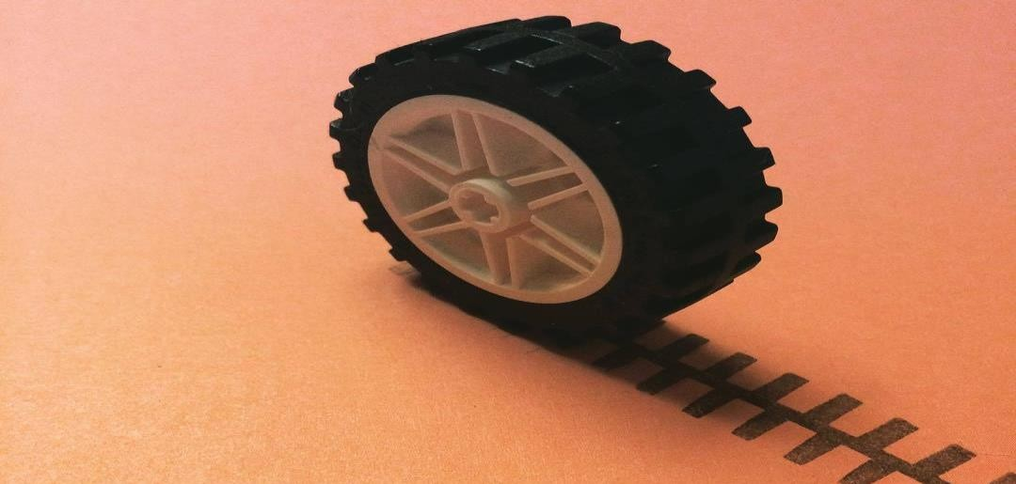

**5) Power source**

All Arduino boards need electric power to function. A power supply is what is used to provide electric power to the boards and typically can be a battery, USB cable, AC adapter or a regulated power source device.

There are different ways to power your Arduino board. The most common way is through the USB connector available on every board, but there are a few other possibilities to power your board. If you like to know more about this, the different ways to supply power to your board are listed below:

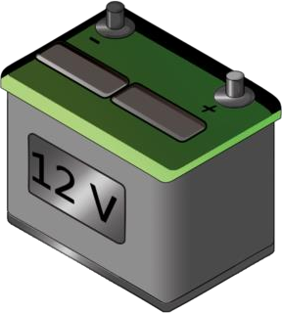A power supply module takes 9V to 12V DC from a wall adapter and converts in to 5V and 3.3V outputs, the 5V output from power supply module is directly connected to 5V pin of Arduino and GND of power supply is connected to GND of Arduino.

Similarly 3.3V from the power supply unit is connected to 3.3V Vcc of ESP8266 (it operates strictly on 3.3V and 5V will kill the module), the ground of power supply is connected to ground of ESP8266.

Make sure you that have inserted the voltage select jumpers correctly.

## USB

Arduino boards can operate satisfactorily on power that is available from the USB port. It provides 5V DC voltage and can be sourced from the port from a PC, wall socket adapter or portable power bank.

## AC socket

Some Arduino boards like UNO, MEGA and DUE, come with an AC socket that can be used to power the boards and to supply additional voltage if needed. A power supply adapter that provides from 7 to 12V (Volts) of DC (Direct Current) is required. The adapter is plugged onto the wall socket and the other end goes directly onto the board's AC socket.

**Make sure the power adapter complies with your Arduino board specifications.**

If you find that additional power is required from your Arduino board to operate it properly, or if you need to operate the Arduino board disconnected from a USB port.

The AC adapters are commonly available in retail stores for use with consumer products are often suitable, but make sure that it has the proper connector for plugging into the power socket on your Arduino board: **5.5mm** diameter cylindrical plug with **2.1mm** pin hole, and that provides Positive voltage on the inside pin hole and Negative (or common/ground) voltage on the outside cylindrical sleeve of the connector plug.

## Battery

Some boards come with a Li-Po (Lithium-ion Polymer) battery socket that fits this kind of batteries. For example, MKR boards (except MKR FOX and WAN 1300) come with this feature. These types of batteries supply 3.7V, are rechargeable and they can provide higher energy than other lithium batteries.

Please make sure the battery connector suits your board's battery connector. For

MKRs the connector is [JST PHR-2](https://www.digikey.se/product-detail/en/jst-sales-america-inc/PHR-2/455-1165-ND/608607).

**Modules Components**

The aim of this proposed voice-controlled software is to A

mobile robot that can be operated by voice commands is known

as a robot vehicle.The speech recognition programme on an

Android phone will recognise voice commands such as

'Forward,''Stop,''Left,''Right,'and'Back,'among others.The

robotic car's working mechanism is based on data sent from the

phone to the robot.

Microcontroller ESP8266:Arduino model boards are widely

used.The ESP8266,however,has a range of advantages over

Arduino programming boards.The ESP8266 is a low-cost on

chip microcontroller with low energy consumption.It comes

with dual-mode Bluetooth and Wi-Fi pre-installed.It is

designed to provide flexibility,reliability,and robustness in a

wide range of applications.MP3 decoding,voice encoding,and

audio streaming are only a few of the applications for this

microcontroller.This microcontroller can easily achieve the

best RF and power output.Since the ESP8266 has a USB port,

it can be considered a plug-and-play device.

The below figure 2 illustrates the circuit diagram of our system.

It shows how the pins and other devices connected to each other to control th voice control car in an efficient way.

**Motor Driver L293D**:High-current quadruple half-H

generators,the L293 and L293D.The L293 can provide input

and output drive currents of up to 1 A at voltages ranging from

4.5 to 36 V.The L293D is capable of asynchronous drive

currents of up to 600 mA at voltages ranging from 4.5 to 36 V.

Both systems are intended to drive voltage levels such as relay

stations,solenoids,DC and bipolar stepping motors,and other

high-current/high-voltage loads in parallel connection

applications.

The below figure 3 shows the motor driver L293D and the pins

of it where we connect the other devices.

Figure.3 Motor Driver L293D

NodeMCU(ESP8266):NodeMCU is an open access LUA

based framework for the ESP8266 Wi-Fi chip.For exploring

features with the ESP8266 chip,NodeMCU configuration

comes with ESP8266 Development board/kit,i.e.NodeMCU International Journal of Engineering Applied Sciences and Technology,2021

Vol.6,Issue 4,ISSN No.2455-2143,Pages 160-170

Published Online August 2021 in IJEAST(http://www.ijeast.com)

164

Anyone can modify, alter, or build their electronics because NodeMCU is an open source software. The NodeMCU Dev Kit/board includes the ESP8266 Wi-Fi enabled chip.The ESP8266 from Espressif Systems is a minimal Wi-Fi chip that relies on the TCP/IP protocol.Further data on theESP8266 can be found at ESP8266 Wi-Fi Module. The below figure 4 illustrates the model of NodeMCU

(ESP8266)where all the sensors and other IOT devices are

connected using jumper cables.

Ultrasonic Sensors:The ultrasonic ranging module HC-SR04

has a pseudo measurement range of 2cm to 400cm and a

varying precision of 3mm.The modules include ultrasonic

transmissions,receivers,and a communication module.The

following are the work criteria in our system:The Module sends

eight 40 kHz pulses and uses an IO trigger for at least a 10us

high level signal to detect whether there is a pulse signal back.

The longer it takes for ultrasonic to travel from sender to

receiver is known as the high-performance IO range. (high

level time / sound velocity (340 M/S) / 2 = test distance.

Figure 5 demonstrates ultrasonic sensors that assist the vehicle

in avoiding collisions or injuries.

Ultrasonic Sensor

**Arduino Nano:** The Arduino Nano, based on the ATmega328

microcontroller, is a lightweight, feature-rich, and breadboard

friendly board (Arduino Nano 3.x). It has similar characteristics

to the Arduino Duemilanove, but it comes as a separate

package. It only has a DC power socket and connects to the

system through a Mini-B USB cable or perhaps a standard USB

cable.

The below figure 6 states Arduino Nano it is similar to

NodeMCU but it has separate kit.

**Arduino Nano**

Rechargeable 9 voltage Battery: The nine-volt battery, also

known as even the 9-volt battery, was first used in transistor

radios in the early 1960s. It has a rectangular prism design with

rounded edges and a mirrored snap connector on the end.

Common nine-volt battery variants include main carbon-zinc

and alkaline chemicals, primary lithium iron disulfide chemistry, and rechargeable nickel-cadmium, nickel-metal hydride, and lithium-ion batteries. A snap connector on one end of the battery links both interfaces. The smaller circular terminal serves as the positive contact, whereas the hexagonal

or octagonal terminal serves as the destructive contact. But for the narrower plug, the battery has the same connectors as the load unit.

The below figure 7 shows the 9-voltage battery it is used for

power supply for the system.

**Voltage Rechargeable battery**

B. Software Components International Journal of Engineering Applied Sciences and Technology, 2021

Vol. 6, Issue 4, ISSN No. 2455-2143, Pages 160-170

Published Online August 2021 in IJEAST (http://www.ijeast.com)

165 Any sensor, electronics, or software linked to the internet that can be used remotely and share data is considered Internet of

Things technology. For improved functionality, technology

often operates in parallel.

**Android Studio**: The official Integrated Development

Environment (IDE) for creating Android apps is Android

Studio, which is based on IntelliJ IDEA. On side of IntelliJ's versatile cod editor and developer tools,

Android Studio provides a unique Gradle-based build framework, a swift and

feature-rich emulator, a centralized platform in which you can code for Android devices, and Implement Improvements,

which allows you to apply code and resource changes to your running app without reinstalling it.

The below figure 8 illustrates the android studio application

where the voice commands is converted to text and the

commands are been transmitted to the vehicle module.

Figure.8 9 Android Studio Application

**Arduino IDE**: The Arduino Integrated Development

Environment (IDE) is a bridge system for Windows, macOS,

and Linux published in C and C++ functions. This is used to

write and upload computer code to Embedded system boards

and several other entrepreneurship development boards with

3rd-party core support. The source code of the IDE is protected

by the GNU General Public License, edition 2. To endorse the

languages C and C++, the Arduino IDE employs code generator

structuring laws. The Connectivity project contains a library

function in the Arduino IDE that includes various of standard

input and output procedures. To launch the simulation and run

the main programmed loop, app code only requires two basic

calculations, which are assembled and linked with a configured

stub main () into an executable file executive programmed

using the GNU toolchain, which is updated to reflect IDE

distribution. The avrdude software is used by the Arduino IDE

to convert source codes to a text file in hexadecimal encoding,

which is then loaded into the Arduino board's chipset by a

loader. Avrdude is the default sharing tool for uploading code

to approved Arduino boards.

The below figure 9 shows the Arduino IDE where the code is

been written in Embedded C Language to run to voice control

vehicle.

Figure.9 Arduino IDE

HiveMQTT Server: Iot systems can generate a huge amount

of data. Choosing a platform that can transport IoT data over

the network and cloud platforms is crucial. The MQTT broker

in HiveMQ is equipped for cloud native installations. Through

use of MQTT decreases the amount of available bandwidth

usage for data transfer. More efficient IoT technologies lead to

lower net operating expenses. Inside any IoT approach,

connecting and transmission of data to and from technology is

a major task. HiveMQ follows the MQTT IoT standard

procedure to securely connect any computer to a cloud service.

Your clients demand IoT products to react immediately.

HiveMQ uses a push technology configured for Iot devices to

transmit and receive data from connected devices.

PORT NO:1883

**3.2 SOFTWARE REQUIREMENTS**

**1) AMR-VOICE App**



## Description of BT Voice Control for Arduino

Android Meets Robots : Voice Recognition

Uses android mobiles internal voice recognition to pass voice commands to your robot

Pairs with Bluetooth Serial Modules and sends in the recognized voice as a string  
  
for example if you say Hello the android phone will return a sting *Hello# to your bluetooth module *and # indicate the start and stop bits  
  
Can Be used with any micro controller which can handle strings  
  
Examples Platforms : Arduino , ARM , PICAXE , MSP430 , 8051 based and many other processors and controllers

# MIT Companion 2.8 Android App Developed -AMR_VOICE Shows Developed Android app with the help of the app we developed an app and named it as AMR_VOICE. The app contains the option to connect to Bluetooth and access the Bluetooth settings of the phone.

**BT Voice Control for Arduino**

Android Meets Robots : Voice Recognition Uses android mobiles internal voice recognition to pass voice commands to your robot Pairs with Bluetooth Serial Modules and sends in the recognized voice as a string for example if you say Hello the android phone will return a sting *Hello# to your bluetooth module *and # indicate the start and stop bits Can Be used with any micro controller which can handle strings Examples Platforms : Arduino , ARM , PICAXE , MSP430 , 8051 based and many other processors and controllers

**4. LAYOUT**

**4.1 CODINGS**

**Programming the arduino uno to recognise commands**

The initial step to start with Arduino is the IDE download and installation.

Let's discuss the basics to start with Arduino programming.

Brackets

There are two types of brackets used in the Arduino coding, which are listed below:

Parentheses ( )

Curly Brackets { }

Parentheses ( )

The parentheses brackets are the group of the arguments, such as method, function, or a code statement. These are also used to group the math equations.

Curly Brackets { }

The statements in the code are enclosed in the curly brackets. We always require closed curly brackets to match the open curly bracket in the code or sketch.

Open curly bracket- ' { '

Closed curly bracket - ' } '

Line Comment

There are two types of line comments, which are listed below:

Single line comment

Multi-line comment

// Single line comment

The text that is written after the two forward slashes are considered as a single line comment. The compiler ignores the code written after the two forward slashes. The comment will not be displayed in the output. Such text is specified for a better understanding of the code or for the explanation of any code statement.

The // (two forward slashes) are also used to ignore some extra lines of code without deleting it.

/ * Multi - line comment */

The Multi-line comment is written to group the information for clear understanding. It starts with the single forward slash and an asterisk symbol (/ *). It also ends with the / *. It is commonly used to write the larger text. It is a comment, which is also ignored by the compiler.

Coding Screen

The coding screen is divided into two blocks. The setup is considered as the preparation block, while the loop is considered as the execution block. It is shown below:

Arduino Coding Basics

The set of statements in the setup and loop blocks are enclosed with the curly brackets. We can write multiple statements depending on the coding requirements for a particular project.

For example:

void setup ( )

{

Coding statement 1;

Coding statement 2;

.

.

.

Coding statement n;

}

void loop ( )

{

Coding statement 1;

Coding statement 2;

.

.

.

Coding statement n;

}

What is Setup? What type of code is written in the setup block?

It contains an initial part of the code to be executed. The pin modes, libraries, variables, etc., are initialized in the setup section. It is executed only once during the uploading of the program and after reset or power up of the Arduino board.

Zero setup () resides at the top of each sketch. As soon as the program starts running, the code inside the curly bracket is executed in the setup and it executes only once.

What is Loop? What type of code is written in the Loop block?

The loop contains statements that are executed repeatedly. The section of code inside the curly brackets is repeated depending on the value of variables.

Time in Arduino

The time in Arduino programming is measured in a millisecond.

Where, 1 sec = 1000 milliseconds

Arduino Coding Basics

The void setup () would include pinMode as the main function.

pinMode ( )

The specific pin number is set as the INPUT or OUTPUT in the pinMode () function.

The Syntax is: pinMode (pin, mode)

Where,

pin: It is the pin number. We can select the pin number according to the requirements.

Mode: We can set the mode as INPUT or OUTPUT according to the corresponding pin number.

Let' understand the pinMode with an example.

Example: We want to set the 12 pin number as the output pin.

Code:

pinMode (12, OUTPUT);

Why is it recommended to set the mode of pins as OUTPUT?

The OUTPUT mode of a specific pin number provides a considerable amount of current to other circuits, which is enough to run a sensor or to light the LED brightly. The output state of a pin is considered as the low-impedance state.

The high current and short circuit of a pin can damage the ATmel chip. So, it is recommended to set the mode as OUTPUT.

Can we set the pinMode as INPUT?

The digitalWrite () will disable the LOW during the INPUT mode. The output pin will be considered as HIGH.

We can use the INPUT mode to use the external pull-down resistor. We are required to set the pinMode as INPUT_PULLUP. It is used to reverse the nature of the INPUT mode.

The sufficient amount of current is provided by the pull-up mode to dimly light an LED, which is connected to the pin in the INPUT mode. If the LED is working dimly, it means this condition is working out.

Due to this, it is recommended to set the pin in OUTPUT mode.

The void loop () would include digitalWrite( ) and delay ( ) as the main function.

digitalWrite( )

The digitalWrite ( ) function is used to set the value of a pin as HIGH or LOW.

Where,

HIGH: It sets the value of the voltage. For the 5V board, it will set the value of 5V, while for 3.3V, it will set the value of 3.3V.

LOW: It sets the value = 0 (GND).

If we do not set the pinMode as OUTPUT, the LED may light dim.

The syntax is: digitalWrite( pin, value HIGH/LOW)

pin: We can specify the pin number or the declared variable.

Let's understand with an example.

Example:

digitalWrite (13, HIGH);

digitalWrite (13, LOW);

The HIGH will ON the LED and LOW will OFF the LED connected to pin number 13.

What is the difference between digitalRead () and digitalWrite ()?

The digitalRead () function will read the HIGH/LOW value from the digital pin, and the digitalWrite () function is used to set the HIGH/LOW value of the digital pin.

delay ( )

The delay () function is a blocking function to pause a program from doing a task during the specified duration in milliseconds.

For example, - delay (2000)

Where, 1 sec = 1000millisecond

Hence, it will provide a delay of 2 seconds.

Follow these steps to upload your sketch:

Connect your Arduino using the USB cable.

The square end of the USB cable connects to your Arduino and the flat end connects to a USB port on your computer.

Choose Tools→Board→Arduino Uno to find your board in the Arduino menu.

You can also find all boards through this menu, such as the Arduino MEGA 2560 and Arduino Leonardo.

Choose the correct serial port for your board.

You find a list of all the available serial ports by choosing Tools→Serial Port→ comX or /dev/tty.usbmodemXXXXX. X marks a sequentially or randomly assigned number. In Windows, if you have just connected your Arduino, the COM port will normally be the highest number, such as com 3 or com 15.

Many devices can be listed on the COM port list, and if you plug in multiple Arduinos, each one will be assigned a new number. On Mac OS X, the /dev/tty.usbmodem number will be randomly assigned and can vary in length, such as /dev/tty.usbmodem1421 or /dev/tty.usbmodem262471. Unless you have another Arduino connected, it should be the only one visible.

Click the Upload button.

This is the button that points to the right in the Arduino environment. You can also use the keyboard shortcut Ctrl+U for Windows or Cmd+U for Mac OS X.

Code:

digitalWrite (13, HIGH);

delay (2000);

digitalWrite (13, LOW);

delay (1000);

Here, the LED connected to pin number 13 will be ON for 2 seconds and OFF for 1 second. The task will repeatedly execute as it is in the void loop ().

We can set the duration according to our choice or project requirements.

String readvoice;

int k=0;

void setup() {

Serial.begin(9600);

pinMode(2,OUTPUT);

pinMode(3,OUTPUT);

pinMode(4,OUTPUT);

pinMode(5,OUTPUT);

}

void loop() {

while (Serial.available())

{

delay(3);

char c = Serial.read();

readvoice += c;

}

if(readvoice.length() &gt; 0)

{

Serial.println(readvoice);

if(readvoice == "forward")

{

digitalWrite(2, HIGH);

digitalWrite(3, LOW);

digitalWrite(4, HIGH);

digitalWrite(5, LOW);

k=1;

}

if(readvoice == "backward")

{

digitalWrite(2, LOW);

digitalWrite(3, HIGH);

digitalWrite(4, LOW);

digitalWrite(5, HIGH);

k=2;

}

if(readvoice == "left")

{

if (k==2)

{

digitalWrite(2, HIGH);

digitalWrite(3, LOW);

digitalWrite(4, LOW);

digitalWrite(5, LOW);

delay(1000);

digitalWrite(2, LOW);

digitalWrite(3, HIGH);

digitalWrite(4, LOW);

digitalWrite(5, HIGH);

}

else

{

digitalWrite(2, HIGH);

digitalWrite(3, LOW);

digitalWrite(4, LOW);

digitalWrite(5, LOW);

delay(1000);

digitalWrite(2, HIGH);

digitalWrite(3, LOW);

digitalWrite(4, HIGH);

digitalWrite(5, LOW);

}

}

if(readvoice == "right")

{

if (k==2)

{

digitalWrite(2, LOW);

digitalWrite(3, LOW);

digitalWrite(4, HIGH);

digitalWrite(5, LOW);

delay(1000);

digitalWrite(2, LOW);

digitalWrite(3, HIGH);

digitalWrite(4, LOW);

digitalWrite(5, HIGH);

}

else

{

digitalWrite(2, LOW);

digitalWrite(3, LOW);

digitalWrite(4, HIGH);

digitalWrite(5, LOW);

delay(1000);

digitalWrite(2, HIGH);

digitalWrite(3, LOW);

digitalWrite(4, HIGH);

digitalWrite(5, LOW);

}

}

if(readvoice == "stop")

{

digitalWrite(2, LOW);

digitalWrite(3, LOW);

digitalWrite(4, LOW);

digitalWrite(5, LOW);

}

}

readvoice="";

}

**4.2 SNAPSHOTS**

The working of each components or devices was checked and tested using the Bread Board before making the final circuit.

All the modules were working fine.

**1) Arduino Uno**

## Testing the Arduino Uno Board

To verify that you are receiving correct data you can test it by setting each channel to ground and power and read the output in the Serial Monitor. To do this you need a wire to connect between the input connectors and power connectors on the Arduino Uno board.

* Connect one end of the wire to A0 port
* Connect the other end to GND port
* Analog0 in the Serial Monitor should now read 0.0 volts
* Remove the wire from GND and connect it to 5V
* Analog0 should now read approximately 5.0 volts
* Remove the wire from 5V and connect it to 3.3V
* Analog0 should now read approximately 3.3 volts
* Repeat the same procedure with A1 ,D2 and D3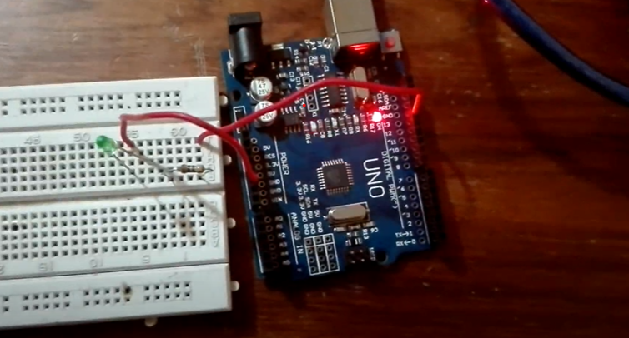

**2) Bluetooth Module**

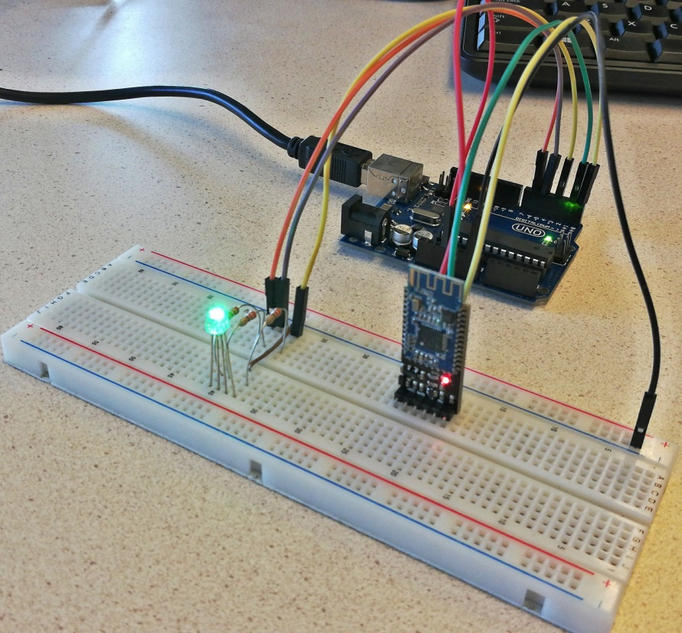

The bluetooth module was tested using a simple LED bulb and a basic android application. The application has a button to on/off the bulb.

The connectivity got established very easily and the bulb started glowing after cliking the on button,

We selected the correct HC-05 Bluetooth Module for use. Others, including the HC-06 Slave-only device and HC-07 iOS compatible device may not have the same commands as given .

Additionally, many HC-05 modules such as the one given [here](https://www.amazon.ca/gp/product/B07NSNQW68/ref=ppx_yo_dt_b_asin_title_o03_s00?ie=UTF8&psc=1) have their own AT Commands (e.g. Do not have the AT+BIND function, return different responses to AT+UART, and use AT+ROLE=M or S instead of 1 or 0. Contact your seller for the datasheet and a list of available commands).

To test the bluetooth connection, start by disconnecting the Slave device from any others (such as your Android), and then setting up the Master HC-05 in "normal" transceiver mode. To debug, it may be wise to keep the Slave Arduino connected to your PC, with the Serial monitor running. Power up the Master Arduino using a 9V battery and Arduino DC jack connector, placing it a distance away from the Slave. The two devices should connect automatically, which can be indicated by the onboard LED, which should blink twice every 2 seconds. To test the device, press the push button. The LED should turn on as long as you hold the button down.

**3) Motor Driver**

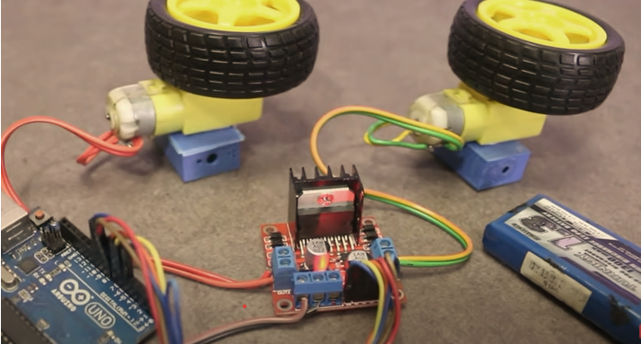

The L298n module should be able to control the motors forward/backward at full speed with or without an Arduino. Connect a supply of +9 to +12 volts on pin 4, ground to pin 5. Leave 12 volt jumper in place to enable 5 volt regulator. motor 1 to pin 1 and 2, motor 2 to pin 13 and 14. Supply +5 volts to both enable pins (this is just a forward/backward test). Run jumper wires from pin 6 (+5 volts) and pin 5 (ground) to the pins 8,9,10, and 11 (N1, N2, N3, N4). Try different combinations. N1 and N2 control motor 1 and N3 and N4 control motor 2.

Motor were able to rotate clockwise and anti-clockwise. Hence the motor driver was working fine.

**5. TESTING**

**#Test Steps-**

1) Install amr_voice app from playstore (Android)

2) Power on the Voice Controlled IOT Car

3) Open amr_voice app

4) Pair to the bluetooth of car as prompted in amr_voice app

5) Press the audio icon at the center of screen to give commands

**5.1 Test Cases**

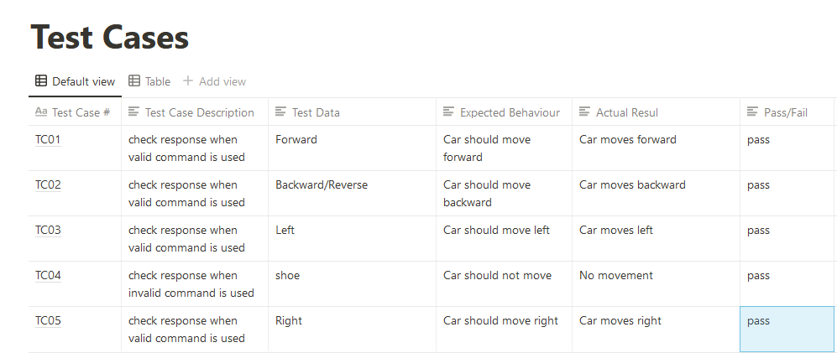

**6. APPLICATION**

* The robot is useful in places where humans find difficult to reach but human voice reaches. E.g- in a small pipeline, in a fire situation, in highly toxic area.
* Command and control of application and equipment.
* This car can be used as the vehicle for the disable persons like people who don’t have limbs.
* **Security**- The robot can be used to monitor a certain institution or university by adding a camera module.
* **Surveillance**- The robot can report a intrusion or misconduct in certain institution or examination centers, hence reducing the human effort.
* **Assist** - Some modifications and updates of this robot can be used for human being who are specially abled to assist them.

**6.1 ADVANTAGES**

* The automation in security can save lesser the human intervention.
* The cost of project is very minimal.
* The size of robot is very small hence can be used in very narrow spaces.
* The robot is portable and can be placed anywhere.

**6.2 DISADVANTAGE**

* The power supply is minimal hence we cannot expect the robot to function for a long duration.
* The communication between the app and the robot is slower because of speech recognition feature.
* In some situations accuracy of the robot might be an issue.
* The noise of the motor can be a threat if the robot is being used in some secret defense operations.

**7. CONCLUSION AND FUTURE WORKS**

**7.1 CONCLUSION**

The proposed framework of our project shows that how a robot can be control utilizing Bluetooth.

The voice controlling orders are effectively transmitted through Bluetooth innovation and the desired activities effectively happen.

This task lessens human endeavours at spots or circumstances where human intercessions are troublesome.

Such frameworks can be brought into utilization at spots, for example, businesses, military and guard, investigate purposes, and so forth.

Internet of Things (IoT) is the ever-growing field. The only way is forward for this area. Autonomous Robots are widely studied area in IoT. Use of robots and automation drastically improve productivity and help reduce resource

wastage. They are an easy replacement for human, without much life-threatening risk at hazardous locations (ex –factories).

Although limited to selected voice commands for now, we aim to expand this further using Machine

Learning and NLP. Further improvements include the addition of DHT sensor to sense temperature and humidity.

Due to its size, it can reach and penetrate areas where humans cannot reach and hence, we can detect regions of extreme temperature and humidity (farms where crops grow so large that ground below is hardly visible).

Also, an initial and obvious expansion of the project would be to attach a camera for better exploration from remote areas.

But then the problem of limited pins arises in NodeMCU boards. We don’t need to look much further;

Raspberry Pi is the solution. But it comes at the cost of increasing complexity. As is the case with most things in the nature, nothing comes free of cost. All said and done, we can all agree upon that the autonomous vehicles and robots will be the stepping stones to the world of IoT in the coming years

**7.2 FUTURE WORK**

This task work has been limited to short range Bluetooth module. Utilizing a long range modules and other availability gadgets will bring about network with the robot for significant distances.

Picture preparing can be executed in the robot to distinguish the shading and the items.

A warm camera can be introduced to detect the warmth produced by bodies valuable in military purposes to distinguish foes on the lines.

Programmed Targeting System can be executed in the robot for following the objective.

The robot is valuable in places where people discover hard to reach however human voice comes to. For example, in fire circumstances, in profoundly poisonous zones.

It is the one of the significant phase of Humanoid robots.

Discourse and voice acknowledgment security frameworks.

The robot can be used for monitoring or investigation.

## 8. REFERENCES

### ◈ 2017 25th Mediterranean Conference on Control and Automation(MED) July 3-6-2017 Valletta,Malta,Differential Mobile Robot Control Study:A Low Cost Experiment based on a Small Arduino based Prototype.

◈ 2016 International Conference on Advances in Electrical, Electronic and System Engineering, 14- 16 Nov 2016, Putrajaya, Malaysia,Android Application based Monitoring and Controlling of Movement of a Remotly Controlled Robotic Car Mounted With Various Sensors via Bluetooth.

◈ International Journal of Computer Applications (0975 – 8887) Volume 152 – No.9, October 2016, Android App Controlled Bluetooth Robot Car.

◈ International Journal of Scientific Engineering and Research (IJSER) [www.ijser.in](http://www.ijser.in/) ISSN (Online): 2347‐3878 Volume 2 Issue 7, July 2014 Android Mobile Phone Controlled Bluetooth Robot Using 8051 Microcontroller

◈ GOLDSMITH, Ben. The Smartphone App Economy and App Ecosystems. The Routledge Companion to Mobile Media