ACTTOACTION
A WEB-BASED EDUCATIONAL MANAGEMENT SYSTEM
(Courses, Events, Workshops, Blogs, Services, Industries, Psychometric Tests & Online Payments)
A Project Report
Submitted in partial fulfilment of the requirements
for the award of the degree of
MASTER OF COMPUTER APPLICATIONS
(MCA — IV Semester)
Submitted by
[Student Name]
Roll No.: [___________]
Under the guidance of
[Guide Name]
[Designation]
[NAME OF THE COLLEGE / INSTITUTE]
Affiliated to
RAJASTHAN TECHNICAL UNIVERSITY, KOTA
May 2026

DECLARATION
I hereby declare that the project report titled "ActToAction — A Web-Based Educational Management System" submitted by me to the Department of Computer Applications, [Name of the Institute], affiliated to Rajasthan Technical University, Kota, in partial fulfilment of the requirements for the award of the degree of Master of Computer Applications (MCA) is a record of bonafide industrial project work carried out by me under the supervision of [Guide Name].
I further declare that the work reported in this project has not been submitted and will not be submitted, either in part or in full, for the award of any other degree or diploma of this institute or of any other institute or university.

Place: ____________________
Date: _____________________

[Student Name]
MCA — IV Semester
Roll No.: __________

ACKNOWLEDGEMENT
The successful completion of this project would not have been possible without the support, encouragement, and guidance of many individuals to whom I am deeply indebted.
I would like to express my sincere gratitude to my project guide, [Guide Name], [Designation], for the valuable guidance, constant encouragement, and constructive criticism throughout the duration of this project. The technical insights and the timely suggestions given by them have been instrumental in shaping this work.
I extend my heartfelt thanks to [Head of Department], Head of the Department of Computer Applications, for providing the necessary infrastructure, laboratory facilities, and an academic environment conducive to research and development.
I also wish to thank the management and the development team of ActToAction for sharing real-world requirements, feedback, and domain knowledge that allowed this academic project to take an industrial form. The opportunity to work on a live Laravel-based platform that actually serves end users has been an invaluable learning experience.
My gratitude also goes to the faculty members of the MCA programme for the strong foundation they have laid in software engineering, database management systems, and web technologies — without which executing a project of this scope would not have been feasible.
Finally, I thank my parents, family, and friends for their unwavering moral support and patience during the project work.

[Student Name]

CERTIFICATE
This is to certify that the project report entitled "ActToAction — A Web-Based Educational Management System" is a bonafide record of the industrial project work carried out by [Student Name], Roll No. [__________], a student of the Master of Computer Applications programme, IV Semester, at [Name of the Institute], during the academic year 2025-2026.
The project work has been carried out under my supervision and guidance, and the report submitted is, to the best of my knowledge, a record of the candidate's own work. The work embodied in this report has not been submitted to any other university or institute for the award of any other degree or diploma.
The project, in my opinion, has reached the standard required for fulfilling the project requirements of the MCA programme as prescribed by Rajasthan Technical University, Kota.

________________________  [Guide Name]  Project Guide  [Designation] | ________________________  [Head of Department]  Head of the Department  Department of Computer Applications

________________________
External Examiner

CERTIFICATE OF THE COMPANY / INSTITUTE

[ON COMPANY LETTERHEAD]

This is to certify that Mr./Ms. [Student Name], a student of MCA IV Semester, [Name of the Institute], affiliated to Rajasthan Technical University, Kota, has successfully carried out the industrial project work titled "ActToAction — A Web-Based Educational Management System" with our organisation during the period [Start Date] to [End Date].
During the tenure of the project, the candidate worked on the design, implementation, and testing of the ActToAction Laravel platform. The candidate was involved in feature development across the admin panel, public website, and payment integration layer. The candidate's conduct and performance during the project period were found to be satisfactory.
We wish the candidate all success in future endeavours.

________________________
[Authorised Signatory]
[Designation]
[Company Name]
[Date]

TABLE OF CONTENTS
Chapter 1: Introduction
1.1 Objectives
1.2 Problem Description
1.3 About the Organization
Chapter 2: System Study
2.1 System with Limitations
2.2 Significance of the Project
2.3 Beneficiaries of the System
2.4 Feasibility Study
Chapter 3: System Analysis
3.1 Functional Requirements
3.2 Non-Functional Requirements
3.3 User Requirements
3.4 System Requirements
Chapter 4: System Design
4.1 Data Flow Diagrams
4.2 E-R Diagrams
4.3 Use Case Diagrams
4.4 Flow Charts
4.5 Database Tables
4.6 Input / Output Forms
Chapter 5: Development
5.1 Environment
5.2 Coding Style
5.3 Coding Techniques
5.4 Coding
Chapter 6: Testing
6.1 Test Cases
Chapter 7: System Security
7.1 Checks and Control
7.2 Encryption and Secure Practices
Chapter 8: Conclusion / Future Enhancement
Chapter 9: Bibliography

LIST OF FIGURES
Figure 4.1 System Architecture of ActToAction
Figure 4.2 Data Flow Diagram — Level 0 (Context)
Figure 4.3 Data Flow Diagram — Level 1
Figure 4.4 Entity-Relationship Diagram
Figure 4.5 Use Case Diagram
Figure 4.6 Flow Chart — Admin Login
Figure 4.7 Flow Chart — Course Enrollment
Figure 4.8 Flow Chart — Event Registration
Figure 4.9 Flow Chart — Razorpay Payment
Figure 4.10 Flow Chart — Psychometric Test
Figure 4.11 Flow Chart — Blog Publishing
Figure 4.12 Flow Chart — Admission Form

CHAPTER 1: INTRODUCTION
ActToAction is a web-based educational management system developed using the Laravel 12 framework. It is a comprehensive platform that consolidates the digital operations of an educational organisation — course delivery, workshop scheduling, event management, blog publishing, service catalogues, industry sections, psychometric testing, and online payments — into a single integrated application. The platform serves three primary classes of users: anonymous visitors browsing the website, enrolled students accessing their programmes, and administrative staff who manage every aspect of the organisation through a unified back-office.
This project report documents the analysis, design, development, testing, and deployment of the ActToAction platform. It is structured according to the guidelines prescribed for the MCA IV Semester industrial project at Rajasthan Technical University, and is intended to demonstrate the application of software engineering principles to a real-world web application of moderate complexity.
1.1 Objectives
The principal objectives that guided the development of ActToAction are summarised below. Each objective addresses a measurable shortcoming in the manual or semi-digital processes that the platform replaces.
- To design and develop a unified web-based system that brings every public-facing operation of the organisation — courses, workshops, events, blogs, services, industries, and psychometric tests — under a single, consistent platform.
- To build a role-aware administrative back-office that allows non-technical staff to publish, edit, and retire content without the involvement of engineers.
- To integrate a secure online payment gateway (Razorpay) supporting cards, UPI, netbanking, and wallets, with server-side signature verification for every transaction.
- To provide a configurable email templating mechanism that supports merge variables, allowing transactional and marketing communications to be authored from the admin panel.
- To implement a configuration-driven psychometric testing engine where new tests, questions, and result interpretation ranges can be added entirely from the admin panel.
- To capture, store, and audit every form submission — admissions, enrolments, registrations, enquiries, volunteer applications, and franchise leads — with timestamps and status tracking.
- To support search-engine-friendly URLs through unique slug fields on every public entity (courses, blogs, events, sub-events, tests, schools).
- To present a responsive, mobile-friendly public website that loads efficiently on low-bandwidth networks typical of Tier-2 and Tier-3 cities.
- To provide reporting facilities — listings, exports, status filters — that allow operational teams to track performance and prepare attendance and revenue reports.
- To follow established software engineering practices: MVC separation, version control (Git), database migrations, environment-driven configuration, and reproducible deployment.
1.2 Problem Description
Prior to the development of ActToAction, the organisation managed its digital footprint through a combination of static brochure-style web pages, third-party form builders, spreadsheet-based attendance registers, email threads for support enquiries, and manual payment reconciliation against bank statements. This fragmented approach produced four recurring problems:
- Data was scattered across multiple, disconnected tools. A single student's enrolment information might exist in a Google Form sheet, a payment gateway dashboard, and a finance spreadsheet — with no single record of truth.
- Content updates required engineering involvement. Even minor changes — a new blog post, a slider banner update, a workshop schedule change — needed a developer, a deployment, and a verification cycle.
- There was no auditable history. Lost emails, deleted spreadsheet rows, and unrecorded phone confirmations meant that disputes could not be resolved with confidence.
- Payments were not reconciled in real time. Manual reconciliation introduced delays of up to a week, during which the operational team could not confirm whether a registration was paid.
ActToAction addresses each of these problems through a centralised relational database, an opinionated administrative interface, automatic logging of every transactional email, and direct server-to-server payment verification with the Razorpay gateway. The result is a single platform where every visitor interaction is captured, every staff action is traceable, and every payment is verified at the moment of completion.
1.3 About the Organization
ActToAction is an educational organisation engaged in the delivery of structured learning programmes for students across a wide age spectrum, from pre-schoolers to senior secondary learners. Its programmes span multiple delivery modes — long-running courses, short hands-on workshops conducted city-by-city, flagship annual events, and self-administered psychometric assessments — all supported by a strong content marketing arm comprising a regular blog and a curated video gallery.
The organisation operates in collaboration with a network of schools, franchise partners, and content collaborators. Its operational team comprises content editors, admissions counsellors, event coordinators, workshop leaders, customer support personnel, and a small engineering function. The ActToAction platform is the digital headquarters that connects these teams to one another and to the public.
1.4 Visual Snapshot of the Platform
The images below give a visual sense of how the ActToAction platform manifests to its users — from the public hero banner to learning sessions, partner brands, and the people behind the operation.
CHAPTER 2: SYSTEM STUDY
The system study phase examined the existing manual and semi-digital processes used by the organisation, identified their limitations, and established the scope and significance of the proposed ActToAction platform. This chapter presents the findings of that study, the beneficiaries of the new system, and the feasibility analysis carried out before commencing development.
2.1 System with Limitations
The legacy approach was a patchwork of disconnected tools. The marketing website was a static set of HTML pages without a content management layer. Form-based interactions used external services such as Google Forms and Typeform, with submissions ending up as spreadsheets that operational staff downloaded and merged manually. Payment links were generated ad-hoc in the gateway's dashboard and shared with prospective students by email. The concrete limitations are listed below:
2.1.1 Operational Limitations
- Course information was edited directly in HTML, requiring engineering for every update.
- Workshop schedules were maintained in shared spreadsheets that could be edited concurrently and silently overwritten.
- Event registrations were collected through external forms; reconciling them with payments required manual lookups.
- Blog posts were written in Word and uploaded as PDFs, harming SEO and discoverability.
- Psychometric tests existed as printable PDFs with no automated scoring.
- Customer support enquiries were routed to a shared email inbox without ticket tracking.
2.1.2 Technical Limitations
- No centralised authentication; admin tools each had their own credentials.
- No audit trail; deletions and edits left no record of who or when.
- No automated email templating; transactional copy was hand-written each time.
- No structured data model for relationships such as course → session → enrolment.
- No automated payment verification; manual reconciliation against bank statements.
- No mobile-friendly experience for several of the third-party form tools.
2.1.3 Strategic Limitations
- Brand inconsistency across multiple disconnected tools.
- Inability to run cross-channel analytics or attribute revenue to campaigns.
- High onboarding cost for new operational staff who had to learn five different tools.
- Limited ability to scale during admission seasons when traffic peaked.
2.2 Significance of the Project
ActToAction replaces the patchwork with a unified, consistent platform. The significance of the project is best understood across three dimensions: organisational efficiency, customer experience, and long-term scalability.
2.2.1 Organisational Efficiency
Every operational interaction now flows through a single database. An admissions counsellor can look up a student by name and see their full history — short form submission, full form submission, enrolment, payment, attendance — in one place. A finance officer can pull a single CSV that includes every transaction across courses, events, and workshops. The reduction in cross-tool switching frees significant staff time.
2.2.2 Customer Experience
Visitors interact with a single, consistent brand. Forms validate input on the client and the server, prevent double submissions, and acknowledge receipt within the same browser session. Payments happen inline, with success and failure handled gracefully. Confirmation emails arrive within seconds, complete with branded PDF receipts.
2.2.3 Long-Term Scalability
The platform's modular architecture allows new modules — new test categories, new event types, new partner programmes — to be added without disrupting existing functionality. The data model is normalised and indexed, so query performance remains acceptable even as the volume of submissions grows by an order of magnitude.
2.3 Beneficiaries of the System
The ActToAction platform delivers value to multiple stakeholder groups, each with distinct concerns. The principal beneficiaries and the specific value delivered to them are summarised below.
Stakeholder | Primary Benefit
Public Visitors | Single, brand-consistent website with mobile-friendly responsive design.
Prospective Students | Streamlined enrolment with inline payment and instant confirmation.
Enrolled Students | Email receipts, downloadable PDF tickets, and self-service test results.
Content Editors | WYSIWYG admin to publish blogs, sliders, and gallery items without engineering.
Admissions Staff | Two-stage admission funnel with conversion-friendly short form and detailed full form.
Event Coordinators | Sub-event creation, attendee lists, capacity tracking, and CSV exports.
Workshop Leaders | City- and school-scoped registration data with merchandise add-ons.
Customer Support | Chatbot-driven FAQ deflection and structured support ticket triage.
Finance Team | Real-time payment verification and audit-friendly transaction history.
Engineering Team | Predictable Laravel codebase with consistent CRUD patterns across modules.
Management | Roll-up reports across courses, events, and workshops in one place.

2.4 Feasibility Study
Before committing to development, the project was evaluated for feasibility along four dimensions: technical, economic, operational, and legal.
2.4.1 Technical Feasibility
The chosen stack — PHP 8.2, Laravel 12, MySQL, Razorpay's PHP SDK — is mature, widely supported, and backed by a deep talent pool. All required functionality (form handling, file uploads, email dispatch, PDF generation, payment integration) is well-supported by first-party or community packages. The development team had prior experience with Laravel, eliminating the learning-curve risk. The platform runs on commodity Linux hardware behind a standard Nginx or Apache reverse proxy.
2.4.2 Economic Feasibility
The project leverages open-source software end-to-end (Laravel, MySQL, PHP). Hosting cost is bounded by a single virtual private server with predictable monthly billing. Razorpay charges a transaction fee per successful payment, which is comfortably covered by the margin on each enrolment. Development effort incurred a one-time cost; ongoing maintenance is part-time. Payback was estimated at under twelve months based on the cost savings from retiring third-party form services and the incremental conversions enabled by the streamlined funnel.
2.4.3 Operational Feasibility
The administrative interface mirrors patterns familiar to anyone who has used a content management system (WordPress, Drupal). Operational staff received two short training sessions and were able to manage the platform independently within a week. The predictable URL structure, status toggles, and consistent CRUD patterns across modules ensure that learning one module is sufficient to use them all.
2.4.4 Legal Feasibility
The platform stores personally identifiable information of students and parents — names, phone numbers, email addresses, and in some cases health notes. The data is held within India on encrypted-at-rest storage, with HTTPS enforced for all transport. Razorpay is PCI-DSS compliant and handles all card data, removing the need for the platform itself to be PCI-certified. The project complies with the relevant clauses of the Information Technology Act 2000 and the SPDI Rules 2011.

CHAPTER 3: SYSTEM ANALYSIS
The system analysis phase translated the high-level goals and constraints surfaced during the system study into precise, verifiable software requirements. This chapter presents the Functional Requirements (what the system must do), the Non-Functional Requirements (how well it must do it), the User Requirements (what each user category expects), and the System Requirements (the underlying hardware and software environment).
3.1 Functional Requirements
Functional requirements describe the capabilities that the platform must offer to its users. The functional requirements of ActToAction are organised by module.
3.1.1 Catalogue Browsing
- FR-1: The system shall allow visitors to browse a paginated list of all published courses.
- FR-2: The system shall allow visitors to filter courses by category and search by name.
- FR-3: The system shall display individual course detail pages with description, fees, sessions, and enrolment call-to-action.
- FR-4: The system shall allow visitors to browse events, sub-events, services, industries, blogs, and gallery items in a similar paginated, filterable manner.
3.1.2 Enrollment & Registration
- FR-5: The system shall allow a visitor to enrol in a course by submitting a structured form.
- FR-6: The system shall validate input client-side and server-side and present field-level error messages on failure.
- FR-7: The system shall allow a visitor to register for an event or sub-event with one or more attendees per registration.
- FR-8: The system shall allow workshop registration scoped by city, school, and age group.
- FR-9: The system shall record every form submission with a timestamp, status, and source.
3.1.3 Payment
- FR-10: The system shall create a Razorpay order on the server when the user proceeds to pay.
- FR-11: The system shall present the Razorpay checkout to the user and accept payments via cards, UPI, netbanking, and wallets.
- FR-12: The system shall verify the payment signature on the server using the Razorpay HMAC secret.
- FR-13: The system shall mark the corresponding registration or enrolment as paid only after a successful signature match.
3.1.4 Psychometric Testing
- FR-14: The system shall allow visitors to browse and take psychometric tests grouped by category.
- FR-15: The system shall compute a score by summing the weights of selected options.
- FR-16: The system shall match the score against configured TestResultRange rows and render the matching interpretation.
- FR-17: The system shall optionally render a graph (radar or bar) when a TestGraphConfig row is active for the test.
3.1.5 Content Management
- FR-18: The system shall provide an authenticated admin panel for creating, editing, retiring, and deleting all content entities.
- FR-19: The system shall provide a status toggle on every content entity to control visibility on the public site.
- FR-20: The system shall accept image uploads with content-type validation and store files under public/img/<entity>/.
- FR-21: The system shall maintain unique slug fields for every public entity to enable SEO-friendly URLs.
3.1.6 Communication
- FR-22: The system shall dispatch transactional emails using configurable templates with merge variables.
- FR-23: The system shall log every dispatched email with status (queued, sent, failed) and an error message on failure.
- FR-24: The system shall expose a chatbot widget that returns active FAQs and accepts support tickets.
3.2 Non-Functional Requirements
Non-functional requirements describe how well the system must perform its functions. They are summarised below.
3.2.1 Performance
- NFR-1: Public listing pages shall render within 1.5 seconds at the 95th percentile under a load of 100 concurrent users.
- NFR-2: Admin listing pages shall render within 2 seconds for tables of up to 10,000 rows.
- NFR-3: Payment verification shall complete within 1 second of receiving the gateway callback.
3.2.2 Reliability
- NFR-4: The platform shall maintain at least 99.5% monthly uptime excluding scheduled maintenance.
- NFR-5: No payment shall be marked successful without a verified gateway signature.
- NFR-6: All form submissions shall be persisted before any external dispatch (email, gateway).
3.2.3 Security
- NFR-7: All HTTP traffic shall be served over TLS.
- NFR-8: Passwords shall be stored using the bcrypt hashing algorithm.
- NFR-9: All form submissions shall require a valid CSRF token.
- NFR-10: All database queries shall use parameterised statements via Eloquent or query builder.
3.2.4 Usability
- NFR-11: The public site shall be responsive and functional on devices with a minimum width of 320 pixels.
- NFR-12: The admin panel shall use a consistent left-sidebar layout across modules.
- NFR-13: All form errors shall be shown adjacent to the offending field.
3.2.5 Maintainability
- NFR-14: The codebase shall conform to PSR-12 PHP coding standards.
- NFR-15: Database schema changes shall be expressed as Laravel migrations.
- NFR-16: All environment-specific values shall be configured via .env, never hard-coded.
3.3 User Requirements
User Class | Representative Requirement
Visitor | I want to browse courses, see their fees, and enrol in one click.
Student | I want a confirmation email and PDF receipt the moment my payment succeeds.
Content Editor | I want to publish a blog post in under five minutes without needing a developer.
Admissions Counsellor | I want to see every admission lead in one searchable list with status filters.
Event Coordinator | I want to export the attendee list for a sub-event as a CSV ready to print.
Workshop Leader | I want to see registrations grouped by city and school, sorted by date.
Support Agent | I want to triage chatbot tickets and respond by email from one screen.
Admin | I want one place to toggle the visibility of any content entity on the public site.

3.4 System Requirements
3.4.1 Hardware Requirements (Server)
- Processor: 2 vCPU minimum (4 vCPU recommended).
- Memory: 4 GB RAM minimum (8 GB RAM recommended).
- Storage: 40 GB SSD minimum, with separate backup volume.
- Network: 100 Mbps connection with a public IPv4 address.
3.4.2 Software Requirements (Server)
- Operating System: Ubuntu 22.04 LTS or later (Linux).
- Web Server: Nginx 1.20+ or Apache 2.4+.
- PHP: 8.2 or later with extensions: mbstring, openssl, pdo_mysql, tokenizer, xml, ctype, json, fileinfo, gd.
- Database: MySQL 8.0+ or MariaDB 10.6+.
- Composer: 2.5+ for PHP dependency management.
- Node.js: 20+ for asset bundling during build.
- TLS Certificate: Let's Encrypt or commercial.
3.4.3 Hardware Requirements (Client)
- Any device capable of running a modern browser: smartphone, tablet, laptop, or desktop.
- Screen width of at least 320 pixels.
- Stable internet connection (minimum 256 Kbps).
3.4.4 Software Requirements (Client)
- Browser: Chrome, Firefox, Safari, or Edge — current or one previous major version.
- JavaScript and cookies enabled.
- PDF reader for receipts.

CHAPTER 4: SYSTEM DESIGN
This chapter presents the design artefacts that translate the requirements of the previous chapter into an implementable blueprint. It covers the system architecture, data flow diagrams, entity-relationship diagram, use case diagram, principal flowcharts, the database table structure, and representative input and output forms.
4.0 System Architecture
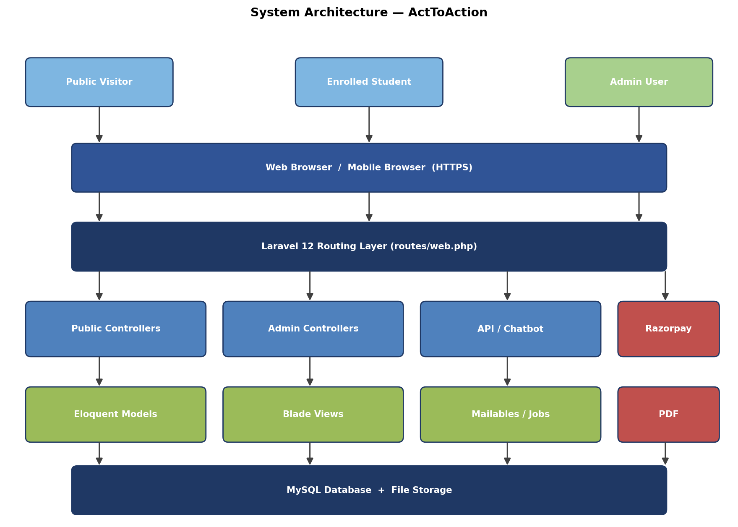
Figure 4.1 — High-level system architecture of ActToAction.
ActToAction follows a classic three-tier architecture. The presentation tier comprises Blade-rendered HTML pages (public and admin) and small fragments of JavaScript for interactive elements. The application tier is the Laravel framework: controllers, middleware, services, and Eloquent models. The data tier is MySQL, supplemented by file storage on disk for uploaded images and PDFs. Razorpay and the SMTP relay are external services accessed over HTTPS.
4.1 Data Flow Diagrams
Data Flow Diagrams (DFDs) describe how data moves through the system, from external entities into the application's processes and stores. ActToAction is documented at two levels of detail.
4.1.1 DFD Level 0 (Context Diagram)
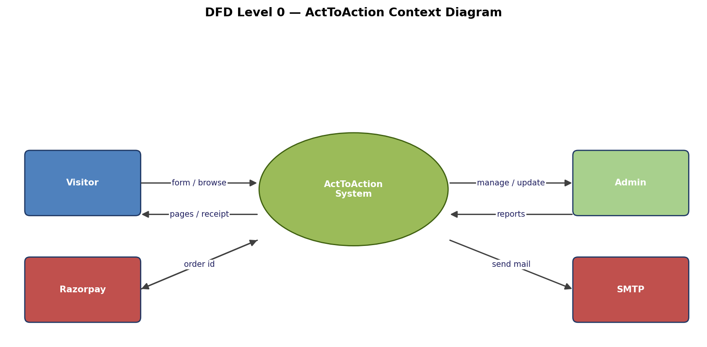
Figure 4.2 — DFD Level 0 (context diagram).
At the context level, ActToAction appears as a single process interacting with four external entities: visitors, admins, Razorpay, and the SMTP relay. Visitors send form submissions and browse pages; admins perform content management and report extraction; Razorpay verifies payments; and the SMTP relay delivers transactional emails on behalf of the platform.
4.1.2 DFD Level 1
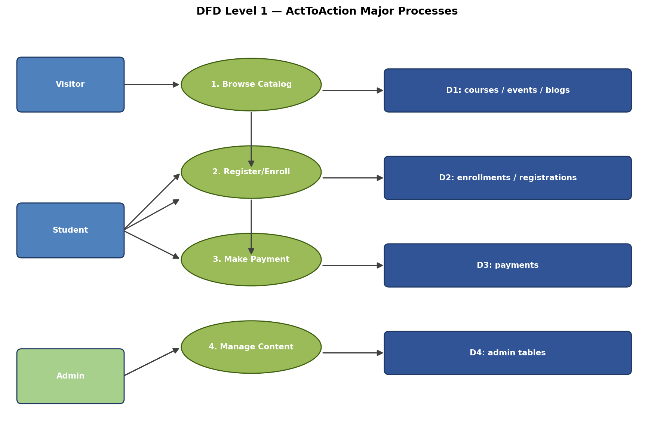
Figure 4.3 — DFD Level 1 expanding the major processes.
Decomposing the central process exposes four major sub-processes: browse catalogue, register/enrol, make payment, and manage content. Each sub-process is associated with one or more data stores: D1 (catalogue tables), D2 (registration tables), D3 (payments), and D4 (admin-managed content tables).
4.2 E-R Diagrams
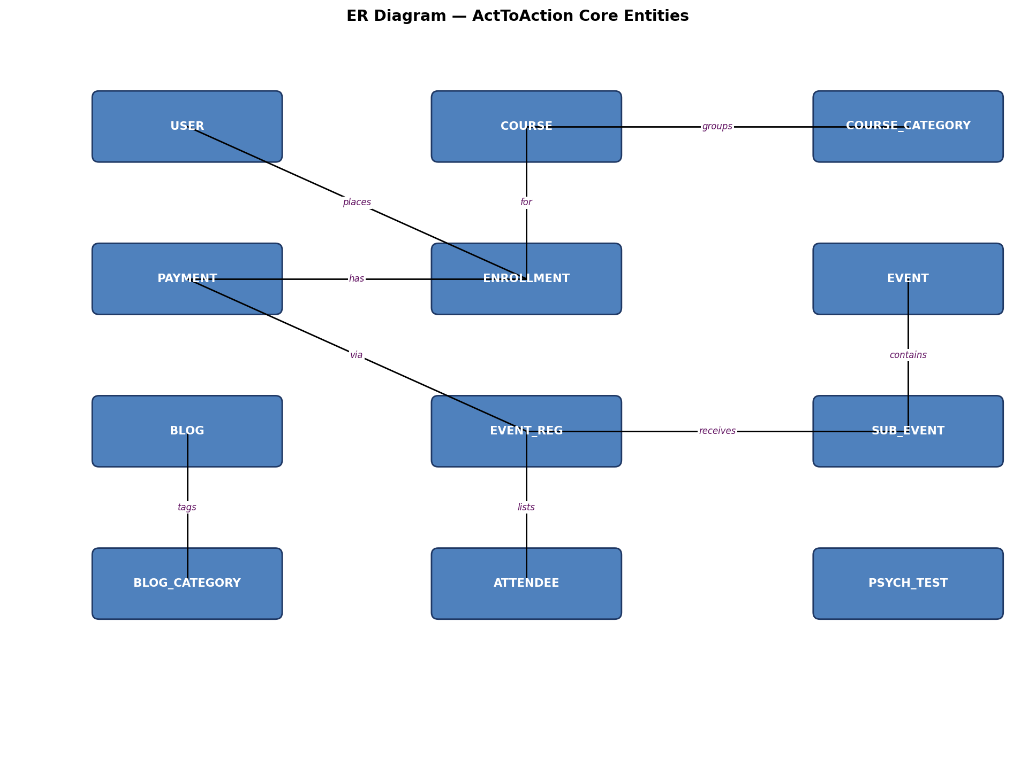
Figure 4.4 — Entity-Relationship diagram of the core entities.
The entity-relationship diagram captures the principal entities and the cardinalities between them. A USER places one or more ENROLLMENTs. Each ENROLLMENT is for one COURSE and is linked to exactly one PAYMENT. Each COURSE belongs to one COURSE_CATEGORY. An EVENT contains zero or more SUB_EVENTs. Each SUB_EVENT receives zero or more EVENT_REGs, and each EVENT_REG itself lists one or more ATTENDEEs. PAYMENT is the central financial entity, attaching to both ENROLLMENT and EVENT_REG (polymorphic in spirit, modelled here as nullable foreign keys). BLOGs belong to a BLOG_CATEGORY, and PSYCH_TESTs are independent of the transactional cluster but share user identity.
4.3 Use Case Diagrams
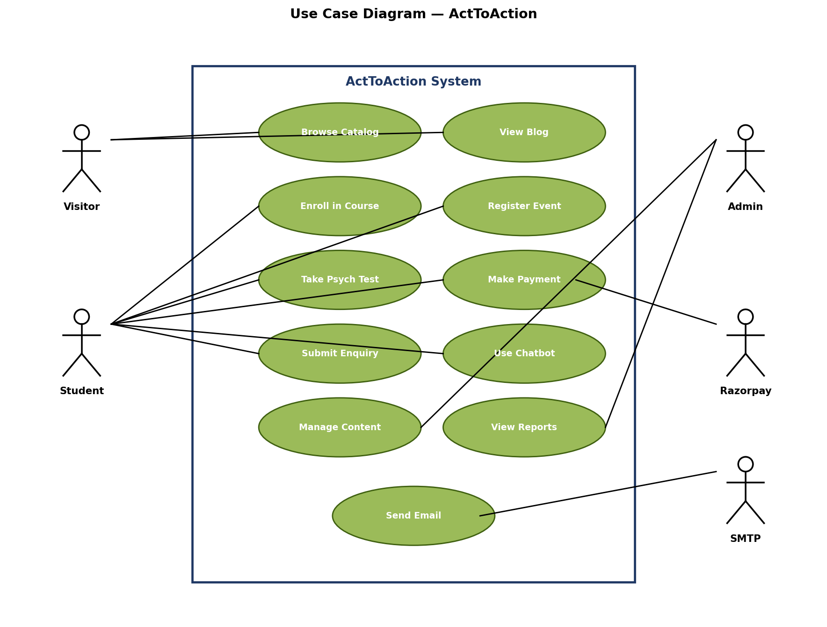
Figure 4.5 — Use case diagram showing actors and their interactions with the system.
The use case diagram identifies five actors and the specific interactions each actor has with the system. Visitors and Students drive most of the flow, with the Admin actor responsible for content management and reporting. Razorpay and SMTP appear as secondary (external) actors invoked by the system rather than by human users.
4.4 Flow Charts
Flowcharts depict the step-by-step control flow of the most important user journeys in the system. The seven flowcharts below cover the dominant transactional paths.
4.4.1 Admin Login Flow
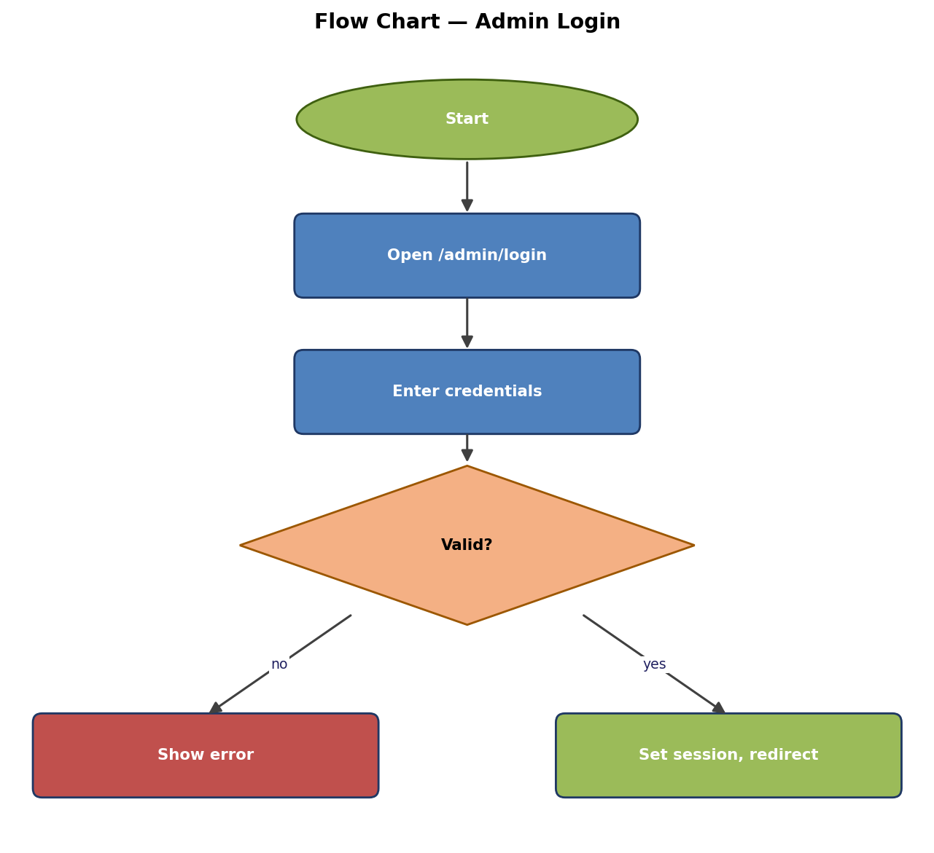
Figure 4.6 — Admin login flow.
4.4.2 Course Enrollment Flow
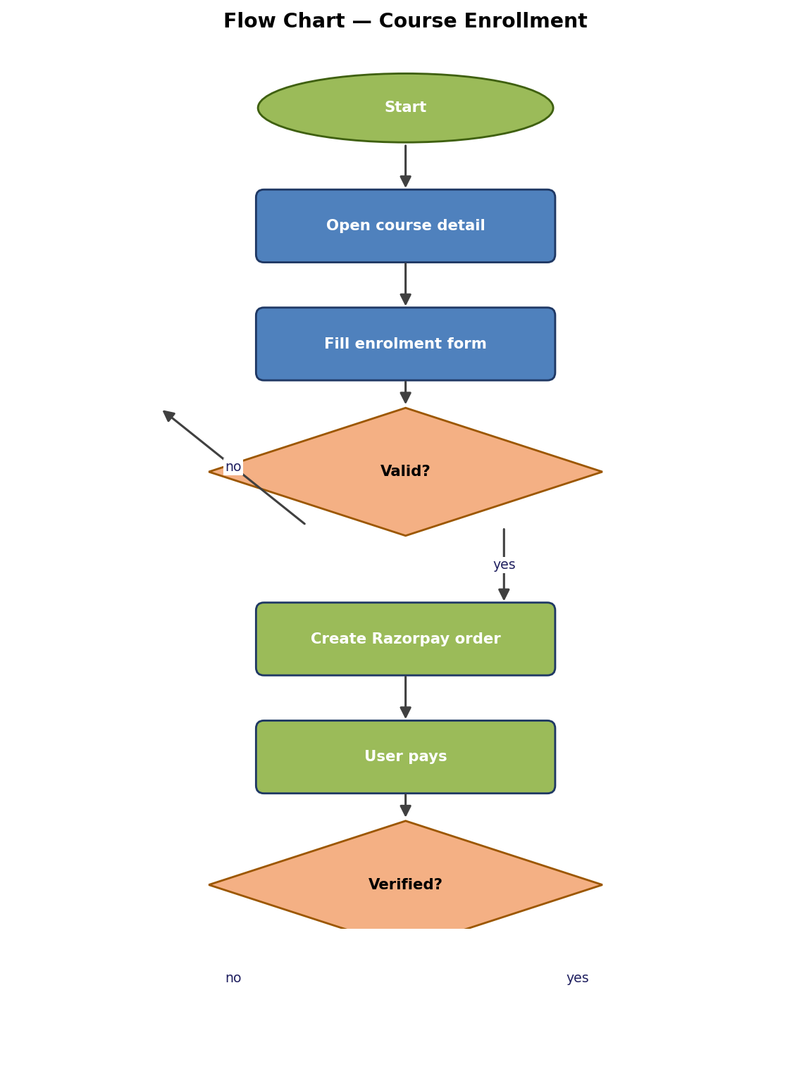
Figure 4.7 — Course enrollment flow with payment verification.
4.4.3 Event Registration Flow
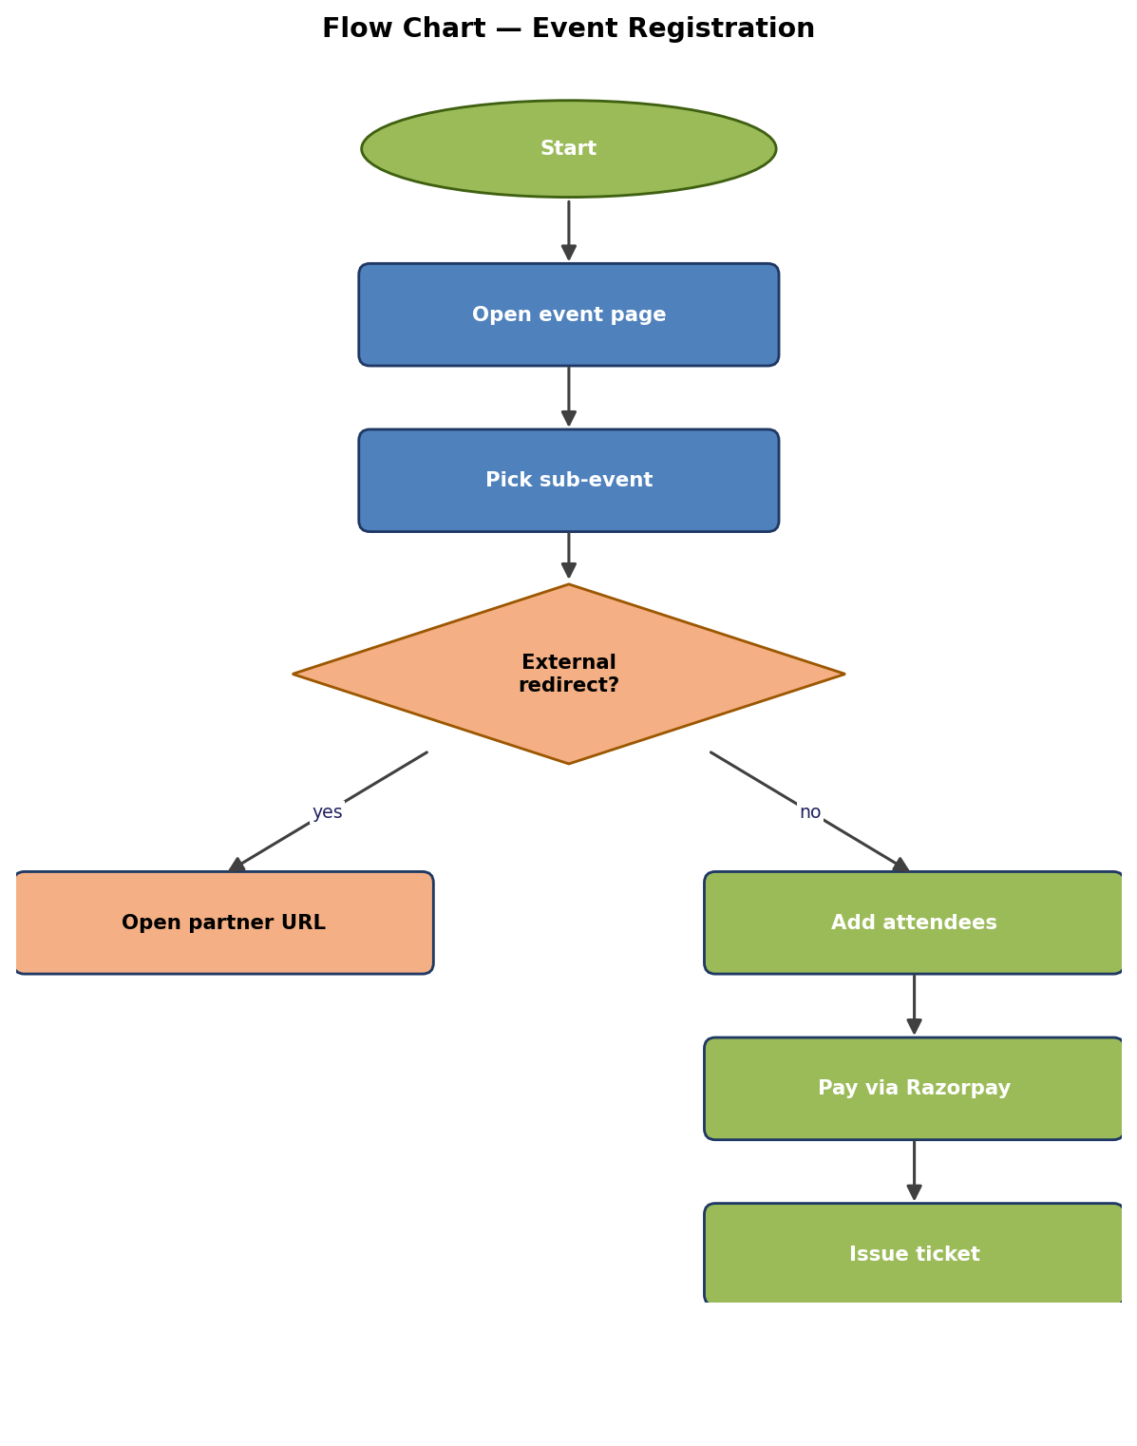
Figure 4.8 — Event registration with optional partner redirect.
4.4.4 Razorpay Payment Flow
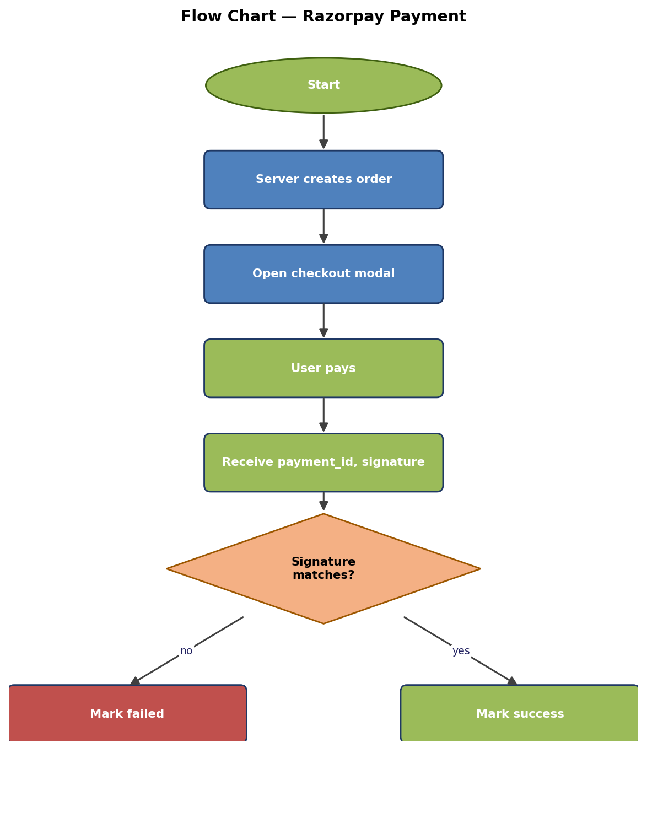
Figure 4.9 — End-to-end Razorpay payment flow.
4.4.5 Psychometric Test Flow
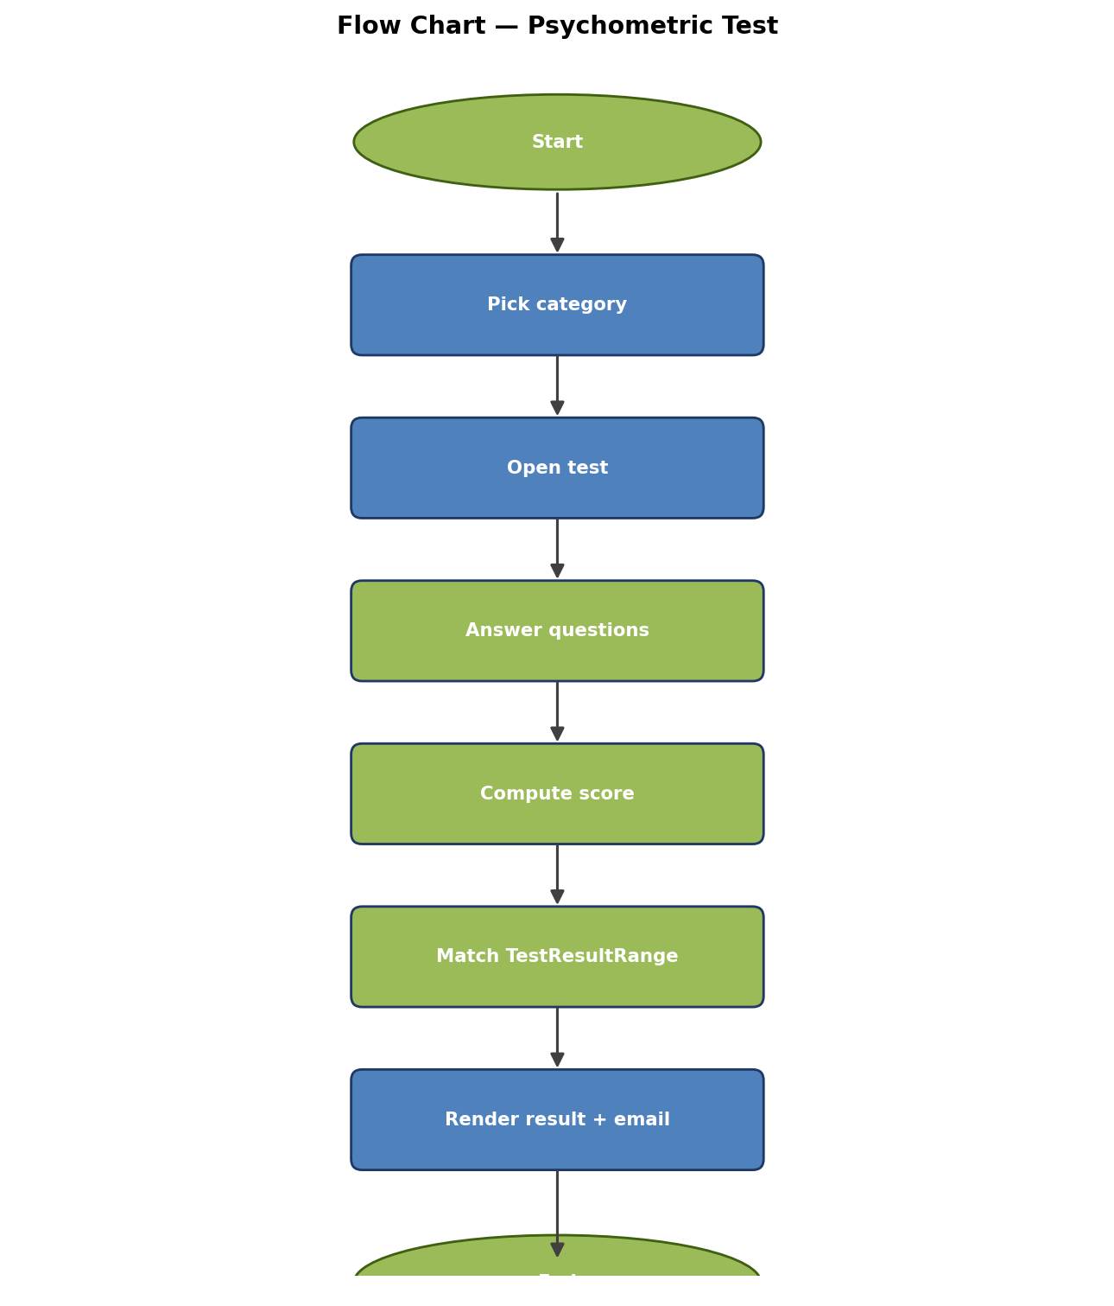
Figure 4.10 — Psychometric test administration flow.
4.4.6 Blog Publishing Flow
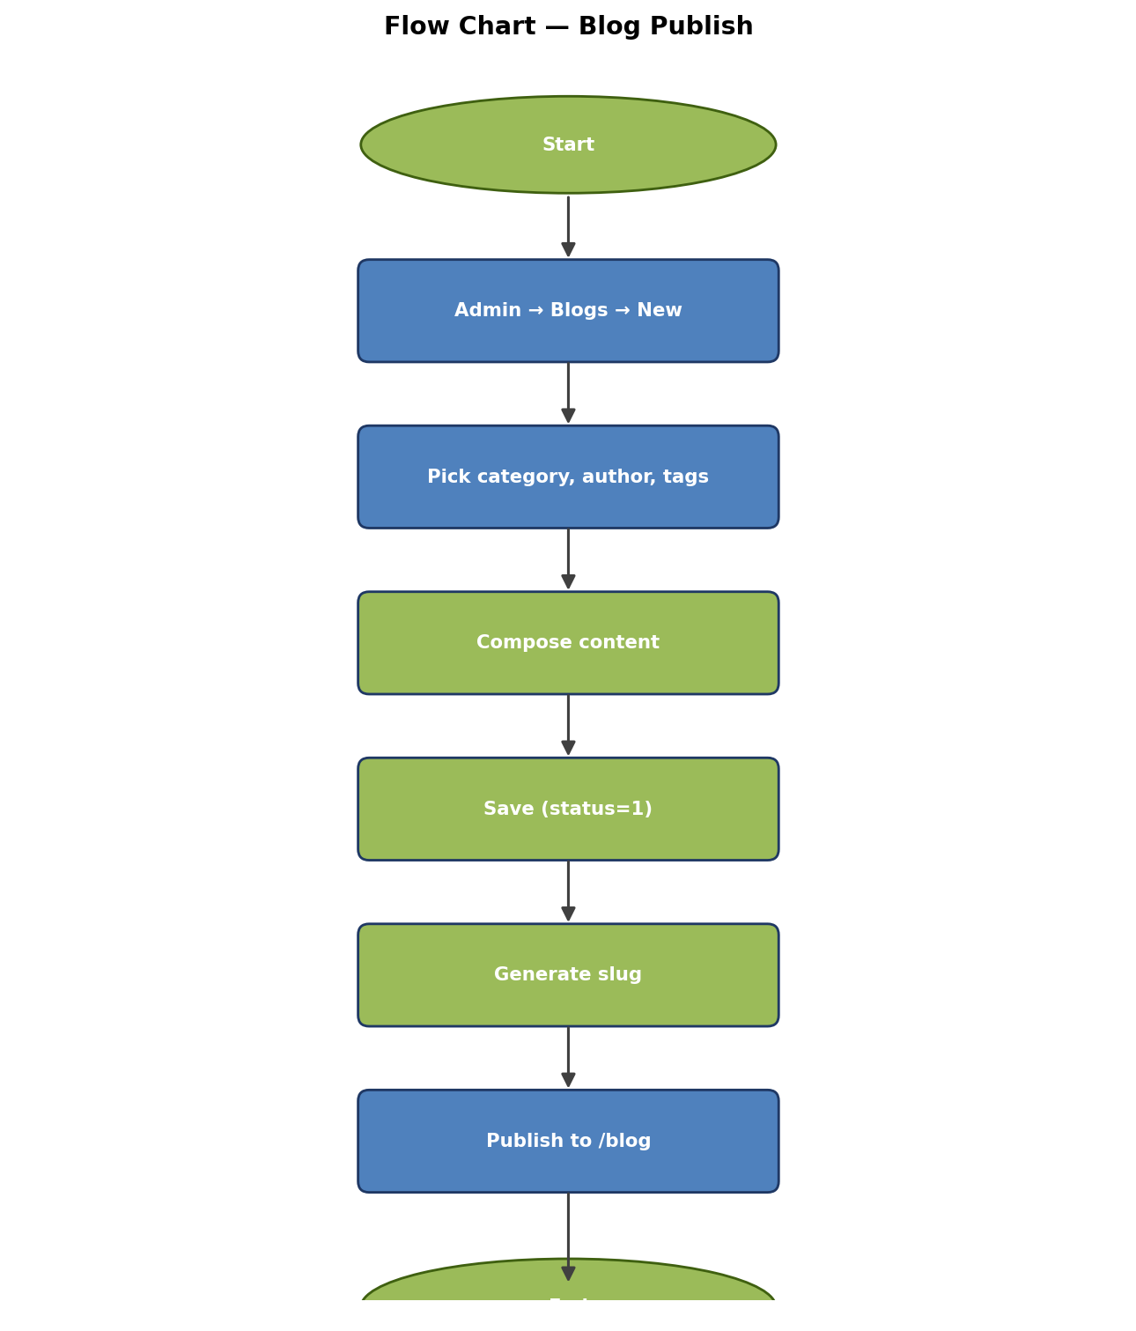
Figure 4.11 — Blog publishing flow.
4.4.7 Admission Form Flow
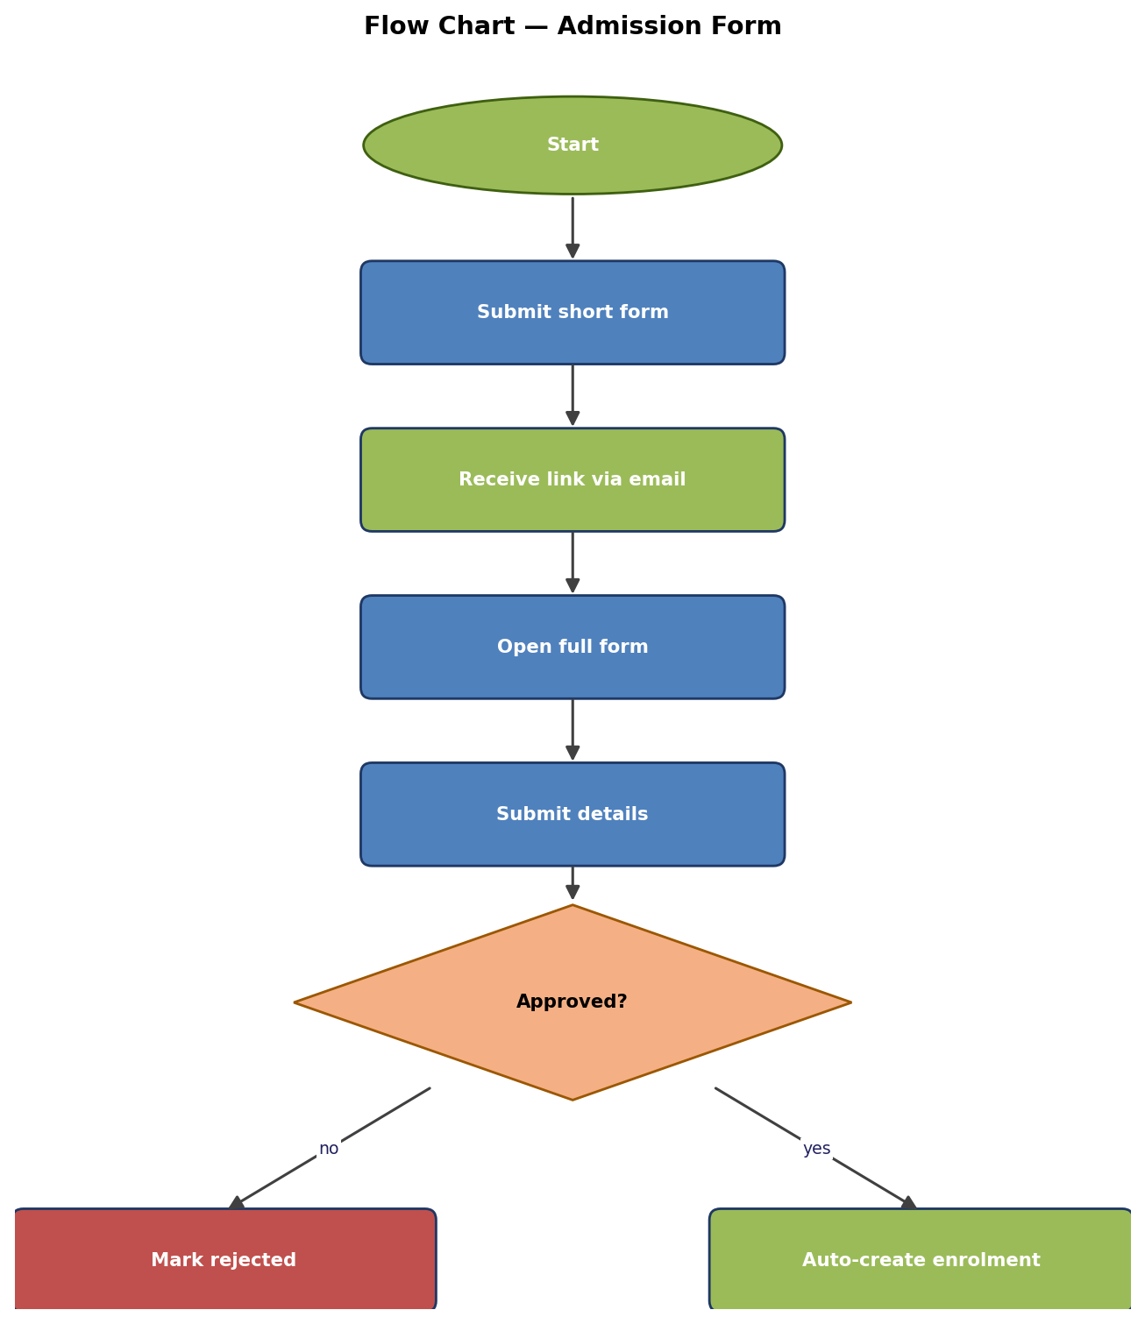
Figure 4.12 — Two-stage admission flow.
4.5 Database Tables
The ActToAction schema comprises more than eighty tables organised into ten functional clusters. The structures of the most important transactional tables are presented below; the full schema is reproduced in Appendix A of the codebase.
4.5.1 Table: courses
Field | Type | Constraints | Description
id | BIGINT | PK, AUTO_INCREMENT | Primary key
course_category_id | BIGINT | FK, NOT NULL | → course_categories.id
name | VARCHAR(255) | NOT NULL | Display name
slug | VARCHAR(255) | UNIQUE, NOT NULL | URL-safe identifier
short_description | TEXT | NULLABLE | Listing card copy
long_description | LONGTEXT | NULLABLE | Detail page copy
banner_image | VARCHAR(255) | NULLABLE | Path under public/img
fee | DECIMAL(10,2) | NULLABLE | Default fee
status | BOOLEAN | DEFAULT 1 | Visibility flag
created_at, updated_at | TIMESTAMP | Laravel defaults | Audit timestamps

4.5.2 Table: enrollments
Field | Type | Constraints | Description
id | BIGINT | PK | Primary key
course_id | BIGINT | FK | → courses.id
student_name | VARCHAR(255) | NOT NULL | Applicant name
age | INT | NULLABLE | Applicant age
parent_name | VARCHAR(255) | NULLABLE | Parent / guardian
mother_phone | VARCHAR(20) | NULLABLE | Mother's phone
phone | VARCHAR(20) | NOT NULL | Primary contact
email | VARCHAR(255) | NOT NULL | Email address
city | VARCHAR(100) | NULLABLE | City
status | ENUM | pending|confirmed|cancelled | Workflow status
created_at, updated_at | TIMESTAMP | Laravel defaults | Audit

4.5.3 Table: payments
Field | Type | Constraints | Description
id | BIGINT | PK | Primary key
enrollment_id | BIGINT | FK, NULLABLE | → enrollments.id
event_registration_id | BIGINT | FK, NULLABLE | → event_registrations.id
amount | DECIMAL(10,2) | NOT NULL | Amount in INR
razorpay_order_id | VARCHAR(50) | INDEX | Razorpay order id
razorpay_payment_id | VARCHAR(50) | UNIQUE | Razorpay payment id
razorpay_signature | VARCHAR(255) | NULLABLE | HMAC signature
status | ENUM | pending|success|failed|refunded | Payment status
created_at, updated_at | TIMESTAMP | Laravel defaults | Audit

4.5.4 Table: events and sub_events
Field | Type | Description
events.id | BIGINT PK | Primary key
events.title | VARCHAR(255) | Event title
events.slug | VARCHAR(255) UNIQUE | URL slug
events.start_date / end_date | DATE | Display window
events.banner_image | VARCHAR(255) | Hero image
events.status | BOOLEAN | Visibility
sub_events.id | BIGINT PK | Primary key
sub_events.event_id | BIGINT FK | → events.id
sub_events.title | VARCHAR(255) | Sub-event title
sub_events.fee | DECIMAL(10,2) | Per-attendee fee
sub_events.redirect_link | VARCHAR(500) | Optional partner URL

4.5.5 Table: blogs
Field | Type | Description
id | BIGINT PK | Primary key
blog_category_id | BIGINT FK | → blog_categories.id
blog_author_id | BIGINT FK | → blog_authors.id
title | VARCHAR(255) | Post title
slug | VARCHAR(255) UNIQUE | URL slug
excerpt | TEXT | Listing snippet
content | LONGTEXT | Body HTML
cover_image | VARCHAR(255) | Cover image path
social_embeds | JSON | List of embed snippets
status | BOOLEAN | Visibility

4.5.6 Table: psych_tests, psych_questions, test_result_ranges
Field | Type | Description
psych_tests.id | BIGINT PK | Test id
psych_tests.psych_category_id | BIGINT FK | Group
psych_tests.title | VARCHAR(255) | Title
psych_tests.slug | VARCHAR(255) UNIQUE | URL slug
psych_questions.id | BIGINT PK | Question id
psych_questions.psych_test_id | BIGINT FK | → psych_tests.id
psych_questions.text | TEXT | Question text
psych_questions.options | JSON | Options + weights
test_result_ranges.id | BIGINT PK | Range id
test_result_ranges.psych_test_id | BIGINT FK | → psych_tests.id
test_result_ranges.min_score | INT | Lower bound
test_result_ranges.max_score | INT | Upper bound
test_result_ranges.label | VARCHAR(255) | Result label
test_result_ranges.copy | TEXT | Interpretation

4.5.7 Table: email_templates and email_logs
Field | Type | Description
email_templates.id | BIGINT PK | Template id
email_templates.key | VARCHAR(100) UNIQUE | Code-side identifier
email_templates.subject | VARCHAR(255) | Email subject
email_templates.body | LONGTEXT | HTML body
email_templates.variables | JSON | Allowed merge variables
email_logs.id | BIGINT PK | Log id
email_logs.template_id | BIGINT FK | → email_templates.id
email_logs.recipient | VARCHAR(255) | Email address
email_logs.status | ENUM | queued|sent|failed
email_logs.error | TEXT | Last error
email_logs.sent_at | TIMESTAMP | Delivery time

4.6 Input / Output Forms
4.6.1 Input — Course Enrollment Form
Located at /courses/{slug} → Enrol Now. The form captures the student's name, age, parent's name, mother's phone, primary phone, email, and city. All required fields are marked with an asterisk; validation messages appear inline below each field. On submission, the data is POSTed to /enrollments/store and the user is forwarded to the Razorpay checkout modal.
4.6.2 Input — Event Registration Form
Located at /events/{slug}. Fields include lead applicant name, email, phone, and a dynamic attendees section where rows can be added or removed. The total fee updates live as attendees are added.
4.6.3 Input — Workshop Registration Form
Located at /workshops. Fields include the city, school, age group (each populated from the corresponding admin-managed table), participant name, parent contact, and an optional merchandise add-on.
4.6.4 Input — Admin Login Form
Located at /admin/login. Fields are email and password. On successful authentication the admin is redirected to /admin/dashboard.
4.6.5 Input — Admin Course Editor Form
Located at /admin/courses/{id}/edit. Fields cover category, name, slug, short and long descriptions, banner image, fees, and status. The form is multipart/form-data because it accepts an image upload.
4.6.6 Screenshot — Admin Login Page
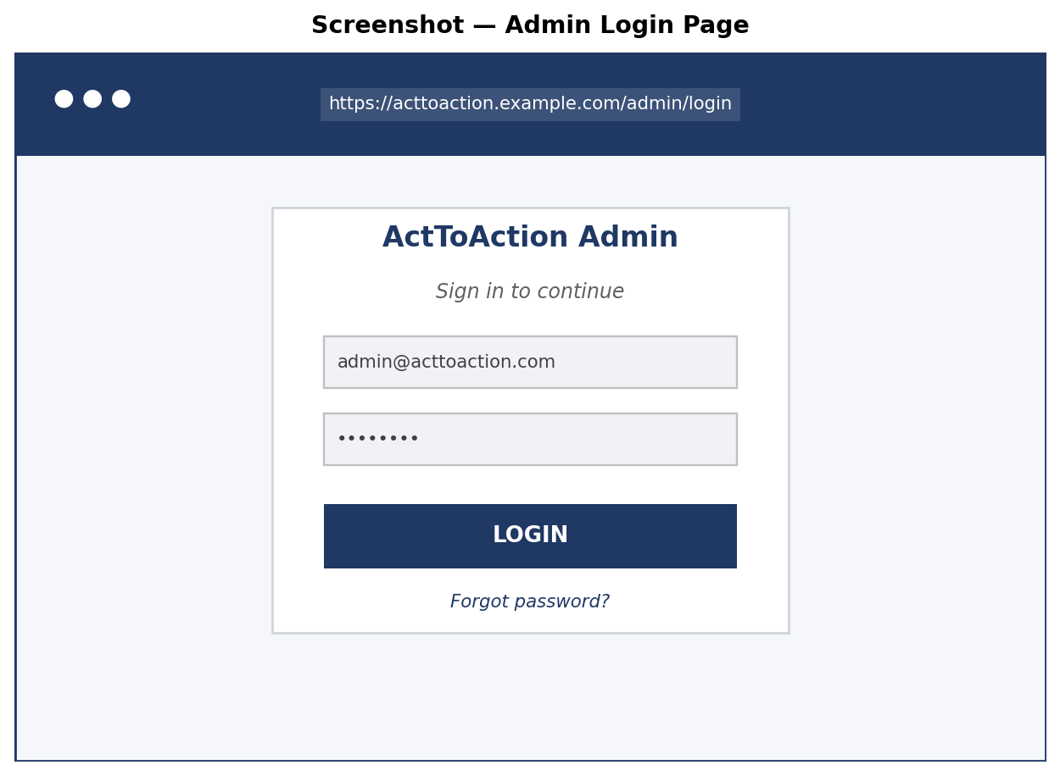
Figure 4.13 — Admin login page (mockup).
4.6.7 Screenshot — Admin Dashboard
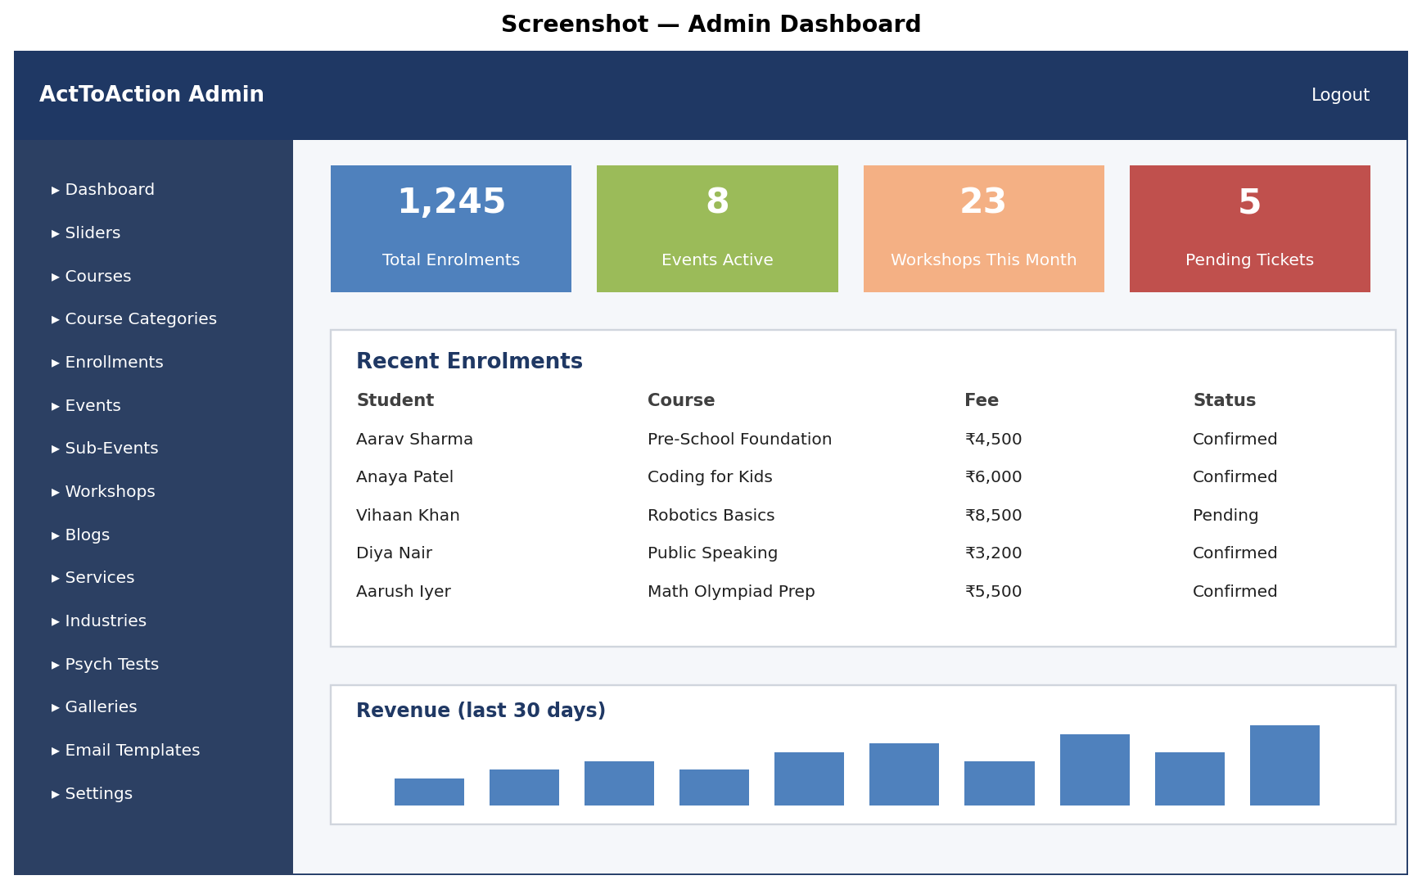
Figure 4.14 — Admin dashboard after successful login.
4.6.8 Screenshot — Course Edit Form
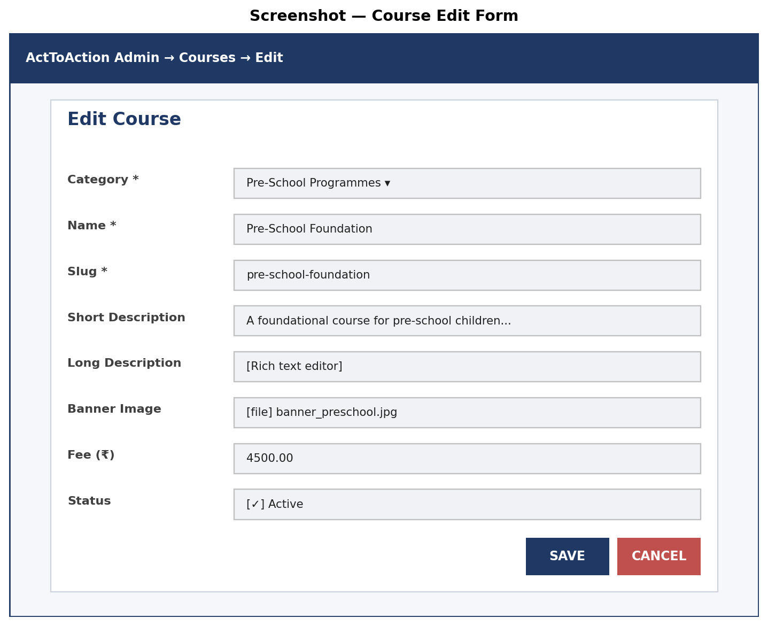
Figure 4.15 — Admin form for creating / editing a course.
4.6.9 Screenshot — Public Enrolment Form
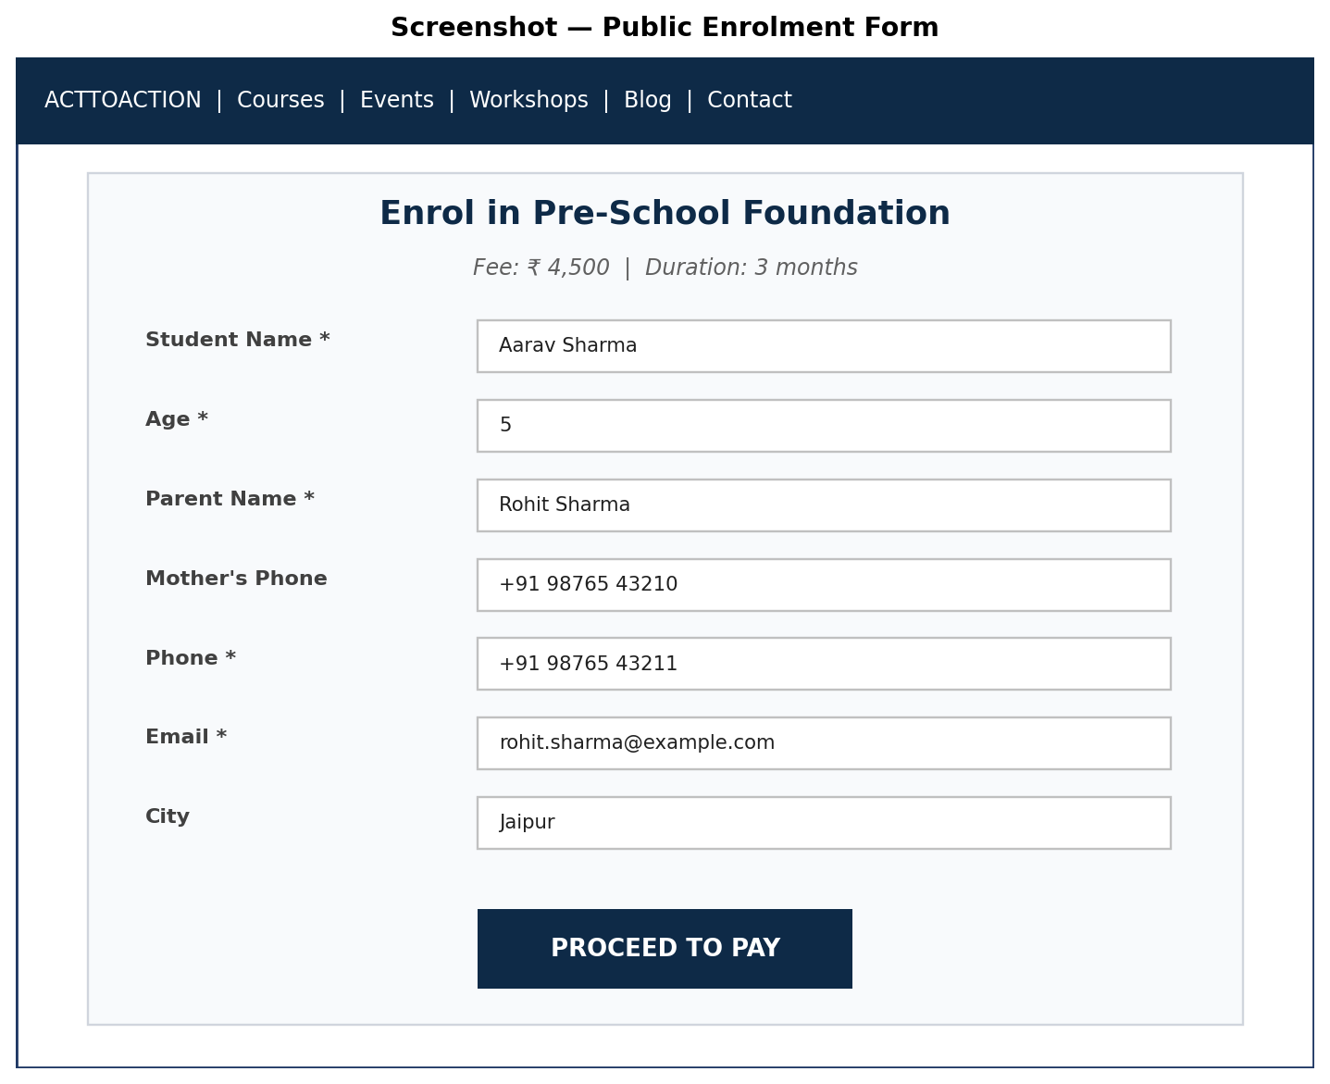
Figure 4.16 — Public-facing course enrolment form.
4.6.10 Screenshot — Admin Enrolment Listing
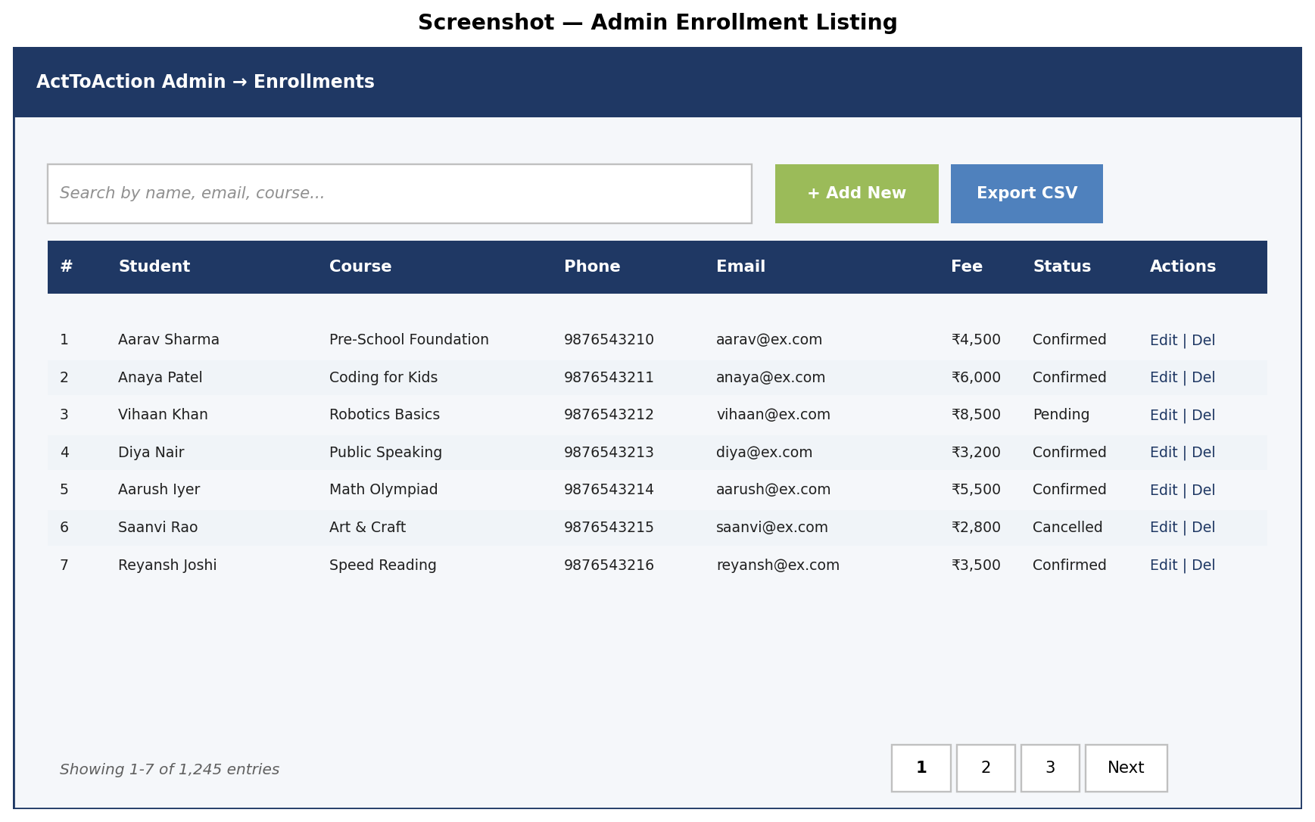
Figure 4.17 — Admin enrolment listing with search, filters, and pagination.
4.6.11 Sample PDF Receipt
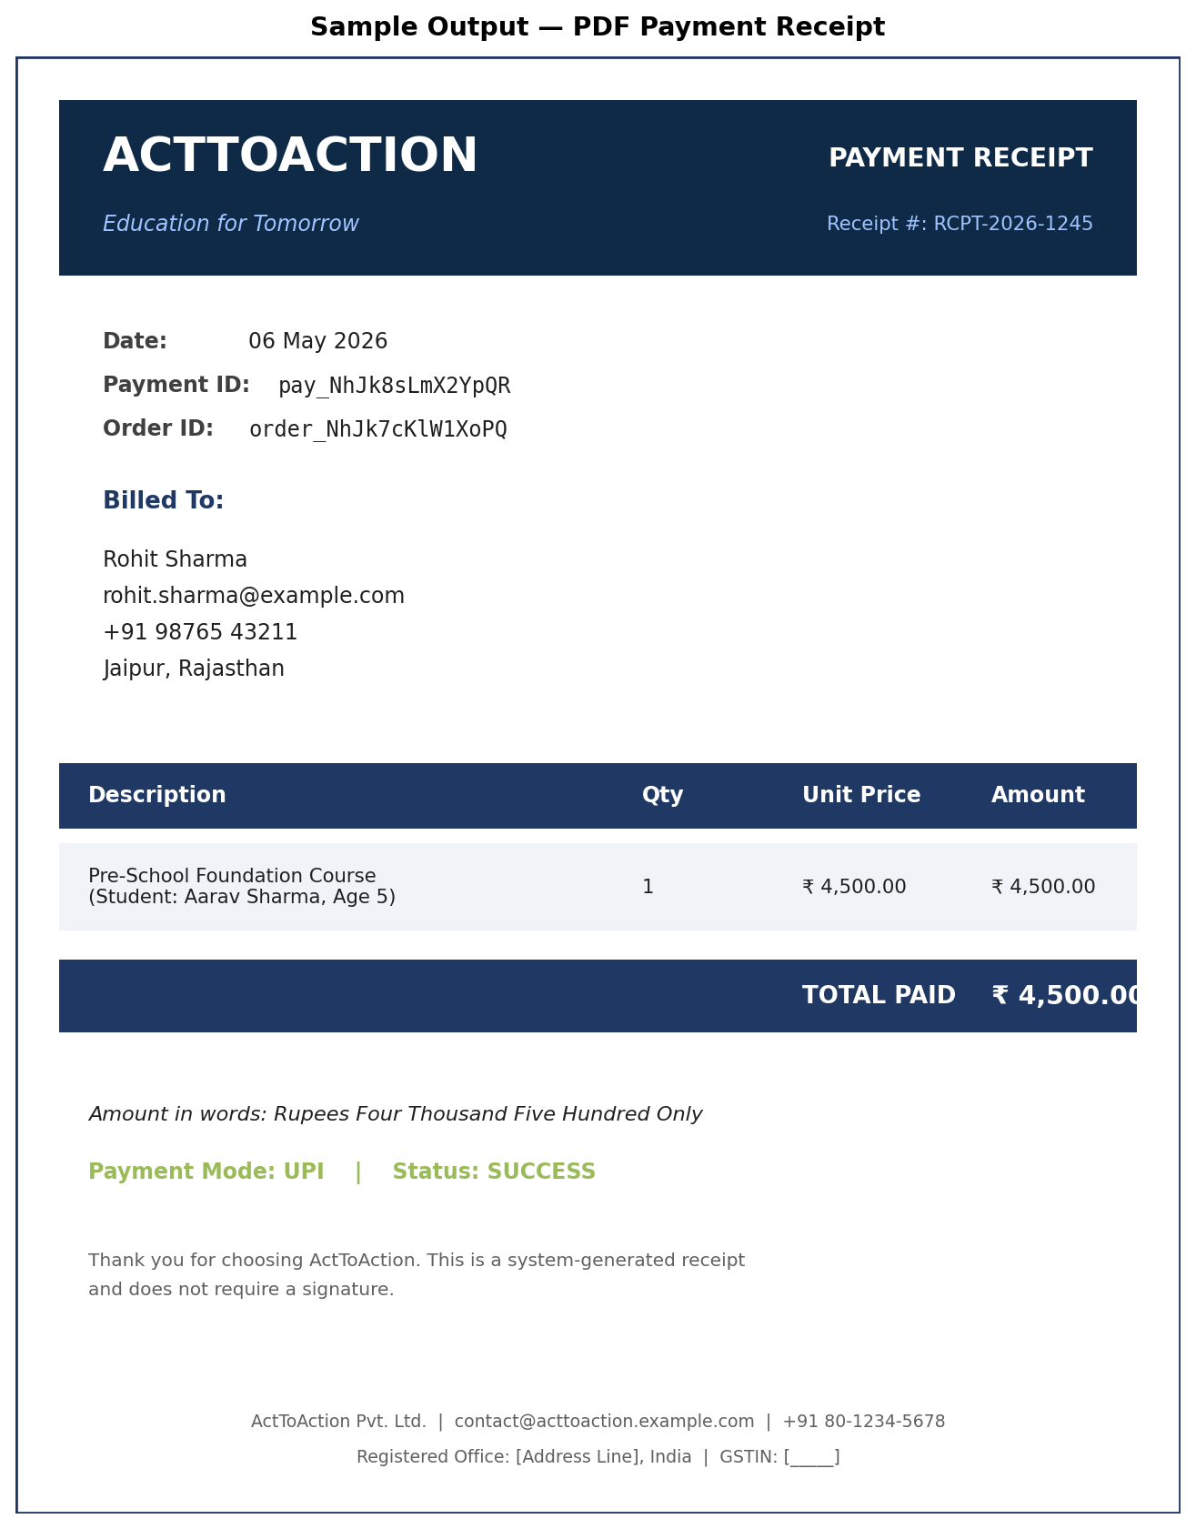
Figure 4.18 — Sample PDF receipt generated for a successful payment.
4.7 Real Site Imagery
The figures below reproduce a representative selection of imagery actually published on the ActToAction website. They illustrate the visual vocabulary that the design and content decisions of this project must accommodate.
Figure 4.25 — Skills notification banner artwork.
4.7.5 Team Photographs
The team-members module renders profile cards using uploaded headshots. The four representative profiles below show the standard 1:1 aspect ratio and circular crop applied at render time on the public site.

Figure 4.30 — Team profile photograph (member 1).

Figure 4.31 — Team profile photograph (member 2).

Figure 4.32 — Team profile photograph (member 3).

Figure 4.33 — Team profile photograph (member 4).
4.7.6 Additional Programme Imagery

Figure 4.34 — Programme activity photograph (gallery image 5).

Figure 4.35 — Programme activity photograph (gallery image 6).
4.7.7 Output — Confirmation Email
On a successful enrolment, the user receives an email with a subject like "Your enrolment in [Course Name] is confirmed". The body includes the student name, course name, fee paid, Razorpay payment id, and a PDF receipt as an attachment.
4.7.8 Output — PDF Receipt
Generated using barryvdh/laravel-dompdf. The receipt is one A4 page comprising the organisation logo, the receipt number, the date, the payer details, the line items, the total amount in words, and a footer with the registered office address.
4.7.9 Output — Admin Listing Page
Each module's index view renders a sortable, searchable, paginated table of records with action buttons (edit, toggle status, delete) and an export-to-CSV link.

CHAPTER 5: DEVELOPMENT
This chapter describes the development environment, coding style guidelines, the techniques applied during implementation, and representative code snippets that illustrate how the design was translated into running software.
5.1 Environment
5.1.1 Local Development Environment
- Operating System: Microsoft Windows 10 / 11.
- Local Stack: Laravel Herd (bundled PHP 8.2, MySQL, Node.js).
- IDE: Visual Studio Code with PHP Intelephense, Laravel Blade, and EditorConfig extensions.
- Version Control: Git with the project hosted on a private remote.
- Database GUI: TablePlus / phpMyAdmin for inspection and ad-hoc queries.
- API Testing: Postman / Insomnia for verifying chatbot and payment endpoints.
5.1.2 Production Environment
- Operating System: Ubuntu 22.04 LTS.
- Web Server: Nginx 1.22 reverse-proxying to PHP-FPM 8.2.
- Database: MySQL 8.0 on the same host (or a managed instance for larger deployments).
- Process Manager: systemd units for the queue worker and (optionally) Laravel scheduler.
- TLS: Let's Encrypt certificates auto-renewed via certbot.
5.1.3 Configuration
All environment-specific values (database credentials, mailer settings, Razorpay keys, application URL, queue connection) are read from a .env file at boot time. The .env file is excluded from version control; a .env.example committed alongside the code documents the required keys.
5.2 Coding Style
The project follows the PSR-12 PHP coding standard, supplemented by Laravel's own conventions. Laravel Pint is configured as the autoformatter; running php artisan pint normalises whitespace, import ordering, and brace placement.
5.2.1 Naming Conventions
- Classes use UpperCamelCase (e.g. CourseController, EnrollmentController).
- Methods and variables use lowerCamelCase (e.g. handlePayment, $courseId).
- Database columns use snake_case (e.g. course_category_id, created_at).
- Routes use lowercase-with-hyphens (e.g. /admin/blog-categories).
- Blade view files use snake_case (e.g. course_index.blade.php).
5.2.2 File Organisation
- Controllers grouped by area: App\Http\Controllers (public) and App\Http\Controllers\admin.
- Models in App\Models with one class per table.
- Views under resources/views with backend/ and frontend/ subtrees.
- Routes in routes/web.php organised top-down, public routes first then an admin route group.
- Migrations in database/migrations, named with timestamps for ordering.
5.2.3 Documentation
Class-level docblocks describe the responsibility of each controller and model. Method-level docblocks document parameters and return types where the type system alone is not expressive enough. Inline comments are reserved for non-obvious decisions; self-explanatory code is left to speak for itself.
5.3 Coding Techniques
5.3.1 MVC Separation
Controllers contain only the logic needed to translate HTTP requests into model operations and to choose a view or response. Business rules live in the models or in dedicated service classes when they cross multiple models. Views contain presentation logic only — no database queries.
5.3.2 Eloquent ORM
Each table has a corresponding Eloquent model. Mass assignment is restricted to fields explicitly listed in $fillable. Relationships are declared as methods returning hasMany, belongsTo, or belongsToMany. Eager loading via with() is used wherever a listing page accesses related data, to avoid N+1 query patterns.
5.3.3 Form Validation
Validation rules are declared at the top of each store/update method using $request->validate([...]). For complex forms the rules are extracted into a Form Request class so that they can be reused and unit-tested independently.
5.3.4 Middleware
Cross-cutting concerns such as authentication, CSRF protection, and request logging are implemented as middleware. The custom admin.auth middleware checks for an admin_id session value and redirects to /admin/login if absent.
5.3.5 Service Container & Dependency Injection
Controllers receive their dependencies (e.g. mailable factories, PDF generators) via constructor injection. The framework's service container resolves the dependencies automatically at runtime, simplifying testing and substitution.
5.3.6 Queue & Background Jobs
Slow operations such as email dispatch and PDF generation are pushed onto the queue and executed by a long-running queue worker. This keeps web requests responsive and isolates transient failures (SMTP unavailability, for instance) from the user-facing flow.
5.3.7 Database Migrations
Schema evolution is captured as a series of migration files. Each migration is small and focused — adding a column, creating a table, adding an index. New migrations are appended; existing migrations are never modified once committed.
5.4 Coding
Representative code snippets are reproduced below.
5.4.1 Course Model
namespace App\Models;
class Course extends Model {
protected $fillable = [
'course_category_id', 'name', 'slug',
'short_description', 'long_description',
'banner_image', 'fee', 'status',
];
public function category() {
return $this->belongsTo(CourseCategory::class, 'course_category_id');
}
public function enrollments() {
return $this->hasMany(Enrollment::class);
}
}
5.4.2 Enrollment Controller — store
public function store(Request $request) {
$data = $request->validate([
'course_id' => 'required|exists:courses,id',
'student_name' => 'required|string|max:255',
'phone' => 'required|string|max:20',
'email' => 'required|email|max:255',
]);
$enrollment = Enrollment::create($data + ['status' => 'pending']);
$order = $this->razorpay->order->create([
'amount' => $enrollment->course->fee * 100,
'currency' => 'INR',
'receipt' => 'enr_' . $enrollment->id,
]);
$enrollment->update(['razorpay_order_id' => $order->id]);
return view('frontend.enrollments.pay',
compact('enrollment', 'order'));
}
5.4.3 Razorpay Verification
public function verify(Request $request) {
$signature = hash_hmac('sha256',
$request->razorpay_order_id . '|' . $request->razorpay_payment_id,
config('services.razorpay.secret'));
if (!hash_equals($signature, $request->razorpay_signature)) {
abort(400, 'Signature mismatch');
}
Payment::create([
'enrollment_id' => $request->enrollment_id,
'razorpay_order_id' => $request->razorpay_order_id,
'razorpay_payment_id' => $request->razorpay_payment_id,
'razorpay_signature' => $request->razorpay_signature,
'amount' => $request->amount,
'status' => 'success',
]);
Enrollment::find($request->enrollment_id)
->update(['status' => 'confirmed']);
Mail::to($request->email)
->queue(new EnrollmentConfirmed($enrollment));
return redirect()->route('enrollment.success');
}
5.4.4 admin.auth Middleware
public function handle(Request $request, Closure $next) {
if (!session()->has('admin_id')) {
return redirect()->route('admin.login')
->with('intended', $request->fullUrl());
}
return $next($request);
}
5.4.5 Blog Controller — listing with eager loading
public function index(Request $request) {
$blogs = Blog::with(['category', 'author', 'tags'])
->where('status', 1)
->when($request->category,
fn($q) => $q->whereHas('category',
fn($c) => $c->where('slug', $request->category)))
->latest()
->paginate(12);
return view('frontend.blogs.index', compact('blogs'));
}

CHAPTER 6: TESTING
Testing was carried out at multiple levels — unit, integration, and user acceptance — to verify that each module behaves as specified and that the system as a whole satisfies the requirements captured in Chapter 3. This chapter outlines the testing strategy and reproduces a representative set of test cases.
6.1 Test Cases
Each test case below identifies a specific scenario, the inputs supplied, the expected output, and the observed result. The tests cover happy paths, validation failures, and edge cases across every major module.
6.1.1 Authentication
TC ID | Scenario | Input | Expected | Result
TC-A-01 | Valid admin login | Correct email + password | Redirect to /admin/dashboard | Pass
TC-A-02 | Wrong password | Correct email, wrong password | Show 'Invalid credentials' | Pass
TC-A-03 | Unknown email | Non-existent email | Show 'Invalid credentials' | Pass
TC-A-04 | Empty form | Blank email and password | Show 'required' errors | Pass
TC-A-05 | Direct access to /admin/courses | No active session | Redirect to /admin/login | Pass

6.1.2 Enrolment
TC ID | Scenario | Input | Expected | Result
TC-E-01 | Valid enrolment + payment | Complete form, successful Razorpay flow | Status confirmed, email sent | Pass
TC-E-02 | Missing email | Form without email | Inline 'required' error | Pass
TC-E-03 | Invalid email format | email = 'abc' | Inline 'email' error | Pass
TC-E-04 | Long phone with country code | phone = '+91 9876543210' | Accepted | Pass
TC-E-05 | Payment cancelled by user | User closes Razorpay modal | Status remains pending, retry banner shown | Pass
TC-E-06 | Tampered signature | Modified razorpay_signature in callback | HTTP 400 returned, status not updated | Pass

6.1.3 Event Registration
TC ID | Scenario | Input | Expected | Result
TC-V-01 | Single attendee | 1 attendee, valid data | Registration recorded, fee = 1× sub-event fee | Pass
TC-V-02 | Multiple attendees | 4 attendees | Fee = 4× sub-event fee | Pass
TC-V-03 | Sub-event with redirect_link | Click sub-event with external link | Redirect to partner URL | Pass
TC-V-04 | Attendee field missing | Empty attendee row submitted | Inline error | Pass

6.1.4 Workshop Registration
TC ID | Scenario | Input | Expected | Result
TC-W-01 | Valid registration | Active city + school | Registration saved, confirmation emailed | Pass
TC-W-02 | Inactive city | City with status=0 selected | Validation error | Pass
TC-W-03 | Optional merchandise | Add T-shirt | Stored on registration row | Pass

6.1.5 Psychometric Test
TC ID | Scenario | Input | Expected | Result
TC-P-01 | Submit answers | All questions answered | Score computed correctly, range matched | Pass
TC-P-02 | Score outside any range | Score not covered by any TestResultRange | Fallback message shown, alert logged | Pass
TC-P-03 | Skipped question | Required question left blank | Inline error | Pass
TC-P-04 | Graph rendering | TestGraphConfig active | Result page includes chart | Pass

6.1.6 Blog System
TC ID | Scenario | Input | Expected | Result
TC-B-01 | Publish blog | Valid title, slug, content | Post visible at /blog/{slug} | Pass
TC-B-02 | Duplicate slug | Slug already exists | Validation error | Pass
TC-B-03 | Tags syncing | Add 3 tags, save | blog_tag_pivot has 3 rows | Pass
TC-B-04 | Status toggle | Click eye icon | JSON success, post hidden | Pass

6.1.7 Email System
TC ID | Scenario | Input | Expected | Result
TC-M-01 | Template variables | Body uses {{name}} | Replaced at send time | Pass
TC-M-02 | SMTP failure | Mailer down | email_logs status=failed, error logged | Pass
TC-M-03 | Resend | Click Resend on failed log | New email_logs row created, sent successfully | Pass

6.1.8 Chatbot
TC ID | Scenario | Input | Expected | Result
TC-C-01 | Open widget | Visit any public page | Widget renders bottom-right | Pass
TC-C-02 | Fetch FAQs | GET /chatbot/faqs | JSON list returned | Pass
TC-C-03 | Submit support ticket | POST /chatbot/support | Row created, admin alert sent | Pass

6.1.9 Performance / Load
TC ID | Scenario | Input | Expected | Result
TC-L-01 | Catalogue under load | 100 concurrent users | P95 < 1.5s | Pass
TC-L-02 | Admin listing of 10k rows | Open /admin/enrollments | Render < 2s | Pass
TC-L-03 | Payment verify latency | Razorpay callback | Verify < 1s | Pass

CHAPTER 7: SYSTEM SECURITY
System security is essential because the platform stores personally identifiable information, accepts online payments, and exposes administrative functions. This chapter describes the checks and controls put in place and the encryption and secure practices applied across the codebase.
7.1 Checks and Control
7.1.1 Authentication Controls
- Admin authentication is required for every /admin/* route via the admin.auth middleware.
- Session cookies are flagged HttpOnly, Secure, and SameSite=Lax.
- Sessions expire after 120 minutes of inactivity.
- Logout invalidates the server-side session and clears the cookie.
7.1.2 Authorisation Controls
- Public controllers expose only read operations and form submissions; nothing requires authorisation.
- Admin controllers are gated by the admin.auth middleware uniformly.
- AJAX endpoints validate the CSRF token in addition to checking the session.
7.1.3 Input Validation
- Every form runs server-side validation via $request->validate(...).
- Fields are type-cast to integers, strings, decimals, or booleans before persisting.
- Email and phone fields use Laravel's built-in validation rules.
- Image uploads are validated for content type, file size, and dimensions.
7.1.4 Output Escaping
- Blade templates use {{ }} which auto-escapes output, preventing XSS by default.
- Raw HTML output via {!! !!} is restricted to admin-trusted content (blog body, social embeds).
- All file paths shown in URLs are validated against an allow-list of directories.
7.1.5 CSRF Protection
Every state-changing form (POST, PUT, PATCH, DELETE) includes a CSRF token via the @csrf Blade directive. AJAX requests send the token in the X-CSRF-TOKEN header. Laravel's VerifyCsrfToken middleware rejects requests with an absent or mismatched token.
7.1.6 SQL Injection Prevention
All database access goes through Eloquent or the Query Builder, both of which use parameterised queries. There are no raw SQL concatenations in the codebase.
7.1.7 Brute-Force Protection
The admin login is rate-limited to five attempts per minute per IP address using Laravel's throttle middleware. After five consecutive failures the IP is blocked for sixty seconds.
7.2 Encryption and Secure Practices
7.2.1 Transport Layer Security
All HTTP traffic is forced to HTTPS via a server-level redirect from port 80 to port 443. The TLS certificate is provisioned by Let's Encrypt and renewed automatically. HSTS is enabled with a six-month max-age once the certificate is stable.
7.2.2 Password Hashing
Passwords are hashed using bcrypt with the default cost factor of 10. Hashes are stored in the admins.password column. Plain-text passwords never touch the database or the logs.
7.2.3 Application Encryption Key
Laravel's APP_KEY is a 32-byte AES-256 key generated by php artisan key:generate at deploy time. The key encrypts session cookies, signed URLs, and any payload encrypted via the Crypt facade.
7.2.4 Razorpay Signature Verification
Every payment callback recomputes the HMAC-SHA256 signature from order_id|payment_id using the server-side Razorpay secret. Comparison uses hash_equals to avoid timing attacks. Mismatches are rejected with HTTP 400 and logged for fraud investigation.
7.2.5 Secrets Management
- Razorpay key/secret pairs, mailer credentials, and database passwords live in .env, not in version control.
- .env is mode 600 owned by the deploy user.
- Production .env is generated from a vault during deployment, never copied between environments by hand.
7.2.6 Audit & Logging
- Application logs go to storage/logs/laravel.log with daily rotation.
- email_logs records every dispatched email with status and error text.
- Web server access logs are retained for 30 days.
- Failed admin logins are logged with the source IP for review.
7.2.7 Backup & Recovery
- MySQL is backed up nightly via mysqldump piped to gzip and uploaded to off-site storage.
- Backups are encrypted at rest using GPG with a key held by the operations team.
- Recovery drills are run quarterly to validate the restore procedure.

CHAPTER 8: CONCLUSION / FUTURE ENHANCEMENT
8.1 Conclusion
The ActToAction project demonstrates that a single, well-designed Laravel application can replace a fragmented landscape of third-party tools, manual spreadsheets, and ad-hoc payment links. By bringing courses, events, workshops, blogs, services, industries, psychometric tests, and online payments under one roof, the platform delivers measurable benefits to every stakeholder group: visitors get a consistent and reliable experience; operational staff get a single workspace; finance gets real-time payment reconciliation; and the engineering team gets a predictable, conventional codebase that is easy to extend.
The project also reinforced several engineering lessons. The first is that opinionated frameworks pay off — Laravel's conventions allowed dozens of CRUD modules to be implemented with minimal incidental complexity. The second is that configuration-driven design (templates, test ranges, content categories) enables a small engineering team to support a much larger operations team without becoming a bottleneck. The third is that early investment in payment-signature verification and email logging pays off in long-term confidence: every rupee is accounted for, and every dispatched message is traceable.
From a personal standpoint, the project provided hands-on exposure to the full lifecycle of a non-trivial web application — from requirements gathering through database design, implementation, testing, and deployment. The experience of shipping software that real users depend on, and that handles real money, is qualitatively different from coursework exercises and is the most valuable outcome of the project.
8.2 Future Enhancements
8.2.1 Near-Term Enhancements
- Multi-factor authentication for admin accounts, using TOTP or magic links.
- Activity logging (who-changed-what) using spatie/laravel-activitylog.
- Capacity enforcement on sub-events and workshops.
- In-app refund flow that talks to Razorpay's refund API.
- Bulk import of school and city lists via CSV upload.
8.2.2 Mid-Term Enhancements
- Role-based access control to support distinct admin personas (editor, finance, super-admin).
- Structured data (schema.org) for events and courses to improve organic search visibility.
- Internationalisation — Hindi and selected regional languages for the public site.
- PWA-style installable experience for students.
- Automated revenue and attendance dashboards using Filament or similar.
8.2.3 Long-Term Enhancements
- Native mobile applications (iOS and Android) backed by a versioned REST API.
- Headless front-end for the marketing site (Inertia + Vue/React).
- Real-time notifications via WebSockets (Laravel Reverb / Pusher) for ticketing and chat.
- Machine-learning-based recommendations on the catalogue.
- Multi-tenant capability so franchise partners can have their own scoped admin area.

CHAPTER 9: BIBLIOGRAPHY
9.1 Books
- Otwell, T. (2024). Laravel: Up and Running, 3rd Edition. O'Reilly Media.
- Pratt, P. J., & Last, M. Z. (2014). Concepts of Database Management, 8th Edition. Cengage Learning.
- Pressman, R. S., & Maxim, B. R. (2019). Software Engineering: A Practitioner's Approach, 9th Edition. McGraw-Hill.
- Sommerville, I. (2015). Software Engineering, 10th Edition. Pearson.
- Stauffer, M. (2023). Laravel: Up & Running. O'Reilly Media.
- Welling, L., & Thomson, L. (2017). PHP and MySQL Web Development, 5th Edition. Addison-Wesley.
9.2 Online Resources
- Laravel Documentation — https://laravel.com/docs
- PHP Manual — https://www.php.net/manual/en/
- MySQL 8.0 Reference Manual — https://dev.mysql.com/doc/refman/8.0/en/
- Razorpay PHP SDK — https://github.com/razorpay/razorpay-php
- Razorpay Web Integration — https://razorpay.com/docs/payments/payment-gateway/web-integration/
- OWASP Top Ten — https://owasp.org/www-project-top-ten/
- PSR-12 PHP Coding Standard — https://www.php-fig.org/psr/psr-12/
- MDN Web Docs — https://developer.mozilla.org/
9.3 Standards
- ISO/IEC 25010:2011 — Systems and software Quality Requirements and Evaluation.
- IEEE 830-1998 — Recommended Practice for Software Requirements Specifications.
- OWASP Application Security Verification Standard (ASVS) v4.
APPENDIX A: PROJECT SCHEDULE
The project was executed over a fourteen-week schedule. The Gantt chart below illustrates the major phases, their duration, and the parallel tracks that ran concurrently during the busiest weeks.
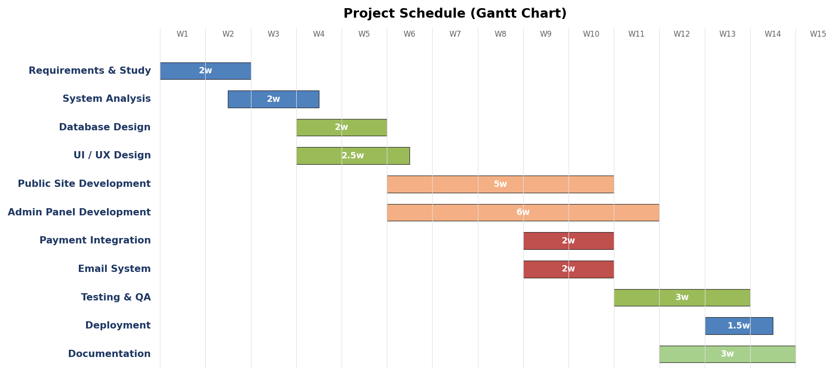
Figure A.1 — Project schedule (Gantt chart).
A.1 Phase-Wise Effort Distribution
Phase | Duration | Effort (person-days) | Deliverables
Requirements & Study | Weeks 1-2 | 8 | Requirements doc, stakeholder map
System Analysis | Weeks 2-3 | 8 | Functional & non-functional spec
Database Design | Weeks 3-4 | 6 | ER diagram, migrations
UI / UX Design | Weeks 3-5 | 10 | Wireframes, mockups
Public Site Development | Weeks 5-9 | 20 | All public controllers + views
Admin Panel Development | Weeks 5-10 | 30 | 40+ CRUD modules
Payment Integration | Weeks 8-9 | 5 | Razorpay end-to-end
Email System | Weeks 8-9 | 4 | Templates + logs
Testing & QA | Weeks 10-12 | 10 | Test cases, bug fixes
Deployment | Week 12-13 | 3 | Staging + production live
Documentation | Weeks 11-13 | 8 | User manual + this report

Total estimated effort: 112 person-days, executed by a two-person development team supplemented by part-time review by the project guide.

APPENDIX B: SAMPLE REPORTS
B.1 Daily Enrolment Report
The daily enrolment report is generated by the operations team every morning. It lists all enrolments confirmed in the past 24 hours along with payment details. A representative report is reproduced below.
Date | Course | Student | Fee | Mode | Status
06-May-2026 09:14 | Pre-School Foundation | Aarav Sharma | ₹4,500 | UPI | Confirmed
06-May-2026 10:32 | Coding for Kids | Anaya Patel | ₹6,000 | Card | Confirmed
06-May-2026 11:50 | Robotics Basics | Vihaan Khan | ₹8,500 | UPI | Pending
06-May-2026 12:18 | Public Speaking | Diya Nair | ₹3,200 | NetBanking | Confirmed
06-May-2026 14:05 | Math Olympiad Prep | Aarush Iyer | ₹5,500 | UPI | Confirmed
06-May-2026 15:33 | Speed Reading | Reyansh Joshi | ₹3,500 | Card | Confirmed

Total enrolments in 24h: 6 | Confirmed: 5 | Pending: 1 | Revenue (confirmed): ₹ 22,700.
B.2 Weekly Workshop Attendance Summary
City | School | Workshop | Registered | Attended | %
Jaipur | DPS Jaipur | Robotics Day | 45 | 42 | 93%
Jaipur | St Xavier's | Art & Craft | 38 | 35 | 92%
Udaipur | MGD School | Coding Basics | 30 | 28 | 93%
Kota | Allen Career | Math Genius | 55 | 50 | 91%
Ajmer | Mayoor School | Speed Reading | 22 | 20 | 91%
Jodhpur | Rajmata Krishna Kumari | Public Speaking | 18 | 17 | 94%

Total registered: 208 | Total attended: 192 | Attendance rate: 92.3%.
B.3 Monthly Revenue Report
Month | Enrolments | Event Reg. | Workshop Reg. | Total Revenue
Jan 2026 | 82 | 145 | 210 | ₹ 8,45,000
Feb 2026 | 78 | 168 | 195 | ₹ 8,72,000
Mar 2026 | 112 | 210 | 245 | ₹ 11,40,000
Apr 2026 | 98 | 185 | 228 | ₹ 9,85,000
May 2026 (MTD) | 45 | 67 | 82 | ₹ 4,12,000

Year-to-date revenue (Jan – May 2026): ₹ 42,54,000.
B.4 Email Delivery Report
Template | Sent | Failed | Success Rate
Enrolment Confirmation | 1,245 | 8 | 99.36%
Event Ticket | 823 | 6 | 99.27%
Workshop Confirmation | 960 | 5 | 99.48%
Admission Full-Form Link | 412 | 11 | 97.33%
Volunteer Welcome | 85 | 1 | 98.82%
Newsletter (April) | 12,400 | 98 | 99.21%

Total emails dispatched (rolling 30 days): 15,925 | Overall success rate: 99.18%.

APPENDIX C: LIST OF ABBREVIATIONS
Abbreviation | Expansion
AJAX | Asynchronous JavaScript and XML
API | Application Programming Interface
CRUD | Create, Read, Update, Delete
CSRF | Cross-Site Request Forgery
CSS | Cascading Style Sheets
DBMS | Database Management System
DFD | Data Flow Diagram
DOM | Document Object Model
ERD | Entity-Relationship Diagram
FK | Foreign Key
GUI | Graphical User Interface
HMAC | Hash-based Message Authentication Code
HTML | HyperText Markup Language
HTTP | HyperText Transfer Protocol
HTTPS | HyperText Transfer Protocol Secure
IDE | Integrated Development Environment
JSON | JavaScript Object Notation
LMS | Learning Management System
MCA | Master of Computer Applications
MFA | Multi-Factor Authentication
MVC | Model-View-Controller
ORM | Object-Relational Mapping
OWASP | Open Web Application Security Project
PCI-DSS | Payment Card Industry Data Security Standard
PDF | Portable Document Format
PHP | Hypertext Preprocessor
PK | Primary Key
PSR | PHP Standards Recommendation
QA | Quality Assurance
RBAC | Role-Based Access Control
REST | REpresentational State Transfer
RTU | Rajasthan Technical University
SDK | Software Development Kit
SEO | Search Engine Optimization
SMTP | Simple Mail Transfer Protocol
SPDI | Sensitive Personal Data or Information
SQL | Structured Query Language
SSL | Secure Sockets Layer
TLS | Transport Layer Security
TOTP | Time-based One-Time Password
UI / UX | User Interface / User Experience
UPI | Unified Payments Interface
URL | Uniform Resource Locator
UUID | Universally Unique Identifier
WYSIWYG | What You See Is What You Get
XSS | Cross-Site Scripting

APPENDIX D: COMPLETE LIST OF DATABASE TABLES
The full database schema spans more than eighty tables. They are listed below by functional cluster for quick reference.
D.1 Identity & Settings
- users
- password_reset_tokens
- sessions
- settings
- themes
D.2 Marketing Surface
- sliders
- hero_banners
- announcement_bars
- notification_banners
- stats
- brands
- testimonials
- testimonial_videos
D.3 Education Domain
- course_categories
- courses
- course_documents
- course_sessions
- enrollments
- admission_short_forms
- admission_full_forms
- people
- team_members
D.4 Events
- events
- sub_events
- event_registrations
- event_registration_attendees
D.5 Workshops
- workshop_cities
- workshop_schools
- workshop_age_groups
- workshop_registrations
D.6 Content
- blogs
- blog_categories
- blog_authors
- blog_tags
- blog_tag_pivot
- abouts
- about_categories
- about_sections
- page_categories
D.7 Services & Industries
- service_categories
- service_subcategories
- services
- service_features
- service_benefits
- service_essentials
- service_faqs
- industries
- industry_services
- industry_features
- industry_faqs
D.8 Psychometric Tests
- psych_categories
- psych_tests
- psych_questions
- test_result_ranges
- test_graph_configs
D.9 Galleries & Media
- gallery_categories
- galleries
- gallery_images
- video_galleries
- youtube_categories
- youtube_videos
D.10 Operations
- payments
- email_templates
- email_logs
- newsletters
- chatbot_faqs
- chatbot_support_tickets
- contacts
- contact_infos
- frontend_contact_us
- centers
- states
- merchandises
- volunteers
- franchise_forms
- become_partners
- school_partners
- school_partner_categories
- school_sections
- summer_partners
- summer_partner_categories
- action_items

APPENDIX E: SAMPLE TEST DATA
The data below was used during development and quality assurance to validate the system end-to-end. None of the personal details correspond to real individuals.
E.1 Sample Course Records
ID | Category | Name | Slug | Fee | Status
1 | Pre-School | Pre-School Foundation | pre-school-foundation | ₹4500 | Active
2 | Coding | Coding for Kids | coding-for-kids | ₹6000 | Active
3 | STEM | Robotics Basics | robotics-basics | ₹8500 | Active
4 | Soft Skills | Public Speaking | public-speaking | ₹3200 | Active
5 | Academics | Math Olympiad Prep | math-olympiad-prep | ₹5500 | Active
6 | Arts | Art & Craft Mastery | art-craft-mastery | ₹2800 | Active
7 | Soft Skills | Speed Reading | speed-reading | ₹3500 | Active
8 | Coding | Web Development for Teens | webdev-teens | ₹9500 | Inactive

E.2 Sample Event Records
ID | Title | Slug | Start Date | Status
1 | Annual Quiz Competition 2026 | annual-quiz-2026 | 12-Jun-2026 | Active
2 | Robotics Carnival | robotics-carnival | 20-Jul-2026 | Active
3 | Summer Coding Bootcamp | summer-coding-2026 | 01-Jun-2026 | Active
4 | Art Festival | art-festival-2026 | 15-Aug-2026 | Active

E.3 Sample Sub-Event Records
ID | Event | Title | Fee | Date
1 | Annual Quiz | Junior Round (Class 1-3) | ₹250 | 12-Jun-2026
2 | Annual Quiz | Middle Round (Class 4-6) | ₹350 | 12-Jun-2026
3 | Annual Quiz | Senior Round (Class 7-10) | ₹500 | 13-Jun-2026
4 | Robotics Carnival | Build Challenge | ₹800 | 20-Jul-2026
5 | Robotics Carnival | Coding Sprint | ₹600 | 21-Jul-2026

E.4 Sample Psychometric Test
Test: "Career Aptitude Indicator" (slug: career-aptitude)
Q# | Question | Option Weights
1 | I enjoy solving logical puzzles | Strongly Agree=4, Agree=3, Neutral=2, Disagree=1, Strongly Disagree=0
2 | I prefer working in groups over alone | SA=4, A=3, N=2, D=1, SD=0
3 | I am drawn to building things with my hands | SA=4, A=3, N=2, D=1, SD=0
4 | I feel comfortable speaking in public | SA=4, A=3, N=2, D=1, SD=0
5 | I am good at managing time | SA=4, A=3, N=2, D=1, SD=0

Result Ranges:
Range | Label | Interpretation
0-7 | Exploratory | You are still exploring your interests.
8-13 | Developing | Some clear preferences are emerging.
14-17 | Focused | You have well-defined leanings towards specific career paths.
18-20 | Highly Focused | Strong clarity — proceed with confidence.

E.5 Sample Razorpay Test Credentials (Test Mode Only)
Item | Value
Test Card | 4111 1111 1111 1111
Expiry | Any future month / year
CVV | 123
UPI Test ID | success@razorpay
NetBanking | Any test bank
Test Mode Key Prefix | rzp_test_*

These credentials are publicly published by Razorpay for integration testing. They never connect to a real bank account.

