**Question Bank-CAT 2**

[**Notes**](https://github.com/neeraj46665/BTech-CS-Notes/tree/main/BTech-2nd-year/sem-4)

Q.1. Explain Reflection and Shearing Transformation with their Transformation equations and Matrices.

A reflection is a transformation that produces a mirror image of an object relative to an axis of reflection. We can choose an axis of reflection in the xy plane or perpendicular to the xy plane.

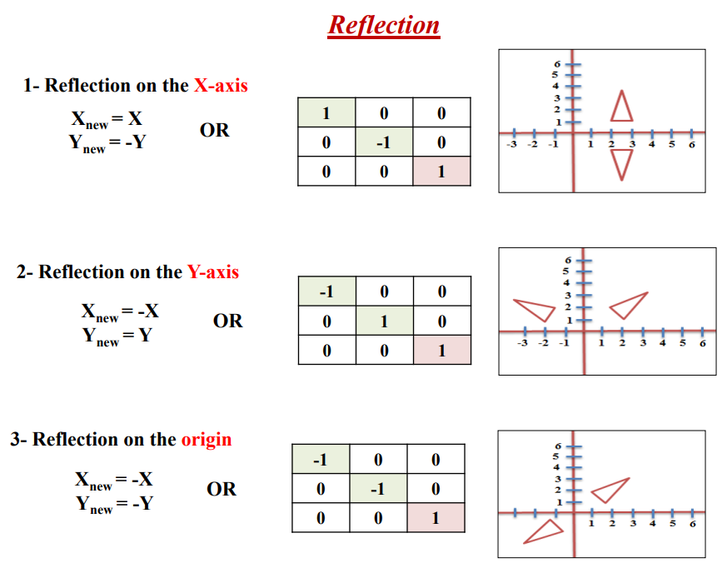

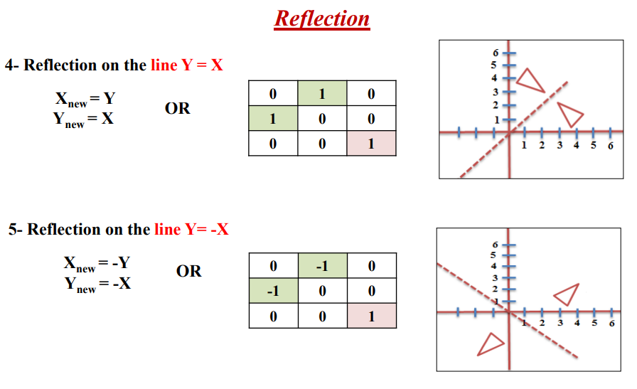

**Shear:-**

A transformation that slants the shape of an object is called the shear transformation.Two common shearing transfor-mations are used.One shifts x co-ordinate values and other shifts y co-ordinate values. However, in both the cases only one co-ordinate (x or y) changes its co-ordinates and other preserves its values.

**X Shear:-**

The x shear preserves the y co-ordinates, but changes the x values which causes vertical lines to tilt right or left as shown in the figure below . The transformation matrix for x shear is given as

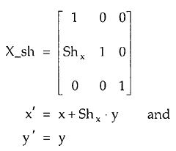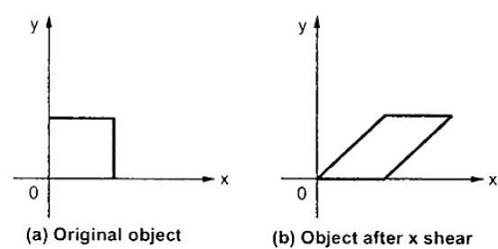

**Y shear:-**

The y shear preserves the x coordinates, but changes the y values which causes horizontal lines to transform into lines which slope up or down, as shown in the figure below. The transformation matrix for y shear is given as

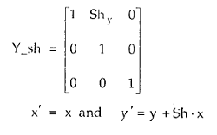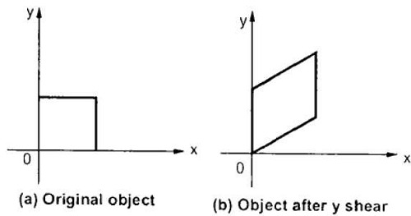

Q.2. Explain Cohen Sutherland Line clipping algorithm.

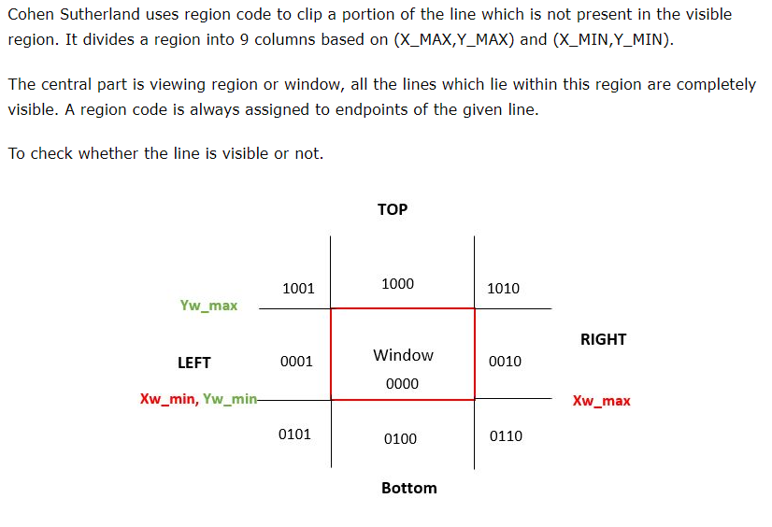 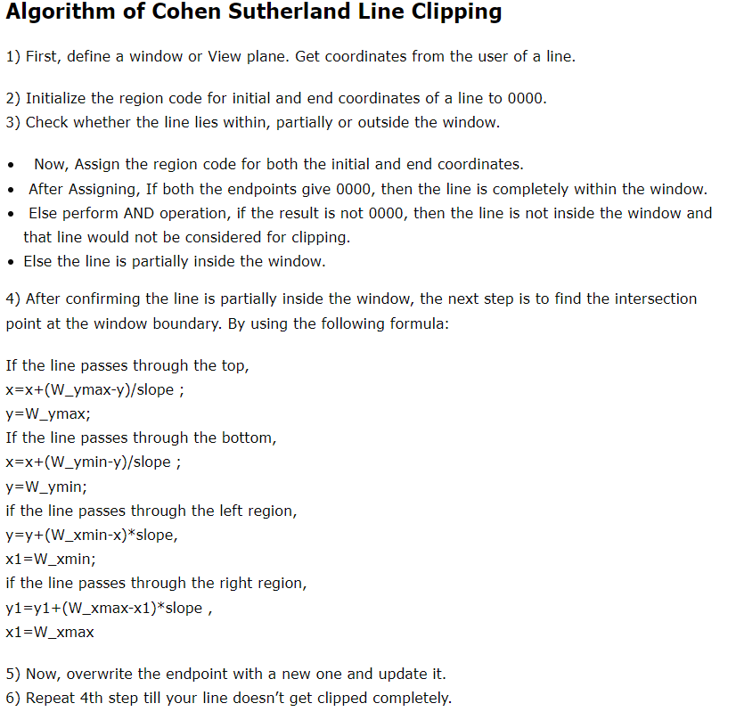

Q.3. Explain Sutherland Hodgeman Polygon Clipping Algo and discuss its advantages and disadvantages.

The Sutherland - Hodgman algorithm performs a clipping of a polygon against each window edge in turn. It accepts an ordered sequence of verices v1, v2, v3, ..., vn and puts out a set of vertices defining the clipped polygon.

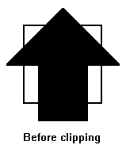 This figure represents a polygon (the large, solid, upward pointing arrow) before clipping has occurred.

The following figures show how this algorithm works at each edge, clipping the polygon.

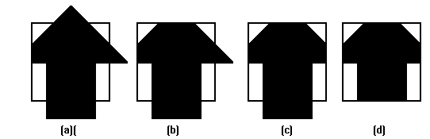

1. Clipping against the left side of the clip window.
2. Clipping against the top side of the clip window.
3. Clipping against the right side of the clip window.
4. Clipping against the bottom side of the clip window.

**Some Problems With This Algorithm**

1. This algorithm does not work if the clip window is not convex.
2. If the polygon is not also convex, there may be some dangling edges.

## Advantages of Sutherland-Hodgman algorithm

The Sutherland-Hodgman algorithm has several advantages that make it preferable to other polygon clipping algorithms. It is simple and straightforward to implement, and it can handle convex and concave polygons, as well as polygons with holes and self-intersections. Additionally, it can clip polygons against any shape of boundary, not just rectangles or circles, while also preserving the original vertices and edges of the polygon unless they are outside the boundary.

Q.4. Derive the matrix for Window to Viewport Transformation.

**Window to Viewport Transformation**is the process of transforming 2D world-coordinate objects to device coordinates. Objects inside the world or clipping window are mapped to the viewport which is the area on the screen where world coordinates are mapped to be displayed.

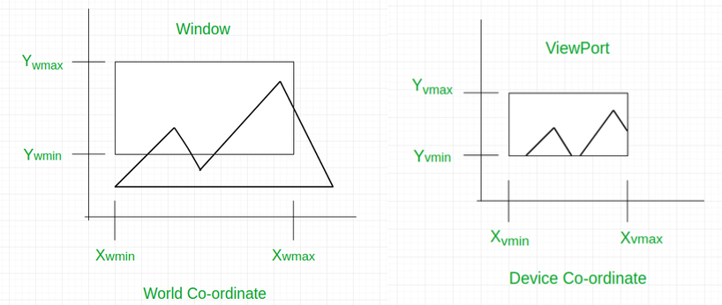

**General Terms:**

* **World coordinate –** It is the Cartesian coordinate w.r.t which we define the diagram, like Xwmin, Xwmax, Ywmin, Ywmax
* **Device Coordinate –**It is the screen coordinate where the objects are to be displayed, like Xvmin, Xvmax, Yvmin, Yvmax
* **Window –**It is the area on the world coordinate selected for display.
* **ViewPort –**It is the area on the device coordinate where graphics is to be displayed.

**Mathematical Calculation of Window to Viewport:**

It may be possible that the size of the Viewport is much smaller or greater than the Window. In these cases, we have to increase or decrease the size of the Window according to the Viewport and for this, we need some mathematical calculations.

(xw, yw): A point on Window

(xv, yv): Corresponding point on Viewport

We have to calculate the point **(xv, yv)**

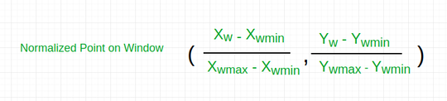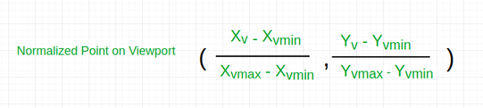

Now the relative position of the object in Window and Viewport are same.

For x coordinate,

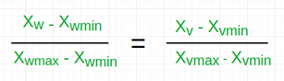

For y coordinate,

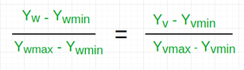

So, after calculating for x and y coordinate, we get

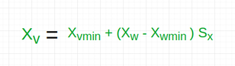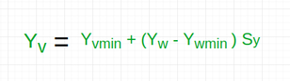

Where sx is the scaling factor of x coordinate and sy is the scaling factor of y coordinate

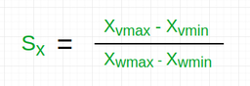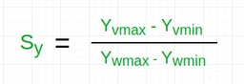

Q.5. Explain Curve Clipping and Text Clipping.

# **Text Clipping:**

Several methods are available for clipping of text. Clipping method is dependent on the method of generation used for characters. A simple method is completely considered, or nothing considers method. This method is also called as all or none. If all characters of the string are inside window, then we will keep the string, if a string character is outside then whole string will be discarded in fig (a).

Another method is discarded those characters not completely inside the window. If a character overlap boundary of window. Those will be discarded in fig (b).

In fig (c) individual character is treated. Character lies on boundary is discarded as which it is outside the window.

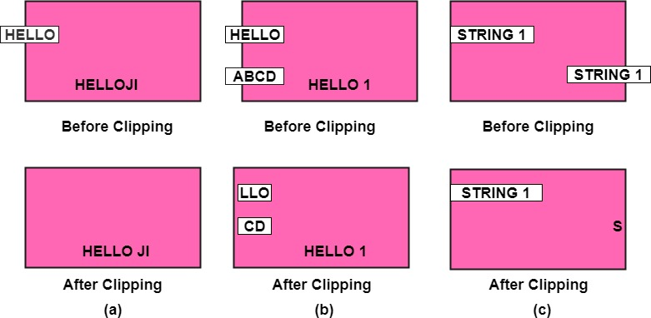

## Curve Clipping:

Curve Clipping involves complex procedures as compared to line clipping. Curve clipping requires more processing than for object with linear boundaries. Consider window which is rectangular in shape. The circle is to consider against rectangle window. If circle is completely inside boundary of the window, it is considered visible. So save the circle. If a circle is in outside window, discard it. If circle cut the boundary then consider it to be clipping case.

Q.6. Explain 3 D Transformations and its types. Also summarize their transformation matrices and equations.

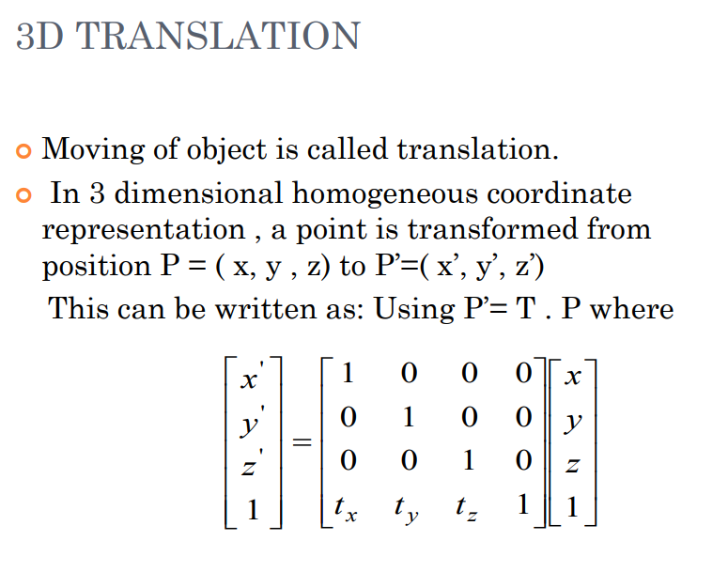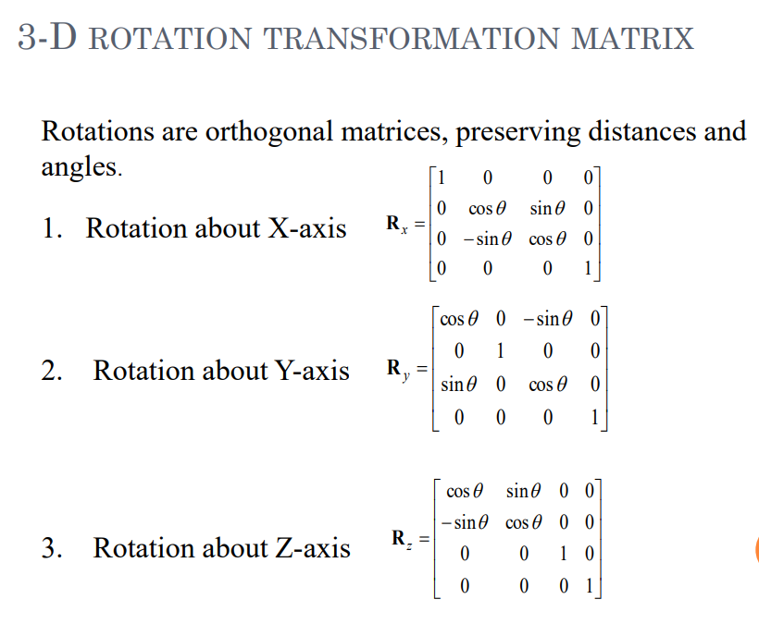

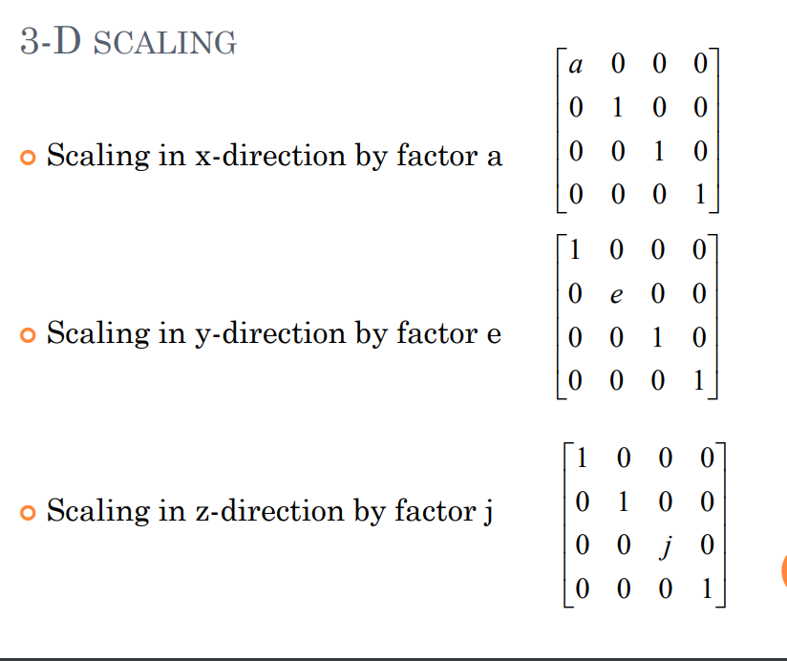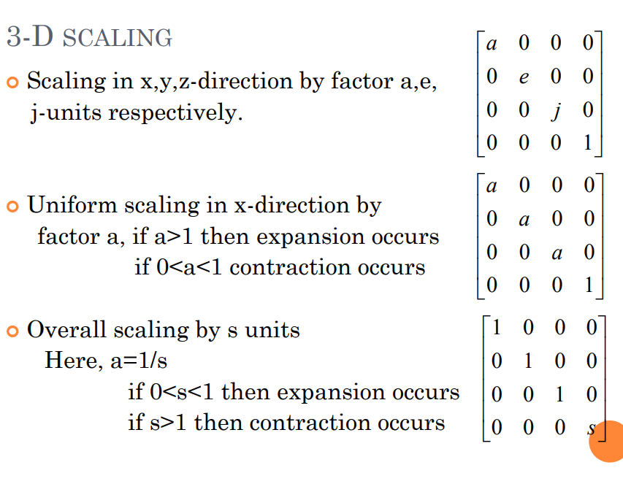

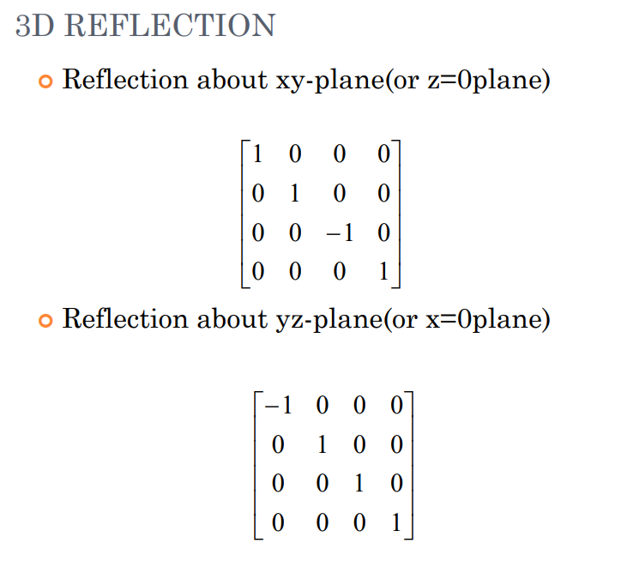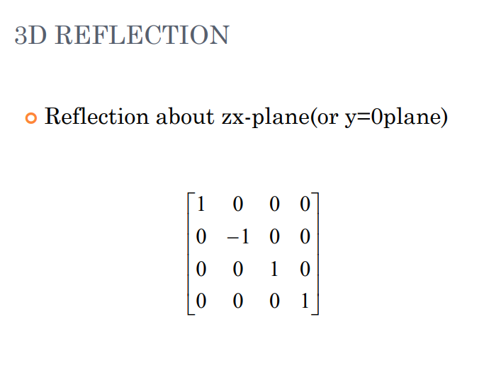

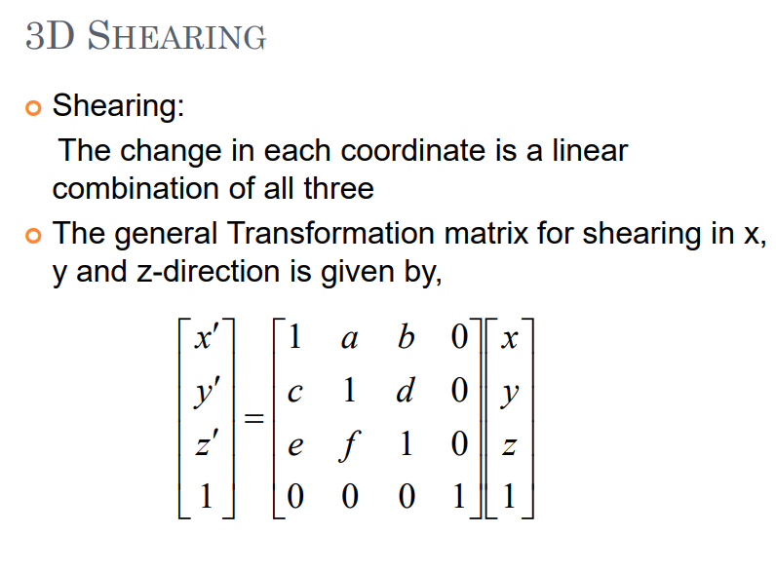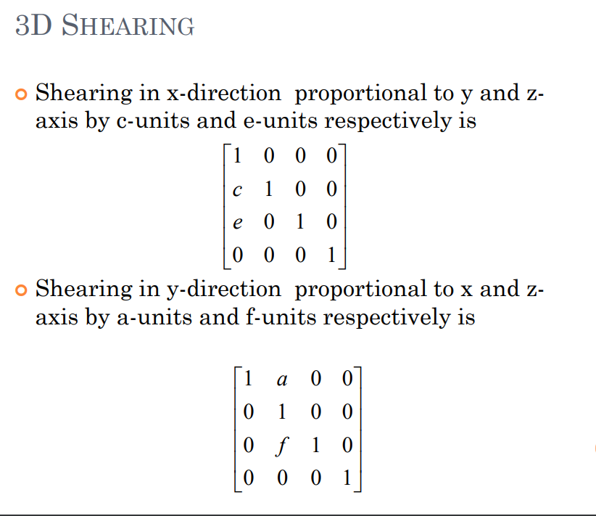

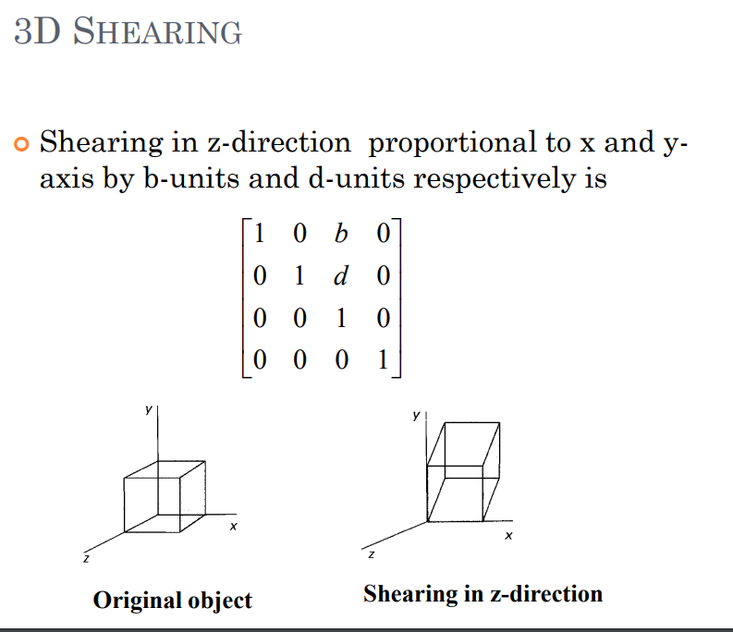

Q.7. Explain in detail 3D Projection and its types with the help of neat diagrams. Write the differences between Perspective and Parallel Projection.

Projection are defined as mapping of three-dimensional points to a two-dimensional plane. There are two type of projection parallel and perspective.

**Difference Between Parallel Projection And Perspective Projection :**

| **SR.NO** | **Parallel Projection** | **Perspective Projection** |
| --- | --- | --- |
| 1 | Parallel projection represents the object in a different way like telescope. | Perspective projection represents the object in three dimensional way. |
| 2 | In parallel projection, these effects are not created. | In perspective projection, objects that are far away appear smaller, and objects that are near appear bigger. |
| 3 | The distance of the object from the center of projection is infinite. | The distance of the object from the center of projection is finite. |
| 4 | Parallel projection can give the accurate view of object. | Perspective projection cannot give the accurate view of object. |
| 5 | The lines of parallel projection are parallel. | The lines of perspective projection are not parallel. |
| 6 | Projector in parallel projection is parallel. | Projector in perspective projection is not parallel. |
| 7 | Two types of parallel projection : 1.Orthographic, 2.Oblique | Three types of perspective projection: 1.one point perspective, 2.Two point perspective, 3. Three point perspective, |
| 8 | It does not form realistic view of object. | It forms a realistic view of object. |

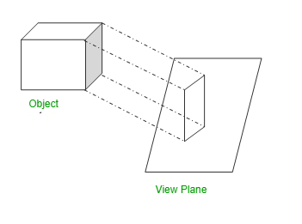 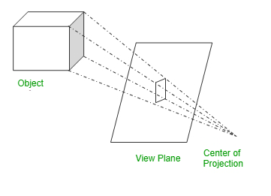

Q.8. Explain Viewing Pipeline.

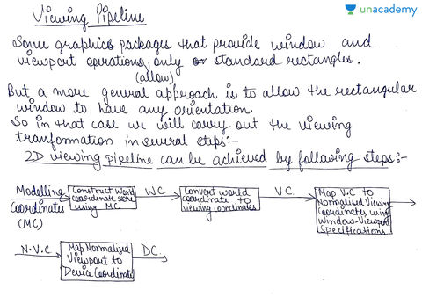

Q.9. Explain and write differences between Bezier and B Spline Curve.

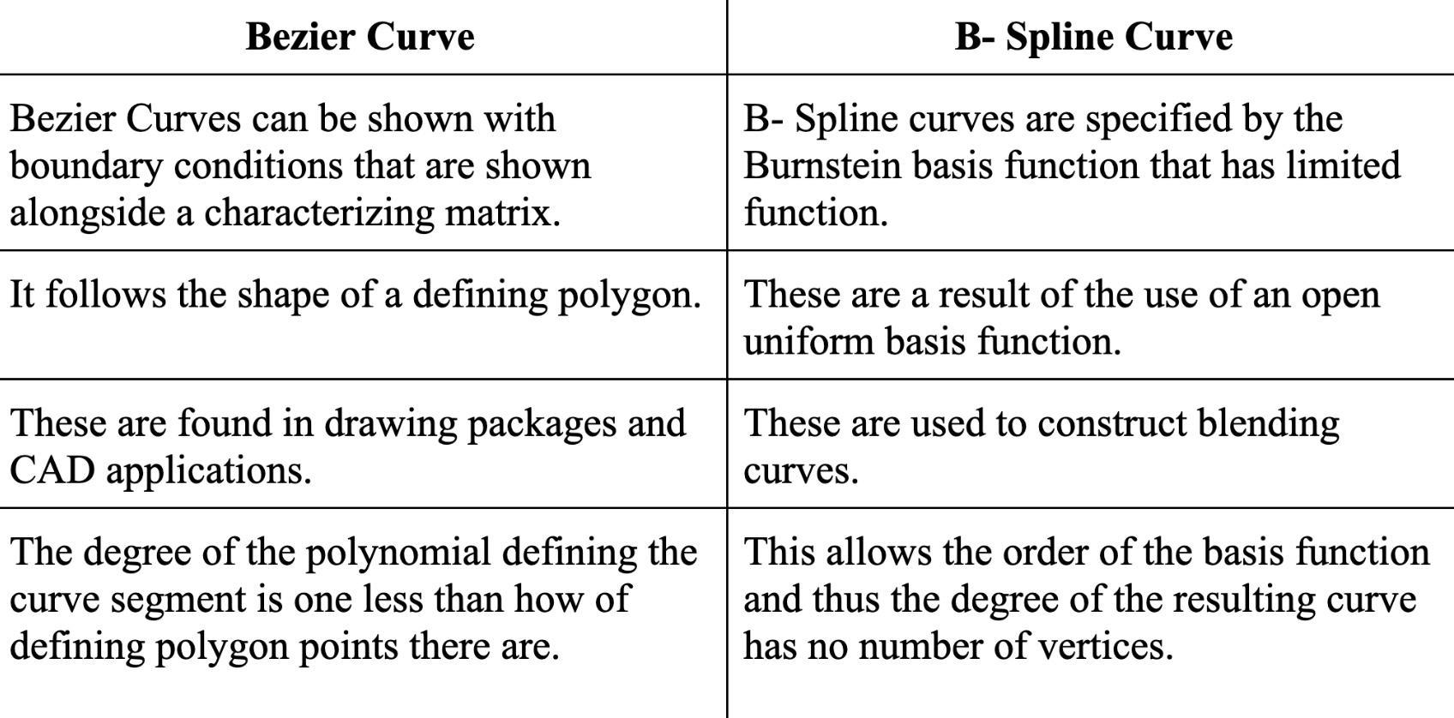

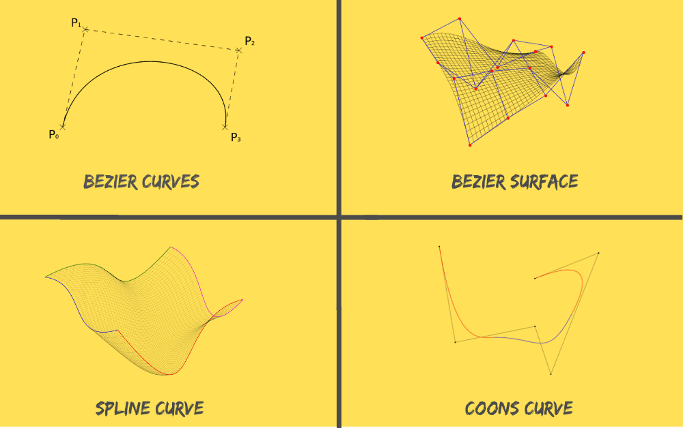

Q.10. Write short notes on Blobby Objects, Polygon Tables, 3 D Primitives, Polygon Meshes, Word Coordinates, Device Coordinates, Normalized Coordinates, Window, Viewport.

1. Blobby Objects: Blobby objects are 3D objects that are represented as a collection of metaballs. These metaballs are mathematical functions that define the shape and size of the object.
2. Polygon Tables: A polygon table is a data structure that stores information about the polygons in a 3D object. It contains information about the vertices, edges, and faces of the polygons.
3. 3D Primitives: 3D primitives are basic 3D shapes that can be used to construct more complex 3D objects. Examples of 3D primitives include cubes, spheres, cones, and cylinders.
4. Polygon Meshes: A polygon mesh is a collection of polygons that are joined together to form a 3D object. Polygon meshes are commonly used to represent 3D objects in computer graphics.
5. Word Coordinates: World coordinates are a system of coordinates used to specify the position of objects in 3D space. The origin of the world coordinate system is typically set at the center of the 3D scene.
6. Device Coordinates: Device coordinates are the coordinates of a 2D display device, such as a computer screen or printer. These coordinates are typically measured in pixels.
7. Normalized Coordinates: Normalized coordinates are a system of coordinates that range from -1 to 1 in each dimension. They are often used in computer graphics to represent the relative position of objects in a scene.
8. Window: In computer graphics, a window is a rectangular area of the screen in which an application or program can display its output.
9. Viewport: The viewport is the part of the window where the 3D scene is displayed. The viewport is usually smaller than the window and is used to control the size and position of the rendered image.

Numerical Examples:

1. Given a triangle with vertices (0,0), (2,0) and(1,1). Reflect this triangle about (a). x axis, (b). y axis (c). Line x=2 (d). y=1, and find the new vertices after reflection.
2. Given a triangle with vertices (0,0), (2,0) and(1,1). Shearing Factors Shx and Shy are 2 and 3 respectively. Apply 2D Shearing Transformation and find the new vertices of the square after shearing in-

a. x direction only.

b. y direction only.

c. x and y directions both.

1. 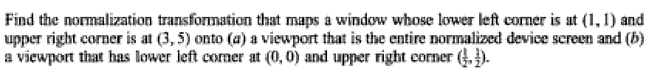



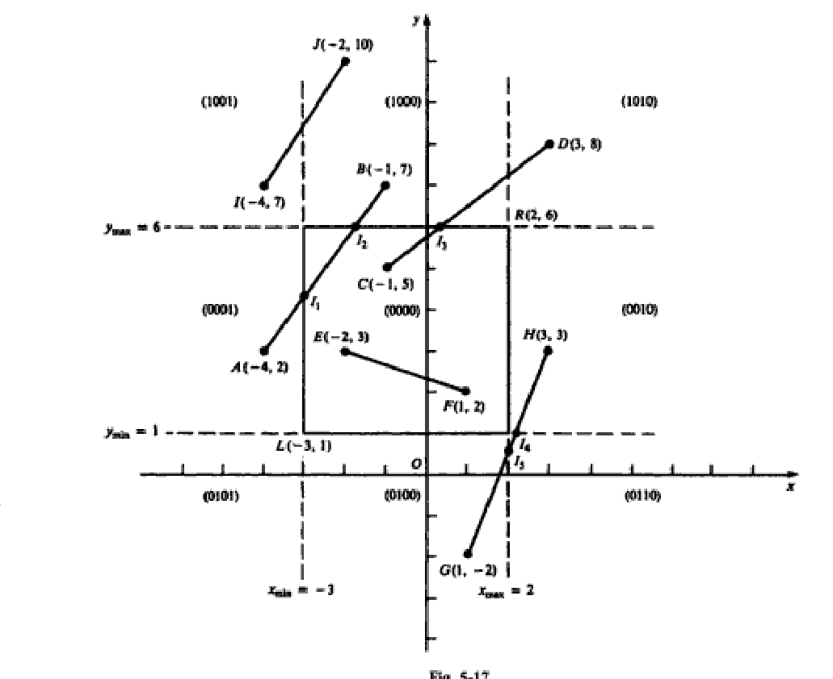

1. 
2. 

Apply Sutherland Hodgeman Polygon Clipping Algorithm to solve the Clip the polygon P1…………P8 against the window.

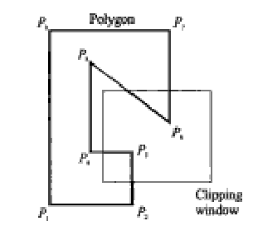

1. Apply Sutherland Hodgeman Polygon Clipping Algorithm to solve the Clip the polygon P1…………P9 against the window.

