**How to Make a Roster**

**Create a Spreadsheet for Different Attributes**

You need a spreadsheet that contains all the repeatable information like employee names and months. This sheet is also important to manipulate data throughout the workbook. It is the basis of using the workbook as a template. This can be done in shifts page

We have included months, years, weekends, shift types, shift codes, and employee names in different columns.

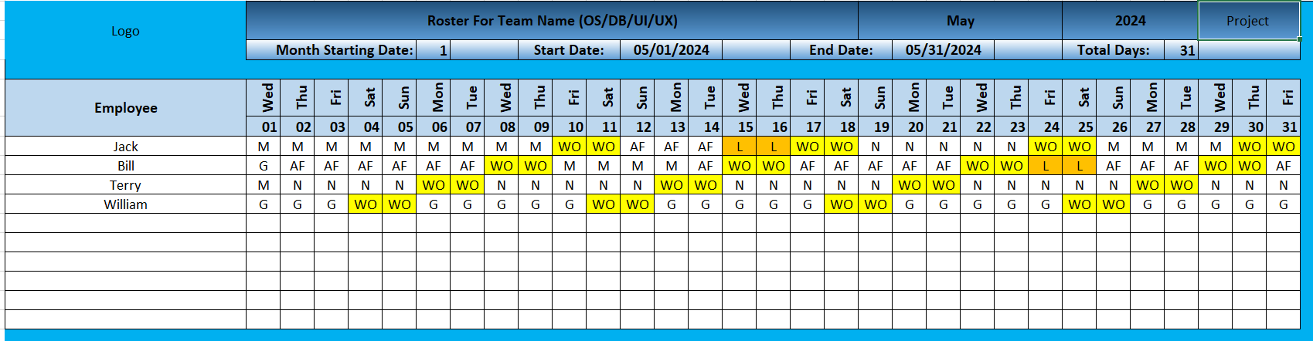

Like this publish the roster to that particular project with all team rosters individually

And admin can see this view and can download this report with roster

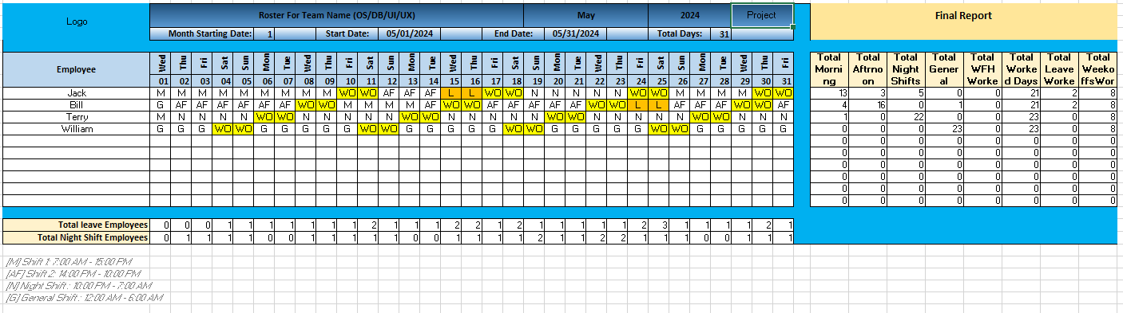

Filters on month & year also project bases in a dep.

Note: No roster should be shared between projects & depts

In side bar below rosters publish roster and view roster & shifts

So, view roster page should be visible to all super admin, Admin, and vendors all

But this publishes by only admin or TL/Manager only so present in the permission page so can control the permission as per the requirement.

This TL/ manager will be from Vendor so please note this part also

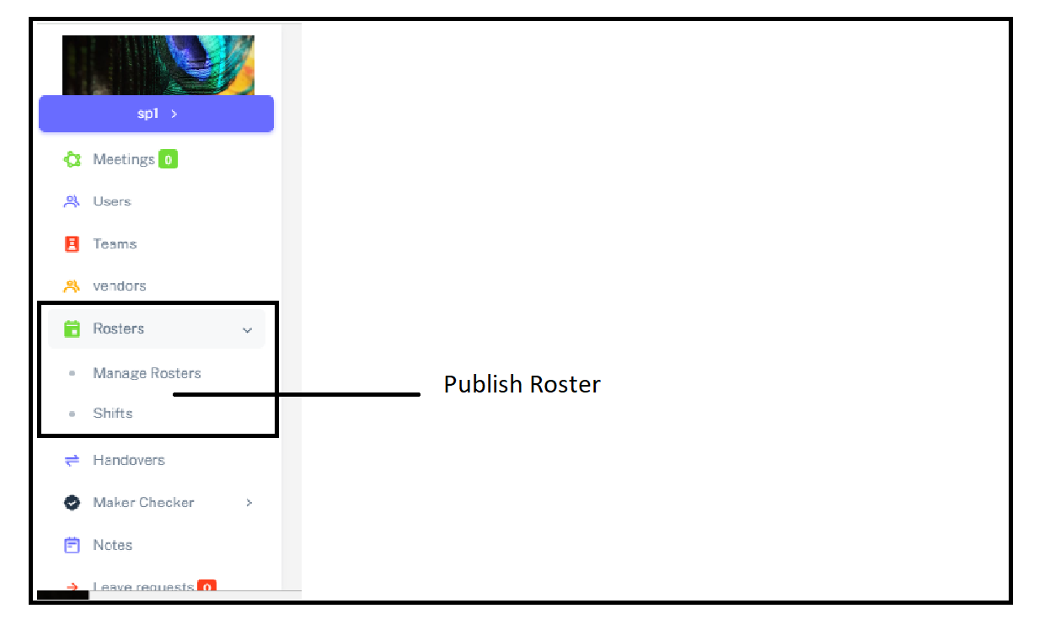

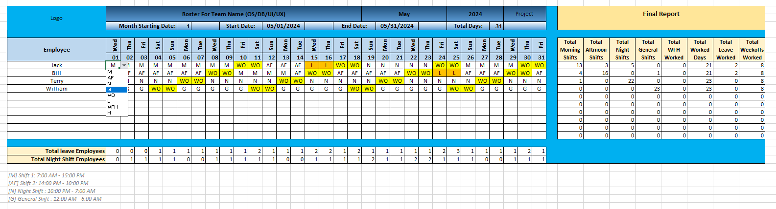

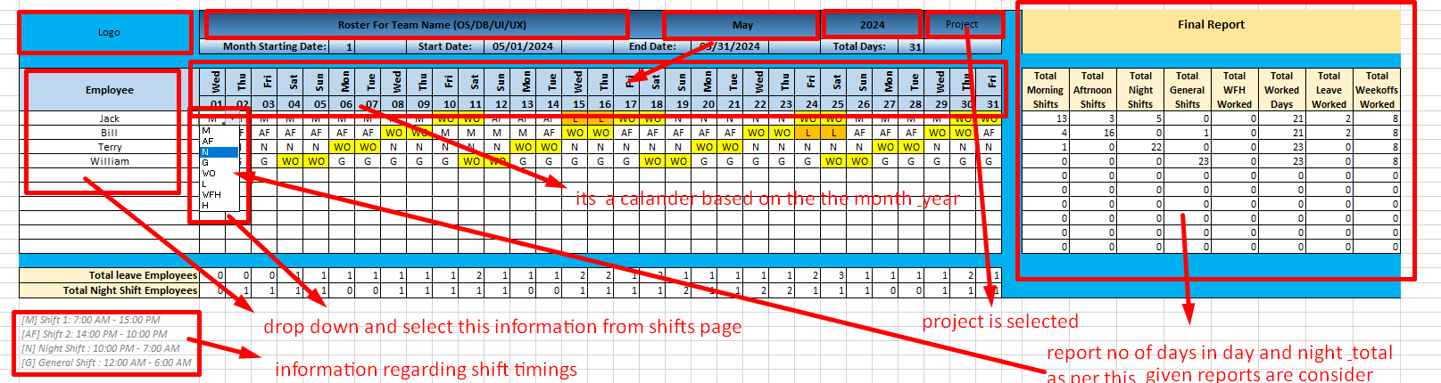

This shift type is selected based on the shift type saved and vendor names assigned to the project and the teams create the roster and publish and save the past rosters.

Reports are created for the roster with days on G, M, AF, N, L, WFH, give options to change the colour also as a excel and publish the table.

Create the reports for all types of mentioned and no of total working is important.