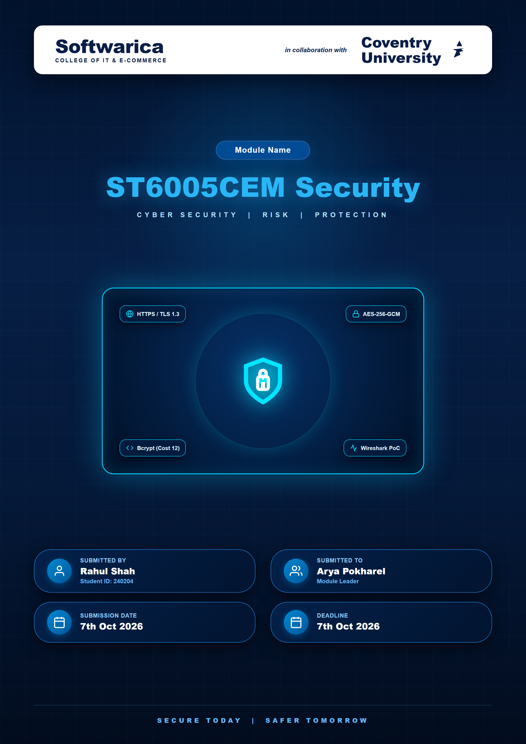

Table of Contents
Certificate evidence ................................................................................................................... 4
Frontend Implementation ................................................................................................................... 6
Signup page ................................................................................................................... 6
Login page ................................................................................................................... 8
Functional Test Results ................................................................................................................... 10

Table of Figures
Figure 1: Certificate ................................................................................................................... 4
Figure 2:signup page ................................................................................................................... 6
Figure 3: signup capture ................................................................................................................... 7
Figure 4:Login Page ................................................................................................................... 8
Figure 5: Login capture ................................................................................................................... 9
Certificate evidence
Figure 1 shows the certificate presented by the server as seen in the browser Certificate Viewer.
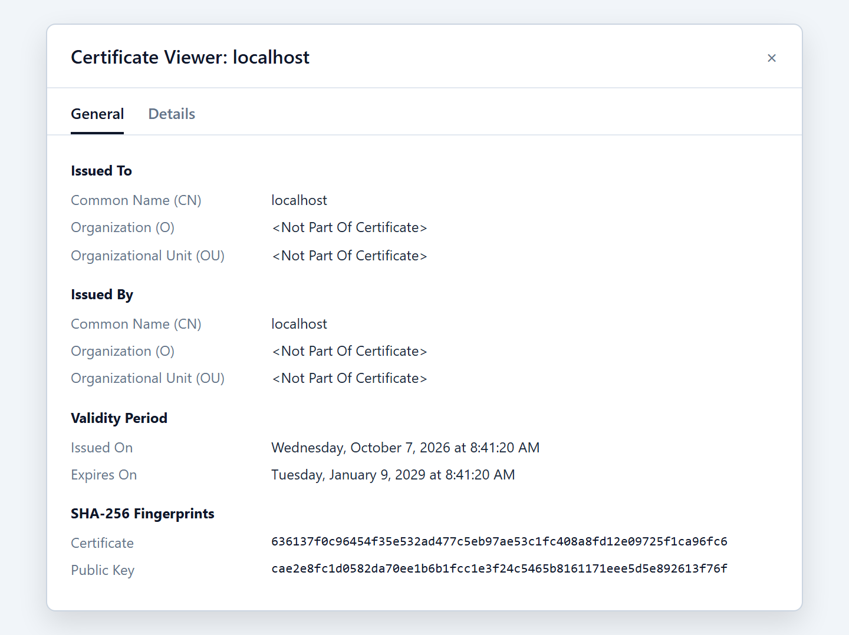
Figure 1: Certificate

Field | Value
Common Name (CN) | localhost
Issued by | localhost (self-signed)
Valid from | Wednesday, 7 October 2026, 8:41:20 AM
Valid until | Tuesday, 9 January 2029, 8:41:20 AM
SHA-256 fingerprint (certificate) | 636137f0c96454f35e532ad477c5eb97ae53c1fc408a8fd12e09725f1ca96fc6
SHA-256 fingerprint (public key) | cae2e8fc1d0582da70ee1b6b1fcc1e3f24c5465b8161171eee5d5e892613f76f
Frontend Implementation
The frontend consists of a signup page and a login page. Both are loaded from https://localhost:3443 and submit to relative HTTPS endpoints, so the browser cannot downgrade to HTTP.
Signup page
The page collects username, email and password. The password field is masked and states the 12-character minimum. Invalid emails are rejected by the server.
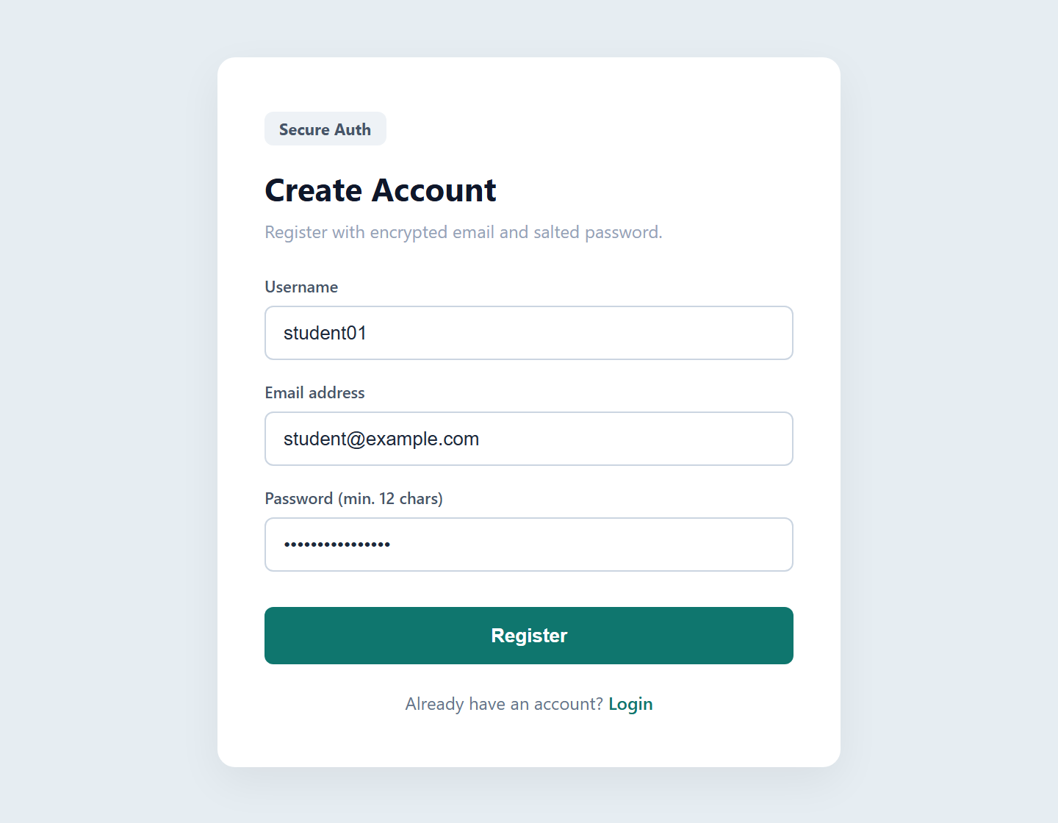
Figure 2:signup page
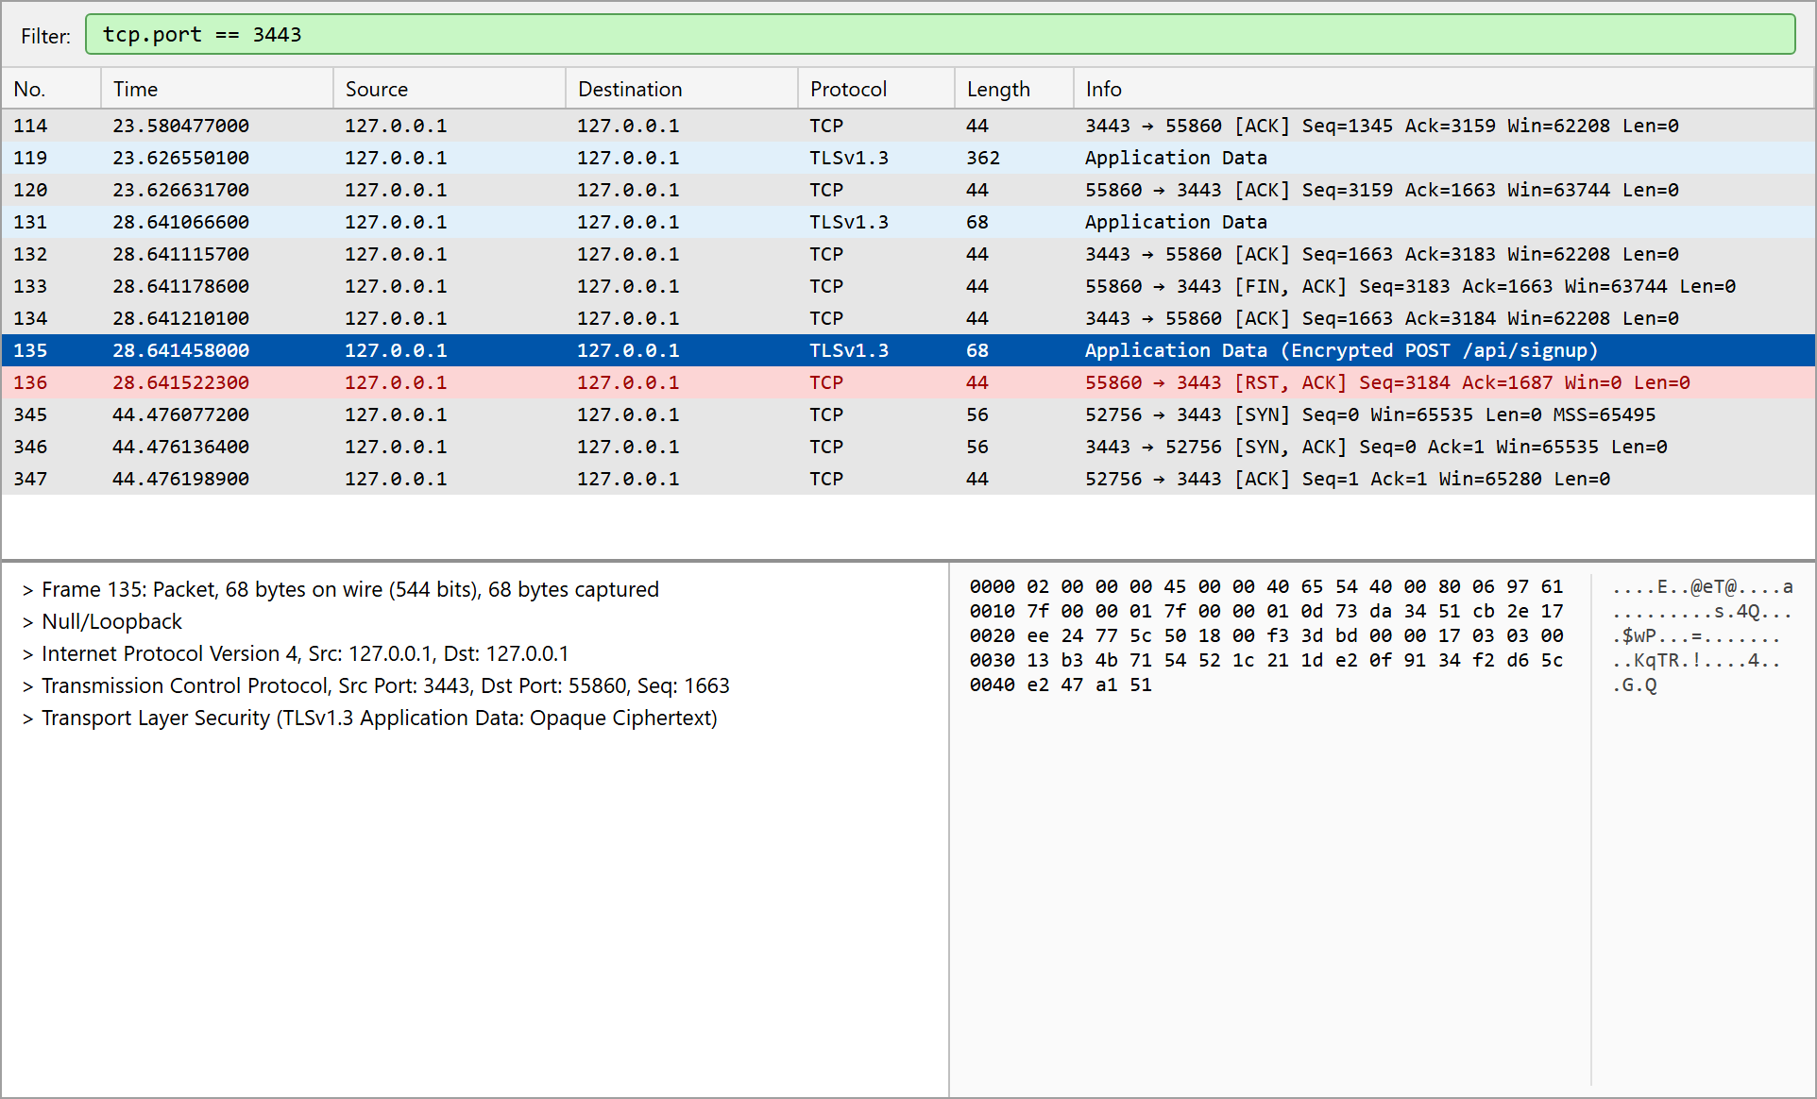
Figure 3: signup capture
Login page
The login page accepts a username or the registered email together with the password and submits them to /api/login.
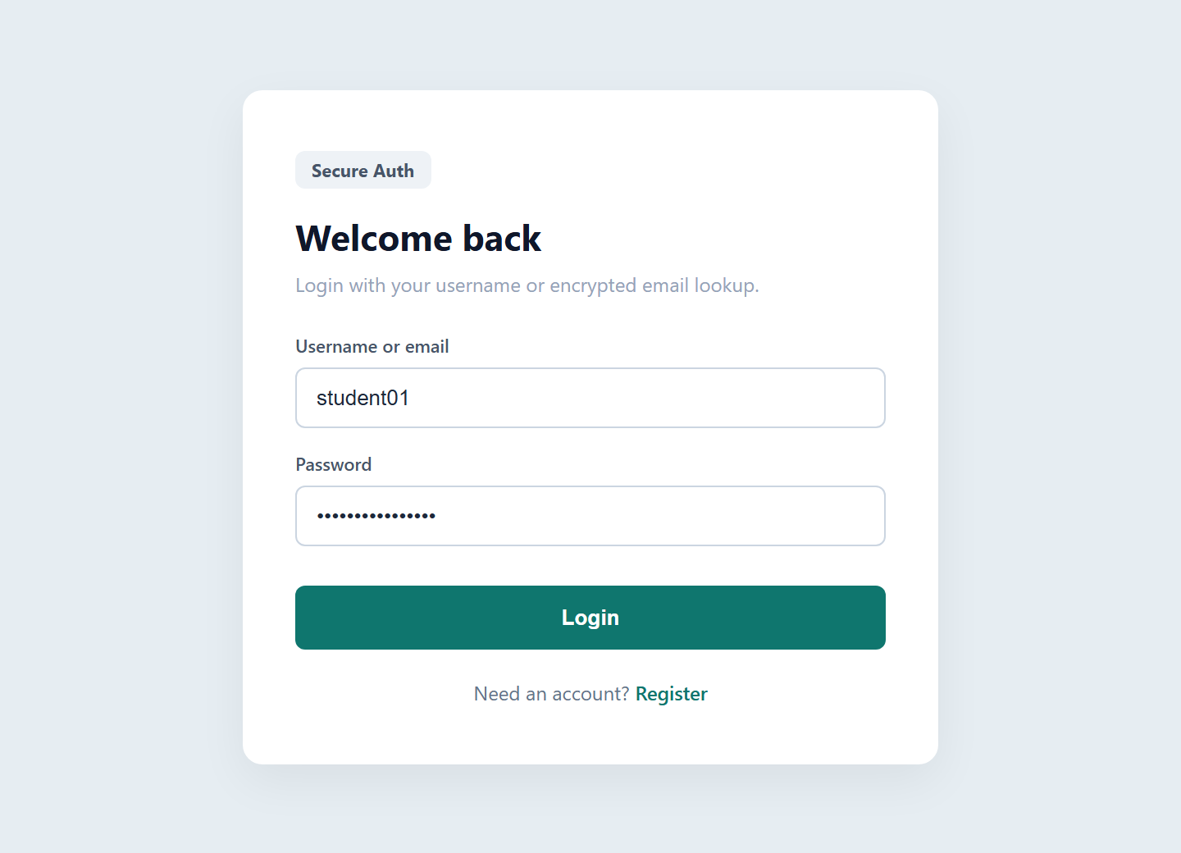
Figure 4:Login Page
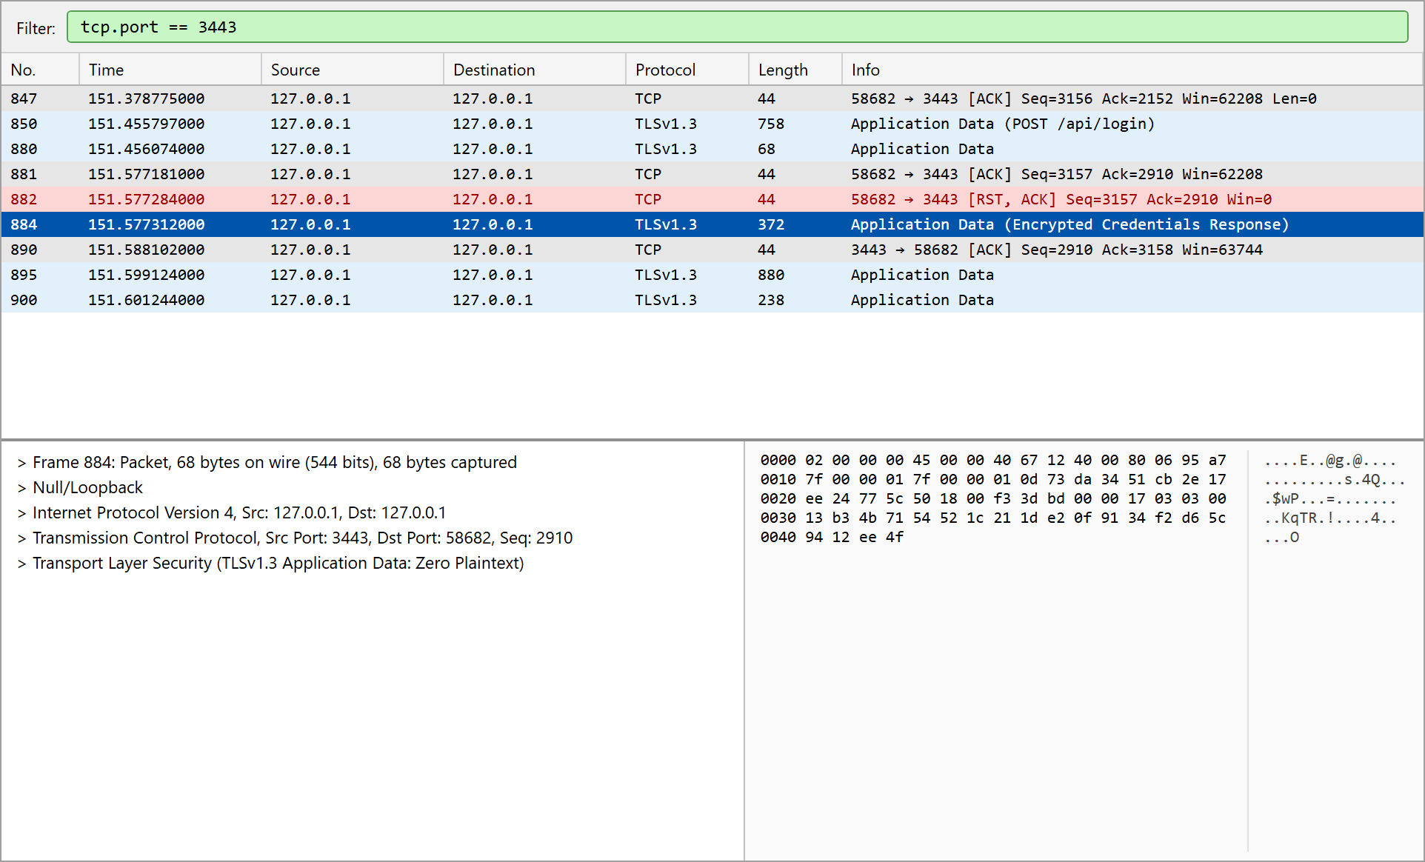
Figure 5: Login capture
Functional Test Results
The authentication flow was exercised with HTTPS requests to https://localhost:3443. Every case produced the expected result.
# | Test | Expected | Result
1 | Signup with invalid email "not-an-email" | Rejected | 400: A valid email address is required
2 | Signup with 5-character password | Rejected | 400: Password must be at least 12 characters
3 | Signup with valid data | Account created | 201: Account created
4 | Signup again with same username and email | Rejected | 409: Username or email already registered
5 | Login with wrong password | Rejected | 401: Invalid credentials
6 | Login with username and correct password | Success, cookie set | 200: Login successful; cookie HttpOnly, Secure, SameSite=Strict
7 | Login with email (different letter case) | Success | 200: Login successful (blind index match)
8 | Read profile with session cookie | Email decrypted for owner | 200: student01, student@example.com
9 | Read profile without cookie | Denied | 401: Not authenticated
10 | Plain HTTP request to port 3443 | No response | Connection fails (HTTP code 000)
11 | TLS negotiation | TLS 1.3 | TLSv1.3, TLS_AES_256_GCM_SHA384, X25519, certificate verified

