ASSIGNMENT 1 - WEB TECHNOLOGY
Name: Devraj
Course: B.Tech CSE

Q1. Difference between Frontend, Backend and Full-Stack Development
Frontend development is the part of a website that the user directly sees and interacts with, like buttons, colors, layout and images. It is built using HTML, CSS and JavaScript. Example: the news feed and like button in Instagram.
Backend development is the server-side part which handles logic, database connections and data processing. The user does not see this directly. Example: when we log in to a website, the backend checks our username and password from the database.
Full-stack development means a developer who can work on both frontend and backend. Example: in a small startup, one single developer often builds the complete website - both the design and the server logic.

Q2. Client-Server Model Diagram
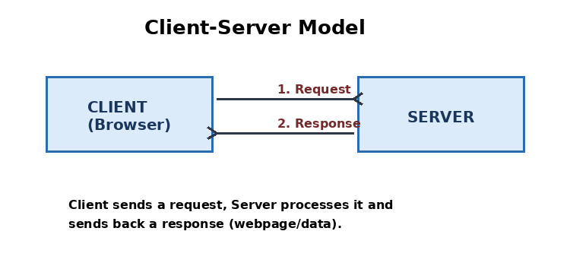
Explanation: The client (browser) sends a request to the server, the server processes it and sends back a response, which the browser then displays.

Q3. How a Browser Requests and Displays a Webpage
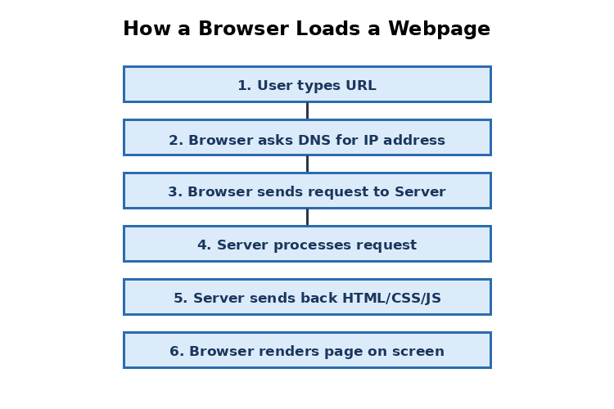
1. User types a URL in the browser.
2. Browser looks up the IP address of the domain using DNS.
3. Browser sends an HTTP/HTTPS request to the server.
4. Server receives and processes the request (may fetch data from a database).
5. Server sends back the response containing HTML, CSS and JS files.
6. Browser parses this response and renders it on the screen for the user.

Q4. Tools Required for Web Development Environment
1. Code Editor (VS Code) - used to write and edit HTML, CSS and JS code.
2. Web Browser (Chrome/Firefox) - used to run and test the website.
3. Node.js - allows JavaScript to run outside the browser; needed for many modern tools and backend development.
4. Git - version control tool, used to track changes in code and save project history.
5. Live Server extension - automatically refreshes the browser whenever code changes, saving time while testing.

Q5. What is a Web Server
A web server is software (and sometimes the hardware it runs on) that receives requests from clients (browsers) and sends back the required webpages or data. It stores website files and serves them when requested.
Examples: Apache HTTP Server, Nginx, Microsoft IIS, LiteSpeed.

Q6. Roles in a Project
Frontend Developer: Designs and builds the part of the website that users interact with. Focuses on layout, styling, responsiveness and user experience.
Backend Developer: Builds the server-side logic, creates APIs, manages communication between frontend and database, and handles the business rules of the application.
Database Administrator (DBA): Manages the database - keeps data organized, safe and backed up, and ensures the database performs well and is secure.

Q7. VS Code Installation and Setup
Steps followed:
1. Downloaded VS Code from code.visualstudio.com
2. Installed it on the system.
3. Installed useful extensions - Live Server (to preview HTML pages instantly), Prettier (to auto-format code), HTML CSS Support.
4. Created a test HTML file and verified it runs correctly using Live Server.
[Screenshot of setup to be attached here]

Q8. Static vs Dynamic Websites
Static Website: Content is fixed and same for every visitor. It does not change unless the code is manually edited. Example: a simple personal portfolio website.
Dynamic Website: Content can change based on user actions or data from a database. Example: Amazon, where product prices and stock update automatically.

Q9. Five Web Browsers and Their Rendering Engines
1. Google Chrome - Blink engine
2. Mozilla Firefox - Gecko engine
3. Apple Safari - WebKit engine
4. Microsoft Edge - Blink engine (Chromium based)
5. Opera - Blink engine
Difference: Rendering engines convert HTML/CSS/JS code into the visual page we see. They differ in speed, how strictly they follow web standards, and support for newer CSS/JS features. For example, WebKit (Safari) is lightweight and battery efficient, while Blink (Chrome/Edge) supports a very wide range of modern web features.

Q10. Basic Web Architecture Flow Diagram
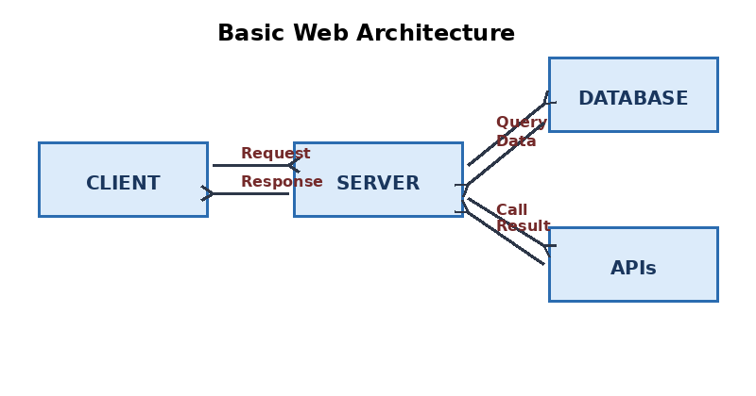
Explanation: The client sends a request to the server. The server may communicate with a database to fetch or store data, and may also call external APIs for additional services. Finally, the server sends the response back to the client, which is displayed as a webpage.

