# User Registration And

# Authentication in Django

Source:

https://www.youtube.com/watch?v=Z3qTXmT0yoI

Virtual Env Package: this is going to allow to create virtual environment on system B’cuz sometimes we don’t want to install a package globally on our system

Pip install virtual env

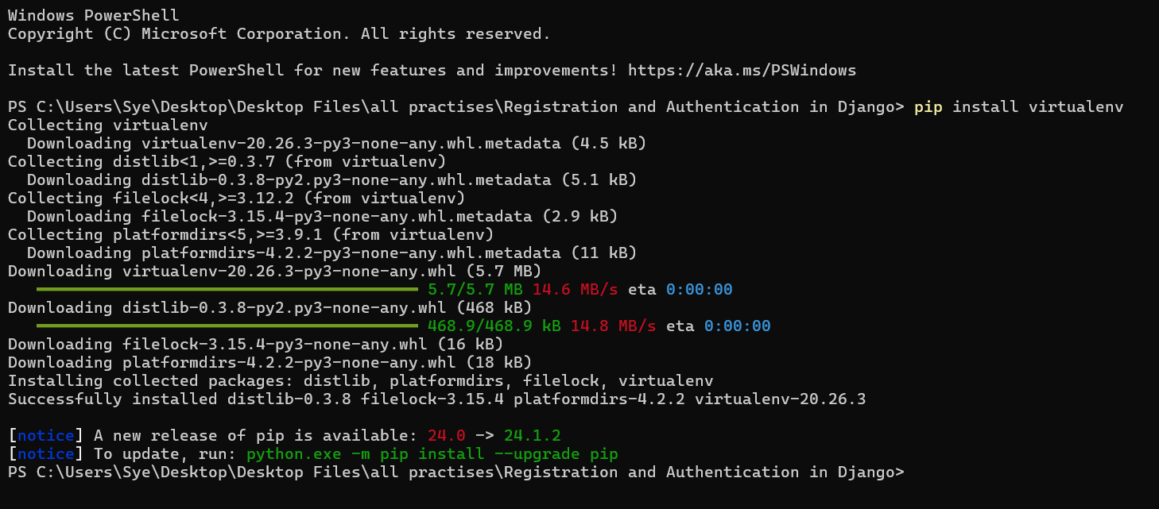

Virtualenv myenv

Myenv is my virtual environment folder/directory name.

**For the very first time we might can be the blockage to run the script by policy so to bypass**

Open Run Command/Console ( Win + R ) Type: gpedit. msc (Group Policy Editor)

Browse to Local Computer Policy -> Computer Configuration -> Administrative Templates -> Windows Components -> Windows Powershell.

Enable "Turn on Script Execution" Set the policy as needed. I set mine to "Allow all scripts".

myenv\Scripts\activate

myenv\Scripts\deactivate

pip install django

django-admin startproject elevate

elevate is my project structure name:

