Mr. Dev Raj Basnet

Web Developer/Graphic Designer

My Services



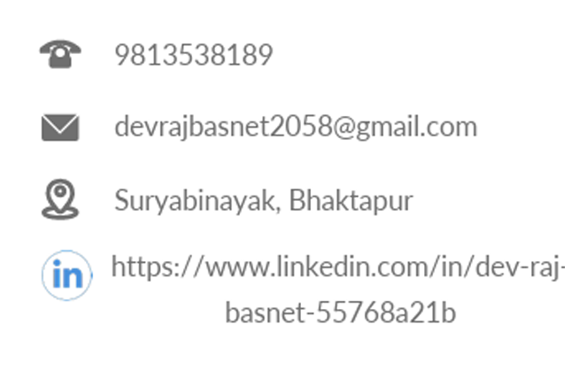Contact me for this services