SOFTWARE ENGINEERING LAB – 2
Agile Backlog Creation & Sprint Simulation in Jira

Pharmacy Expiry Reorder System
Student Name | Bhavin G Kamat
SRN | PES1UG24AM065
Problem Statement | #15 – Pharmacy Expiry & Re-order Dispatch Engine
Domain | Healthcare & Telemedicine
Jira Project | Pharmacy Expiry Reorder System (PERS)
This report documents the Jira backlog, Agile user stories, story-point estimates, sprint simulation, burndown evidence, and reflection for the assigned problem statement.

EPICS
The lab instructs students to break Lab 1 requirements into major functional themes (Epics) before creating User Stories.
Epic | Description
Medicine Batch & Expiry Management
Inventory & Stock Monitoring
Automated Re-order Management

expiry

a
Manage medicin batches, batc numbers, an dates to ensur accurate trackin

Maintain accurate medicine stock quantities and monitor inventory levels against configur Automatically generate and dispatch purchase orders to inventory suppliers when medici
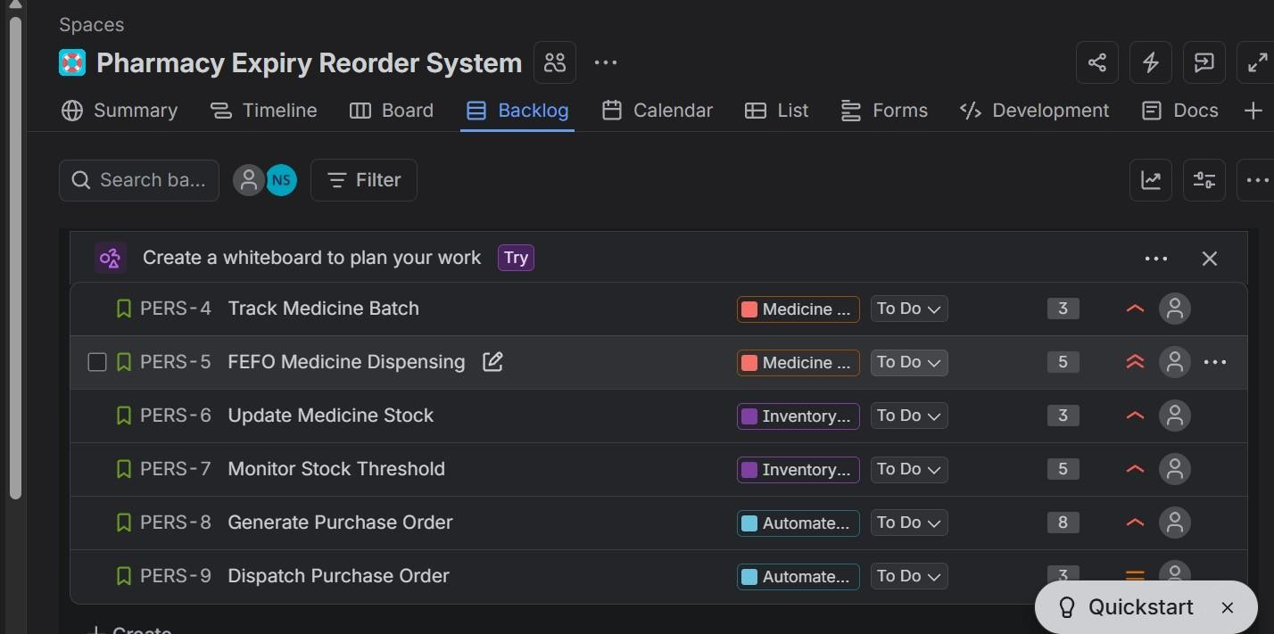
Figure 1. Jira backlog showing the six User Stories, their Epic associations, and story points.

USER STORIES, PRIORITY & STORY POINTS
The lab uses the format As a [user role], I want [goal], so that [benefit]. Story points are estimated using the Fibonacci-style sequence.

As a want to batch dates,
Pharmacy Clerk, record medicin numbers and expir so that I can a
As a Pharmacy Clerk
# | User Story | Priority | Points | Description
1 | Track Medicine Batch | High | 3
2 | FEFO Medicine Dispensing | Highest | 5
3 | Update Medicine Stock | High | 3
4 | Monitor Stock Threshold | High | 5
5 | Generate Purchase Order | High | 8
6 | Dispatch Purchase Order | Medium | 3

want the system to select the medicine
batch with the neares valid expiry As a
Pharmacy Clerk, I wa

the system to automatically update medicine quantities after dispen

As a Pharmacy Clerk, I want the system to monitor medicine stock levels against safety threshol As a Pharmacy Clerk, I want the system to automatically generate a purchase order when me
As an Inventory Supplier, I want to receive purchase orders from the pharmacy system, so tha

Total backlog estimate: 27 story points.

SPRINT 1 – ACTIVE SPRINT EVIDENCE
Sprint: PERS Sprint 1 Duration shown by Jira: 5 Oct 2026 – 12 Oct 2026
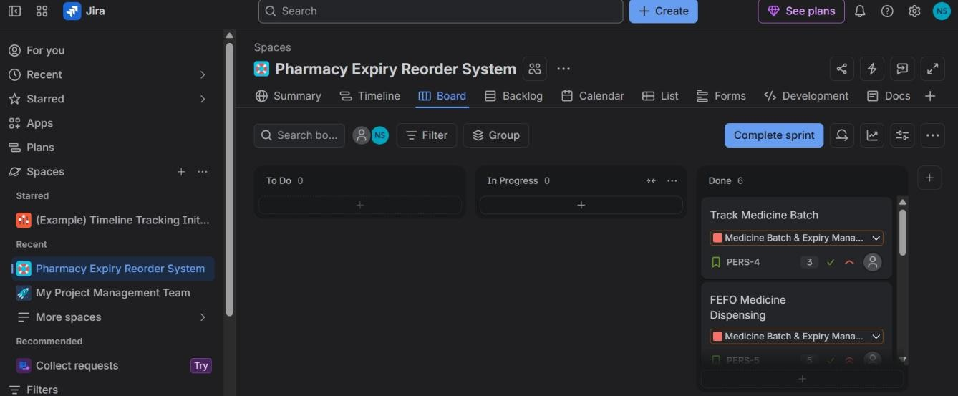
Workflow: To Do → In Progress → Done
Figure 2. Jira Active Sprint board showing completed work items.

SPRINT 1 BURNDOWN CHART
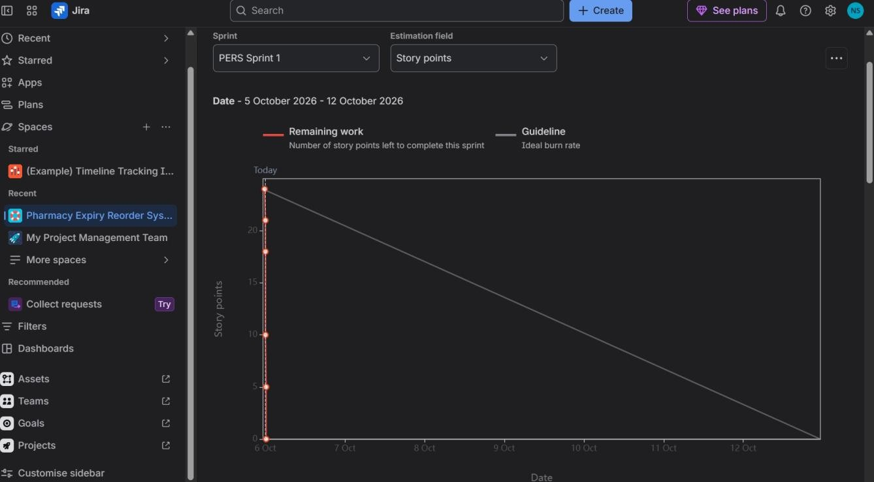
Jira's Sprint 1 report uses Story points as the estimation field. The chart shows remaining work and the ideal guideline.
Figure 3. PERS Sprint 1 Burndown Chart.

SPRINT 2 – ACTIVE SPRINT EVIDENCE
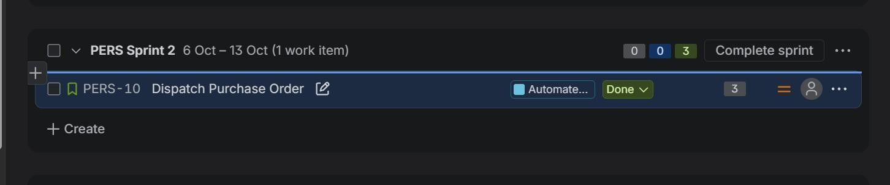
Sprint: PERS Sprint 2 Work item: Dispatch Purchase Order Points: 3
Figure 4. PERS Sprint 2 showing Dispatch Purchase Order completed.

The Lab 2 handout instructs students to finish two sprints; Sprint 2 contains the remaining 3-point work item.

SPRINT 2 BURNDOWN CHART
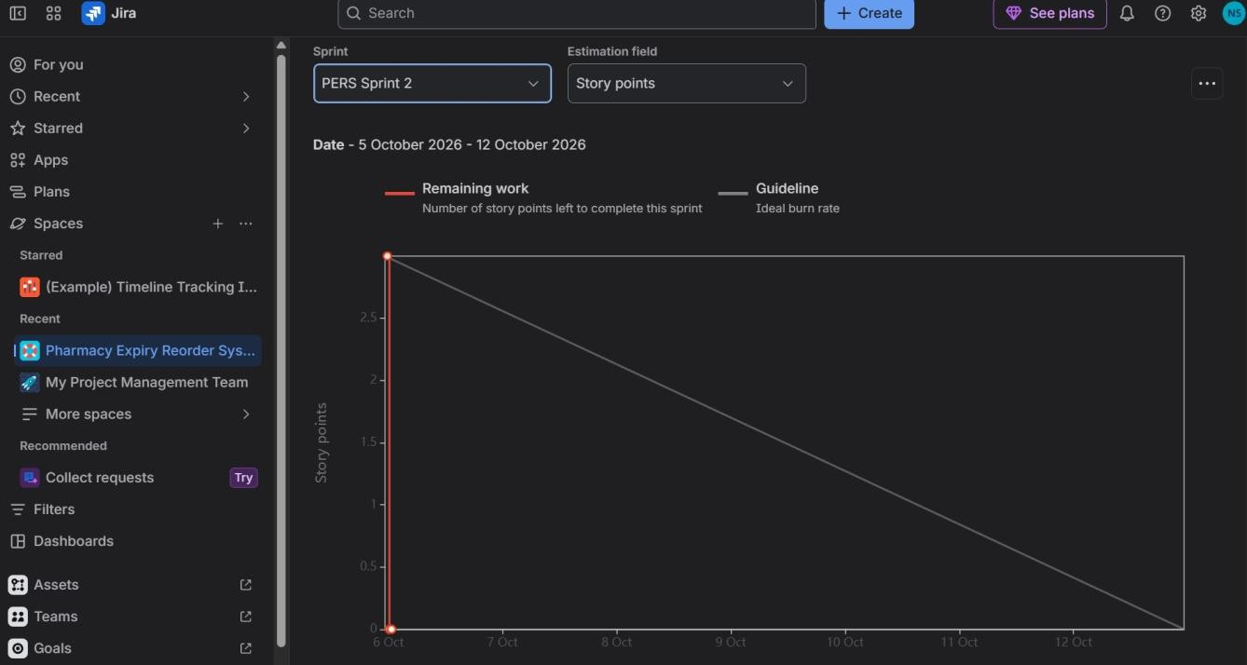
Jira's Sprint 2 report shows Story points as the estimation field and the 3-point work item reaching zero remaining work.
Figure 5. PERS Sprint 2 Burndown Chart.

REFLECTION

Did your estimations reflect the actual effort?
Yes. The story points reasonably reflected the relative effort and complexity of the user stories. Simpler activities such as updating medicine stock received fewer points, while generating a purchase order received more points because it involves additional processing and supplier-related functionality.

Was your backlog well-prioritized?
Yes. Important pharmacy operations such as FEFO dispensing, stock updating, stock monitoring, and purchase-order generation were given high priority because they directly affect medicine availability and inventory management.

How did your simulated sprint align with your plan?
The simulated sprint followed the planned Agile workflow. Work items were moved through the Jira status flow and the remaining work item was completed in Sprint 2, demonstrating the sprint-based approach.

What insights did the burndown chart give about your team's capacity?
The burndown charts showed remaining story points during each sprint. The work reached zero after the planned items were completed, indicating that the simulated sprint work was completed successfully.

FINAL CHECKLIST
Deliverable | Status
Epics | Completed
User Stories | 6 created
Priority assignments | Completed
Story points | Completed
Sprint 1 | Completed
Sprint 2 | Completed
Active sprint evidence | Included
Sprint 1 Burndown Chart | Included
Sprint 2 Burndown Chart | Included
Reflection questions | Answered

HEMANT D C | PES1UG24AM119

