Harry Potter House Sorting Test

Jessica Nebolsky

Table of Contents

**History and Context**2

Inspirational Links2

**Potential Questions and Answer Weights**3

**Concept of Final Look**4

**Point Breakdown**5

**House Final Letters**8

Gryffindor8

Hufflepuff8

Ravenclaw9

Slytherin9

**History and Context:**

The sorting hat quiz is a staple of the Harry Potter fandom, starting from when Harry was first sorted into Gryffindor. Since then, countess children (myself included) have wanted to know what our house would be if we were going to the Hogwarts School of Witchcraft and Wizardry.

Hogwarts has 4 main houses. Each house was founded by a different famous wizard, each priding themselves on different virtues. Because of this, each house accepts different types of people.

There is Gryffindor, for the brave, chivalrous and determined; Slytherin, for the cunning, resourceful, and ambitious; Hufflepuff, for the hardworking, dedicated, and patient; and Ravenclaw, for those who are characterized by their wit, learning and wisdom.

Students in the same house tend to have some of the same traits or goals, like Ravenclaws enjoy pursuing knowledge (not always school related). Because of this we can determine someone’s house by how they answer certain questions. On Pottermore, the official Harry Potter website, potential witches and wizards can take the sorting hat quiz to find out what their house would be. Using this very official and totally empirical test, we can deduce accurately the appropriate house for every witch and wizard.

The official quiz on Pottermore was created by author J.K. Rowling herself, with each question pertaining to aspects of the taker’s character to determine the house that would suit them best. Even though the questions are all available online, the weights and points for each question have never been released. There have been fan theories and sites trying to map the weights, but just this past year, the entire Pottermore site was revamped and the sorting house quiz re-weighted as well.

**Inspirational links:**

<https://www.pottermore.com/> (where the official test is)

<http://www.playbuzz.com/jordanm23/the-sorting-hat-pottermore-quiz> (every single possible question from said pottermore quiz)

<http://pottermoreanalysis.tumblr.com/post/35873379539/as-promised-a-quick-and-dirty-sorting-hat-guide> (a potential breakdown of the old point system that pottermore used)

<http://www.gotoquiz.com/pottermore_sorting_quiz_all_possible_question> (all possible questions)

**Potential Questions and Answer Weights:**

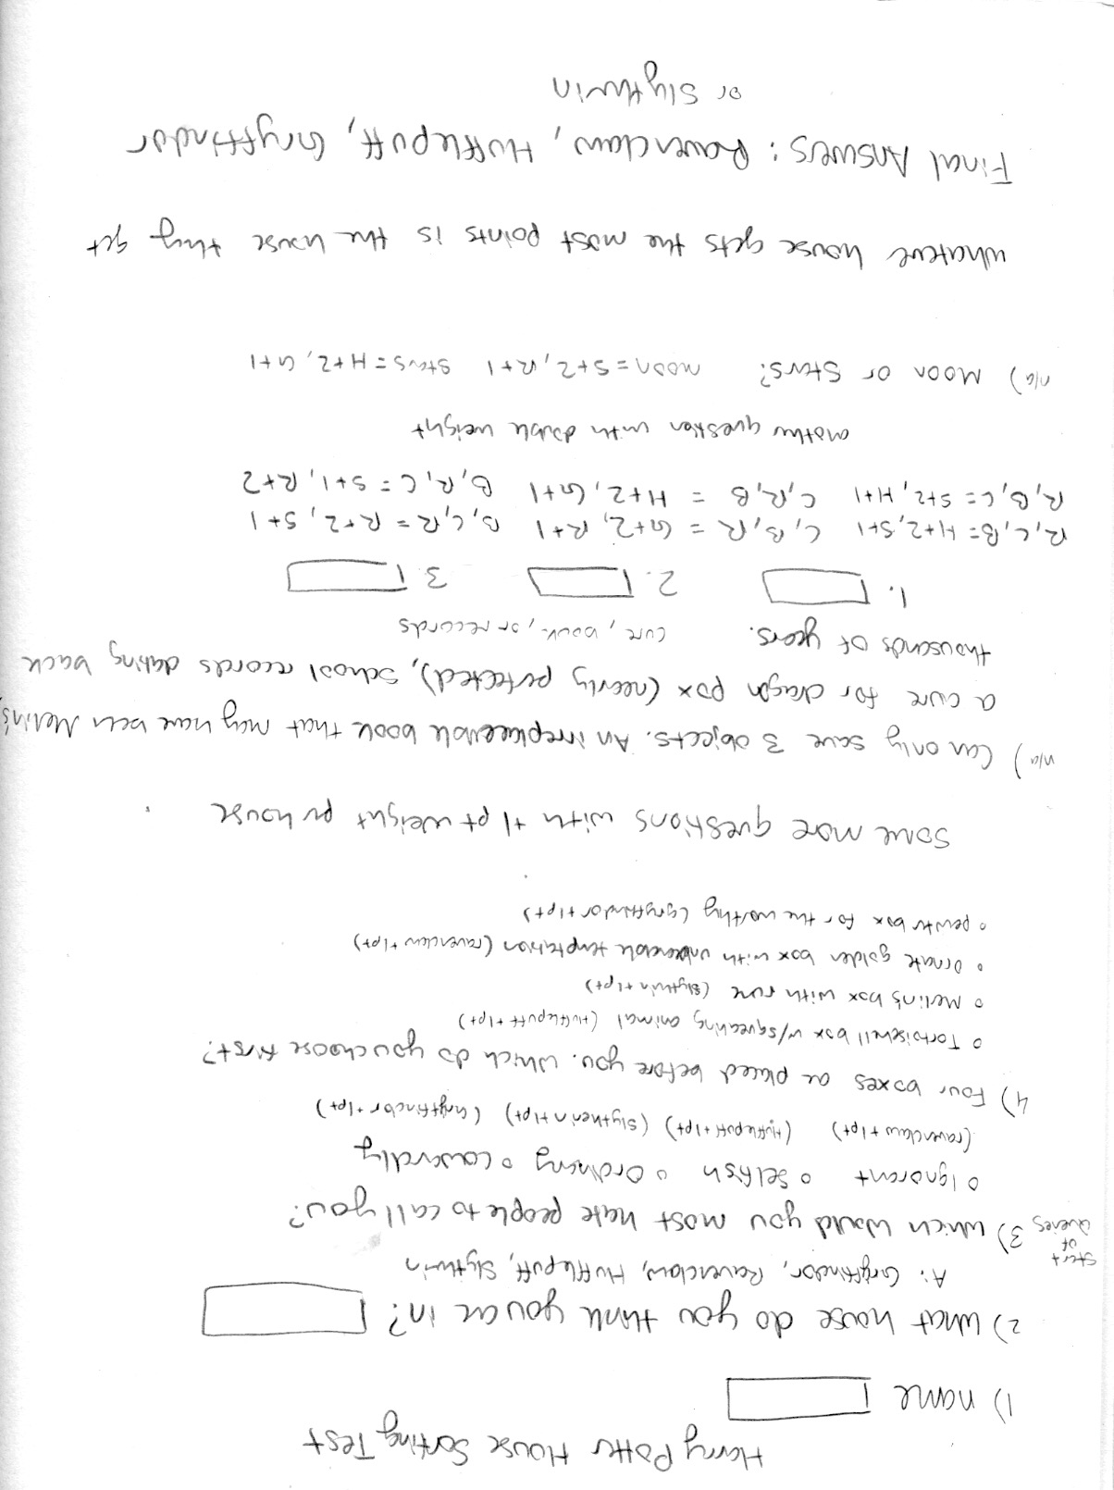

**Concept of Final Look:**

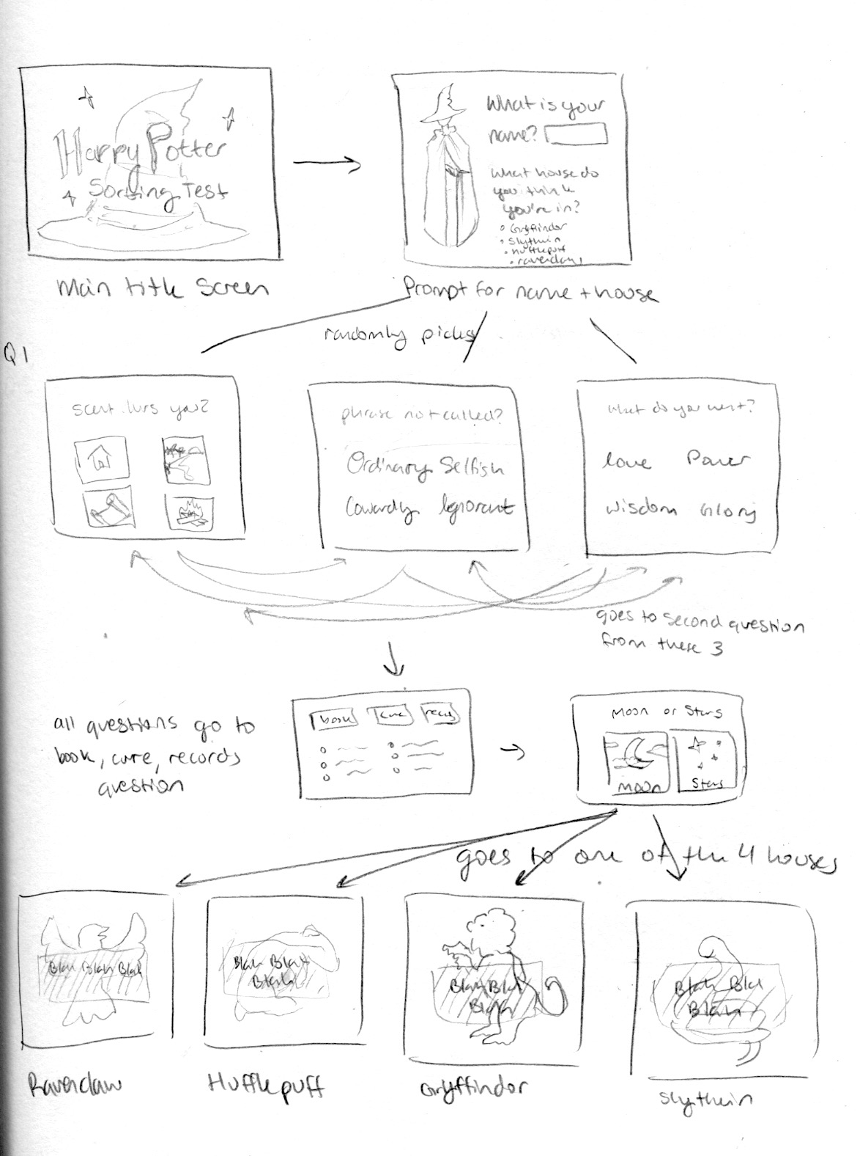

**Point Breakdown*:**

1. Which would you most hate people to call you?
   1. Ignorant (Rav+1)
   2. Selfish (Huf+1)
   3. Ordinary (Sly+1)
   4. Cowardly (Grf+1)
2. Given the choice, would you rather invent a potion that would guarantee you:
   1. Glory (Grf+1)
   2. Wisdom (Rav+1)
   3. Love (Huf+1)
   4. Power (Sly+1)
3. How would you like to be known to history?
   1. The Wise (Rav+1)
   2. The Good (Huf+1)
   3. The Bold (Grf+1)
   4. The Great (Sly+1)
4. You enter an enchanted garden. What would you be most curious to examine first?
   1. The silver leafed tree bearing golden apples (Rav+1)
   2. The fat red toadstools that appear to be talking to each other (Huf+1)
   3. The bubbling pool, in the depths of which something luminous is swirling (Sly+1)
   4. The statue of an old wizard with a strangely twinkling eye (Grf+1)
5. Four boxes are placed before you. Which would you try and open first?
   1. The small tortoiseshell box, embellished with gold, inside which some small creature seems to be squeaking. (Huf+1)
   2. The gleaming jet black box with a silver lock and key, marked with a mysterious rune that you know to be the mark of Merlin. (Sly+1)
   3. The ornate golden casket, standing on clawed feet, whose inscription warns that both secret knowledge and unbearable temptation lie within. (Rav+1)
   4. The small pewter box, unassuming and plain, with a scratched message upon it that reads ‘I open only for the worthy. (Grf+1)
6. Four goblets are placed before you. Which would you choose to drink?
   1. The foaming, frothing, silvery liquid that sparkles as though containing ground diamonds. (Rav+1)
   2. The smooth, thick, richly purple drink that gives off a delicious smell of chocolate and plums. (Huf+1)
   3. The golden liquid so bright that it hurts the eye, and which makes sunspots dance all around the room. (Grf+1)
   4. The mysterious black liquid that gleams like ink, and gives off fumes that make you see strange visions. (Sly+1)
7. A troll has gone berserk in the Headmaster’s study at Hogwarts. It is about to smash, crush and tear several irreplaceable items and treasures, including a cure for dragon pox, which the Headmaster has nearly perfected; student records going back 1000 years and a mysterious handwritten book full of strange runes, believed to have belonged to Merlin. In which order would you rescue these objects from the troll’s club, if you could? (The user will type the order in 3 text boxes))
   1. Cure book records (Grf+2 Rav+1)
   2. Cure records book (Huf+2 Grf+1)
   3. Book cure records (Rav+2 Sly+1)
   4. Book records cure (Sly+2 Rav +1)
   5. Records cure book (Huf+2 Sly+1)
   6. Records book cure (Sly+2 Huf+1)
8. Which would you rather be?
   1. Trusted (Huf+2 Grf+1)
   2. Liked (Huf+2)
   3. Imitated (Rav+2)
   4. Praised (Grf+2 Sly+1)
   5. Envied (Sly+2 Rav+1)
   6. Feared (Sly+2)
9. Which of the following do you find most difficult to deal with?
   1. Hunger (Huf+2 Rav+1)
   2. Cold (Sly+2 Huf+1)
   3. Loneliness (Huf+2 Grf+1)
   4. Boredom (Grf+2 Sly+1)
   5. Being Ignored (Sly+2 Rav+1)
10. Moon or Stars?
    1. Moon (Huf+2 Grf+1)
    2. Stars (Sly+2 Rav+1)
11. What house do you think you belong in? (If you don’t know choose which animal you like the best)
    1. Ravenclaw (if tied choose Rav or if tied between Grf and Huf choose grf if Grf and Sly choose Sly)
    2. Gryffindoor (if tied choose Grf or if tied between Rav and Huf choose Rav if Huf and Sly choose Huf)
    3. Hufflepuff (if tied choose Sly or if tied between Grf and Rav choose Grf if Rav and Sly choose Rav)
    4. Slytherin (if tied choose Sly or if tied between Rav and Huf choose Rav if Huf and Grf choose Grf)

**\***Over the course of user testing I found that this point system was giving too many ties for houses, leading to more inaccurate results. For the final product I upped the weights for the first 6 questions to 2 points each and the later ones gave 3 points to the dominant house, and 1 point to the secondary house. This helped to rectify the majority of the ties that were occurring.

**House Final Letters:**

GRYFFINDOR:

Congratulations! I’m Prefect Percy Weasley, and I’m delighted to welcome you to GRYFFINDOR HOUSE. Our emblem is the lion, the bravest of all creatures; our house colours are scarlet and gold, and our common room lies up in Gryffindor Tower.

This is, quite simply, the best house at Hogwarts. It’s where the bravest and boldest end up – for instance: Albus Dumbledore! Yes, Dumbledore himself, the greatest wizard of our time, was a Gryffindor! If that’s not enough for you, I don’t know what is.

I won’t keep you long, as all you need to do to find out more about your house is follow Harry Potter and his friends as I lead them up to their dormitories. Enjoy your time at Hogwarts – but how could you fail to? You’ve become part of the best house in the school.

HUFFLEPUFF:

Congratulations! I’m Prefect Gabriel Truman, and I’m delighted to welcome you to HUFFLEPUFF HOUSE. Our emblem is the badger, an animal that is often underestimated. Our house colours are yellow and black, and our common room lies one floor below the ground, on the same corridor as the kitchens.

Hufflepuffs are trustworthy and loyal. We don’t shoot our mouths off, but cross us at your peril; like our emblem, the badger, we will protect ourselves, our friends and our families against all-comers. Nobody intimidates us.

What else do you need to know? Oh yes, the entrance to the common room is concealed in a stack of large barrels in a nook on the right hand side of the kitchen corridor. Tap the barrel two from the bottom, middle of the second row, in the rhythm of ‘Helga Hufflepuff’, and the lid will swing open.

Our Head of house, Professor Pomona Sprout, is Head of Herbology, and she brings the most interesting specimens (some of which dance and talk) to decorate our room – one reason why Hufflepuffs are often very good at Herbology.

I think that’s nearly everything, and once again: congratulations on becoming a member of the friendliest, most decent and most tenacious house of them all.

RAVENCLAW:

Congratulations! I’m Prefect Penelope Clearwater, and I’m delighted to welcome you to RAVENCLAW HOUSE. Our emblem is the eagle, which soars where others cannot climb; our house colours are blue and bronze, and our common room is found at the top of Ravenclaw Tower, behind a door with an enchanted knocker. When you rap on the door, the knocker will ask you a question, and if you can answer it correctly, you are allowed in.

Without wishing to boast, this is the house where the cleverest witches and wizards live. Our founder, Rowena Ravenclaw, prized learning above all else – and so do we.

Another cool thing about Ravenclaw is that our people are the most individual – some might even call them eccentrics. But geniuses are often out of step with ordinary folk, and unlike some other houses we could mention, we think you’ve got the right to wear what you like, believe what you want, and say what you feel.

I think that’s nearly everything. Oh yes, our house ghost is the Grey Lady. The rest of the school thinks she never speaks, but she’ll talk to Ravenclaws. She’s particularly useful if you’re lost, or you’ve mislaid something. And once again: well done on becoming a member of the cleverest, quirkiest and most interesting house at Hogwarts.

SLYTHERIN

Congratulations! I’m Prefect Gemma Farley, and I’m delighted to welcome you to SLYTHERIN HOUSE. We’re like our emblem, the snake: sleek, powerful, and frequently misunderstood. Our house colours are emerald green and silver, and our common room lies behind a concealed entrance down in the dungeons. As you’ll see, its windows look out into the depths of the Hogwarts lake. We like to feel that our hangout has the aura of a mysterious, underwater shipwreck. Now, there are a few things you should know about Slytherin – and a few you should forget.

Firstly, let’s dispel a few myths. You might have heard rumours about Slytherin house – that we’re all into the Dark Arts, and will only talk to you if your great-grandfather was a famous wizard, and rubbish like that. Well, you don’t want to believe everything you hear from competing houses.

But that’s enough about what we’re not. Let’s talk about what we are, which is the coolest and edgiest house in this school. We play to win, because we care about the honour and traditions of Slytherin. As far as we’re concerned, once you’ve become a snake, you’re one of ours – one of the elite.

Well, I think that’s all for now. And once again, congrats on becoming a member of the most interesting houses at Hogwarts.