Md. Riazul Islam
515, South Monipur,
Mirpur, Dhaka
Cell Phone: 01722754100
E-mail: riazul56@gmail.com

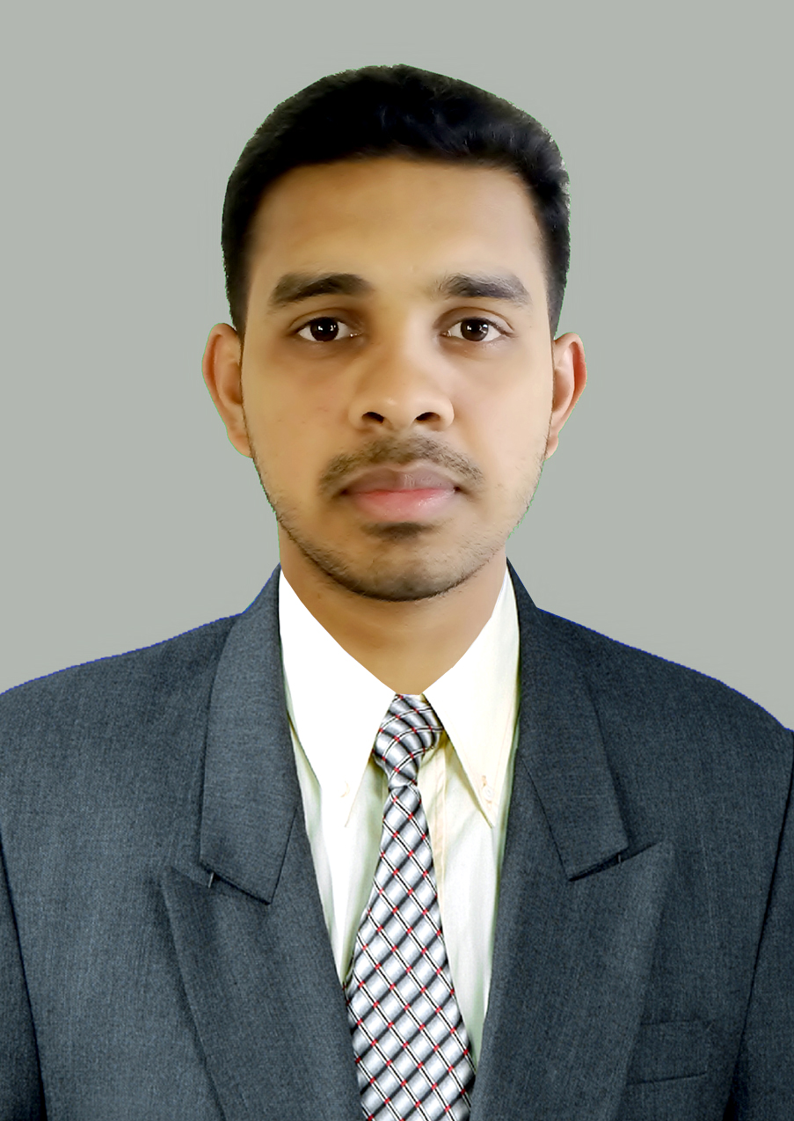

Career Objectives:

I want to build up my career with a active team where I shall be able to understand my own values and also to show my experience, creativity and innovative power.

Personal Particulars:

Name : Md. Riazul Islam
Date of Birth : 2nd September, 1993.
Father’s Name : Md. Abu Taher
Mother’s Name : Khadiza Begum.
Nationality : Bangladeshi (by birth)
National ID : 19938621404000010
Gender : Male
Marital Status : Single
Blood Group : O+ ve
Religion : Islam
Permanent Residence : Vill: Gaiddia P.O & P.S: Bhedargonj. Dis: Shariatpur
Present Address : House no: 515, South Monipur, Mirpur, Dhaka
Educational Background:

Bachelor in Engineering:
Field of Study (Dept) : Computer Science & Engineering Technology
Institute : Fareast International University (FIU)
Result : 1st Semester (Running)
Course Year : 3 years
Session : Spring 2016

Diploma in Engineering:
Field of Study (Dept) : IT & Telecommunication Engineering
Instituite : Shariatpur Gov’t Polytechnic Institute
Course Year : 4 years
Passing year : 2015

Secondary School Certificate (SSC/Dakhil):
Field of Study (Group) : Arts/Humanities.
Institute : Gaiddia M.S Degree Madrasha.
GPA : 5.00 out of 5.00
Year : 2011

Language Skills:
- Language Name: English 2. Language Name: Bengali
Reading: High Reading: High
Writing: High Writing: High
Speaking: High Speaking: High

Training & practical Educational Background:

- Name of Training : Computer office application 2003, 2007, 2010, 2013.
Field of Experience : MS Word, MS Excel Sheets, MS Power Point, Internet Browsing.
Institute : Uttoron Computer center.
Result : First Division (A+)
Course Times : 6 Months.

- Name of Training : English Writing & Spoken Course.
Field of Experience : Fluency in English, Writing & Spoken Skills.
Institute : Prottasha English Spoken Academy.
Result : First Division (A+)
Course Times : 6 Months.

- Name of Training : Air conditioner & Refrigerator.
Field of Experience : Refrigeration and Air Conditioning System, Maintenance & Servicing of Refrigerators & Air Conditioners.
Institute : Department of Youth Development.
Result : First Division (A+)
Course Times : 6 Months.

- Name of Training : Computer Networking Device & Hardware Installing.
Field of Experience : Telecommunication System, Maintenance & Installing Hardware Devices, Wi-Fi, LAN, MAN, WAN, Drawing of network architecture, Topology Drawing, Printing etc.
Company : StarLink Engineers Ltd.
Result : Best Performer
Course Times : 3 Months.

- Name of Training : Land Survey & Mapping Engineering.
Field of Experience : Surveying Land & papers of map, Islamic rules.
Institute : Moynamoti technical training Institute
Result : First Division (A+)
Course Times : 6 Months.

Projects & Thesis:
- Automatic Attendance System Software (Certified by STEP),
- Automatic House Light Control by LDR (Certified by SPI)
- Bandwidth Routing & Sharing (SL Engineers Ltd)
- Grass cutting any limited size Machine(Certified by Campus)
- Design Network Architecture
- BTCL Network Model
- Wi-Fi & LAN Network System
- Network Design topology

IT & Computers Skills:

Operating system:

- Windows XP,
- Windows 7
- Windows 8
- Windows 8.1
- Windows 10
- Linux Red HAT,
- Windows server 2008

Operating software:

- Microsoft Office 2003,10,13,15
- Notepad/Notepad++.
- Email & Social communication.
- Internet browsing and downloading.
- Microsoft Visual Basic 2008

Graphics Design software:

- Adobe Photoshop 7.
- Photoscape.
- Adobe Illustrator.
- Ulead Media studio.
- Adobe Photoshop CS.
- E-Draw Max
- AutoCAD

Website Design software:

- Dreamweaver HTML & PHP
- Notepad++/Note
- SQL Server 2010

Extra Curriculum:

- I won “The best skills competition project performer” award 2014.
- Won the Inter Hall Computer Performer & Troubleshooter.
- Experienced in Home Networking and repair the various electronics devices.
- Mobile software & firmware development & troubleshooting.
- LAN establishing, troubleshooting and repairing..
- Computer Hardware Device Installing.
Professional Experience:

Duration : Aug 2015 to Dec 2015.
Company : StarLink Engineers Ltd.
Address : Gulshan-1, Dhaka
Position : Commissioning Engineer @ Core Department.
Field of Working : Networking Device & Hardware Commissioning & Equipment testing.

References:

Academic:  Mr. Sanjit Kumar Mistry  Instructor of  Shariatpur polytechnic institute  Department of Bangla  Burirhaat, Shariatpur  Mobile No: +88-0172-1003813  Email: sanjitkumarbd@gmail.com | Relative:  Engr. Md. Mahfuzur Rahman  Manager (HVAC)  BLIL-HVAC  PRAN-RFL GROUP  105 Middle Badda, Dhaka-1212  Mobile No: +88-01924-601052  E-Mail: blil101@prangroup.com

=================
Signature of the applicant

