**BDD(Behavior Driven Development)**

It is an agile software development process that encourages collaboration between developers, business analysts, or a real non-technical client on a software project. It is an agile software development process that encourages collaboration between developers, business analysts, or a real non-technical client on a software project. In most software projects developed today, the testing phase takes place at the final stage of the development process. BDD, on the other hand, enables test-oriented software development, unlike these conventional software development processes. There may be many stakeholders from different business groups for a software project to be developed. With the BDD approach, it is ensured that these stakeholders use a common language during the software development process. Since we write like a spoken language in the BDD approach, we eliminate the communication wall.

We can say that the BDD approach not only makes the software more test-oriented, but also allows everyone to understand the code written by the Developer. BDD approach takes testing processes one step ahead and supports writing test cases before coding like TDD. Thanks to these test scenarios, which will be created with the scenarios obtained from the user stories, the test costs are significantly reduced.

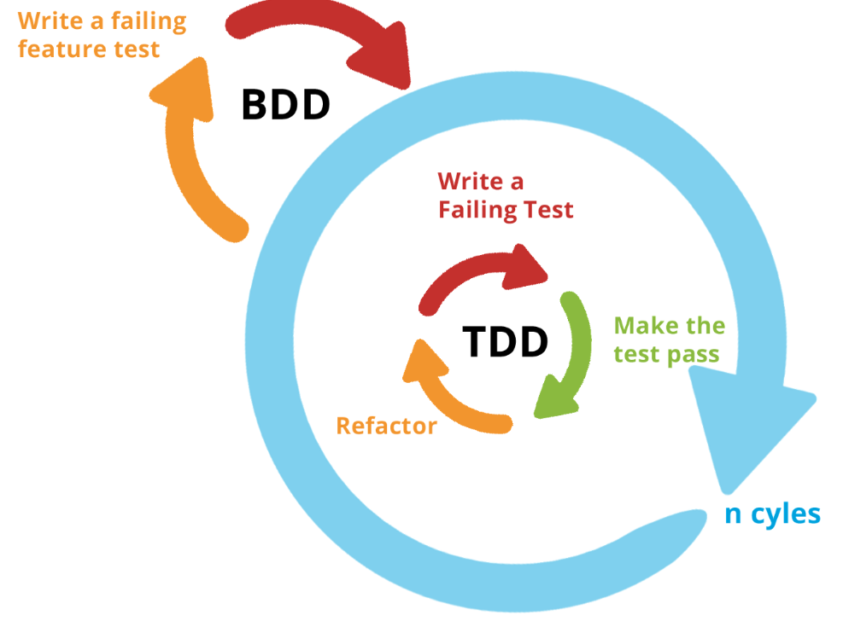

BDD emerged with the aim of removing the complexity of the TDD approach. It is an approach that enables software processes to progress more test-oriented. Software is designed by preparing test scenarios over user stories.

The usual project development method was as follows:

1- Planning

2- Design

3- Development

4- Test

5- Delivery

In such a project method, testing is the last stage before product delivery. The customer's expectations and the product developed by the Developer may not be the same. In such cases, late detection of errors creates negative results in terms of cost and customer satisfaction. The BDD approach is a solution to these problems.

BDD prevents the loss of effort and cost that may occur in the project by relocating the product development and testing steps.

BDD changes the order above:

1- Planning

2- Design

3- Test

4- Development

5- Delivery

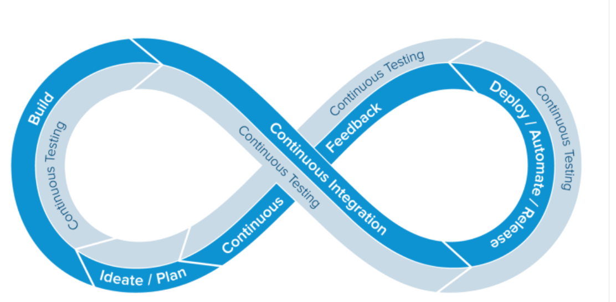

If we apply the "Test at Every Stage" logic in the entire sprint cycle; software development process will bring along better quality and reliable software products.

BDD has an easy typing method. Commands such as Given, When, Then are used while writing test cases. Given, a specified test scenario is written. When, an action occurs.

Then tells how the application will return after the determined scenario and action.

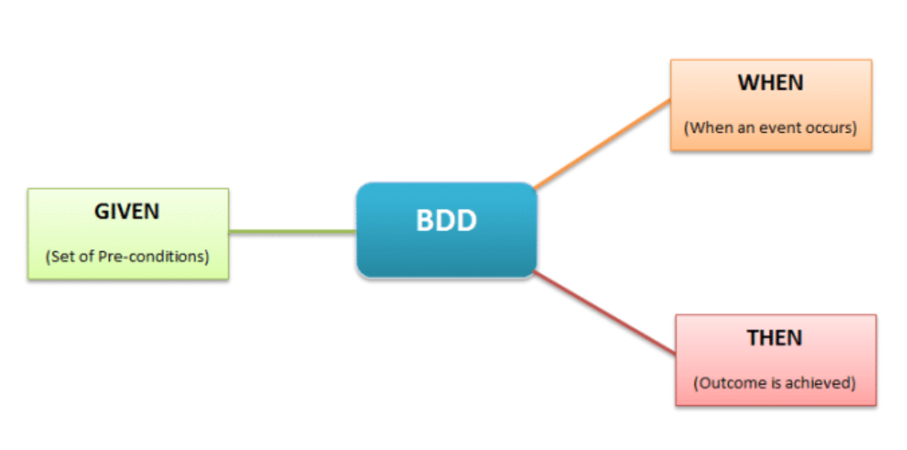

**For example, suppose a user wants to log into the system, the BDD steps would be as follows:**

**Given:** The user enters an incorrect password in the password field.

**When:** Presses the enter button.

**Then:** An error message is displayed stating that the user wants to log in with an incorrect password.