**E2E(END TO END)**

End to End Testing is a software testing technique that makes us test the entire application from start to finish, in an environment that is similar to production . It checks the integration of the software’s dependencies ensuring that all the interfaces, databases work together as expected.

End to End Testing tests how the application communicates with hardware, network connectivity, external dependencies, databases, UI, API layers, and other applications.

End to End testing complements other forms of testing like unit testing, system testing, functional testing by providing additional coverage and verifying the system as a whole.

When programmers develop new software, they create a small unit and test it. This creates an easy to follow feedback loop. Then they integrate these units into modules and test them. In an ideal scenario, this process would incrementally cover all parts of the system but it’s rarely the case.

Software applications these days are highly complex and interconnected with multiple subsystems. Even if a single system fails, it would fail the entire software.End to End Testing can increase the coverage of our testing as it checks the entire flow including all the subsystems similar to the user environment. It detects issues and decreases system failures.

It avoids the risk by

* By verifying the backend of the system.
* Interacting with different layers of the architecture as it checks the overall functionality.
* Increasing the test coverage and scope of the application.
* Performing repeatable tests at different points and processes in the application.
* Involving the front end in the testing ensures a better user experience.

**End-to-End Testing Lifecycle**

End to End Testing Life Cycle consists  four phases:

* Test Planning
* Test Design
* Test Execution
* Result Analysis

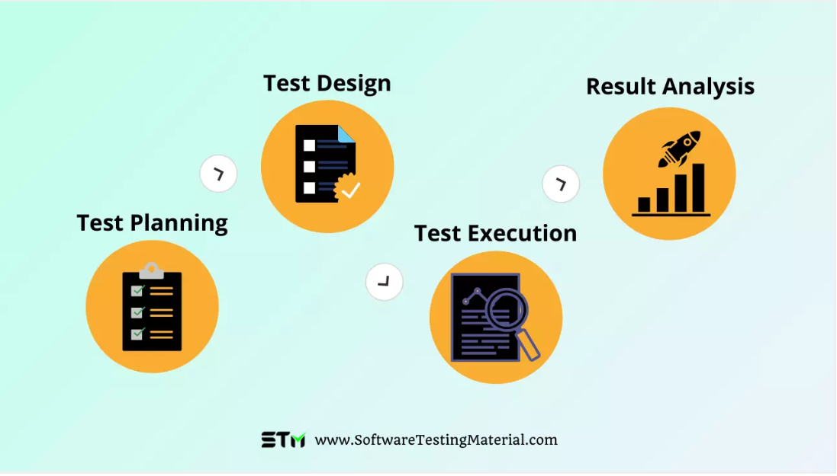

**Test Planning:** End to End Life Cycle is similar to STLC, here we plan the important phases, it helps us specify the critical task, schedule the timeline and resources for the testing.

**Test Design:** In this phase, we generate test cases, test specifications and perform usage analysis, risk analysis and then schedule tests.

**Test Execution:**Here we execute the test, verify the application from end to end. We’ll document the issues, observations and remarks.

**Result Analysis:**In this stage, we analyse and compare the test results.