**TDD(Test Driven Development)**

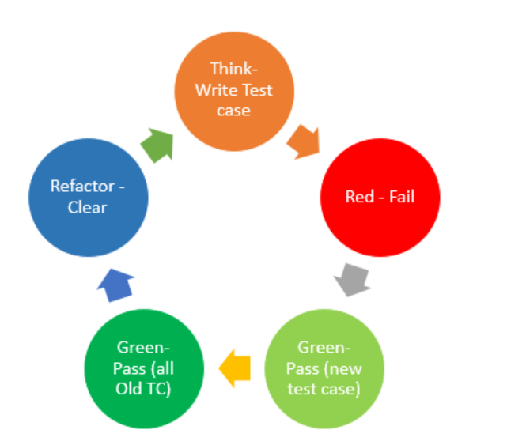

As we will see in the picture, TDD consists of a few very simple steps.

1. A test is written.

2. The test fails.

3. The test is successful.

4. It is ensured that all existing tests are successful.

5. The code is refactored. In other words, improvement and (or) cleaning is done in the code.

In this context, it should be noted that it is not TDD to write the code beforehand and then test it. In TDD, the test must be written in the first place.

While developing a code as the main logic, TDD supports determining test cases before writing the code and writing and refactoring the code based on these scenarios. A test is written. The test fails. The code is developed and the test is successful. It is ensured that all existing tests are successful. The code is refactored.

In TDD, the test must be written first.