**DEEP LİNK?**

Deep linking is a technique that allows an app to be opened to a specific UI or resource, in response to some external event. The “deep” refers to the depth of the page in an App hierarchical structure of pages. This is a very important feature for user engagement, it also makes the app more responsive and capable of navigation to arbitrary content in response to external events like Push Notification, Emails, web links etc.

**What problem Deep Link solve?**

Web links don’t work with native mobile apps.

If you use your mobile device to open a link to an article, you are taken to the destination in your web browser even if you have the article app installed. This is a problem because the article app is a better user experience than the mobile version of the article app.

**The different way of implementing Deep Linking?**

There are two ways of implementing deep linking:

URL scheme

Universal Links

URL schemes are a well-known way of having deep linking, Universal links are the new way Apple has implemented to easily connect your webpage and your app under the same link.

URL schemes are more easy to implement then Universal Links

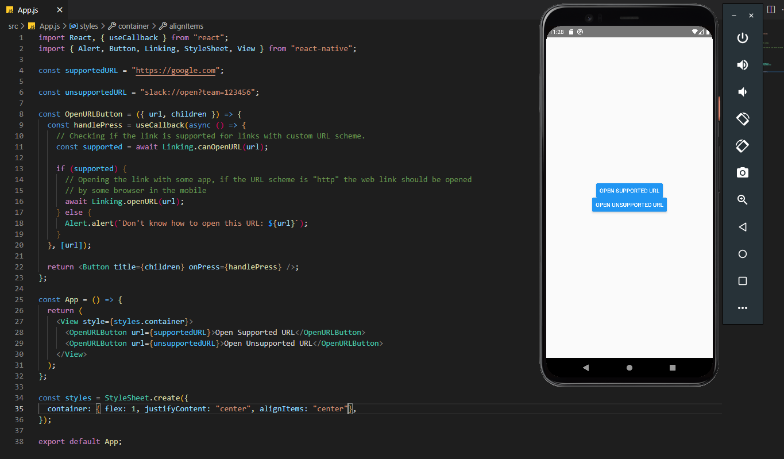Here is basic example;