**PROBLEM**

The following is seen on the command line when pushing or pulling:

SSL Certificate problem: unable to get local issuer

**CAUSE**

There are two potential causes that have been identified for this issue.

1. A Self-signed certificate cannot be verified.
2. Default GIT crypto backend (Windows clients)

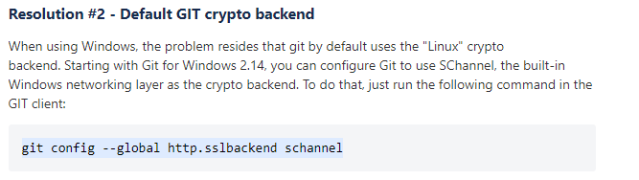

Link: <https://confluence.atlassian.com/bitbucketserverkb/ssl-certificate-problem-unable-to-get-local-issuer-certificate-816521128.html>