**GETTING START with TYPESCRIPT**

If you're starting a new project, there are a few different ways to get started.

We can use TypeScript template;

npx react-native init MyApp --template react-native-template-typescript

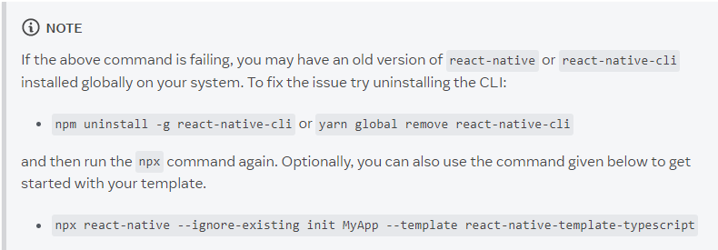

**Adding TS to an Existing Project;**

npm install -D typescript @types/jest @types/react @types/react-native @types/react-test-renderer

Add a TypeScript config file. Create a tsconfig.json in the root of your project:

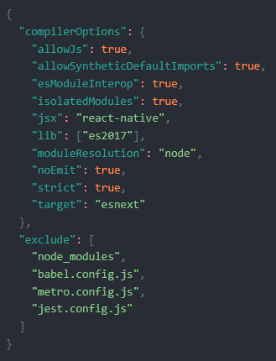

Create a jest.config.js file to configure Jest to use TypeScript

